The epistemic value of brain-machine systems for the study of the brain

Abstract. Leading researchers have claimed that bionic systems, connecting biological tissues with computer or robotic devices through brain-machine interfaces, can contribute not only to the restoration of lost sensory-motor abilities but also to neuroscientific research. This claim has been recently undermined by philosopher of neuroscience Carl Craver, who has proposed a sceptical argument on the epistemic value of bionic systems. This paper has a specific and a more general goal. The first one is to show that Craver’s argument, though logically sound, fails to support a negative view on the role of brain-machine systems in neuroscience. The more general objective is to argue that bionic technologies can really assist in the discovery of brain mechanism. This goal will be pursued by distinguishing between, and exemplifying, various bionics-supported methodologies for the study of the brain, which chiefly include simulative and non-simulative experiments. The critical discussion of Craver’s argument and the taxonomy proposed here may contribute to building up a finer-grained understanding of the variety of ways in which bionic systems can be used not only to restore sensory-motor capacities but also to model biological behaviours, and, for this reason, it may be of interest to all those wishing to understand the role of bionics in contemporary neuroscience and cognitive science research.

Introduction
Research on brain-computer interfaces is rapidly advancing towards the construction of electronic and robotic systems – sometimes called bionic systems – that may be reliably controlled by the neural activity of living tissues. These technologies may enable the restoration of communication, sensory and motor abilities lost due to accidents, stroke, or other causes of severe injury (see for example the case of the locked-in patient described in Hochberg et al., 2006). In addition, leading researchers have claimed that “the general strategy… of using brain-derived signals to control external devices may provide a unique new tool for investigating information processing within particular brain regions” (Chapin et al., 1999, p. 669), and that brain-machine interfaces “can become the core of a new experimental approach with which to investigate the operation of neural systems in behaving animals” (Nicolelis, 2003, p. 417). Recently, however, philosopher of neuroscience Carl Craver (2010) has taken a sceptical position on the epistemic value of bionic systems. He has argued that one can build a functionally efficient prosthesis without having understood the input-output behaviour of the biological component replaced by the prosthesis, as robotic prostheses need not connected to the same inputs that drive the behaviour of the replaced limbs. Moreover, he has argued that one can build an efficient prosthesis without knowing the sensory-motor mechanism governing the target component. For these reasons, the ability to build a successful prosthetic system does not demonstrate that one has discovered the behaviour or the sensory-motor control mechanism governing the replaced biological system.
This paper has a specific and a more general goal. The specific goal is to show that Craver’s argument, although logically sound, is not sufficient to support a sceptical view on the epistemic value of brain-machine technologies for the study of the brain. The more general goal is to support a positive view on the role that bionics can play in neuroscientific research. Indeed, Craver’s argument will be neutralized by showing that it is based on a too narrow conception of the ways in which bionic technologies can be used to discover brain mechanisms. A classification of various bionics-based methodologies for the study of the brain will be proposed, which extends the preliminary taxonomy proposed in (Datteri, 2009) in some important respects. And it will be shown that Craver’s sceptical argument has no bearing on some elements of it. I believe that the critical discussion of Craver’s argument made here, and the extension of the taxonomy proposed in (Datteri, 2009), may therefore contribute to building up a finer-grained understanding of the variety of ways in which bionic systems can be used not only to restore sensory-motor capacities but also to model biological behaviours, and that, for this reason, it may be of interest to all those wishing to understand the role of bionics in contemporary neuroscience and cognitive science research.
The structure of the article is as follows. After discussing some epistemological and methodological assumptions underpinning the ensuing analysis (section 2), Craver’s argument will be presented in section 3. Then a distinction between replacement and connection bionic experiments, and between simulative and non-simulative methodologies, will be made and exemplified in section 4. These distinctions will be used in section 5 to critically analyse Craver’s argument. Some concluding remarks will be made in the last section of this paper.

Mechanistic models and simulations
The expression “mechanistic model” is used here to refer to the description of a mechanism (Craver, 2007). Mechanistic models describe the regular behaviour of system components by means of generalizations (Glennan, 2005; Woodward, 2002). For example, a component termed the “vestibulo-reticular pathway”, which supposedly establishes a regular relationship between vestibular and reticular neurons, is thought to play a crucial role in the mechanism of postural control in lampreys (Orlovsky et al., 1992). As mentioned later in this paper, a bionic preparation has recently been used to precisely characterize the regular relation between the activity of the vestibular and reticular neurons.
As pointed out by various authors, mechanistic models can differ from each other along a number of dimensions. First, they may be more or less precise. A precise formulation of the relation holding between vestibular and reticular neuron activity in the lamprey will take the form of a mathematical relationship, whereas a more qualitative generalization will contain unfixed coefficients or only be informally stated. Second, mechanistic models can be more or less sketchy in the sense discussed by Craver (2007), a mechanism sketch being a mechanism description containing gaps or lacking components. Mechanism sketches need not be imprecise (one may precisely describe all the components of a mechanism but one), and vice versa (one may imprecisely describe all the components of a putative mechanism). Third, mechanistic models may be more or less decomposed, depending on the extent to which mechanistic analysis has been iterated in relation to each component (Bechtel, Richardson, 1993; Craver, 2002; Craver, Darden, 2001). A model that is less decomposed is not necessarily less sketchy or less precise, and vice versa.
All mechanism descriptions, irrespective of their position along each of these dimensions, are general in the sense that they can describe the mechanism at work in many different systems. The same regularity can characterize the behaviour of the vestibulo-reticular pathway of many different lampreys. It can also characterize the behaviour of artificial components. More generally, any given mechanistic model is general as it may be realized by systems differing from each other in their material substrate, but having components behaving as stated in the model and organized accordingly. Note that all mechanistic models are general, in the sense clarified here, independently of whether they are more or less decomposed.
An artificial, man-made system may be said to simulate a mechanistic model if it has components behaving as specified in the models and organized accordingly – in short, if it realizes the mechanistic model in the sense specified above. Computer and robotic simulations are used in scientific research for at least two purposes. In what may be called data-oriented simulation studies, a simulation of a particular mechanistic model is built to obtain (predict) data on the behaviour of a target system that are difficult or impossible to obtain by more conventional measurement or observational techniques. For example, computer simulations are used as “computational microscopes” to obtain detailed information about conformational changes in ion channels based on the ions’ molecular structure and the laws governing atomic interaction (Dror et al., 2012). Whether the output of the simulation may be viewed as a reliable predictor of the target system’s behaviour is a question that depends on whether (a) the simulated mechanistic model is a good model of the target system, and whether (b) it is accurately realized by the simulation (Guala, 2002; Humphreys, 2004; Parker, 2009).
In other cases, simulations are used to test a mechanistic model of the target system’s behaviour rather than to obtain data on it. This use of simulation is made in what will be called here model-oriented simulation studies. In this scenario, one builds a computer or robotic simulation of a mechanistic model, and compares its behaviour with the behaviour to be explained. If a match is obtained, one may be induced to conclude that the simulated mechanistic model is a good model of the target system; otherwise, one may be induced to reject the model. In both cases, a theoretical conclusion on the model under scrutiny is inferred from the analysis of the behaviour produced in the simulation, an inference that implicitly relies on various auxiliary methodological assumptions discussed in the epistemological literature (Webb, 2001; Datteri, Tamburrini, 2007). Computer and robotic systems have been used as model-oriented simulations in Artificial Intelligence (Newell, Simon, 1961) and contemporary biorobotics (Floreano et al., 2014; Reeve et al., 2005). Note that model-oriented and data-oriented studies differ from each other not only in terms of their objectives, but also with regard to their epistemic requirements. To be justifiably used in a model-oriented study, the artificial system must accurately realize (simulate) the mechanistic model under scrutiny (Condition b above). However, in contrast with the data-oriented scenario, the mechanistic model need not have been previously established as a good model of the target system – model-oriented studies are carried out precisely to test whether the model at issue is a good one. Later on in this paper, it will be claimed that model-oriented, bionic simulations may be used to test hypotheses on the sensory-motor mechanisms underlying animal behaviour.

A sceptical argument on the epistemic value of bionic experiments
A number of studies, some of which will be mentioned in the ensuing sections, suggest that brain-machine systems can really play a significant epistemic role in the study of the brain. This view is undermined in (Craver, 2010). In his article, Craver focuses on “what, if anything, building a prosthetic mechanistic model adds to our confidence that we have a valid mechanistic model over and above the degree of confidence provided by models and simulations alone” (p. 843). His answer is a qualified “nothing”. However, at the end of the paper he arrives at a rather stronger conclusion, defending a sceptical view as to whether “the ability to build a successful prosthesis counts as evidence that one knows how the system works” (p. 850). Both claims strikingly contrast with the enthusiastic views on the epistemic role of bionics cited in the Introduction. In particular, the first assertion is at odds with Chapin’s claim that brain-machine technologies “may provide a unique new tool” to discover brain information processing mechanisms (emphasis added). The second, stronger assertion contrasts with Nicolelis’ claim that brain-machine technologies pave the way to the development of new experimental approaches with which “to investigate the operation of neural systems in behaving animals”.
Craver’s argument runs as follows. He refers to a prosthesis as affordance valid “to the extent that the behaviour of the simulation could replace the target in the context of a higher-level mechanism” (p. 842). A robotic arm enabling one to perform all the movements and actions she could perform with a biological arm – such as grasping, lifting, or pushing objects – is affordance valid. The development of affordance valid limb prostheses for the restoration of missing sensory-motor capacities is one of the main objectives of research in bionics (see Nicolelis, 2011 for a review). A prosthesis is said to be phenomenally valid to the extent that “its input-output relationship is relevantly similar to the target input-output relation” (p. 842) under standard or non-standard conditions. A robotic arm, for example, is phenomenally (or behaviourally) valid if the relationship between its inputs and its movements is relevantly similar to the relationship between the inputs and the movements of the biological arm it is replacing. Finally, a prosthesis is said to be mechanistically valid to the extent that its parts, activities, and organizational features are relevantly similar to the parts, activities, and organizational features in the target (p. 842). A robotic arm, for example, will be mechanistically valid if its internal mechanism is relevantly similar to the internal mechanism governing the replaced arm (mechanistic validity will be discussed more in detail below).
Craver’s first point is that affordance valid prostheses need not be phenomenally valid. He rightly argues that robotic systems can partially replace the functionality of a missing arm or leg even if their inputs are very different from the inputs of the replaced biological components. The arm prosthesis described in Carmena et al. (2003), for example, is affordance valid (a monkey could use a brain-controlled prosthesis to carry out tasks which she had previously carried out by using her own hands). However, the neurons whose activity controlled the prosthesis were not those providing input to the animal’s biological arm, as the prosthesis was controlled by the activity of various frontoparietal neural ensembles acquired through a multi-electrode brain-machine interface. Even though these brain areas participate in motor control, monkey arms are not directly connected to these areas. The input of the prosthesis was very different from the input of biological monkey arms. For this reason, the input-output behaviour of the prosthesis was radically different from the input-output behaviour of monkey arms, and the prosthesis was therefore to be regarded as phenomenally invalid. The fact that arm prostheses can be reliably controlled by signals directly acquired from neural ensembles in various brain areas is one of the major discoveries made in the framework of bionics research so far. Neural networks can be used to extract several motor parameters, including hand velocity and gripping force, from brain areas which are relatively distant from the motoneurons which directly stimulate muscle activity. This discovery has important theoretical implications, as stressed later, as it sheds light on the way motor representations are encoded in the brain.
The fact that affordance validity can be achieved without phenomenal validity has also, according to Craver, an important consequence as to whether bionics research can really contribute to the discovery of brain mechanisms: being able to build an affordance valid prosthesis does not imply having understood the input/output relationship characterizing the replaced biological component.
Another point made by Craver is that affordance and phenomenal validity do not imply mechanistic validity: “a prosthetic model might be affordance valid and phenomenally valid yet mechanistically invalid”; “building a functional prosthesis that simulates a mechanistic model is insufficient to demonstrate that the model is mechanistically valid” (p. 845). Recall that a prosthesis is said to be mechanistically valid to the extent that its parts, activities, and organizational features are relevantly similar to the parts, activities, and organizational features in the target. Therefore, here Craver is arguing that a prosthesis may be affordance or phenomenally valid even though its internal mechanism is not relevantly similar to the internal mechanism of the target. This is because many different mechanisms, in principle, could produce the same input-output behaviour: in the philosophical jargon, the mechanism is underdetermined by the device’s input-output behaviour, or, equivalently, the latter is said to be multiply realizable.
Phenomena are multiply realizable in lower-level mechanisms. Multiple realizability obstructs the inference from a model’s phenomenal validity to its mechanistic validity. The space of phenomenally adequate simulations might well be too large and heterogeneous to provide any assurance that the mechanistic features of a phenomenally adequate simulation are relevantly similar to the mechanistic features of the target (p. 844).
It is important to understand what exactly Craver means with “target” in these claims. The problem of multiple realizability obstructs inferences from the behaviour of a system to the mechanism producing that behaviour. In a simulation study, in particular, one builds an artificial system A simulating a theoretical model of target (biological) system B. In this context, the problem of multiple realizability can be stated as follows: the fact that simulation system A reproduces the input-output behaviour of target system B is insufficient to conclude that A’s internal mechanism is relevantly similar to the mechanism governing B. Craver warns us that building a prosthesis that reproduces the input-output behaviour of a biological component (thus being phenomenally valid) is insufficient to conclude that the prosthesis reproduces the internal mechanism of that biological component, namely of the component replaced by the prosthesis. His point is that a phenomenally valid arm prosthesis, for example, can fail to reproduce the mechanism governing the replaced arm. To sum up, Craver argues that being able to build a phenomenally valid prosthesis is not sufficient to demonstrate that one has understood the mechanism governing the biological component replaced by the prosthesis.
Taken together, the arguments discussed so far allow Craver to conclude that “affordance valid models need not mechanistically or phenomenally valid. This is a blessing for engineers and a mild epistemic curse for basic researchers” (p. 850). Building an efficient prosthesis is insufficient to conclude that one has discovered the mechanism governing the component replaced by the prosthesis. This sceptical thesis on the epistemic value of bionics research will be neutralized by showing that it rests on a narrow understanding of the various ways bionic systems can be used to discover brain mechanisms. Let us then introduce some of these ways.

Bionics-based methodologies for the study of the brain
One of the aims of this paper is to argue that bionic systems can assist in the discovery of brain mechanisms. In particular, I will argue that they can be used to obtain two kinds of theoretical conclusions on the layout of brain mechanisms. To illustrate, let M be a purely notional mechanistic model making reference to components b₁, b₂, and b₃ of target system S (see the box-and-arrow model in Figure 1 left, in which the model of S is labelled M_{S}). And suppose that model M describes, in a more or less precise way, the putative regular behaviour of each component. To test whether M is a good model of S, one may want to assess whether all the components of S actually exhibit the corresponding regularities – for example, whether component b₁ of M_{S} actually exhibits the putative behaviour r(b₁). Bionic systems can be used for this purpose: more generally, they can assist in addressing theoretical hypotheses on the input-output behaviour of specific components of sensory-motor mechanisms. Moreover, I will argue that bionic systems can be used to inquire into the internal mechanism governing the behaviour of particular components. Let us label scientific questions of the first kind as “level-1” questions, to distinguish them from “level-2” questions in which mechanistic decomposition is iterated in relation to a particular component (see Figure 1 right).
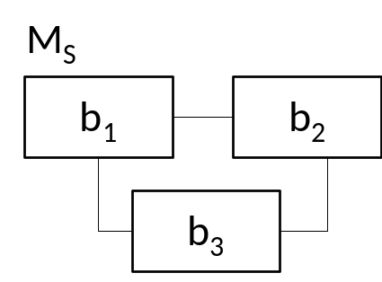 | 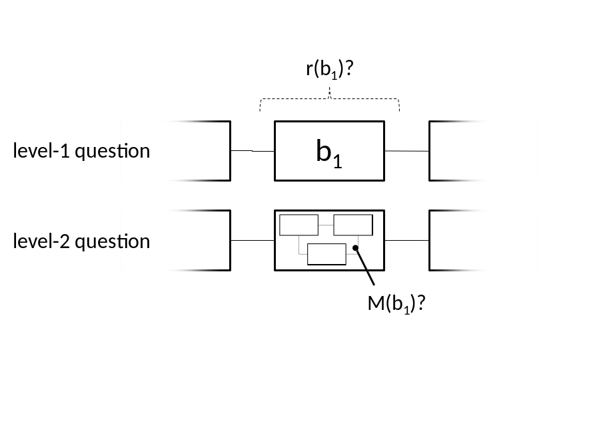
Figure 1 – Left: box-and-arrows model of system S. Right: the distinction between level-1 and level-2 questions.
A number of bionics-based methodologies can be adopted to address level-1 and level-2 questions. In this section a distinction between replacement and connection experiments, and between simulative and non-simulative methodologies will be made, drawing from – and extending – a taxonomy of bionic experiments proposed in (Datteri, 2009). These distinctions will be useful both to emphasizing the epistemic value of bionic experiments for the study of the brain, and to neutralizing the sceptical argument discussed in the previous section.

Replacement and connection methodologies
Bionic systems are all obtained by connecting electronic or robotic devices with living tissues via invasive (e.g., microelectrode arrays) or non-invasive (e.g., electroencephalographic electrodes) interfaces. However, they may be used in different ways to discover brain mechanisms. A first distinction can be made, based on (Datteri, 2009), between replacement and connection experiments. These two experimental methodologies differ from each other with respect to whether the component whose input-output behaviour (level-1 question) or internal mechanism (level-2 question) is under investigation is replaced by, or connected to, a prosthetic device. They will be only briefly outlined and exemplified here: for a more detailed description see (Datteri, 2009).

Replacement experiments. Consider the level-1 goal of checking whether component b₁ of M_{S} actually exhibits the putative behaviour r(b₁). To achieve this goal, one might build an artificial component a₁ that is known to display behaviour r(b₁); replace the target component b₁ with a₁, thus obtaining a hybrid bionic system H; and finally check whether H’s behaviour is relevantly similar to the behaviour of S. If it is, one might be induced to conclude that b₁ actually exhibits r(b₁), thus corroborating one of the theoretical claims stated in M. Indeed, if H’s behaviour does not change after replacing b₁ with an artificial component a₁ displaying behaviour r(b₁), then one must conclude that b₁ displays behaviour r(b₁) too. If, on the other hand, H’s behaviour changes as a result of the replacement, one might conclude that the behaviour of a₁ does not match the behaviour of b₁, and therefore that b₁ does not exhibit r(b₁). To sum up, in this methodology one investigates the behaviour of a component by replacing it with an artificial one (see Figure 2). Experiments of this kind are called ArB (“artificial replacement of biological components”) experiments in (Datteri, 2009). This methodology is exemplified in a bionics-supported study on lamprey sensory-motor coordination (Zelenin et al., 2000), in which a model of the input-output behaviour of a component of the lamprey nervous system is obtained by replacing that component with an electro-mechanical device and checking whether the behaviour of the resulting hybrid system is relevantly similar to the behaviour of the original, intact lamprey.
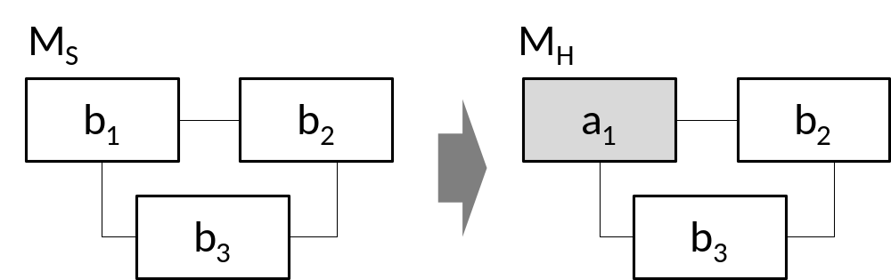
Figure 2 – Schema illustrating the relationship between a model of the target system S and a model of the hybrid system H in the replacement strategy.

Connection experiments. In replacement experiments, as shown in the previous section, the target component is replaced with an artificial device exhibiting the hypothesized behaviour r(b₁). Other bionic experiments adopt a completely different methodology to identify the input-output behaviour of b₁: the target component is connected to (rather than replaced by) artificial components a₂ and a₃ whose behaviour is known (see Figure 3). The behaviour of b₁ is then inferred from the behaviour of the resulting hybrid system H: one theorizes on what behaviour b₁ must exhibit for the whole hybrid system H to generate the observed behaviour, in light of the (known) behaviours r(a₂) and r(a₃) of the artificial components to which b₁ is connected. To obtain further evidence, one may also replace b₁ in H with an artificial component a₁, thus obtaining a fully artificial system A. If H’s behaviour turns out to be relevantly similar to A’s behaviour, then one may be induced to conclude that b₁’s behaviour is relevantly similar to a₁’s behaviour; given that the behaviour of a₁ is known (a₁ being a man-made device), one automatically knows the behaviour of b₁ as well. Experiments of this kind are called BrA (“biological replacement of artificial components”) experiments in (Datteri, 2009). The connection strategy is exemplified by a study on the lamprey nervous system carried out by the Mussa-Ivaldi research group (Karniel et al., 2005; Mussa-Ivaldi et al., 2010). In that study, the so-called vestibulo-reticular component of a lamprey was extracted and placed in the control loop of a robotic system. Then, the input-output behaviour of that component was inferred from an analysis of the behaviour of the resulting hybrid system.
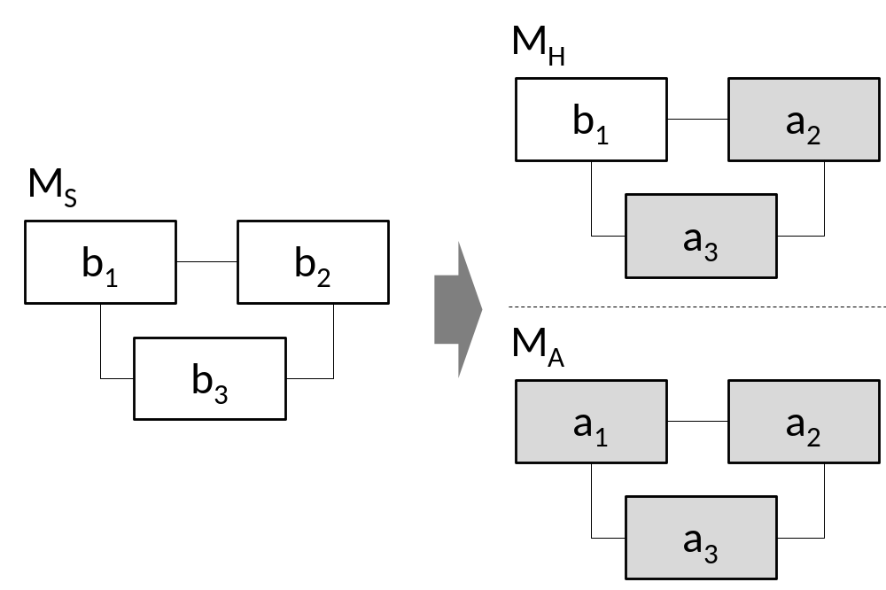
Figure 3 - Schema illustrating the relationship between a model of the target system S, a model of the hybrid system H, and a model of a fully artificial simulation A in the simulation-connection strategy.
A level-2 question on the internal mechanism of the vestibulo-reticular component was also addressed in that study by using the same hybrid preparation. Indeed, after reasoning on the input-output behaviour of the target component, the authors hypothesized a variety of possible mechanistic models of it, differing from each other in terms of the pattern of the connections among input and output neurons. They built computer simulations of each of these models. Then, the biological vestibulo-reticular component was extracted from H and replaced with each of these “how-possibly” artificial vestibulo-reticular components in turn, thus obtaining an equal number of fully artificial systems A₁, … A_{n}. Finally, the overt behaviour of each A_{i} system was compared with the overt behaviour of H. The idea was that the A_{i} system whose behaviour most closely matched H’s behaviour would contain the “how-possibly” artificial vestibulo-reticular component whose behaviour most closely matched the target component’s behaviour. See (Karniel et al., 2005; Mussa-Ivaldi et al., 2010; Datteri, 2009) for a more detailed description of the results.
Other examples of connection experiments include the study on thalamic circuitry described in (Le Masson et al., 2002) and the study on insect sensory-motor control described in (Kanzaki et al., 2013). Notably, a number of studies carried out by the research groups led, among others, by John Chapin and Miguel Nicolelis partially conform to the connection strategy. In those studies, theoretical conclusions on the mechanisms of motor representation and motor control in the brain have been obtained by connecting particular brain areas with electro-mechanical devices through suitable multi-electrode interfaces. However, the methodology adopted in these studies differs from the connection methodology illustrated in Figure 3 in one important respect, as discussed in the next section.

Simulative and non-simulative methodologies
The replacement and connection methodologies discussed so far share a common methodological feature: in both cases, the behaviour of the target component is inferred from the overt behaviour of the bionic system (as well as on the basis of other auxiliary theoretical and methodological assumptions). In particular, in the replacement methodology discussed in section 4.1 the input-output behaviour of the removed component b₁ is inferred from the analysis of the behaviour of the hybrid system H. Similarly, in the connection methodology described there, b₁’s behaviour and internal mechanism are inferred from the behaviour of the hybrid simulation H and of fully artificial simulation of the theoretical model M_{S}.
In this respect, the replacement and connection methodologies analysed so far are hybrid variants of the model-oriented simulation methodology discussed in Section 2. In AI and biorobotic simulation studies, theoretical conclusions on a biological system are drawn by analysing the behaviour of an artificial (computer or robotic) system implementing a theoretical model of it. In the replacement and connection methodologies analysed here, theoretical conclusions on biological component b₁ are drawn by analysing the behaviour of a hybrid simulation of a theoretical model of a system containing it. For this reason, the replacement and connection methodologies discussed so far can be regarded as hybrid simulation methodologies.
The analysis of the sensory-motor behaviour displayed by the whole system plays a less crucial role in other bionic connection experiments, which are therefore called here non-simulative bionic experiments. The non-simulative, connection strategy is only marginally covered by the analysis provided in (Datteri, 2009), which focuses on bionic simulative experiments only. However, it has led to significant insights on the mechanisms underlying motor representation and motor control in the brain. While few examples of the simulative replacement and connection methodologies discussed in the previous section are reported in the literature, the non-simulative connection strategy which is to be discussed here is at the basis of important neuroscience research projects. Philosophers reflecting on the epistemic value of bionic experiments typicaly have non-simulative connection experiments in mind (including Chirimuuta, 2013 and, as we will suggest in Section 5, Craver 2010 too). For this reason, a reflection on the structure of this methodology and on the extent to which it differs from the simulative methodologies discussed before represents an important integration to the taxonomy provided in (Datteri, 2009).
As in the simulative connection methodology, these experiments are based on connecting the target component with artificial devices; however, in the non-simulative method the behaviour of the target component is inferred from direct recordings of the activity of the neurons reached by the brain-machine interface (Figure 4), rather than from the overt behaviour of the entire hybrid system. There is an important difference between these studies and the more traditional electrophysiological methodologies based on recording neural activity in living tissues, however, a difference which is overlooked in (Datteri, 2009). In non-simulative bionic experiments the target biological component is not connected to a recording apparatus only: neural activity picked up by the interface controls the behaviour of a robotic effector such as an arm or a leg prosthesis. And the biological component receives a feedback on the prosthesis’ behaviour, a feedback that can be visual (if the subject is able to monitor the movements of the robotic limb), neural (if the interface is bi-directional, thus being able to directly stimulate neural activity in addition to recording it), or of a different sort. Many interesting insights on the brain mechanisms underlying sensory-motor control in living animals have been obtained by reasoning on how neural activity changes in time during (or after) control of the prosthesis. In other terms, in non-simulative connection experiments the recording apparatus is connected to an “active” artificial component which typically modifies the target biological component in a significant way.
To be sure, experiments in electrophysiology often involve artificial stimulations of the target biological tissue. For example, one may intervene on the membrane potential of particular neurons after blocking specific kinds of ion channels in order to find the threshold above which action potentials are generated in those conditions. Note that, in experiments of this sort, the nature and magnitude of the “input” stimulation (e.g., of changes in membrane potential) do not systematically depend on the effects of that stimulation (e.g., on whether action potentials are generated or not). The “input” parameters are independent of the “output” of the interventions: the experimenter explores a relevant portion of the “input” space and measure the effects in order to find a correlation. Quite on the contrary, in non-simulation, connection bionic experiments, the nature and magnitude of the stimulation received by the biological system crucially depends on the “output” of biological activity – that is to say, on the behaviour of the prosthesis as determined by the biological system itself. Plastic changes in the subject’s brain depend on the feedback informing the subject about the way her brain is moving the prosthesis. Brain activity determines prosthetic behaviour; information on prosthetic behaviour determines changes in brain activity. Such a “circular” connection between the nature and magnitude of the stimulations applied to brain circuits and the nature and magnitude of the effects of those stimulations is not established in traditional electrophysiological intervention experiments.
Experiments of this kind are different from many traditional electrophysiological experiments also because the stimulating device is, in most cases, a (possibly not mechanistic nor phenomenally, but only affordance valid) model of the replaced component. The subject’s brain is modified by the connection with a device which is able to functionally replace a component of her sensory-motor system. For these two reasons the non-simulative connection methodology is significantly different from the recording/stimulation methodologies traditionally adopted in electrophysiology.
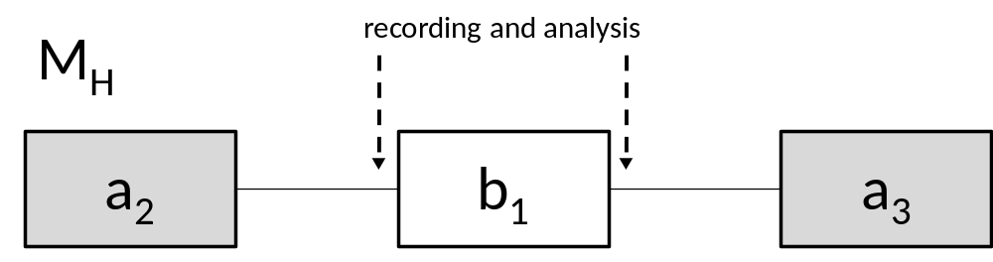
Figure 4 - Schema illustrating the stimulation-connection methodology.
To illustrate it, let me focus on a series of experiments carried out by the Nicolelis research group (see, for example, Carmena et al., 2003) involving monkeys implanted with arrays of micro-elecrodes in several frontal and parietal brain areas. A first striking experimental finding obtained in this research was that neural network algorithms could be used to predict various motor parameters – including hand position, hand velocity, and gripping force – based on the activity of the neural ensembles monitored by the interface (Wessberg et al., 2000). This result paved the way for the construction of reliable brain-controlled robotic arms (Nicolelis, 2001). It has also supported the development of a number of “principles of neural ensemble physiology” (Nicolelis & Lebedev, 2009), including the so-called “distributed coding” principle – stating that the representation of movements is distributed across many brain areas – and the “single-neuron insufficiency” principle – stating that single neurons have limited ability to encode behavioural parameters and therefore to reliably control the motor behaviours of a prosthesis (Chirimuuta, 2013). In addition to their importance for prosthetic control, these general principles, which flow from the analysis and mathematical modelling of electrophysiologically recorded neural activity, clearly concern the working of the intact brain and are therefore relevant to basic neuroscience (for a reconstruction of the long-standing debate between ultra-localizationist views of the brain and novel “distributionist” approaches, as well as the role being played in the study of the brain by novel multi-electrode arrays for electrophysiological recording, see Nicolelis, 2011).
Other striking findings obtained in this series of experiments concerned processes of functional re-organization occurring in the brain after connection with the robotic arm. To understand the nature and dynamics of such processes, the authors analysed the activity of the neurons monitored by the interface while the monkey was learning to control the external device by modulating its neural activity. Eventually, they discovered that the target neurons were changing their directional tuning profiles, i.e., the relationship between their firing rate and the direction and velocity of the arm movements (Carmena et al., 2003). Perhaps one of the most impressive results was that, once the monkey began to gain control of the prosthesis through the brain-machine interface, neural activity became less representative of the movements of the monkey’s “real” limbs while starting to be highly representative of the movements of the robotic arm (Lebedev et al., 2005). These results suggest that the dynamics of the prosthesis may be assimilated into the physiological properties of brain neurons. Note that these experimental and theoretical conclusions, which reveal regular relationships between changes in neural and motor properties, clearly contribute to the discovery of the mechanisms of motor control in the monkey. To be sure, they shed light on the physiological assimilation of a robotic brain-controlled prosthesis. However, as extensively discussed in Nicolelis (2011), they also contribute to the more general goal of understanding the mechanisms of plastic adaptation occurring during the use of any kind of tool, as well as the mechanisms governing the creation and updating of the representation of one’s body schema in the brain.
To sum up, in this type of bionic study, theoretical conclusions on the target biological component are not inferred from overall bionic system behaviour, as in simulative connection experiments, but rather are obtained from the electrophysiological analysis of neural activity. This is why experiments of this kind are termed here non-simulative connection experiments, to distinguish them from the methodologies discussed in the previous sections.

The epistemic value of bionic systems
As suggested so far, a variety of bionics-supported methodologies can contribute to discovering brain mechanisms. The distinctions made in the previous section, over and above illustrating the epistemic value of bionic systems for neuroscientific research, can be useful to critically analyse the import of Craver’s sceptical argument on the epistemic value of bionic systems.
Craver’s first point is that affordance valid prostheses need not be phenomenally (behaviourally) valid: robotic prostheses can partially replace the functionality of a missing limb even if their inputs are very different from the inputs of the replaced biological components. This is not true for all prosthetic systems, however: in some cases, affordance validity implies phenomenal validity. Craver’s scepticism rests on the assumption that bionic prostheses are never connected to the original brain inputs of the replaced biological component (“no currently available [bionic] device, to my knowledge, makes use of just those brain inputs that move limbs in typical animals”, p. 845). Probably Craver has in mind studies such as (Carmena et al., 2003) and (Hochberg et al., 2006), in which prosthetic arms are controlled by signals directly acquired in frontal and parietal areas of the brain cortex, which are in fact relatively distant from the spinal pathways that directly modulate biological arms.
However, as suggested in the previous sections, cases of bionic devices being connected to the “real-life” inputs of the replaced biological component do exist. In these studies, the device made use of exactly those brain inputs that drive the replaced components in the animal. Notable examples are the study by Le Masson et al. (2002) and the simulative replacement study on the lamprey sensory-motor system reported in (Zelenin et al., 2000; see Section 4.1). Lampreys are able to maintain a stable roll position by moving tail, dorsal fin, and other body parts in response to external disturbances caused by water turbulence or other factors. A particular portion of the lamprey nervous system – called the reticulo-spinal pathway, from now on rs – is thought to play a crucial role in this behaviour. As discussed in (Datteri, 2009), the goal of Zelenin and co-authors’ study was to discover the behaviour of rs – or more precisely, to discover the relationship between the “input” neurons of rs (the reticular neurons) and the roll angles of the animal, which vary as a function of the activity of the “output” spinal neurons. The authors initially formulated a relatively simple hypothesis r(rs) about this relationship. To test it, they built an electro-mechanical device whose input-output behaviour was r(rs). They then removed the reticulo-spinal component and replaced it with the electro-mechanical device: the artificial component picked up the activity of the reticular neurons and produced stabilization movements in line with the hypothesized regularity. Finally, Zelenin and colleagues experimentally tested whether the hybrid system exhibited stabilization abilities comparable to those of the intact system. This happened to be the case: the authors therefore concluded that the electro-mechanical device was a good substitute for the rs component – and, as a consequence, that the rs component actually exhibited the hypothesized input-output regularity r(rs).
This case study nicely exemplifies the simulative replacement methodology outlined in Section 4.1. It also suggests that Craver’s thesis, stating that affordance validity does not imply phenomenal validity, is not true for every kind of prosthetic system. The electro-mechanical device in the lamprey study described here was driven by the same neural input (i.e., by the activity of the reticular neurons) that, in intact lampreys, drive the behaviour of the target reticulo-spinal component. The prosthesis proved able to functionally replace the target component (thus being affordance valid) and for this reason the authors concluded that its input-output behaviour matched the target component’s input-output behaviour (i.e., that it was phenomenally valid too).
Another point made by Craver is that affordance (and phenomenal) validity do not imply mechanistic validity: being able to build an artificial device which reproduces the input-output behaviour of a biological component does not imply that one has understood the mechanism governing it. It is important to clarify what exactly we can learn from this observation. Evidently, as argued before, Craver is warning us that building a working (affordance or phenomenally valid) prosthesis does not imply that we have understood the mechanism governing the behaviour of the replaced biological component (for example, of the replaced arm, in the case of an arm prosthesis). His argument, therefore, specifically targets the epistemic value of bionic experiments in which the target component (i.e., the component whose behaviour or internal mechanism is to be discovered) is replaced by the prosthesis (i.e., those experiments referred to in this paper as replacement experiments). Moreover, it is intended to support a sceptical view as to whether such experiments can assist in discovering the internal mechanism of the replaced component, that is to say, as to whether they can help one address what have been referred to here as level-2 questions.
I will reply to Craver’s argument in two steps. First, as borne out by many successful model-oriented simulation studies, the fact that the input-output behaviour underdetermines the internal mechanism does not imply that building a phenomenally valid prosthesis provides no evidence at all regarding the structure of the replaced component’s internal mechanism. Second, as suggested earlier, bionic technologies enable experimental strategies that are significantly different to the simulative replacement methodology described in section 4.1, and which can also contribute to the discovery of brain mechanisms by addressing level-1 questions. Craver’s multiple realizability argument does not apply to these strategies, and therefore does not support a generalized sceptical view of the epistemic value of bionic experiments.
Let me begin from the first step. Craver is right in pointing out that, strictly speaking, phenomenal validity does not imply mechanistic validity. However, this argument does not exclude that building a phenomenally valid prosthesis can provide evidence contributing to the discovery of the internal mechanism of the replaced component. Craver construes evidence as “a finding that shapes (or constrains) the space of possible mechanisms for a given phenomenon” (Craver, 2010, p. 843). Now, the fact that the input-output behaviour of the prosthetic component a_{i} matches the input-output behaviour of the replaced component b_{i} – thus, that the prosthesis is phenomenally valid – is not a conclusive reason to claim that a_{i}’s internal mechanism is relevantly similar to b_{i}’s internal mechanism. Nevertheless, in many cases it is a good reason to include a_{i}’s internal mechanism within the space of the possible mechanisms governing b_{i}. Similarly, realizing that the prosthesis is not phenomenally valid may be legitimately taken to be a good reason to exclude its internal mechanism from the space of how-possibly models of the replaced component. Purely behavioural tests often lead artificial intelligence and biorobotics researchers to expand or restrict the space of the possible models of the target living system. An example is the model-oriented biorobotic study reported in (Grasso et al., 2000), in which mismatches between the overt behaviours of the simulation and of the target system – with no “internal” comparison between the two systems – were taken as reason to conclude that the mechanism implemented in the robot could not be a good model of the animal. To sum up, Craver’s underdetermination argument excludes that phenomenal validity strictly implies mechanistic validity. Nevertheless, it does not exclude that phenomenal validity can provide evidence constraining the space of the possible models of the target system – thus, that it can contribute to model discovery.
The second step is more easily taken. Craver’s underdetermination argument focuses on the fact that it is mistaken to infer a prosthesis’ mechanistic validity from its phenomenal validity. Recall that a prosthesis is mechanistically valid to the extent that it realizes the mechanism governing the replaced component. Therefore, Craver’s underdetermination argument supports a sceptical view as to whether building a phenomenally valid prosthesis can contribute to discovery of the mechanism governing the replaced limb. However, as discussed before, in bionic connection studies one theorizes on the behaviour of component b_{i} by connecting it to, rather than by replacing it with, artificial devices. For this reason, the underdetermination argument has no force against these kinds of studies. Consider also that the argument applies only when the mechanism governing the behaviour of the replaced component is inferred from the behaviour of the prosthesis or the behaviour of the hybrid system. Inferences of this kind are made in what have been called here simulation bionic experiments. As argued in section 4.2, in non-simulation bionic studies neural mechanisms are discovered on the basis of direct electrophysiological recordings, rather than on the basis of inferences from bionic system behaviours. The underdetermination argument has therefore nothing to say on experiments of the latter kind – thus, among other examples, on the aforementioned experiments carried out by the research groups led by Chapin and Nicolelis.
One should also be careful to note that bionic experiments can contribute to mechanism discovery by addressing level-1 questions too. Level-1 questions concern the input-output behaviour of the replaced or connected component. As suggested in Section 3, identifying this behaviour can contribute to discovering the mechanism of the overall intact system containing the target biological component b_{i}, even though nothing is learnt about the mechanism internal to b_{i}. Craver’s underdetermination argument does not rule out theoretical conclusions of this sort, given that it concerns inferences from the target component’s behaviour to its internal mechanism. Identifying the target component’s behaviour is sufficient to answer a level-1 question.
In sum, Craver (2010) does not offer strong arguments for excluding that bionic technologies can provide evidence for the discovery of brain mechanisms. If one takes into account a broader view of the experimental methodologies enabled by current bionic technology, his arguments lose part of their force. The taxonomy provided in Section 3 offers reasons to believe that bionic experiments can truly assist in “probing neural circuits” (Nicolelis, 2003).
To conclude, another claim made by Craver in his article is that bionic methodologies do not offer significant epistemic advantages over other kinds of methodologies currently adopted in neuroscience: “the effort to build a prosthetic model allows a decisive test of affordance validity but offers no distinct advantages for assessing the model’s phenomenal and mechanistic validity” (p. 841). However, as acknowledged by Craver himself, simulations in general can significantly speed up the process of evaluating the behavioural implications of the mechanistic model at issue. In some cases, this is likely to be also true for bionic simulations. Consider the simulative replacement lamprey study described in Section 4.1 (Zelenin et al., 2000). To assess whether the reticulo-spinal pathway performed the hypothesized regularity r(rs), the authors could well have recorded reticular activity and measured roll movements in an intact, swimming lamprey, in search of a correlation between the two. Even though it is difficult to say a priori whether building such a recording apparatus would have been more difficult than setting-up the bionic preparation described in the article, the bionic solution offered a relatively direct means of assessing whether the authors’ hypothesis was correct: instead of searching for a correlation, they just checked whether the hybrid animal was able to stabilize itself. Similarly, it is reasonable to believe that the bionic preparation described in the simulation-connection lamprey study carried out by (Karniel et al., 2005) enabled the authors to speed up their identification of a correlation between vestibular and reticular neurons, with respect to, say, adopting a methodology based on systematically delivering vestibular stimuli, checking the subsequent reticular output, and searching for a correlation. As described in their paper, the authors even discovered something about vr’s behaviour and internal mechanism by merely observing the bionic system’s behaviour in the experimental arena. Finally, consider the non-simulative connection experiments described in Section 4.2. It is reasonable to believe that the connection with an actual prosthetic device played a crucial role in the development of the various theoretical hypotheses on the neural assimilation of external tools reported in (Carmena et al., 2003; Lebedev et al., 2005; Nicolelis, 2011) – and therefore, that the deployment of bionic technologies has made a decisive contribution, vis-à-vis other experimental methodologies, to achieving these results. There are no sufficiently general criteria for assessing the relative epistemic advantages of vastly different (bionic versus non-bionic) methodologies. However, one may reasonably believe that at least in some cases (as in the examples discussed here) bionics can offer particularly insightful and informative experimental methodologies for the discovery of brain mechanisms.

Conclusions
Bionic systems can serve as experimental tools for the testing of neuroscientific and cognitive science mechanism descriptions. In particular, they can assist in modelling the input-output relationship governing particular components of a mechanism, and in discovering their internal mechanistic organization. These claims have been supported here by distinguishing between replacement and connection experiments, and between simulative and non-simulative methodologies, in a way that extends a taxonomy of bionic experiments recently proposed in the literature. These distinctions have been used to critically analyse Craver’s sceptical argument on the epistemic role of bionic systems in neuroscientific research.
The analysis made here can be refined by addressing a number of interesting epistemological and methodological questions concerning non-simulative connection experiments in particular. What auxiliary assumptions are needed to infer theoretical conclusions on the non-replaced, target part of a biological system from the result of bionic experiments in this methodology? Variants of this question have been addressed in (Datteri, 2009) concerning simulative (replacement and connection) experiments only. What criteria guide inferences from the analysis of plastic changes occurring in the brain after connection with a robotic device to the theoretical modelling of plastic changes occurring in the brain during control of a biological limb? And, more generally, what kind of theoretical questions can be fruitfully addressed through this methodology? I have claimed that bionic experiments can assist in addressing level-1 (on the behaviour of particular components of a mechanism) and level-2 (on the mechanism governing particular components of a mechanism) questions. Chirimuuta (2013) has argued that bionic systems can distinctively assist in the discovery of organizational principles rather than of mechanistic models. In her view, organizational principles do not concern “the layout of an actual neural circuit or mechanism”, but rather “the operational principles that allow a range of neuronal mechanisms to do what they do” (p. 629). The “principles of neural ensemble physiology” discussed in section 4.2 are cases in point. I agree with the claim that bionic technologies can assist in the discovery of organizational principles. However, the classification proposed here shows that they can also play a significant role in outlining the actual neural layout of specific sensory and motor mechanisms, thus directly contributing to the testing and discovery of neuroscientific mechanistic models. This is true of simulative replacement and simulative connection experiments, as discussed in section 4.1. But it is also true of the non-simulative connection experiments discussed in section 4.2, to the extent that they enable the identification of systematic regularities between changes in neural properties in different parts of the brain (for example, in the directional tuning profiles of frontoparietal neurons) and the motor activity of the subject, the discovery of regularities in the brain being an essential part of the discovery of brain mechanisms. Addressing the questions sketched here may contribute to the piecewise understanding of the various ways bionics technologies can contribute to neuroscientific research.

References
Bechtel, W., & Richardson, R. C. (1993). Discovering complexity: Decomposition and localization as scientific research strategies. Princeton: Princeton University Press.
Carmena, J. M., Lebedev, M. a, Crist, R. E., O’Doherty, J. E., Santucci, D. M., Dimitrov, D. F., … Nicolelis, M. a L. (2003). Learning to control a brain-machine interface for reaching and grasping by primates. PLoS Biology, 1(2), E42.
Chirimuuta, M. (2013). Extending, changing, and explaining the brain. Biology & Philosophy, 28(4), 613–638.
Craver, C. (2007). Explaining the brain. Mechanisms and the mosaic unity of neuroscience. Oxford University Press.
Craver, C., & Darden, L. (2001). Discovering Mechanisms in Neurobiology. The Case of Spatial Memory. In P. Machamer, R. Grush, & P. McLaughlin (Eds.), Theory and Method in Neuroscience.
Craver, C. F. (2002). Interlevel Experiments and Multilevel Mechanisms in the Neuroscience of Memory. Philosophy of Science, 69(S3), S83–S97.
Craver, C. F. (2010). Prosthetic Models. Philosophy of Science, 77(5), 840–851.
Datteri, E. (2009). Simulation experiments in bionics: a regulative methodological perspective. Biology & Philosophy, 24(3), 301–324.
Datteri, E., & Tamburrini, G. (2007). Biorobotic Experiments for the Discovery of Biological Mechanisms. Philosophy of Science, 74(3), 409–430.
Dror, R. O., Dirks, R. M., Grossman, J. P., Xu, H., & Shaw, D. E. (2012). Biomolecular simulation: a computational microscope for molecular biology. Annual Review of Biophysics, 41, 429–52.
Floreano, D., Ijspeert, A. J., & Schaal, S. (2014). Robotics and Neuroscience. Current Biology, 24(18), R910–R920.
Glennan, S. (2005). Modeling mechanisms. Studies in History and Philosophy of Science Part C: Studies in History and Philosophy of Biological and Biomedical Sciences, 36(2), 443–464.
Grasso, F. W., Consi, T. R., Mountain, D. C., & Atema, J. (2000). Biomimetic robot lobster performs chemo-orientation in turbulence using a pair of spatially separated sensors: Progress and challenges. Robotics and Autonomous Systems, 30(1-2), 115–131.
Guala, F. (2002). Models , Simulations , and Experiments. In L. Magnani & N. J. Nersessian (Eds.), Model-Based Reasoning. Science, Technology, Values (pp. 59–74). New York: Springer US.
Hochberg, L. R., Serruya, M. D., Friehs, G. M., Mukand, J. A., Saleh, M., Caplan, A. H., … Donoghue, J. P. (2006). Neuronal ensemble control of prosthetic devices by a human with tetraplegia. Nature, 442(7099), 164–71.
Humphreys, P. (2004). Extending Ourselves: Computational Science, Empiricism, and Scientific Method (p. 182). Oxford University Press, USA.
Kanzaki, R., Minegishi, R., Namiki, S., & Ando, N. (2013). Insect-machine hybrid system for understanding and evaluating sensory-motor control by sex pheromone in Bombyx mori. Journal of Comparative Physiology. A, Neuroethology, Sensory, Neural, and Behavioral Physiology, 199(11), 1037–52.
Karniel, A., Kositsky, M., Fleming, K. M., Chiappalone, M., Sanguineti, V., Alford, S. T., & Mussa-Ivaldi, F. A. (2005). Computational analysis in vitro: dynamics and plasticity of a neuro-robotic system. Journal of Neural Engineering, 2(3), S250–S265.
Le Masson, G., Renaud-Le Masson, S., Debay, D., & Bal, T. (2002). Feedback inhibition controls spike transfer in hybrid thalamic circuits. Nature, 417(June), 854–858.
Lebedev, M. a, Carmena, J. M., O’Doherty, J. E., Zacksenhouse, M., Henriquez, C. S., Principe, J. C., & Nicolelis, M. a L. (2005). Cortical ensemble adaptation to represent velocity of an artificial actuator controlled by a brain-machine interface. The Journal of Neuroscience, 25(19), 4681–4693.
Mussa-Ivaldi, F. a, Alford, S. T., Chiappalone, M., Fadiga, L., Karniel, A., Kositsky, M., … Vato, A. (2010). New Perspectives on the Dialogue between Brains and Machines. Frontiers in Neuroscience, 4(1), 44.
Newell, A., & Simon, H. A. (1961). Computer simulation of human thinking. Science, 134(3495), 2011–2017.
Nicolelis, M. (2011). Beyond Boundaries: The New Neuroscience of Connecting Brains With Machines And How It Will Change Our Lives. New York: Times Books.
Nicolelis, M. a L., & Lebedev, M. a. (2009). Principles of neural ensemble physiology underlying the operation of brain-machine interfaces. Nature Reviews. Neuroscience, 10, 530–540.
Nicolelis, M. A. L. (2001). Actions from thoughts. Nature, 409, 403–407.
Nicolelis, M. A. L. (2003). Brain-machine interfaces to restore motor function and probe neural circuits. Nature Reviews. Neuroscience, 4(5), 417–22.
Orlovsky, G. N., Deliagina, T. G., & Wallén, P. (1992). Vestibular control of swimming in lamprey. Experimental Brain Research.
Parker, W. S. (2009). Does matter really matter? Computer simulations, experiments, and materiality. Synthese, 169(3), 483–496.
Reeve, R., Webb, B., Horchler, A., Indiveri, G., & Quinn, R. (2005). New technologies for testing a model of cricket phonotaxis on an outdoor robot. Robotics and Autonomous Systems, 51(1), 41–54.
Suppe, F. (1989). The semantic conception of theories and scientific realism (p. 496). University of Illinois Press.
Webb, B. (2001). Can robots make good models of biological behaviour? Behavioral and Brain Sciences, 24, 1033–1050.
Wessberg, J., Stambaugh, C. R. R., Kralik, J. D. D., Beck, P. D. D., Laubach, M., Chapin, J. K. K., … Nicolelis, M. A. L. a. (2000). Real-time prediction of hand trajectory by ensembles of cortical neurons in primates. Nature, 408(6810), 361–365.
Woodward, J. (2002). What Is a Mechanism? A Counterfactual Account. Philosophy of Science, 69, S366–S377.
Zelenin, P. V, Deliagina, T. G., Grillner, S., & Orlovsky, G. N. (2000). Postural control in the lamprey: A study with a neuro-mechanical model. Journal of Neurophysiology, 84(6), 2880–7.

The term “model” is used here to emphasize the fact that mechanism descriptions may be more or less abstract in the sense clarified by (Suppe, 1989): they characterize the behaviour of each component as depending on a restricted (though not necessarily narrow) set of factors. For example, a model might characterize the activity of the reticular neurons as depending on the firing rate of vestibular neurons only; a less abstract model would take into account more input or boundary factors. In either case, one obtains a counterfactual generalization stating that the behaviour of reticular neurons would be such and such, if it depended only on that restricted set of factors (Suppe, 1989; Woodward, 2002).
Note that, as stressed in (Datteri, 2009), to infer the behaviour of the replaced component from the behaviour of the hybrid system in line with the strategy outlined here, one must exclude significant plastic changes in the non-replaced portions of H (represented by b₂ and b₃ in Figure 2). Adaptations of this kind occur frequently in bionic systems and, as discussed below, are even required for the proper functioning of prostheses or brain-controlled communication devices. However, they must be excluded in order to theorize about the behaviour of b₁ on the basis of the behaviour of H. Indeed, plastic adaptation processes may eventually enable the hybrid system to display satisfactory stabilization behaviour even if the artificial component a₁ is not behaviourally equivalent to b₁: in that case, analysis of the behaviour of H would not support any conclusions regarding the behavioural match between a₁ and b₁, nor consequently regarding the behaviour of b₁. According to (Chirimuuta, 2013), this “no plasticity” constraint “rules out the majority of [hybrid] preparations as not useful for the modeling of motor systems in the brain” (p. 623), and for this reason supports a negative view on the experimental value of bionic technologies for neuroscientific research. In footnote 4, I will briefly show that her arguments in support of this claim are flawed.
Note also that the resulting system H may be viewed as a hybrid simulation of the mechanistic model M. A fully artificial simulation of M would include artificial components a₁, a₂ and a₃ exhibiting the behaviours defined in M; in contrast, in the current example there is only one artificial component – a₁ – which has been appropriately connected to the target biological system S.
In footnote 3 I have mentioned that a “no-plasticity” constraint is needed to infer the input-output behaviour of the target component from the analysis of hybrid system behaviour in simulative replacement experiments. The “no-plasticity” constraint rules out plastic changes occurring in the non-replaced – thus non-target – part of the hybrid system. However, as Chirimuuta (2013) has rightly argued, “plastic changes are a pervasive feature of [bionic system] research and are actually required for the correct functioning of the technology” (p. 620). In her opinion, the “no-plasticity” constraint therefore “rules out a vast swathe of [hybrid bionic systems] research as not informative in the modelling of actual biological systems for sight, hearing or reaching” (p. 622). Yet the bionic studies mentioned in this section, in which plastic changes have occurred in the brain after connection with a prosthesis, have led to interesting insights into mechanisms of motor control in primates. Therefore if Chirimuuta is right in claiming that the “no-plasticity” constraint rules out these studies as uninformative for the modelling of actual biological systems, this is indeed bad news for the “no-plasticity” constraint and, more generally, for the entire methodological analysis proposed in (Datteri, 2009), which should consequently be rejected as excessively restrictive. However, Chirimuuta’s argument is patently flawed. She appears to overlook the fact that the “no-plasticity” constraint is placed on the simulative replacement method only, called ArB in (Datteri, 2009): it “[is] needed to draw theoretical conclusions on the behaviour of b₁ on the basis of bionic system behaviours” (p. 311), b₁ representing in that context the replaced biological component. At the same time she overlooks the fact that, as discussed in this section, the studies she mentions (e.g., Carmena et al., 2003) are not instances of this methodology. The primate studies cited by Chirimuuta therefore fall outside the scope of the no-plasticity constraint, and cannot be said to violate it. For these reasons, the “no-plasticity” constraint does not rule out the studies in question as uninformative for neuroscientific research (in fact, it has no bearing on them whatsoever). Let me also stress that the no-plasticity constraint rules out the occurrence of plastic changes in the non-target (non-replaced, biological) parts of a simulation-replacement system. It therefore cannot be used to rule out studies aimed at theorizing on plastic changes occurring in the target biological component of a bionic system (the various studies carried out by the Nicolelis research group being cases in point). These are good reasons to refute the claim that the methodological analysis proposed in (Datteri, 2009) rules out a vast swathe of brain-machine research as not informative in the modelling of actual biological systems.
To be more precise, they inhibited the activity of this component by using a particular experimental apparatus. See the cited article itself for further detail.
As pointed out earlier, a level-2 question – what is the mechanism governing the behaviour of the vestibulo-reticular component? – was also addressed in (Karniel et al., 2005) by comparing the behaviour of the bionic system with the behaviour of fully artificial simulations of plausible mechanistic models of it. This study nicely exemplifies how the analysis of simulation behaviours can constrain the search for an internal mechanism. Indeed, in the cited study, only a few models turned out to be able to generate a behaviour that was sufficiently comparable to the behaviour of the bionic system to justify their inclusion in the space of the how-possibly models.

