The Manipulability of What? The History of G-Protein Coupled Receptors

Forthcoming in Biology & Philosophy

Ann-Sophie Barwich  Columbia University  Presidential Scholar in Society and Neuroscience  Departments of the Biological Sciences and Philosophy  The Center for Science and Society,  Fayerweather 511, 1180 Amsterdam Ave., New York, NY 10025, USA  ab4221@columbia.edu; Cell: +1-907-407-1272 | Karim Bschir  ETH Zurich  Society in Science - Branco Weiss Fellow  Department of Humanities, Social and Political Sciences  Clausiusstrasse 49, 8092 Zürich  Switzerland  bschir@phil.gess.ethz.ch

Abstract: This paper tells the story of G-protein coupled receptors (GPCRs), one of the most important scientific objects in contemporary biochemistry and molecular biology. By looking at how cell membrane receptors turned from a speculative concept into a central element in modern biochemistry over the past 40 years, we revisit the role of manipulability as a criterion for entity realism in wet-lab research. The central argument is that manipulability as a condition for reality becomes meaningful only once scientists have decided how to conceptually coordinate measurable effects distinctly to a specific object. We show that a scientific entity, such as GPCRs, is assigned varying degrees of reality throughout different stages of its discovery. The criteria of its reality, we further claim, cannot be made independently of the question about how this object becomes a standard by which the reality of neighbouring elements of enquiry is evaluated.

Keywords: Scientific Realism; Instrumental Intervention; Cell Signaling Mechanism; Biochemistry; Pharmacology; Wet-Lab Research

Introduction

Many objects of scientific investigation are introduced into the vocabulary of science as theoretical postulates. The ether, the atom, the gene, or, more recently, the Higgs Boson are just a few of many examples. As research proceeds, some of these theoretical posits become accepted as existing bits of reality, and they turn into integral parts of science. From this perspective, it is fair to say that scientific objects, like many other things, do in fact have a history.
In the debate on scientific realism, however, questions about the reality of scientific objects are often treated in an ahistorical fashion. Instead of asking at what point in time a formerly hypothetical object becomes accepted as real, philosophers of science largely focus on the search for adequate criteria of reality (e.g., observability or experimental manipulability), or for a definition of what actually exists (e.g., structures or entities). To be sure, philosophers do not completely ignore history. But the debate on scientific realism is historical only insofar as it analyzes the history of theories and the dynamics of theory changes in order to find out which entities or structural features are retained over time, or whether historical developments might pose a challenge for certain realist arguments. A focus on the history of the scientific objects themselves is scant.
Among the criteria of reality for theoretical objects, one in particular has attracted the attention of philosophers. Ever since Ian Hacking’s seminal Representing and Intervening (Hacking 1983), the belief in the existence of scientific objects has been closely related to the notions of manipulability and experimental intervention. According to Hacking, the fact that we use unobservable entities to produce well-controlled observable effects, or to manipulate other entities, serves as a criterion for their reality. Hacking’s famous conditional “If you can spray them, then they are real” (Hacking 1983, p. 23) seems quite unambiguous in this respect: Manipulability is supposed to be a criterion for the acceptance of an entity as real.
Linking the reality of a scientific object to its manipulability in this way, however, does not guarantee that the object manipulated in an experimental intervention is, in fact, the object that the experimenter believes it to be. How do we know that what we manipulate actually is a specific kind of object? Why are some experimentally measured effects unified under the concept of a particular scientific object, instead of being attributed to other, already existing objects, or considered as disparate phenomena altogether? Manipulability cannot be a sufficient condition because manipulability by itself does not provide the identity conditions required for something to count as an object in the first place. While it is true that if we spray something, and we may know that something is real, the experimental practice itself (the spraying) does not tell us what is real. In particular, it does not give us the criteria necessary to accommodate and unify the things sprayed under the concept of a particular entity (the electron in Hacking’s case).
In what follows, instead of providing a sufficient criterion for reality, we will focus on the biographies of scientific objects in the course of which they acquire an increasing degree of reality at different stages of their history. Our argument is that while manipulability is surely required for entities in wet-lab science to be accepted as real, manipulability itself presupposes a hypothetical formulation of the object that encompasses a range of effects from instrumental interventions. This hypothetical entity may initially only serve to unify separate explanatory functions under a single concept, without strong ontological implications about its object status or reality yet. The central point, we think, is that in the context of wet-lab research, manipulability or instrumental intervention as a basic condition for entity realism becomes operationally meaningful only once we decide how and why we conceptually coordinate the measured effects to some object.
We conclude that the reality of scientific objects is not sufficiently captured through an accumulation of measurable effects alone. Rather, manipulability must be analyzed through the historical developments by which it reaches the stage where it can serve as a criterion of reality. The consequence of such an analysis, we show, is that manipulability is not only a matter of instrumental possibility. It also requires a certain form of ontological pre-formatting, meaning that we have a hypothetical object as a possible placeholder for these effects within our scientific ontology. This object or placeholder defines with what kind, function, organization, structure, etc. the observed effects are associated. Furthermore, we will introduce the concept of ontological charge, which describes a historical turn in which the potential for successful manipulations exceeds mere data accumulation, but where scientific concepts start to corroborate and affect our understanding of related entities within the same experimental framework. It is in this context that we must understand scientific reality as relational to successive experimental insights into neighboring elements within an active research environment.
To support our argument, we tell the story of one of the most exciting objects of investigation in contemporary biochemistry and molecular biology: G-protein coupled receptors (GPCRs). GPCRs constitute the largest protein family in the mammalian genome by far (Palczewski 2006). As cell surface receptors, they regulate fundamental cell signaling processes and bind to a large array of structurally diverse ligands (e.g., neurotransmitters, amino acids, proteins, lipids, sugars, odorous volatile molecules, and photons). Despite their centrality for biological and pharmacological studies today, the existence of GPCRs was doubted deep into the 1970s. By analyzing the career of GPCRs over the past 40 years, and by looking at how they turned from a hypothetical entity into a real one, we demonstrate that realism about entities deserves, and requires, renewed philosophical attention.
Our interest in the recent history of GPCRs is twofold. First, GPCRs constitute one of the most important objects of investigation in contemporary biology. Second, their history has not been part of philosophical or historical studies. Despite their centrality in contemporary proteomics, the study of the cell surface receptors that were going to be known as GPCRs is a very recent endeavor. Since their existence was controversial deep into the 1970s, their career as a scientific object only spans the past 40 years. Within the last 30 years, however, six Nobel Prizes were awarded to studies related to signaling processes by G-proteins and GPCRs. It is thus intriguing to ask: What exactly happened throughout these past decades that turned the initially hypothetical receptors from a conceptual placeholder into a well-established object of modern biology?
We begin, in the next section, by recapitulating the fascinating story of the discovery of GPCRs. It will become clear that this discovery not only involved a variety of experimental techniques through which GPCRs became increasingly accessible in laboratory practice, but that crucial theoretical and conceptual contributions were likewise necessary for the formation of GPCRs as an integral object of biological investigation. Section 3 offers a philosophical argument for why we believe that the relationship between manipulability and realism has to be rethought. We introduce a model for the biography of GPCRs at different stages. As it turns out, the increasing capacity to manipulate GPCRs in the lab played a central role in the whole process. However, it was at best necessary for the acceptance of the reality of GPCRs. Manipulability plays a much more subtle role than it usually gets ascribed in the philosophical literature.

The History of GPCRs

Our current understanding of GPCRs

GPCRs present a fundamental research target for neurobiological studies on cell signaling mechanisms. GPCRs mediate chemical or electromagnetic signals from outside the cell and play an essential role in the signal-transduction involved in almost all physiological processes such as smell, sight, taste, etc. They constitute the largest gene family in the mammalian genome. In fact, today we know of almost a thousand different genes that code for different GPCRs in the human genome alone. More than 50% of pharmacological studies target GPCRs and their activation and inhibition (Zhang and Xie 2012). Figure 1 provides an overview of the signaling pathway mediated by an olfactory GPCR.

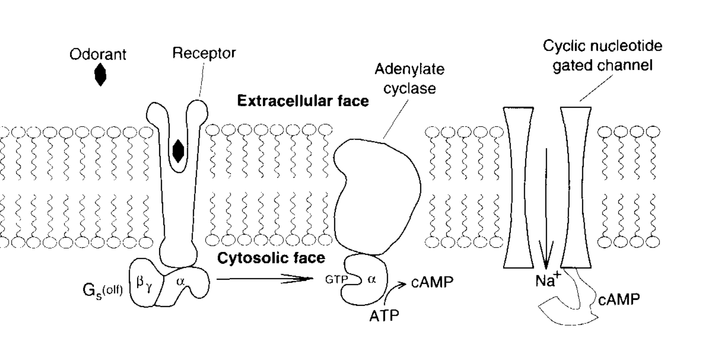
Figure 1. Overview of the signaling pathway mediated by GPCRs. The second messenger mechanism is initiated by a ligand (here, an odor molecule) binding to the receptor protein. This initiates a cascade of reactions, starting with the decoupling of the heterotrimeric G-protein from the receptor and the conversion of GDP (Guanosine diphosphate) to GTP (Guanosine triphosphate). The signal then gets further processed by the activation of adenylate cyclase. Image taken from Buck and Axel (1991).

In terms of structure, GPCRs are membrane-bound receptor proteins consisting of seven α-helical transmembrane motives, three extracellular loops and three intracellular loops, which are responsible for the coupling with a heterotrimeric G-protein (α, β, γ in Figure 1). Ligand binding takes place at specific structural motifs between the extracellular parts of the transmembrane helices. Binding of the G-protein to the receptor at the inside of the membrane increases the affinity of the receptor for its ligands by inducing a change in its conformation. The “G” in G-protein stands for “guanine nucleotide-binding.” Depending on the type of receptor and the type of G-protein involved, the activation the G-protein upon binding of guanosine triphosphate (GTP) leads to an up/down regulation of different downstream cell responses (in the case of the olfactory receptor in Figure 1, the cell response is mediated via the activation of adenylate cyclase and the subsequent activation of an ion channel). The activity of the GPCR can be further regulated through phosphorylation/dephosphorylation of the receptor by a range of G-protein coupled receptor kinases (GRK) or second messenger kinases (PKA) depending on the type of receptor involved.
One of the most remarkable features of GPCRs is their genetic makeup. On the one hand, members of the GPCR superfamily exhibit an extraordinarily high degree of interclass similarity regarding their transmembrane regions. Sequence similarities between rhodopsin and the olfactory receptors, for instance, can be up to 40% (Crasto 2009). On the other hand, the GPCR superfamily also shows a high degree of intraclass diversity of its members. For example, sequence similarity between members of the olfactory receptor family, the largest family amongst the GPCR superfamily, can vary between 40-98% (Firestein, Greer, and Mombaerts 2014). Such high GPCR intraclass diversity is linked to their affinity to ligands of various structures, as GPCRs have developed to recognize a vast array of structurally diverse molecules such as neurotransmitters, hormones, peptides, odorants, and even photons.
Given their functional diversity and their ubiquity in the organism it is hard to deny that GPCRs play an absolutely central role in current biology. However, it was not until the early 1980s that their existence has generally been accepted. Before that time, the existence of membrane-bound receptors was highly controversial. Nevertheless, the concept of a cell surface receptor as such had been around for quite a while.

The mythical creature of receptor proteins

Our modern understanding of receptors depicts them as a molecular gateway between extracellular and intracellular environments. As such a gateway, receptors initiate a cascade of reactions specific to particular substances. What appears as a simple and compelling picture of cell signaling is the result of century-long debates about nerve excitation and physiological signaling processes. In hindsight, Claude Bernard’s 19th century experiments on curare, a very effective nerve poison, may be considered something like a starting point of receptor research. Bernard set out to understand why curare was deadly when administered by an arrow but harmless when ingested. He realized that curare only affected motor but not sensory nerves and thus concluded that the poison must act differently in different tissues. The idea of drug-target specificity was born (Limbird 2012). Certainly, at the time, researchers did not yet associate the specificity of the drug effects with the idea of a receptor, or anything alike.
One of the earliest mentions of something that we nowadays would refer to as a receptor was made by Cambridge pharmacologist John Newport Langley as early as 1905. Langley did not use the word “receptor,” though. Instead, he spoke of a “receptive substance” in biological cells. A similar idea had already been proposed in immunology by the German physician and future Nobel laureate Paul Ehrlich, who advocated the so-called “side chain theory”. According to this theory, the protoplasm of biological cells contains chemical “side-chains” to which toxic substances from outside the body bind, leading to an absorption of the toxin. The more side chains a cell produces, the better it is able to resist the noxious effects of the toxin. Exposure to a toxin leads to an increased production of the corresponding side chains and hence to a sort of immunization. Ehrlich, looking at the selective effects of toxic agents, had even introduced the term “receptor” in 1900, but he believed that his theory was only applicable to immunology. Langley, on this account, was the first who explicitly proposed a receptor theory of drug action (Maehle 2004).
For several years, Langley had been studying the mechanisms through which certain drugs like adrenalin, nicotine, and others cause specific effects in different tissues. Initially, it was thought that drugs affect the nerve endings in the respective target organ. Based on his observations, Langley became more and more convinced that the drugs may act directly on the cells themselves, leading to specific effects like increase in heart rate, muscular contraction, or glandular secretion. He speculated that there must be something in the cells that mediates the effect of the drug:

So we may suppose that in all cells two constituents at least are to be distinguished, a chief substance which is concerned with the chief function of the cell as contraction and secretion, and receptive substances which are acted upon by chemical bodies and in certain cases by nervous stimuli. The receptive substance affects or is capable of affecting the metabolism of the chief substance. (Langley 1905, p. 411, cited in Lefkowitz 2013.)

On a closer look, Langley postulated not only one, but two endogenous substances. These are responsible for the mediation of the effect of the exogenous drug, and are supposed to form some sort of functional unit. The “receptive substance” {Langley, 1911, The effect of various poisons upon the response to nervous stimuli chiefly in relation to the bladder@@author-year}is affected by chemical and nervous stimuli, and it further affects the “chief substance” that is associated with certain metabolic processes of the cell. It can be safely assumed, however, that neither Langley nor anybody else at the time had even the slightest idea what the exact chemical composition of these substances was. Unsurprisingly, immediate criticisms and even ridicule were raised in the scientific community concerning the plausibility of Langley’s speculation.
Even Langley’s own student, Sir Henry Hallett Dale, raised doubts about the idea of a receptive substance. Dale was able to show that a number of structurally different amines would lead to the same effects as the compounds that Langley had used in his experiments. Because of this high structural diversity, Dale found it unlikely that these chemicals could form a chemical bond with some kind of “receptive substance” in the cell, and that therefore the mechanism of drug action must be different (Maehle 2004, p. 171, see also Barger and Dale 1910). While substance-specific effects on cell tissues were beyond dispute, Dale considered these to be results of particular chemical processes without requiring the presence of an additional unknown entity such as a receptor (Limbird 2012). So although Langley had good abductive reasons to postulate the existence of a “receptive substance” in cells, those reasons did not go uncontested. Still, not everybody was convinced of the explanatory extra value of the receptor hypothesis in comparison to the direct action hypothesis. Langley’s postulate remained purely hypothetical.
Notwithstanding the doubted existence of receptors, what continued to occupy the minds of practitioners was the specificity with which drugs were observed to act on cells. Langley’s concept of a receptive substance provided a qualitative description of substance-cell interactions. However, given Dale’s comparative experiments, it had yet to be assigned a quantitative measure in order to be attributed to specific effects. Such quantitative measures were subsequently introduced by Archibald Hill, A.J. Clark, John Henry Gaddum, Heinz Otto Schild, Everhardus Jacobus Ariëns, Robert Stephenson, and many others. Their work merged into what is now referred to as “Classical Receptor Theory,” providing mathematical models for measuring the effect of drugs on cells (Colquhoun 2006).
By the 1960-70s, target specific effects of drugs had been turned into a measurable quantity. The concept of cell receptors had grown from a functional and purely qualitative concept into mathematical formulations of ligand binding affinity and efficacy. Nevertheless, the concept of receptors remained highly theoretical. The hypothetical character of the receptor idea was in fact explicitly restated by the pharmacologist Raymond Ahlquist. As early as 1948, Ahlquist had distinguished between two kinds of receptors for adrenaline. Notably, he introduces “[t]he adrenotropic receptors” as “those hypothetical structures or systems located in, on or near the muscle or gland cells affected by epinephrine” (Ahlquist 1948, p. 586). So although Ahlquist is often credited as the discoverer of α and β adrenalin receptors, he himself, more than twenty years after his discovery, still argued for a strictly instrumentalist interpretation of the receptor concept:

This would be true if I were so presumptuous as to believe that α and β receptors really did exist. There are those that think so and even propose to describe their intimate structure. To me they are an abstract concept conceived to explain observed responses of tissues produced by chemicals of various structures (Ahlquist 1973, p. 121, cited in Lefkowitz 2013).

Ahlquist’s words are representative of a wider conviction about the hypothetical nature of receptor proteins amongst scientists at the time (Lefkowitz 2007a). His statement exemplifies that even though the hypothesis of receptors was formulated quite early, and specific biological functions were attributed to the receptor concept, profound skepticism with respect to their actual existence persisted for several decades. However, that skepticism did not prevent scientists like Ahlquist from trying to design pharmaceutical therapies based on the idea of such receptors. Even as fairly hypothetical entities, receptors were thought to play an important role in physiology and pharmacology. Nevertheless, the concept continued to be more of a mathematical convenience instead of denoting actual entities in pharmacological models. Overall, despite all the experimental successes, questions of whether these receptors exist, what they are, or according to which mechanism they operate, remained unanswered.

From proxy to entity: The molecular steps towards membrane receptor realism

As a consequence of the mathematization of pharmacology, receptors had turned into a useful explanatory concept with measurable effects by the late mid-20th century. It was against this background that biochemists started entering the field of receptor studies. During the following decades, parallel efforts by pharmacologists and biochemists led to the stepwise realization of membrane receptors.
The first step towards a deepened understanding of membrane receptors was made in pharmacology in the early 1960s when Sir James Black and others initiated the quest for substances with β-blocking properties (Black 1989). Black’s focus lay on the treatment of coronary heart diseases. His idea was to decrease the oxygen demand of the heart by blocking β-receptors. Black’s efforts resulted in the development of the first clinically applicable β-receptor antagonists pronethalol and propranolol (the latter is still used in clinical practice today, whereas the former has actually never be been used clinically because of its cancerogenicity). To be sure, it was still unknown at the time what the structure of the β-adrenergic receptors was, let alone that their mechanism involves what is known today as the G-protein.
Despite the undeniable manipulative success underlying Black’s research on beta-blockers, receptors continued to be speculative entities. Even the most generous realist interpretations at this time did not state them as independent entities. Rather, the instrumental effects were assigned to an already known object of cell signaling mechanisms, namely adenylate cyclase: “It seems likely that in most and perhaps all tissues the beta receptor and adenyl cyclase are the same. The results of many previous studies have pointed to this conclusion, and we feel that the studies with the perfused rat heart have added further to its possible validity” (Robison, Butcher, and Sutherland 1967, p. 710). The careful wording of likelihood and possible validity may convey a sense of ambiguity at first. But the title of Nobel Laureate Sir Earl Sutherland’s 1967 study quickly gives the underlying sentiment away: ‘Adenyl cyclase as an adrenergic receptor.’ While it became increasingly clear that something regulating these molecular effects was real, it was by now means obvious what this something would be. It was not until the advent of new analytic tools such as radio ligand binding techniques, photoaffinity labeling, affinity chromatography, and the patch clamp technique in the late 1960s and 1970s that it became possible to study the regulation of the receptors and to formulate possible mechanisms of receptor action, or, as Nobel laureate Robert J. Lefkowitz put it, “to bring these mythical receptors to life” (Lefkowitz 2013, p. 6367). What made these techniques, especially radioligands, so crucial for receptor studies was that they allowed tracing the potential existence of receptor function in a bottom-up fashion, instead of previous top-down conjecture, so “that … [receptor] properties no longer needed to be inferred from downstream signaling events” (Lefkowitz 2007b, p. 10).
With the rise of these techniques, interest in receptor activity was conducted in three different experimental contexts: in parallel with Lefkowitz’ hunt for the β-adrenergic receptors, Jean-Pierre Changeux and his colleagues were targeting nicotine cholinergic receptors while other labs intensified research on the light-sensitive rhodopsin. At the time, however, there was no indication that these three parallel experimental systems could be related at all (Lefkowitz 2007a).
Applying radioligands to binding studies with the β -adrenergic receptor, Lefkowitz and his team at the Duke University Medical Center discovered that binding curves for antagonists were monophasic (they showed only one binding event so to speak), whereas the binding curves for agonists indicated two distinct binding states: a state where the receptor has a low affinity for the agonist, and a state where the affinity is high. It was also found that adding guanine nucleotides induced a transformational change to the low-affinity state in the receptor.
Based on these findings, Lefkowitz, together with Andre DeLean, formulated a speculative ternary complex model for the receptor (see Figure 2). According to this model, the low-affinity state is a complex of the receptor with the agonist (HR). The high-affinity complex included a further, then unknown, membrane component X. And as in the famous case of X-rays, the letter X was used here too as a placeholder for an unknown entity, the postulation of which was thought to be necessary in order to explain certain experimental data.

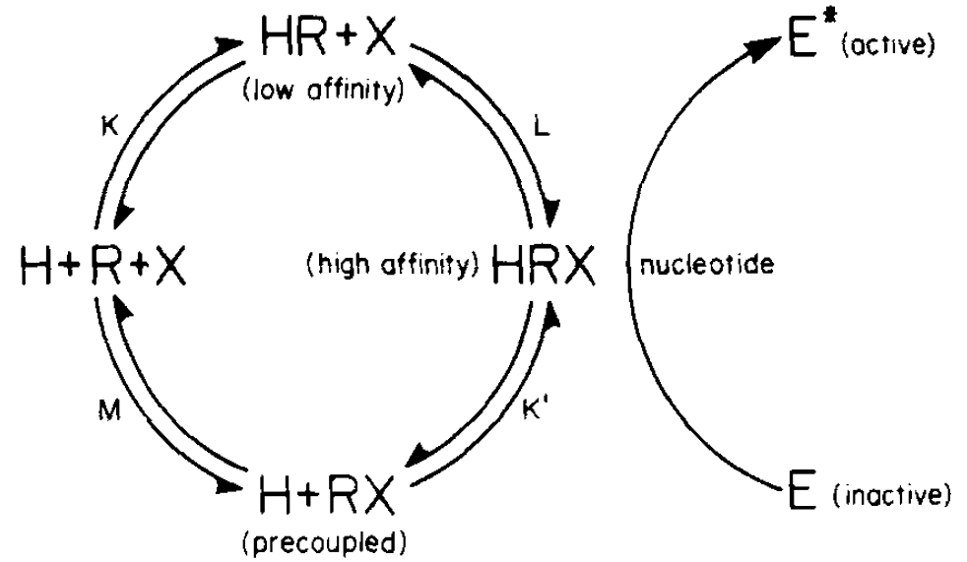
Figure 2. The ternary complex model for β-adrenergic receptor activity. Figure taken from De Lean, Stadel, and Lefkowitz (1980). In this model, the affinity of a ligand binding to a receptor is influenced by the presence of an unknown substance, called X here. X was subsequently identified as the G-protein.

It had been known previously that the receptor mechanism is associated with acetylate cyclase activity, so it was assumed that the component X might be the active unit of adenylate cyclase. However, it turned out that an activated receptor state could be formed without an active adenylate cyclase. Furthermore, there were indications that the nucleotide binding site must be part of the ternary complex. Hence it became highly probable that the component X is responsible for the guanine nucleotide binding, which in itself seemed to be relevant for the formation of the high-affinity state of the receptor (De Lean, Stadel, and Lefkowitz 1980, Limbird, Gill, and Lefkowitz 1980).
In the same year the ternary complex model was proposed. Northup et al. (1980) at the Virginia School of Medicine had purified a trimeric protein responsible for the regulation of adenylate cyclase activity. It stood to reason that the component X in Lefkowitz’ ternary complex might be identical with the regulatory unit of adenylate cyclase since that protein also had the capacity to bind guanine nucleotides, it was called the “G-site” or the G-protein (De Lean, Stadel, and Lefkowitz 1980, p. 7116). On this account, Lefkowitz’ studies in the early 1980s provided the first evidence for the allosteric interaction of the receptor protein with the G-protein through which the affinity of the receptor for its specific agonists is regulated.
Definite proof for the integral role of the G-protein in the signaling process was provided when Lefkowitz, together with Richard Cerione, Lutz Birnbaumer, and Eva Neer, reconstructed the full adenylate cyclase signaling system artificially. To do so, the researchers produced double-layered phospholipid vesicles containing the β-adrenergic receptor in its membrane-bound state, the G-protein as well as the catalytic unit of adenylate cyclase. By adding β-adrenergic agonists, they were able to induce the production of cAMP in the vesicles. It was also shown that adenylate cyclase activity is inhibited by the antagonist alprenolol and that the system is not functional in the absence of the G-protein (Cerione et al. 1984).
Before the vesicles could be produced, it was of course necessary to have the β-adrenergic receptor available in purified form (as mentioned, the adenylate cyclase and the G-protein had already been purified). The purification of the receptor protein turned out to be a daunting task because not only are receptors bound to the cell membrane containing a lot of other protein components, but they are also expressed in very low amounts. The purification process required a 100’000-fold purification and took over a decade of work. The difficulties were overcome by applying affinity chromatographic techniques, where agonist molecules for the β- and α- receptors were used as chromatographic matrices. Finally, by exploiting the high specificity of the receptor proteins for their agonists, the researchers obtained homogeneous fractions of the different α₁-, α₂-, β₁- and β₂-receptors. They turned out to be glycoproteins with a size of approximately 60-65 kDa (Cerione et al. 1984, Lomasney et al. 1986, Dohlman et al. 1991).
Even with the purified receptors at hand, Lefkowitz initially found that “[s]keptics continued to question whether such isolated molecules could in fact convey to cells the ability respond, in this case to adrenergic ligands” (Lefkowitz 2007a, p. 750). Notwithstanding their quantitative measurability, instrumental success, and molecular characterization, the reality of membrane receptors was not embraced lightly. Indeed, it was only through the above-mentioned vesicle study that the reconstituted materials were assigned an unambiguous receptor function as a regulating and selective gateway.
In 1986, with enough of the purified receptor available, the Lefkowitz lab finally succeeded in cloning β₂-receptor cDNA using the cyanogen bromide sequencing technique (Dixon et al. 1986). With the cloned sequence of the β₂- and other receptors in hand, Kobilka et al. (1988) succeeded in generating chimeric receptors containing sequences from different receptors allowing the researchers to identify the domains involved in ligand and G-protein binding. Successively, the researchers identified all features that are typical for a GPCR such as the seven transmembrane domains and the phosphorylation sites in the cytoplasmic domain (see Figure 3).
To the surprise of the scientists, the receptor sequences of β-adrenergic receptors showed significant homology with rhodopsin, the protein responsible for light sensation in the retina. Rhodopsin had been sequenced a few years earlier, and the seven transmembrane motifs were thought to be an exclusive feature of light-sensitive proteins (Lefkowitz 2013, Kobilka 2013). Now that the newly found adrenergic receptor showed this high degree of sequence homology, the notion began to emerge that the adrenergic receptor and the photon-sensitive rhodopsin might be members of the same protein family. And indeed, today we know very well that rhodopsin operates according to the same basic functional mechanism as all the other member of the large superfamily of GPCRs. In retrospect, the cloning of the four adrenergic receptors and the detection of their homology with rhodopsin provided, in Lefkowitz’ words, “the Rosetta Stone” that paved the road for the identification of other members of the large superfamily of GPCRs (Lefkowitz 2013, p. 6368).

GPCRs as touchstones for the experimental realization of other entities

The comparatively recent history of GPCRs nicely shows that their realization certainly depended on several successful interventions, but cannot be ascribed to any one of them exclusively. Consider Lefkowitz having, literally, the purified proteins in his hands, but yet again faced skepticism. GPCRs seized almost undivided attention in biochemical research shortly after, however. Instead of ending up being a mere material byproduct of a discovery process, simply presenting another entity in the molecular catalog of modern biochemistry, GPCRs became the central element of cell signaling studies. Their existence opened up further options to tackle the very processes they were doubted to regulate for a long time.
In the early 1990s, detailed structural investigations began. Rhodopsin was the first GPCR whose structure was studied on the basis of two-dimensional crystals (Schertler, Villa, and Henderson 1993). But it took over a decade more until Brian Kobilka’s lab at the Stanford University School of Medicine reported the first three-dimensional crystal structure of a ligand-activated GPCR (Rasmussen et al. 2007).

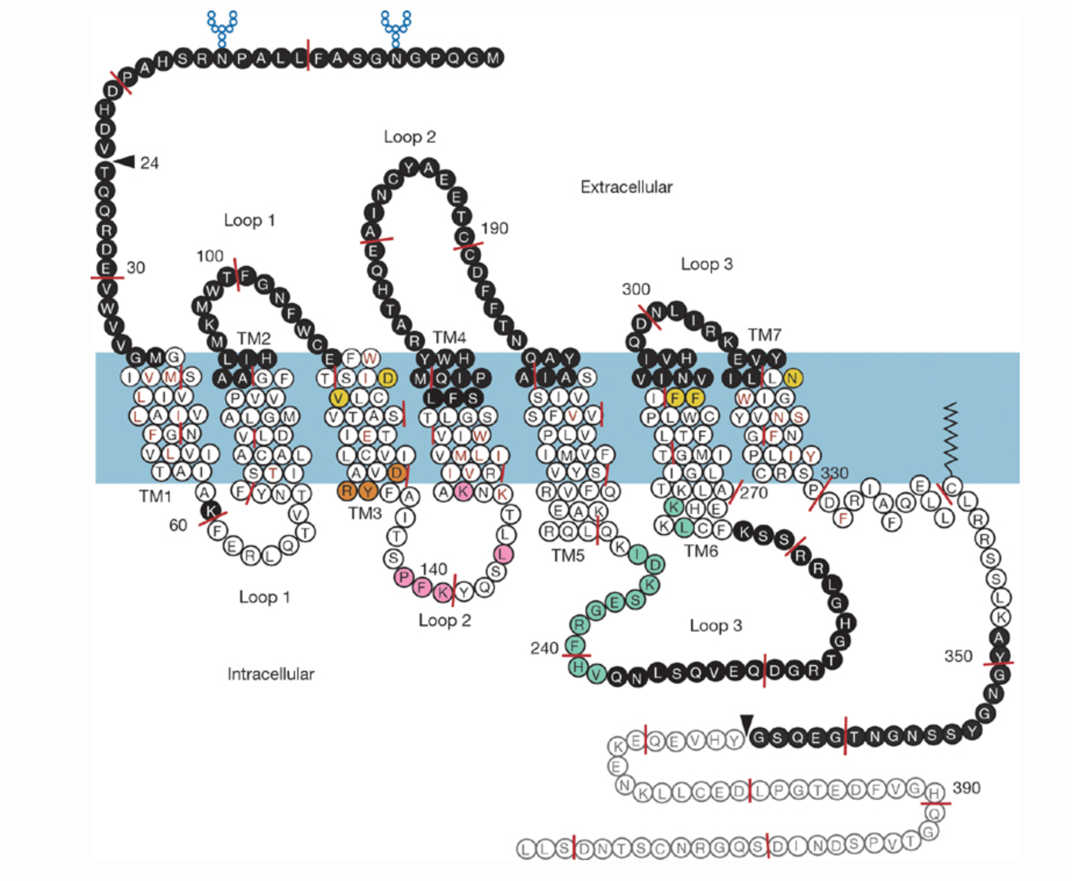
a)

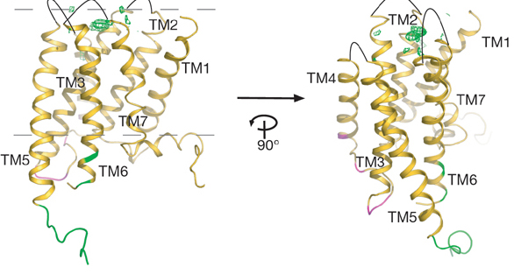
b)

Figure 3. a) The sequence of the β₂-adrenergic receptor. b) 3D-structure of the β₂-adrenergic receptor showing sites of the interactions with Fab5 (an antibody fragment that binds to the third loop and stabilizes it). Figures taken from Rasmussen et al. (2007).

From that point on, further questions concerning the function of GPCRs could be addressed. The two processes that characterize this regulatory function are activation and desensitization. Desensitization denotes the remarkable fact that the presence of an agonist leads to a metabolic response in the cell (such as an increase of cAMP), which after a few minutes becomes attenuated despite the continuous presence of the receptor agonist. GPCR desensitization can be seen as an instance of the more general phenomenon of homeostasis, which plays a crucial role in many biological processes. Henceforth, research on receptor desensitization led to insights into fundamental biological control and feedback mechanisms that have relevance far beyond the field of receptor studies.
Meanwhile, the presence of this newly found protein superfamily had guided parallel inquiries into other cell signaling mechanisms. Most notably Linda Buck and Richard Axel’s (1991) discovery of the olfactory receptors (ORs) and their identification as GPCRs spurred further interest in the crucial role of receptors in a variety of physiological processes. The OR family was discovered to exhibit two characteristics that present them as a paradigm to study GPCR structure-function relations: first, its size (ORs constitute up to 4% of most mammalian genomes (Zhang et al. 2007)), and, second, the structural diversity of its members. In essence, while olfactory receptors are highly diverse in comparison with each other (40-98% sequence similarity), the family of olfactory receptors shares a significant amount of conserved amino acid sequences with other GPCR families. This intriguing structural character promises to shed further light on the evolutionary ties of GPCRs and their remarkable ability to detect structurally highly diverse ligands (Firestein, Greer, and Mombaerts 2014, Barwich 2015).
By the mid 1990s, further protein families involved in the GPCR signal transduction process, such as arrestins and certain G-protein coupled kinases, were discovered, starting to complete our understanding of the two main paradigms of GPCR function: activation of a cell response through G-protein coupling and second messengers on the one hand, and desensitization via arrestins and phosphokinase activity on the other (Lefkowitz 2007a). More recently, there has been growing interest in in vivo studies of receptor function and mouse knockout experiments with GPCRs (Matsuda and Aiba 2004). Such functional investigations provide increasing warranty for the reality of receptors. Today, no biochemist in her (or his) right mind would dare to question the importance of GPCRs in biology, let alone raise serious doubts about their very existence. Quite the contrary, due to their importance for our understanding of cellular mechanisms as well as for drug development, GPCRs have become key to research in modern biochemistry (Snogerup-Linse 2012).
That said, the statement that no right-minded scientist would doubt the existence of GPCRs today is a psychological one. One should be careful not to confuse the widely held belief in the existence of GPCRs among scientists with the reasons that justify this belief. The philosophically interesting question to be asked when it comes to the reality GPCRs should not merely pertain to the simple fact that most scientists take GPCRs to be real, but rather to why and how they came to hold this belief. As the above story nicely shows, the reasons for this indeed have to do with manipulability, and the increasing capability to intervene on the receptors and related structures. However, the history of GPCRs also indicates that manipulability played a much more subtle role than it is usually credited with in philosophical debates on entity realism, where manipulability is usually treated as a straightforward criterion for reality, at least by those who take the realist side in the debate. We believe that the role of manipulability in the realism debate deserves renewed attention. So what precisely was the role that manipulability played in the formation of GPCRs as a real scientific object?

Manipulability and Realism

Philosophical debates about entity realism often revolve around the question of whether manipulability should be seen as a sufficient criterion for reality, or whether the ability to manipulate something is merely necessary for our belief in the existence of that thing. Ian Hacking’s original proposal of entity realism is commonly interpreted as claiming that we can justify the belief in the existence of an entity, independently of the belief in the truth of the theories in which that entity plays an explanatory role. In this reading, entity realism contends that we are entitled to believe in the existence of our theoretical entities (if we can spray them or do other things with them) to a higher degree than we are entitled to believe in the truth of our current best theories in which these entities appear. Accordingly, the aim of entity realism is to divorce the belief in the existence of an entity from the belief in the truth of theories.
It has been a matter of extensive debate whether Hacking actually intended manipulability to be a sufficient criterion for reality. He did however state explicitly that he never intended manipulability to be a necessary criterion:

My experimental argument for entity realism may imply a sufﬁcient (epistemological) condition for holding that an entity exists. But it does not imply a necessary condition. There may be many kinds of evidence that an entity exists. I hold only that manipulationability is the best evidence (Hacking 1995, p. 540).

In any case, Hacking’s account was criticized on many grounds, and it has been questioned whether manipulability can serve as an adequate criterion for realism at all, be it necessary or sufficient. Shapere (1993), for instance, has argued that manipulability cannot be necessary because it is not inclusive enough as a criterion. Even though we can manipulate something and thus have sufficient reason to believe that it is real, there are things that are commonly accepted as real in science and that a scientific realist should want to include in her ontology, but which cannot be manipulated. Shapere refers to theoretical entities in astronomy such as gravitational lenses.
Gross (1990) raises similar concerns regarding the entities of the historical sciences like geology or evolutionary biology. These sciences, too, describe events and processes that are experimentally inaccessible but are nevertheless believed to be real. Gross further raises concerns about manipulability as a sufficient criterion. He points out that there is always the possibility that we wrongly believe to be manipulating something, and that, in consequence, our belief in the reality of the manipulated something might be unwarranted. One example for an entity that possessed this kind of instrumental reality and manipulative success but that later disappeared from the scientific ontology is, of course, phlogiston (Kim 2008). A first indicator for the unreality of phlogiston was a central discordance in the results from such manipulative procedures. While phlogiston appeared to have a measurable weight with respect to some experiments, this manipulative success failed to translate to other methods (e.g., thermometric measurement and instruments such as the hydrometer, gasometer, and calorimeter). Nonetheless, such strong discordance of empirical results from multiple sources is easier to recognize in hindsight. In an unsettled experimental inquiry, data discordance is commonplace (Stegenga 2009).
Gelfert (2003) maintains that manipulability is not a sufficient criterion because there are things that we can manipulate, but which we know not to be real. He refers to quasi-particles in particle physics such as unoccupied electron states in semiconductors or so-called excitons or magnons. These quasi-entities can be manipulated despite the fact that they have no “material basis,” as Gelfert calls it, and, hence, manipulability cannot be sufficient for the reality of these entities. To be sure, Gelfert’s argument makes presuppositions that the entity realist might be unwilling to accept. It is not our purpose, however, to enter into the details of this quarrel. We simply want to draw attention to the fact that manipulability as a criterion for the reality of theoretical entities is highly contested.
Despite these and other criticisms, it still appears reasonable not to discard manipulability altogether when it comes to the question of realism. After all, manipulability does indeed play a role when scientists are confronted with the question of whether they should accept an entity as real or not. At least in wet-lab science it surely does, as we have shown in the history of GPCRs outlined in the previous section. However, the same history also shows that even after the first experiments on adrenergic receptors had been performed and well-controlled quantifiable cause-effect relationships could be established, even when the proteins themselves were purified to homogeneity, skepticism concerning the reality of receptors qua receptors (i.e., their causal role) persisted.
None of the experimental interventions in isolation were sufficient for the acceptance of receptors as real. A sufficiently large justificatory basis for the belief in the existence of GPCRs was created only by the combination and through a contingent historical sequence of experimental interventions and conceptual refinements. Moreover, the experimental interventions and manipulations became possible only once the concept of a receptor had been articulated with sufficient perspicuity. So the acceptance of GPCRs as real objects did not merely depend on successful experimental manipulation, but also on an adequate conceptual grasp of their potential structural and functional roles. To put it in simpler terms: The scientists needed a conceptual hunch of what they were looking for before they could begin their search in the lab. As a consequence, manipulability appears no longer a matter of mere instrumental possibility. Manipulative success further requires a form of what we call ontological pre-formatting of an object that defines – even just hypothetically – with what kind, function, organization, or structure the observed effects are associated.
In a recent article, Aaron Novick and Raphael Scholl (forthcoming) have linked the development of techniques that increase the purification or manipulability of an experimental object to an increasing approximation of the so-called vera causa principle. Novick and Scholl argue that theoretical entities in the life sciences are often found, and their existence is often justified, by adherence to this principle, and not by inferences to best explanations (as others have claimed). The vera causa principle demands an anti-realist attitude toward claims about objects whose existence and causal features are “known” merely on explanatory grounds. An object may be taken to exist only once we have independent support, i.e., support that does not depend exclusively on the explanatory power of the hypotheses in which the object appears. We could not agree more with this line of reasoning. The only thing we would like to add is to say that successful manipulation, although it ultimately provides the justification for the existence of an object, is not fully independent from any conceptual or, if you will, theoretical grounds. Having a clear conceptual grasp of what one is manipulating is a prerequisite for the success of experimental interventions.
The history of GPCRs outlined in the previous section serves as a paradigm case in this respect. The case exemplifies what we believe holds for many other theoretical entities in modern science, namely that the belief in their existence can only be justified by taking into account the historical trajectory of their discovery. Such trajectories involve conceptual steps, in which the functional or structural role of the object is defined, as well as experimental steps, where the defined functions and structures are manipulated. In the recent literature, similar approaches to the development of scientific research have been discussed under the notion of “epistemic iteration”. Hasok Chang defined iteration as “a process in which successive stages of knowledge, each building on the preceding one, are created in order to enhance the achievement of certain epistemic goals. […]; in each step, the later stage is based on the earlier stage, but cannot be deduced from it in any straightforward sense. Each link is based on the principle of respect and the imperative of progress, and the whole chain exhibits innovative progress” (Chang 2004, p. 226). Epistemic iteration thus describes a continuous interplay between conceptual and experimental procedures, which gradually leads to the establishment of generally accepted scientific knowledge. Such an iterative process, we think, not only applies to the acceptance of knowledge claims, but also the acceptance of the reality of a scientific object. So let us briefly reiterate the history of the discovery of GPCRs and distinguish five stages in the process through which GPCRs came to be widely accepted as existing objects.
First, we saw how the idea of a receptor originated as a theoretical and explanatory proxy. Langley’s initial concept of a “receptive substance” brought together two observations of cell activity that were investigated separately beforehand: response specificity and signal transmission. Such a conceptual framing constituted the preliminary identity conditions for the reference to a hypothetical entity in terms of certain functional and structural features. The term “receptive substance” could now be used to refer to a potential entity as responsible for the substance-specific reception and transmission of chemical signals, whatever its other properties may be. These conditions set the frame for how researchers were able to refer to an object, even though the very existence of the object was purely speculative at the time.
The second step is what we like to call the ontological pre-formatting stage. At this point, the object consolidates its role as a placeholder for certain functions or structures associated with specific observable effects. Hereby, the hypothetical object turns from a purely conceptual entity into a candidate for realism through its progressive entrenchment in an experimental context. Such entrenchment is characterized by several factors, encompassing an explanatory role of the entity within a wider theoretical context, the material tractability of effects associated with the entity through various methods, and the stability of links produced between explanatory function and quantifiable, tractable effects. This whole process is accompanied by an ongoing debate about the identity of the receptor, and the organizational role of the receptor idea in assigning certain effects under an umbrella concept gets manifested. This development was mostly a consequence of the emerging mathematical formulations for certain drug-target effects in pharmacological studies over the first half of the 20th century. As a result, estimations about what kinds of effects were possible to produce experimentally came more and more to the foreground. In our story, this part coincides with the early pharmacological experiments on adrenergic receptors by Ahlquist, Black, and others.
The third stage is characterized by a refinement of the ontological pre-formatting and the experimental access to the object. In the history of GPCRs, this stage includes Lefkowitz’ study of receptor affinity through radioligand binding techniques, and the formulation of the ternary complex model. Moreover, the receptors now could be handled for the first time as isolated objects after they had been successfully purified via affinity chromatography. Nevertheless, the measurability of quantitative drug target effects or the successful isolation of the receptor molecules did not aid and abet a more positive climate of receptor realism amongst practitioners. Over several decades, Lefkowitz and others tried to fill the molecular gaps that lay between the receptor concept as a functional gateway and the distributed biochemical effects that may as well have been part of other key entities at this time, such as adenylate cyclase.
From this perspective, the experimental realization of GPCRs first may seem to be a consequence of what can be considered a form of “robust” manipulability (Wimsatt 2007). A classical entity realist would count this as sufficient for the acceptance of an object’s existence, perhaps. Nonetheless, the striking resistance towards the reality of these receptors—even in light of their materialization in purified form—must not be ignored in the philosophical analysis. These receptors seemed to have had it all: an explanatory function, measurable quantifiable effects, successful drug interventions, visual traces of target specificity, and now even purified molecules! And, yet, skepticism prevailed.
This is where we see the need to emphasize two further key developments in the biography of wet-lab entities. As a fourth stage, we encounter a historical turn where a concept exceeds its organizational role in bringing together previously encountered issues. Instead of mere accumulation of data, the receptor concept acquired something of an ontological charge. By ontological charge we mean that the potential of manipulation at some point exceeds mere manipulability, and the resulting effects are affecting the understanding of other entities within the same experimental framework. Persistent skepticism in the existence of adrenergic receptors was overcome only once the receptor molecules became productive as part of a larger framework. Notably, this is also when they began to facilitate new empirical findings and novel research outlooks. A crucial step in this process was the experiment in which Lefkowitz and collaborators induced responsiveness to ß-adrenergic agonists in cells lacking ß-adrenergic affinity. Besides, by introducing the receptor into the membrane of those cells with the help of G-protein containing phospholipid vesicles, they also clarified the crucial role of the G-protein in receptor activation. This is the point where the image of a receptor as a functional unit including the transmembrane protein, the G-protein, and the second messenger emerges, and remaining doubts about the causal role of the previously isolated membrane proteins are removed. Phenomena that were previously seen as separate effects now become unified under a joint concept. This process facilitated the unanticipated discovery of the structural homology to rhodopsin, the emergence of a protein superfamily, and, last but not least, the crystallographic structure of the receptor. Thus, the acceptance of receptors as real objects ultimately depended on the embedment of the receptor concept in a larger functional molecular mechanism, i.e., the second messenger pathway, and the degree to which the receptor concept opened up the road to further research questions. While all of this happened only over the past 40 years, today the long-standing speculative nature of these receptors sounds like an artifact of distant history.
At the fifth and concluding stage, we see the object becoming an integral part of a scientific paradigm to the extent that it assumes the role of a standard. By this, we refer to its pertinent role of acting as a touchstone by which other effects, hypothetical entities, or mechanisms are evaluated in their capacity to represent potential candidates for realism. Having established the existence of receptors allowed for the accurate prediction of numerous associated elements and downstream effects in the second messenger pathway, which opened up new avenues for research in a variety of disciplines including neurobiology, pharmacology, and medicine. The predictive success of models is sometimes interpreted as an indicator of their maturity in the philosophical debate (Worrall 1989). Predictive success in this context is often evoked in discussions about the general success of science and regarding the no miracles argument (Musgrave 2007). However, while constituting a marker for the empirical success of the encompassing models, predictive success alone is insufficient to warrant the reality of scientific objects, as many predictively successful scientific models containing non-existing objects have demonstrated.
At the end of this whole development, the formerly purely speculative notion of a receptor has led to what is now regarded as central object of investigation in modern biochemistry. Current research is now focusing on solving the complex puzzle of structure-function relations in protein receptor activation. Overall, we found that the acceptance of GPCRs was conditional on two main factors that were realized iteratively over the course of the five phases that we outlined above. On the one hand, we found a molecular representation linked to the specific functions that, initially, such cell surface receptors had occupied as conceptual proxies only. Insight into this molecular expression was a product of both robust experimental strategies (ranging from radio ligands to patch clamp) as well as manipulative success (e.g., Black’s beta blocker). On the other hand, we saw that the acceptance of GPCRs required further justification that was grounded in what we called their ontological charge. In our argument, the concept of charge represented the last stages of their experimental maturity when the function of the receptor was unambiguously established by determining the elements that are necessary and sufficient for the receptor mechanism, and the receptor concept is integrated into a larger experimental context, fostering the understanding of second messenger processing (e.g., the role of arrestins) and the discovery of further protein families (e.g., the olfactory receptors).
In closing, our case study has highlighted a central motif regarding the role of manipulability for philosophical interest in entity realism. Manipulation has played a central role throughout the entire history of GPCRs. However, its potential as a reality criterion strongly depended on methodological developments in which the hypothetical receptor concept turned from having a theoretical and organizational role to becoming an active constituent within a developing experimental context. This turn was characterized by more than the gradual accumulation of data but a change in what we named the ontological charge of a theoretical entity as a productive force within an experimental framework. From this point on, the reality of GPCRs must be considered as relational to insights into related, neighboring, elements within a specific but dynamic research ontology.

References

Ahlquist, RP. 1948. "A study of the adrenotropic receptors." American Journal of Physiology 153 (3):586-600.
Ahlquist, RP. 1973. "Adrenergic receptors: a personal and practical view." Perspectives in biology and medicine 17 (1):119-122.
Arabatzis, T. 2006. Representing electrons: A biographical approach to theoretical entities. Chicago: University of Chicago Press.
Barger, G, and HD Dale. 1910. "Chemical structure and sympathomimetic action of amines." Journal of Physiology 41 (1-2):19-59.
Barwich, AS. 2015. "What is so special about smell? Olfaction as a model system in neurobiology." Postgraduate Medical Journal 92:27-33.
Black, JW. 1989. "Drugs from emasculated hormones: the principle of syntopic antagonism." Science 245 (4917):486-93.
Buck, LB, and R Axel. 1991. "A novel multigene family may encode odorant receptors: A molecular basis for odor recognition." Cell 65 (1):175-187.
Cerione, RA, DR Sibley, J Codina, JL Benovic, J Winslow, EJ Neer, L Birnbaumer, MG Caron, and RJ Lefkowitz. 1984. "Reconstitution of a hormone-sensitive adenylate cyclase system. The pure beta-adrenergic receptor and guanine nucleotide regulatory protein confer hormone responsiveness on the resolved catalytic unit." Journal of Biological Chemistry 259 (16):9979-82.
Chakravartty, A. 2007. A metaphysics for scientific realism: Knowing the unobservable. Cambridge: Cambridge University Press.
Chang, H. 2004. Inventing Temperature : Measurement and Scientific Progress. Oxford: Oxford University Press.
Colquhoun, D. 2006. "The quantitative analysis of drug–receptor interactions: a short history." Trends in pharmacological sciences 27 (3):149-157.
Crasto, CJ. 2009. "Computational biology of olfactory receptors." Current bioinformatics 4 (1):8-15.
Daston, L. 2000. Biographies of scientific objects. Chicago: University of Chicago Press.
De Lean, A, JM Stadel, and RJ Lefkowitz. 1980. "A ternary complex model explains the agonist-specific binding properties of the adenylate cyclase-coupled beta-adrenergic receptor." Journal of Biological Chemistry 255 (15):7108-17.
Dixon, RA, BK Kobilka, DJ Strader, JL Benovic, HG Dohlman, T Frielle, MA Bolanowski, CD Bennett, E Rands, RE Diehl, RA Mumford, EE Slater, IS Sigal, MG Caron, RJ Lefkowitz, and CD Strader. 1986. "Cloning of the gene and cDNA for mammalian beta-adrenergic receptor and homology with rhodopsin." Nature 321 (6065):75-9.
Dohlman, HG, J Thorner, MG Caron, and RJ Lefkowitz. 1991. "Model systems for the study of seven-transmembrane-segment receptors." Annual Review of Biochemisty 60:653-88.
Egg, M. 2014. Scientific Realism in Particle Physics: A Causal Approach. Boston/Berlin: De Gruyter.
Elliott, KC. 2012. "Epistemic and methodological iteration in scientific research." Studies in History and Philosophy of Science Part A 43 (2).
Firestein, S, C Greer, and P Mombaerts. 2014. "The Molecular Basis for Odor Recognition. Cell Annotated Classic." http://www.cell.com/pb/assets/raw/journals/research/cell/cell-timeline-40/Buck.pdf, accessed 9 July 2017.
Gelfert, A. 2003. "Manipulative success and the unreal." International Studies in the Philosophy of Science 17 (3):245-263.
Gross, AG. 1990. "Reinventing Certainty: The Significance of Ian Hacking's Realism." PSA: Proceedings of the Biennial Meeting of the Philosophy of Science Association 1990:421-431.
Hacking, I. 1983. Representing and intervening: Introductory topics in the philosophy of natural science. Cambridge: Cambridge University Press.
Hacking, I. 1995. "Comments on Zeidler & Sobczynska's Paper." Foundations of Science 1 (4):537-542.
Kay, LE. 2000. Who Wrote the Book of Life? A History of the Genetic Code. Stanford: Stanford University Press.
Kim, MG. 2008. "The ‘instrumental’reality of phlogiston." Hyle 14 (1):27-51.
Kobilka, BK, TS Kobilka, K Daniel, JW Regan, MG Caron, and RJ Lefkowitz. 1988. "Chimeric alpha 2-,beta 2-adrenergic receptors: delineation of domains involved in effector coupling and ligand binding specificity." Science 240 (4857):1310-1316.
Kobilka, BK. 2013. "The structural basis of G-protein-coupled receptor signaling (Nobel Lecture)." Angewandte Chemie International Edition 52 (25):6380-6388.
Langley, JN. 1905. "On the reaction of cells and of nerve-endings to certain poisons, chiefly as regards the reaction of striated muscle to nicotine and to curari." Journal of Physiology 33 (4-5):374-413.
Langley, JN. 1921. The autonomic nervous system. Cambridge: W. Heffer & Sons, Ltd.
Lefkowitz, RJ. 2007a. "Seven transmembrane receptors—A brief personal retrospective." Biochimica et Biophysica Acta 1768 (4):748–755.
Lefkowitz, RJ. 2007b. "Seven transmembrane receptors: something old, something new." Acta physiologica 190 (1):9-19.
Lefkowitz, R J. 2013. "A brief history of G-protein coupled receptors (Nobel Lecture)." Angewandte Chemie International Edition 52 (25):6366-6378.
Limbird, LE, DM Gill, and RJ Lefkowitz. 1980. "Agonist-promoted coupling of the beta-adrenergic receptor with the guanine nucleotide regulatory protein of the adenylate cyclase system." Proceedings of the National Academy of Sciences 77 (2):775-779.
Limbird, LE 2012. Cell Surface Receptors: A Short Course on Theory and Methods: A Short Course on Theory and Methods. Springer Science & Business Media.
Lomasney, JW, LM Leeb-Lundberg, S Cotecchia, JW Regan, JF DeBernardis, MG Caron, and RJ Lefkowitz. 1986. "Mammalian alpha 1-adrenergic receptor. Purification and characterization of the native receptor ligand binding subunit." Journal of Biological Chemistry 261 (17):7710-7716.
Maehle, AH, CR Prüll, and RF Halliwell. 2002. "The emergence of the drug receptor theory." Nature Reviews Drug Discovery 1 (8):637-6341.
Maehle, AH. 2004. ""Receptive substances": John Newport Langley (1852-1925) and his path to a receptor theory of drug action." Medical History 48 (2):153-174.
Maehle, AH. 2009. "A binding question: the evolution of the receptor concept." Endeavour 33 (4):135-140.
Matsuda, I, and A Aiba. 2004. "Receptor knock-out and knock-in strategies." Methods Mol Biol 259:379-390.
Morrison, M. 1990. "Theory, intervention and realism." Synthese 82 (1):1-22.
Musgrave, A. 2007. "The miracle argument for scientific realism." The Rutherford Journal: The New Zealand Journal for the History and Philosophy of Science and Technology 2. http://www.rutherfordjournal.org/article020108.html, accessed 9 July 2017.
Neher, E, and B Sakmann. 1976. "Single-channel currents recorded from membrane of denervated frog muscle fibres." Nature 260 (5554):799-802.
Nickles, T. 1997. "A multi-pass conception of scientific inquiry." Danish Yearbook of Philosophy 32:11-44.
Northup, JK, PC Sternweis, MD Smigel, LS Schleifer, EM Ross, and AG Gilman. 1980. "Purification of the regulatory component of adenylate cyclase." Proceeding of the National Academy of Sciences 77 (11):6516-6520.
Novick, A, and R Scholl. forthcoming. “True causes and unconceived alternatives: Inheritance from pangenes to DNA.”
Parascandola, J, and R Jasensky. 1974. "Origins of the receptor theory of drug action." Bulletin of the History of Medicine 48 (2):199-220.
Palczewski, K. 2006 “G Protein–Coupled Receptor Rhodopsin.” Annual Review of Biochemistry. 75: 743–767.
Rasmussen, SG, HJ Choi, DM Rosenbaum, TS Kobilka, FS Thian, PC Edwards, M Burghammer, VR Ratnala, R Sanishvili, RF Fischetti, GF Schertler, WI Weis, and BK Kobilka. 2007. "Crystal structure of the human beta2 adrenergic G-protein-coupled receptor." Nature 450 (7168):383-387.
Rheinberger, HJ. 1997. Toward a history of epistemic things: Synthesizing proteins in the test tube. Stanford: Stanford University Press.
Robison, GA, RW Butcher, and EW Sutherland. 1967. "Adenyl Cyclase as an Adrenergic Receptor." Annals of the New York Academy of Sciences 139 (3):703-723.
Rosenbaum, DM, GFS Rasmussen, and BK Kobilka. 2009. "The structure and function of G-protein-coupled receptors." Nature 459 (7245):356-363.
Schertler, GF, C Villa, and R Henderson. 1993. "Projection structure of rhodopsin." Nature 362 (6422):770-772.
Shapere, D. 1993. "Astronomy and antirealism." Philosophy of Science 60 (1):134-150.
Silverstein, AM. 2002. Paul Ehrlich's receptor immunology: the magnificent obsession. San Diego: Academic Press.
Snogerup-Linse, S. 2012. "Scientific Background on the Nobel Prize in Chemistry 2012. Studies of G-Protein-Coupled Receptors. Award Ceremony Speech." The Royal Swedish Academy of Sciences, https://www.nobelprize.org/nobel_prizes/chemistry/laureates/2012/presentation-speech.html, accessed 9 July 2017.
Stegenga, J. 2009. "Robustness, discordance, and relevance." Philosophy of Science 76 (5):650-661.
Valenstein, ES. 2006. The war of the soups and the sparks: The discovery of neurotransmitters and the dispute over how nerves communicate. New York: Columbia University Press.
Wimsatt, WC. 2007. Re-engineering philosophy for limited beings: Piecewise approximations to reality. Cambridge, MA: Harvard University Press.
Wimsatt, WC. 1987. "False models as means to truer theories." In Neutral Models in Biology, edited by N. Nitecki and A. Hoffman, 23-55. Oxford: Oxford University Press.
Winsberg, E. 2009. "A Function for Fictions. Expanding the Scope of Science." In Fiction in Science. Philosophical Essays on Modelling and Idealisation, edited by Mauricio Suárez, 179-190. London: Routledge.
Worrall, J. 1989. "Structural realism: the best of both worlds?" Dialectica 43 (1-2):99-124.
Zhang, R, and X Xie. 2012. "Tools for GPCR drug discovery." Acta pharmacologica Sinica 33 (3):372-384.
Zhang, X, O De la Cruz, JM Pinto, D Nicolae, S Firestein, and Y Gilad. 2007. "Characterizing the expression of the human olfactory receptor gene family using a novel DNA microarray." Genome biology 8 (5):R86.

Author names are in alphabetical order. Both authors contributed equally and survived.
The latter question has been addressed at a conference entitled “The History of Science and Scientific Realism” in February 2016 in Indianapolis hosted by Timothy D. Lyons, Peter Vickers, and Yafeng Shan.
Some salient exceptions are, for instance, Rheinberger (1997) on protein synthesis; Arabatzis (2006) on the electron; an edited collection by Daston (2000), involving a range of historical biographies of entities such as cytoplasmic particles; Valenstein (2006) on the controversy surrounding soups and sparks in neuroscience; and Kay (2000) on the history of the genetic code.
See Chakravartty (2007, Ch. 2), Gelfert (2003) and Morrison (1990) as examples in the literature that take up Hacking’s line of thought and discus the issue of entity realism predominantly in terms of experimental manipulability.
These Nobel Prizes are: 1967 Nobel Prize in Physiology or Medicine to Ragnar Granit, Haldan Keffer and George Wald for the physiological and chemical processes underlying photoreception; 1971 Nobel Prize in Physiology of Medicine to Sir Earl W. Sutherland Jr. for his studies on the activity of hormones; 1988 Nobel Prize in Physiology of Medicine to Sir James W. Black for the discovery of propranolol (blocking ß-adrenergic receptors) and histamin H₂ receptor blocker cimetidine; 1994 Nobel Prize in Physiology of Medicine to Martin Rodbell and Alfred Gilman for heterotrimeric G-proteins; 2004 Nobel prize in Physiology or Medicine to Linda B. Buck and Richard Axel for the discovery of olfactory receptors; 2012 Nobel Prize in Chemistry to Robert Lefkowitz and Brian Kobilka for the general study of GPCRs (Snogerup-Linse 2012).
For an excellent review on the structure and function of GPCRs as well as an outlook on current and future applications see Rosenbaum et al. (2009).
See Lefkowitz (2013, p. 6367).
Today, we know that curare blocks nicotinic acetylcholine receptors.
See also Maehle, Prüll, and Halliwell (2002) and Maehle (2009). For the history of the receptor concept and the mutual influences of Langley and Ehrlich see also Parascandola and Jasensky (1974), and Silverstein (2002).
In a later synthesis of his ideas in 1921, Langley is more explicit about the chemical character of the interaction between the drug and the receptive substance: “The known physical characters of drugs are insufficient to account for the effects they produce, though they account for a difference in rate of action; in consequence I consider that there is a chemical combination between the drug and a constituent of the cell – the receptive substance. On the theory of chemical combination it seems necessarily to follow that there are two broad classes of receptive substances; those which give rise to contraction, and those which give rise to inhibition” (Langley 1921, p. 44. Cited in Maehle 2004, p. 173).
In essence, affinity refers to the binding capacity of a substance to a target domain, whereas efficacy describes the degree to which a substance initiates a response when binding to the target domain.
The patch clamp technique is a tool used in electrophysiology for the study of electrochemical potentials on double-lipid membranes and in particular the currents of single ion channels. Patch clamp was first introduced by Erwin Neher and Bert Sakmann in 1976 and soon became a crucial tool for the study of cell signaling mechanism through membranes (Neher and Sakmann 1976). Neher and Sakmann were awarded the 1991 Nobel Prize in Physiology or Medicine “for their discoveries concerning the function of single ion channels in cells.”
In radioligands, one or more atoms are replaced by radioisotopes. Such radiolabeling allows targeting and tracing a receptor’s binding activity via the measurement of differences in radioactivity in bound and unbound ligands.
To avoid confusion, it should be noted that nicotinic cholinergic receptors do not belong to the GPCR family of receptors.
“The simplest model for hormone-receptor interactions which can explain and reproduce the experimental data involves the interaction of the receptor R with an additional membrane component X, leading to the agonist-promoted formation of a high affinity ternary complex HRX.“ (De Lean, Stadel, and Lefkowitz 1980, p. 7108).
Allosteric regulation refers to the well-studied biological phenomenon that the binding of a ligand to a protein is often regulated by the binding of further compound at another site of the protein, inducing a conformational change in the protein’s structure (in this case the regulation of the extracellular binding of ligands through the binding of the G-protein to the intracellular domain of the receptor).
An obstacle for the initial design of this experiment is the fact that almost all cells contain certain amounts of adrenaline receptors. Lefkowitz and his team found an exception in the cells of the African clawed toad. Most fortunately, these cells contain the entire molecular apparatus of a second messenger process but lack adrenergic receptors.
We thank Brian Kobilka for drawing our attention to the importance of in vivo studies.
See Egg (2014, Ch. 2.2).
A similar point could be made with respect to the conflicting observations about the movement of the ether in 19th century physics. Nonetheless, an analysis of the reasons that lead to the abandonment of scientific objects must not necessarily mirror the reasons for their step-wise realization.
Similar ideas have been suggested before, though not under the term “iteration”. See for instance Wimsatt (1987) or Nickles (1997). For an overview discussion see Elliott (2012).
An example for this are silogens, which are postulates of silicon-hydrogen hybrid atoms. Winsberg (2009) analyzed these hypothetical atoms as part of the recent philosophical debate on fictionalization strategies in scientific modeling. The argument goes that, while these entities do not exist, they can still provide successful explanations and even predictions for real phenomena, in this case the calculation of molecular dynamics.

