The spatiotemporal problem of entanglement
Author: Jørn Kløvfjell Mjelva

Abstract: In this paper, I present a novel formulation of the spatio-temporal problem of entanglement. This is the problem of resolving a purported tension between the Special Theory of Relativity and the non-local causal influences seemingly needed to explain the EPRB correlations. I argue that the traditional formulations of the problem suffer from a lack of generality, which obscures the central issues raised by it; a shortcoming which the new formulation remedies.

Introduction
One of the possible interpretations of the predicted and observed violation of Bell-type inequalities for certain experiments done on pairs of entangled particles (EPRB experiments) is that there must exist a causal connection between two events that lie outside each other’s backward light cones. These non-local causal influences have been thought to be in tension with – or even ruled out by – the Special Theory of Relativity (STR), and the problem of resolving this tension is known as the spatio-temporal problem of entanglement (Näger, 2016).
Though the spatio-temporal problem of entanglement has been widely recognized and much discussed, there have been varying opinions about what the problem exactly is, as well as the source of the purported tension. Some authors, like for instance Jarrett (1989), go as far as claiming that non-local causal influences between the outcomes of EPRB experiments are ruled out by STR. This view has been contested by Maudlin (2002), who nevertheless argue that though non-local causal influences aren’t ruled out outright, their existence would pick out a privileged reference frame, and hence violate the relativity postulate at the heart of STR.
A disadvantage with the current discussions of the spatio-temporal problem is that the problem is usually framed in terms of a specific interpretation of quantum mechanics rather than more generally. The goal of this paper is to rectify this, by presenting a novel way of framing the spatio-temporal problem of entanglement that does not rely on a specific interpretation of quantum mechanics. Instead the problem is formulated in terms of what I take to be two plausible principles regarding the nature of causal relations. I will argue that these principles are inconsistent with the predictions of STR, given the existence on non-local causal influences.
The new way framing the spatio-temporal problem will be developed in section 3. In preparation for this I will first set up the problem as it is traditionally framed and discuss some of the drawbacks of this formulation. I will argue that the traditional way of framing the spatio-temporal problem obscures some of the central issues raised by it – issues that are put front and centre in my new formulation.

The traditional spatio-temporal problem of entanglement
The EPRB experiment is illustrated in figure 1: An entangled quantum state λ classically described as a pair of particles is created at c and sent towards the A and B wings before a measurement is performed on each of the particles at m_{A} and m_{B}. The outcome of each measurement is then registered. The experimenter is free to measure different properties by choosing the setting of the measurement devices at s_{A} and s_{B}.
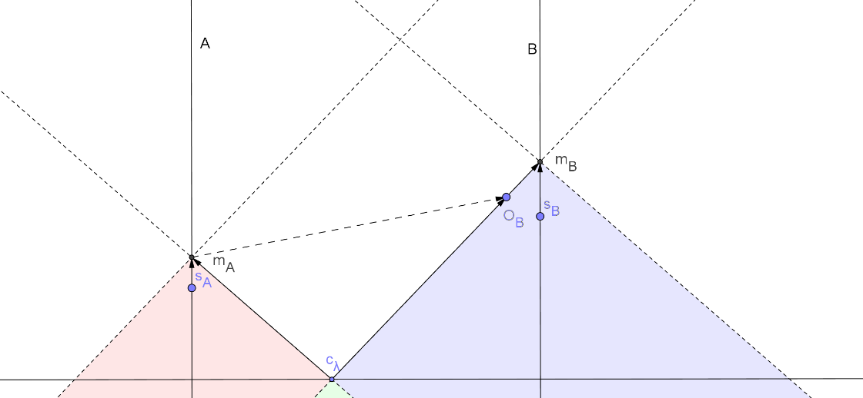
Figure 1: A possible causal structure of the EPRB experiment
Quantum mechanics predicts that, for entangled quantum systems, the final outcomes at the two wings will correlated. Furthermore, the correlations partly depend on the settings of the measurement devices. What Bell’s theorem proves is that no local model – i.e., no model where the correlation between the outcomes can only be attributed to causal factors in the shared past of the particles – can explain these correlations. One might therefore draw the inference that there must be some other non-local causal connection, either between the two outcomes, or between the setting at one wing and the outcome at the other. Since the two wings can be arbitrarily far apart, the causally connected events can be separated such that not even a light signal can be present at both events. This puts a causal explanation of the EPRB correlations in conflict with STR.
Unlike what is often believed, the source of the problem is not that a causal explanation of the EPRB correlations implies superluminal causation, and that this is prohibited by STR. Firstly, STR does not rule out transmission of superluminal signals or even superluminal energy-matter-transference, only that it is possible to accelerate objects from subluminal to superluminal velocities (Lawden, 2004, pp. 73-74). The existence of tachyons – particles created with superluminal velocities, but which cannot be slowed down to subluminal speeds (Maudlin, 2002, p. 72) – has been theorized (Lawden, 2004, pp. 51-53). Secondly, the causal influences need not be due to any energy-matter-transference, and restrictions on the manipulability of the quantum states might make it impossible to use the non-local correlations to send any controllable signal.
Rather than arising from some purported speed-limit, the spatio-problem of entanglement arises due to how STR reimagines time and simultaneity. In order to set up the presentation of the problem, the central elements of this reimagination will be presented in the following section.

Simultaneity and temporal priority in STR
A central feature of STR is that it replaces the traditional Galilean equations for transforming spatial and temporal coordinates between reference frames with the Lorentz transformations (Maudlin, 2002, pp. 45-47):
$$\begin{matrix}x^{'}=γ\left(x-ut\right) \\ y^{'}=y \\ z^{'}=z \\ t^{'}=γ\left(t-{ux}/{c^{2}}\right)\end{matrix}$$
Equation 1: The Lorentz transformations
Where $\left(x,y,z,t\right)$ and $\left(x^{'},y^{'},z^{'},t^{'}\right)$ are the spatial and temporal coordinates in two different reference frames, $S$ and $S'$, respectively, $u$ the relative velocity of the two frames, $c$ is the velocity of light and $γ=\sqrt{1-\frac{u^{2}}{c^{2}}}$ is the Lorentz-factor.
A consequence of the Lorentz transformation is that two events that are simultaneous in the unprimed $S$ frame ($∆t=0$), will not be simultaneous in a different reference frame, but will be separated by the time interval given by $∆t'=\frac{ud'}{c^{2}}$, where $d'$ is the spatial distance between the events measured in the primed frame (Lawden, 2004, p. 28). This is the relativity of simultaneity.
Similarly, it also follows from the Lorentz transformations that the temporal priority of the events (i.e. which event happens first, and which happens last) can be frame dependent. To see this, consider the frame $S$ where event $B$ happens after event $A$ (so that $∆t=t_{B}-t_{A}>0$). Then ${t'}_{B}-{t^{'}}_{A}=γ\left(∆t-{ud}/{c^{2}}\right)$, where $d$ is the distance between the events as measured in the unprimed frame. By choosing a reference frame so that $u>{c^{2}∆t}/d$, we find that ${t'}_{B}-{t^{'}}_{A}<0$, i.e., the temporal priority of the events is reversed.
Notice that, under the restriction that the velocity of the frame must be less than the speed of light ($u<c$) this entails that $c∆t<d$, i.e., the distance between the events is greater than the distance travelled by light in the time interval between them. We say that such events lie outside each other’s light cones and are thus spacelike separated. For events lying inside each other’s light cones, so that $c∆t>d$, it is not possible to find a frame such that $c>u>{c^{2}∆t}/d$. Hence, for such timelike separated events, temporal priority is not frame dependent.
The relativity of temporal priority implied by STR will play a crucial role in the new formulation of the spatio-temporal problem of entanglement, which will be presented in section 3. First however, I will present the traditional problem, which is due to the relativity of simultaneity.

The traditional spatio-temporal problem of entanglement
The traditional spatio-temporal problem of entanglement typically begins with assuming what is known as the orthodox interpretation of non-relativistic quantum mechanics.
On this interpretation, the quantum state λ undergoes an instantaneous change when measured at one wing, known as wave collapse (Maudlin, 2002, p. 192; Griffiths, 2005, pp. 2-5). The collapse is further assumed to occur simultaneously at both wings when a measurement is performed at either wing, so that the measurement performed at one wing of the experiment fixes both the state of the local particle and the state of the particle at the distant wing. Afterwards, the distant particle continues until it reaches the measurement device at the distant wing, where a new measurement occurs, giving the final outcome. See figure 2.
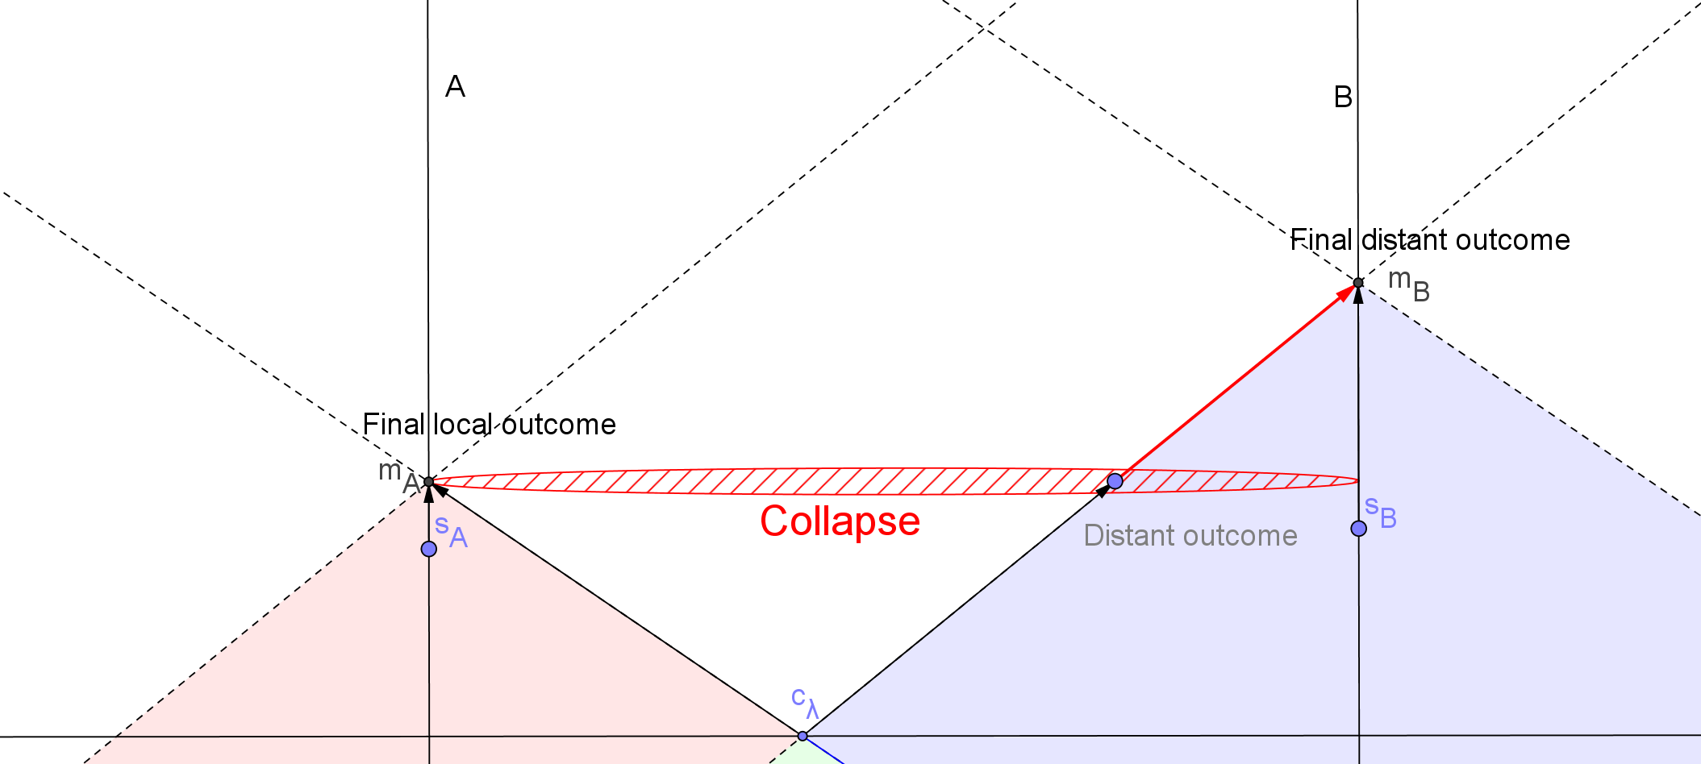
Figure 2: The causal structure of EPRB on the orthodox interpretation
This gives us what I call the traditional spatio-temporal problem of entanglement: By including the notion of two events happening simultaneously in our fundamental description of the world, we violate the principle known as the relativity postulate, which states that all physical laws should have the same formulation in all reference frames (Lawden, 2004, p. 11). Since it follows from the relativity of simultaneity that the events are only simultaneous in some reference frames, whereas they will not be simultaneous in others, the law stating that the collapse occurs simultaneously at both wings will not adhere to the relativity postulate. Instead, it picks out a subclass of privileged reference frames where the events are simultaneous; if we imagine the collapse as occurring along flat, spacelike hyperplanes, the “correct” frame is then one where these hyperplanes are simultaneity slices (Maudlin, 2002, p. 202).

Problems with the traditional spatio-temporal problem
Though the traditional way of framing the spatio-temporal problem of entanglement does rightly bring out the tension between non-local causal influences and STR, it suffers some disadvantages:
Firstly, we had to rely on the orthodox interpretation of quantum mechanics to state the problem. As this is only one of many interpretations – one which faces many other problems aside from the spatio-temporal one – we might be wrongly led to believe that the problem is due to the orthodox interpretation, while it in fact arises for other interpretations as well, like for instance Bohmian mechanics (Maudlin, 2002, pp. 212-217). Consequently, the problem is more general than what the traditional way of stating it suggests, and this should be reflected in how the problem is framed. This has the added benefit that it can open the discussion for more ways of resolving the problem than has currently been considered, as we do not need to limit ourselves to the solutions that follow naturally from a given interpretation.
Secondly, the traditional way of formulating the problem suggests that the existence of non-local causal influences implies a rejection of the relativity postulate. This is not the case: It is possible to come up with a theory where non-local causal influences and the relativity postulate happily coexist. One such account is Gordon Fleming’s hyperplane-dependent theory (Fleming and Bennett, 1989; Fleming, 1986). On this theory, rather than collapsing along only one hyperplane, the wave function collapses along an infinity of hyperplanes going through either measurement event, corresponding to a `simultaneity slice´ in every possible reference frame. It follows that the collapse happens simultaneously at both wings regardless of choice of reference frame, leading to no privileged reference frame, and no violation of the relativity postulate (Maudlin, 2002, pp. 211-212). See figure 3.
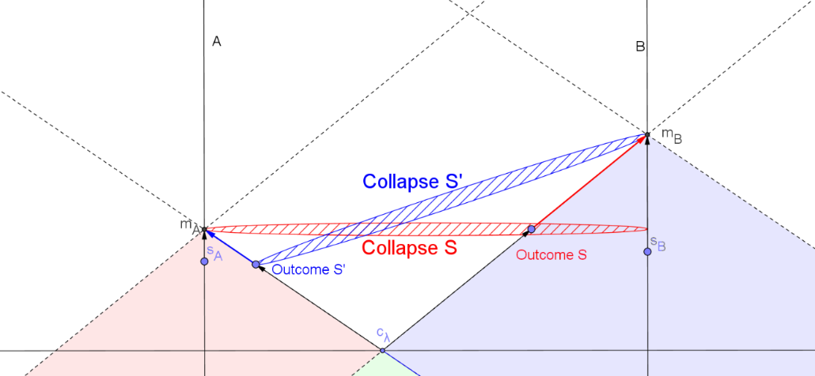
Figure 3: EPRB on Fleming’s hyperplane-dependent theory
Finally, barring Fleming’s theory, one may be tempted to consider this version of the spatio-temporal-problem of entanglement and conclude “too bad for the relativity postulate”. After all, as long as there is no way of telling what the privileged frame is, the problem of there being one is merely a matter of philosophical taste (Bell, 2004 [1976]). This type of response obscures some of the deeper challenges raised by the spatio-temporal problem – challenges pertaining to our intuitions regarding the nature of causal relations. These will be presented in the next section, as I lay the necessary groundwork for a new version of the spatio-temporal problem of entanglement.

A new take on the spatio-temporal problem of entanglement

Causal and temporal asymmetry
Rather than assuming a specific interpretation of quantum mechanics when formulating the spatio-temporal problem of entanglement, I instead proceed from the following two widely-held claims: (a) whenever one event causes another, there is some matter of fact as to which event is the cause and which is the effect; and (b) that temporal and causal asymmetry are related.
Aside from its intuitive plausibility, (a) is motivated by the desire to include causal explanations in our scientific theories: There should be some matter of fact as to whether it is the fusion of hydrogen atoms that causes a release of high-energy photons or the release of high-energy photons that causes the fusion of hydrogen atoms; it shouldn’t be a matter of perspective. In extension, any two observers, even employing different reference frames, should be able to agree on which event causes the other – that is to say, the causal order should be frame invariant.
Furthermore, to preserve the universality we desire of scientific theories, the answer to the question of which event causes the other should also be independent of the context of which the question is evaluated: Whether it is the fusion of hydrogen atoms that causes a release of high-energy photons or the release of high-energy photons that causes the fusion of hydrogen atoms should not depend on whether it happens in a fusion-reactor at Earth or in a distant star, or whether it is observed by humans or by aliens in the Andromeda-galaxy.
Together this suggests the following principle:
ABSOLUTENESS For any two causally connected events, the causal order of the events (i.e., which is the cause, and which is the effect) is frame invariant and context-independent.
As for (b), though it is difficult to deny that causal and temporal asymmetry are related in some way, there is considerably more controversy as to precisely how they are related. Luckily, we don’t need to commit to any particular theory about the direction of causation, but can make do with the following minimal requirement, which is compatible with most views:
TEMPORALITY If an event B is causally between A and C, it is also temporally
between A and C.
The betweeness-relation is inspired by Reichenbach (1956): If A causes B and B causes C, then B is causally between A and C. It is transitive: If B is between A and C, and C is between B and D, then C is between A and D. Is also non-directional: If B is between A and C, it is also between C and A.
Two points that should be noted:
(1) TEMPORALITY would follow from any view that holds that the direction of causation is the direction of time: If A causes B, B causes C, and the direction of causation is the same as the direction of time, it follows that B is after A and C is after B, so B is temporally between A and C. However, it does not make any claims about whether causal or temporal asymmetry is metaphysically or logically prior.
(2) Unlike the aforementioned views, TEMPORALITY is also compatible with retrocausation: If A causes B, and B causes C, B is causally and hence temporally between A and C. This will be the case even if the direction of causation is the opposite of the direction of time, i.e., if C occurs before B, which occurs before A. This is fortunate, as retrocausal models are discussed as a viable alternative to non-local causal models of EPR (Price, 1996; Evans, Price and Wharton, 2013; Price and Wharton, 2015; Evans, 2015), and it would thus be remiss to exclude them by definition.
ABSOLUTENESS and TEMPORALITY thus capture the intuitions expressed in (a) and (b) in more precise terms, while not losing much generality. Yet, as I will argue in the following section, these principles are inconsistent with the relativity of temporal priority entailed by STR in the case of non-local causation. This is the new spatio-temporal problem of entanglement.

The new spatio-temporal problem of entanglement
I am now able to state a new version of the spatio-temporal problem: As we saw in the beginning of section 2, the EPRB experiment can be set up so that the measurement events and setting events at each wing can end up lying outside each other’s past light cones. Hence, it follows from the Lorentz transformations that the temporal priority of the events will be frame dependent. In one reference frame the measurement event at the B wing occurs after the measurement event (and setting event) at the A wing, whereas in a different reference frame it occurs before the measurement event (and setting event) at the A wing. It follows that, depending on the choice of reference frame, the outcome at the B-wing (let’s call it $o_{B}$) is temporally between $c_{λ}$and $m_{A}$, or $m_{A}$ is temporally between $c_{λ}$ and $o_{B}$.
If we assume ABSOLUTENESS, the causal order must be frame invariant. Thus, assuming that $o_{B}$ is causally between $c_{λ}$ and $m_{A}$ relative to one reference frame, this must be the case in all reference frames. It then follows from TEMPORALITY that $o_{B}$ is also temporally between $c_{λ}$ and $m_{A}$ in all reference frames. However, as we’ve seen, this isn’t the case when the $m_{A}$ and $m_{B}$ (and hence $o_{B}$) are spacelike separated – STR predicts that there are reference frames where the temporal priority of these events are reversed. Consequently, either STR is wrong, or there is something wrong with one (or both) of the principles.
Notice also that, unlike the traditional way of framing the problem, the preceding result does not rely on the assumption that there is no privileged reference frame, only on the empirically verifiable predictions of STR. As we have little reason to doubt the predictions of STR, we have good grounds to believe that the fault must lie with ABSOLUTENESS or TEMPORALITY. The spatio-temporal problem of entanglement can then be seen as the problem of choosing between these two horns of the dilemma.
This is, as far as I’m aware, a novel way to frame the spatio-temporal problem of entanglement. The advantage of this formulation is that brings out the tension between the existence of non-local causal influences and STR without assuming any specific interpretation of quantum mechanics. It also makes the underlying presuppositions about the nature of causal relations explicit, and thus opens the discussion for alternative ways to resolve the problem.
Before concluding, I want to consider how some of the possible ways to resolve the traditional spatio-temporal problem of entanglement – i.e., i) Flemings hyperplane-dependent theory and ii) rejecting the relativity postulate – can be analysed in terms of our new version.

Analysis of some solutions to the traditional problem
I. Fleming’s hyperplane-dependent theory
It follows from the relativity of simultaneity that two observers subscribing to the same wave-collapse theory, but occupying different reference frames, might tell radically different stories about what happens: According to one, a measurement event at A has caused the wave function to collapse, fixing the state of the particle en route to the measurement device at B, which in turn causes the final outcome at the B wing as it interacts with the measurement device. According to the other, it is the measurement at the B wing that causes the wave function to collapse, fixing the state of the particle en route to the measurement device at the A wing, in turn causing the outcome at the A wing. See figure 3.
The preceding remarks applies just as well for the orthodox interpretation as for Fleming’s theory. What Fleming’s theory implies – that the orthodox interpretation doesn’t – is that both observers are correct insofar as they give a correct description of the events relative to the family of hyperplanes that are simultaneity slices in their respective reference frames. On this theory, the causal relations – which event is the cause and which is the effect – will be contextual, dependent upon the hyperplane one considers (Maudlin, 2002, pp. 211-212). Hence, rather than being a curious exception, our new way of framing the spatio-temporal problem of entanglement reveals that Fleming’s theory resolves the dilemma by rejecting ABSOLUTENESS.

II. Rejecting the relativity postulate
As we saw when discussing the traditional problem of entanglement, one possible solution is to reject the relativity postulate and accept that the collapse picks out the subclass of privileged reference frames where the measurement event on one wing and the outcome at the other are simultaneous.
In choosing this option, we would also need to reject TEMPORALITY: It is not the case that the temporal order matches the causal order like specified by this principle, unless you happen to find yourself in one of the privileged reference frames. Thus, rejecting the relativity postulate solves the dilemma by rejecting TEMPORALITY.
Now we also see the deeper implications of this option: By detaching causal and temporal order in this way, we also concede that temporal order isn’t a reliable guide to causal order. Unless we in some way can know which of the infinitely many possible reference frames are privileged in the sense that the temporal order matches the causal order, we will be unable to tell what the true causal order is.
This isn’t too big of a problem if non-local causal influences are rare, since the frame invariance of the temporal priority of timelike separated events ensures that we at least get the causal order of these right. If non-local causal influences are more abundant than we have previously realised, however, this will raise serious concerns about our ability to know anything about the causal structure of reality.
The problem is avoided if we exclude non-local causation, as TEMPORALITY places no restrictions on the temporal order of two events when the events aren’t causally connected. Though different observers might disagree about the temporal priority of the events that are spacelike separated, they will – since the temporal priority of timelike separated events is frame invariant – still be able to agree about the temporal and hence causal order of the events that are causally connected. Hence, in this case the temporal order of causally connected events will serve as a reliable guide to causal order.

Conclusion
This paper has dealt with the spatio-temporal problem of entanglement – what it is, and what it isn’t. In the course of answering this question, I have presented both a traditional version of the spatio-temporal problem, as well as a novel way of framing the problem.
In the new version, the problem is analysed not as a problem inherent to a specific interpretation of quantum mechanics, but more generally as a challenge raised by the existence of non-local causal influences against some widely accepted principles regarding the nature of causal relation. The new spatio-temporal problem of entanglement is the dilemma of choosing which of these principles to reject. I have further argued that some of the ways to resolve the traditional spatio-temporal problem can be interpreted as choosing different horns of this dilemma.
The advantage of the formulation given in this paper is that by not being limited to a specific interpretation of quantum mechanics, it brings the underlying issues more clearly to light. In this way, it broadens the discussion on the spatiotemporal problem of entanglement while placing clear restrictions on how the problem may be resolved. On the one hand, this way of framing the problem might lead to other approaches to resolve it than have been hitherto considered. Alternatively, by bringing out what is truly at stake, it might give those sceptical about the existence of non-local causal influences further reason to doubt it.

References
Albert, D. Z. (1992) Quantum Mechanics and Experience. Cambridge, Massachusetts: Harvard University Press.
Bell, J. S. (2004 [1964]) 'On the Einstein-Podolsky-Rosen paradox', Speakable and Unspeakable in Quantum Mechanics. 2 ed. Cambridge: Cambridge University Press, pp. 14-21.
Bell, J. S. (2004 [1975]) 'The theory of local beables', Speakable and Unspeakable in Quantum Mechanics. 2 ed. Cambridge: Cambridge University Press, pp. 52-66.
Bell, J. S. (2004 [1976]) 'How to teach special relativity', Speakable and Unspeakable in Quantum Mechanincs. 2 ed. Cambrdige: Cambridge University PRess, pp. 67-80.
Chang, H. and Cartwright, N. (1993) 'Causality and realism in the EPR experiment', Erkenntnis, 38(2), pp. 169-190.
Evans, P. W. (2015) 'Retrocausality at no extra cost', Synthese, 192(4), pp. 1139-1155.
Evans, P. W., Price, H. and Wharton, K. B. (2013) 'New Slant on the EPR-Bell Experiment', The British Journal for the Philosophy of Science 64(2), pp. 297-324.
Fleming, G. N. (1986) 'On a Lorentz Invariant Quantum Theory of Measurement', Annals of the New York Academy of Sciences, 480(1), pp. 574-575.
Fleming, G. N. and Bennett, H. (1989) 'Hyperplane dependence in relativistic quantum mechanics', Foundations of Physics, 19(3), pp. 231-267.
Griffiths, D. J. (2005) Introduction to Quantum Mechanics. Upper Saddle River: Pearson Prentice Hall.
Jarrett, J. P. (1989) 'Bell's Theorem: A Guide to the Implications', in Cushing, J.T. and McMullin, E. (eds.) Philosophical Consequences of Quantum Theory: Reflections on Bell's Theorem. Notre Dame, Indiana: University of Notre Dame Press, pp. 60-79.
Lawden, D. F. (2004) Elements of Relativity Theory. Mineola, New York: Dover Publications, Inc.
Maudlin, T. (2002) Quantum Non-Locality and Relativity. Malden: Blackwell Publishing.
Näger, P. M. (2016) 'The causal problem of entanglement', Synthese, 193(4), pp. 1127-1155.
Price, H. (1996) Time's Arrow and Archimedes' Point: New Directions for the Physics of Time. Oxford: Oxford University Press.
Price, H. and Wharton, K. (2015) 'Disentangling the Quantum World', Entropy, 17(11), pp. 7752.
Reichenbach, H. (1956) The Direction of Time. Mineola: Dover Publications, Inc. Reprint, 1999.

This essay is partly based on ideas and extracts from my master’s thesis “Causality and Non-Locality in Quantum Mechanics: An argument for retrocausation”, available at http://urn.nb.no/URN:NBN:no-61126
See Bell (2004 [1964]); Bell (2004 [1975]) Bell’s argument also relies on the assumption that to explain the correlations, the commons cause(s) should also screen off the correlation between the outcomes. This assumption has been challenged, for instance by Chang and Cartwright (1993), but this paper does not address this debate.
In fact, transference of energy is explicitly ruled out by quantum theory (Maudlin, 2002, pp. 72-73)
Which follows from the fact that the statistical predictions of quantum mechanics are Lorentz invariant – see Albert (1992, pp. 160-161)

