The “Inch-Worm Episode”: Reconstituting the Phenomenon of Kinesin Motility
Introduction
Philosophical models of how phenomena are “reconstituted” in science tend to emphasize the importance of explanatory considerations in driving phenomenon reconstitution. On such models, phenomena are reconstituted as researchers gain insight into the explanatory mechanisms underpinning phenomena of interest (Bechtel and Richardson 1993/2010; Craver 2007), or as researchers recognize that their favored explanans is better suited to explain a phenomenon occurring at a “level of abstraction” higher than was initially assumed (Kronfeldner 2017). This emphasis is perhaps unsurprising as mechanistic philosophy of science has, by and large, focused its efforts on explanation leaving the phenomena themselves construed as little more than the target thereof. That said, a number of philosophers following (Bogen and Woodward 1988) have considered the ways in which scientists treat phenomena as objects of investigation in their own right. This paper follows in that tradition, analyzing a case of phenomenon reconstitution that occurred entirely within an experimental program dedicated to characterizing, rather than explaining, the phenomenon of kinesin movement.
Research on kinesin—a molecular motor that transports cargo around cells by moving unidirectionally along microtubule protofilaments—involves a substantial amount of experimental work dedicated to characterizing the phenomenon of kinesin movement. Unlike with macroscopic objects whose movements are readily observable, molecular motor movement is a phenomenon that takes place at the nanoscale. Characterizing it therefore presents challenges that require sophisticated experimental tools. In what follows, I focus on a particular tool, the single-molecule motility assay. Like patch-clamp recordings that made possible the characterization of the action potential and ion channels, the single-molecule motility assay enabled researchers to study the kinetic activities of single kinesin molecules and was an invaluable tool in the effort to characterize kinesin movement.
That the appropriate characterization of kinesin movement is that it walks “hand-over-hand” along microtubules was a guiding idea for researchers using the single-molecule motility assay. In fact, the hypothesis was first suggested in 1989 in the very article reporting the development of this experimental tool. Over the following ten years, data from studies using variations on the basic design of the assay were interpreted as supporting hand-over-hand (HoH) walking, generating a limited consensus that, indeed, the correct characterization of the phenomenon of kinesin movement was that it walked HoH.
However, in 2002, a study involving a particularly interesting variation on this assay briefly disrupted this consensus, making a compelling case that kinesin walks in an “inch-worm” fashion rather than HoH. This study was quickly followed by a number of further single-molecule studies that re-established an even more robust HoH consensus. However, this is not a story of HoH advocates having been correct all along. Rather, the phenomenon of HoH walking was importantly “reconstituted” across the 2002 study.
In section I, I discuss the initial battery of single-molecule studies that were taken to support the HoH model of kinesin motility paying particular attention to the empirical criteria—processivity and coordinated head activity—that individuated HoH models as such and informed researchers’ interpretations of their experimental results. Further, I describe the limitations this way of characterizing the phenomenon of HoH walking placed on the probative value of the single-molecule assay, leaving researchers to adjudicate between merely conceptually distinct HoH models with indirect, theoretical argumentation. Section II discusses an important 2002 study which exploited the latent experimental significance of ideas forwarded in the context of theoretical debate. This study re-drew the lines along which motility models were individuated, making torque generation the primary criterion. This new taxonomy enabled these researchers to design a more probative single-molecule study which lead them to reject HoH and forward an “inch-worm” model. Section III discusses the post-2002 studies that further exploited the new criterion for individuating motility models and secured consensus that kinesin walks hand-over-hand—now reconstituted as asymmetric HoH. Section IV concludes the article with a discussion of the case in light of extant philosophical models of phenomenon reconstitution.
As will be seen—and contrary to extant philosophical models—the reconstitution of kinesin motility did not occur in the context of attempting to explain the phenomenon, mechanistically or otherwise. Rather, it occurred entirely within the context of experimental efforts to characterize the phenomenon. More specifically, the reconstitution was driven by a recognition that individuating models of kinesin motility in terms of torque generation enhanced the probative value of the experimental program’s primary investigative tool—the single-molecule motility assay. With this new taxonomy of motility models in hand, single-molecule researchers were able to use their assay to greater effect and establish a consensus that, indeed, kinesin walks hand-over-hand—now reconstituted as asymmetric hand-over-hand.

Section I: “Hand-Over-Hand” circa 1989 - 2002

By the 1980s, researchers had identified two molecules that function as motors – transforming energy into motion – myosin and dynein. In 1985, Vale and colleagues identified a third, kinesin, that was responsible for moving cargo such as organelles around the cell interior.
Once kinesin had been identified and named, researchers turned to characterizing its structure and behavior. Bloom, Wagner, Pfister et al. (1988) subjected purified kinesin to centrifugation, differentiating two heavy and two light chains. They interpreted their results as showing that “bovine brain kinesin is a highly elongated, microtubule-activated ATPase comprising two subunits each of 124,000 and 64,000 daltons . . . and that the heavy chains are the ATP-binding subunits.” Electron microscope studies revealed globular heads at the N-terminal end of the heavy chains, which Scholey, Heuser, Yang et al. (1989) proposed serve both to bind to the microtubule and to be the locus of ATP hydrolysis. They further hypothesized that the point of having two heads is that one remains attached to the microtubule while the other detaches and moves (Figure 1).

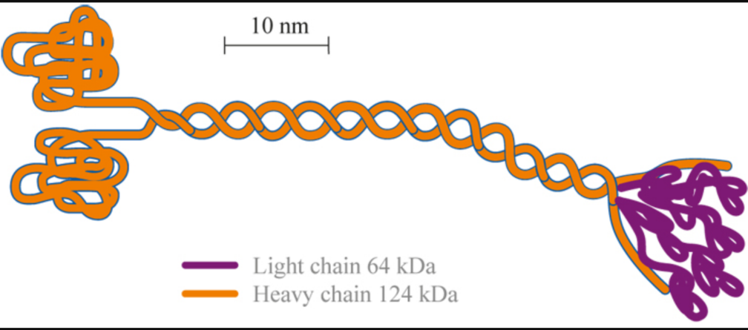
Figure 1: Kinesin molecule. The light chains (right) bind cargo and the heavy chains (“heads”; left) bind the molecule to the microtubule. The heads are also the site of ATP hydrolysis.

Howard, Hudspeth and Vale (1989) (henceforth, HH&V) reiterated this idea suggesting, on the basis of their findings using their newly developed technique for studying individual kinesin molecules, that it walks “hand-over-hand” along a microtubule. As their single-molecule motility assay became a central tool for investigating kinesin motility, it is worth explaining in some detail.
In order to develop an assay to investigate the motion produced by a single kinesin molecule, HH&V had first to establish that a single kinesin is capable of moving a microtubule in the first place. Their experimental design inverts how kinesin movement along microtubules may be normally understood—thinking of the microtubule as fixed and the kinesin as moving along it. Inverting this picture, these researchers immobilized kinesin molecules “heads-up” on glass cover slips in solutions containing progressively less kinesin to see how low they could go and still observe movement when microtubules were added. Their hypothesis was that if a single kinesin molecule could produce movement, they should observe microtubule movement at very low kinesin concentrations. Initially finding that only when kinesin density exceeded a rather high threshold did microtubules move, these researchers distinguished two hypotheses—first, that kinesin-induced microtubule movement is a highly collaborative affair requiring a number of kinesin molecules working in concert and, second, that kinesin denatures when adsorbed onto the coverslips and only when a sufficient number of molecules are present do a few adsorbed kinesins remain in a conformation that can support movement. Clearly, the first hypothesis, if true, would be damning for the prospects of developing an assay meant to study movement produced by a single molecule.
Optimistically assuming the latter hypothesis, HH&V pre-treated the coverslips to prevent the hypothesized denaturation. Their optimism paid off. They found that they could produce microtubule movement with one-third of the kinesin concentration required with non-treated coverslips. The clincher, however, was the character of the microtubule movement that they observed:

Each moving microtubule rotated erratically about a roughly vertical axis through a fixed point on the surface . . . presumably as a result of thermal forces, or of torques produced when a kinesin molecule bound to different protofilaments. When its trailing end reached this nodal point, the microtubule dissociated from the surface and diffused back into solution.

The nodal point, these researchers concluded, was a single kinesin molecule. Thus, they found that a single kinesin, immobilized on a glass cover-slip, can move a microtubule and, at the same time, developed a technique for studying this movement that would prove central to the investigation of the phenomenon of kinesin motility. More specifically, they found that a single kinesin can move a microtubule several micrometers. They reasoned that kinesin can remain attached to a microtubule by one of its heads, pushing the microtubule along as the other head moved forward, through 200 – 1000 iterations of its hydrolytic cycle. Linking this finding to the fact that the molecule has two globular heads, these researchers suggested that the molecule works “hand-over-hand” with one head always remaining attached to the microtubule. However, they also suggest an alternative possibility. Here is the full quote:

It is possible that kinesin’s two globular heads work hand-over-hand, so that one head is always bound and prevents the microtubule from diffusing away. Alternatively, the two heads may work independently . . . If this is so, the time in the reaction cycle during which the kinesin heads are detached from the microtubule must be so brief, probably less than 1 ms, that the microtubule is unlikely to diffuse out of reach of the kinesin molecule (my emphasis).

It's important to attend closely to what “hand-over-hand” meant from the point of view of this 1989 experiment. The contrast HH&V draw between their alternatives makes clear that, as opposed to a model on which the heads work independently and, thus, on which the whole molecule (both heads) detaches from the microtubule, the “hand-over-hand” model has it that the kinesin heads coordinate their activity such that the molecule remains attached to the MT by at least one head during its walk. In other words, HoH walking consists in 1) the molecule remaining attached to the MT (processivity) by at least one head by means of 2) coordinated head activity. These became the empirical criteria that were taken by subsequent researchers to individuate HoH models as such and which informed the interpretation of experimental results for the next decade.
Over the course of the following decade, two versions of the single-molecule assay developed. 1) “MT-gliding assays” in which kinesin molecules are immobilized to glass cover slips and microtubule movement is observed and 2) “bead assays” in which microtubules are immobilized and kinesin-bound beads are observed to move as the kinesin attaches to and walks along the immobilized microtubule. Both “geometries” of the single-molecule assay lent support to both aspects of HH&V’s HoH hypothesis.
Not all studies were immediately univocal in this respect, however. In a version of the bead assay, Block, Goldstein and Schnapp (1990) immobilized microtubules, rather than kinesin, on glass cover-slips. Coating silica beads with carrier protein and exposing them to low concentrations of kinesin, these researchers were able to observe the beads as single kinesin molecules moved them along the immobilized microtubule tracks. Using optical tweezers— which split laser beams to trap kinesins—to individually manipulate the moving beads, they found that under the forces exerted by the optical trap, the bead would detach from the microtubule after, on average, 1.4 μm and be pulled back toward the center of the trap. This, they argued, provides support for the claim that, “the kinesin molecule might detach briefly from the substrate during each mechanochemical cycle” (not processive) and referred to their alternative model of kinesin motility as a “stroke-release” model.
However, a number of influential single-molecule studies over the next 10 years strongly supported HoH over the non-processive stroke-release model. In a clever variation on the MT-gliding assay, Ray et al. (1993) constructed microtubules consisting of 12, 13 or 14 protofilaments (12-mers, 13-mers, 14-mers). Protofilaments of 13-mers run parallel to the MT axis while 12 and 14-mers exhibit right- and left-handed helical organizations (“twists”) respectively. Observing the movement of these microtubules induced by single immobilized kinesin molecules, the researchers found that the 12 and 14-mers rotated with the pitch and handedness predicted by the hypothesis that the kinesin molecule follows the protofilament axis. That kinesin movement is constrained in this way—that it “tracks the protofilament”—suggested that at least one head remains attached to the MT during its walk, therefore lending support to that aspect of the HoH model of kinesin movement.
In a version of the bead assay, Berliner et al. (1995) attached single-headed kinesin derivatives to streptavidin-coated polystyrene beads and found that, unlike intact kinesin or two-headed constructs, the single-headed molecule moved beads perpendicular with respect to the microtubule axis and failed to drive continuous unidirectional movement. This perpendicular movement suggested that the single-headed molecules lack the means to maintain their association with a particular protofilament track, namely, another head with which to coordinate its activity. The absence of perpendicular movement suggested that the opposite is true for two-headed kinesin, lending support to the idea that the activity of the two heads is coordinated to ensure that one head remains MT-bound at all times. This, in turn assures that the molecule tracks the protofilament axis as it was found to do in the study described in the paragraph above.
Further support for the HoH model came with the introduction of fluorescent labelling in the single-molecule assay. In a version of the MT-gliding assay, Vale et al. (1996) directly observed the movement of individual fluorescently labeled kinesin molecules finding that the labeled two-headed kinesin travels an average distance of 600nm per encounter with a microtubule whereas single-headed constructs shows no detectable movement. This corroborated Berliner et al. (1995)’s finding discussed above, suggesting that the two heads working together is required for movement.
Hancock and Howard (1998) immobilized single-headed kinesin onto glass cover slips and found that a minimum of four to six single headed molecules are necessary to produce movement. They further showed that, even at high ATP concentration, the single-headed molecules detached from microtubules 100-fold more slowly than their two-headed counterparts “directly support[ing] a coordinated, hand-over-hand model in which the rapid detachment of one head . . . is contingent on the binding of the second head.” Thus, their study demonstrated a degree of “chemical coordination” between the two heads lending biochemical substance to the idea that kinesin motility involves coordinated head activity.
While single-molecule studies such as these generated a limited consensus that kinesin walks HoH, a number of motility models that met the HoH criteria and were consistent with extent single-molecule data were conceptually distinguished in the literature during this time. However, without empirical criteria by which to distinguish them experimentally, it was left to single-molecule researchers to adjudicate between these models by way of indirect argumentation that appealed to data from sources external to the single-molecule program.
To illustrate, (Figure 3) on page 13 distinguishes five stepping patterns understood to be variably consistent with the data to that time. Findings regarding the structure and dimensions of the molecule, the lattice structure of microtubules and the sites on tubulin heterodimers to which kinesin was understood to bind provided fodder for indirect arguments in favor of or against such conceptually distinguished models. (see Cross, 1995; Howard, 1996; Block, 1998 for reviews). As we see in (Figure 2), microtubules consist in protofilaments arranged in cylindrical fashion. Each protofilament consists of alternating tubulin (α- and β-tubulin) heterodimers.

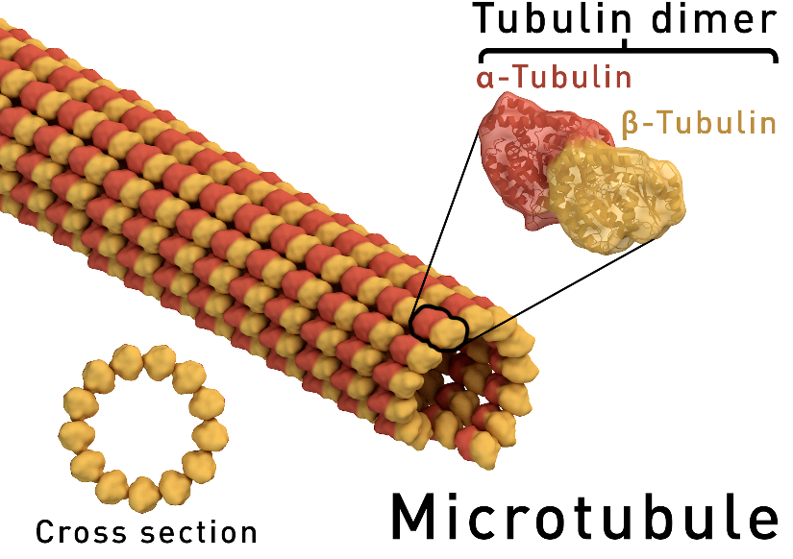

Figure 2: Microtubule structure.

Several biochemical studies suggested that a tubulin heterodimer can bind only one kinesin head (Song and Mandelow, 1993; Walker, 1995; Tucker and Goldstein 1997). This fact, coming from outside the single-molecule program, was appealed to in adjudicating between conceptually distinct models. For instance, as we see in (Figure 3), an “inchworm model” had been distinguished prior to 2002. On this model, one head always remains in the lead with the other head trailing behind. This model, however, requires each tubulin dimer to have two binding sites (or a single, shared binding site) so that the two heads could be brought into proximity with one another. This, argued Block and Svaboda (1995), was difficult to square with binding patterns gleaned from the aforementioned biochemical studies. They note further that such a model involves an implausibly more complicated step consisting of a “two-part cycle comprising the successive action of both heads.” That is, rather than each 8nm step consisting of a single head relocating to the next tubulin binding site, it would involve, first, the lead head moving and, second, the trailing head moving up from behind to keep pace.
These same researchers also argued that “long stride” seemed implausible on the grounds that it required the relatively small kinesin molecule to extend a full 16nm to move the centroid of the molecule 8nm as had been observed in their motility assays. Since this would require that the stalk connecting kinesin’s heads be capable of this kind of extension, Long Stride was deemed speculatively possible at best. Cross (1995) seems to have the same worry in mind in criticizing motility models that require kinesin to stretch its heads across a protofilament, straddling it on either side, and walking along the protofilaments adjacent to it. This would be like “two-step I” only with the squares moved over one protofilament to the right. Cross says of such a model that it is “barely credible.”
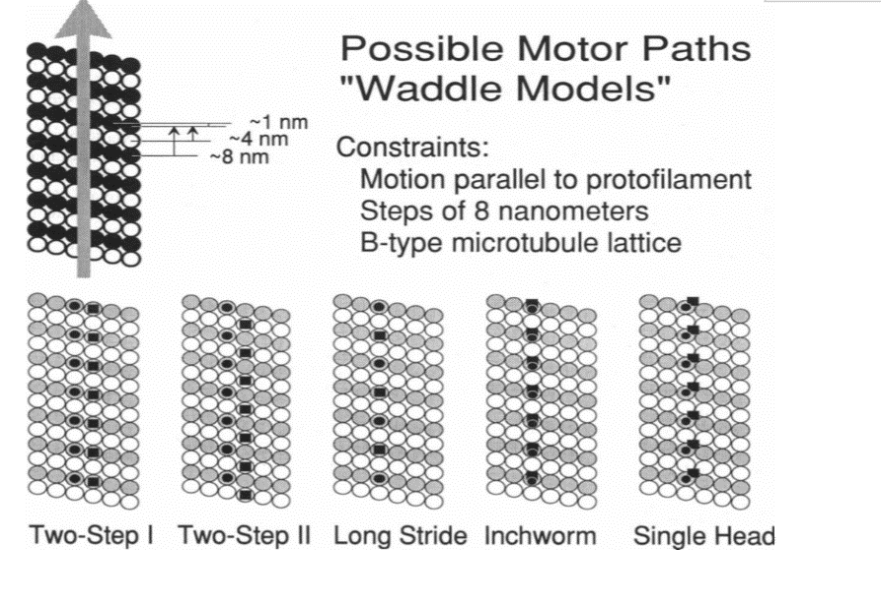
Figure 3: Conceptually distinguished motility models the plausibility of which was left to be adjudicated by indirect arguments based on data coming from outside the single-molecule program.

This kind of indirect argumentation was characteristic of attempts to adjudicate between the motility models that had been conceptually distinguished in the first ten years of single-molecule research. While most researchers agreed that HoH was the correct characterization of kinesin motility (rather than “stroke-release”), a number of HoH models could be distinguished that were consistent with single-molecule data. Thus, a space of merely conceptually distinct models existed to which researchers using the single-molecule motility assay had no experimental access. They were therefore left with indirect argumentation based on findings from experimental sources external to the single-molecule research program.
Notably absent from most of this indirect argumentation were considerations of torque. This, despite the fact that HH&V had mentioned it in the very paper in which they coined the phrase “hand-over-hand.” There was an exception, however. In an impressively comprehensive review, Howard (1996) did bring the idea that HoH walking produces torque into the discussion along with a number of other considerations the experimental significance of which would be exploited in a 2002 study that represented a significant challenge to the hand-over-hand consensus.
Howard (1996)’s indirect argument represents a compelling theoretical analysis. He assumes, on the basis of analogy with other known molecular motors, that kinesin has a “two-fold axis of rotational symmetry” and infers that, therefore, the heads are functionally equivalent – “they have the same hydrolysis cycles and make the same motions.” He calls this the “equivalence hypothesis.” Tracing out the consequences of this hypothesis in conjunction with extant experimental data, Howard argued that the most plausible model for kinesin motility was a “rotary model” on which the molecule’s heads pass each other on the same side each step (Figure 3) rather than on alternating sides like the way in which our human legs move past each other as we walk.
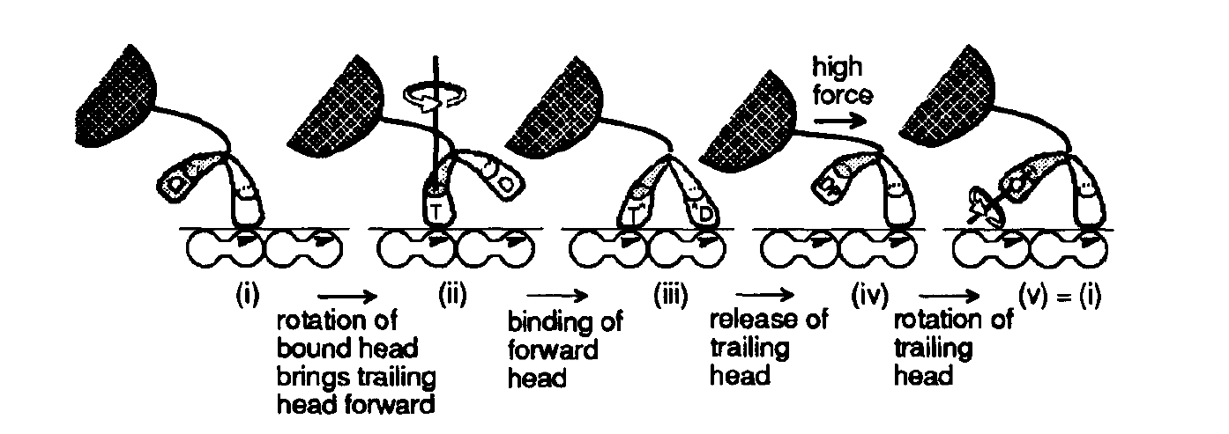
Figure 3: Each head has the same hydrolysis cycle and the same stepping movement, the stepping head always passing the MT-bound head on the same side. Notice that state (i) is identical to state (v).

His argument involves three key ideas the experimental significance of which was only realized later. First, taking his equivalence hypothesis in conjunction with the protofilament tracking data discussed above, Howard argues against models like the ones labeled Two-Step in figure 1. According to such models, the molecule switches back and forth, alternately binding adjacent protofilaments with each head. Assuming the equivalence hypothesis, a consequence of which is that the beginning of each step finds the molecule in the same 3D conformation, Howard argues that if one head, attached to a protofilament (a) were to undergo a conformational change and motion so as to bring the other head to an adjacent protofilament (b), then the equivalent conformational change in head 2 - required by the equivalence hypothesis - would bring head 1 to the next protofilament (c). This would induce a rotation in the 13-mer microtubules that was not observed in the single-molecule study discussed above. Inter alia, this reasoning leads Howard to his rotary model. As for the second key idea, Howard notes a “seemingly unthinkable” consequence of this model. Because of the assumed equivalence between the heads, the molecule will always rotate in the same direction and “Thus the tail (and organelle) will tend to wind up like the rubber band of a toy airplane.” Howard suggests that this torsion could be accommodated by the torsional flexibility the neck was found to exhibit in an earlier study (Hunt and Howard 1993). That the neck has this torsional flexibility is the third key idea.
The experimental significance of these three ideas—1) the equivalence hypothesis, 2) that kinesin motility may produce torque which is communicated to the cargo and 3) that the kinesin neck is torsionally flexible—later came to be appreciated and exploited in a study that introduced a new empirical criterion for individuating motility models. Recall, from the late 1980s to the late 1990s, the criteria that individuated HoH models as such were that 1) the molecule is genuinely processive and that it is so by means of 2) coordinated head activity. From the point of view of this taxonomy, a number of HoH motility models could be conceptually distinguished that were more or less consistent with available experimental data but adjudicating between them was left a matter of indirect argumentation using data from sources external to the single-molecule program. As we’ll see, Hua et al.’s 2002 study re-drew the taxonomic lines and, as a result, lent further probative value to the single-molecule motility assay.

Section III: Hand-over-Hand vs. Inchworm
Hua, Chung, and Gelles (2002) inaugurated an important shift in the empirical criteria by which motility models were individuated. As mentioned above, their study exploited ideas that had been floated in the literature in the context of indirect, theoretical argumentation. First, the design of the experiment was a modified version of (Hunt and Howard 1993)’s assay used to measure the torsional flexibility of the kinesin neck. However, rather than using native kinesin which, in that study, had been found to have a flexible neck, Hua and colleagues used a stiff-necked, two-headed biotinated kinesin derivative (K448-BIO). This ensured that the connection between the microtubule, this molecule, and the glass cover slip on which the molecule was immobilized would be torsionally stiff, thus guaranteeing that if torque was indeed generated by the walking molecule, as Howard’s model predicted, it would not be taken up by a flexible neck. Rather, it would be communicated to the cargo and generate a clearly observable 180-degree rotation of the microtubule with each step of the molecule. Their design, therefore, took the “seemingly unthinkable” consequence Howard had traced out eight years earlier and cleverly turned it into an intervention.
Further, they pointed out that whether the heads of the molecule pass each other on the same side, as in Howard’s rotary model, or pass each other on alternating sides, the orientation of the molecule relative to the microtubule axis would switch as the heads alternate between being the leader and being the follower. This, in turn, would generate torque, and induce an observable microtubule rotation. In other words, the differences between the intermediate states of rotary models and left-right alternate stepping models were immaterial. What mattered for torque generation was that the molecule begins each step in the same 3D conformation only with the heads swapping between leading and following. Hua et al., dubbed these torque generating models symmetric hand-over-hand (Figure 3A). By the lights of the criterion of torque generation, both Howard’s rotary model and alternate left-right stepping models count as symmetric HoH models.

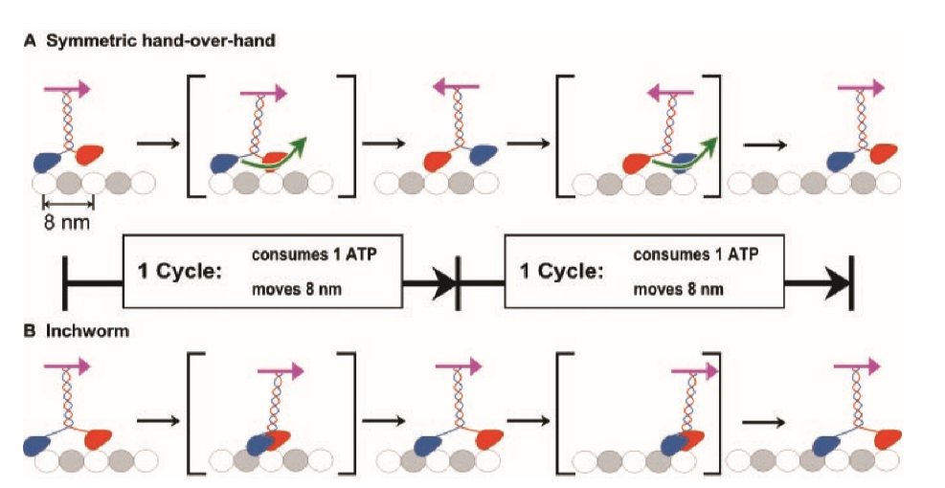
Figure 3: The brackets around the intermediate stages of the steps in A indicate their irrelevance. Whether the stepping head passes on the same side, as it does in the diagram, or passes on alternating sides of the bound head, the molecule will change its orientation as indicated by the arrows on top of the molecule.

To appreciate the shift in criteria for individuating motility models these researchers introduced, consider the sense in which Howard’s rotary model would be considered a species of HoH model prior to this study. It would count as an HoH model because it sees the molecule as remaining attached to the microtubule by at least one head (processivity) and that it does so by means of coordinated head activity. The same goes for alternate left-right stepping models. From the point of view of the new criterion—torque generation—both count as HoH models but for very different reasons. First off, they would no longer count as HoH models full stop. Rather they would be considered instances of symmetric HoH to be distinguished from an asymmetric HoH model—a distinction I will discuss in more detail shortly. Further, rather than processivity or coordinated head activity serving to distinguish them as HoH models (as opposed to stroke-release), they count as (symmetric) HoH models because they generate torque. This, again, for the reason that both models view the molecule as beginning each step in the same 3D conformation, rotating its orientation relative to the microtubule axis during its step and, thus, generating torque.
It was with respect to torque generation that the distinction between symmetric HoH and asymmetric HoH was drawn. Asymmetric HoH models deny that the molecule generates torque by denying the equivalence of the heads’ steps. On this model, kinesin alternates between two distinct conformations—a different one at the beginning of each step—“in precisely such a way as to cancel the 180-degree reorientation induced by head alternation.”
Finally, and most importantly, after this re-drawing of the taxonomic lines, “inchworm” was no longer to be considered a sub-species of HoH as it was by the lights of the pre-2002 empirical criteria—processivity and coordinated head activity. Now, with torque generation serving to individuate models, inchworm was distinguished from HoH along empirically tractable lines.
Armed with this more probative empirical criterion by which to individuate motility models, Hua et al. (2002) developed and ran their single-molecule assay, failing to observe the microtubule rotations predicted by symmetric HoH models. They therefore rejected that characterization of the phenomenon of kinesin motility. This left two non-torque generating possibilities: 1) that the molecule walks in an asymmetric HoH fashion or 2) that it walks inchworm-style. In a way reminiscent of the indirect arguments discussed above, Hua and colleagues argued against the plausibility of asymmetric HoH. In brief, they found it implausible that the differences between 3D conformations at the start of each step could be such that they could exactly compensate for the rotation and, in turn, the torque produced by an asymmetric walk. Rejecting asymmetric HoH on these grounds, these researchers argued that the correct characterization of the phenomenon of kinesin motility is that it walks in an “inchworm” fashion.
So, what led these researchers to reject HoH as an appropriate characterization of the phenomenon and adopt inchworm? Note that although their rejection is experimentally motivated, they did not experiment for the purpose of gathering evidence to undermine that which had already been found in support of the HoH model. That is, they did not gather evidence to undermine the single-molecule studies that had supported the claim that the molecule is processive and that its heads coordinate their activity. Thus, they did not employ a “defeater-strategy” as in the case of “memory transfer” discussed by Colaco (2019). Rather, as described above, they recognized the experimental significance latent in certain ideas that had already been floated in the literature. They then constructed a new taxonomy using torque generation as the criterion for individuating motility models which, in turn, enabled them to design a more probative version of the single-molecule motility assay. It further enabled them to recognize an important distinction—that between symmetric and asymmetric HoH models. Their single-molecule study, they recognized, only bore directly on symmetric HoH models. Their study refuted symmetric HoH leaving the refutation of the asymmetric model to be done by indirect argumentation. Thus, between their empirical results and indirect argumentation, they rejected symmetric and asymmetric HoH models respectively, and defended inchworm as the most plausible model for the phenomenon of kinesin motility.

Section IV: Further Experimental Implications of the New Taxonomy
In section I, we noted the role that indirect argumentation played in adjudicating between conceptually distinct models. While such arguments, in addition to the single-molecule data, led to a limited consensus, they were not decisive in adjudicating between available HoH motility models. However, these more theoretical arguments led to ideas that had latent experimental significance. It was just a matter of unlocking it. The empirical criteria in terms of which models of kinesin motility were initially individuated— processivity and coordinated head activity—left open an experimental dead-space seemingly inaccessible to the single-molecule assay. The key granting the single-molecule assay experimental access to the dead-space was torque generation. Turning this key generated a new taxonomy, one enabling the development of a more probative variation of the single-molecule motility assay.
The studies that emerged in the following two years took advantage of this more experimentally tractable taxonomy, re-securing a consensus that kinesin walks HoH—now reconstituted as asymmetric HoH. Kaseda et al. (2003) tested the inchworm model’s prediction that only one head is hydrolytically active. These researchers used optical tweezers in a bead assay to measure the stepping rate of kinesins mutated such that one head hydrolyzes ATP more slowly than the other. If both heads are hydrolytically active, they reasoned, their mutant molecule should show a “limp” in its stepping pattern as it walks. This is in fact what they observed undermining the inchworm models prediction of single-head catalysis. That same year, Asbury et al. (2003), using optical tweezers in a bead assay, found that kinesin constructs with two identical wild-type heads also show a “limp” in their stepping suggesting that the molecule alternates between two conformations from step to step thus supporting asymmetric HoH walking. Yildez et al. (2004) directly observed the movement of kinesin heads tagged with a fluorescent dye and found that each head moves 16nm per step and also that the tagged heads pause after each movement presumably while the other untagged head moved. These findings are inconsistent with the inchworm model which takes each head to move 8nm per ATPase cycle and supports an asymmetric HoH model. Higuchi et al. (2004) observed a difference in the timing of every other step in kinesins with identical mutations in the nucleotide-binding sites in each head. The limping they observed is similar to that observed by Asbury and colleagues above, but more pronounced due to the mutation.
Each of these studies exploited the reimagined taxonomy of motility models inaugurated by Hua et al. (2002). Interestingly, it was no advancement in tool-development that enabled researchers to observe kinesin’s “limping” step. The instrumentation necessary to do so—the single-molecule bead assay and optical tweezers—had been in place for over a full decade prior to its being observed. It was rather a conceptual innovation ushered in by the new taxonomy that enabled researchers to look for kinesin’s limping step and appreciate its significance. In fact, even if the limping step had been observed prior to this reconstitution of the phenomenon, it is not obvious that researchers would have recognized its significance, at least not in the way that it was recognized afterwards. It was in observing kinesin’s limp against the backdrop of a taxonomy of motility models which included the category of asymmetric HoH that its significance for experimental work in characterizing the phenomenon of kinesin motility became apparent. Therefore, although recent philosophical efforts to emphasize innovative tool-development in driving scientific research are to be applauded, the case of the “inch-worm episode” reminds us conceptual innovation remains an important factor.

Section V: The “Reconstitution” of Hand-over-Hand Walking
As I mentioned in my introduction, and as the history I have laid out reveals, the story of the re-establishment of the HoH consensus is not one according to which HoH advocates were shown to have been right all along. Rather, the phenomenon of HoH walking was importantly reconstituted across the inchworm episode from HoH to asymmetric HoH. The inchworm episode and the reconstitution it inaugurated took place entirely within the context of an experimental program dedicated to characterizing, rather than explaining, the phenomenon of kinesin motility. This is of particular philosophical interest as standard philosophical models of phenomenon reconstitution have it that explanatory considerations drive phenomenon reconstitution.
Bechtel and Richardson (1993/2010)’s model of phenomenon reconstitution, for instance, was motivated by their case study of the “Mendelian trait.” Classically, the Mendelian trait was understood as a macroscopically observable phenotypic trait. Faced with the fact that patterns of phenotypic inheritance could not be explained in terms of single genes – “phenotypic traits were the products of many genes in a complex organization”—researchers in the middle of the 20th century abandoned the phenotypic trait as the central Mendelian unit in favor of a unit at a lower level of mechanistic analysis, the enzyme. Thus, the explanandum phenomenon to be accounted for in terms of single genes was reconstituted, shifting it down from the phenotypic trait to the enzyme, in the effort to develop mechanistic accounts of gene action.
Craver (2007) discusses a further way in which phenomena can be reconstituted in the context of seeking mechanistic explanations. According to Craver, phenomena can be reconstituted in the wake of researchers recognizing that they have committed one of two errors – the “lumping error” or the “splitting error.” Both errors require inquiry into the phenomenon to have developed to a point at which researchers have both a characterization of the phenomenon and putative mechanistic explanations on the table. Scientists observe they have committed the splitting error when they recognize that they have erroneously thought that some phenomena of interest are due to two or more distinct types of mechanisms when, in fact, they are due to mechanisms of the same type. They may then reconstitute the phenomena such that where once they thought of them as two distinct phenomena underpinned by two distinct types of mechanisms, they now understand them as one phenomenon underwritten by a single mechanism-type. The lumping error, on the other hand, occurs when a particular phenomenon is thought to be generated by a single mechanism while, in fact, two distinct mechanisms underwrite the phenomenon. In light of recognizing this error, scientists may reconstitute the phenomenon, considering it now as two distinct phenomena.
(Kronfeldner 2015)’s model differs from both of the above. She describes how phenomenon reconstitution can result not only as a result of researchers gaining insight at the level of mechanism, but also by researchers “moving up to a level of greater abstraction.” To illustrate, a researcher interested in explaining a particular phenotypic trait of a particular person - their height, say - will be unable to do so as it is widely recognized that such traits are the result of complex interactions between an individual’s genetic inheritance and their ontogenetic environment. This does not mean, however, that genes do not explain. By moving up to an explanandum phenomenon at a greater level of abstraction, e.g. average differences between the heights of males and females in a population, researchers can appeal explanatorily to differences in genotype, ignoring the complexity introduced by gene-environment interactions. In this way, researchers can hold fast to a particular “causal factor” in terms of which they wish to pitch their explanations and constitute the phenomena to be explained accordingly.
All three models have it that phenomenon reconstitution is driven by explanatory considerations. The research on kinesin motility discussed throughout this paper, however, involves experimental work dedicated solely to characterizing the phenomenon of kinesin movement. Developing mechanistic explanations of kinesin movement (not discussed) involves researchers determining how the energy released from ATP-hydrolysis occurring in the molecule’s nucleotide binding sites results in structural changes throughout the molecule. Mechanistic explanation asks after the role played (if any) by thermal forces in bringing the heads forward in their stepping pattern. It attempts to determine whether elastic tension on the neck linker generated as the molecule stretches during its walk provides energy—in addition to that provided by ATP-hydrolysis—that may or may not be necessary for walking. These (and further issues) are, of course, important for developing mechanistic explanations for kinesin motility—for answering the question of how kinesin manages to walk in the way it does. But considerations at this explanatory level did not, as we saw, figure into the reconstitution story. Again, it took place entirely within the context of experimental efforts to characterize the phenomenon—to characterize the way kinesin walks, not the means by which it manages to walk that way.
In closing, Colaco (2020) notes “there is a lacuna in the literature regarding how researchers determine whether their characterization of a target phenomenon is appropriate for their aims.” This paper helps to illuminate that lacuna. In order to experimentally adjudicate between alternative characterizations of kinesin motility, single-molecule researchers sought empirical criteria by which to individuate them—criteria that distinguished them along lines that were testable from the point of view of the single-molecule motility assay. It was determined that individuating models of kinesin by appeal to torque generation rather than merely processivity and coordinated head activity, enabled access to what was antecedently an experimental dead-space consisting of merely conceptually distinct motility models. The new taxonomy rendered that space experimentally accessible to the single-molecule assay. Thus, the “inchworm” episode illustrates how researchers can recharacterize phenomena to the end of enhancing the probative value of their experimental tools.

Craver, C. F. (2007). Explaining the brain: Mechanisms and the mosaic unity of neuroscience. Oxford University Press. Bechtel, W., & Richardson, R. C. (2010). Discovering complexity: Decomposition and localization as strategies in scientific research. MIT press. philosophical perspectives on cognitive neuroscience. Kronfeldner, M. (2015). Reconstituting phenomena. In Recent Developments in the Philosophy of Science: EPSA13 Helsinki (pp. 169-181). Springer, Cham.
Bogen, J., & Woodward, J. (1988). Saving the phenomena. The Philosophical Review, 97(3), 303-352.. Feest, U. (2011). What exactly is stabilized when phenomena are stabilized?. Synthese, 182(1), 57-71. Colaço, D. (2018). Rip it up and start again: The rejection of a characterization of a phenomenon. Studies in History and Philosophy of Science Part A, 72, 32-40.
This idea guided researchers using other methods as well, in particular, those using traditional biochemical techniques to study the hydrolytic cycle of the kinesin molecule. The interactions between the biochemical and single-molecule programs was important in the effort to map the stages of kinesin’s mechanical steps to stages in its hydrolytic cycle. Here, I focus on the single-molecule program’s attempts to characterize the molecule’s mechanical steps.
Vale, R. D., Reese, T. S., & Sheetz, M. P. (1985). Identification of a novel force-generating protein, kinesin, involved in microtubule-based motility. Cell, 42(1), 39-50.
Bloom, G. S., Wagner, M. C., Pfister, K. K., & Brady, S. T. (1988). Native structure and physical properties of bovine brain kinesin and identification of the ATP-binding subunit polypeptide. Biochemistry, 27(9), 3409-3416.
Scholey, J. M., Heuser, J., Yang, J. T., & Goldstein, L. S. (1989). Identification of globular mechanochemical heads of kinesin. Nature, 338(6213), 355.
Howard, J., Hudspeth, A. J., & Vale, R. D. (1989). Movement of microtubules by single kinesin molecules. Nature, 342(6246), 154. Notice the mention of “torque.” The idea that HoH walking may produce torque was on the table very early on. As we will see, however, this factor was thoroughly backgrounded in subsequent discussions of experimental results taken to bear on the HoH model of kinesin motility.
Interestingly, they compare the probative force of their assay with that of patch-clamp recording designed to study the activity of single ion channels in neurons: “like patch-clamp recording from ion channels, the study of movement produced by single motor molecules provides an assay sensitive enough to monitor the activity of an individual protein molecule.” Ibid., 158.
Ibid., 158
The invention of optical tweezers was significant for research on kinesin motility in ways beyond those discussed here. For instance, since kinesin motility is a phenomenon occurring at the nano-scale, thermal forces are relevant. It is therefore difficult to discern what observed motion is Brownian motion and what is due to the action of the molecule. Having kinesin move cargo against the forces exerted on it by the “trap” ensures that whatever motion is observed is due to the molecule’s action. This technique enabled Svoboda, Schmidt, Schnapp et al. (1993) to observe abrupt transitions of 8 nm steps, a distance that corresponds to the repeat distance between successive α-β tubulin dimers. They propose “that the two heads of a kinesin molecule walk along a single protofilament—or walk side-by-side on two adjacent protofilaments—stepping ~8 nm at a time, making one step per hydrolysis (or perhaps fewer, requiring multiple hydrolyses per step)” Svoboda, K., Schmidt, C. F., Schnapp, B. J., & Block, S. M. (1993). Direct observation of kinesin stepping by optical trapping interferometry. Nature, 365(6448), 721.
Block, S. M., Goldstein, L. S., & Schnapp, B. J. (1990). Bead movement by single kinesin molecules studied with optical tweezers. Nature, 348(6299), 348. These researchers also suggested a model on which the molecule is always bound by at least one head but “weakly” – just strong enough to remain attached in the face of thermal forces, but not strongly enough to remain attached when subjected to the forces of the optical trap.
Ray, S., Meyhöfer, E., Milligan, R. A., & Howard, J. (1993). Kinesin follows the microtubule's protofilament axis. The Journal of cell biology, 121(5), 1083-1093.
Berliner, Elise, Edgar C. Young, Karin Anderson, Hansraj K. Mahtani, and Jeff Gelles. "Failure of a single-headed kinesin to track parallel to microtubule protofilaments." Nature 373, no. 6516 (1995): 718-721.
Vale, Ronald D., Takashi Funatsu, Daniel W. Pierce, Laura Romberg, Yoshie Harada, and Toshio Yanagida. "Direct observation of single kinesin molecules moving along microtubules." Nature 380, no. 6573 (1996): 451-453.
Hancock, W. O., & Howard, J. (1998). Processivity of the motor protein kinesin requires two heads. The Journal of cell biology, 140(6), 1395.
Cross, R. A. (1995). On the hand over hand footsteps of kinesin heads. Journal of muscle research and cell motility, 16(2), 91-94. Howard, J. (1996). The movement of kinesin along microtubules. Annual review of physiology, 58(1), 703-729. Block, S. M. (1998). Kinesin: what gives?. Cell, 93(1), 5-8. For micrographic data relevant to these indirect arguments see: Kikkawa, M., Ishikawa, T., Nakata, T., Wakabayashi, T., & Hirokawa, N. (1994). Direct visualization of the microtubule lattice seam both in vitro and in vivo. The Journal of cell biology, 127(6), 1965-1971. Song, Y. H., & Mandelkow, E. (1995). The anatomy of flagellar microtubules: polarity, seam, junctions, and lattice. The Journal of cell biology, 128(1), 81-94. Harrison, B. C., Marchese-Ragona, S. P., Gilbert, S. P., Cheng, N., Steven, A. C., & Johnson, K. A. (1993). Decoration of the microtubule surface by one kinesin head per tubulin heterodimer. Nature, 362(6415), 73.
Though not a “hand-over-hand” model in what is perhaps the intuitive sense of the phrase, by the lights of the empirical criteria that distinguished HoH models as such (distinguished them from e.g. stroke-release models) “inchworm” models were a species of HoH. As we will see, it was not until the introduction of a new empirical criterion that inchworm models were adequately distinguished from HoH models along empirically tractable lines.
Block, S. M., & Svoboda, K. (1995). Analysis of high resolution recordings of motor movement. Biophysical journal, 68(4 Suppl), 237s.
Cross, R. A. (1995). On the hand over hand footsteps of kinesin heads. Journal of muscle research and cell motility, 16(2), 92.
Howard, J. (1996). The movement of kinesin along microtubules. Annual review of physiology, 58(1), pp. 724.
For an intuitive sense of what having a “2-fold axis of rotational symmetry” means, imagine two chairs facing each other on either side of a line and equidistant from that line. Rotating one chair 180 degrees with respect to that line will bring that chair into the precise position of its mate. Howard assumed that the relation between kinesin’s two heads was the same.
Howard, J. (1996). The movement of kinesin along microtubules. Annual review of physiology, 58(1), pp. 724.
Hunt, A. J., & Howard, J. (1993). Kinesin swivels to permit microtubule movement in any direction. Proceedings of the National Academy of Sciences, 90(24), 11653-11657.
Hua, W., Chung, J., & Gelles, J. (2002). Distinguishing inchworm and hand-over-hand processive kinesin movement by neck rotation measurements. Science, 295(5556), 844-848.
Hua et al. 847.
Kaseda, K., Higuchi, H., & Hirose, K. (2003). Alternate fast and slow stepping of a heterodimeric kinesin molecule. Nature Cell Biology, 5(12), 1079.
Asbury, C. L., Fehr, A. N., & Block, S. M. (2003). Kinesin moves by an asymmetric hand-over-hand mechanism. Science, 302(5653), 2130-2134.
Yildiz, A., Tomishige, M., Vale, R. D., & Selvin, P. R. (2004). Kinesin walks hand-over-hand. Science, 303(5658), 676-678.
Higuchi, H., Bronner, C. E., Park, H. W., & Endow, S. A. (2004). Rapid double 8‐nm steps by a kinesin mutant. The EMBO journal, 23(15), 2993-2999.
Bickle, J. (2016). Revolutions in neuroscience: Tool development. Frontiers in systems neuroscience, 10, 24.
Bechtel, W., & Richardson, R. C. (2010). Discovering complexity: Decomposition and localization as strategies in scientific research. MIT press.
Craver, C. F. (2007). Explaining the brain: Mechanisms and the mosaic unity of neuroscience. Oxford University Press. pp. 123-124.
Kronfeldner, M. (2015). Reconstituting phenomena. In Recent Developments in the Philosophy of Science: EPSA13 Helsinki (pp. 169-181). Springer, Cham.
Ref to Bechtel and Bollhagen “Molecular Motors: Transforming energy to motion.”
Colaço, D. Recharacterizing scientific phenomena. Euro Jnl Phil Sci 10, 14 (2020). https://doi.org/10.1007/s13194-020-0279-z

