INFORMATION-DEVOID ROUTES FOR SCALE-FREE NEURODYNAMICS

Arturo Tozzi (Corresponding author)
Center for Nonlinear Science, University of North Texas
1155 Union Circle, #311427, Denton, TX 76203-5017 USA
tozziarturo@libero.it
Arturo.Tozzi@unt.edu

James F. Peters
Department of Electrical and Computer Engineering, University of Manitoba
75A Chancellor’s Circle, Winnipeg, MB R3T 5V6, Canada and
Department of Mathematics, Adıyaman University, 02040 Adıyaman, Turkey, Department of Mathematics, Faculty of Arts and Sciences, Adıyaman University
02040 Adıyaman, Turkey and Computational Intelligence Laboratory, University of Manitoba, WPG, MB, R3T 5V6, Canada
james.peters3@umanitoba.ca

Neuroscientists are able to detect physical changes in information entropy in the available neurodata. However, the information paradigm is inadequate to describe fully nervous dynamics and mental activities such as perception. This paper suggests explanations to neural dynamics that provide an alternative to thermodynamic and information accounts. We recall the Banach–Tarski paradox (BTP), which informally states that when pieces of a ball are moved and rotated without changing their shape, a synergy between two balls of the same volume is achieved instead of the original one. We show how and why BTP might display this physical and biological synergy meaningfully, making it possible to model nervous activities. The anatomical and functional structure of the central nervous system’s nodes and edges makes it possible to perform a sequence of moves inside the connectome that doubles the amount of available cortical oscillations. In particular, a BTP-based mechanism permits scale-invariant nervous oscillations to amplify and propagate towards widely separated brain areas. Paraphrasing the BTP’s definition, we could state that: when a few components of a self-similar nervous oscillation are moved and rotated throughout the cortical connectome, two self-similar oscillations are achieved instead of the original one. Furthermore, based on topological structures, we illustrate how, counterintuitively, the amplification of scale-free oscillations does not require information transfer.

KEYWORDS: Banach–Tarski paradox; brain; power law; fractal; oscillations; information.

Broadly successful information theory permits the appraisal of general features of physical/biological systems, suggesting that our world (including ourselves) is made up of a fundamental physical assembly termed information (Shannon 1948; Bekenstein, 2003). Over time, numerous information-related perspectives have been portrayed: e.g., information theory has been correlated with statistical thermodynamics, Renyi entropy, Bekenstein-Hawking entropy, quantum mechanics, and so on (Jaynes 1957; Lloyd 2000; Marzuoli and Rasetti, 2005, Bromiley et al., 2010; Cafaro et al., 2016; Tozzi et al., 2018). After the launch of the slogan “it from bit” (Wheeler 1990), neuroscientists asked themselves whether physical information could be used to describe and quantify brain activity, mental functions and their neural correlates (Tozzi and Peters, 2016). Noteworthy attempts are free-energy Bayesian approaches (Friston 2010) based on energy budgets (Attwell and Laughlin, 2001), and pairwise entropy extracted from fMRI neurodata (Watanabe et al., 2013 and 2014). Neuroscientists are providing an effort to correlate modifications in sensations and perceptions with changes in brain informational content, investigating the neural correlates of mental tasks in terms of information entropy. Nonetheless, it is quite clear that something is amiss with the duet information/nervous activity. Just observing simple pictures and sequences of video frames, it easy to grasp that information entropy is inadequate to assess and classify the activities and the high-dimensional topological structures that we term mental functions. The entropic content of different photographs can be accurately quantified through several available techniques (see, e.g., Allen and Triantaphillidou, 2009). Looking at simple pictures, it can be noticed that a grey picture displays zero entropy, while a coarse-grained picture with black, grey and white tiny dots displays the highest levels of entropy (Figures 1A-B). From the standpoint of the naïve observer, both the pictures are a collection of meaningless spots devoid of content. In turn, photographs depicting, say, a tender infant or a pleasant landscape display values of entropy relatively close to each other, even though the photographs are imbued with fully different meaning and sense (Figures 1C-D). These latter pictures produce vivid perceptions that trigger emotions, reasoning, thoughts, i.e., in short, all sorts of psychological activities. This means that correlation information/sensation does not suffice for, or is irrelevant, when it comes to understanding cognitive functions. Perhaps, making an even stronger claim, perception and psychological functions of the observer are not correlated at all with the physical informational content of sensed objects. Therefore, the efforts of neuroscientists to quantify the changes in brain information entropy during different mental tasks are doomed to failure, because the entropic modifications detected through the available neuro-techniques (such as, e.g., EEG, fMRI, tractography) could not be correlated with mental activities.
Even if it is assumed that brain states do carry information, there is a lack of evidence to justify the claim that cognitive activity involves, or depends on, extracting information. Here we propose a process, devoid of information transfer, that makes it possible to duplicate (we could say: clone) brain activities in different areas of the central nervous system. In particular, we show how and why the Banach–Tarski paradox (BTP) from set-theoretic geometry permits the replication of one of the foremost features of brain oscillations: the occurrence of power laws.

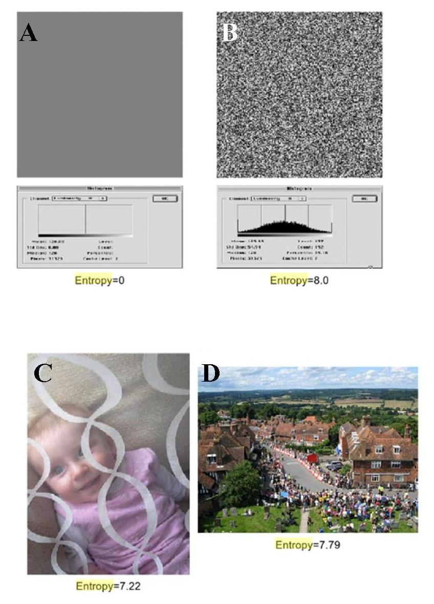

Figure 1. Entropy level in different pictures. Modified from: Allen and Triantaphillidou (2009).

A PHYSICAL MEANING FOR THE BANACH TARSKI PARADOX

The Banach–Tarski paradox (BTP) from set-theoretic geometry suggests that a solid 3‑dimensional ball decomposed into at least five disjoint subsets can be reassembled in a different way to yield two identical copies of the original ball (Banach and Tarski, 1924; Churkin 2010). In plain words, given any two volumes in the Euclidean space R³ such that each volume is bounded and has nonvoid interior, volume can be partitioned (cut into separate pieces) into a sufficient number of sub-volumes and moved by rigid motions (translations and rotations) to construct a copy of This can be proved using the Axiom of Choice (Aliprantis, Border 2006). That is, if is a collection of nonempty sets X of a nonvoid set , there is always a mapping defined by In effect, the Axiom of Choice tells us that we can always find an index i and choose subsets so that the union of the subsets gives us back the original set The Banach-Tarski paradox is a glorious extension of the Axiom of Choice. When pieces of a ball are moved and rotated without changing their shape, we achieve two balls, instead of the original one. Figure 2 illustrates how a few cuts, followed by simple geometric rotations and translations, allow the duplication of a mathematical structure without volumetric modification. The paradox goes against the everyday experience because common sense presupposes changes in volume when objects are split. Any physical analogy would involve division into two objects with the same volume, but half the density of the original. The case of BTP is different: contrary to a physical sphere which is equipped with a finite number of atoms, the pieces described by BTP are infinitely divisible, i.e., they encompass an infinite number of points. Each piece here is so infinitely complex that it is immeasurable, or, in physical words, it does not have a well-defined measurable volume. These pieces are highly pathological in nature, so that their construction requires the use of the axiom of choice.
The BTP is about a ball that, counterintuitively (not necessarily paradoxically), can be decomposed into disjoint pieces whose subsequent composition leads to two balls, both the same size as the original ball. It is a kind of cloning procedure, and the minimum number of pieces required is astonishingly small, namely five. In quest for alternatives to information accounts of the brain activity, the next step is to ask: could BTP be useful in describing nervous dynamics? When coping with the central nervous system, what is the object or the event separable in at least five pieces that can be cloned by dissection and reconstruction? Our effort is constrained by a few dictates: we need to split a ball (or, in our case, some features of nervous activity) into amorphous, non-measurable sets where the volume measure does not count. Does there exist in the brain and the nervous system a feature, a neural assembly, a system, a dynamical process that obeys the conditions and geometric properties dictated by BF?

The answer is affirmative if we consider scale-free dynamics. When Fourier analysis of brain waves is performed, it can be observed that the frequency spectrum of the cerebral activity exhibits a scale-invariant behavior (Mandelbrot 1967; Pritchard 1992):

S(f)= 1/f^{n},

where S(f) is the power spectrum, f the frequency and n the power spectral density. The power spectral density, also termed the “fractal dimension”, equals the negative slope of a log power versus frequency scatter plot (Milstein et al., 2009). It is noteworthy that fluctuations with complex scaling properties are spontaneously generated by the brain even in the absence of exogenous perturbations or changes in controlling parameters (Papo 2014). Such scale-invariant behavior is not restricted to cortical electric activity but has been also detected in spontaneous neurotransmitter release (Fox and Raichle, 2007). Universal scaling stands for a general spatio-temporal property of physiological and pathological brain signals. The emergence of power law distributions has been interpreted in terms of self-organized criticality (Lubeck, 2004), a mechanism of slow energy accumulation and fast energy redistribution that drives the system towards a critical state (De Arcangelis and Herrmannn, 2010). It has been proposed that the same cognitive processes can be framed in terms of complex activities equipped with scaling properties (Sengupta and Stemmler, 2014). Power law distributions contain information on how large-scale physiological and pathological outcomes arise from the interactions of many small-scale processes: this means that the volume where a single process takes place does not count anymore (Tinker and Velazquez, 2014; Kawe et al., 2019).
Therefore, it is suitable to make use of scale-free oscillations (both “spatial” fractals and/or “temporal” power laws) to build a BTP framework of the nervous activity. Indeed, scale-free nervous oscillations display the same features required by the BTP set-theoretic decomposition: these nervous oscillations are non-measurable sets with no well-defined volume and absence of mass conservation. The occurrence of power laws makes it possible to detect the same oscillatory pattern at different levels of observation, independent of the neuronal volume being considered. Fractals and power laws repeat themselves from the micro- to the macro-levels of observation, unchanged when split and reunited. Paraphrasing the BTP’s formulation, we could say that: when at least five components of a scale-invariant nervous oscillation are moved, translated and rotated without changing their shape, we achieve two scale-invariant nervous oscillations instead of the original one. In other words, we suggest that the proper sequence of moves duplicates the scale free oscillations generated (spontaneously or not) by the central nervous system.

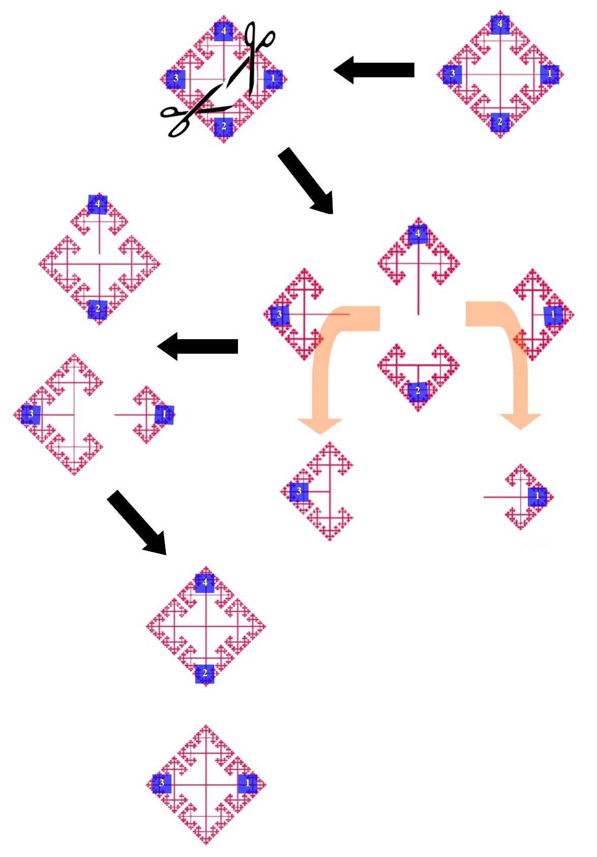

Figure 2. This classical example illustrates the operations required by BTP through decomposition into sets. Starting from a single manifold, once performed a series of cuts and translations, two manifolds are achieved equal to the original one. Note that, if we include the parent (original manifold) as one of the pieces, we get a total of five, that is the minimum number of pieces required to let BTP work.

POWER LAWS MEET THE BANACH TARSKI PARADOX

In the previous paragraph, we described the theoretical background to link two apparently irreconcilable frameworks, i.e., the abstract mathematical apparatus of BTP and the impalpable scale-free dynamics occurring in the nervous system. In this paragraph we seek to operationalize their partnering in the real-world system of the human brain. We show how it is feasible to physically/biologically illustrate the counterintuitive claim that both objects and nervous processes can be duplicated without changes in volume, energy, information. The canonical example of one sphere which becomes two spheres after a series of cuts and rotations/translations has been previously illustrated in Figure 2. Here we describe how, with the choice of just a few cuts, a fractal manifold can be decomposed into three structures with matching description (Figure 3). Technically, BTP makes it possible to achieve k copies of a ball in the Euclidean n-space from one, for any integers n ≥ 3 and k ≥ 1, by using the Lie rotation group SO(n). Here we consider the Sierpinski triangle, a fractal fixed set with the overall shape of an equilateral triangle, subdivided recursively into smaller equilateral triangles (Ali et al., 2019). Figure 3 shows how three Sierpinski triangles can be achieved, starting from just one. Therefore, with the proper choice of cuts and translations, scale-free structures obey the BTP dictates.

The paradox can be also used in another slightly different way, allowing the assessment of physical and biological dynamics (Figure 4). In this case, the main issue is not the split of pieces, rather the growth of BTP stages. We start with multiple spherical composite vertexes in a nexus. In the sequel, multiple sequences of contiguous spacetime spheres are produced (Figures 4A-C). BTP can be also viewed as a piecewise division of one sphere into the interior of another sphere (Figure 4D). The BTP process starts with a single sphere serving as a generator of another sphere. The required pieces are not “solids” in the usual sense, rather infinite scatterings of vertexes standing for physical counterparts of points in an algebraic topology (Alexandroff 1935; Peters 2020). These vertexes represent the minuscule spacetime chunks in shape assemblies that are the basic building blocks of vortex nerve structures in a CW topology (Peters 2018; Peters 2019). Therefore, the multiple spacetime spherical divisions illustrated in Figure 4D lead to incarnation of multiple generators of offspring spheres that are pivots in path-connected vortical structures, which have high affinity to complex-valued activation functions (Ỏzgủr et al., 2020). A path can then be traced from the surface of a parent sphere (call it e1) along the surface of a child sphere (call it e2), stretching in an unbounded fashion to a nexus of contiguous new offspring spheres, forming the collection of BTP generators In effect, the algebraic Betti number for a burgeoning BTP sphere isin a free Abelian group representation of a sequence of BTP sphere divisions (Don et al., 2020).

In group theory, a group is defined by a nonempty set G together with a binary operation denoted by +. In G, there is a zero element 0 and every member g in G has an inverse -g so that g – g = 0. G is Abelian, provided g + g’ = g’ + g for all members g, g’ in G. Recall that a finite group G is cyclic, provided every element g in G can be written as an integer multiple of a generating element h in G so that

In effect, every member of a cyclic group can be written as linear combination of a generating element (called a generator). A finite free Abelian group G has a collection of generators of cyclic subgroups so that every member of G can be written as a linear combination of its generating elements. These observations lead to a concise way of pigeonholing free Abelian groups so that each pigeonhole is identified by a single number named after Enrico Betti by Poincare (Peters 2020). A Betti number is a count of the number of generators in a free Abelian group.

Vortex cycles containing vertices that are path-connected provide a rich source of free Abelian groups with concise characterizations with Betti numbers. In such vortexes, there are distinguished vertices h (path generator) so that every path between vertexes can be written as a linear combination of h. In effect, every vortex introduced here has a free Abelian group representation, concisely identified by its Betti number.

In sum, independent of volumetric parameters, we achieve the growth of one (Figure 4D) or many (Figure 4A-C) spheres through a well-defined series of stages.

The next step is to use this approach to evaluate the flows of the scale-free nervous oscillations taking place in the brain. Once shown that fractal structures can grow and modify according to the BTP dictates, we need to find their nervous counterparts. We require two ingredients: a) scale-free oscillations; b) a manifold where rotations and translation can take place. The nervous scale-free oscillations are fully available in the brain and have been described in the previous paragraphs. Concerning the manifold, we will utilize the node-based correlation matrix of the human brain termed connectome (Van den Heuvel and Sporns, 2011). The anatomical and functional connections described by the connectome display the proper edges, nodes, angles, bifurcations and standard reciprocal relationships that allow us to perform the rotations and translations required by BTP. Despite the claim that cortical connections are arranged in self-similar patterns is controversial (see: Sporns 2006 vs. Reese et al. 2012), in this paper we do not require the connectome to be fractal by itself, because we use it just as a static manifold, a locally Euclidean setting for our operations.

Figure 5 provides a tentative description of how a nervous BTP could work in the case of brain oscillations being equipped with scale-free temporal dynamics (i.e., the temporal power law counterparts of the above-described spatial fractals). Cortical oscillations are characterized by pink noise, i.e., by power law spectrum: therefore, they are self-invariant at different temporal and spatial scales and can be assessed in terms of growing spheres (Figure 5A). Starting from an oscillation equipped with power law spectrum in a given area of the connectome (Figure 5B, left), we are allowed to perform translation and rotation operations (not shown in Figure), achieving in other areas of the connectome two (or more) oscillations with the same feature, i.e., with the same power law spectrum (Figure 5B, right).
In sum, we could state that, due to a BTP mechanism, a neuronal oscillation in a brain area is cloned in other areas with minimum energetic consumption.

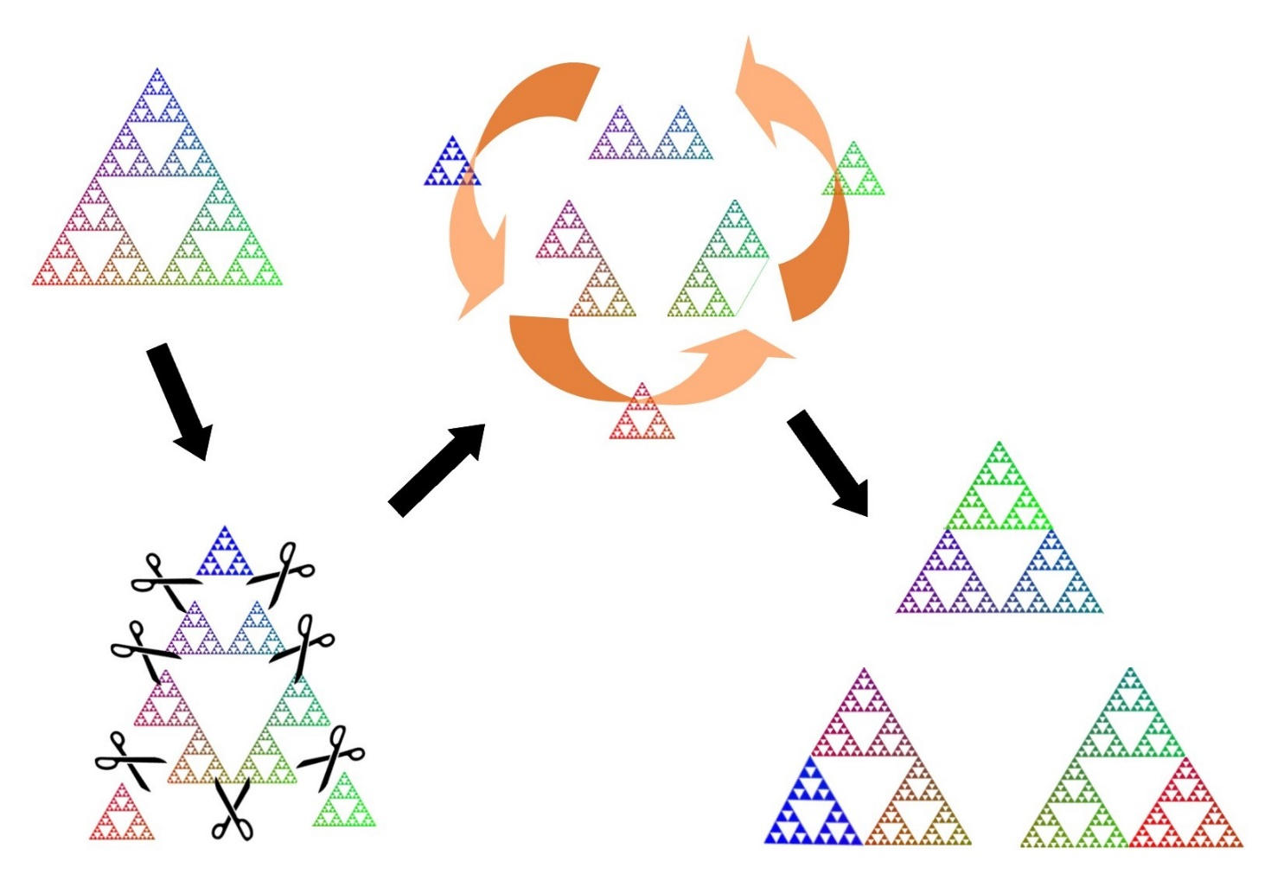

Figure 3. Decomposition in three pieces of a Sierpinski triangle, a fractal manifold made of triangles. A few cuts and a rotational movement allow to achieve three Sierpinski triangles, starting from just one.

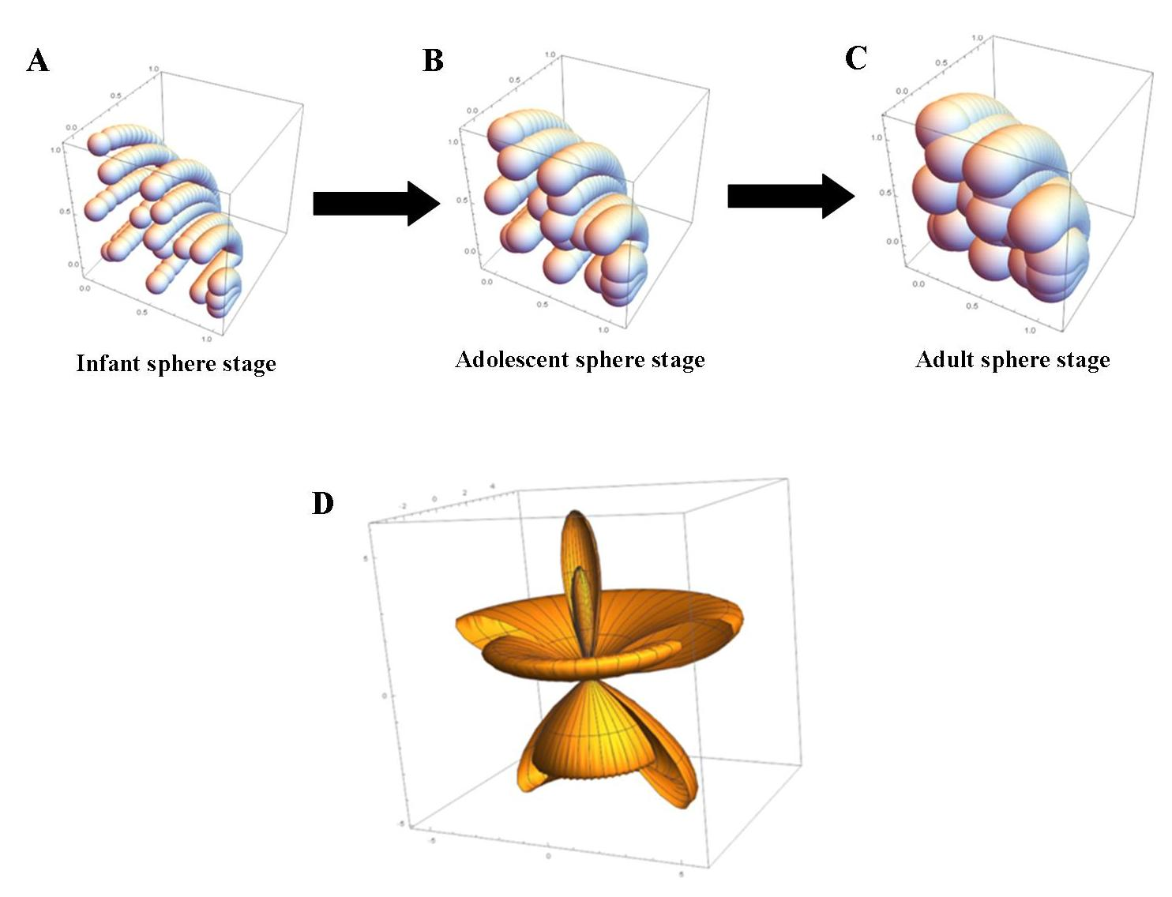

Figure 4. Burgeoning growth BTP stages. Figure 4A. The beginning BTP stage starts with multiple tiny infant spheres (i.e., spherical composite vertexes in a nexus) that continuously form multiple sequences of contiguous spacetime spheres. Figure 4B. The growth of BTP spherical divisions leads to contiguous adolescent spheres. Figure 4C. Next, in a spacetime, seemingly a Hegelian synthesis stage, BTP spherical divisions that form path-connected vortexes lead to a nexus of contiguous adult spheres. Figure 4D. BTP process viewed as a piecewise division of one sphere into the interior of another sphere. In this case, a single sphere serves as a generator of another sphere.

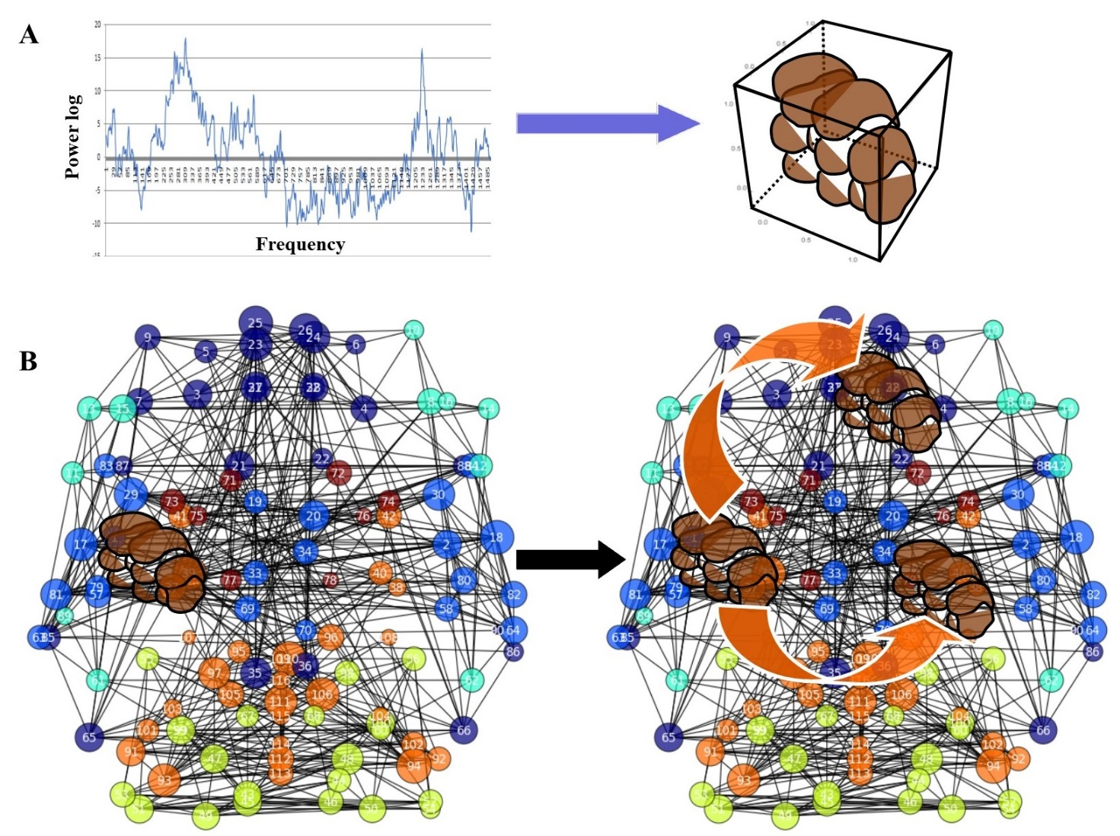

Figure 5. Theoretical example of how BTP could be able to duplicate brain oscillations throughout different cortical areas. Figure 5A. Scale-free oscillations experimentally detected in the brain through Fourier analysis (left) and their illustration in terms of multiple tiny spheres (right). Figure 5B. Scale-free oscillations are located inside a single area of the connectome, described here in terms of Python/FSL Resting State Pipeline. The pipeline is a collection of steps that can be used to process a single subject’s resting state raw data into a node-based correlation matrix representing connectivity among different cortical regions. Figure 5C. BTT comes into play: with the proper translations and rotations (not shown here) along the edges and the nodes of the connectome, the scale-free oscillations are split in different chunks with matching description. Due to the scale-invariant behavior of power law oscillations, every chunk displays the same features of the original scale-free oscillation. This allows us to achieve a “duplication”, a “cloning” of the original seed oscillation in two (or more) oscillations with the same pink noise located in different areas of the connectome. Modified from: https://wiki.biac.duke.edu/biac:analysis:resting_pipeline

CONCLUSIONS

This paper has three starting-points: (a) measures based on syntactic information alone are not sufficient to describe brain activity exhaustively; (b) there is large-scale spatial coherent neural activity across the brain; (c) the brain is a multi-scale system with dynamics at different time scales. The paper makes an additional point though: the BanachTarski-Paradox (BTP) can be employed to specify (b) or (c), and thus complement information measures as in (a) to characterize brain activity more completely. We described nervous propagation through BPT, showing how a sequence of moves related to scale-free brain oscillations allows cloning, duplication and increases in the number of cortical waves. We assessed brain activity in terms of BPT neurodynamics across different time scales, looking at interlevel relations connecting adjacent levels of activity. The fact that BTP might work in physical and biological systems would mean, as already suggested by Tozzi and Papo (2020), that topological changes may give rise to modifications devoid of thermodynamic constraints and topological superimposition, so that events occur that do not require an identifiable cause. Against all informational odds, it is noteworthy that BTP can be used to describe duplications of nervous oscillations that do not entail information transfer. Although the moves dictated by BTP in the physical/biological setting of the connectome require at least a small amount of energy to be performed, they do not require information transfer. To elucidate this intricate issue, we need to start from symbolic dynamics, a topological tool that has been already used to address interlevel relations between micro- and macro-states in complex systems equipped with deep structure (Atmanspacher, 2016). In symbolic dynamics, we consider “flows”, that stand for compact metric spaces with homeomorphism groups (Furstenberg 1967). An infinite discrete group G is equipped with an action termed G-flow, made of closed, G-invariant subflows (Glasner et al., 2019). Two dynamical systems or sets are termed disjoint if at least one of them is minimal, i.e., it is not equipped with further subflows (Glasner and Weiss, 2018). When the subset is minimal, it is devoid of Bernoulli flows, or, in an alternative formulation, the processes with entropy zero are disjoint from Bernoulli flows. This means there is no input from the preceding spatial proximal subflow to the next iteration, i.e., the distal subflow and, even more important, no information transfer occurs when the two subsets are disjoint. It is noteworthy that the “pieces” described by HBT display the same ingredients and features required by disjointed dynamical systems in topological dynamics: indeed, BTP subflows are related to the geometric study of fixed points of a self-mapping on a metric space. In a geometry of fixed points of a self-mapping on a metric space, new generalized contractive conditions have been established that ensure a self-mapping having a fixed disc or a fixed circle (Özgür and Taş, 2019). In other words, we may state that HBT is characterized by an infinite discrete group split by an arbitrary free Abelian group of rotation through the axiom of choice, giving rise to at least five subflows. Every different subflow (every “piece”) is minimal and disjoint from the others. In sum, in both symbolic dynamics and BPT approaches, fine-grained state dynamics are mapped onto coarser-grained (symbolic) state dynamics in such a way that the dynamics are topologically conjugate. It might be objected that in this case BTP-cloning is not “information-devoid”, because moving across levels typically changes the granularity of phase space partitions. Also, a kind of syntactic information can be associated with any such partition: since the partitions are different, this could stand for an information flow across levels. However, even if these objections hold true, this would not be an information flow due to causal interaction. To further corroborate our suggestion that no information transfer occurs among the subflows, it must be emphasized that four of the five sets described in the BTP construction are not Lebesgue-measurable: this means that no information is lost, since the information never existed.

An important limitation must be considered: even though neurodynamics shows scale-free behavior over time (or frequency) scales, the frequency range over which power-law behavior persists is extremely limited in the brain. Indeed, the power spectral density can be detected just in the frequency range of about 0,1-40 Hz, while the tails do not display power laws. This means that the ideal picture of the Sierpinski triangle, which is self-affine over all length scales, cannot be achieved in the brain. In other words, power-law behavior in the brain does not cover infinite frequencies/amplitudes, but rather it covers just a discrete interval. Since the BTP significantly works with infinities, the question arises how such infinities may or may not be consequential for phenomena in our finite world. Here a novel technique comes in to play which makes it possible to undermine infinity in biophysical issues correlated with pink noise (Tozzi and Peters, 2020). This approach suggests the possibility of mapping real systems’ paths to a manifold, which corresponds to an Alexander Horned sphere (AHS). AHS is equipped with one arm where white noise takes place, and another arm where pink noise takes place. This approach allows us to achieve manageable representations, because a continuous mono-dimensional line becomes an assembly of countless superimposed bi-dimensional lines, giving rise to quantifiable knots and bifurcations. Therefore, techniques do exist that are able to overtake the limitation of extending a real-world discrete phenomenon to abstract infinite phenomena.

In this paper, we focused on the BTP as a tool to explain scale-free neurodynamics. In addition, BTP can be also used in other ways, such as, e.g., to motivate some coupling between different kinds of dynamics. The object to be cloned could be an abstract structure, such as an attractor in the phase space in which the dynamics is represented. Another possibility is to argue that a BTP-type cloning might give rise to large-scale coherence in neurodynamics. A next step would be to compare it to alternative approaches explaining large-scale coherence in brain dynamics, such as functional connectivity in recurrent/recursive networks, and to look for the proper network to use. To provide an example, it has been recently demonstrated that recurrent activity in the mouse vibrissal somatosensory neurons can drive input-specific amplification during behavior (Peron et al., 2020). In touch with this computational modelling which implements amplification and allows pattern completion, the operations required by BTP could be guaranteed by local recurrent circuits and spatially intermingled neurons with similar receptive fields/increased connectivity.

The last, but not the least, the brain vortexes and Betti numbers recently described in cortical lag threads (Don et al., 2020) can be duplicated with simple spatial transformations (the passage of oscillations through brain wires), without energy transfer. This is a fruitful operation, because it leads to a new form of Borsuk-Ulam theorem (BUT) in terms of Betti numbers. In fact, the underlying mechanism in instantiations of BUT (Tozzi and Peters, 2017) provides a terse description of the inner workings of BTP in the context of neuro-dynamics. Here are two examples: a) Antipodal, symmetric vortexes serving as generators of offspring spheres dictated by BTP on the surface of a sphere have the same algebraic Betti number (count of the number of generators), with an underlying geometric Betti number (e.g., count of the number of cycles in each vortex). This form of BUT carries over into the study of symmetric activation regions in rs-FMRI videos; b) BTP -produced antipodal, symmetric vortexes on the surface of a sphere have the same algebraic Betti number (count of the number bridge segments x 2 attached between vortex cycles).

In conclusion, a BTP -based approach facilitates tackling brain issues from an unusual standpoint. Against all informational odds, it is noteworthy that BPT can be used to describe duplications of nervous oscillations that do not entail information transfer.

REFERENCES
- Alexandroff P. 1932, 1961. Elementary Concepts of Topology. Dover Pubs., Inc., New York. ISBN 0-486-60747-X.
- Ali A, Rafique H, Arshad T, Alqarni MA, Chauhdary SH, Bashir AK. 2019. A Fractal-Based Authentication Technique Using Sierpinski Triangles in Smart Devices. Sensors (Basel), 19(3). pii: E678. doi: 10.3390/s19030678.
- Allen E, Triantaphillidou S. 2009. The Manual of Photography. Tenth Edition. Taylor and Francis Group, Abdingdon, Oxon.
- Atmanspacher H. 2016. On Macrostates in Complex Multi-Scale Systems. Entropy 2016, 18(12), 426; https://doi.org/10.3390/e18120426
- Attwell D, Laughlin SB. 2001. An energy budget for signaling in the grey matter of the brain. Journal of Cerebral Blood Flow and Metabolism: Official Journal of the International Society of Cerebral Blood Flow and Metabolism, 21(10):1133–1145. http://doi.org/10.1097/00004647-200110000-00001.
- Banach S, Tarski A. 1924. Sur la décomposition des ensembles de points en parties respectivement congruentes. Fundamenta Mathematicae, 6: 244–277.
- Bekenstein JD. 2003. Black holes and information theory. arXiv:quant-ph/0311049.
- Bromiley PA, Thacker NA, Bouhova-Thacker E. 2010. Shannon entropy, Renyi entropy, and information. Tina 2004-004, Statistic and Inf Series, Imaging Sci. and Biomed. Eng., Univ. of Manchester, UK.
- Aliprantis CD, Border KC. 2006. Odds and Ends. Springer-Verlag, Berlin, ISBN-10 3-540-29586-0.
- Cafaro C, Ali SA, Giffin A. 2016. Thermodynamic aspects of information transfer in complex dynamical systems. Phys. Rev. E 2016, 93, 022114.
- Churkin VA. 2010. A continuous version of the Hausdorff–Banach–Tarski paradox. Algebra and Logic. 49 (1): 81–89. doi:10.1007/s10469-010-9080-y.
- de Arcangelis L, Herrmann HJ. 2010. Learning as a phenomenon occurring in a critical state. Proceedings of the National Academy of Sciences 107, 3977-3981.
- Don AP, Peters JF, Ramanna S, Tozzi A. 2020. Topological View of Flows inside the BOLD Spontaneous Activity of the Human Brain. Front. Comput. Neurosci. | doi: 10.3389/fncom.2020.00034.
- Fox MD, Raichle ME. 2007. Spontaneous fluctuations in brain activity observed with functional magnetic resonance imaging. Nature reviews. Neuroscience 8, 700-711.
- Friston K. 2010. The free-energy principle: a unified brain theory? Nature Reviews Neuroscience, 11(2), 127–138. http://doi.org/10.1038/nrn2787.
- Furstenberg H. 1967. Disjointness in ergodic theory, minimal sets, and a problem in diophantine approximation. Mathematical systems theory, 1:1–49.
- Glasner E, Weiss B. 2018. On the disjointness property of groups and a conjecture of Furstenberg. arXiv:1807.08493.
- Glasner E, Tsankov T, Weiss B, Zucker A. 2019. Bernoulli disjointness. arXiv:1901.03406.
- Jaynes ET. 1957. Information Theory and Statistical Mechanics. Phys. Rev 106: 620.
- Kantor FW. 1977. Information Mechanics. Wiley-Interscience. ISBN 10: 0471029688 / ISBN 13: 9780471029687.
- Kawe TNJ, Shadli SM, McNaughton N. 2019. Higuchi's fractal dimension, but not frontal or posterior alpha asymmetry, predicts PID-5 anxiousness more than depressivity. Sci Rep, 9(1):19666. doi: 10.1038/s41598-019-56229-w.
- Lloyd S. 2000. Ultimate physical limits to computation. Nature 406, 1047-1054 (31 August 2000) | doi:10.1038/35023282
- Lübeck, S. 2004. Universal scaling behavior of non-equilibrium phase transitions. International Journal of Modern Physics B 18, 3977-4118.
- Mandelbrot B. 1967. How long is the coast of Britain? Statistical self-similarity and fractional dimension. Science, 56(3775):636-8.
- Marzuoli A, Rasetti M. 2005. Computing Spin Networks. Annals of Physics 318: 345–407.
- Milstein J, Mormann F, Fried I, Koch C. 2009. Neuronal shot noise and Brownian 1/f2 behavior in the local field potential. PLoS One. 2009;4(2):e4338. doi: 10.1371/journal.pone.0004338.
- Ỏzgủr N, Taş N, Peters JF. 2020. New complex-valued activation functions. An Int. J. of Optimization and Control Theories & Applications 10(1), 66-72, http://doi.org/10.11121/ijocta.01.2020.00756.
- Özgür N, Taş N. 2019. Pata Zamfirescu Type Fixed-Disc Results with a Proximal Application. arXiv:1910.12302.
- Papo D. 2014. Functional significance of complex fluctuations in brain activity: from resting state to cognitive neuroscience. Frontiers in systems neuroscience 8, 112
- Peron S, Pancholi R, Voelcker B, Wittenbach JD, Ólafsdóttir HF, et al. 2020. Recurrent interactions in local cortical circuits. Nature; 579(7798):256-259. doi: 10.1038/s41586-020-2062-x. Epub 2020 Mar 4.
- Peters JF. 2018. Proximal vortex cycles and vortex nerves. Non-concentric, nesting, possibly overlapping homology cell complexes, J. of Mathematical Sciences and Modelling 1(2), 80-85, arXiv:1805.03998.
- Peters JF. 2019. Vortex nerves and their proximities. Nerve Betti numbers and descriptive proximity. Bull. of the Allahabad Math. Soc. 34(2), 263-276.
- Peters JF. 2020. Computational Geometry, Topology and Physics of Digital Images with Applications. Shape Complexes, Optical Vortex Nerves and Proximities. Springer Nature, Switzerland AG, ISBN 978-3-030-22191-1.
- Pritchard WS. 1992. The brain in fractal time: 1/f-like power spectrum scaling of the human electroencephalogram. The International journal of neuroscience 66, 119-129.
- Reese TM, Brzoska A, Yott DT, Kelleher DJ. 2012. Analyzing Self-Similar and Fractal Properties of the C. elegans Neural Network. PLoS ONE 7(10): e40483. (doi:10.1371/journal.pone.0040483).
- Sengupta B, Stemmler MB. 2014. Power Consumption During Neuronal Computation. Proceedings of the IEEE 102, 738-750.
- Shannon CE. 1948. A Mathematical Theory of information. The Bell System Technical Journal 27:379-423.
- Sporns O. 2006. Small-world connectivity, motif composition, and complexity of fractal neuronal connections. Biosystems 85(1):55-64. https://doi.org/10.1016/j.biosystems.2006.02.008.
- Tinker J, Velazquez JL. 2014. Power law scaling in synchronization of brain signals depends on cognitive load. Front Syst Neurosci. 2014 May 1;8:73. doi: 10.3389/fnsys.2014.00073.
- Tozzi A, Peters JF. 2016. A Topological Approach Unveils System Invariances and Broken Symmetries in the Brain. Journal of Neuroscience Research 94 (5): 351–65. doi:10.1002/jnr.23720.
- Tozzi A, Peters JF. 2017. From abstract topology to real thermodynamic brain activity. Cogn Neurodyn. 11(3):283–292. doi: 10.1007/s11571-017-9431-7.
- Tozzi A, Peters JF, Cankaya MN. 2018. The informational entropy endowed in cortical oscillations. Cognitive Neurodynamics, 12(5), 501-507. DOI: 10.1007/s11571-018-9491-3.
- Tozzi A, Papo D. 2020. Projective mechanisms subtending real world phenomena wipe away cause effect relationships. Progress in Biophysics and Molecular Biology. 151:1-13. DOI: 10.1016/j.pbiomolbio.2019.12.002.
- Tozzi A, Peters JF. 2020. A Topological Approach to Infinity in Physics and Biophysics. Found Sci. https://doi.org/10.1007/s10699-020-09674-0.
- Van den Heuvel MP, Sporns O. 2011 Rich-club organization of the human connectome. J Neurosci. 31, 15775-15786. doi: 10.1523/JNEUROSCI.3539-11.2011.
- Wheeler JA. 1990. Information, physics, quantum: The search for links. In Zurek, Wojciech Hubert. Complexity, Entropy, and the Physics of Information. Redwood City, California: Addison-Wesley. ISBN 9780201515091. OCLC 21482771.
- Watanabe T, Hirose S, Wada H, Imai Y, Machida T, et al. 2013. A pairwise maximum entropy model accurately describes resting-state human brain networks. Nature Communications, 4, 1370. http://doi.org/10.1038/ncomms2388.
- Watanabe T, Kan S, Koike T, Misaki M, Konishi S, et al. 2014. Network-dependent modulation of brain activity during sleep. NeuroImage, 98, 1–10. http://doi.org/10.1016/j.neuroimage.2014.04.079.

