TITLE: Fidelity and the grain problem in cultural evolution

Mathieu Charbonneau
Central European University, Departments of Philosophy and of Cognitive Science, Budapest,
Hungary

Pierrick Bourrat
Macquarie University, Department of Philosophy, North Ryde, NSW, 2109, Australia
The University of Sydney, Department of Philosophy, Unit for the History and Philosophy of Science
& Charles Perkins Centre, Sydney, NSW 2006, Australia

Abstract
High-fidelity cultural transmission, rather than brute intelligence, is the secret of our species’ success, or so many cultural evolutionists claim. It has been selected because it ensures the spread, stability and longevity of beneficial cultural traditions, and it supports cumulative cultural change. To play these roles, however, fidelity must be a causally-efficient property of cultural transmission. This is where the grain problem comes in and challenges the explanatory potency of fidelity. Assessing the degree of fidelity of any episode or mechanism of cultural transmission always depends upon an investigator’s choice of grain of analysis at which cultural traditions are being studied. The fidelity of cultural transmission then appears to be relative to the granularity at which one approaches cultural variation, and since there is a multiplicity of grains of description by which the same tradition can be studied, there results a multiplicity of measures of fidelity for a same event or mechanism of cultural transmission. If this is correct, because fidelity is always relative to the grain of analysis dictated by the local and specific research interests of the investigator, then there seems to be no fact of the matter as to whether cultural transmission is faithful or not, independently from a researcher’s framework of analysis. The aims of this paper are to offer a conceptual clarification of the grain problem in cultural evolution, to assess its causes, to unpack its epistemological implications, and to examine its reach and consequences for a science of cultural evolution.

Introduction
High-fidelity cultural transmission, rather than brute intelligence, is the secret of our species’ success, or so many cultural evolutionists claim. (Henrich, 2016; Laland, 2017; Richerson & Boyd, 2005) The story broadly goes as follows. When learning from one another, we use social learning mechanisms, such as imitation and teaching. These mechanisms ensure the high-fidelity transmission of information across individuals, which in turn leads to the spread and maintenance over multiple generations of advantageous cultural traditions (Henrich, 2016; Mesoudi, 2011; Richerson & Boyd, 2005). This is opportune as learning from others decreases the cost of having to discover adaptive knowledge, skills, and technologies through individual trial-and-error learning alone. These social learning mechanisms are adaptations complementing individual learning (Boyd & Richerson, 1995; Rogers, 1988) and have been selected for their high-fidelity (Acerbi et al., 2012; Nakahashi, 2013). High-fidelity transmission is also remarkable in that it allows for cumulative cultural evolution, the process by which traditions are gradually modified and improved upon over time. Without high-fidelity transmission, advantageous innovations would not be retained and passed on for further improvement (Tennie et al., 2009; Tomasello, 1999). Cumulative culture is a human-specific adaptation explaining why our species is remarkable and so successful (Dean et al., 2014; Laland, 2017). Relying on our high-fidelity transmission mechanisms, it allows us to socially distribute the incremental development of complex knowledge and technologies that no single individual could invent on their own (Boyd & Richerson, 1996; Muthukrishna & Henrich, 2016).
Central to this story are the multiple causal and explanatory roles played by transmission fidelity. Fidelity brings about culture; it ensures the spread, stability and longevity of cultural traditions; it is selected for, and it supports cumulative cultural change. To play each of these roles, however, fidelity must be an objective, causally efficient property of cultural transmission. This is where the grain problem comes in and challenges the soundness of the story. Assessing the degree of fidelity of any episode or mechanism of cultural transmission always depends upon an investigator’s choice of grain of description at which cultural traditions are being studied. The fidelity of cultural transmission then appears to be relative to the granularity at which one approaches cultural variation, and since there is a multiplicity of grains of description by which the same tradition can be studied, there results a multiplicity of measures of fidelity for a same event or mechanism of cultural transmission. If this is correct, because fidelity is always relative to the grain of description dictated by the local and specific research interests of the investigator, then there seems to be no means, independently from a researcher’s framework of analysis, to assess whether cultural transmission is faithful or not.
To our knowledge, the premises of the grain problem in cultural evolution have been first spelled out in Acerbi & Mesoudi (2015). Noting the relativity of any assessments of transmission fidelity to the choice of a grain of description, they conclude there is no epistemically privileged grain of description one could choose to identify the correct degree of fidelity of any case of cultural transmission. Acerbi and Mesoudi settle by promoting an opportunistic pluralism in the choice of grain of description and thus of measures of fidelity instead of demanding a principled answer as to whether cultural transmission is, overall, of high or low fidelity. Following Charbonneau (2020), adopting such a pluralism leads to major difficulties for any explanatory project that demands a single, generalized notion of fidelity. Indeed, if there is a plurality of measures of transmission fidelity for a same tradition, and if these measures often conflict, then it is unclear how to support the generalization that human cultural transmission is of higher-fidelity than non-humans’.
In this paper, we build on Acerbi & Mesoudi (2015) and Charbonneau (2020) and we argue that given current practices in cultural evolution, the notion of transmission fidelity is better understood as the description of phenomena in need of explanation (fidelity as an explanandum) rather than a causal, explanatory notion (fidelity as an explanans), as the standard story would have it. Indeed, if fidelity is a by-product of the analytical framework used by cultural evolutionists rather than a factual property of cultural transmission mechanisms, then differences in degrees of fidelity cannot effectively play a causal role in the evolution of culture, in stabilizing traditions over time, in supporting cumulative culture, let alone being a selected feature of social learning mechanisms. In other words, if fidelity is in the eye of the beholder, then it cannot ground the secret of our species’ success. The aims of this paper are to offer a conceptual clarification of the grain problem in cultural evolution, to assess its causes, to unpack its epistemological implications, and to examine its reach and consequences for a science of cultural evolution. In Section 1, we review the theoretical background and practices upon which the grain problem emerges and explicate the notion of grain of description as it relates to cultural transmission. In Section 2, in line with Acerbi & Mesoudi (2015) and Charbonneau (2020), we analyse how the grain problem challenges the idea that fidelity is an objective property of cultural transmission. While both these contributions argue for the relativity of fidelity to the choice of a grain of description, they do not examine how fidelity varies with different grains of description. We offer an analysis of this relation in terms of determinables and determinates (Wilson 2017). Moreover, while a pluralistic approach to the grains of description is desirable, we discuss how it can be misused and argue for norms of proper practices. Finally, in Section 3 we identify and discuss a consequence of the grain problem when assessing the fidelity of different forms of social learning. While both Acerbi & Mesoudi and Charbonneau claim that processes of cultural transmission, such as imitation, emulation, etc., can be more or less faithful, we argue that, because these processes are defined in terms of input-output relations, which form of social learning is involved in a specific episode of cultural transmission is also relative to an investigator’s choice of grain of description. While the grain problem does challenges explanatory projects that rely on the view that fidelity is a description-independent property of cultural transmission, we conclude by suggesting some ways cultural evolutionists can change their practices in order to avoid the grain problem while embracing fidelity as a non-explanatory, descriptive notion. Finally, we indicate avenues to reconceptualize fidelity as an explanatory notion.

1—Granularity and Cultural Transmission

What is cultural transmission?
The transmission of cultural information between two individuals boils down to two key steps: the learning of a cultural trait and its public reproduction. First, a model produces a public display of a cultural item based on her mental representation of what that item consists of, e.g., by producing an utterance, an action, or an artefact, etc. Then, another individual—the learner—observing the model’s public display, forms her own mental representation of what the cultural trait consists of. The cycle starts again with the learner then producing a public display of the cultural trait, therefore allowing further transmission to go on.
As cultural evolutionists do not have direct access to the mental representations of the model nor of the learner—they are private mental events—, they assess the content and fidelity of cultural transmission through the observed similarities between the public displays of the model and the ones produced by the learner (Acerbi & Mesoudi 2015; Charbonneau 2020). The notion of transmission fidelity characterises cultural transmission in two ways (Charbonneau 2020). First, fidelity serves as a measure of the extent to which the public display of a learner is similar to that of the model. In this case, it qualifies the outcome of an episode of cultural transmission: the more similar the public displays, the more faithful the transmission. Second, fidelity can also refer to the extent to which a mechanism involved in cultural transmission produces episodes of high-fidelity transmission. Here, fidelity is understood as a property of the process of cultural transmission: the more a learning mechanism ensures high-fidelity transmission (outcome), the more faithful that mechanism (process).

What is a grain of description?
By grain of description, we mean the degree of precision at which cultural variation is being effectively studied and measured. The more precise the analysis, the finer the granularity; the less precise, the coarser it is. Precision does not refer here to the scientific quality of the research but instead to the resolution at which the investigator tackles cultural variation. Different investigative projects ask for different grains of description. We are thus not interested in claiming that more precision—because it provides more information—is generally better (it is not). Instead, we acknowledge that, given the plurality of explanatory projects pursued by cultural evolutionists, it is common practice to use different grains of description, even when studying the same cultural tradition. What we aim to clarify are the conflicts regarding the assessment of transmission fidelity that can emerge from these practices (see section 2).
The same cultural tradition can be studied using different grains of description, going from coarser to finer. Depending on the type of measurements used to assess cultural variation, the grain of description chosen by an investigator will vary on either a quantitative scale (e.g., ordinal, interval, ratio, etc.) or on a qualitative one (e.g., nominal categories).
One can study cultural variation using more or less precise quantitative measurements. The variation of a trait measured at a coarser grain serves as a class that contains variants of that same trait measured at finer grains (O’Brien et al., 2010). In other words, finer grains are determinates of coarser ones, determinables (Wilson, 2017). This is common practice among cultural evolutionists. For instance, using an example from O’Brien, Darwent, and Lyman (2001), when measuring variation in lithic arrowheads, one can adopt a coarse grain of description where the presence or absence of some attribute, say of a basal indentation, is recorded (see figure 1). A finer grain of description could discriminate between different types of basal indentation into classes denoting the pattern of their curvature, e.g., arc-shaped, normal curve, triangular or folsomoid. An even finer grain of description would measure the basal indentation ratio, measured as the ratio between the medial length of a specimen and its maximum length. In cultural evolutionary models, these differences in grain of description are typically modelled in terms of ‘types of traits’: coarser grains are often modelled as presence/absence traits, more specific classes as discrete, non-binary alternatives (quantitative or not), and even finer grains as quantitatively continuous traits (Boyd & Richerson, 1985; Cavalli-Sforza & Feldman, 1981). While the same feature of a cultural item can be measured at different grains, not all features can be so. For instance, whether a projectile point is fluted may not be measured with more precision than by noting its presence or absence (e.g., feature H in figure 1).
[figure 1 about here]
Of course, the study of cultural variation is not limited to artefacts. It can be applied to practices or behaviours. For instance, in their ethnographical study of the transmission of technical knowledge among Orinoco Delta peasant farmers, Ruddle and Chesterfield (1977) were interested in examining the modes of transmission of different necessary skills and knowledge required to become a cultivator. Their analysis thus decomposes the skill of cultivation, a coarse-grained trait, into component modules constitutive of their skill, finer variants of the ‘cultivation’ trait. Their analysis thus emphasises the specific ways different, finer-grained techniques (e.g., burning, sowing, transplanting, etc.) and expertise (e.g., plant identification, seed selection, use of a digging stick, etc.) are acquired from others (from whom and how) so that an individual can become, through their combination, a full-fledged cultivator.
In contrast, studies of gene-culture co-evolution typically rely on an agglomerative, coarser-grained presence/absence description of cultural variation that ignores finer variants of such complex behavioural traits. For instance, Aoki (1986) and Feldman and Cavalli-Sforza (1989) develop models tracking the co-evolution of alleles for lactose absorption with the cultural trait of milk use (a presence/absence trait). Milk-use here is a relatively coarse description of a cultural trait that involves many finer-grained variants (e.g., what type of animal milk is being used, the frequency of its use, the type of treatment received by the milk (processed or not), and the form of the dairy product (milk, cheese, etc.)). Similarly, Holden and Mace (1997) track the affinities between lactose absorption genes to the adoption of pastoralism among individuals in different populations. Pastoralism is also a very coarse-grained description of a complex set of knowledge, skills, and handling techniques, a set which can greatly vary depending on the type of livestock raised.
Differences in the grain of description at which some cultural item is studied have implications on the degree of fidelity one will measure when studying its transmission. For the same case of cultural transmission, by changing the grain of description, one often obtains different degrees of transmission fidelity. While this grain problem has been discussed by others (Acerbi & Mesoudi, 2015; Charbonneau, 2020), the reasons why the problem emerges have yet to be addressed. In the next section we characterize the grain problem more precisely and draw some of the consequences it has on cultural evolution explanations relying on fidelity as an explanans.

2—Granularity, fidelity, and explanations

Changing grain
Opting for a specific grain of description effectively defines and constrains the space in which the features of a cultural tradition can be observed to vary. Using a coarse presence/absence space of variation, there are only two possible states for a trait to vary: either it is present, in any form, or it is not. Using more precise measurements or decompositions, such as identifying different states in which a trait can be present, one opens the possibility of detecting more variants by allowing the identification of different forms of a presence trait. The same logic applies with even finer grains, e.g., using quantitatively continuous measurements opens an infinite number of potential variations by opening a finer space for cultural items to vary through.
A direct consequence of this sensitivity of measured variation to the grain of description is that different grains of description are likely to skew measurements of transmission fidelity in different ways. Analysing some tradition, using a finer grain of description renders the observation of imperfect transmission more likely since there is a greater possibility that a learner’s trait will vary in some finer respect from the model’s trait. Indeed, there is always the possibility of using a grain so fine that any cultural trait will be observed to be perfectly unique. In contrast, using a coarser grain of description effectively conflates multiple variant states into fewer ones, thus reducing the possibility of detecting differences between a learner’s trait and that of the model. Moreover, there is always a grain of description coarse enough so that any two traits will be observed to be identical. This means that we cannot determine the degree of fidelity of an episode of cultural transmission without specifying a grain of description at which variation is measured because we cannot generalize across all possible grains of description whether an episode of cultural transmission has been of high- or low-fidelity. Figure 2 illustrates this point.
[figure 2 about here]
Moreover, there is an asymmetry in the way a choice of grain of description can skew the degree of fidelity at which a tradition is observed to be transmitted. Measuring high-fidelity using a fine grain of description, shifting for a coarser grain of description will also yield high-fidelity. For instance, if a specific shade of colour for painting pottery is faithfully transmitted, say ‘carnelian’, it is a logical necessity that the coarser colour, ‘red’, will also be faithfully transmitted. This is because the faithful transmission of a determinate property necessarily involves the faithful transmission of a more determinable property. In contrast, measuring high-fidelity transmission using a coarse grain is no guarantee that the same fidelity will be measured when using a finer grain. This is because many different finer measurements may correspond the same coarser measurement. For instance, observing the faithful transmission of painting some pottery red is no guarantee that the specific shades used—say ‘carnelian’, ‘sanguine’, or ‘scarlet’—are themselves transmitted faithfully. Figure 3 visually illustrates this asymmetry.
[figure 3 about here]
It is important to keep in mind that what we are discussing here are the expected differences in fidelity assessments when comparing coarser and finer grains of description for the same case of cultural transmission. We are not claiming that the actual measurements of fidelity made at some specific grain of description are arbitrary. Whether an investigator effectively measures high or low fidelity at some particular grain of description is an empirical question that is not affected by the relativity of fidelity to the investigator’s choice of a grain of description. Indeed, once a cultural variant has been selected and a grain of description has been clearly specified for its analysis, whether some variant trait at the selected grain of description has been faithfully transmitted depends on the behaviour of the specific case under study. For instance, whether a specific pot has been painted in a carnelian tone rather than a sanguine one is not relative to the investigator’s choice of grain of description—it is an empirical matter of fact that the pot is carnelian, sanguine, or of some other colour—and so a measure of fidelity can be objectively measured within some grain of description. Instead, the issue is the relativity of fidelity assessments across grains of description. There is always a way of changing the grain of description and, with it, whether we observe high-fidelity or low-fidelity transmission (e.g., by using coarser nominal categories, or finer and finer grains when measuring continuous variation).
Our analysis shows that any assessment of the fidelity of transmission of some cultural trait or tradition must take the form ‘trait T was transmitted with high (or low) fidelity when assessed at granularity G’, where G defines the grain of description used by the investigator, i.e., the state space defining all possible measurable variants. Once a specific grain of description has been selected, it is possible to empirically measure, as a matter of fact, the similarity of cultural variation at that specific grain. In contrast, statements that an episode of cultural transmission was of high- or low-fidelity in general—i.e., without specifying a specific grain of description—remain incomplete.

Uses and abuses of granularity: the case of cultural replication
There are means to abuse the choice of granularity at which one examines cultural transmission in order to favour the observation of high- or low-fidelity cultural transmission. Memetics offers a clear example of the exploitation of this relativity in favour of the thesis that cultural transmission is, overall, of high-fidelity.
Memeticists argue that cultural transmission is a replicative process: culture is composed of memes, cultural items that are faithfully replicated (Blackmore, 1999; Boudry, 2018; Dennett, 2017; Tamariz, 2019). Many if not most cultural evolutionists reject this idea (e.g., Henrich, Boyd, and Richerson 2008; Boyd and Richerson 2000; Sperber 2000; inter alia). Memeticists to this day nevertheless persist in seeing cultural transmission as mainly a replicative process. We are not interested here in debating the alleged pervasiveness of replicative cultural transmission and so will take no stance in this debate. Instead, we want to examine the strategic role memeticists give to the granularity at which they approach cultural variation in supporting their position.
The main reason memeticists give as an answer to the sceptics of pervasive cultural replication is to point out that if one adopts a high-enough level of abstraction—in our suggested nomenclature: if one uses a grain of analysis coarse enough—, then we can see that replication is a serious way to characterise cultural transmission overall (Boudry 2018; Dennett 2017). Dennett (2017) develops this argument through the idea of digitisation. Generalising from the evolution of words, Dennett argues that successful cultural traditions are those that manage to ‘digitise’ themselves into discrete, easily differentiable classes, which ensures they are faithfully copied (p.226-7). Most cultural items may not be identical in their finer details—lasagne and ravioli may not be very similar in shape, ingredients, preparation and cooking procedures, etc.—but if we understand them at a grain coarse enough—they are both types of pasta—then we can recognise them as a same cultural item, the pasta meme (Dennett 2017, p.211). Variation in the finer details of knowing how to make or cook pasta does not matter much. Whether one knows how to make or cook spaghetti or ravioli instead, one knows how to make or cook pasta. And transmitting how to make or cook pasta seldom if ever leads one to erroneously learn how to prepare and bake a cake through miscopying. Approaching culture this way, we agree, does indeed lead to the observation of pervasive cultural replication.
By choosing to study cultural variation with a very coarse grain of analysis only and by lumping finer-grained variation into discrete presence/absence variants, memeticists reduce next to nil the possibility of any non-replicative case of cultural transmission: “This is the heart of digitization, obliging continuous phenomena to sort themselves out into discontinuous, all-or-nothing phenomena.” (Dennett 2017, 200) What memeticists fail to realise, however, is that by considering only cultural variation with such coarse grain, they are effectively insulating their approach from counterevidence to replication. They commit what we can call a reductio ad replicatum: whenever a lack of transmission fidelity is observed, one can simply argue that this is because the tradition was not analysed using the right granularity and then find some coarser grain of analysis (higher level of abstraction) where replication obtains. This renders the memetics approach effectively unfalsifiable since whenever we recognise that some type of cultural trait has been transmitted, we already have recognised some grain of description at which we can logically claim that the cultural trait has been perfectly replicated. Replication then becomes analytically unavoidable and, consequently, an explanatorily empty concept.
The memeticists’ trivialisation of the explanatory usefulness of replication does not mean that opting for a coarse grain of analysis should be avoided altogether. On the contrary, there are sound explanatory projects for which adopting a coarse grain of analysis is useful even if it entails that cultural transmission will be understood to be replicative. Studies of gene-culture co-evolution often do not need to deal with finer grains of analysis because the cultural traditions they study are contrasted with genetic responses to the transmission of the tradition. In the case of the co-evolution of lactose tolerance and dairying, it is justified to abstract away from the nitty-gritty details of the specific techniques, knowledge, type of animals, etc., required for transmitting dairy farming because what matters are the biological effects of dairy farming, namely the adult consumption of dairy products, and the finer variants have no expected relevant effect on the phenomena under study.
In the case of the replication of dairy-farming, ‘co-evolutionists’ makes no specific assumptions about the precise mechanisms involved in the transmission of the tradition. Transmission mechanisms are, in fact, effectively black-boxed (see Section 3). It is safe to assume that the transmission of such complex traits involves a mixture of multiple transmission mechanisms, some more or less faithful than others. As mentioned above, Ruddle & Chesterfield (1977; see also Chesterfield and Ruddle 1979) document how young individuals learn to ‘cultivate’, a trait described with a similar granularity as ‘dairy-farming’. They show how the component techniques and knowledge necessary to acquire this complex skill are transmitted through multiple channels, using different pedagogical and learning processes, dependent on a precise learning order, and exploiting multiple cognitive processes and ecological scaffolds. However, a detailed analogous analysis of the underlying learning mechanisms necessary to pass along dairy-farming may not prove useful if the investigator is interested in the effects of dairy consumption on the gene pool of a population. For such an explanatory project, block replication of the complex trait is a reasonable approximation. Assuming a coarse grain of analysis and thus assuming the cultural trait is replicated are both idealisations allowing for more tractability and analytical simplicity when building co-evolutionary models, not statements about the reality of the transmission process (Boyd & Richerson, 1987).

Consequences of the grain problem for explanations by fidelity
We can now turn to two key consequences that the relativity of fidelity to a choice of grain of description has on the field of cultural evolution. First, this relativity means that controversies concerning the degree of fidelity of cultural transmission can be fuelled by different parties unknowingly adopting different grains of description, leading the investigators to talk pass one another. As argued by Acerbi & Mesoudi (2015), in the debates between the so-called Californian and Parisian schools (Sterelny, 2017), the question as to whether human cultural transmission is, overall, preservative or transformative may not be solvable since what seems preservative at some granularity may be transformative at another, and vice versa. Indeed, if there are no epistemically-privileged grain of description one needs to choose to identify the correct degree of fidelity of the transmission of a cultural tradition independently from a specific investigation question, the issue of whether human cultural transmission is generally of high or low fidelity is moot (see also Charbonneau 2020). From this, Acerbi and Mesoudi suggest dropping debates about whether human cultural transmission is faithful overall or not and instead promote an opportunistic pluralism when it comes to choosing the granularity at which one decides to study cultural variation and its successful transmission. Assessments of transmission fidelity ought to be settled on a case by case basis, not by generalising over whether human cultural transmission is, overall, of high-fidelity or not (Charbonneau 2020).
Acerbi & Mesoudi, however, do not identify the more radical, second consequence of the relativity of fidelity to a choice of grain of description. This is where the grain problem becomes a pressing issue for cultural evolutionists. If any assessment of transmission fidelity depends on an investigator choosing a grain of description best suited for their explanatory project, and that measurements of fidelity varies with the choice of grain of description, then any statement based on a generalized assessment of fidelity—i.e., in abstraction of any grain of description—are incomplete statements.
Generalized claims of this kind are at the very core of the story of what many cultural evolutionists see as the defining feature of our species. Recall the ‘standard’ story with which we opened our discussion. Central to this story is that fidelity is a factual, causally efficient property of human cultural transmission. According to this story, the overall high-fidelity of human cultural transmission would explain the stability and longevity of our cultural traditions, it would serve as a key causal ingredient in our capacity for cumulative culture, and it would be a feature of social learning that was selected for by natural selection. All these claims seem to rely on the assumption that fidelity is a grain-independent property of cultural transmission of the form ‘trait T was transmitted with high fidelity [irrespective of the grain of description]’ and ‘cultural transmission is, overall, of high fidelity [irrespective of the grain of description]’. And indeed, if fidelity is to serve these explanatory, causal-roles, then it does need to be a generalizable property of cultural transmission. However, if the grain problem is genuine, then any assessment of fidelity is relative to a choice of grain of description by the investigator, which contradicts the causal role on which the standard story depends. However, to serve such explanatory roles, the fidelity of an episode of cultural transmission would need to be a grain-independent property. Given the actual practices of cultural evolutionists—in contrast to the standard story they tell—, fidelity is used as a descriptive notion. If the explanatory projects forming the standard story are to be pursued, then their proponents need to find a way to solve—or avoid—the grain problem.
At this point, one may argue that the standard story doesn’t in fact require an objective, grain-independent value of fidelity to argue that human species’ success is due to its higher-fidelity in transmission. All that is required, instead, is that for any given trait and grain of description (or for most of them), humans achieve a higher degree of fidelity than, say, other hominids. For instance, we might be able to show that human children transmit techniques to open artificial fruits with more fidelity than chimpanzee does, using a same grain of analysis (e.g., Whiten et al. 2009). If these differences would generalize over most cultural traits and at different grains of analysis, then the grain problem wouldn’t challenge the standard story as it could be claimed that human cultural transmission is, overall, of higher fidelity than non-humans’.
While this may very well be true, the argument fails to save fidelity as an explanatory concept. Indeed, by comparing different traits at different grains, what one obtains is the observation that human traditions are, overall, transmitted more faithfully than non-human ones, i.e., that overall, traits in learners and models are more similar for humans than non-humans. However, here these differences in fidelity do not explain what makes human special. Instead, these observations describe something special about our species: an interspecific difference that is in need of explanation. The argument relies on what Charbonneau (2020) refers to as episodic fidelity, the degree of similarity between two cultural items. Episodic fidelity is a descriptive notion characterizing the outcome of an episode of cultural transmission and being strictly descriptive it has no causal power. Fidelity here again is not explanatory as the standard story would have it, as one would then make the circular argument that human traditions are transmitted more faithfully at different grains than those of other species because human are capable of higher-fidelity transmission. What is required is a causal notion of fidelity, one that can offer explanatory power independently of the grain problem. A promising avenue is Charbonneau’s notion of propensity-fidelity, the degree by which learning mechanisms can ensure the faithful transmission of items. We examine this avenue in more details in Section 3.
Finally, the grain problem has even more insidious consequences on selectionist approaches, here specifically to those in cultural evolution (e.g. Dennett 2017; Mesoudi 2011). As noted by Bourrat (2019), the grain problem also implies that there is no unified manner to describe the process of natural selection nor any other evolutionary process defined in terms of, or by definition contrasted with, transmission fidelity. Indeed, as evolution by selection is often defined in terms of inheritance (e.g., Godfrey-Smith, 2009; Lewontin, 1970), then if the inheritance of variation is relative to the grain of analysis chosen by the investigator, a change of grain can lead to observing or failing to observe a selection process. While a full comparison of the grain problem in biological and cultural evolution would exceed the scope of this paper, it should be noted that in the case of biological inheritance this problem is mitigated by the existence of nearly universal mechanisms fixing the grain of description at which fidelity is ultimately to be measured (e.g., nucleobases for genetic inheritance, methylation patterns for epigenetic inheritance, etc.). Even in cases where these mechanisms are not explicitly stated, such as in quantitative genetics (see Falconer & Mackay, 1996), these mechanisms are implicitly assumed.
The conclusion that the reality of evolution by selection is itself relative to a choice of grain of analysis by the investigator should deter us from considering a laissez-faire solution as an adequate position when confronted with the grain problem. We discuss solutions to this issue in the conclusion below by examining whether mechanisms of social learning can fix the proper grain of description for cultural transmission

3—The grain problem and mechanisms of social learning
The grain problem might be thought to be circumventable by attending directly to the processes of social learning underlying cultural transmission rather than the episodes of cultural transmission. For instance, if there is a cognitive mechanism of social learning that sets the relevant grain at which an event or set of actions is learnt, then this would suggest which grain of description is the correct one to use, thereby bypassing the grain problem. Moreover, if fidelity is a property of social learning processes rather than one of transmission episodes (e.g., see Charbonneau 2020), then fidelity would be a causal, explanatory notion.

Social learning and grains of description
Consider two forms of social learning: production imitation—the reproduction of an observed action or sequence of actions and its end-goal—, and goal emulation—the reproduction of the outcome of an action or sequence of actions but not necessarily of the actions leading to this end result. (Hoppitt & Laland, 2013, p. 64) Everything else being equal, we know by definition alone that imitation will either exhibit the same fidelity or a higher fidelity than emulation. This is because imitation is capable of transmitting content that emulation is incapable of, namely the specific actions used by a model to produce some end-result. The grain problem does not challenge the idea that imitation can be understood to be a form of social learning of higher fidelity than emulation. Indeed, given how cultural evolutionists conceptualise imitation and emulation, by definition imitation always transmits what emulation transmits, and potentially more. Instead, what we will focus on evaluating is how investigators identify the form of social learning involved in any given episode of cultural transmission and show that, perhaps surprisingly, the form of social learning used by an individual can depend, and thus vary, with the grain of description elected by the investigator.
Consider the research on ‘over-imitation’ showing that infants tend to imitate functionally irrelevant actions when learning from an adult (Gergely et al., 2002; Meltzoff, 1988). In these experiments, an infant observes an adult activate a lightbox on a table with their forehead, an ineffective action considering the model could have used her hands instead. The grain of description coded for by the experimenters contrasts between using one’s hands or using one’s head (two cultural variants). Infants were then observed to mostly use their heads in activating the lightbox instead of using their hands, even though it would have been more efficient to use their hands. The results indicate that infants learned by imitation since they used their heads to activate the lightbox, just as the model did. Instead, had they learned by emulation, the participants would have used their hands, reconstructing the more efficient way to obtain the same observed goal.
Alternatively, the experimenters could have used a finer grain of description, for instance by controlling which part of the head was used to activate the lightbox (e.g., their forehead, their nose, their mouth, their ears, etc., all finer descriptions of the ‘using their head’ variant). Adopting such a finer grain of description, Gergely & Király (unpublished manuscript) found that, while the adult model used their forehead to activate the box, the participating infants instead preferred using other parts of their heads (mostly their mouth and nose) and only very rarely used their forehead. At this finer grain of description, we thus seem to observe that the infants were, in fact, emulating the sub-goal of pushing the box with their head and not imitating which part of the head to use, a result lost at the coarser grain of description.
It is, indeed, sensible to expect that the finer the grain of description one adopts, the less likely one will observe a form of social learning typically assumed to be of high-fidelity. Continuing with the contrast between imitation and emulation, the finer the grain of description used for characterising the cultural transmission of actions, the more likely one will observe emulative learning rather than imitation. Indeed, actions at coarser grains of description will appear as sub-goals of a more complex action when a finer grain of description is employed (Csibra 2008). For instance, one is much more likely to learn by imitation how to pick and offer an object (say a pair of scissors) if the action is analysed in terms of a grasping action (e.g., seize by the blades) and a pulling-back action (e.g., offer the handles). However, we can analyse the same technique in finer details, identifying two sub-goals, seize-by-the-blades and offer-the-handles, and measure action transmission instead in terms of the precise finger, hand, elbow, and shoulder spatial kinematics employed when passing the pair of scissors (see Csibra (2008, 439-41) and Hoppitt and Laland (2013, 74) for similar examples). As a direct consequence of the asymmetry discussed above, since it is less likely that actions (or any other cultural variants) will be passed on exactly if they are described with a grain fine enough, transmission will appear to be emulative. Inversely, the coarser the grain chosen, the less likely there will be sub-goals involved in the description of the behaviour, and thus the more likely the investigator will diagnose imitative learning (e.g., whichever part of the scissors is grasped and presented, the ‘passing scissors’ trait will have been transmitted). Csibra (2008) summarises this logic by pointing out that, by using a grain of description fine enough, “[…] any action reproduction will at some point be seen as emulation rather than imitation because the differences between the imitator’s and the model’s body will not allow perfect matching in all movement parameters.”

What is a social learning mechanism?
In their textbook survey of the field, and as most cultural evolutionists do, Hoppitt and Laland (2013) define all forms of social learning in behavioural, rather than cognitive terms (for a synthetic table of definitions, see p.64). Imitation, emulation, social facilitation, etc., are all defined in terms of a mapping between what a learner observes—the public displays (e.g., behaviours) of the model—and what a learner produces in response—the learner’s public displays (idem)—, rather than in terms of the workings of the underlying cognitive mechanisms involved in these forms of social learning. In other words, forms of social learning such as imitation and emulation are cashed out in terms of mappings between classes of observational inputs and classes of behavioural outputs. For instance, imitation is a mapping between observed actions and goal (input) and a reproduction of the same actions and goal (output), whereas for a same class of inputs emulation guarantees only the reproduction of the observed goal as an output. Instead, cognitive mechanisms such as action perception and action mirroring, intermodal matching, motor control and motor representations, goal-understanding and perspective-taking, etc., the bread and butter of cognitive scientists, are scarcely mentioned in the cultural evolution literature (Heyes, 2016, 2018; Sperber, 2006).
What makes these functional descriptions sensitive to a choice of granularity on the part of the investigator is that the input and output classes defining these forms of social learning are intrinsically defined in terms of the variation that is effectively being transmitted during some episode of cultural transmission. Since this variation needs to be characterised using some grain of description, changing the grain of description can lead to a change in the content of these classes, and thus result in a different mapping between these classes. Consequently, because a difference in grain of description can produce differences in the observed mapping of input/output, a change in the grain of description can lead to identifying different forms of social learning.
When testing for any form of social learning, an investigator always needs to first decide about the granularity at which the input-output mapping will be measured, a choice that can modulate which form of social learning she will observe. To illustrate this idea, consider that to differentiate between imitative and emulative learning, an investigator needs at least to adopt a grain of description fine enough so that variants actions and variant end-results can be discriminated. For some explanatory projects, the investigator may have no reasons to make such a partitioning, and thus adopt a coarse description of actions devoid of sub-goals. For instance, explanatory projects such as gene-culture coevolution do not need to decompose complex actions such as dairy-farming into finer sub-goals (see above). Yet, there are explanatory projects for which the very difference between action and end-result can itself depend on the grain of description used by the investigator, as the case about over-imitation discussed above shows.
Although cultural evolutionists are keen on talking of social learning as ‘mechanisms’ (e.g., see the subtitle of Hoppitt & Laland (2013)), it must be kept in mind that their practice is, in fact, more akin to a behavioural approach than a cognitivist one. Differences in forms of social learning are cashed out not in terms of precise cognitive mechanisms but instead in terms of differences in the mapping between classes of observational inputs and classes of behavioural outputs, however these mappings are effectively secured within the learner. In fact, it is safe to say that these descriptions of social learning effectively black-box cognition as cultural evolutionists generally abstract away from the details of the cognitive mechanisms that are involved in producing these mappings (Heyes, 2016, 2018; Sperber, 2006).
To be clear, our discussion does not argue for a relativity of the underlying cognitive mechanisms effectively involved in an episode of cultural transmission. Instead, it seems more appropriate to read cultural evolutionists’ claims that human cultural traditions are being transmitted through some form of social learning, such as imitation or emulation, as being about which features of a cultural trait were transmitted (e.g., actions and end-goal for imitation, end-goal only for emulation), not as claims about the precise cognitive mechanisms involved in the transmission of these traditions. What our discussion does show is the relativity—to the choice of the grain of description made by the investigator—of which mapping description of social learning best characterises episodes of cultural transmission, not that the underlying cognitive processes effectively engaged in some episode of cultural transmission vary with the investigator’s choice of grain of description.

Conclusion
In this paper, we have clarified the logic of the grain problem identified in Acerbi & Mesoudi (2015) and Charbonneau (2020). In addition, we have shown how the grain problem can lead to abuses and misuses and have suggested means to avoid them. We have also analysed through the notions of determinables and determinates how changing the grain of description at which cultural variation is measured can alter the observed degree of fidelity of an episode of cultural transmission. Furthermore, we have argued that identifying whether cultural transmission has obtained through some form of social learning, such as imitation and emulation, also depends on a choice of grain of description and thus suffers from the same relativity. These results are problematic for cultural evolution because they mean that explanatory projects relying on a causal notion of fidelity that is independent of any grain of description—such as those relying on a generalized notion of fidelity serving as a causal explanation of cultural stability and longevity, as a necessary ingredient for cumulative culture, and as an adaptive feature of cultural transmission mechanisms—are based on a conceptual mistake. Although the grain problem does offer a substantial challenge to narratives theorizing our species’ success on a special capability for high-fidelity transmission, the problems it poses to a science of cultural evolution do not imply the notion of fidelity ought to be dropped altogether.
The grain problem does not challenge the use of fidelity as a descriptive, non-explanatory concept, such as a measure of similarity between cultural traits forming traditions (outcome) or as a measure of the propensity for a mechanism to produce episodes of faithful transmission (process) (Charbonneau 2020). Fidelity, so long as its grain of description is properly specified, remains a sound descriptive scientific notion. In fact, descriptive uses of fidelity invite several important questions for a science of cultural evolution. Why and how do different degrees of fidelity obtain at some grains of description but not others? Why are some mechanisms effective at ensuring similarity at certain grains of description but not at others, for certain types of features but not for others, etc.? Some have already approached these questions, examining how cognitive processes (e.g., memory, motor control, etc.) affect the fidelity of transmission of some traditions (e.g. Eerkens, 2000; Miton et al., 2015; Strachan et al., 2020). Others have focused on ecological factors, such as the size of artefacts and the difficulty of tasks in ensuring faithful reproduction of technological traditions (e.g., Gandon et al., 2014; Roux, 2003; Schillinger et al., 2014).
The grain problem needs to be taken seriously for at least two reasons. First, ignoring the grain problem means that different researchers using different grains of description risk not being able to agree on observed degrees of fidelity for the same tradition. Worse, they might even convince themselves that cultural transmission is generally of high or low fidelity when their differing assessments are, in fact, mostly driven by the different grains of description with which they describe cultural variation. One way to solve this issue is for cultural evolutionists to agree and abide by convention on a choice of granularity at which different types of traditions or different domains of cultural evolution are best studied. How these conventions will be determined is an open question, with those conventions being likely sensitive to the specific type of traditions (e.g., technologies, art, religion, etc.) under investigation (Acerbi & Mesoudi, 2015). However, while adopting a specific convention will help in avoiding crosstalk between cultural evolutionists, it remains a convention imposed by the relevant scientific community, which does not help in making fidelity a more objective, causal phenomenon.
So, second, if cultural evolutionists want fidelity to serve as a causal, generalized explanatory notion, then the grain problem needs to be solved. One possible avenue would be for investigators to study the same tradition at multiple grains of description and examine how degrees of fidelity fluctuate depending on the choice of granularity. This may lead to the identification of some grains of description screening off others (recall discussion in Section 2). For instance, there may be a grain at which any coarser grain yields the same degree of fidelity, or inversely, there may be a grain a which any finer grains yields no degree of fidelity at all, in each case suggesting that beyond those grains nothing interesting for the investigator is to be found. Moreover, these comparisons can be done with non-human traditions. For instance, we might observe that only humans are capable of high-fidelity transmission at certain grains of description, a difference that can be indicative of differences in cognitive mechanisms between species. The causal question then concerns how the different cognitive mechanisms involved in the transmission of those traditions affect the fidelity of their transmission, and this at different grains. By examining the workings of the underlying cognitive mechanisms rather than using functionally defined forms of social learning (Section 3), it would then be possible to offer not only causal explanations of why some traditions are faithfully transmitted, but also have a better understanding as to how some properties and traditions, at some grain of description, are transmitted.
Taking the grain problem seriously does not mean rejecting the possibility of an explanatory notion of cultural fidelity—the notion of propensity-fidelity, as defined by Charbonneau (2020), is promising—, but it does call for a change in the practices in which the notion is expected to play a key causal role. As we argued, given current practices, fidelity is better understood as a descriptive notion in need of explanation. Before pushing for broad narratives about human cultural evolution using a generalized but explanatorily problematic concept of fidelity, cultural evolutionists are better to look closer at the diversity of mechanisms and processes involved in transmitting different cultural traditions and at the specific patterns they produce when transmitting cultural variation at different grains of description.
Acknowledgements
Special thanks to Ildikó Király and György Gergely for sharing their unpublished results, and to Ildikó Király for discussing them. MC was was supported by the European Research Council under the European Union’s Seventh Framework Programme (FP7/2007–2013)/ERC grant agreement (number 609819), SOMICS. PB was supported by a Macquarie University Research Fellowship and a Large Grant from the John Templeton Foundation (Grant ID 60811).
References
Abrams, M. (2009). What determines biological fitness? The problem of the reference environment. Synthese, 166(1), 21–40. https://doi.org/10.1007/s11229-007-9255-9
Abrams, M. (2014). Environmental Grain, Organism Fitness, and Type Fitness. In G. Barker, E. Desjardins, & T. Pearce (Eds.), Entangled Life (Vol. 4, pp. 127–151). Springer Netherlands. http://dx.doi.org/10.1007/978-94-007-7067-6_7
Acerbi, A., Jacquet, P. O., & Tennie, C. (2012). Behavioral constraints and the evolution of faithful social learning. Current Zoology, 58(2), 307–318.
Acerbi, A., & Mesoudi, A. (2015). If we are all cultural Darwinians what’s the fuss about? Clarifying recent disagreements in the field of cultural evolution. Biology & Philosophy, 30, 481–503.
Aoki, K. (1986). A stochastic model of gene-culture coevolution suggested by the “culture historical hypothesis” for the evolution of adult lactose absorption in humans. Proceedings of the National Academy of Sciences, 83, 2929–2933.
Beatty, J. H. (1984). Chance and Natural Selection. Philosophy of Science, 51(2), 183–211.
Blackmore, S. (1999). The Meme Machine. Oxford University Press.
Boudry, M. (2018). Replicate after reading: On the extraction and evocation of cultural information. Biology & Philosophy, 33(27).
Bourrat, P. (2019). Natural selection and the reference grain problem. Studies in History and Philosophy of Science Part A.
Boyd, R., & Richerson, P. J. (1985). Culture and the Evolutionary Process. University of Chicago Press.
Boyd, R., & Richerson, P. J. (1987). Simple models of complex phenomena: The case of cultural evolution. In J. Dupré (Ed.), The Latest on the Best: Essays on Evolution and Optimality. MIT Press.
Boyd, R., & Richerson, P. J. (1995). Why does culture increase human adaptability? Ethology and Sociobiology, 16, 125–143.
Boyd, R., & Richerson, P. J. (1996). Why culture is common, but cultural evolution is rare. Proceedings of the British Academy, 88, 77–93.
Boyd, R., & Richerson, P. J. (2000). Memes: Universal acid or a better mousetrap? In R. Aunger (Ed.), Darwinizing Culture (pp. 143–162). Oxford University Press.
Brandon, R. N. (1990). Adaptation and environment. Princeton University Press.
Cavalli-Sforza, L. L., & Feldman, M. W. (1981). Cultural Transmission and Evolution: A Quantitative Approach. Princeton University Press.
Charbonneau, M. (2015a). All innovations are equal, but some more than others: (Re)integrating modification processes to the origins of cumulative culture. Biological Theory, 10(4), 322–335.
Charbonneau, M. (2015b). Mapping complex social transmission: Technical constraints on the evolution cultures. Biology & Philosophy, 30, 527–546.
Charbonneau, M. (2018). Technical Constraints on the Convergent Evolution of Technologies. In M. J. O’Brien, B. Buchanan, & M. I. Eren (Eds.), Convergent Evolution in Stone-Tool Technology (pp. 73–89). MIT Press.
Charbonneau, M. (2020). Understanding cultural fidelity. British Journal for the Philosophy of Science, 71(4), 1209–1233.
Chesterfield, R., & Ruddle, K. (1979). Traditional Agricultural Skill Training among Peasant Farmers in Venezuela. Anthropos, 74, 549–565.
Claidière, N., & André, J.-B. (2012). The Transmission of Genes and Culture: A Questionable Analogy. Evolutionary Biology, 39, 12–24.
Claidière, N., Scott-Phillips, T. C., & Sperber, D. (2014). How Darwinian is cultural evolution? Philosophical Transactions of the Royal Society B, 369(1642).
Csibra, G. (2008). Action mirroring and action understanding: An alternative account. Sensorymotor Foundations of Higher Cognition. Attention and Performance XXII, 435–459.
Dean, L. G., Vale, G. L., Laland, K. N., Flynn, E., & Kendal, R. L. (2014). Human cumulative culture: A comparative perspective. Biological Reviews, 89, 284–301.
Dennett, D. C. (2017). From bacteria to Bach and back: The evolution of minds. WW Norton & Company.
Eerkens, J. (2000). Practice makes within 5% of perfect: The role of visual perception, motor skills, and human memory in artifact variation and standardization. Current Anthropology, 41, 663–668.
Falconer, D. S., & Mackay, T. F. (1996). Introduction to quantitative genetics (4th edn). Longman.
Feldman, M. W., & Cavalli-Sforza, L. L. (1989). On the theory of evolution under genetic and cultural transmission with application to the lactose absorption problem. In M. W. Feldman (Ed.), Mathematic Evolutionary Theory (pp. 145–173). Princeton University Press.
Gandon, E., Roux, V., & Coyle, T. (2014). Copying errors of potters from three cultures: Predictable directions for a so-called random phenomenon. Journal of Anthropological Archaeology, 33, 99–107.
Gerbault, P., Liebert, A., Itan, Y., Powell, A., Currat, M., Burger, J., Swallow, D. M., & Thomas, M. G. (2011). Evolution of lactase persistence: An example of human niche construction. Philosophical Transactions of the Royal Society B: Biological Sciences, 366(1566), 863–877.
Gergely, G., Bekkering, H., & Király, I. (2002). Developmental psychology: Rational imitation in preverbal infants. Nature, 415(6873), 755.
Godfrey-Smith, P. (2009). Darwinian Populations and Natural Selection. Oxford University Press.
Godfrey-Smith, P. (2012). Darwinism and cultural change. Philosophical Transactions of the Royal Society B, 367, 2160–2170.
Henrich, J. (2016). The Secret of Our Success. Princeton University Press.
Henrich, J., Boyd, R., & Richerson, P. J. (2008). Five Misunderstandings About Cultural Evolution. Human Nature, 19, 119–137.
Heyes, C. (2016). Blackboxing: Social learning strategies and cultural evolution. Philosophical Transactions of the Royal Society B, 371(20150369).
Heyes, C. (2018). Cognitive Gadgets: The Cultural Evolution of Thinking. Oxford University Press.
Holden, C. J., & Mace, R. (1997). Phylogenetic analysis of the evolution of lactose digestion in adults. Human Biology, 69, 605–628.
Hoppitt, W., & Laland, K. N. (2013). Social Learning: An Introduction to Mechanisms, Methods, and Models. Princeton University Press.
Laland, K. N. (2017). Darwin’s Unfinished Symphony: How Culture Made the Human Mind. Princeton University Press.
Lewontin, R. (1970). The Units of Selection. Annual Review of Ecology and Systematics, 1, 1–18.
Meltzoff, A. N. (1988). Infant imitation after a 1-week delay: Long-term memory for novel acts and multiple stimuli. Developmental Psychology, 24(4), 470.
Mesoudi, A. (2011). Cultural Evolution: How Darwinian Theory Can Explain Human Culture and Synthesize the Social Sciences. University of Chicago Press.
Miton, H., Claidière, N., & Mercier, H. (2015). Universal cognitive mechanisms explain the cultural success of bloodletting. Evolution and Human Behavior, 36, 303–312.
Morin, O. (2016). How Traditions Live and Die. Oxford University Press.
Muthukrishna, M., & Henrich, J. (2016). Innovation in the collective brain. Philosophical Transactions of the Royal Society B, 371(20150192).
Nakahashi, W. (2013). Evolution of improvement and cumulative culture. Theoretical Population Biology, 83, 30–38.
O’Brien, M. J., Darwent, J., & Lyman, R. L. (2001). Cladistics Is Useful for Reconstructing Archaelogical Phylogenies: Palaeoindian Points from the Southeastern United States. Journal of Archaeological Science, 28, 115–1136.
O’Brien, M. J., Lyman, R. L., Mesoudi, A., & VanPool, T. L. (2010). Cultural traits as units of analysis. Philosophical Transactions of the Royal Society B, 365, 3797–3806.
Richerson, P. J., & Boyd, R. (2005). Not by Genes Alone: How Culture Transformed Human Evolution. University of Chicago Press.
Rogers, A. R. (1988). Does Biology Constrain Culture? American Anthropologist, 90(4), 819–831.
Roux, V. (2003). Ceramic Standardization and Intensity of Production: Quantifying Degrees of Specialization. American Antiquity, 68(4), 768–782.
Ruddle, K., & Chesterfield, R. (1977). Education for Traditional Food Procurement in the Orinoco Delta. University of California Press.
Schillinger, K., Mesoudi, A., & Lycett, S. J. (2014). Copying-error and the cultural evolution of “additive” vs. “reductive” material traditions: An experimental assessment. American Antiquity, 79(1), 128–143.
Scott‐Phillips, T., Blancke, S., & Heintz, C. (2018). Four misunderstandings about cultural attraction. Evolutionary Anthropology: Issues, News, and Reviews, 27(4), 162–173.
Shea, N. (2009). Imitation as an inheritance system. Philosophical Transactions of the Royal Society B, 364, 2429–2443.
Sperber, D. (2000). An objection to the memetic approach to culture. In R. Aunger (Ed.), Darwinizing Culture (pp. 163–173). Oxford University Press.
Sperber, D. (2006). Why a deep understanding of cultural evolution is incompatible with shallow psychology. In N. J. Enfield & S. C. Levinson (Eds.), Roots of Human Sociality (pp. 431–449). Berg.
Sterelny, K. (2017). Cultural evolution in California and Paris.
Sterelny, K., & Griffiths, P. E. (1999). Sex and Death: An Introduction to Philosophy of Biology. University of Chicago Press.
Strachan, J. W., Curioni, A., Constable, M. D., Knoblich, G., & Charbonneau, M. (2020). A methodology for distinguishing copying and reconstruction in cultural transmission episodes.
Tamariz, M. (2019). Replication and emergence in cultural transmission. Physics of Life Reviews.
Tennie, C., Call, J., & Tomasello, M. (2009). Ratcheting up the ratchet: On the evolution of cumulative culture. Philosophical Transactions of the Royal Society B, 364, 2405–2415.
Tomasello, M. (1999). The Cultural Origins of Human Cognition. Harvard University Press.
Whiten, A., McGuigan, N., Marshall-Pescini, S., & Hopper, L. M. (2009). Emulation, imitation, over-imitation and the scope of culture for child and chimpanzee. Philosophical Transactions of the Royal Society B, 364, 2417–2428.
Wilson, J. (2017). Determinables and Determinates. In E. N. Zalta (Ed.), The Stanford Encyclopedia of Philosophy (Spring 2017 Edition). https://plato.stanford.edu/archives/spr2017/entries/determinate-determinables/

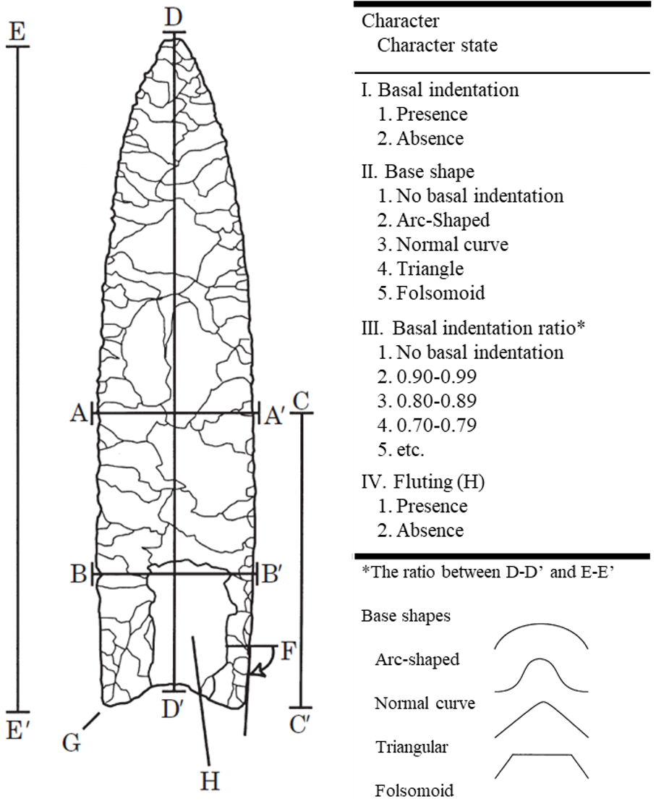
Figure 1—Examples of different grains of description used for measurement of basal indentation in projectile points. At the coarsest grain, basal indentation can be construed as the presence/absence of a trait (I), at a finer grain by the pattern of its curvature (II), and at an even finer grain in terms of basal indentation ratio (III). In this example, the basal indentation ratios are set within a range of 0.1, but a finer grain could deal with smaller ranges (e.g., 0.05, 0.01, etc.). These ranges are arbitrary to the extent that they depend on the investigator’s preferred degree of precision (see main text). (adapted from O’Brien et al. 2001)

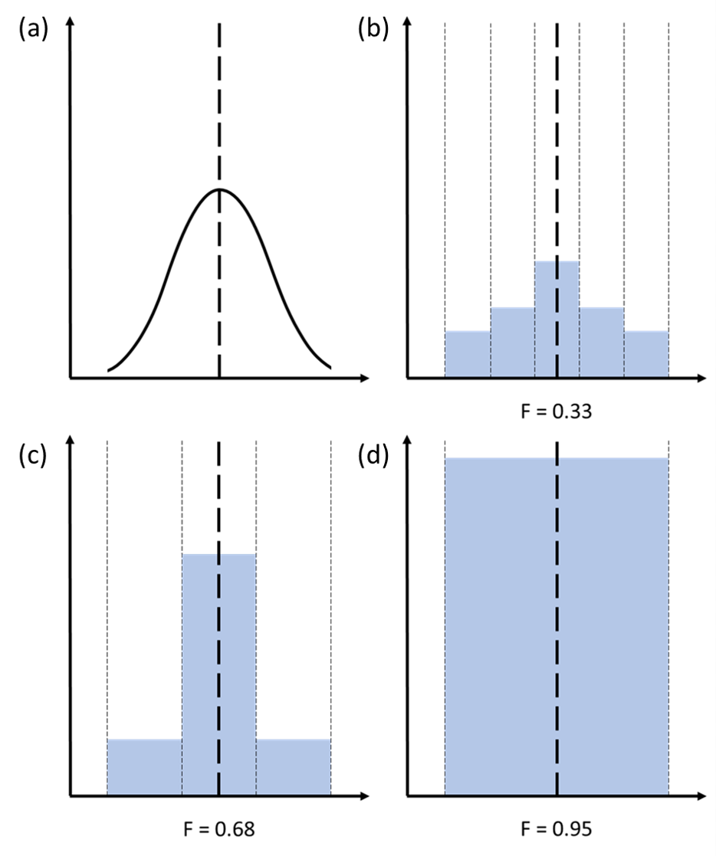
Figure 2—Differential impacts of a change in granularity on the measured degree of fidelity of the same cultural item. The vertical axis represents the frequency of learners with some trait value (between 0 and 1). The horizontal axis represents the different values the cultural item can take, specified by the dotted lines representing the grain of analysis (class boundaries). The black dashed line represents the trait value of the model. The blue rectangles represent the frequency of learners’ trait taking some value given the grain of analysis. (a) The curve represents a hypothetical distribution of trait value of the learner given a model’s trait value, for simplicity assumed to be normally distributed over a continuous dimension. (b) Fine grain of analysis (5 discrete states). The probability F that a randomly drawn learner replicates the model’s trait is low (F=0.33). (c) With a coarser grain (3 discrete states), the probability increases (F=0.68). (d) With the coarsest grain (1 state; presence/absence measure), replication is nearly guaranteed (F=0.95). By conflating into a coarse grain (e.g., a discrete range of values) what would count as different variants using a finer grain (e.g., specific values), a coarser granularity effectively makes it more likely to observe high-fidelity transmission simply because there are fewer potential variants that a learner can deviate into ‘mislearning’.

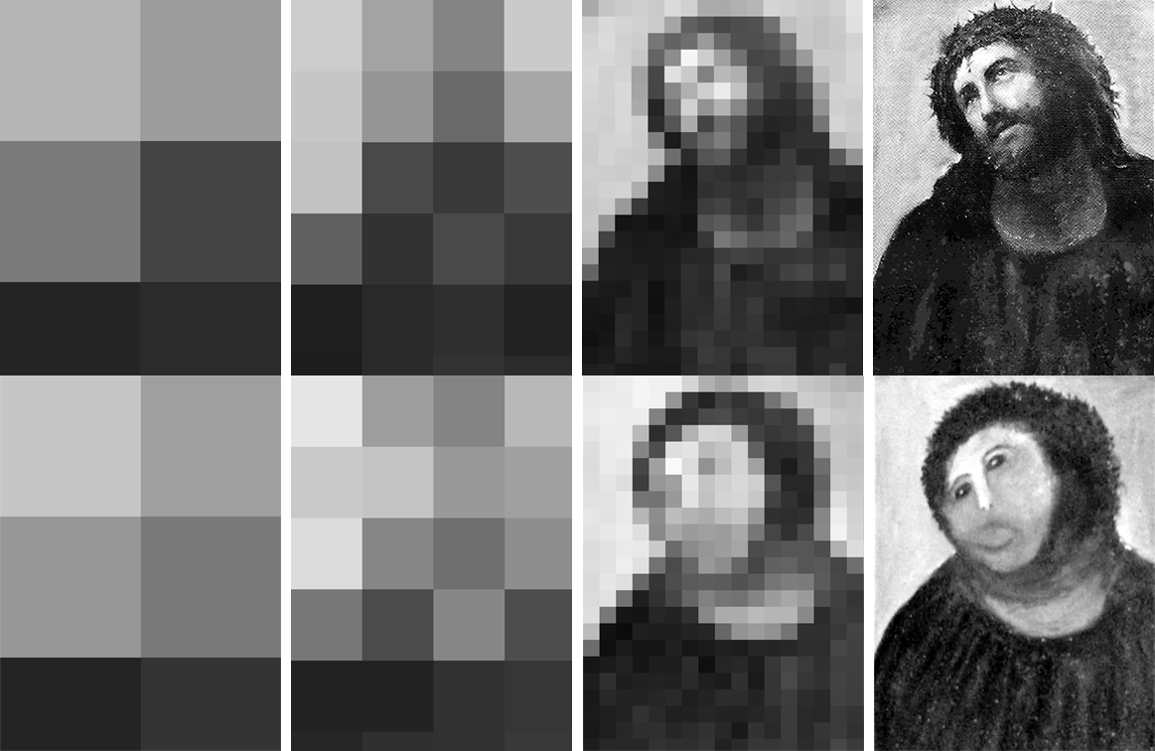
Figure 3— The upper row represents the model’s public display, and the lower one the learner’s. Each pixel represents the mean tone within its surface. Coarse-grained description (left column) renders very similar patterns (high-fidelity transmission), which become more and more dissimilar as the grain is refined (towards the right). (upper-right, Ecce Homo, circa 1890, Elías García Martínez ; lower-right, Ecce Homo restoration, credit Cecilia Giménez)

Each element of the story has had its share of criticisms (e.g., Charbonneau, 2015a, 2020; Claidière et al., 2014; Claidière & André, 2012; Heyes, 2018; Morin, 2016; Shea, 2009; Sperber, 2000).
Charbonneau (2020) refers to fidelity as an outcome as ‘episodic fidelity’ and fidelity as a process as ‘propensity fidelity’. Although we use different labels, our categories map on those used by Charbonneau.
Several expressions are used in the literature to refer to what we call ‘grain of description’. Acerbi and Mesoudi (2015) speak of ‘granularity of analysis’. Boudry (2018) speaks of ‘level of resolution’ and ‘level of abstraction’; Godfrey-Smith (2012) of ‘contrast’. Hoppitt and Laland (2013) speak of the ‘size’ of (action) units; Scott‐Phillips, Blancke, and Heintz (2018, 165) of ‘levels of detail and granularity’. Etc.
Our example of projectile point features is based on morphometrical analysis alone. More complexity can be added by considering the specific techniques used to produce the features, in which case even the flute feature may be more complex than a mere presence/absence trait (see Charbonneau (2015a; 2018) for discussion of the implications of dealing with the variation of production techniques in addition to morphological variation).
We thank an anonymous referee for asking us to clarify this point.
A similar kind of abuse could be made by systematically opting for a grain of analysis so fine that any cultural trait will be seen as unique, and thus always different in some respect from another, consequently leading to the impossibility of any form of replication. We know of no actual instances of such abuse, so we decided to focus on actual abuses rather than hypothetical ones.
It is important to note that the philosophical program developed by Dennett (2017)—showing how intelligent design can emerge from non-intelligent design—is not affected by the argument developed here. This is because, for Dennett’s argument to work, all that is required is that those cultural traits that bring about competence without comprehension do so on a rather coarse grain of description at which they replicate (e.g., cognitive traits such as counting, reading, formal logic, etc.), not that replication be a pervasive property of cultural learning. We do not deny some cultural variants are better studied with such grain, and so our argument does not challenge Dennett’s philosophical program.
Although sometimes these details do count, as fermented dairy products such as yogurt or cheese contain less lactose than milk, and therefore can be consumed by lactose intolerant populations (Gerbault et al., 2011).
We thank Maria Kronfeldner for pointing to this idea (personal discussion, MC).
The grain problem is not unique to cultural evolution. For instance, it has a rich history in the philosophy of biology, where several authors have discussed how choosing a grain at which a population, adaptations, or even the environment are described affects assessments about natural selection (Abrams, 2009, 2014; Beatty, 1984; e.g., Brandon, 1990). For instance, see a similar discussion about the grain problem in evolutionary psychology in Sterelny and Griffiths (1999, chapter 13).
Hoppitt & Laland (2013) prefer the expression ‘behaviorial level’ (p.53).
In fact, most if not all evolutionary models arguing in favour of some form of social learning (or a capacity for social learning in general) as a fitness-enhancing adaptation for culture in fact do not model how some specific cognitive mechanisms were selected to serve that role, but instead model in which ecological conditions some behaviourally-characterized form of social learning—i.e., learning patterns spelled out in terms of input and output classes of observed cultural variation—would be adaptative (e.g., Boyd & Richerson 1995). This strategy is akin to adopting a cultural analog to the phenotypic gambit (Laland 2004).

