The Methodological Value of Coincidences: Further Remarks on Dark Matter and
the Astrophysical Warrant for General Relativity

WILLIAM L. VANDERBURGH
Wichita State University

Word count: 4631 word main text, 2 figures, 108 word abstract

Abstract
This paper compares four techniques for measuring the masses of galaxies and larger astrophysical systems from their dynamics. The apparent agreement of these techniques is sometimes invoked as reason for hypothesizing the existence of huge quantities of “dark matter” as the best solution to “the dynamical discrepancy”, the 100-fold disparity between the amount of mass visible in large scale astrophysical systems and the amount calculated from dynamics. This paper argues that the agreement, though suggestive, is not definitive. The coincident measurements remain the best reason for preferring dark matter over revisions to General Relativity for solving the dynamical discrepancy, but the resulting warrant for this preference is weak.
1. Introduction. The “dynamical discrepancy” for galaxies, clusters of galaxies and other large scale dynamical systems—popularly known as the “dark matter problem”—arises because the mass visible in such systems (the total of stars, gas and dust detected at all wavelengths) is up to 100 times less than the mass inferred from their dynamics. The dynamical discrepancy was first discovered in the 1930s; despite persistent efforts it remains unresolved today. In principle it has two classes of possible solutions: either there is a huge quantity of unseen matter of unknown type in large scale astrophysical systems, or Einstein’s General Theory of Relativity, our current best theory of gravity, needs to be seriously revised or entirely replaced.
The astrophysical dynamical discrepancy raises many interesting and difficult philosophical questions, not the least of which is how to decide what theory correctly describes the action of gravity at large scales. The class of viable gravitation theories is larger and more diverse than physicists and philosophers of science typically suppose. And the theory choice problem in this case is especially difficult.
Vanderburgh (2003, 814-15) points out that the available dynamical evidence only directly constrains the action of gravity for interactions taking place over scales corresponding to roughly the size of our solar system (hereafter, ‘stellar system scales’). General Relativity (hereafter ‘GR’) not only makes predictions that agree to high precision with all the available stellar system scale phenomena, but in fact also has a much stronger kind of confirmation at those scales, namely from the fact that the observed phenomena can be used to measure the parameters of the theory. These measurements from phenomena (the echo of Newtonian method is deliberate) are the basis for epistemically robust theory comparisons via the Parametrized Post-Newtonian or ‘PPN’ framework. The result of applying the PPN framework is that, at stellar system scales at least, GR has a high degree of empirical support, and is clearly better than every rival gravitational theory so far articulated. (See Harper and DiSalle 1996, Will 1993, and Earman 1992, 177ff.) On the basis of these stellar system scale successes, GR is inductively extended to cover all phenomena, just in the way Newton used diverse-seeming phenomena—pendulums, the Moon, planetary orbits, the Jovian moons, and so on—to measure the force of gravity to be inverse square, and then inductively extended that law to cover all phenomena.
However, the existence of the astrophysical dynamical discrepancy means that the observed motions within galaxies, clusters of galaxies and other large scale dynamical systems are actually inconsistent with the predictions of General Relativity given the assumption that the amount and distribution of mass within those systems is indicated by the amount and distribution of light within them. The class of empirically viable gravitation theories therefore includes members each of which are predictively equivalent to General Relativity for interactions taking place at stellar system scales but which make predictions that differ from those of GR, in some cases radically, for interactions taking place over distances corresponding to the radii of galaxies or larger systems (hereafter, ‘galactic and greater scales’).
Vanderburgh (2003) argues that, unlike at stellar system scales, dynamical evidence cannot be used to decide what dynamical law governs interactions at galactic and greater scales. This is obviously a less than ideal evidential situation; it forces us to consider non-dynamical factors in the attempt to resolve the dynamical discrepancy. Vanderburgh (in preparation) considers what help can be obtained toward resolving this theory choice problem from methodological principles such as Newton’s Rules for the Study of Natural Philosophy. The present paper considers further details of the available astrophysical evidence in an effort to determine whether any grounds for preferring GR over rival gravitation theories can be found there.
The overall conclusion is that a set of empirical coincidences—namely, roughly agreeing mass measurements based on apparently independent measurement techniques—do provide some grounds, albeit weak and defeasible, for thinking GR is better than its rivals. The preference for GR over its rivals is thus methodologically rather than strictly empirically based. A merely methodological warrant is a weaker sort of warrant than could be hoped for, but it is the best possible in the present evidential context, and it may be adequate for some purposes (such as helping to decide directions for future research). The issue of comparing the differential methodological warrant of currently observationally indistinguishable (but note, neither predictively nor epistemically equivalent!) gravitational theories is complicated by the fact that only two theories of gravity have so far been proposed as solutions to the dark matter problem, and neither of them survive critique (see Vanderburgh 2003, 820-22): there are currently no genuine articulated rivals to compare against General Relativity. It could be argued that “merely possible” rivals of the sort in contention with GR as potential solutions to the dynamical discrepancy have no weight, and should not be taken to pose any epistemic challenge to an entrenched theory. Though I agree in general with this sentiment, I think that taking seriously this particular theory choice problem is illuminating in several respects, not least in that it forces us to consider in more detail and with greater care the basis for continued belief that GR is the correct theory to apply to astrophysical phenomena.
2. Possible Solutions to Dynamical Discrepancies. The astrophysical dynamical discrepancy is closely analogous to the discrepancy discovered in Uranus’ orbit in the early 1800s. The motions of Uranus were inconsistent with the predictions of Universal Gravity given the then-known distribution of mass in the solar system. Two possible solutions were available: either modify Universal Gravity, or posit the existence of previously unknown mass. The latter, of course, was the kind of solution pursued independently by Adams and Leverrier; in 1846 LeVerrier’s prediction of the geocentric position of the unknown planet was good enough to lead to the telescopic discovery of Neptune. (See Grosser 1979 or Standage 2000.) The case of Mercury’s excess perihelial precession is another example of a dynamical discrepancy that is analogous to the astrophysical case; in the Mercury case, however, the correct solution was adopting a new theory of gravity (namely, GR) rather than proposing the existence of previously unknown extra mass. (See Earman and Janssen 1993.)
The Uranus and Mercury analogies demonstrate that there are two classes of possible solutions to dynamical discrepancies in general:
(1) The first class, the matter solutions, propose the existence of about 100 times more mass than is visible in astrophysical systems. The distribution of this mass, on the assumption that it exists, is fairly easy to calculate from the observed dynamics. It is more difficult to say what this matter is. It is called “dark” matter because it neither emits not absorbs detectable electromagnetic radiation at any wavelength. Dark matter has so far eluded detection despite almost thirty years of active searching. A plethora of candidates have been proposed, ranging from otherwise unknown fundamental particles to black holes. Many of the candidates have been ruled out, at least as the whole solution, on empirical and theoretical grounds. Those that remain have little to no positive empirical support beyond the fact that it is not impossible, so far as we can now tell, that they could in principle resolve the dynamical discrepancy.
(2) The second class, the gravity solutions, postulate no excess unseen matter, and instead revise the action of gravity at large scales. The empirical constraints on such theories are surprisingly weak: they must agree to high precision with the predictions of General Relativity for phenomena taking place at stellar system scales, and they must be consistent with the observed dynamics of large scale astrophysical systems given the mass visible in those systems, but otherwise anything is possible. (A combination of matter and gravity solutions is another option, but this is rarely discussed in the scientific literature.)
There is no empirical reason to think that a matter solution to the astrophysical dynamical discrepancy is more probable than a gravity solution, or vice versa, just as in the Uranus and Mercury cases it was impossible to tell in advance which type of solution would ultimately succeed (solutions of both types were tried for both problems). The class of gravitation theories that are empirically viable in the current evidential situation therefore includes theories that are empirically equivalent to General Relativity at stellar system scales but whose predictions may diverge radically from GR’s at larger scales. It would be ideal to construct a testing framework analogous to the PPN formalism for empirical comparisons within this class of gravitational theories. However, “the dark matter double bind” seems to rule out the possibility of carrying out such a testing program:
In order to evaluate the empirical adequacy of any gravitation theory at galactic and greater scales, the mass distribution in dynamical systems at those scales must first be known—but because of the astrophysical dynamical discrepancy the mass distribution is not known. In order to infer the mass distribution from the observed motions, a gravitational law must be assumed—but such a law cannot legitimately be assumed, since the very thing at issue is which gravitational law ought to be taken to apply at galactic and greater scales. (Vanderburgh 2003, 824)
In light of this, it is possible that GR could turn out to be the “stellar system scale” limit of some successor relativistic gravitation theory, in the same way that Newton’s Universal Gravity turned out to be the “low velocity, weak field” limit of GR.
3. Coincident Measurements. Vanderburgh (in preparation) agrees with Harper and DiSalle (1996) that Newtonian methodological ideals inform current gravitation physics. An important part of Newton’s use of Reasoning from Phenomena in the argument for Universal Gravitation is that diverse phenomena yield precisely agreeing measurements of parameters of the theory. The coincidence of these measurements lends strength both to the unification of these apparently diverse phenomena under a single gravitational law, and to the inductive extension of that law to all possible cases. (The unification argument is that since the same force law governs each of the phenomena, therefore the very same force—gravity—is at work in each case. The inductive extension or generalization of the results of reasoning from phenomena says that the law found for all phenomena studied so far should be taken to be the law governing all phenomena whatsoever. These two inferences are grounded by Newton’s third and fourth “Rules for the Study of Natural Philosophy” respectively.) The methodological value of such coincident measurements, then, is that the coincidence is the foundation for stronger arguments in favor of a theory than would be possible without it.
There is a set of measurements of the masses of galaxies and larger structures that appear to provide independent coincident results. Does the coincidence of these measures do for GR at galactic and greater scales what the coincident measures at stellar system scales do? That is, do these coincident measures provide a strong (or any) methodological basis for thinking of GR as preferentially supported over its rivals? In what remains of this paper I explore the details of the coincident measures in an attempt to answer these questions.
I began this paper by mentioning a discrepancy between different kinds of measurements of the masses of galaxies and larger structures. More exactly, calculations of “luminous masses” are systematically much less than measures of the “dynamical masses” of the same systems and types of systems. The “luminous mass” is obtained by measuring a system’s total luminosity at all wavelengths and comparing that to a “mass-to-light” ratio derived from a combination of empirical and theoretical considerations. The “dynamical mass” is calculated by one of four methods. The different dynamical mass measurement techniques are used for different types of systems. First, for spiral galaxies, which have a well-defined plane and sense of rotation, a “rotation curve” can be taken, and from it an overall mass distribution for the system can be inferred. Second, for elliptical galaxies and clusters of galaxies, where the internal motions are essentially random, a “velocity dispersion” can be taken and the Virial Theorem applied to obtain the mass of the system. Third, many galaxies and clusters are enveloped in a cloud of diffuse gas that emits X-rays because it is heated by the gravitational field of the system. The “X-ray temperature” of a system can be converted into an estimate of its total mass. Fourth, in rare cases, a foreground galaxy or cluster lies along the line of sight to a background galaxy, cluster or quasar, and the gravitational field of the foreground object deflects the light of the background object—this is called “gravitational lensing”. From the appearance of the image of the background object, the mass of the foreground object can be estimated.
Rotation curves, velocity dispersions, X-ray temperatures and gravitational lensing give apparently agreeing measurements of the masses of large scale astrophysical systems. Since the techniques seem to be independent of one another, the coincidence of their results is taken to provide strong grounds for thinking that the astrophysical dynamical discrepancy will have a matter solution rather than a gravity solution. However, I aim to show in what follows that the apparent coincidence of the measures is in reality not as evidentially or methodologically significant as it is sometimes made out to be. That said, these measurements taken together are still the best available reason for preferring matter solutions over gravity solutions, and thus for thinking that GR rather than some rival gravitational theory correctly describes the action of gravity at galactic and greater scales. I now discuss each of these mass measurement techniques in more detail.
4. Details of the Four Mass Measurement Techniques. Rotation curves are obtained by taking spectroscopic observations of the stars and gas clouds within spiral galaxies. By the well-known relationship between an object’s velocity along the line of sight and the Doppler shifting of its spectrum, the observed “redshifts” give the component of rotation along the line of sight. A graph of redshift against distance from the galactic center yields the rotation curve. The mass interior to any given radius can be calculated from the rotational velocity of objects orbiting at that radius. The principle is the same as measuring the mass of the Sun from the radius and speed of the orbit of a planet around it. The observed rotation curves for spirals show that the absolute value of the rotation at any given radius is much higher than predicted given the luminous mass and the Newtonian limit of GR. Even more importantly, instead of eventually falling off asymptotically to zero, observations of gas clouds show that the rotation velocity actually remains flat or even rises out to several times the radius of the disk of stars. (See Figures 1a through 1d.)
< insert Figure 1 about here >

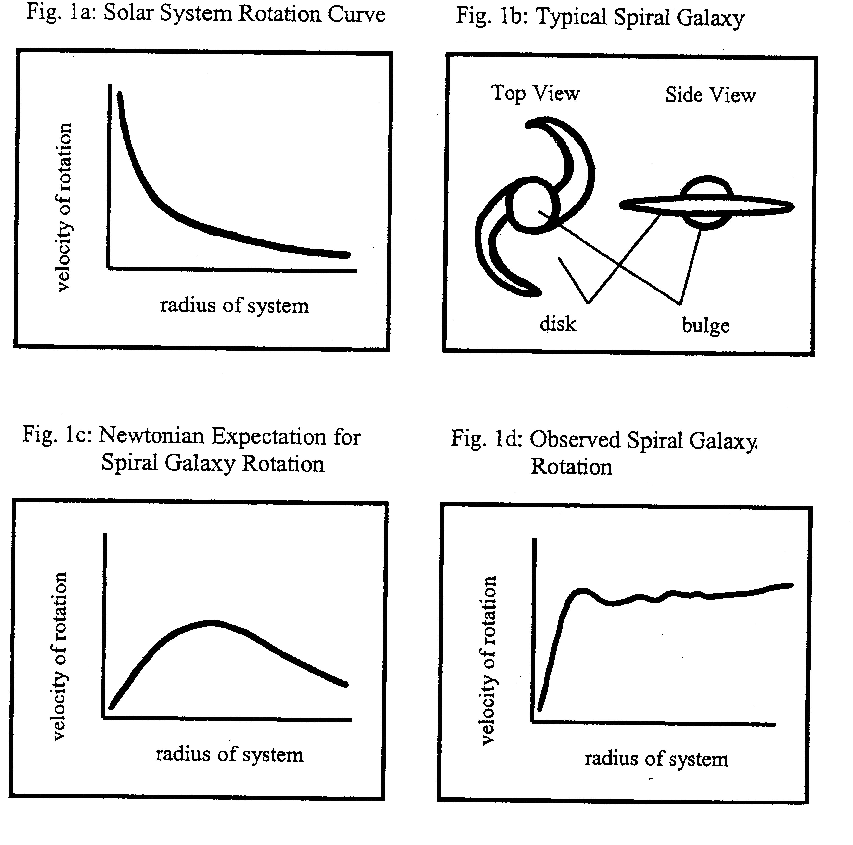

On the assumption that the Newtonian limit of GR correctly describes the action of gravity at galactic and greater scales, the only way to account for the observed rotation curves is to hypothesize the existence of a spherical “halo” of invisible matter surrounding every spiral, where the halo extends to several times the disk radius and contains about 100 times the mass visible in the galaxy. The alternative to this extravagant excess of invisible mass of unknown type is to propose a new account of gravity at galactic and greater scales.
Parallel results are found for elliptical galaxies and clusters by the method of velocity dispersions. Velocity dispersions are obtained spectroscopically as well. The collection of relative redshifts of the components of ellipticals and clusters (stars and galaxies respectively) gives information about the motions within those systems. The Virial Theorem, originally developed in thermodynamics from principles of Newtonian mechanics, can then be applied to determine the gravitational potential needed to produce the observed velocities, and this yields a value for the total mass of the system. The Virial Theorem is m = r⟨v²⟩/αG, where ⟨v²⟩ is the average of the squares of the velocities at a given radius r, G is the gravitational constant, and α is a constant whose value depends on the mass distribution but which is usually of order unity (Tayler 1991, 194). This is the most common way of calculating the dynamical masses of large scale astrophysical systems.
Mass measurements from the observed X-ray temperatures of clouds of diffuse gas enveloping galaxies and clusters operate on the assumption that gravity is the only plausible explanation of the continual heating of the gas that is required for the continual emission of X-rays. The intensity and spectrum of the X-ray emissions determines the amount of heating needed, and this in turn is converted into a value for the gravitational potential generated by the system in question. On the assumption that the Newtonian limit applies, this leads to an estimate of the total mass of the system. As in the case of rotation curves and velocity dispersions, the masses found by this method are about 100 times greater than the luminous masses inferred from observations of stars, gas and dust in these systems.
The three previous measurements types are in actual practice performed using only Newtonian physics—the systems in question satisfy the weak-field, low-velocity limit, and thus no relativistic contributions to the dynamics are expected. Gravitational lensing, in contrast, depends on the specifically relativistic parts of GR. Gravitational lensing is well understood theoretically: given that GR is correct, we can predict the image patterns that will be produced by different magnitudes and configurations of mass in the “lens” (the foreground object whose gravity deflects the background light) given different distances and alignments between observer, lens and background object. (See Figure 2.) Conversely, from an observed image pattern, the mass of the lens can be inferred. We now know of cases of gravitational lensing where the background objects are quasars and galaxies, and where the foreground objects are spirals, ellipticals and even clusters of galaxies.

< insert Figure 2 about here >
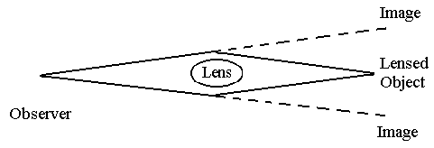

Advocates of gravity solutions to the dynamical discrepancy might try to claim (as Mannheim did in response to a question in a colloquium at the University of Western Ontario in 1995) that if these different measurement techniques yield agreeing measurements of the masses of astrophysical systems, then they must be wrong by the same amount. It is hard to see how this could plausibly be the case, however. Rotation curves, for example, require only Newtonian physics to yield the dynamical masses of spirals, whereas gravitational lensing makes use of the specifically relativistic parts of GR. A better way to approach the challenge of agreeing measures is to point out that the agreement is less than it appears to be, and leaves enough room for gravity solutions.
With each of these methods, a general trend has been found wherein larger systems tend to have a higher ratio of dynamical mass to luminous mass. This is true both within and across system types: larger spirals have a larger dynamical discrepancy than smaller spirals, and clusters have a larger discrepancy than individual galaxies. (A likely explanation of this trend is that in the early universe locations where dark matter was more concentrated attracted more baryonic matter, which later became the luminous parts of galaxies and clusters. Or it could be that something else such as initial density fluctuations seed galaxy formation, and that baryonic matter and dark matter are both preferentially attracted to the larger seeds.) Despite this general trend, however, I contend that there is a problem with claiming that we get agreeing measures of the masses large scale astrophysical systems from these independent methods.
The first point is that often we cannot apply more than one method to any one system. Rotation curves, for example, are possible for spirals but not ellipticals, and the velocity dispersion technique applies to ellipticals but not to spirals. There are relatively few cases of gravitational lensing known. The available gravitational lensing results do find that the masses of spirals that act as lenses are of the same order of magnitude as is typically found by rotation curves for spirals of similar diameters and luminosities; likewise, where the lens is an elliptical galaxy the mass derived from the lensed image agrees to within an order of magnitude with the typical masses found by velocity dispersions for ellipticals whose parameters are similar to those of the lens in question. But (so far as I am aware) no single galaxy has had its mass determined both through gravitational lensing and through either rotation curves or velocity dispersions. (Systems that act as lenses are normally extremely distant, and hence too dim for the detailed spectroscopic work necessary to construct a rotation curve or velocity dispersion.) This means that the “agreement” between rotation curves or velocity dispersions and gravitational lensing is based on an analogical argument. Analogical, order of magnitude agreement for types of systems is suggestive, but it is certainly not definitive. (Closer agreement between lensing and other measurements is not possible because of the margins of error introduced by the assumptions necessary to perform the lensing calculation, including assumptions about the radius of the lens and the shape of its overall mass distribution, its distance from us, and its distance from the background object lensed.)
It is true that many galaxies and clusters have their masses estimated both from velocity dispersions and from X-ray temperatures, and that the results essentially agree. But the margins of error are not small in either kind of measurement. In any case, two other points are important to mention. The first point is that X-ray temperatures and velocity dispersions are based on the same Newtonian principles, and hence it could be argued that they are not really independent methods. The second and more telling point is that if an alternative gravitational law were assumed in these techniques, we might equally well find agreeing measurements of a different amount of mass. This is to say that the mass results from velocity dispersions and X-ray temperatures are fairly sensitively model dependent. Thus the fact that their results agree in a given case could indicate that the correct value for the dynamical mass has been found, or it could be construed as an agreeing measurement of the parameters of an alternative theory of gravitation. In short, by itself the agreement between velocity dispersion and X-ray mass measures only confirms the overall size and character of the dynamical discrepancy, it does not give preferential support to the notion that hidden mass is really the cause of the discrepancy.
Buote et al. (2002) note that in a few galaxies the orientation of the cloud of X-ray gas is different from that of the luminous matter. This is an interesting result because, as they argue, it implies that there must really be a halo of dark mass surrounding the luminous matter. We know on theoretical grounds that the shape of the gravitational potential heating the gas must be the same as the shape of the overall mass distribution, whatever gravitational law holds. So the fact that the X-ray-emitting gas cloud is oriented differently than the luminous mass indicates that there must exist a distribution of hidden mass in the galaxy that dominates the luminous mass and which is oriented in the same pattern as the X-ray cloud. If robust, these results show that there really is dark matter. Note, however, that this result can hold even if the correct theory of gravity for galaxies and larger structures is not (the Newtonian limit of) GR. That is, this result is perfectly consistent with alternative theories of gravity: it does not prove that the dark matter needed to heat the X-ray emitting gas is the complete solution to the dynamical discrepancy. We might have a complex solution involving both dark matter and a new law of gravitation.
5. Conclusion. The preceding discussion shows that it is not possible to assert definitively that the four methods of measuring dynamical mass at galactic and greater scales yield agreeing measurements of the masses of large scale astrophysical systems. The agreement we get from these techniques is somewhat loose and could be merely coincidental. At the very least, whatever agreement is present, it does not have the same epistemically robust character as (for example) the multiple, agreeing and precise measurements of the mass of the Sun obtained from the motions of several planets.
It cannot be denied, however, that the four methods discussed here do give roughly agreeing results. The roughness of the agreement must be taken into account, as should the fact that what is being measured is the mass of these systems on the assumption that (the Newtonian limit of) GR applies to these systems. Strictly speaking, these techniques give us agreeing measures (insofar as they are agreeing) of the value of the total forces produced by the compound of “mass distribution plus gravitational law”. The techniques do not tell us the relative weights of those two components: the measured values could result from just the visible matter plus a new law of gravity at large scales, or from the Newtonian limit of GR plus dark matter, or some combination new matter and new gravity. That said, however, my intuitions are with that of most physicists: the available evidence seems more likely to yield to a matter solution than a gravity solution, which is to say that on balance it seems more likely that GR is the correct theory of gravitational interactions at galactic and greater scales. That position is only weakly warranted, however: a gravity solution of the dynamical discrepancy remains quite possible.

REFERENCES
Buote, David A., Tesla E. Jeltema, Claude R. Canizares, and Gordon P. Garmire (2002), “Chandra Evidence for a Flattened, Triaxial Dark Matter Halo in the Elliptical Galaxy NGC 720”, Astrophysical Journal 577: 183-196.
Earman, John (1992), Bayes or Bust? A Critical Examination of Bayesian Confirmation Theory. Cambridge: MIT Press.
Earman, John, and Michel Janssen (1993), “Einstein’s Explanation of the Motion of Mercury’s Perihelion”, in John Earman, Michel Janssen and John D. Norton (eds.), The Attraction of Gravitation. Boston: Birkhauser: 130-31.
Grosser, M. (1979 [1962]), The Discovery of Neptune. (First published by Harvard University Press.) New York: Dover Publications.
Harper, William, and Robert DiSalle (1996), “Inferences from Phenomena in Gravitational Physics”, Philosophy of Science 63 (Proceedings): S46-54.
Mannheim, Philip D., and Demosthenes Kazanas (1994), “Newtonian Limit of Conformal Gravity and the Lack of Necessity of the Second Order Poisson Equation”, General Relativity and Gravitation 26.4: 337-361.
Milgrom, Mordehai (1994), “Dynamics with a Non-Standard Inertia-Acceleration Relation: An Alternative to Dark Matter in Galactic Systems”, Annals of Physics 229: 384-415.
Standage, Tom (2000), The Neptune File: A Story of Astronomical Rivalry and the Pioneers of Planet Hunting. New York: Walker and Company.
Trimble, Virginia (1987), “Existence and Nature of Dark Matter in the Universe”, Annual Review of Astronomy and Astrophysics 25: 425-472.
Tayler, Roger J. (1991), The Hidden Universe. Chirchester, Great Britain: Ellis Horwood Limited.
Vanderburgh, William L. (in preparation), “Newton’s Rules for the Study of Natural Philosophy and Theory Choice in Current Gravitation Physics,” under editorial review.
——— (2003), “The Dark Matter Double Bind: Astrophysical Aspects of the Evidential Warrant for General Relativity,” Philosophy of Science 70: 812-832.
Will, Clifford M. (1993), Theory and Experiment in Gravitation Physics. Revised edition (first edition 1981). Cambridge: Cambridge University Press.

FOOTNOTE

Binary pulsars, the decreasing periods of which provide an important test of GR, are included under stellar system scale phenomena; as Vanderburgh (2003, 814-15) describes, the available tests of GR are all for interactions taking place over (much) less than a light year, whereas galaxies have radii in the range 10⁴ to 10⁵ lightyears or larger, and the distance between the galaxies in clusters averages 10⁶ lightyears or more. The available tests of GR thus probe only the tiniest fraction of the relevant distances.

