Computing the Uncomputable,

or,

The Discrete Charm of Second-Order Simulacra

Matthew W. Parker

London School of Economics

Abstract. We study an especially attenuated application of “mediating models”, in which computer simulations suggest that a certain dynamical system exhibits non-computable behaviour. These simulations are defended by reference to a simpler model of the model (hence “second-order simulacra”). We will see that this defence is problematic, but there are general reasons to believe the simulations are accurate. And though these models do not prove anything specific about an actual physical system, they influence our general expectations, and provide an essential component for any complete explanation of why and how the qualitative behaviour of some actual systems may be non-computable.

If we could take as the finest allegory of simulation the Borges tale where the cartographers of the Empire draw up a map so detailed that it ends up exactly covering the territory…, this fable would then have come full circle for us, and now has nothing but the discrete charm of second-order simulacra.
—Baudrillard, Simulations and Simulacra

1. Introduction
The Borges parable to which Baudrillard refers is no doubt well known to those who study the use of models and simulations in science. It is in fact titled “On Exactitude in Science” (1999), and it expresses, with a sense of the sublime, the simple point that there is great value in simplification and omission. Lewis Carroll’s gigantic map, with a scale of “a mile to the mile”, may be less familiar (2005). Due to enormous practical problems with this map, a bearded gentleman explains, "we now use the country itself, as its own map, and I assure you it does nearly as well". The ironic implication, of course, is that in truth it does almost as badly. A useful representation must be manageable, and this requires that it be incomplete and inaccurate. One problem for philosophy of science is to understand how the contents of a map—a good map, a simplified representation—are related to the real world, and in particular, how we can trust and learn from a map when we know very well that it is inaccurate or even plain false. This problem, which we might call the validation problem, arises for models as well as for simulations, defined by Hartmann as processes in which a model imitates the time evolution of a real system (2005).
Our main purpose here is to consider the validation problem in the restricted context of one real case, taking into account how the orgiginal scientists themselves have attempted to address it. The case considered here, due to Sommerer and Ott (1996), is especially interesting for two reasons. Firstly, the authors argue that a certain dynamical system, one that could plausibly be physically instantiated, exhibits strictly non-computable behaviour. It seems worthwhile, for the epistemology of physics, to investigate whether this is true and in exactly what sense. This has been addressed elsewhere (Parker 2003, 2005). Secondly, the case exhibits multiple layers of modelling and simulation: a continuous-time dynamical system, governed by differential equations, is simulated on a computer, and the interpretation of the simulation is justified by appeal to yet another model, a simpler discrete-time (hence “the discrete charm”) model of the model (hence “second-order simulacra”), and indeed, this in turn is analysed in terms of yet an other model. I will argue that the justification given by Sommerer and Ott is problematic, but there are other, more general and intuitive reasons to believe their results. These concern the structural similarities between the two models, of course, and the robustness of the relevant properties with respect to small changes to these models.
Little attempt will be made here to draw general lessons for any comprehensive theory of models or simulations. Perhaps more than anything else, the complexity of our example illustrates (yet again) what varied hats such simulacra actually wear. But if we insist on a general lesson, it may be this: that we do not have to trust a model in order to learn from it. Models can teach and explain just by revealing general features of how things might go.

2. Sommerer and Ott’s continuous system
In the 1990s there was a flurry of papers claiming or speculating that some physical system or model exhibits non-computable behaviour. (See Parker 2003.) In particular, it was suggested that some basin of attraction, or some other set of states charaterised by the long-term behaviour of the system, was undecidable. No algorithm could determine which states were in the set, and hence no algorithm could determine the long-term behaviour of the system from its present state—it was claimed. Unfortunately, the physicists making such allegations often neglected the conceptual difficulties that arise in the attempt to apply computability theory to real numbers and continuous spaces, the matter from which their models are hewn, but we will return to that point later.
Sommerer and Ott (1996) were among those who argued that the behavior of some dynamical system is non-computable. Their model was described as a point particle moving in a two-dimensional potential, periodically “kicked” by an additional force. The motion is governed by
$\frac{d^{2}x}{{dt}^{2}}=−γ\frac{dx}{dt}−∇V(x)+a\text{sin}(ω t ) i$, (1)
where x = (x, y) varies over ², γ is the friction coefficient, i is the unit vector in the
positive x direction, a is the amplitude of the periodic force, ω / 2π is the frequency of the periodic force, and ∇V is the gradient of the potential given by
V(x) = (1 – x²)² + sy²(x² − p) + ky⁴. (2)
The parameters s, p, and k may be varied to obtain a family of potentials. Here we hold all parameters fixed at Sommerer and Ott’s chosen values: γ = 0.632, a = 1.0688, ω = 2.2136, s = 20, p = 0.098, and k = 10.
The periodic force $a\text{sin}(ω t) i$ in Equation 1 depends explicitly on time. However, we can obtain an autonomous (time-independent) system by regarding t itself as a state variable, so that a state for the system is a quintuple (x, y, dx/dt, dy/dt, t). Thus the motion is completely determined by the initial values of the state variables, and

(a)
(b)
(c)
Figure 1. Sommerer and Ott’s forced potential. The equations describe the motion of a marble rolling on this surface as the surface periodically rocks left and right. Part (a) shows the potential V unaltered (except for the flattening at the top of the graph, which is an artifact of the graphing utility). Parts (b) and (c) show close-ups of the potential with rocking.
solutions form a dynamical system on a phase space with five dimensions, corresponding to these five variables.
Intuitively, the system can be visualized as a marble rolling around on the curved surface described by V(x): a deep well with two dips in the bottom, flanking the y-axis, and a small bump between them. (See Figure 1.) To incorporate the periodic force, imagine this surface rocking gently to the left and right. Due to friction, the marble will tend to settle into one of the two dips, but due to the rocking, it will continue to roll left and right within that dip, near the x-axis. While friction drags the path of the marble down nearer and nearer to the x-axis, where the dip is deepest, the central bump introduces an element of instability: if our marble rolls up onto the bump, it will fall away from the x-axis.
Simulations suggest that this destabilization can occur no matter how closely the marble has settled in near the x-axis (as long as it does not begin exactly on the axis with velocity exactly parallel to it). Typically, two initial conditions that are very close in phase space result in orbits that remain nearly identical for a brief time, then diverge. (See Figures 2 and 3.) The position coordinates in the x-y-plane for each orbit soon settle down to a nearly one-dimensional oscillation very near the x-axis, perhaps with both orbits in the left-hand well. Their motion left and right is extremely erratic, driven by the periodic force but not synchronized with it. Occasionally, one orbit may become destabilized, swing around, and settle down again. This seems to happen less and less as time passes. Yet at any time, one orbit might become destabilized, swing all the way into the other well, and settle down there, so that the once nearly identical orbits now live in
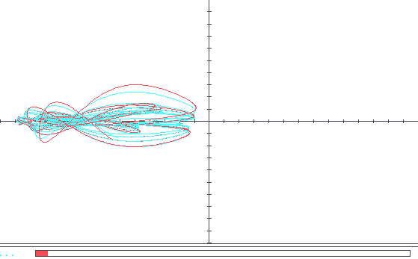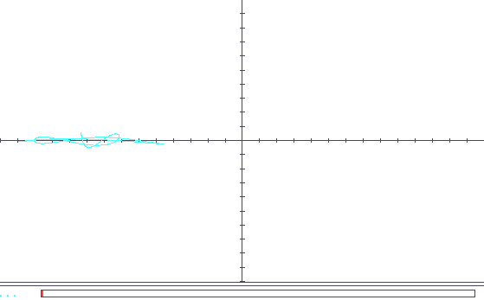
(a)
(b)
Figure 2. Orbits of Sommerer and Ott’s system (I). Position coordinates of two orbits with very nearby initial conditions are shown. The length of the red bar at the bottom of each graph indicates time elapsed since the initial states. (a) The two orbits are so similar they are indistinguishable and are shown as one orbit. (b) The orbits soon diverge. (Continued on next page.)
(b)
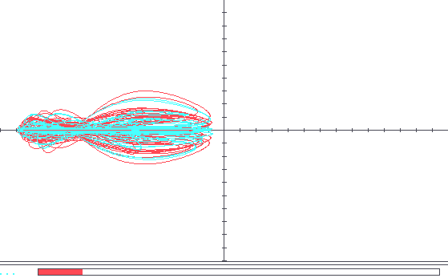
(c)
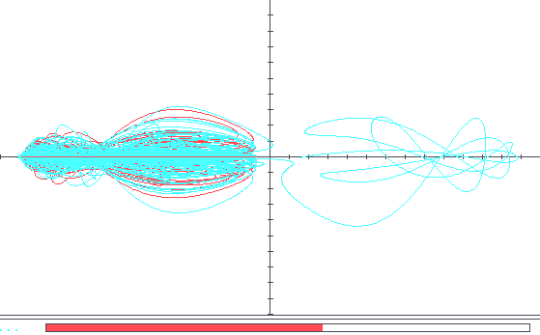
(d)
Figure 3. Orbits of Sommerer and Ott’s system (II). (c) Both orbits soon settle down very close to the x-axis, shown only by the straight red line on the x-axis. (d) After a long time, one orbit becomes erratic and escapes to the other attractor, where it will probably stay. Thus two nearly indistinguishable initial states result in orbits approaching different attractors.
(d)
(d)
separate dips, probably forever.
Given these seemingly unpredictable episodes of destabilization, one might suppose that orbits never settle down permanently. However, Sommerer and Ott give an analytic (or at least partly analytic) argument that the system does in fact have two attractors corresponding to motion along the x-axis in each of the two dips, so a significant portion of orbits do settle down for good. The argument reveals the structural features of the system that will be important later. The three-dimensional subspace where y = dy/dt = 0, corresponding to marbles that roll along the x-axis exactly, is an invariant manifold: orbits within it stay in it. (This follows immediately from Equations 1 and 2.) Orbits within this manifold form a dynamical system all their own, governed by the much studied two-well Duffing equation,
$\frac{d^{2}x}{{dt}^{2}}+γ\frac{dx}{dt}−4x(1−x^{2})=a\text{sin}(ω t)$, (3)
which we obtain by substituting 0 for both y and dy/dt in equations 1 and 2. The authors make use of two facts about this subsystem that are apparently well known and are confirmed by their simulations (though the present author does not know whether they have been proven analytically): (1) It has two attractors, corresponding to the two dips, relative to the invariant manifold (i.e., sets whose basins of attraction have positive three-dimensional volume within that manifold). (2) Motion on these attractors is chaotic. Given these assertions, they then argue analytically that the two attractors of the subsystem are also attractors for the larger original system, so many orbits within the five-dimensional phase space are drawn to the attractors within the invariant manifold. That is, in many cases our marble is eventually trapped in one or the other dip.
Numerically approximated graphs illustrate the basins of the attractors. (Permission to reproduce those graphs here has not been obtained. Please see Parker 2003 or Sommerer and Ott 1996.)

3. Computing the uncomputable!
Sommerer and Ott’s graphs suggest that both basins occupy significant portions of each neighborhood in phase space. Since the basins are disjoint, this would imply that they are riddled: in any neighborhood, the measure (volume) of the complement of either basin is non-zero. (They would also be intermingled, meaning that in any neighborhood containing an element of one set there is a positive-measure subset of the other set.) Hence, Sommerer and Ott argue, any algorithm to calculate whether a given state lies in a given basin would have to make full use of the exact initial conditions. But that cannot be done by anything like a Turing machine, since it would require reading infinitely many symbols in finite time. Hence, the basins are “uncomputable”.
Unfortunately, Sommerer and Ott do not define their notion of uncomputable set very precisely. In the theory of computable analysis, where string representations of real numbers are operated upon by Turing machines (or something similar), it turns out that almost all sets of real n-tuples—all except the null set and ^{n}—are undecidable in the strictest and most natural sense (Weihrauch 2000). Consequently, many relaxed notions of decidability for sets of real numbers or n-tuples have been introduced, including recursive open, recursive closed (Weihrauch 2000), recursively approximable (r.a.) (Ko 1991), decidable ignoring boundaries (Penrose 1989, Myrvold 1997), and decidable up to measure zero (d.m.z.) (Parker 2005, 2006; called μ-decidable in Parker 2003). This last, d.m.z., means that there is a decision procedure that succeeds for all possible inputs x ∈ ^{n} except possibly some set with zero measure (volume), for which it might give incorrect output or none at all. It has been argued that what Sommerer and Ott’s uncomputability argument shows is that if their basins really are riddled, then they are not d.m.z., and more generally, no riddled set with positive measure is d.m.z. (Parker 2003, 2005). Hence, what makes their undecidability result strong is that every algorithm will fail in a significant portion of cases. If we associate the measure of a set of states with probability that a state in that set will occur (a common and appealing but philosophically problematic move; see Sklar 1993, 182ff), then this means any algorithm will have a significant chance of failing.
What especially concerns us here is that these results are based on images of the basins generated by computer simulations. As Sommerer and Ott themselves note, one may ask how these computations can be trusted if the basins are indeed non-computable. The physicists do address this question, but in a rather informal way that was made more precise elsewhere (Parker 2003). Sommerer and Ott give an argument that supports the claim that the basins are recursively approximable (r.a.), though they do not use that term nor even sketch the concept. R.a. means, essentially, that there is an algorithm that will decide membership in the set in question with as small a non-zero error rate as you like. In addition to input, one specifies a parameter n, any whole number whatsoever, and the algorithm will then give the correct output for each input except perhaps for some set of inputs having measure no greater than 2^{-n}. This would make it possible to generate a very accurate graph of the basins of attraction revealing their topological and measure-theoretic properties, such as riddling.
Now how does this argument, to the effect that the basins are r.a., go? Sommerer and Ott are trying to validate their graphs. These are generated by numerically simulating the system for a large array of initial conditions, each associated with a pixel in the graph. If a simulated orbit comes very close to an attractor, it is inferred that the trajectory will tend to that attractor in the limit, and the corresponding pixel is colored black or white, depending on which attractor is approached. The problem now is to justify this inference from finite-time behaviour to limiting behaviour. It should be emphasized that this is not primarily a question of how accurately the simulation represents the true behaviour of the model, but of how to extrapolate from finite-time behaviour to infinite-time behaviour; even if we could compute the exact finite-time behaviour, this problem would remain.
To justify this extrapolation, Sommerer and Ott refer to a discrete-time dynamical system of simpler construction but with similar dynamics studied previously (Ott et al. 1993; 1994). They write,
[W]e note that previous results [Ott et al. 1993; 1994] on how the measure of a riddled basin scales with distance from the basin’s attractor allow us to estimate the probability of making an error in drawing the computer pictures…. Consider a line segment parallel to, but a distance d away from, the invariant manifold containing the attractor whose basin is riddled. The fraction f of the length of that segment that is not in the basin of the attractor scales as f ~ d^{η}, where η > 0 is given in terms of (finite-term) Lyapunov exponents. Thus, the closer one gets to the attractor, the greater the probability that one is in its basin. Therefore, when one carries out a numerical simulation, one can quantify the confidence in an initial condition belonging to the riddled basin if its long-time image lies very close to the attractor. Based on the value of η for this example, and the end conditions used in the simulation, we estimate that even for the highest magnification shown in Fig. 2, fewer than 1% of the initial conditions are erroneously ascribed to the incorrect attractor. Longer computer runs and greater precision in the computation would allow us, at least in principle, to make the error rate arbitrarily small; no finite amount of computation, however, could reduce the error rate to zero for any system with intermingled basins. (1996, 248-249)

Thus they argue that there is a procedure to decide membership in the basins with as much statistical accuracy as one likes, short of 100 percent. This is the central feature of recursive approximability. They also distinguish between this near-computability and that which their system lacks: the possibility of deciding the basins with exactly 100 percent accuracy. (The important distinction they do not mention is that between 100 percent accuracy with respect to volume and perfect accuracy, point-for-point, which is only possible for the most trivial sets.) Hence r.a. seems to explicate their claims that approximate computation is possible.
Sommerer and Ott’s validity argument (above) certainly establishes the plausibility of their claim, but it is far from a proof. They mention no reason to expect similar scaling behaviour in the continuous system and the discrete one, except for that implicit in referring to “results on how the measure of a riddled basin scales”, namely that both seem to have riddled basins. Of course, the only evidence presented to show that the continuous system does have riddled basins consists of the computer-generated pictures, the validity of which is precisely what they are now trying to establish. Notice also the vague quantification in the phrase “a riddled basin”—does this mean any riddled basin? In fact, they have only found analytic results for a couple of simple discrete-time systems, and numerical results for some other continuous systems, but of course the latter are subject to the same questions of validity under consideration here. However, Sommerer and Ott conjecture in the 1994 paper that power-law scaling is universal for systems “near the riddling transition”. (In the systems they consider, some set will suddenly acquire a riddled basin of attraction as some parameter is varied, and Ott et al. pay special attention to systems near that transition.) This then would seem to be the intended justification. If such scaling were truly universal for some class of systems including their continuous 1996 example, this would indeed imply recursive approximability.
Sadly, it is not. We will now examine one of the discrete systems of 1994, the one most similar to the 1996 continuous system, but here somewhat generalized. We will see why universality fails, but also why it is nonetheless very plausible that the behaviour of the continuous is similar to that of the discrete.

4. The discrete system
It behooves us to generalize Ott et al.’s constructions slightly, since we are concerned with the extent to which results about this system generalize to others. At the same time, we must impose some minimal computability conditions in order to obtain recursively approximable basins. Besides seeing that the scaling law posed by Ott et al. fails, we want to see that the basins of this system are indeed r.a. but not d.m.z. This has been proved rigorously (Parker 2005), and here we just want to get a sense of the argument.
Our version of the system consists of iterations of a non-invertible map ϕ on the rectangle X = [0, 1] × [-1, 1] with the following general properties:
(i) The effect of ϕ on y-values is to take them toward 1 or –1, depending on x.
(ii) The effect of ϕ on x-coordinates is a stretch-and-fold operation similar to the Bernoulli shift map φ(x) = 2x mod 1. Hence motion in the x-direction is in effect random, in a sense to be clarified below.

As a result of (i) and (ii), the motion of the y-coordinates will switch directions at random. Nonetheless, we will ensure that the upper and lower edges of X, namely A– = [0, 1] × {–1} and A₊ = [0, 1] × {1}, turn out to be attractors.
To do all of this, we choose a computable function α: [–1, 1] → (0, 1) defining a curve x = α(y) that divides the rectangle X into left and right sections. (See Figure 5.) To facilitate the aruments, we assume that for y greater than some y*, α(y) is a constant α ₊ strictly between 0 and 1/2, and for y < –y*, α(y) is a constant α – strictly between 1/2 and 1. We also choose a computable bijection f: [–1, 1] → [–1, 1] such that f ^{i}(y) → 1 and
f ^{–i}(y) → –1 as i → ∞. This is the generalisation; Ott et al. specify a particular such function, but this is immaterial as far as the questions of riddling and r.a. are concerned.
Now consider a horizontal line segment [0, 1] × {y} across X. Our function ϕ maps the left portion [0, α(y)) × {y} of that segment downward onto [0, 1) × {f ^{–1}(y)}, stretching the x-values out linearly by a factor of 1/α(y). Similarly, it maps the right-hand portion [α(y), 1] × {y} upward onto [0, 1] × {f(y)}, stretching the x-values by a factor of 1/(1 – α(y)). For a given point (x₀, y₀), we let (x_{n}, y_{n}) denote ϕ ^{n}(x₀, y₀).

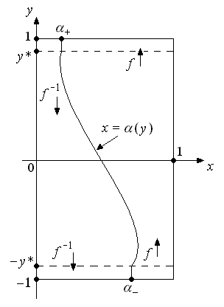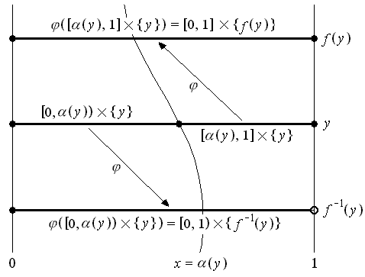
(a)
(b)
Figure 5. A discrete-time dynamical system with intermingled basins. Based on Ott et al. 1994. Part (a) shows the domain of the map ϕ with schematics of the functions α and f from which ϕ is constructed. Part (b) shows the operation of ϕ on a horizontal line segment: the left portion is stretched and lowered while the right portion is stretched and raised.

We are interested in whether d.m.z. and r.a. hold of certain two-dimensional sets, but we will first have to consider the one-dimensional Lebesgue measure of certain subsets of horizontal line segments, and it is helpful to regard that measure as a probability. This is potentially confusing: The concepts of r.a. and d.m.z. involve measure. They are motivated by probabilistic concerns, but at the moment we are only interested in whether or not they hold, so we are interested in the measure—in this case the one-dimensional Lebesgue measure, i.e., the total length—of certain sets. Yet it is useful to think of length as a probability, so that we can apply known results from probability theory. So when we refer to the probability that a property Φ holds of an orbit {(x_{n}, y_{n})}_{n ∈ } , we mean, for some fixed y₀, the total length of the set of values x₀ such that Φ ({(x_{n}, y_{n})}_{n ∈ }) holds. Here probability is just a tool for thinking about Lebesgue measure.
Under iterations of ϕ, motion in the x-direction is random in the sense that the “probable” value of x_{n} is independent of the coarse-grained history of the preceding values x_{i} with respect to the partition imposed by the line x = α(y). More precisely, let H be a set of natural numbers and let H_{n} be the statement that for all i < n, x_{i} < α(y_{i}) if and only if i ∈ H. Then for any measurable subset S of the interval [0, 1], the probability that x_{n} is in S is completely independent of H_{n}; in fact, it is just the measure of S. That is,
Pr(x_{n} ∈ S | H_{n}) = Pr(x_{n} ∈ S) = λS
(Parker 2005). Consequently, motion in the y-direction is also random, but in a different sense: the y-values form a Markov chain. That is, the probable value of y_{n} depends only on y_{n – 1} and not on any previous values of y ; given any n constants y₀′, y₁′,…, y_{n – 1} ∈ [–1, 1], we have
Pr(y_{n} = y_{n}′ | y₀ = y₀′, y₁ = y₁′,…, y_{n – 1} = y_{n – 1}′) = Pr(y_{n} = y_{n}′ | y_{n – 1} = y_{n – 1}′).
In particular, the y-motion is equivalent to a “random walk” over the values f ^{i}(y₀), with the probable direction of each n^{th} step determined by α(y_{n}). In fact, these values f ^{i}(y₀) can be mapped onto the integers so that the motion becomes a (spatially inhomogeneous) random walk on the integers. This is just what Ott et al. do, and it is from this random walk that their arguments and the proofs in Parker 2005 proceed. The random walk serves as a model of the model of the model—a third-order simulacrum. It is a simplification and a distillation of the discrete map, but it’s relation to that map is mathematically precise.
Despite the erratic Markovian motion in the y-direction, the extreme horizontals A₊ and A– turn out to be attractors in the long run. This is just because, by our choice of the curve α, orbits near an attractor are more likely to move toward it than away. If an orbit moves even closer to the attractor, it becomes less likely that it will ever move away. In fact, all but a measure-zero set of orbits eventually approach one of these attractors (Parker 2005).
Because α is constant near the attractors, it can be shown that (for a given y₀) the probability that an orbit will ever recede from a given attractor decreases in a very regular way as the orbit comes closer to the attractor. For example, given that y_{n} > y* is above y = 0 by k iterations of f (or more precisely, f ^{k – 1}(0) ≤ y_{n} < f ^{k}(0)), the probability that some later y_{m} will ever fall below y* decreases exponentially with k. Hence the probability that (x₀, y₀) ∈ β(A–) given that y_{n} ≥ f ^{k – 1}(0) decreases at least as quickly as an exponential function of k. In fact, Ott et al. show (though it is garbled by a typographical error ) that the basin β(A–) scales as B[α₊/(1 − α₊)]^{k} for some constant B. This is a generalization of their power law scaling result, and it is key to the proof that the basins are r.a.
That proof is now fairly straightforward. To determine with high confidence in which basin a point lies, we need only approximate its orbit (making use of the fact that f and α are computable) until the orbit comes sufficiently close to one of the attractors. (To satisfy the definition of r.a., we must also ensure that this procedure halts on all initial conditions, but this can be arranged with a little effort.) The full algorithm (excluding details on how to approximate f and α) is given in Parker 2005. In fact, it was shown there that the basins are not only r.a., they are computable in just about every sense from the literature of computable analysis, except d.m.z.
They are not d.m.z. because they are intermingled. This is because the probability of taking a step away from an attractor, though it may be small, has a non-zero minimum, so there is always a non-zero chance of taking many consecutive steps away from the nearest attractor and toward the other. Once near the other attractor, the orbit is more likely to tend toward that one. Therefore every horizontal [0, 1] × {y} contains subsets of both basins, each with positive one-dimensional measure. Now remember what ϕ does to x-values: it stretches them. Consequently, even a very small horizontal line segment contains a sub-interval that will eventually be stretched all the way across X. Therefore, every tiny horizontal line segment contains positive-measure portions of both basins. If we integrate these tiny horizontals over any small two-dimensional neighborhood, we find that both basins have positive two-dimensional measure there. Hence the basins are intermingled, and hence non-d.m.z.

5. Why universality fails
We can now see why the scaling law stated by Ott et al. (1994) is not universal. It simply depends on the choice of f. Our only requirements on f were that it be a computable bijection, and that f ^{i}(y) → 1 and f ^{–i}(y) → –1 as i → ∞. This is enough to justify the random walk model and all the results that follow from it. In particular, f ^{i}(y) can converge to 1 at any rate whatsoever. Hence the probability
Pr[(x₀, y₀) ∈ β(A–) | y₀ = y] = B[α₊/(1 − α₊)]^{k},
where again, k is the number of f-steps from 0 to y, can be made to converge to 0 at any rate you like as y → 1, just by choosing f so that f ^{i}(y) converges to 1 more or less quickly. In fact, the result of Ott et al. for their particular choice of f, correcting the typographical error, is that
Pr[(x₀, y₀) ∈ β(A–) | y₀ = y] = $B(1−y/1+y)^{{\bar{η}}_{+}}$
where ${\bar{η}}_{+}$ is a constant. Even this is not strictly a power of the distance d = 1 − y.
Recall that the universality conjecture was supposed to cover systems near the riddling transition. So can we find violations near such a transition? Well, the only parameters in our system that affect riddling are α₊ and α₋. If α₊ ≥ ½, for example, then the line y = 1 will not be an attractor at all, and otherwise it will be riddled. But we have made no assumptions about how close α₊ is to this riddling transition, and clearly the argument of the last paragraph holds regardless of what value, above ½, α₊ takes.
Perhaps then what Ott et al. have in mind is that the scaling always approaches a power law as d → 0. This, however, can only mean that near y = 1, the probability p(y) = Pr[(x₀, y₀) ∈ β(A–) | y₀ = y] has a derivative with respect to y which converges to the derivative of some power law, and this is not always true. The derivative of a power law approaches either zero or infinity as its value goes to zero, depending on whether the exponent is greater or less than one. Since f is arbitrary, we can choose it so that the derivative of p is non-zero and finite. One might object that the exponent in the power law could be 1, but in that case its derivative can approach any number, so the claim becomes trivial. Anyway, there is no point calling a linear function a power law.
But r.a. does not require such a power law. In fact, it is quite enough if there is some computable function that dominates the probability p(y) near y = 1; then when y_{n} is close to 1, we can be confident that the orbit will tend towards y = 1. And the existence of such a function is trivial. If f is, as we assume, computable, then it is continuous (Grzegorczyk 1955). Since f ^{i}(y₀) converges to 1 and f is a continuous bijection, f ^{i}(y₀) increases monotonically. And since p(y) → 0 as f is iterated, p(y) → 0 as y → 1. Therefore there is certainly some computable function, and yes, even a power law, that converges to zero slower than p(y), i.e., that dominates p(y) near y = 1.
The fact that r.a. comes so cheap should suggest that it is not as helpful as it might have seemed. Indeed, r.a. only guarantee that there is some algorithm to decide a set with arbitrarily small but non-zero error. To find that algorithm is another matter, and in our context this requires us to find a recursive function that dominates the measure of the complement of a basin in neighbourhoods near the attractor. In their validation argument quoted above, Sommerer and Ott suggest that this can be determined from the Lyapunov exponents of the attractor. However, since f is so arbitrary in our discrete example, it is not clear that the attractor must have well-defined Lyapunov exponents; it might be that the rate at which orbits divergence varies erratically near y = 1 and does not approach any limit. Perhaps then a scaling law can be calculated from the Lyapunov exponents for systems having such exponents. This is an interesting and useful conjecture, but rather different from that proposed by Ott et al. In particular, the scaling law for a given system may not be a power law with constant exponent. And again, such a universal rule, if it holds only for systems that exhibit riddling, cannot help us to prove that riddling occurs in a given system.
This, then, brings us to consider other criteria for applying such a rule, and in fact the same criteria that motivated the conjecture of Ott et al. in the first place, namely the structural properties that seem to result in riddling.

6. Structural similarity
I will not attempt to explicate the notion of structural similarity. I only want to do two things in this section. Firstly, I want to illustrate the important features that the continuous and the discrete system discussed here have in common, and secondly, I want to point out that the success of the analogy between these systems, i.e., the plausible transference of computability results, depends on the robustness of these results in the face of small changes to the system.
The results that we have seen for the discrete system are very general. We have made only very broad assumptions about our functions f and α. Even the assumption that α is constant near the attractors can now be relaxed. We have assumed that the constant α₊ , for example, is between 0 and ½. This enables us to show that the probability that an orbit will ever recede from A₊ decreases in a very regular way near A₊, and this is true even if α₊ is very close to ½. Suppose now that α₊ is indeed very close to 1/2, and suppose we replace the function α with a function α ′ that is not constant near A₊ but is less than α₊ in that region. (See Figure 6.) This can only mean that the probability that an orbit will ever recede from A₊ is even smaller near A₊. We can still use our algorithm to determine in which basin a point most likely lies, and it will be all the more efficient. Yet, provided α ′ has a non-zero minimum, there will still be a positive probability of escaping the attractor, so the basins will still be intermingled and non-d.m.z. Consequently, all of our results hold for any computable (and therefore continuous) function α ′, provided only that α ′(1) < ½ < α ′(−1), and for all y, 0 < α ′(y) < 1.
We have also assumed that, in a single iteration, ϕ stretches both the left and right portion of a horizontal all the way across the domain X. This too can be relaxed. As long as ϕ affects some minimal stretching, so that every small line segment is eventually stretched enough to include portions of both basins, we still have intermingled basins. In fact, the particular form of the motion in the x direction does not matter much, so long as

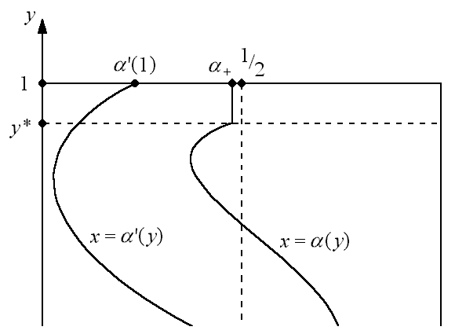
Figure 6. Generalizing the discrete system. If we replace α with another computable function α ′: [–1, 1] → (0, 1) such that α ′ < α₊ for y > y*, the basins are still intermingled, non-d.m.z., and recursively approximable. This holds even for α₊ very close to 1/2 and y* very close to 1, so α ′ may be any computable function with α ′(1) < 1/2 and (by a parallel argument) 1/2 <
α ′(–1).

almost all orbits spend some time in regions that are drawn toward a given attractor (such as x < α(y)) and some in regions that are pushed away (x > α(y)).
In these respects, Sommerer and Ott’s continuous system is very much like the discrete system. The two attractors have stable regions (the dips in the potential) and unstable regions (the central hump). Motion near the attractors is chaotic, spending some time in both the stable and unstable regions. The similarity between the two systems becomes more striking if we just modify the discrete system a little (Figure 7): translate and bend the rectangle X so that both attractors lie on the x-axis, with the unstable regions close together. Then produce the mirror image of this figure below the x-axis. As in the continuous system (looking only at the x- and y-dimensions), we now have two chaotic attractors on the x axis that are largely stable, but unstable in a small central region. It therefore seems very plausible that, like those of the discrete system, the basins of the continuous system are indeed intermingled but r.a. Ott et al. may have over-stated their conjecture that riddled basins always scale according to a power law near attractors, but it also seems likely that, for a continuous system like theirs, there will be some rule to the effect that orbits near an attractor tend toward it, so that, if the differential equations are sufficiently regular (i.e., Lipschitz) and computable, the basins will be r.a.
Ott and his collaborators (1994; Alexander et al. 1991) discuss the important structural features in detail. The systems in which they find riddling always have an invariant manifold (induced by a symmetry in the dynamics). Within this there is an attractor for the subsystem within the invariant manifold, not necessarily an attractor for the whole system. This attractor is chaotic. Furthermore, the invariant manifold has regions where nearby orbits move away from the manifold and regions where orbits are drawn closer (for example, the attracting dips and the repelling hump in the potential V of equation 2). Orbits within the manifold spend time in both regions. But if they typically spend more time in the attracting region, or the attraction is stronger than the repulsion, or more generally, if the net effect is attraction on the average (negative transverse
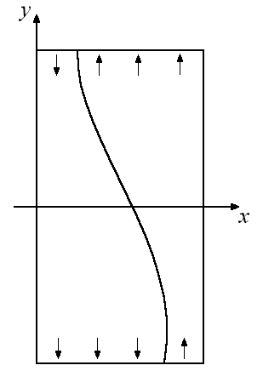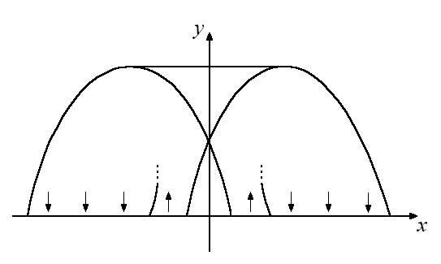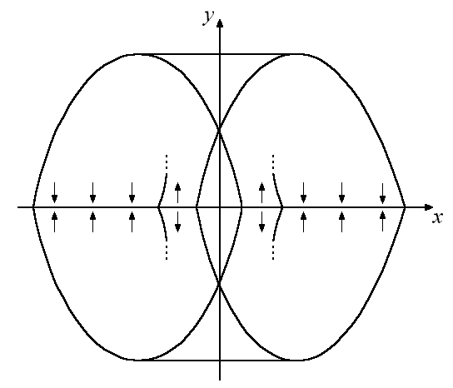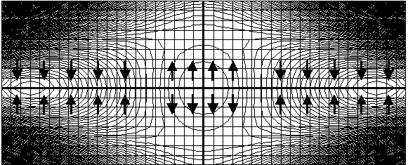
Figure 4.7. Comparison of the discrete and continuous systems. (a) The original domain X of the discrete system, with arrows showing attracting and repelling regions of the chaotic attractors. (b) X translated and folded. (c) A reflection of the result is appended to the system to make the similarity to the continuous system apparent. (d) A contour graph of the potential V of the continuous system, showing attracting and repelling regions of the x-axis, where the two chaotic attractors intersect this graph.
(a)
(b)
(c)
(d)
Lyapunov exponents), then the attractor for the manifold becomes an attractor for the larger space. Due, however, to the random motion of orbits through attracting and repelling regions, there is always a chance that a particular orbit will spend a great deal of time in the repelling region, and therefore the basin will be riddled.
It is the recognition of these structural features of the dynamics that leads Ott et al. to conjecture universality in the first place. The conjecture is “[b]ased on our understanding of these results as arising from fluctuation of the perpendicular Lyapunov exponent”.

7. What do these models model?
Sommerer and Ott describe their continuous model as a particle in potential well, and the dynamics are described in terms of force and friction. Their goal, however, is not to understand the motion of particles in funny-shaped wells. Their model is constructed from another that has a very different physical application: the two-well Duffing equation, which governs motion on the invariant manifold in Sommerer and Ott’s system, was originally introduced to model the vibration of a steel beam subject to periodic forcing. However, Sommerer and Ott make no mention of specific applications. Their intention seems to be to show that some very strange and in particular non-computable behaviour is possible within a relatively simple system, and one that is natural in a vague and general sense. [They remark that Cristopher Moore’s dynamical systems, which also are claimed to exhibit non-computable long-term behavior (1990, 1991) have not been considered very “physical”.] The suggestion is that perhaps there could be real physical systems with similar dynamics, but interestingly, the model comes first and the phenomena for it to model are sought afterwards. The discrete system models the continuous one, but the continuous one doesn’t model anything in particular.
Now is Sommerer and Ott’s system very “physical”? Might this kind of unpredictability exist in real physical systems? There are at least three issues in particular to consider here: (1) Are there likely to exist systems with roughly the same dynamics? (2) How does noise affect the dynamics? And (3) do not the model and its computability and non-computability properties break down at the quantum level?
One is not likely to stumble on a surface in the shape of the potential V steadily tilting left and right with a marble on it. However, it would not be impossible to manufacture such a system, and accurately enough that its behavior would reflect the riddled structure of Sommerer and Ott’s basins. What makes this plausible is the fact that the riddling is structurally stable: it survives small changes in the parameters of the motion. The relevant variables include the amount of friction, the frequency and amplitude of the periodic force, and perhaps most significantly, the shape of the surface, or the potential V. If we were to manufacture a rocking two-welled dish in hopes of reproducing the erratic behavior of Sommerer and Ott’s model, the shape of the dish would not have to be exact . The same qualitative dynamics persist over a range of different potentials defined by varying the parameters. Ott et al. (1994) explicitly report this for a potential qualitatively different from V, and Kan (1993) actually proves an analogous result for certain discrete-time systems on the thickened torus T² × [0, 1]. We have also seen in intuitive terms that the riddled basins in the discrete system of Ott et al. 1994 persist under many broad variations. Sommerer and Ott (1996) at least suggest that the same holds for their continuous 1996 system, and a handful of simulations conducted by the present author using the “Phaser” software seem to confirm this.
Intuitively, some insensitivity to the shape of the potential is to be expected, since, as we have noted, the riddling results from a few of its gross features: the two dips, which tend to draw orbits in if friction is present, and the central hump, which tends to destabilize orbits that run near the invariant manifold. Sommerer and Ott emphasize the importance of maintaining the y-symmetry in Equations 1 and 2 in order to maintain riddling, and of similar symmetries in other riddled systems. The symmetry guarantees the existence of an invariant manifold, a critical part of the analysis by Sommerer and Ott and by Alexander et al. (1992). However, even this symmetry is not strictly necessary. One can always make a change of coordinates that destroys the y-symmetry without changing the dynamics, or to put it another way, one can apply nearly any homeomorphism to the system and just let the new dynamics be defined by applying the same transformation to the old dynamics. The new basins will just be the images of the old basins, and if the homeomorphism preserves sets of positive measure, riddling is maintained. So the important thing is not the symmetry per se but having a chaotic attractor in an invariant manifold. Yet, perhaps even an attractor that is not strictly contained in an invariant manifold could also generate riddling. That remains to be seen.
The rocking of our fabricated surface would not have to be exactly as prescribed by Sommerer and Ott’s equation either, in order to generate riddled basins. The important thing there is that it should keep the marble moving left and right chaotically. Just about any oscillating force with approximately the right direction, amplitude, and frequency would surely suffice.
Of course, our real interest is not in marbles on strange surfaces, but in systems in general with qualitatively similar behavior. Heagy, Carroll, and Pecora (1994) have observed an actual electrical circuit, the behavior of which shows clear evidence of a riddled basin with positive measure, or at least an approximately riddled basin. Ott and Sommerer (1994) suggest that riddled basins might also occur in some chemical reaction-diffusion systems.
Noise is another real-world factor that undermines models like Sommerer and Ott’s, and this does have a major impact on the dynamics. Ott et al. suggest that low noise would have the effect of disturbing even those orbits that would otherwise have settled down to an attractor (1994, 392). There would still be an appearance of riddled basins, but they would not really be basins of attraction, as almost no orbits would approach an attractor in the limit. Rather, almost all orbits would behave in the same general way, forever drifting from one near-attractor to the other, so the qualitative behavior would be trivially d.m.z. Heagy et al. observe that in their circuit, the power-law scaling of the (apparent) basin levels off very near the (apparent) attractor, and they attribute this to noise. True riddling, it seems, is reserved for truly isolated, deterministic systems.
Further, these models and their basin structure seem to break down at the quantum level. A basin is only really riddled if even the smallest neighborhoods of phase space contain positive-measure portions of its complement. Computability, and in particular d.m.z., is also an absolute, ideal concept, and whether or not a set is d.m.z. depends on arbitrarily small details of the set’s structure. If riddling is to be the basis of non-d.m.z. character, there must be no scale at which the riddling ceases. For extremely tiny differences in initial conditions, quantum mechanics predicts behavior quite different from that observed at the macroscopic level, and even the general framework of precise, unique positions and velocities represented in a finite-dimensional phase space becomes inadequate. Hence it is not obvious that quantum mechanics permits any undecidability related to non-d.m.z.

8. Conclusions

Sommerer and Ott’s non-computability argument is strong and meaningful. It has often been pointed out that in chaotic systems, where specific and precise prediction sof future states are impossible, qualitative behaviour is a fruitful topic to investigate. Sommerer and Ott’s argument shows that any procedure to determine even the qualitative long-term behaviour of a system with riddled basins will fail in a non-zero percentage of cases. Yet it might be possible to bring this percentage as close to zero as you like, and thus reveal the riddled structure itself. In short, riddled basins are non-d.m.z. but might still r.a.
The argument that this occurs in their example is problematic. The evidence of riddling, as presented, consists in computer-generated pictures, and the validation of these pictures rests on a claim of universality for systems with riddled basins. This is obviously circular, and furthermore the universality claim, as presented, is false. But there is another kind of argument to make, one that plays a strong background role in their research. Riddling is due to certain general structural features. It is robust; it is structurally stable. The finer details don’t make much difference for the broader topological and measure-theoretic properties of the basins. Models that have these structural features in common should behave similarly, and to check this does not require any simulation.
Unfortunately, the models discussed here do not prove anything about specific real physical systems. Nonetheless they are informative. Like many results from nonlinear dynamics, they serve to open our eyes to possibilities; they influence our expectations.
We have already found real systems that do exhibit some approximate riddling, but even if true riddling at the smallest scales is impossible in nature, these results do show something about the world. They help to complete our understanding of unpredictability, to explain why and in what ways we may be unable to predict physical systems.
The situation is rather like a case of causal over-determination. Imagine a man is executed by a firing squad. One bullet pierces his heart, another his brain. How could we explain his death? To give a full account of one bullet and not the other would be inadequate. Even without the first bullet, the second would have done him in.
Unpredictability in our world is similar. We have quantum indeterminacy, and we have noise—small disturbances due to the reality that there is no such thing as an isolated system. These things make true riddling more difficult to achieve, if not impossible. But without them we would have riddling, sensitive dependence, and non-computability. Even if we cannot trust models that exhibit riddled basins, without such models we could not have a complete explanation of what we can and cannot predict, in exactly what sense, and why.

REFERENCES

Alexander, J.C., James A. Yorke, Zhiping You, and Ittai Kan. 1992. Riddled basins. International Journal of Bifurcation and Chaos 2: 795-813.
Borges, Jorge Luis. 1999. Collected Fictions. Penguin.
Brattka, Vasco and Klaus Weihrauch. 1999. Computability on subsets of Euclidean space I: closed and compact subsets. Theoretical Computer Science 219: 65-93.
Carroll, Lewis. 2005 [1893]. Sylvie and Bruno Concluded. http://www.hoboes.com/html/FireBlade/Carroll/Sylvie/Concluded Retrieved 31 May, 2006.
Earman, John. 1986. A Primer on Determinism. Dordrecht: D. Reidel Publishing Company.
Grzegorczyk, Andzrej. 1955. Computable functionals. Fundamenta Mathematicae 42: 169-202.
–––. 1957. On the definitions of computable real continuous functions. Fundamenta Mathematicae 44: 61-67.
Hartmann, Stephan. 2005. The world as a process: Simulations in the natural and social sciences. PhilSci Archive: http://philsci-archive.pitt.edu/archive/00002412
Heagy, James F., Thomas L. Carroll, and Louis M. Pecora. 1994. Experimental and numerical evidence for riddled basins in coupled chaotic systems. Physical Review Letters 73: 3528-3531.
Kan, Ittai. 1994. Open sets of diffeomorphisms having two attractors, each with an everywhere dense basin. Bulletin (New Series) of the American Mathematical Society 31: 68-74.

Ko, Ker-I. 1991. Complexity Theory of Real Functions. Boston: Birkhauser.
Milnor, John. 1985. On the concept of attractor. Communications in Mathematical Physics 99: 177-195.
Moore, Cristopher. 1990. Unpredictability and undecidability in dynamical systems. Physical Review Letters 64: 2354-2357.
–––. 1991. Generalized shifts: Unpredictability and undecidability in dynamical systems. Nonlinearity 4: 199-230.
Myrvold, Wayne C. 1997. The decision problem for entanglement. In R. S. Cohen et al., eds., Potentiality, Entanglement, and Passion-at-a-Distance. Great Britain: Kluwer Academic Publishers, 177-190.
Ott, Edward, J. C. Alexander, Ittai Kan, John C. Sommerer, and James A. Yorke. 1994. The transition to chaotic attractors with riddled basins. Physica D 76: 384.
Ott, Edward, and John C. Sommerer. 1994. Blowout bifurcations: the occurrence of riddled basins and on-off intermittency. Physics Letters A 188: 39-47.
Parker, Matthew W. 2003. Undecidability in R^{n}: Riddled basins, the KAM tori, and the stability of the solar system. Philosophy of Science 70: 359-382.
–––. 2005. Undecidable long-term behavior in classical physics: Foundations, results, and interpretation. Ph.D. dissertation, University of Chicago.
–––. 2006. Three concepts of decidability for general subsets of uncountable spaces. Theoretical Computer Science 351: 2-13.
Penrose, Roger. 1989. The Emperor’s New Mind: Concerning Computers, Minds, and the Laws of Physics. New York: Oxford University Press.
Sklar, Lawrence. 1993. Physics and Chance: Philosophical Issues in the Foundations of Statistical Mechanics. Cambridge, England: Cambridge University Press.
Sommerer, John C., and Edward Ott. 1996. Intermingled basins of attraction: Uncomputability in a simple physical system. Physics Letters A 214: 243-251.
Turing, Alan. [1936-1937] 1965. On computable numbers, with an application to the entscheidungsproblem. Proceedings of the London Mathematical Society. Series 2. 42: 230-265. Errata in v. 43: 544-546. Reprinted in Davis 1965, 116-154.
Weihrauch, Klaus. 2000. Computable Analysis: An Introduction. Berlin: Springer. Figure 5.2, p. 127, Chapter 5, Copyright 2000 Springer-Verlag Berlin Heidelberg, with kind permission of Springer Science and Business Media.

Here, ‘attractor’ is used in a sense similar to that of Milnor (1985): an attractor is essentially a set whose basin of attraction has positive Lebesgue measure. Under other, perhaps more standard definitions of attractor, all points near an attractor must lie in its basin, so an attractor cannot have a riddled basin. Milnor-type attractors are more appropriate to our discussion. Sommerer and Ott also specify that an attractor must be a compact set with a dense orbit. This is slightly different from Milnor’s definition, but the differences will not matter for us.
Sommerer and Ott do not specify the precise sense in which the attractors are chaotic, but they make use of a theorem (due to Alexander et al. 1991) that requires a particular kind of chaos. The conditions of the theorem require that the attractor is ergodic with respect to some invariant probability measure on that attractor. Perhaps this is known to hold for the two-well Duffing equation, but Sommerer and Ott make no case for it in their 1996 paper.
They show that the Lyapunov exponents transverse to the invariant manifold are negative and then appeal to a theorem of Alexander et al. (1991) that if the attractors are chaotic in the sense of footnote 6, these Lyapunov exponents imply that the attractors for the invariant manifold are also attractors for the larger system.
There is another validation problem here that Sommerer and Ott do not address. How do we know that the short-term behaviour of the simulation is representative? The system in question exhibits sensitive dependence on initial conditions. Consequently, round-off errors in the course of the simulation will compound and grow rapidly, so that after a short time the simulated trajectory might not resemble the true trajectory at all. This problem is usually addressed by appeal to shadowing theorems, which state that for each simulated trajectory there is a real trajectory, with slightly different initial conditions, that stays close to the simulated trajectory as long as you like. In that case, a numerical simulation may not provide accurate predictions for a particular, given set of initial conditions, but it does accurately reflect the behaviour of some orbit. The trouble is, Sommerer and Ott do not just want to show what some orbits do; they claim that their basins are riddled, and this is a measure-theoretic property. Hence their graphs are required to represent the measure-theoretic reality; each black or white pixel must correspond to, not only a single state that lies in a given basin, but a positive-measure set of states in that basin. Some further argument is required to show that the behaviour of their simulated orbits reflects the statistics of real orbits. It seems likely that some measure-theoretically strengthened shadowing theorem will do the job, but I am not aware of any established such theorem.
Ott et al. (1994, 409) use Φ₊(z) for the probability that an initial state (x₁, y₁) (they use ones instead of zeros here) lies in β(A–) given that y₁ is z steps by f above y = 0. Hence their z is our k. They argue that Φ₊(z) = A + B(α ₊ /β ₊), where A and B are constants and β₊ = 1 – α₊, and then argue that A = 0. They conclude, “Φ₊(z) = $B({α_{+}}/{β_{+}})^{z}y_{1^{{\bar{η}}_{+}}}$”, where ${\bar{η}}_{+}$ is another constant. Clearly this should read Φ₊(z) = $B({α_{+}}/{β_{+}})^{z}$, which by their definitions can be written as $B(1−{y_{1}}/1+y_{1})^{{\bar{η}}_{+}}$.
It is worth pointing out here that as defined, our map ϕ is not computable, due to the discontinuity along the curve α. One might think it is unsurprising that a non-computable map should have undecidable basins. Given the robustness of our results, however, it should be possible to construct a continuous and computable mapping for which the basins are still r.a., intermingled, and non-d.m.z. The map would be similar to ϕ, but for each horizontal it would stretch out the points near x = α to connect the two horizontal images ϕ([0, α(x)) × {y}) = [0, 1) × f ⁻¹(y)} and ϕ([α(x), 1] × {y}) = [0, 1] × f (y)}. Hence the image of each horizontal would be either a ‘Z’ or a horseshoe.
Specifically he shows that for some k there is an open set of C ^{k} diffeomorphisms of the thickened torus having two attractors with intermingled basins (that is, an open set among the diffeomorphisms of the thickened torus, all of which preserve the invariant manifolds T ² × {0} and T ² × {1}).

