DISCUSSION DRAFT. PLEASE DO NOT CITE WITHOUT PERMISSION

The Crux of Crucial Experiments: Confirmation in Molecular Biology

Paper presented at the conference Confirmation, Induction and Science
London School of Economics, 8-10 March 2007

Marcel Weber
University of Basel
Philosophy Department and Science Studies Program
marcel.weber@unibas.ch

Abstract
I defend the view that single experiments can provide a sufficient reason for preferring one among a group of hypotheses against the widely held belief that “crucial experiments” are impossible. My argument is based on the examination of a historical case from molecular biology, namely the Meselson-Stahl experiment. “The most beautiful experiment in biology”, as it is known, provided the first experimental evidence for the operation of a semi-conservative mechanism of DNA replication, as predicted by Watson and Crick in 1953. I use a mechanistic account of explanation to show that this case is best construed as an inference to the best explanation (IBE). Furthermore, I show how such an account can deal with Duhem's well-known arguments against crucial experiments as well as Van Fraassen's “bad lot” argument against IBE.

1. Introduction
Some of the major discoveries in the history of molecular biology are associated with an alleged “crucial experiment” that is thought to have provided decisive evidence for one among a group of hypotheses. Well-known examples include the Hershey-Chase experiment (1952), which showed that viral DNA, not protein, enters a bacterial cell to reprogram it to make virus particles, or the “PaJaMo” experiment (1958), which showed that a certain bacterial gene makes a substance that represses the activity of other genes. In both cases, there were two major hypotheses that could explain the facts known beforehand: Either viral protein or viral DNA contains the information for making new virus particles (Hershey-Chase). Similarly, either “generalized induction” (in the molecular biological, not logical sense!) or suppression of a repressor (the “double bluff” theory of Leo Szilard) was thought to be responsible for the regulation of sugar metabolism in bacteria. In both cases, a single experiment seems to have enabled a choice between the competing hypotheses at hand, thus strongly resembling Bacon’s “instances of the fingerpost” or Newton’s “experimentum crucis”.

Philosophers of science, of course, have been less than enthusiastic about the possibility of crucial experiments. Following Duhem (1954), many seem to think that a single experiment, as a matter of principle, is not able choose among a group of hypotheses. However, as I will show, Duhem made extremely strong assumptions concerning the kind of inferences that are to be permitted. Namely, he allowed only deductive inferences to be used. The main goal of this paper is to show that when crucial experiments are construed along the lines of inductive (ampliative) inference, Duhem’s arguments don’t go through.

I want to demonstrate the possibility of crucial experiments on a concrete historical example, namely the Meselson-Stahl experiment (1957) in molecular biology. Even though there is an extremely detailed historical study of this experiment available (Holmes 2001), it has to my knowledge never been subjected to a thorough methodological analysis. “The most beautiful experiment in biology,” as it has been called, is widely thought to have demonstrated semi-conservative replication of DNA as predicted by Watson and Crick in 1953. But it remains to be shown that this experiment was actually decisive from a methodological point of view.

In Section 2, I will discuss Duhem’s infamous argument against crucial experiments. Section 3 provides a brief account of the Meselson-Stahl experiment and some of the theoretical controversies that preceded it. In Section 4, I argue that the case is best construed in terms of a mechanistic version of inference to the best explanation (IBE). Section 5 analyzes what I would like to call the “theory of the instrument”, which showed that the experimental method used by Meselson and Stahl was reliable. In Section 6, I show how my approach can handle Van Fraassen’s (1989) “bad lot” argument against the soundness of IBE. This will lead me to the conclusion that crucial evidence and inductive inferences in molecular biology are underwritten by complex systems of material assumptions and background knowledge.

2. Duhem on the Logic of Crucial Experiments
Duhem characterized crucial experiments as follows:

Do you wish to obtain from a group of phenomena a theoretically certain and indisputable explanation? Enumerate al the hypotheses that can be made to account for this group of phenomena; then, by experimental contradiction eliminate all except one; the latter will no longer by a hypothesis, but will become a certainty (Duhem 1954, 188).

This passage strongly suggests that Duhem thought of crucial experiments in terms of eliminative induction, in other words, in terms of the following logical scheme:

(1) H₁ ∨ H₂
(2) H₁ ⇒ e
(3) H₂ ⇒ ¬e
(4) e
(5) From (3), (4): ¬H₂ [by modus tollens]
(6) From (1), (5): H₁ [by disjunctive syllogism]

Such a train of inference faces two major problems according to Duhem. The first problem is the one that is today known as “Duhem’s problem”. This is the problem that auxiliary assumptions are needed to secure the deductive relation between hypothesis and evidence. Therefore, (5) will never involve a hypothesis alone; it will always be a conjunction of hypotheses that can be said to be falsified. Famously:

The only thing the experiment teaches us is that among the propositions used to predict the phenomenon and to establish whether it would be produced, there is at least one error; but where this error lies is just what it does not tell us (ibid., 185).

But if the falsity of one of the hypotheses at issue cannot be asserted, the inference (6) does not go through.

As if this weren’t enough, Duhem identifies a second problem:

Between two contradictory theorems of geometry there is no room for a third judgment; if one is false, the other is necessarily true. Do two hypotheses in physics ever constitute such a strict dilemma? Shall we ever dare to assert that no other hypothesis is imaginable? Light may be a swarm of projectiles, or it may a vibratory motion whose waves are propagated in a medium; is it forbidden to be anything else at all? (ibid., 190).

The answer to the latter, rather rhetorical question is clear: Unlike mathematicians, Physicists can never have grounds for assuming that they have exhausted the space of possible truths. In other words, there can be no warrant for premise (1) in the scheme above.

Given what he sets out to prove, Duhem’s arguments are impeccable. But note that Duhem is clearly thinking in terms of deductive inference. What he proves is that experiment conjoined with deductive logic is unable to bring about a decision for one among a group of hypotheses. He is dead right about that. However, Duhem’s arguments do not touch the possibility of inductive or ampliative inference enabling such a choice. An ampliative inference rule might very well be able to mark one hypotheses as the preferable one. The critical question will be if
such a procedure will not run into the same or similar difficulties. I shall save this question for later. Right now, it is time to introduce my historical example.

3. “The Most Beautiful Experiment in Biology”
As is well known, James D. Watson and Francis H.C. Crick closed their landmark paper on the structure of DNA with the short and crisp remark “It has not escaped our notice that the specific base pairing we have postulated immediately suggests a possible copying mechanism for the genetic material” (Watson and Crick 1953). It is fairly obvious what Watson and Crick had in mind: Because of the complementarity of the base sequences of the two nucleotide chains in the double helix, a DNA molecule could be copied by first separating the two strands, followed by the synthesis of two new strands using the two old strands as templates. On this scheme, each newly synthesized DNA molecule will contain one strand that was already present in the parental molecule, and one newly made strand. This scheme is called “semi-conservative replication.” However, as plausible as this scheme might seem, skeptics were quick to notice some theoretical difficulties. Here is the greatest skeptic of them all, Max Delbrück:

I am willing to bet that the complementarity idea is correct, on the basis of the base analysis data and because of the implication regarding replication. Further, I am willing to bet that the plectonemic coiling of the chains in your structure is radically wrong, because (1) The difficulties of untangling the chains do seem, after all, insuperable to me. (2) The X-ray data suggest only coiling but not specifically your kind of coiling (Delbrück to Watson, 12 May 1953, quoted from Holmes 2001, 21-22).

The term “plectonemic” referred to the topological property that, according to Watson and Crick, two DNA strands are twisted about each other so that they cannot be separated without uncoiling. The “base analysis data” refer to the work of Erwin Chargaff, who had shown previously that the building blocks of DNA occur in certain fixed ratios. Delbrück is also pointing out that the double helix was, at the time when Watson and Crick proposed it, strongly underdetermined by the available X-ray diffraction data (i.e., other coiled structures would have been consistent with these data).

But Delbrück not only expressed skepticism about the specific kind of coiling. His point (1) called into question the whole idea of a semi-conservative replication mechanism as suggested by Watson’s and Crick’s model. The problem was that, given the plectonemic topology of the Watson-Crick double helix, untangling the two strands requires the breaking and rejoining of the sugar-phosphate backbone of the molecule. Given the fast rate by which DNA replicates, especially in rapidly dividing bacterial cells, the molecule would have to rotate at mind-boggling velocities. This was also known as the “problem of untwiddling”. For a while, it was a major source of skepticism about Watson’s and Crick’s extremely elegant solution. While the structure itself became rapidly accepted thanks to the available of improved X-ray data, the semi-conservative replication mechanism continued to be doubtful for the years to come.

In the years following Watson’s and Crick’s announcement, two alternative replication mechanisms were proposed. Delbrück devised a scheme under which each newly synthesized DNA molecule contains bits of the parental molecule that are interspersed with newly synthesized material:

This became known as the dispersive mechanism.

Gunther Stent proposed that the whole double-stranded DNA molecule could serve as the template for synthesizing a copy. This would not require any untwisting of the parental molecule:

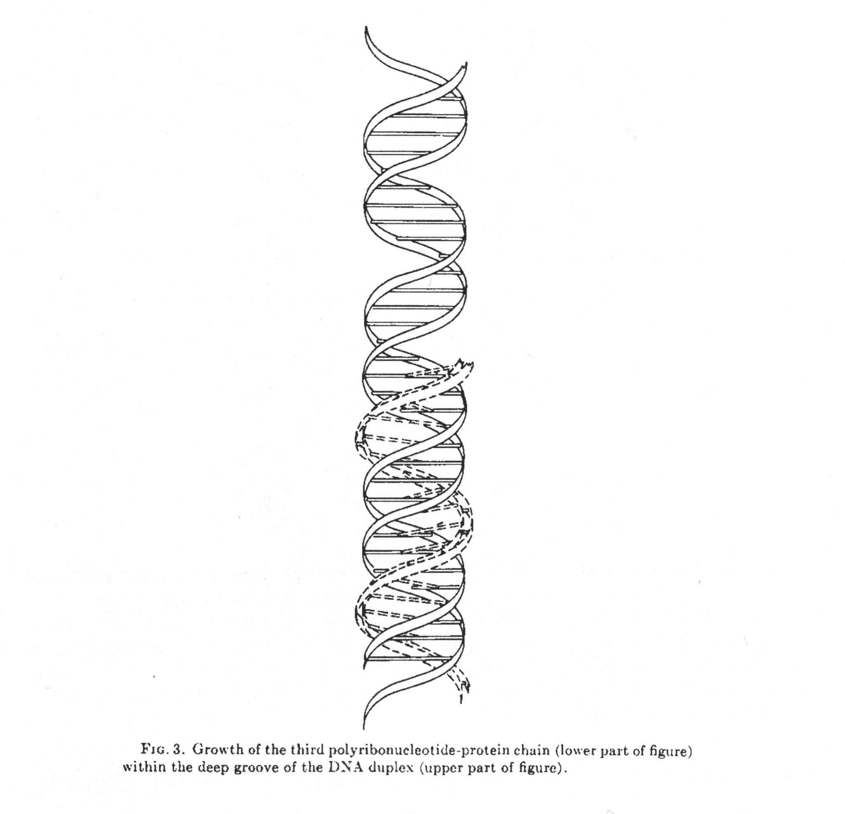
According to this mechanism, which was called the conservative mechanism, the parental molecule emerges unchanged from the replication process while the newly synthesized molecules contain only new material. The three mechanisms thus differ with respect to the distribution of parental and newly synthesized material that end up in the daughter molecules. This is summarized in the following diagram:

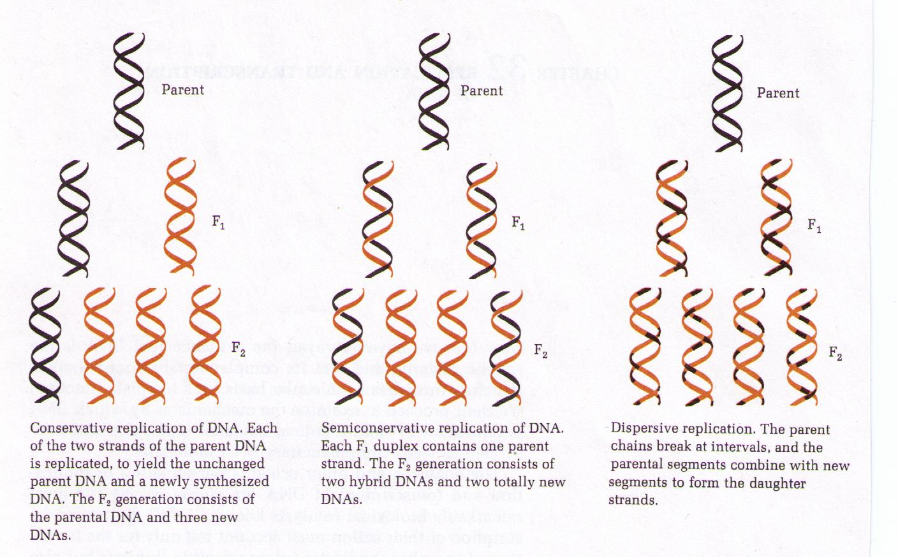

Thus, in the mid-1950s there were three different hypotheses concerning the distribution of parental and newly synthesized nucleic acid chains.

Now enter two young experimentalists, Matthew Meselson and Frank Stahl, working at the California Institute of Technology in Pasadena. Using a powerful analytic ultracentrifuge, they performed a remarkable experiment in 1957. In order to convey to the uninitiated reader the basic idea of this experiment, I will first show a highly schematic representation, before I discuss it in more detail.

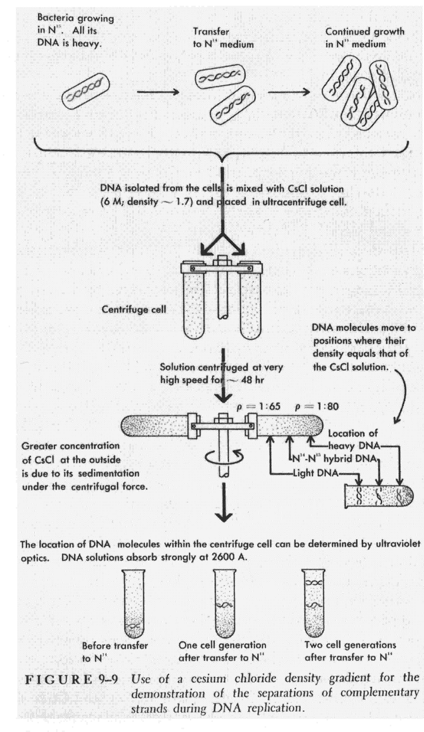

Meselson and Stahl grew E. coli bacteria in the presence of a heavy isotope of nitrogen, nitrogen-15. Ordinarily, DNA contains the most common isotope of nitrogen, which is nitrogen-14. But when grown in the presence of nitrogen-15, the bacteria incorporate the heavy nitrogen into their DNA. Now, DNA that contains the ordinary, light nitrogen atoms and the DNA containing heavy nitrogen can be distinguished by their weight. Of course, DNA occurs not in large enough quantities to be weighed by an ordinary balance. But Meselson and Stahl developed a highly precise instrument for determining the weight of DNA. They first dissolved the bacterial cells in a strong detergent. Then they placed the extract on a very dense solution of the salt CsCl. When a CsCl solution is centrifuged at very high speed in an ultracentrifuge for many hours, it will form a density gradient after a while. At equilibrium, the DNA molecules will float in that region of the gradient that corresponds to their own density. They form a band that can be observed with the help of UV light. Thus, they weight of the DNA molecules can be measured by determining the position of the band.

The experiment that Meselson and Stahl now did was to transfer the bacteria from a medium containing heavy nitrogen to a medium containing light medium and allowing the bacteria to multiply further. At regular time intervals after the transfer, they took samples and placed them in the ultracentrifuge. What they observed is that after one generation, a band of intermediate density appeared. After another generation, the intermediate band was still present, but a new band that corresponded to light DNA occurred. This is as the semi-conservative hypothesis predicted: If the intermediate band consists of hybrid DNA molecules that contain one light and one heavy strand, it therefore demonstrates semi-conservative replication.

The picture shown above is actually a highly schematized and in fact somewhat misleading depiction of the experiment, taken from James D. Watson influential textbook Molecular Biology of the Gene from 1965. I am showing it because it makes it easy to grasp the idea of the experiment. In Watson's depiction, the centrifuge buckets look like those of a preparative centrifuge familiar to most biology students. But of course, Meselson and Stahl used an analytical ultracentrifuge, which is a huge and complex machine where the rotor looks very different and is equipped with sophisticated optical equipment in order to monitor the refractive index and UV absorption of the sample.

Meselson and Stahl's original data therefore looked rather different:

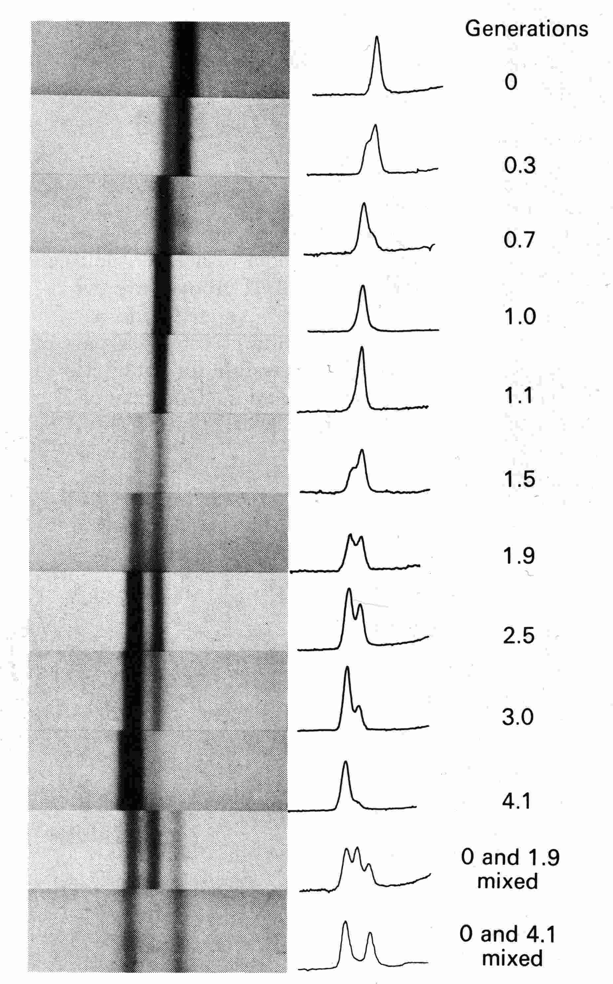

These are UV absorption photographs of the ultracentrifuge cell. The bands show where the DNA floats in the CsCl density gradient. What is particularly important about these data is that the band of intermediate density was located exactly in between the heavy and light bands. As both theoretical calculations and measurements showed, the density gradient was very nearly linear in the range were the DNA was floating (see Section 5). This allowed the inference that the intermediate band contained molecules that were composed of heavy and light nitrogen exactly in a 1:1 ratio, as predicted by the semi-conservative hypothesis.

The impact of this experiment on the scientific community at that time was considerable. Almost everyone agreed that the Meselson-Stahl experiment beautifully demonstrates semi-conservative replication. The only exception known to me is Max Delbrück, but his role in the closely knit molecular biology of that time seems to have been that of advocatus diaboli anyway.

In the following section, I shall provide a methodological analysis of this experiment and its evidential support for Watson’s and Crick’s semi-conservative mechanism.

4. A Mechanistic Version of Inference to the Best Explanation
I suggest that the Meselson-Stahl experiment selects the semi-conservative hypothesis by an inference to the best explanation (IBE). In order to make this thesis good, I first need to elaborate on the relevant concept of scientific explanation. For the purposes of this paper, I shall adopt a mechanistic account of explanation. According to such an account, to explain a phenomenon means to describe a mechanism that produces this phenomenon. We are thus talking about a causal-mechanical account of explanation (Salmon 1984). A highly influential account of the relevant concept of mechanism has been given by Machamer, Darden, and Craver (2000), who define mechanisms as “entities and activities organized such that they are productive of regular changes from start or set-up conditions to finish or termination conditions”. A considerable body of scholarship exists know that shows how much experimental research in biology is organized around mechanisms in this sense (Craver and Darden 2001; Darden and Craver 2002; Craver, forthcoming).

For the purposes of my analysis, I will need to distinguish between two kinds of mechanisms: a) physiological mechanisms and b) experimental mechanism. Physiological mechanisms are mechanisms that operate in a living cell. This kind of mechanism has received much attention lately. By contrast, to my knowledge, no-one has discussed experimental mechanisms in the context of the recent debates in mechanisms in philosophy of science. I want to leave the meaning of the term ‘mechanism’ itself pretty much the same, but allow the entities and activities as well as the changes, set-up and finish conditions to include parts of the experimental system used. In other words, the artificially prepared materials as well as the characteristic manipulations and measurement devices used in the experiment also qualify as parts of a mechanism – an experimental mechanism.

In order to motivate this move a little, note that it makes perfect sense to speak of the mechanism that produced the UV absorption bands in Meselson’s and Stahl’s experimental setup. This mechanism includes the heavy nitrogen added to the growth medium, as well as the transfer of the growing bacteria into a medium containing light nitrogen. Furthermore, the mechanism includes the mechanical devises used to grind up the cells, extract the DNA and transfer them onto the CsCl gradient (which, needless to say, is also part of the mechanism). The only difference between this experimental mechanism and a physiological mechanism is that the latter occurs in nature, while the former requires external interventions (not necessarily human; the manipulations could be carried out by a lab robot). Of course, this difference is methodologically relevant. Interventions are crucial in generating experimental knowledge and in testing causal claims (Woodward 1993). What is also important is that the physiological mechanism – i.e., the mechanism of DNA replication in this case – is somehow embedded in the experimental mechanism. In other words, it is responsible for some of the regular changes that constitute the experimental mechanism. Mechanisms often form hierarchical structures where particular entities and activities can be themselves decomposed into lower-level mechanisms (Craver and Darden 2001). The lower-level mechanisms may be responsible for some of the activities that feature in higher-level mechanisms. But such a hierarchical organization is not necessary. Mechanisms may be related by one mechanism providing the substrate that another mechanism operates on. Biochemical pathways are a nice example for this. Thus, mechanisms may be vertically linked. Such vertical links exist in our present example: the heavy nitrogen is an entity of the experimental mechanism, and it is a substrate on which the physiological mechanism can act if it is provided instead of the usual substrate (i.e., light nitrogen).

Why this extension of the notion of mechanism? What I would like to suggest is that the experimental mechanism provides an explanation for the actual patterns that Meselson and Stahl saw in their experiment. Further, I want to claim that this explanation is better than the two alternative explanations that involve the dispersive or conservative replication mechanism instead of the semi-conservative one. In other words, the experimental mechanism in combination with the semi-conservative physiological mechanism is the best explanation for the banding patterns obtained by Meselson and Stahl, at least in the group of experimental mechanisms that involve either the semi-conservative, the dispersive or the conservative mechanism and are otherwise identical. Therefore, the semi-conservative mechanism is inferred by an IBE.

Such an account requires that we be able to say (1) why the semi-conservative mechanism is a part of the best explanation, and (2) why this provides grounds for the truth of the statements that describe the mechanism. For this purpose, I would like to refer to Lipton’s distinction between the “likeliest” and the “loveliest” explanation. The former is the explanation that is most probable. The latter is “the one which would, if correct, be the most explanatory or provide the most understanding” (Lipton 2004, 59). As Lipton shows, IBE can only be used in a non question-begging way if there are reasons to believe that loveliness is a guide to likeliness. I will come back to the question of whether we could have such reasons in this case in Section 6. The question right now is if there is any sense in which the experimental mechanism in combination with the semi-conservative scheme is more explanatory, i.e., provides more understanding than the experimental mechanisms containing the alternative schemes.

I think there is clearly such a sense. For if we assume any of the other schemes to be correct (the dispersive and conservative schemes), then we would expect different banding patterns. On the conservative scheme, we would not expect bands intermediate in density. By contrast, on the dispersive scheme we would expect more bands of intermediate density than just one after further rounds of replication. But Meselson and Stahl observed exactly one.

At this stage, the question arises why we cannot simply say that the semi-conservative scheme was the only one to survive the test to which Meselson and Stahl subjected it, while the alternative schemes did not survive this test and were therefore falsified? This would mean that we could do without IBE. But note that this would amount to an eliminative induction, which is exactly the kind of reasoning that is not possible according to Duhem. If we construe the experimental reasoning like this, both of Duhem’s objections can be raised: First, it can be argued that the dispersive and conservative hypotheses could still be true because one or several auxiliary assumptions might have been false. For example, it could be that Meselson and Stahl were wrong about the molecular units that they resolved in their ultracentrifuge. Technically, what the centrifuge data show is merely that there are three colloidal substances of different density. It does not show that these substances were simple DNA duplexes. In other words, the identification of this:

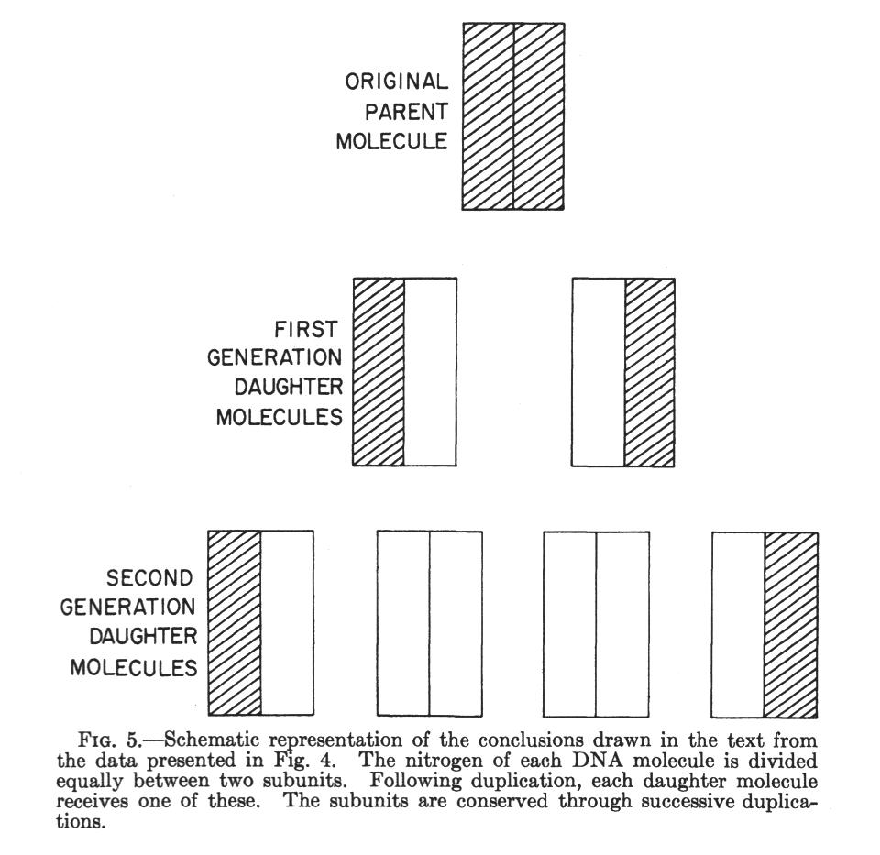

with this:

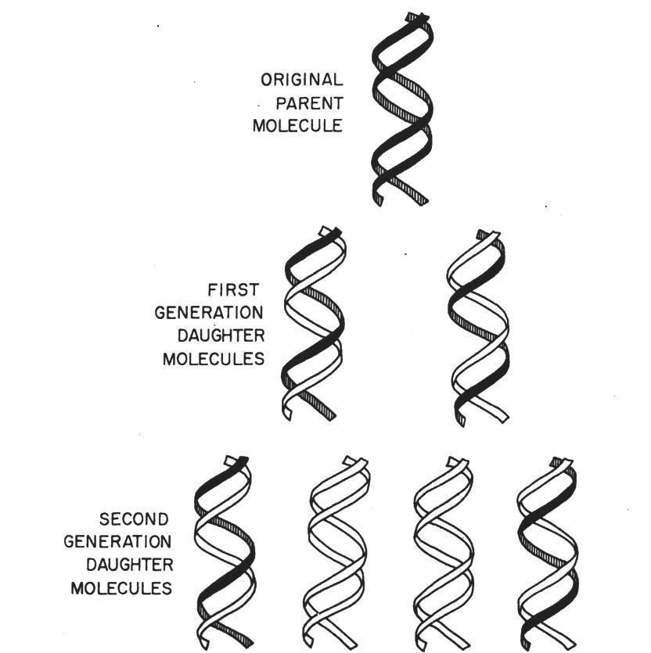

could have been false. This is all the more so because it is known today that Meselson and Stahl were wrong about the length of the molecules they saw floating in their gradients. Although the length of total E. coli DNA had been determined pretty accurately, the hypodermic syringes that Meselson and Stahl used to load the DNA onto the gradient must have mechanically sheared the DNA molecules into much smaller pieces – unbeknownst to these scientists in 1957! This did not alter the result because the CsCl-gradient technique separates DNA molecules according to density, not length. Quite to the contrary: the interpretation of the data would have been much more difficult had the DNA not been sheared. The reason is that if the samples had contained intact E.coli genomic DNA, some proportion of the molecules could have been incompletely replicated, which would have meant a whole smear of material of intermediate density. Sometimes it’s good of experimentalists don’t know too much about their experimental system!

In fact, Meselson and Stahl were quite cautious in stating their conclusions:

The structure for DNA proposed by Watson and Crick brought forward a number of proposals as to how such a molecule might replicate [the semi-conservative, dispersive and conservative mechanisms, M.W.] These proposals make specific predictions concerning the distribution of parental atoms among progeny molecules. The results presented here give a detailed answer to the question of this distribution and simultaneously direct our attention to other problems whose solution must be the next step in progress toward a complete understanding of the molecular basis of DNA duplication. What are the molecular structures of the subunits of E.coli DNA which are passed on intact to each daughter molecule? What is the relationship of these subunits to each other in a DNA molecule? What is the mechanism of the synthesis and dissociation of the subunits in vivo? (Meselson and Stahl 1958, 681).

As this passage makes clear, Meselson and Stahl did not even draw the inference from their data to the semi-conservative mechanism, at least not officially. The questions they raise toward the end of this passage are exactly those that their experiment is supposed to have answered! In print, Meselson and Stahl did obviously not want to go beyond what their data said. However, unofficially they showed less caution. Meselson sent J.D. Watson a little poem:

Now ¹⁵N by heavy trickery / Ends the sway of Watson-Crickery. / But now we have WC with a mighty vengeance … or else a diabolical camouflage.

The hint with the “diabolical camouflage” is quite revealing. It suggests that Meselson thought it unlikely in the extreme that their experiment had turned out the way it did had the semi-conservative hypothesis been false. This suggests yet another construal of the case: It could be argued that what Meselson and Stahl actually provided was a severe test in the sense of Deborah Mayo’s error-statistical theory of scientific reasoning (Mayo 1996). A severe test in this sense is a test with a low error probability, in other words, a low probability that the hypothesis passes a test in spite of being false. The problem with such a construal is to say what justifies the judgment that this probability was low or sufficiently low. The mechanism does not imply a probability distribution for different outcomes, which are the classic cases where a Neyman-Pearson test can be run. Thus, introducing error probabilities does not solve any problem here. We need to know why Meselson thought it unlikely that the DNA would behave as it did, had the semi-conservative scheme been false. How could this judgment be justified on Meselson’s and Stahl’s behalf?

I can’t think of a better answer than just saying that it would be a strange coincidence if Meselson’s and Stahl’s experiment behaved as if a semi-conservative mechanism was at work while, in fact, there was some other physiological mechanism at work. But this is just another way of expressing the intuition that this was unlikely; it does not really give a justification for it. Therefore, I think a construal of the case as a severe test with a low error probability does not really solve the problem.

I want to claim that my construal of the case as an IBE does solve the problem. On this view, the reason why the experiment supported the semi-conservative hypothesis was because there is an experimental mechanism that interacts with the semi-conservative mechanism in such a way that it explains the banding pattern obtained by Meselson and Stahl in a very lovely way (in Lipton’s sense). By contrast, there is no mechanism involving the conservative or dispersive mechanisms that would explain this result. In theory, there are of course possible epicycles that one could introduce to make them do so. One possibility of doing this is as follows. As already mentioned, what the experiment showed was merely the symmetrical distribution of heavy nitrogen in replication, not that the bands correspond to single DNA duplexes. It was technically possible that the intermediate band represents an end-to-end association of parental DNA duplexes with newly synthesized duplexes rather than hybrid molecules composed of a light and a heavy strand (this would make the results compatible with the conservative hypothesis). This interpretation was ruled out about five years later, when Meselson’s student Ron Rolfe showed that the DNA can be broken into smaller fragments by sonication without affecting its density (Hanawalt 2004).

At this point, we face a juncture: Either we could say that before this additional test was done, Meselson and Stahl had no decisive evidence for the semi-conservative hypothesis (i.e., evidence that provides grounds for holding the hypothesis to be true, see Achinstein 2001). In fact, this was Meselson’s and Stahl’s own official view as stated in the conclusions of their paper (see above). However, this throws us on a slippery slope toward skepticism. For it is always possible to come up with an interpretation of Rolfe’s data that make them compatible with one of the alternative hypotheses (perhaps there were covalent crosslinks between the parental and newly synthesized duplexes that were resistant to the sonication treatment, and so on). This move allows Duhemian underdetermination to run amok. Furthermore, this does not reflect how many scientists really thought about the experiment at that time.

Fortunately, there is another way. Instead of saying that the jury was in only in once all the auxiliary assumptions had been tested (i.e., never), IBE allows us to argue that the Meselson-Stahl experiment supported the semi-conservative hypothesis by its own wits, that is, even without the help of additional tests that ruled out possible errors in the interpretation of the data. This is because the semi-conservative mechanism, together with what I have called the experimental mechanism, can explain the data without any help. By contrast, the alternative schemes have no such explanatory force with respect to the data actually obtained (they do have the power to explain different banding patterns, but those were not actually obtained). Even if there are possible epicycles that one can introduce to make them fit, these would have a strong ad hoc character and go totally unexplained. For instance, nothing in the conservative scheme implies that the parental and progeny molecules would remain covalently attached to each other, thereby tricking scientists into believing they are seeing hybrid molecules composed of one conserved and one newly synthesized strand. Even if such an epicycle can be added, the conservative mechanism wouldn’t explain it by itself. This, I suggest, is an epistemically important difference between the conservative and semi-conservative schemes. The latter requires no further assumptions, not even extra mechanistic detail, in order to explain the banding pattern, except for the experimental manipulations carried out by Meselson and Stahl. This, I suggest, is what made the experiment compelling evidence for Watson’s and Crick’s replication scheme. Thus, Duhem’s first predicament can be solved with the help of my mechanistic version of IBE.

In the following section, I shall address a further complication to the story.

5. The Theory of the Instrument
So far, I have argued that the mere fact that there was an experimental mechanism that, in combination with the semi-conservative scheme, explained the banding pattern provided grounds for holding the latter to be true, even though some possible alternative interpretations of the data had not (yet) been ruled out, that is, even though there were lots of untested auxiliary assumptions. But this is not quite the full story yet. Clearly, the evidence is only as good as the correlation between the density of the DNA and the position of the bands. As we have seen, it was crucially important that the band of intermediate density was lying exactly between the heavy and light bands. But how good was Meselson’s and Stahl’s analytic technique to resolve molecules according to their density? Obviously, a good calibration of the instrument was of the essence for this experiment. For this reason, I want to briefly examine how this was done.

The theory of ultracentrifugation had been worked out to a large extent by Theodor Svedberg in the 1920s. In his PhD thesis, Matthew Meselson extended the work of Svedberg to experiments with solutions of very high density, such as the CsCl-gradients that they were using. Meselson investigated in particular the conditions under which such a gradient and the macromolecules that float in would reach a point of equilibrium. At equilibrium, the centrifugal force and the buoyant force would balance each other, tending to keep the DNA at that point where its buoyant density equals that of the solution. But there is another force that tends to displace the DNA from this equilibrium: namely molecular diffusion or Brownian motion. Meselson was able to show theoretically that, at equilibrium, these opposing forces would generate a Gaussian distribution of the molecules.

Here is the relationship that Meselson derived:

This equation describes the concentration of a charged polymer such as DNA in a linear density gradient. This is a Gaussian distribution with standard deviation σ. Meselson also obtained the following expression for the standard deviation:

partial specific volume of the polymer PX_{n}
slope of the density gradient
ω angular velocity
r distance from rotation axis

The width of the distribution therefore allowed the biologists to calculate the molecular weight of the bands. The physical reason for this is that lighter molecules diffuse more rapidly, therefore they will smear more strongly when they form a band.

Meselson and Stahl checked these theoretical results against their experimental data, using DNA from bacteriophage T4 as a marker. The agreement was quite remarkable:

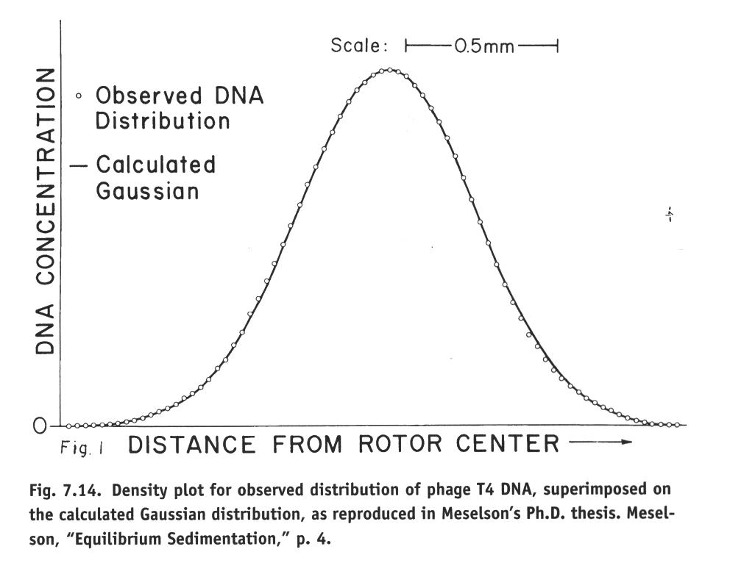
This clean result may be viewed as a test that the measuring device worked properly and that the gradient was almost perfectly linear over a certain range. Thus, distances from the center of rotation translates directly into buoyant density. This linear CsCl gradient was an important part of what I have called the experimental mechanism, which is the centerpiece of my IBE-based reconstruction of the experiment. I would like to call the theory of how centrifugation produces a linear gradient from which the density of molecules that float in it can be read off directly the theory of the instrument. The final question to be discussed in this section is how this theory of the instrument was confirmed.

My proposed answer to this last question is that the theory of the instrument was also supported by an IBE-type argument, and that explanation is best understood in the mechanistic sense. Here, the relevant experimental mechanism contains the DNA molecules, the cesium and chloride ions, as well as the water molecules. These entities interact by electrostatic forces and weak chemical bonds (hydrogen bonds). Further, this experimental mechanism involves the centrifuge itself with its rotor and the cell containing the DNA / CsCl solution. Together with physical laws (Newton’s laws, Coulomb’s law, and the laws of thermodynamics), this mechanism explains why, under suitable conditions, DNA molecules will reach a sedimentation equilibrium, in which they are distributed in accordance with a Gauss curve where the mean is a linear function of density and the width an inversely linear function of molecular weight, which is what was actually observed. It is this explanatory relation that provided grounds for thinking that the analytic ultracentrifuge is a reliable instrument for determining the density of certain biopolymers. In other words, it’s IBE-turtles all the way down.

6. Van Fraassen’s ‘bad lot’ Argument
In the previous section, I have shown that the IBE approach combined with a mechanistic account of explanation avoids Duhem’s first problem. But we still have Duhem’s second problem to cope with, which is that scientists can never have rational grounds for believing that the available hypotheses exhaust the space of possible hypotheses. There is a more recent version of this argument that pertains directly to IBE, namely Van Fraassen’s ‘bad lot’ objection (Van Fraassen 1989, 142ff.). According to this argument, IBE can perhaps rank a set of hypotheses with regard to their explanatory merits, but it cannot provide grounds for accepting one of them as true. For the best explanation could still be a very bad one; it affords no epistemic distinction to be the best of a bad lot.

The best way of meeting this objection for the present case study is by focusing on the genesis of the three alternative hypotheses and trying to show that the process of hypothesis construction had a certain propensity to produce a set of alternatives that contain the true one. For this purpose, it is helpful to note that all three schemes of DNA replication had to incorporate some very stiff constraints. Most importantly, the schemes had to explain how DNA molecules with the same nucleotide sequence as an existing molecule could be synthesized. Thus, explanatory considerations were already involved in the construction of hypotheses. This fits nicely with Lipton’s two-stage process, according to which the generation of a number of “live options” of candidate hypotheses is followed by a stringent selection of the “loveliest” one and where explanatory considerations enter at all stages of the research process. The main difference to my account is that I propose to base these explanatory considerations on a mechanistic account of explanation.

This mechanism-based view puts very stringent constraints on what qualifies as a live option. Suitable candidate hypotheses must incorporate a considerable body of knowledge from organic chemistry and molecular biology. In my example, the double helix model was such a constraint. It incorporated a great body of knowledge from organic chemistry, the physical chemistry of colloids, and crystallography. Furthermore, it was already fairly clear at that time that the sequence of bases in DNA was biologically highly significant (see Crick 1958, who could already cite a considerable body of evidence that supported this idea). Therefore, the replication mechanism had to preserve the nucleotide sequence of DNA. The complementarity of base pairing provided a lovely explanation for how a mechanism of DNA synthesis could achieve this. Hence, it was set that either single or double-stranded DNA had to serve as a template for the (then still putative) DNA polymerase. Indeed, all the three major replication mechanisms that were considered as live options during the mid-1950s incorporated this template idea. The great open questions were whether the template was single- or double stranded, and the extent to which the template was conserved in the process. Thus, background knowledge imposed a set of mechanistic constraints on the space of possible solutions to the replication problem. Unless this background knowledge was rotten to the core, the plausible hypotheses that had been proposed were not a bad lot.

Of course, it is not possible to exclude with certainty that the background knowledge that constrained the live options was fundamentally mistaken. But such is the nature of inductive inference: It strongly relies on material assumptions about the domain of induction (Norton 2003) and it is only as reliable as these assumptions are.

7. Conclusions
I have argued that a mechanistic version of IBE permits a reconstruction of the Meselson-Stahl experiment according to which the latter provided decisive veridical evidence for the semi-conservative hypothesis, while the two alternatives remained without such support. This is pretty close to what crucial experiments were always supposed to do, except that that I am of course not claiming that such an experimental demonstration reaches the apodictic certainty of deduction (as Duhem required, see Section 2). We are in the world of uncertain, inductive inference. As I have already argued elsewhere (Weber 2005), two major accounts of scientific inference – Bayesianism and Mayo’s error-statistical approach – don’t do quite enough to illuminate hypothesis testing in experimental biology. What both accounts lack is a good justification for judgments about evidential likelihoods or error probabilities. In this paper, I have argued that IBE can provide this. In contrast to Lipton’s (2004) account of IBE, I have used a mechanistic account of explanation. An advantage of such an account is that it does justice to actual explanations in molecular biology. Another advantage is that it makes explanation an objective relation between explanans and explanandum, which means that the evidential relation can also be objective.

I have introduced the notion of an experimental mechanism, which is like the physiological mechanisms discussed by philosophers of biology and neuroscience, except that it may include human manipulations and artificially created entities and activities. This notion allows IBE to be extended to infer hypotheses from experimental data such as the banding patterns observed in an analytic ultracentrifuge. Furthermore, IBE can also reconstruct the tests that the scientists did in order to make sure their measurement apparatus functions reliably.

Finally, I have shown that the two predicaments that Duhem identified for crucial experiments (though on the assumption that all inferences would have to be deductive) as well as Van Fraassen’s well-known “bad lot”-objection to IBE can be dissolved in the IBE-based framework that I have used. As regards Duhem’s first problem, the mechanistic variant of IBE allows (fallible) inferences to hypotheses about mechanisms even if there are untested experimental assumptions. Even so, some experimental assumptions were actually tested in this case. Van Fraassen’s “bad lot” problem (which I take to be basically Duhem’s second problem as applied to ampliative instead of deductive inference) can be handled by showing how an extensive body of background knowledge provided a host of stringent material constraints on the candidate hypotheses. Mechanistic-explanatory considerations are involved in the construction of such candidates as well as in the selection of the best one by a crucial experimental test.

References
Achinstein, Peter (2001), The Book of Evidence. Oxford: Oxford University Press.
Bogen, James, and James Woodward (1988), “Saving the Phenomena”, Philosophical Review 97: 303-352.
Cartwright, Nancy (1989), Nature's Capacities and Their Measurement. Oxford: Oxford University Press.
Craver, Carl (forthcoming), Explaining the Brain: Mechanisms and the Mosaic Unity of Neuroscience. Oxford: Oxford University Press.
Craver, Carl F., and Lindley Darden (2001), “Discovering Mechanisms in Neurobiology: The Case of Spatial Memory”, in Peter K. Machamer, Rick Grush and Peter McLaughlin (eds.), Theory and Method in the Neurosciences. Pittsburgh-Konstanz Series in the Philosophy and History of Science, Pittsburgh: Pittsburgh University Press, 112-137.
Crick, Francis H.C. (1958), “On Protein Synthesis”, Symposia of the Society for Experimental Biology 12:138-163.
Darden, Lindley, and Carl Craver (2002), “Strategies in the Interfield Discovery of the Mechanism of Protein Synthesis”, Studies in History and Philosophy of Biological and Biomedical Sciences 33C (1):1-28.
Duhem, Pierre (1954), The Aim and Structure of Physical Theory. Translated by P. Wiener. Princeton: Princeton University Press.
Glennan, Stuart S. (1996), “Mechanisms and The Nature of Causation”, Erkenntnis 44: 49-71.
Hanawalt, Philip C. (2004), “Density Matters: The Semiconservative Replication of DNA”, Proceedings of the National Academy of Science of the United States of America 101 (52): 17889-17894.
Holmes, Frederic L. (2001), Meselson, Stahl, and the Replication of DNA: A History of 'The Most Beautiful Experiment in Biology'. New Haven: Yale University Press.
Laudan, Larry (1990), “Demystifying Underdetermination”, in C. Wade Savage (ed.), Scientific Theories. Minnesota Studies in the Philosophy of Science Vol. XIV, Minneapolis: University of Minnesota Press, 267-297.
Lipton, Peter (2004), Inference to the Best Explanation, 2nd Edition. London: Routledge.
Machamer, Peter, Lindley Darden, and Carl Craver (2000), “Thinking About Mechanisms”, Philosophy of Science 67 (1): 1-25.
Mayo, Deborah G. (1996), Error and the Growth of Experimental Knowledge. Chicago: University of Chicago Press.
Meselson, Matthew, and Franklin W. Stahl (1958), “The Replication of DNA in Escherichia coli”, Proceedings of the National Academy of Science of the United States of America 44 (7):671-682.
Norton, John D. (2003), “A Material Theory of Induction”, Philosophy of Science 70 (4): 647-670.
Okasha, Samir (2000), “Van Fraassen's Critique of Inference to the best Explanation”, Studies in History and Philosophy of Science 31 (4): 691-710.
Rheinberger, Hans-Jörg (1997), Toward a History of Epistemic Things: Synthesizing Proteins in the Test Tube. Stanford: Stanford University Press.
Salmon, W. C. (1984), Scientific Explanation and the Causal Structure of the World. Princeton: Princeton University Press.
Van Fraassen, Bas C. (1989), Laws and Symmetry. Oxford: Clarendon Press.
Watson, James D., and Francis H.C. Crick (1953), “Molecular Structure of Nucleic Acids. A Structure for Deoxyribose Nucleic Acid”, Nature 171: 737-738.
Weber, Marcel (2002a), “Incommensurability and Theory Comparison in Experimental Biology”, Biology and Philosophy 17 (2): 155-169.
——— (2002b), “Theory Testing in Experimental Biology: The Chemiosmotic Mechanism of ATP Synthesis”, Studies in History and Philosophy of Biological and Biomedical Sciences 33C (1): 29-52.
——— (2005), Philosophy of Experimental Biology. Cambridge: Cambridge University Press.
Woodward, James (2003), Making Things Happen. A Theory of Causal Explanation. Oxford: Oxford University Press.

See Weber (2005, Chapter 3) for a detailed account of the latter example. Another case, the closure of the oxidative phosphorylation controversy, is treated extensively in Chapters 4 and 5 and in Weber (2002a, b).
A similar point can be found in Laudan (1990), though he discusses not crucial experiments but underdetermination of theory by evidence in general.
Today, it is known that this is actually what happens. There is a whole class of enzymes called topoisomerases that control the coiling of the DNA molecule. These enzymes can catalyze extremely fast breaking and re-joining of the sugar-phosphate backbone of DNA. Some enzymes can even introduce rotational strain into the molecule under the expenditure of metabolic energy.
See Holmes (2001) for an extremely detailed account. As usual, this experiment was preceded by a long and painstaking series of failures and cul-de-sacs. Holmes, who had the complete lab records available and conducted extensive interviews with the two scientists, traces the progress of Meselson’s and Stahl’s work on a day-to-day bases.
See Lipton (2004) for a book-length philosophical study of IBE. Lipton uses a contrastive account of causal explanation, whereas I shall use a mechanistic account.
The term “mechanism” is sometimes used in a double sense in this literature, sometimes ontological and sometimes epistemic. The latter use is shorthand for “description of a mechanism” or “model of a mechanism” and the context should normally make it clear which of the two senses is relevant.
Experimental mechanisms are part of experimental systems in the sense of Rheinberger (1997). See my (2005, Chapter 5) for a critical assessment of the experimental systems approach.
Hanawalt (2004). Thanks to Beatrix Rubin for bringing this paper to my attention.
Meselson to Watson, 8 November 1957. Quoted from Holmes (2001, 327-328).
For similar reasons, I don’t think that an appeal to Bayesian confirmation theory is of much help here. However, as Lipton (2004, Chapter 7) nicely shows, Bayesianism and the IBE approach are not necessarily in conflict. Explanatory considerations could be one possible way of estimating likelihoods. As for the error-statistical approach, perhaps a similar reconciliation is possible. Of course, this could lead to diverging claims with respect to the evidential import of the experiment. At any rate, this is not an issue that I can pursue any further here.
This curve appeared only in Meselson’s Ph.D. thesis, not in the 1958 publication. By the way, the thesis committee contained Linus Pauling and Richard Feynman. This obviously means that, had there been a problem with the physics, this could not have gone unnoticed!
Some proponents of a mechanistic account of explanation have argued that laws are redundant; all the explanatory work they were once thought to do can be captured by activities (see also Cartwright 1989). In Weber (2005, Chapter 2), I criticize this view. So does Glennan (1996).
A penetrating critique of the argument can be found in Okasha (2000).
Daniel Sirtes (unpublished) argues that mechanism boundaries are sensitive to pragmatic contexts. If correct, this obviously would spell difficulties for the alleged objectivity of the explanatory and mutatis mutandis for the evidential relation. This problem will have to be treated elsewhere.
Existing accounts of IBE, in particular Lipton’s seem to have focused on phenomena rather than data as the explanandum in IBEs. I must take exception to Bogen’s and Woodward’s view that data cannot be predicted or systematically explained by theory (Bogen and Woodward 1988, 305-306). Experimental mechanisms, as I use the term, do provide causal explanations for data in the sense of directly observable patterns produced by some measurement device. In experimental biology, theories are typically descriptions of mechanisms.

