(Word count including all material but 2 figures 4846;allowance made for 2 small figures and equations: )

Theories, Models, and Equations in Biology: The Heuristic Search for Emergent Simplifications in Neurobiology*

Kenneth F. Schaffner⁺

[part of the Craver, Weber, Bogen Hodgkin-Huxley 2006 symposium]

^{*Date received:}
⁺ Kenneth F. Schaffner
University Professor of History and Philosophy of Science
University of Pittsburgh
1017 Cathedral of Learning
Pittsburgh, PA 15260 USA
Tel: 1-412-624 5878/5896
Fax: 1-412-624-6825
e-mail: kfs@pitt.edu

Abstract
This paper begins with a review of some claims made by biologists such as Waddington, von Bertalanffy, and others, that biology should seek general theories similar to those found in physics. I disagree with that view, and describe an alternative framework for biological theories as collections of prototypical interlevel models that can be extrapolated by analogy to different organisms. To exemplify this position, I look in detail at the development of the Hodgkin-Huxley giant squid model for action potentials. The Hodgkin-Huxley strategy uses equations, but in specialized ways involving heuristic approximations, to build their model, which is here viewed as an “emergent simplification.” Very current elaborations of the Hodgkin-Huxley model, including Hille’s, utilize gene “superfamily” language to license generalization from one channel type to the others, and indicate that the Hodgkin-Huxley model is interpretable as an emergent unifier. Emergent unifiers, which require simplifications of a variety of sorts, represent an application of the types of heuristics discussed in Wimsatt’s writings on reduction, but with a twist: In the interpretation given them in the present paper, the heuristics are utilized to generate emergent rather than reductive explanations.
1. Introduction: The Structure of Biological Theories. Until fairly recently, many of the analyses of theories in the biological and biomedical sciences had subscribed to what I term the "Euclidean Ideal." This notion assumes that the ideal structure of a scientific theory resembles Euclid's approach to geometry: a small number of fundamental definitions and axioms constitute the essence of a theory. The axioms are formulated in mathematical symbols, and are then elaborated deductively in the form of theorems and applications that cover a broad (scientific) domain. This view of theory structure obtains fairly strong support in the physical sciences, in say mechanics, thermodynamics, electromagnetics, and quantum mechanics ( see e.g., Stratton, 1941 and von Neuman, 1955). But a similar orientation toward general theory in biology also can be found in the work of von Bertalanffy on “general systems theory” and his sets of multiple partial differential equations and in the kinds of theories found in Waddington in his (1968).
These biologists as well as some philosophers of biology, such as the early Michael Ruse (1973), had maintained that the laws and theories of biology have the exact same logical structure as do those of the physical sciences (though some changes in this approach began to surface in the 1980s-- see Schaffner (1980), Kitcher (1984), Rosenberg (1985), Culp and Kitcher (1989), and my elaboration on these developments in my (1993), esp. chapter 3). This simple unity view is actually only supportable using almost atypical examples, such as certain formulations of Mendelian genetics and of population genetics, especially Jacquard’s axiomatization of Sewell Wright’s theory, as summarized in my (1993), 341-343. But a deeper analysis of even these theories, however, will disclose difficulties with a strong methodological parallelism with the physical sciences (see Schaffner, 1980 and 1986, and Kitcher, 1984). I believe that a close examination of a wide variety of other biological theories in genetics, immunology, physiology, embryology, and the neurosciences suggests that the typical theory in the biomedical sciences is a structure of overlapping interlevel causal temporal prototypical models.
The models of such a structure usually constitute a series of idealized prototypical mechanisms and variations (some of which may be mutants) that bear family or similarity resemblances to each other, and characteristically each has a (relatively) narrow scope of straightforward application to (few) pure types. The models (or mechanisms) are typically interlevel in the sense of levels of aggregation, containing component parts which are often specified in intermingled body part (e.g., head or tail), cellular (e.g., neuron or axon), and biochemical (e.g., receptor or ions) terms. I argued at length (as far back as in my 1980) that this new type of theory, which I suggested might be termed a "theory of the middle range" (with apologies to R.K. Merton (1968) who first used that term in a somewhat different context), both is found and should be expected to be found in the biomedical sciences.
Though the Waddington and von Bertalanffy programs have not been confirmed in the typical accomplishments and representations in molecular biology in general, and molecular genetics in particular, there are interesting advances that fall between those searches for broad theories couched in mathematically precise differential equation form, and the narrow classes of mechanisms, usually described in qualitative multilevel causal language, that constitute the vast majority of current biomedical explainers.
There are several other theories that are equation-based which can be identified in contemporary biomedicine, and in the remainder of this paper I discuss one these in detail. My view is that these can disclose some important ways that very general and quantitative principles can be applied fruitfully in biology and medicine. They also disclose the limitations of this kind of physics-oriented approach to biology, and a comparison of those areas where mathematical modeling works and at what points it begins to fail may even indicate ways that what is now referred to by the buzz word “systems biology” can approach the issues of theories, models, and equations in this nascent area.
I now turn to a brief account of the development of the Hodgkin-Huxley giant squid model for action potentials, a stunning accomplishment for which Hodgkin and Huxley shared the Nobel Prize in physiology or medicine in 1963. One of the current standard textbooks of neuroscience, (Kandel et al. 2000) states that fifty years after it’s publication, “the Hodgkin-Huxley model stands as the most successful quantitative computational model in neural sciences if not all of biology” (p. 156).

2. The Development of the Hodgkin-Huxley Giant Squid Model for Action Potentials.

Action potentials (APs) are waves of potential difference (or voltage) that move down nerve axons, communicating the effect of a stimulus from the receptors located near the beginning of the neuron to the termination of the nerve cell. To a first approximation, APs are the result of a rapid (millisecond) changes in the membrane’s permeabilities to sodium and potassium ions, changes which underlie the wave of potential difference. Hodgkin and Huxley’s work on the action potential in nerve cells began from Hodgkin’s earlier work on electric currents on the shore crab in the late 1930s (Hodgkin 1964). He teamed up with Huxley, who was his student at Cambridge University, and they jointly turned their attention to the giant squid axon, which was a much more tractable experimental system in which to investigate the movement of specific ions, including sodium and potassium. Though their work was interrupted by World War II, they resumed their project in 1946, and in the late 1940s through to the early 1950s they conducted their classical experimental and theoretical investigations (Huxley 1964). A series of papers culminated in their extraordinary 1952 article in the Journal of Physiology in which they systematically lay out the steps and their reasoning that culminates in the classical action potential model of nerve transmission (Hodgkin 1952).
The 1952 paper closely parallels their more historical account of their steps toward their quantitative model that appears in the two Nobel Prize lectures (Hodgkin 1964) (Huxley 1964). They begin by first discussing their careful experimental results which had employed the voltage clamp apparatus, developed in 1949 by Kenneth Cole. This experimental device permits the establishment of a set of different potential differences across the squid nerve cell membrane, and recording of the effects that the different membrane potential have on the state of the cell. (A detailed description of the apparatus and technique can be found in the textbox on page 152 of (Kandel et al. 2000).) Their earlier papers had indicated that the movement of currents based on ions across nerve cell membrane could be well represented by an “equivalent circuit” involving a capacitor and three resistors, all in parallel, and with each resistor in series with a source of an electrical potential difference. This circuit captures the sodium (Na) and potassium (K) currents, as well as a small leakage current (l).This equivalent circuit, adapted from their 1952 paper is shown in the figure below (compare with (Huxley 1964)).

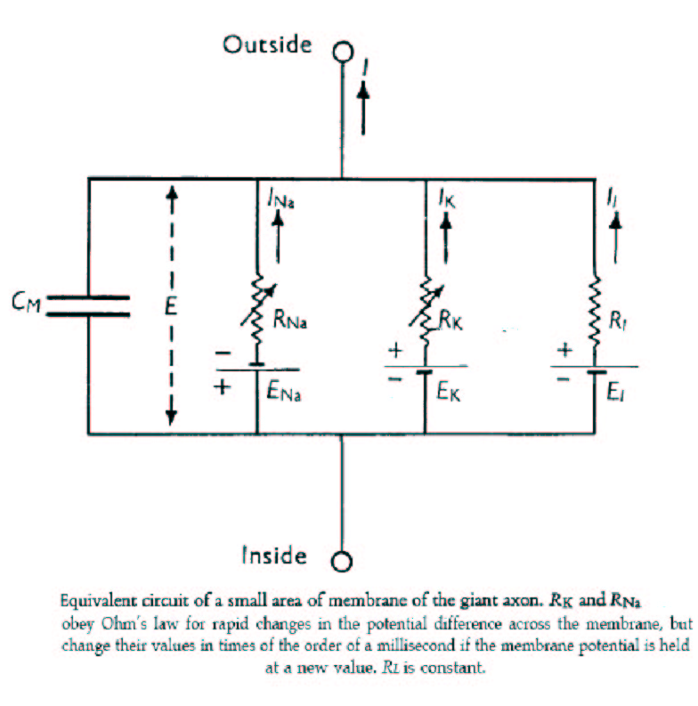
Figure 1 from H&H, 1952

The “laws of working” ( a term originally used by John Mackie, but see my discussion of the phrase in my 1993, pp. 287, 306-307) that govern this circuit are the standard physical laws including Ohm’s law as noted in the legend to the figure above. Additionally the potential difference across the membrane established by differences in the Na and K ions is as required by the Nernst equation:
V_{ion} = RT/zF ln (X_{o}/X_{i}),
where V is the potential difference (voltage), R and F are the universal Boltzmann and Faraday constants , T is the temperature, z is the valence of the ion, and X_{o} and X_{i} are the concentrations of the ion outside and inside the cell. (Such laws are constraints and foundations, but are not the complete derivational source, for the later H&H equations I introduce further below (also see Bogen (2005) and Craver (2007) on this point, as well as the other papers in the present symposium.)
Part II of the Hodgkin-Huxley paper is a “mathematical description of membrane current during a voltage clamp.” Equations for the sodium and potassium currents, as conductances are developed. The equations do not come from “first principles” but rather are empirical equations fitted from the voltage clamp data. They are typically chosen based on simplicity, with a first order equation being preferred over a second order, etc.. A first order equation is satisfactory to represent a portion of the time course of nerve depolarization (a rapid change of voltage across the membrane), but a fourth order equation is needed to represent the beginning of the potassium depolarization process. The equation for potassium conductance, in the form that it could be compared with the empirical results, was chosen as:
It is a theoretical equation, to use H&H’s language, based on the equivalent circuit and the general empirically found form of the rise and fall of ion conduction during depolarization and repolarization. H&H doubt it gives a “correct picture” of the membrane, though they do provide a possible physical basis for the equation (see pp. 506-507 of the 1952 article). The equation contains a constant τ_{n} that can then be specified to be the best fit to experimentally determined depolarizations of different potential membrane differences. Hodgkin and Huxley found that there was reasonable agreement between theoretical and experimental curves. H&H then go on to develop the somewhat more complex reasoning leading to the equation for sodium conductance, which I shall not discuss, but which can be found on pp. 512-515 of their 1952 paper. They also develop equations for rate constants α and β, and the dimensionless proportions n, m, and h, of ions inside and outside the membrane, in part II as well.

At the beginning of Part III of their (1952) paper, titled “Reconstruction of Nerve Behavior,” H&H summarize the equations they have developed in Part II of that paper. The summary is from the H&H (1952) article) and the numbering of the equations in parentheses comes from their original equation numbers. The summary looks like this:

$I=C_{M}\frac{\text{dV}}{\text{dt}}+{\bar{g}}_{K}n^{4}(V−V_{K})+{\bar{g}}_{\text{Na}}m^{3}h(V−V_{\text{Na}})+{\bar{g}}_{l}(V−V_{l})$ (26)
${\text{dn}}/{\text{dt}}=α_{n}(1−n)−β_{n}n$ (7)
${\text{dm}}/{\text{dt}}=α_{m}(1−m)−β_{m}m$ (15)
${\text{dh}}/{\text{dt}}=α_{h}(1−h)−β_{h}h$ (16)
$α_{n}=0\text{.}\text{01}(V+\text{10})/\left(\text{exp}\frac{V+\text{10}}{\text{10}}−1\right)$ (12)
$β_{n}=0\text{.}\text{125}\text{exp}(V/{\text{80}})$ (13)
$α_{m}=0\text{.}1(V+\text{25})/\left(\text{exp}\frac{V+\text{25}}{\text{10}}−1\right)$ (20)
$β_{m}=4\text{exp}(V/{\text{18}})$ (21)
$α_{h}=0\text{.}\text{07}\text{exp}(V/{\text{20}})$ (23)
$β_{h}=1/\left(\text{exp}\frac{V+\text{30}}{\text{10}}+1\right)$ (24)

The first four of these equations are the differential equations which govern the system’s behavior. The many computer simulations of the H&H model involve programs that repeatedly step through those first four equations (see Fodor, 2007, for one example).
Equation (26) is then applied to the action potential. We are most interested in the “propagated action potential,” as distinguished from a uniform membrane action potential. In the propagated action potential, the local circuit currents have to be provided by the net membrane current. At this point in their (1952) paper, H&H appeal to a well known partial differential equation from cable theory (which is a variant of Laplace’s well known heat diffusion partial differential equation) relating the current to the second partial derivative of the potential difference (V) with respect to distance (x). This equation is given by the expression:
i = [ 1/( r₁ + r₂) ] ∂ ²V/∂x² (27)

There are some simplifications then invoked, e.g., since r₁ << r₂, r₁ can be dropped. The expression for the current density for the fiber with a radius of a then allows the equation to be rewritten as:
I = [ a/2r₂) ] ∂ ²V/∂x²

This relation is then substituted into equation (26), which yields a partial differential equation that is “not practical to solve as it stands” (p. 522). But a similarity is noted for the condition of steady propagation, one which permits the equation to be converted into an ordinary differential equation that can be solved numerically, if laboriously given the computational tools available in 1952. This is the propagated action potential equation and was written as:

(30) a d²V = C_{M} dV + g_{K} n⁴ (V – V_{K}) + g_{Na} m³h (V – V_{Na}) + g_{l} (V – V_{l}),
2_{R}θ² dt² dt

where θ is a paramenter that has to be estimated numerically, based on the behavior of the equation at extreme boundary conditions (see p. 522 of H&H for details). A section on numerical methods of solution of such equations is interpolated in the 1952 article, and after a minor (abbreviational) substitution, equation (30) is rewritten as equation (31) (not shown here, but see p. 524 of the original article). This equation (either 30, or the equivalent 31, is solved numerically, and graphs of the membrane conductances during a propagated action potential are depicted. H&H’s graphical results were shown in their figure 17 that were based on numerical solutions of equation (31) showing components of membrane conductances (g) during propagated action potential (-V). This figure is widely reproduced in standard neuroscience texts (also see their original article, page 530. Readers will also recognize such graphs of the conductances as THE classical action potential result, which is re-presented, based on largely qualitative considerations, in typical neuroscience textbooks.

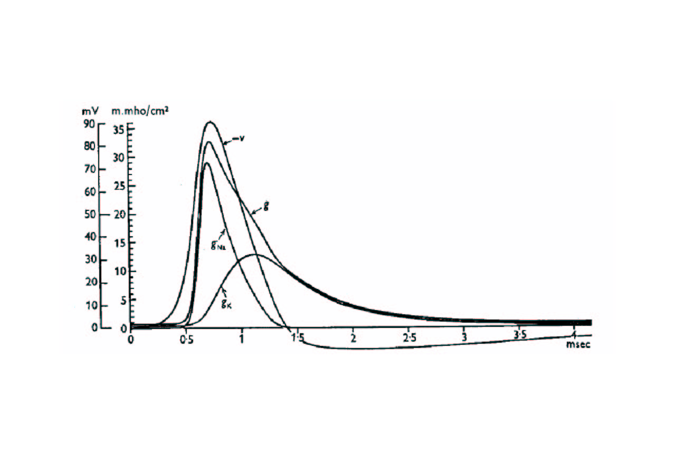
Figure 2. Conductances (g) of sodium g_{Na}, potassium g_{K}, and total g, as well as the propagated action potential (-V) from H&H’s original Figure 17.

3. Implications of the Hodgkin-Huxley Model and their Methodology.

3.1 One basic mechanism with many types of molecular realizations?

An examination of the form of the key equations, especially the batch summarized beginning with (26) on page 8 above and then numbers (30-31) might suggest that H&H’s accomplishment is not that different than, say, Maxwell’s articulation of the electromagnetic theory of light and Maxwell’s derivation of the wave equation for an electromagnetic disturbance. But the H&H equations are not universal equations as were Maxwell’s – the H&H equations were empirically generated from curve fittings to the squid action potential changes read using the voltage clamp technique. Hodgkin and Huxley remarked on the limitations of their model a number of times during the course of their (1952) article, limitations that are well summarized by Bogen (2005) and Craver (2007).
Toward the very end of the 1952 paper, H&H wrote:
Applicabilility to other tissues. The similarity of the effects of changing the concentrations of sodium and potassium on the resting and action potentials of many excitable tissues (Hodgkin, 1951) suggest that the basic mechanism of conduction may be the same as implied by our equations, but the great differences in the shape of action potentials show that even if equations of the same form as ours are applicable in other cases, some at least of the parameters must have very different values (p.542) (my emphases).

In addition, toward the end of his Nobel lecture, Hodgkin returned to this issue and the related theme of a specific or “definite” model of the membrane when he wrote:

To begin with we hoped that the analysis might lead to a definite molecular
model of the membrane. However, it gradually became clear that different
mechanisms could lead to similar equations and that no real progress at the
molecular level could be made until much more was known about the chemistry
and fine structure of the membrane. On the other hand, the equations
that we developed proved surprisingly powerful and it was possible to predict
much of the electrical behaviour of the giant axon with fair accuracy.
Examples of some of the properties of the axon which are fitted by the equations
are: the form, duration and amplitude of the action potential; the conduction
velocity; impedance changes; ionic movements; and subthreshold
phenomena including oscillatory behaviour. (1962, p. 42)

A review of contemporary molecular models of various ion channels capable of supporting action potentials suggests that H&H happened on a most remarkable level of abstraction/aggregation that would support very broad generalization in terms of the specificity of membrane currents, though not any specific molecular mechanisms. For example, the chapter by Koester and Siegelbaum on “Propagated Signaling: The Action Potential” in Kandel et al 2000 states somewhat “teleologically” that:

The squid axon can generate an action potential with just two types of voltage- gated channels. Why then are there so many different types of voltage-gated channels found in the nervous system? The answer is that neurons with the expanded set of voltage-gated channels have much more complex information-processing abilities than those with only two types of channels. (p. 159). (my emphasis)
The number and types of ion channels are explained, and to an extent unified, by the underlying genetics (and epigenetics) of ion channel diversity, a topic to which I turn next.

3.2. Genetic and epigenetic diversity accounts for ion channel diversity.

Hille recounts the history of ion channel research over the course of the last half-century following H&H’s classic paper. The progress he writes has been “phenomenal,” and “the field has become highly interdisciplinary, combining approaches of biophysics, pharmacology, protein chemistry, molecular and medical genetics, and cell biology” (Hille 2001) p. 61. Several recent Nobel prizes have, in point of fact, been awarded for ion channel research, including to Neher and Sakmann in 1991, who developed the “patch clamp method” that provided direct evidence of ion channels, and to MacKinnon in 2003, for structural and mechanistic studies of ion channels, including his pore model.
Genetic studies that began in the 1980s have indicated that there are three general genetic “superfamilies” of ion channels, comprising ligand-gated, gap-junction, and the H&H type of action-potential generating voltage gated channels. This last class, which are activated by depolarization, also contains three subclasses of channels selective for Na+ and K+ and Ca++ (Siegelbaum 2000). (Siegelbaum 2000) describe the similar architecture of this class of channels writing:
They contain four repeats of a basic motif composed of six transmembrane segments [known as] (S1-S6). The S5 and S6 segments are connected by a loop, through the extracellular face of the membrane, the P-region, that forms the selectivity filter of the channel. A single subunit of voltage gated Na+ and Ca++ channels contains four of these repeats. Potassium channels are composed of four subunits, each containing one repeat. ( p. 119).

Additional ion family channels are in the process of being discovered and characterized, including a class of Cl- channels. But already the number of different channel types is according to (Siegelbaum 2000) “enormous.” The diversity is accounted for in part because “most channels are made up of multiple subunits that can be combined in different permutations to produce channels with different functional properties” (p. 119). Additionally, the variability is “produced by differential expression of two or more closely related genes, by alternative splicing of mRNA transcribed from the same gene, or by editing of mRNA” (p. 120).
Some simplification of this extensive diversity occurs in the axonal region of the neuron where just the two major channel types, Na+ and K+ are involved. However, even here, Hille also describes an extensive “diversity of K channels” in different tissues and even within single-cells. He sums up this “microheterogeneity of K channels,” noting that “such results are typical of experimental discoveries today. The finer the method of analysis, the more apparent subtypes of channels are discovered” ((Hille 2001) p. 74). In spite of this extensive diversity and variation, genetics can provide a rationale for generalization, at least involving similarity modeling. On this point Hille writes: “The NA, Ca, and K families of voltage gated channels form a homologous gene superfamily, as may be expected from their broad apparent functional similarity. This means that many findings for one type of channel can be generalized to the others” (Hille 2001), p. 85.

3.3. The H&H “basic mechanism” as an emergent simplification.

The account of the extensive diversity of specific mechanisms of ion channel types just summarized raises the question of how unity can be effective achieved amid such natural variation. In a significant sense, H&H achieved that unification and simplification in advance of the more recent molecular knowledge by working at a higher level of abstraction. Their accomplishment suggests that in certain areas of biology, investigators can capture what might be termed “emergent simplifications” that transcend the specific workings of the molecular details. In a way, a more abstract mechanism can be a “basic mechanism,” even if it is clearly realized that there are as yet unknown molecular details of the mechanism. Possibly such a basic mechanism is more like a “prototypical” mechanism, which identifies and characterizes salient core features of a biological entity and its actions.
In some circumstances, the core features of those simplifications can be generated by quantitative investigations and represented by mathematical equations that are formally analogous to what we find in the Euclidean types of theories discussed in section 1. But they lack that very broad universality, and instead serve their functions by being prototypes for analogical modeling to similar prototypes, albeit in this case, analogical modeling to other quantitative prototypes. In addition, they are not usually uni-level, but instead mix levels of aggregation. In the H&H work, the discussion is focused on current flows and potential difference changes due to ions and inferred ion channels, but as situated in an axon of a particular species. Further reflection of the H&H systems-level methodology may provide important generalizable heuristics that can inform biology pursued at the level of general systems.

4. Emergent simplification and a reverse application of Wimsatt’s reductionistic heuristics

In a series of papers beginning in 1980, Bill Wimsatt has analyzed a series of “heuristics,” thought of as guides or “rules of thumb,” which are employed when scientists proceed in a reductionist manner. In a recent paper, Wimsatt (2006) summarized these reductionistic heuristics under some 20 headings. These range from bias toward a unitary and monadic level, to inappropriate simplifications -- or even total disregard -- of the environment. In general, Wimsatt views the simplifying reductionistic heuristics as accounting for the power of reductionistic approaches, but as paying for this power by shortchanging the roles of the environment and actual complex multilevel interactions.
The emergent simplification of H&H described above also uses simplifying heuristics which shield us from more complex interactions. Ironically, the complexity that H&H decided not to pursue was at more reductionistic levels, such as the actual mechanisms of ion transport.
Some of what Wimsatt describes as reductionistic heuristics were adopted by H&H in service of their research at an emergent simplified level. For example, Wimsatt’s reductionistic heuristic of “contextual simplification” states the reductionist should simplify environment before simplifying system.” H&H followed this strategy by controlling for, and systematically varying, the external ionic concentrations. Also, the theory was initially tested using their preferred “model organism,” the squid, though H&H did speculate on generalization of their results as noted above. And the absolutely key voltage clamp tool also represents the application of a third of Wimsatt’s heuristics of “tool binding.”
But reductionistic heuristics are also not followed by H&H, as in their recognition that they did not describe their system exhaustively (Wimsatt’s “extra-perspectival blindness or perceptual focus). Similarly, H&H did not attempt to try to refer all descriptions and processes “to entities at a given level” – their analysis is multi-level as described in the analysis earlier in this paper and in the companion papers in this symposium. Additional Wimsattian heuristics could be reviewed and commented on in terms of whether H&H followed them, but space does not allow additional discussion in the present paper.
Suffice it to say that we desperately need simplifications to make sense of neural processes, and in the above sections we see the actions of such simplifications in one of the most fundamental, central, and many would say one of the simplest of the types of processes encountered in the neurosciences – the generation of action potentials. But the simplifications are in the service of producing results at an emergent level, not a reductionistic level. As one seeks to analyze neural connections related to behavior, even in such simple neural networks as one finds in C. elegans and Drosophila, the need for simplifications becomes evident (Schaffner 2006). And as one attempts to analyze human neuroscience, strategies for simplifications become all the more urgent (Schaffner, 2008).

References

Bogen, James 2005. Regularities and causality; generalizations and causal explanations.
Studies in the History and Philosophy of Science, C. 36: 397-420.
Craver, Carl.F. (2006) [forthcoming]. Explaining the Brain. Oxford: Oxford University Press

Culp, Sylvia and Kitcher, Philip (1989) "Theory Structure and Theory Change in Contemporary Molecular Biology," British Journal for the Philosophy of Science 40: 459-483.
Fodor, Anthony A. (2007) H&H interactive on-line simulation at: http://www.afodor.net/HHModel.htm (accessed March 28, 2007)

Hille, B. (2001). Ion channels of excitable membranes. Sunderland, Mass., Sinauer.

Hodgkin, Andrew L. (1964). "The Ionic Basis Of Nervous Conduction." Science 145: 1148-54.

Hodgkin, A. L. and Huxley, A. F. (1952). "A Quantitative Description of Membrane Current and its Application to Conduction and Excitation in Nerve." Journal of Physiology 117: 500-544.
Huxley, Andrew F. (1964). "Excitation and Conduction in Nerve: Quantitative Analysis." Science 145: 1154-9.
Kitcher, Philip "1953 and all that: A tale of two sciences." Philosophical Review 18 (1984): 335-73.
Kandel, Eric R., James H. Schwartz and Theodore M. Jessell (2000). Principles of neural science. New York, McGraw-Hill, Health Professions Division.
Koch, Christof (2004) The Quest for Consciousness. Englewood, CO: Roberts.
Merton, Robert. K. "On sociological theories of the middle range." In Social Theory and Social Structure., edited by R. K. Merton. New York: Free Press, 1968.
Rosenberg, Alex. The structure of biological science. Cambridge: Cambridge University Press, 1985.
Ruse, Michael. Philosophy of biology. London: Hutchinson, 1973.
Schaffner, Kenneth F. "Theory structure in the biomedical sciences." The Journal of Medicine and Philosophy 5 (1980): 57-97.
Schaffner, Kenneth. F. "Exemplar reasoning about biological models and diseases: A relation between philosophy of medicine and philosophy of science." The Journal of Medicine and Philosophy 11 (1986): 63-80.
Schaffner, Kenneth. F. Discovery and explanation in the biomedical sciences. Chicago: University of Chicago Press, 1993.
Schaffner, Kenneth.F. "Reduction: The Cheshire Cat Problem and a Return to Roots," Synthese Volume 151, Number 3 / August, 2006. Pages 377-402.
Schaffner, Kenneth F. (2007) "Theories, Models, and Equations in Systems Biology," in Boogerd, Fred et. al. (eds) Towards a Philosophy of Systems Biology, Netherlands: Elsevier
Schaffner, Kenneth.F. (2008) “Etiological Models in Psychiatry: Reductive and Nonreductive “ in K. Kendler and Josef Parnas,(eds.) Philosophical Issues in Psychiatry. Baltimore: Johns Hopkins University Press. In press.

Siegelbaum, S. A., and Koester, J. (2000). Ion channels. in Kandel, J. H. Schwartz and T. M. Jessell (eds.) 2000, pp. 105-123.

Stratton, Julius A. (1941) Electromagnetic Theory. 1st ed. New York: McGraw-Hill.

von Bertalanffy , Ludwig General System Theory, Braziler, New York, 1968.
von Neumann, John. (1955) Mathematical foundations of quantum mechanics. Tr. Beyer, R.T. Princeton: Princeton University Press.
Waddington, Conrad H. "Introduction." In Towards a theoretical biology., edited by C. H. Waddington. Vol. 1. Chicago: Aldine Press, 1968.
Weber , Marcel (2004) Philosophy of Experimental Biology. New York: Cambridge University Press.
Wimsatt, illiam. C. (1980) Reductionistic research strategies and their biases in the units of selection controversy. In T. Nickles (ed.) Scientific discovery—Vol II: Case studies. Dordrecht: Reidel. Pp. 213-259.
Wimsatt, William C. (2006) Reductionism and its heuristics: Making methodological reductionism honest. Synthese, Volume 151, Number 3 / August, 2006. Pages xxx-xxx.
Footnotes

An earlier version of my account of the Hodgkin-Huxley model was in fact utilized to generate recommendations for how “systems biology” might proceed. See my 2007 for these comments.
The philosophy of science literature has just recently begun to address the Hodgkin-Huxley action potential model as an important exemplar. Weber in his (2004) book discusses it at some length in chapter 2 of his book, and Bogen (2005) and Craver (2007) analyze it as well, and of course this symposium is focused in depth on the exemplar.
In his recent book The Quest for Consciousness, Koch writes “that action potentials are the “Universal Communication Protocol” (2004, p. 35).

