MECHANISMS AND DOWNWARD CAUSATION

Max Kistler
Université Pierre Mendès France
Département de philosophie
UFR SH
BP 47
38040 Grenoble Cedex 9
France
Fax ++33476827833
kistler@free.fr
http://max.kistler.free.fr

Abstract

To explain phenomenon R by showing how mechanism M yields output R each time it is triggered by circumstances C, is to give a causal explanation of R. This paper analyses what mechanistic analysis can contribute to our understanding of causation in general and of downward causation in particular. It is first shown, against Glennan (1996), that the concept of causation cannot be reduced to that of mechanism. Second it is suggested to correct Craver and Bechtel’s (2006) claim that the framework of mechanistic explanation dissolves the appearance of causal processes that « cut across levels ». Their analysis is inadequate for cases of « downward causation ». I suggest construing a decision's influence on molecules in muscle cells as a global constraint. Microscopic laws determine the detailed evolution of muscle cells and glucose molecules, but this evolution is constrained by the fact that it must be compatible with the action caused by the decision. The constraint the decision exercises on microscopic processes in muscle cells cannot be understood in terms of constitution because the decision doesn't constitute the microscopic processes.

Introduction: Scientific explanation and causal explanation

According to the traditional conception of logical empiricism, all scientific explanations are causal explanations. The deductive-nomological analysis was intended to indicate at the same time what it takes to be a scientific explanation and what it takes to be related as cause and effect. However, it is well known that there are explanations that satisfy the formal requirements of the DN analysis without intuitively being causal: in such explanations, the initial conditions do not appear to refer to a cause of the explanandum. Additional requirements need to be imposed on two facts or events in order for them to be related as cause and effect, requirements that may be alternative or additional to the requirement of playing the logical roles of initial condition and conclusion in a valid DN-argument. One important suggestion is that causation requires the existence of a mechanism linking the cause to the effect. Such a mechanistic conception of causation falls into the wider category of process conceptions of causation according to which: 1) causes and effects are essentially localised in space and time, in other words they are events, and 2) the causal relation between such events is based on a local, intrinsic process the end points of which are the cause and the effect. According to one proposal, causal processes are distinguished by their capacity to transmit marks introduced by an interaction, where the transmission does not require any additional interactions. Another proposal has it that the process underlying causation consists in the transmission of an amount of a conserved quantity, such as energy.

Mechanist analysis of complex systems

The concept of mechanism has recently been revived in the context of the analysis of complex systems. According to the mechanistic conception of the scientific explanation of the behaviour of complex systems, such an explanation typically takes the form of showing how the parts of a system, thanks to their articulation and interactions, make the whole system evolve and behave as it does. The aim of the explanation is to show how the evolution of the parts together with their interactions guarantees the regular transition from an initial state to a final state of the whole system.
The explanation of Long Term Potentiation (LTP) is one important example. LTP, sketched in fig. 1, leads to the strengthening of certain synapses in the brain and is considered to be an essential part of a fundamental mechanism of learning. The mechanism of LTP has been closely investigated in the hippocampus. Its main effect is thought to be the increase in the response of a postsynaptic cell (on the right, in fig. 1) to an action potential coming from the presynaptic cell (on the left, in the fig. 1), as a consequence of enhanced receptivity of the postsynaptic neuron. The neurotransmitter glutamate mediates the transmission of the signal over the synaptic cleft. One type of glutamate receptor in the postsynaptic cell is the NMDA (N-Methyl D-Aspartate) receptor. A glutamate molecule that binds to a NMDA receptor changes the latter’s shape, in such a way that it opens up a channel for Ca²⁺ ions. When the postsynaptic cell is depolarized, these Ca²⁺ ions float into the neuron, where they trigger a complex chain of biochemical events, resulting eventually in the expression of new proteins and the creation of new dendritic spines at the synapse. These spines form new synapses with the presynapytic neuron, which facilitates future transmission of action potentials through this pathway.
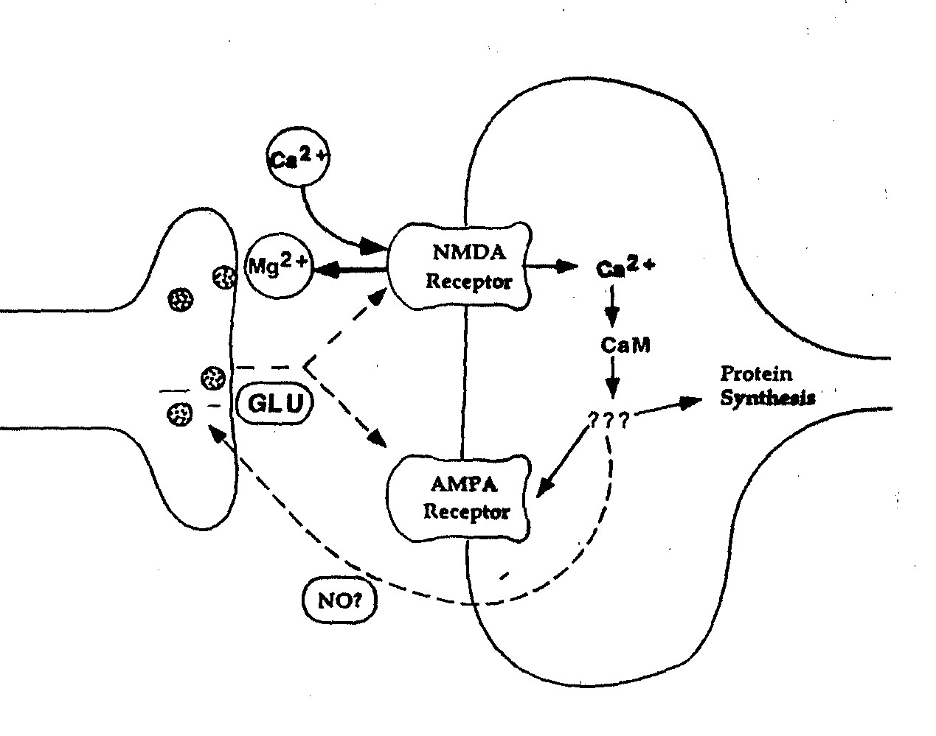Fig. 1 Sketch of spatial memory (LTP) mechanism (from Craver 2002, p. S 87).

It is characteristic of a mechanism such as LTP that it essentially involves several levels of organisation. One cannot understand the mechanism without speaking of what it achieves at the level of the behaviour of an animal: it modifies its behavioural capacities. The mechanism has been selected during the evolution of the species because it is a means to adapt the animal’s behaviour to its environment. In fig. 2, the level of the organism is sketched with the example of a mouse learning to navigate in a Morris water maze. This learning is mediated by the modification of the synaptic structure of the hippocampus which is thought to develop a “spatial map” of the maze (second level from above in fig. 2). The modification of single synapses (third level from above in fig. 2) is a crucial part of the mechanism leading to modification of the synaptic structure of the hippocampus. The modification of the NMDA receptor (bottom level in fig. 2) is an essential part of the modification of a synapse.

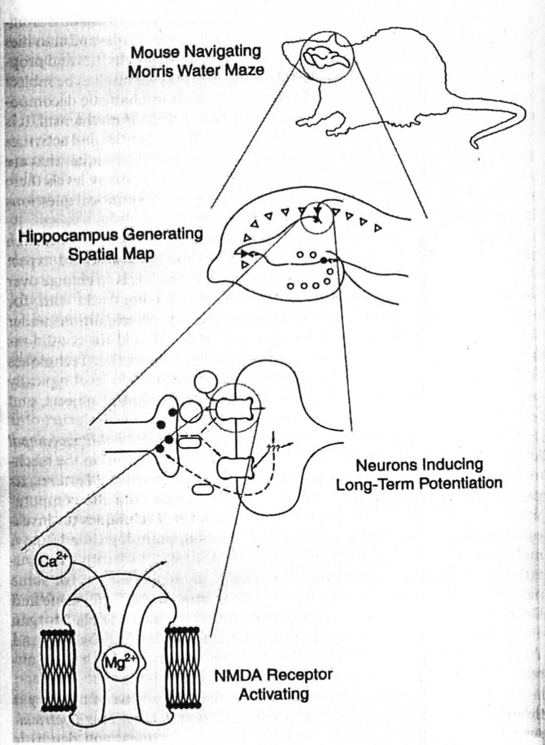
Fig. 2. Levels of the LTP mechanism (from Craver 2002, p. S90).

Reducing causation to mechanism?

No doubt, mechanistic explanations are causal explanations. It is part of what it means to be a mechanism that it extends from an initial to an end condition, where the former causes the latter. It is clear that initial and end conditions are meant to bear on different moments in time. Hence there can be no question of a “mechanism” linking two aspects of the same event. As a consequence, a mechanistic analysis avoids the wrong prediction of the DN analysis, that there may be causal relations between different properties of one substance at one time, such as between the temperature and the pressure of a given sample of gas.
But some have made the stronger claim that the concept of causation can be reduced to that of mechanism. According to Stuart Glennan, “events are causally related when there is a mechanism that connects them” (Glennan 1996, p. 49). True, Glennan admits that such a mechanistic account of causation “cannot explain causation in fundamental physics” (1996, p. 50). It cannot be true of interactions between elementary particles that the existence of a causal relation is equivalent to the existence of a mechanism. Glennan replies that there are two fundamentally different kinds of causation and suggests that “there should be a dichotomy in our understanding of causation between the case of fundamental physics and that of other sciences.” (1996, p. 50)
However, one would need stronger reasons to justify the radical and counterintuitive conclusion that there are two distinct concepts of causation, one for fundamental physical interactions and one for all other causal relations. This consequence is avoided as soon as one abandons the idea that causation can be reduced to mechanism. On closer inspection, it appears that the concept of mechanism presupposes that of causation, far from being reducible to it. Providing a mechanistic explanation means to decompose the working of a complex system into a number of simpler subsystems that interact causally with each other. These subsystems can in general themselves be analysed in still simpler subsystems, so that the interactions between the former subsystems can also be mechanistically explained. The crucial point is that each step of the analysis of a mechanism makes essential use of the notion of cause, and thus presupposes it. If one pushes the analysis far enough, one eventually reaches interactions between elementary particles. These however, cannot in their turn be given a mechanistic analysis, because elementary particles cannot be decomposed into their parts. It follows that the concept of mechanism cannot be used to analyse the concept of causation and that, quite on the contrary, the concept of causation is among the irreducible conceptual instruments of mechanistic analysis. Mechanist causation rests in the last instance on the causation of fundamental physical processes.

“Top-down” and “bottom-up” experiments

Even if the concept of mechanism does not provide the means to reduce the concept of causation, reflection on the mechanistic analysis of complex systems and their experimental investigation may help us answer a major question raised in recent philosophical work on causation. Jaegwon Kim (1998) has forcefully argued that the hypothesis of so-called “downward causation” leads to insuperable conceptual difficulties and can thus be refuted by reductio. However, the experimental investigation of mechanisms seems to contradict Kim’s conclusion. Scientific experiments on mechanisms seem to rely on causal processes crossing the boundary between levels of composition, both in upward and downward direction.

- In “bottom-up” experiments, one manipulates properties (“independent variables”) of individual components of a mechanism in order to observe the consequences of this intervention at the level of system properties (“dependent variables”), i.e. properties belonging only to the whole mechanism but to none of its parts.
- In downward or “top-down” experiments, the experimental intervention consists in manipulating system properties and observing its effects on properties of components of the mechanism.

An important category of bottom-up experiments uses the so-called “knockout” technique: organisms are genetically modified in such a way that specific genes are deleted. The observation of the development and behavioural capacities of such animals is taken to license inferences about the causal contribution of the knocked out genes to the development and capacities of the animal. It has, e.g., been experimentally discovered that mice in which the gene that codes for the NMDAR1-subunit of the NMDA-receptor is knocked out selectively in the relevant region of the hippocampus, exhibit characteristic deficits in the acquisition of long-term memory: They have, e.g., difficulties to learn the location of the submerged platform in a Morris water maze. In such experiments, a causal intervention at the molecular level seems to have effects at the level of the learning capacities of the organism. It seems to be a case of “bottom-up causation”.
If there is bottom-up causation, we may expect there also to be top-down causation where a cause consisting in the modification of system properties has effects at the level of the system’s microscopic constituents. Kim argues that such “downward causation” is unacceptable. However, some experimental strategies seem to presuppose its possibility. In techniques of brain-imaging such as fMRI (functional magnetic resonance imaging) and single-cell recording, the experimenter manipulates system properties, e.g. by putting animals in a situation in which they accomplish a specific behavioural task, and observes subsequent modifications of properties at lower levels: fRMI allows to measure nervous activity in specific brain regions; single cell recording allows to observe the activity of individual neurons. It has, e.g., been discovered that the CA3 and CA1 regions of the hippocampus of rats and mice contain so-called place cells that fire intensely only when the animal’s head is in a certain part of the environment called the cell’s “place field”. Such experiments causally intervene at the level of the organism: one manipulates the behaviour of the whole animal. The measured effect of that intervention lies at the level of the animal’s microscopic constituents: one observes modifications of the properties and activities of neurons in the hippocampus.
Are such “interlevel” experiments instances of top-down and bottom-up causation, or are they grounded on interlevel causal relations? Scientists’ statements suggest an affirmative answer. In Eric Kandel’s words, the “biological analysis of learning requires the establishment of a causal relation between specific molecules and learning” (Kandel 2000, p. 1268). More specifically, Kandel acknowledges the existence of downward causation: “Learning produces changes in the effectiveness of neural connections” (p. 1275). Downward causation also seems to be required to make sense of psychotherapy: “Insofar as social intervention works …[e.g.] through psychotherapy … it must work by acting on the brain” (ibid.). Kandel takes bottom-up causation to be required to understand how changes in the brain can affect cognitive processes and behaviour. In particular, “certain diseases (‘organic diseases’) affect mentation through biological changes in the brain” (ibid.).
Recent philosophical work on causation also seems to lead to acknowledge bottom-up and top-down causation. According to Woodward (2003), causation can be analysed in terms of manipulability. If a cause of some event, property or factor E is any factor C, such that interventions on C allow to manipulate E, then the bottom-up and top-down manipulations undertaken to understand the working of mechanisms are all cases of causation.
However, downward causation, through which the evolution of a complex system causally influences the evolution of its own parts, raises considerable conceptual difficulties. To clarify these, let us examine Kim’s (1998) argument that downward causation is conceptually incompatible with two plausible metaphysical hypotheses. The first, suggested by the success of physics in explaining physical phenomena, is the principle of the “causal closure of the domain of physical phenomena”. It says that for a given physical event e that takes place at time t, for each time t* preceding t, there is a complete physical cause c (at t*) of e. Kim’s analysis of downward causation is sketched in figure 3.

Fig. 3. Downward causation

The second principle is that there is no systematic overdetermination of microscopic events by independent micro- and macroscopic events. If event e at t has a complete physical cause c at time t* (where t* is earlier than t), then it does not (at least not in the general case) in addition have another complete cause C at the same time t*, which is independent of c. In particular, if e is a neural event happening in a subject’s brain at t, and c is a complete cause of e at the neural level, there will not (at least not in each case) be other complete causes of e that are simultaneous with c; in particular, there will not be a complete cause C at a cognitive level that is independent of c.
Here I can only sketch the argument against the conceivability of downward causation that Kim develops on the basis of these principles. It proceeds in two steps. In the first step, Kim shows that the only way a mental event C could cause a second event E, is indirect, by causing, through a process of downward causation, e, the physical basis of E. By causing e, C necessarily brings about E, because e is E’s supervenience basis. The supervenience relation entails that every instance of e is necessarily an instance of E. In a second step, Kim argues against the possibility of downward causation, which would, according to the first step, be required for mental causation. Given the causal closure of the physical domain, e has, at the time of C, a complete physical cause c. Now, either C is supervenient on c, in which case C is not an independent cause from c. Or C is independent from c, in the sense that one could occur without the other. Then C’s causing e is a case of overdetermination of an event, e, by two independent causes, c and C. It is controversial whether overdetermination is possible in exceptional cases, but it is generally taken for granted that it is implausible to suppose that all mental causes are cases of independent overdetermination.
Kim’s argument puts us before a dilemma: either the argument is sound and we must revise our interpretation of interlevel manipulation of complex systems, so that it does not require any downward causation after all, or we abandon one of the two metatheoretical principles Kim uses in his argument, so as to open up the logical space for downward causation.

Analysing interlevel causation in terms of constitution

Craver and Bechtel (2006) argue for the first of these options: although they admit that it may be convenient to speak, in a loose way, of downward causation when a part of a mechanism is manipulated by intervening on a system property, it is not necessary to postulate the existence of downward causation in a strict sense. The relevant downward relationship, they argue, “is not a causal relation” (2006, p. 1; their emphasis). In what follows, I shall first present Craver and Bechtel’s proposal to “analyse away” apparent cases of bottom-up and downward causal relations and argue that their analysis is not adequate in all cases. If I am right, then in order to take account of some recalcitrant cases of downward causation, it is inevitable to choose the second horn of the dilemma and resist Kim’s verdict against downward causation. Second, I shall sketch a general reason to abandon Kim’s principle of the causal closure of the domain of physical phenomena, which is also a reason to acknowledge the conceptual possibility of downward causation.
Craver and Bechtel (2006) argue that all apparent instances of bottom-up or top-down causation can be conceived of as composed of intra-level causation and non-causal determination. However, their interpretation of this determination relation in terms of constitution is flawed in the case of downward causation: top-down determination cannot be analyzed in terms of constitution.
Let us first look at Craver and Bechtel’s analysis of bottom-up causation. If a low-level cause c (at time t*) appears to cause a high-level effect E (at time t), this may be the consequence of two underlying patterns of combinations of intra-level causation and constitution.
In scenario 1, c causes e (intra-level) and e is one of the constituent parts of E.

In scenario 2, c is one of the constituent parts of C, and C causes E (intra-level).

Craver and Bechtel consider the case of a virus killing a person. Contamination by the virus (c) triggers a long and complex causal chain of events, all at the level of microscopic constituents of the contaminated person. That process leads eventually to physiological conditions (e) that are constitutive of the death of the person (E). The causal process leading from c to e is exclusively intra-level, whereas the relation between e and E is not causal but conceptual: e is a way of dying. This process follows the pattern of scenario 1 sketched above.
Sometimes it takes more than conceptual analysis to discover that e is constitutive of E. The relation between properties at different levels may involve nomological determination. Take the case of NMDA receptors in the hippocampus of a mouse. NMDA receptors contribute to determine the learning capacity of a mouse in a non-causal way: their presence does not cause the mouse’s capacity to learn because there is neither time lag nor spatial distance between their presence and the presence of the learning capacity. The possession of the parts necessary for the learning mechanism in their functional articulation is simultaneous with the possession of the whole mechanism that gives the mouse its learning capacity, and the set of parts occupies the same space as the mechanism. However, NMDA receptors are not logically or conceptually constitutive of the mouse’s learning capacity. The contribution of NMDA receptors to the learning capacity can only be discovered by a posteriori experimental research.
Let us now turn to Craver and Bechtel’s analysis of apparent cases of downward causation. Take their example of the process that begins with a person’s decision to start a tennis game and leads to appropriate tennis-playing behaviour. The latter requires a raise of glucose consumption in the person’s muscle cells. The decision, a system property of the person, seems to have effects at the cellular and molecular levels. However, Craver and Bechtel argue that this is a misleading appearance, which disappears at closer inspection. “The case can be described without remainder by appeal only to intra-level causes and to constitutive relations” (Craver and Bechtel 2006, p. 13). If this is correct, downward causation can be analysed according to one of two patterns. In scenario 1, C (the decision) determines c (the brain state underlying the decision), which then causes e (enhanced consumption of glucose in muscle cells) by intra-level causation.

In scenario 2, C (as before) causes E (appropriate behaviour at the level of the organism), which then determines e (as before) in a non-causal way.

The first scenario is inadequate if, as is generally assumed, mental events such as decisions to play tennis are multirealisable by many different brain states. Which particular brain state c realises C depends on the person’s history and the circumstances. At any rate, C does not by itself determine c. Furthermore, even if it did (in other words, if we abstract away from multiple realisation), the downward determination of a brain event by a mental event could not possibly be construed as a relation of constitution, because constitution is a bottom-up relation.
The same reasons seem to make scenario 2 inadequate: First, E does not in itself determine e because tennis-playing behaviour, and even a given detailed bodily move, can be realised at the molecular level in many ways. Second, E does not constitute e: parts can be constitutive of wholes but wholes cannot be constitutive of their parts.

Downward causation and downward constraints

However, I think that it is possible to reinterpret scenario 2 in such a way that it may represent the situation correctly. I suggest modifying Craver and Bechtel’s proposal in two respects. First, the downward relation by which E determines e is a relation of constraint not of constitution. Second, the constraint imposed on e by E is not complete but partial.
The process leading from the decision (C) of a person to her playing tennis (E) is an intra-level causal process at the level of the organism. How can we understand the relation between tennis playing and the underlying microscopic events taking place in the body, such as enhanced glucose uptake in muscle cells? The state of organism E exerts a constraint on its parts, in the sense that the fact that the organism is in state E limits the space of possible states of its muscle cells. However, the detailed evolution of each muscle cell is also constrained at the cellular and molecular level, by the physical state of the cell and its surrounding.
My suggestion to conceive of the influence by E on e as a partial constraint seems to resemble what Craver and Bechtel call the “enlisting” of the system’s parts by the whole system. However, they interpret enlisting to be a form of identity or constitution. To say that the tennis player’s “glucoregulatory mechanisms are enlisted” (Craver and Bechtel 2006, p. 13; their emphasis) by his activity, is according to them equivalent to saying that “a change in the activity of the mechanism as a whole just is a change in one or more components” (ibid.).
However, the fact that many detailed states of the parts are compatible with a given state of the whole makes identity (“just is”) inappropriate to characterise the relation between E (“a change in the activity of the mechanism as a whole”) and e (“a change in one or more components”). A given change in the activity of the mechanism as a whole is compatible with many changes in the states of the parts. By analogy with multiple realization, we might call the constraint exercised by E on e “multiple determination”. However, it is more adequate to call it partial determination: in the particular situation, E, together with other constraints that lie at the cellular and molecular levels, determines one particular microscopic change e.
Here is a sketch of how downward causation is conceivable in the form of a downward constraint exercised by global properties of complex systems on the evolution of their parts.

Fig. 4. Model of downward causation: intra-level causation + top-down constraint

This model presupposes that many microscopic events (occurring e.g. at a cellular or molecular level) in complex systems (e.g. living organisms), are not completely determined, in the long run, by same-level events. The brain may exhibit “deterministic chaos”. The possibility to make predictions about the evolution of a chaotic system is limited to a short time span. In other words, one cannot (deductively) explain a molecular event in a living organism (such as the transformation of an ATP in an ADP molecule in order to release the energy necessary for muscle contraction), on the basis of other molecular events that have occurred much earlier. If we treat diachronic determination of event e by event c as equivalent to the possibility to deductively explain e by c together with laws, then e at t is not completely determined by molecular events that have occurred at t*, where t* is much earlier than t. However, e is not for that reason left indeterminate. The success of ethology and psychology in explaining behaviour suggests that organisms also obey laws constraining their evolution at the level of systemic properties, such as laws determining actions on the basis of reasoning and decision making. The constraints exercised on the organism by laws at different levels, at the level of the organism as a whole and at various lower levels corresponding to its parts, create no conflict. If the determination of a molecular event is incomplete at its own level, it may nevertheless be completely determined jointly by laws at molecular and system levels.
The possibility of this scenario shows that, contrary to what Kim’s first principle says, present-day scientific knowledge does not exclude the hypothesis that the domain of physical phenomena is not closed. The microphysical state of a complex system at t* may not completely determine its microphysical state at a much later time t. In such a system, the microphysical state at t may be partially determined in a downward direction by the constraint that the system must, at t, be in a global state compatible with system level laws, such as cognitive laws.

Conclusion

Mechanisms are causal processes, and their analysis shows that they contain other more elementary causal processes. At the bottom level, there are fundamental physical causal processes that cannot, for lack of parts, themselves be given a mechanistic analysis. Therefore the concept of mechanism cannot be used to provide a noncircular analysis of the concept of causation.
Nevertheless, the analysis of mechanistic explanation can help us decide whether the mind can influence matter, and in particular, whether our decisions to behave can be considered as causes of microscopic changes in our body. Many philosophers take such “downward causation” to be mysterious and incompatible with general metaphysical principles abstracted away from science, such as the principle of the causal closure of the domain of physical events. I have tried to show that partial downward determination of microphysical states of a complex system is conceivable and does not violate any plausible scientific or metaphysical principles.
Craver and Bechtel (2006) have argued that, far from allowing us to make sense of downward causation, the analysis of mechanisms shows that all apparent cases of downward causation are really compositions of intra-level causal relations and relations of constitution. I have raised the following objection against their analysis of apparent cases of downward causation: they interpret the top-down determination relation of “enlisting” as identity or constitution. But downward determination is not identity because downward constraints can be met by many micro-events, and it is not constitution because constitution is an antisymmetric relation in which parts stand to the whole. This excludes the possibility of the whole being constitutive of its parts.

References

- Cartwright, Nancy (1999), The Dappled World. A Study of the Boundaries of Science, Cambridge, Cambridge University Press.
- Craver, Carl F. (2002), Interlevel Experiments and Multilevel Mechanisms in the Neuroscience of Memory, Philosophy of Science 69, p. S 83- S 97.
- Craver, Carl F. (2006): Constitutive Explanatory Relevance, manuscript.
- Craver, Carl F. and Bechtel, William (2006), Top-down causation without top-down causes, Biology and Philosophy, online, p. 1-17.
- Dowe, Phil (2000), Physical Causation, Cambridge, Cambridge University Press.
- Fair D. (1979), Causation and the Flow of Energy, Erkenntnis 14, pp. 219-250.
- Hebb, Donald O. (1949), The Organization of Behavior, New York, Wiley.
- Humphreys, Paul W. (1989), The Causes, Some of the Causes, and Nothing But the Causes, in: Minnesota Studies in the Philosophy of Science, vol XII: Scientific Explanation, Minneapolis, University of Minnesota Press, p. 283-306.
- Glennan, Stuart (1996), Mechanisms and the Nature of Causation, Erkenntnis 44, p. 49-71.
- Kandel, Eric (2000), Cellular Mechanisms of Learning and the Biological Basis of Individuality, in Kandel, Schwartz and Jessell, Principles of Neural Science, chap. 63, p. 1247-1279. McGraw-Hill.
- Kim, Jaegwon (1998), Mind in a Physical World. Cambridge (Mass.), MIT Press.
- Kistler, Max (1998), Reducing Causality to Transmission, Erkenntnis 48, p. 1-24.
- Kistler, Max (2004), Causation in contemporary analytical philosophy, Quaestio-Annuario di storia della metafisica, vol. 2, ed. C. Esposito and P. Porro, Turnhout (Belgium), Brepols, 2002, p. 635-668.
- Kistler, Max (2005), Is Functional Reduction Logical Reduction ?, Croatian Journal of Philosophy 5, p. 219-234.
- Kistler, Max (2006), Causation and Laws of Nature, London, Routledge (English version of Causalité et lois de la nature, Paris, Vrin, 1999).
- Kistler, Max (2006a), The Mental, the Macroscopic, and their Effects, Epistemologia (Genova, Italy), 29 (2006), p. 79-102.
- Lehnertz, K. and C.E. Elger (eds.) (2000), Chaos in Brain?, World Scientific, Singapore.
- Lowe, E.J. (2000), Causal Closure Principles and Emergentism, Philosophy 75, p. 571-585.
- Lowe, E.J. (2000a), An Introduction to the Philosophy of Mind, Cambridge, Cambridge University Press.
- Ludvig, Nandor (2001), Juan M. Botero, Hai M. Tang, Baiju Gohil and John G. Kral, Single-cell recording from the brain of free moving monkeys, Journal of Neuroscience Methods 106 (2), 179-187.
- Mills, Eugene (1996), Interactionism and Overdetermination, American Philosophical Quarterly 33, p. 105-17.
- Muller, Robert (1996), A Quarter of a Century of Place Cells, Neuron 17, p. 813-822.
- Nakazawa, Kazu, Thomas J. McHugh, Matthew A. Wilson and Susumu Tonegawa (2004), NMDA Receptors, Place Cells and Hippocampal Spatial Memory, Nature Reviews Neuroscience 5, p. 361-372
- Newman, David V. (2001), Chaos, Emergence, and the Mind-Body Problem, Australasian Journal of Philosophy 79, p. 180-196.

- Salmon, Wesley (1984), Scientific Explanation and the Causal Structure of the World, Princeton University Press.
- Salmon, Wesley (1990), Four Decades of Scientific Explanation, Minneapolis, University of Minnesota Press.
- Salmon, Wesley (1994), Causality Without Counterfactuals, Phil. of Science 61, pp. 297-312.
- Schurz, Gerhard (2002), Ceteris paribus Laws: Classification and Deconstruction, Erkenntnis 57, p. 351-372.
- Skarda, C. and W.J. Freeman (1990), Chaos and the New Science of the Brain, Concepts in Neuroscience 1, p. 275-285.
- Walden, Scott (2001), Kim’s Causal Efficacy, Southern Journal of Philosophy 39, p. 441-460.
- Woodward, James (2003), Making Things Happen, Oxford, Oxford University Press.

See, e.g., Humphreys (1989, p. 300/1), Salmon (1990, p. 46-50), Kistler (2004).
Salmon (1984).
Different versions of this proposal have been defended by Fair (1979), Dowe (2000), Salmon (1994), Kistler (1998 ; 2006). The analysis of causation in terms of a local physical process between two spatio-temporally localised events is opposed to views according to which causes and events are facts, which can be more or less abstract and even negative, disjunctive or relational.
See, e.g., Machamer, Darden and Craver (2000).
The idea that learning arises from the modification of synapses has first been introduced by Hebb (1949). For a concise presentation of present-day knowledge about LTP, see Kandel (2000).
Since its introduction in 1984, the Morris water maze has become a major experimental tool for the behavioral investigation of spatial learning and memory. Rats or mice are placed in a circular pool filled with opaque water, which hides from their view a small platform under the surface of the water, on which they can stand. Rats swim well but prefer to stay on the platform. Experiments study the rats’ learning of the location of the platform in different circumstances.
See Nakazawa et al. (2004).
See Ludvig et al. (2001).
See Muller (1996).
Cf. Kim (1998, p. 37/8), Lowe (2000; 2000a, p. 26ff.).
I have analysed Kim’s argument in more detail in Kistler (2005) and (2006a).
It has been argued, e.g. by Mills (1996) and Walden (2001), that the effects of mental causes are systematically overdetermined by mental and physical causes, and that this overdetermination is not the result of the dependency of the mental causes on the physical causes. Mills makes it clear that « causal overdetermination requires the distinct, independent causal sufficiency of P [a physical cause] and of my believing » (Mills 1996, p. 107; italics Mills’). For lack of space, I cannot here examine Mills’ and Walden’s arguments in detail. Let me just note that Mills’ own justification for the causal efficacy of a certain belief, with respect to the fact that his arm raises, contradicts this claim of independence. He justifies it by the truth of a counterfactual according to which the belief causes the arm movement in a possible world in which its physical cause is absent. Now, this counterfactual is true only because “worlds in which my belief is accompanied by some physical event that causes the arm-raising preserve actual laws, whereas worlds in which my belief is unaccompanied by any such physical event do not” (Mills 1996, p. 109). This reasoning seems to presuppose that there is a nomic correlation between physical and mental properties, which contradicts their independence.
I have justified this sketch in a little more detail in Kistler (2006a).
Cf. Skarda and Freeman (1990), Lehnertz and Elger (2000), Newman (2001).
Cognitive laws linking actions to reasoning and decision are one case of what Schurz (2002) calls “system laws”. Insofar as an organism exhibits regularities at the level of the organism, it is what Cartwright (1999) calls a ”nomological machine”.

