Producing a Robust Body of Data with a Single Technique

Greg Gandenberger

Many techniques used in science produce raw data that requires interpretation. In many cases, it is impossible to discover or test by direct observation a method of interpreting raw data. It is natural to assume that in such cases the justification for a method of interpretation must come from a theory about the process that produces the raw data. Contrary to this view, scientists have many strategies for validating a method of raw-data interpretation. Those strategies can be used to produce multiple arguments in support of a single technique that may depend on largely independent sets of presuppositions. Thus, it is possible to produce a robust body of data with a single technique. I illustrate and support these claims with a case study of the introduction of the cathode-ray oscillograph into electrophysiology.

1. Introduction

Scientists use specialized techniques to acquire information that is not available to the unaided senses. Many of those techniques produce raw data that requires substantial interpretation. For instance, the curve a cathode-ray oscillograph produces has to be assigned a coordinate system before it can serve as a record of voltage as a function of time. The method of assigning a coordinate system, like many other methods of rata-data interpretation, has been standardized and automated over time. Before it could be standardized and automated, however, it had to be developed and validated.
How do scientists develop and validate a method of interpreting raw data from a new technique? When a technique purports to provide information that is not available to the unaided senses, it is impossible to use direct observation to discover or check a method of interpreting raw data from that technique. In such circumstances, it is natural to think that the justification for a particular method of interpretation must come from a theory about the process that produces the raw data. For instance, one might think that the justification for assigning the curve an oscillograph produces to a particular coordinate system must come from a theory about the process that leads from the voltage in the nerve to the recording of the curve on the oscillograph screen.
Call this idea—that when a technique provides information that is not available to the unaided senses, the justification for a particular method of raw-data interpretation must come from a theory of the process that produces the raw data—the Process-Theory View. Sylvia Culp affirms such the Process-Theory View when she says that “interpretations of raw data depend on theories about the processes being used to produce the raw data” (1995, 450). She recognizes this theory-dependence as a potential threat to the objectivity of experimental inquiry and responds by arguing that “this dependence can be eliminated by using a number of techniques, each of which is theory-dependent in a different way, to produce a robust body of data” (1995, 441).
Contrary to the Process-Theory View, scientists have many strategies for validating a method of raw-data interpretation that do not depend upon a comprehensive theory of the technique. Those strategies can be divided into two categories, which I call direct causal inference and process tracing. Direct causal inference and process tracing can supply arguments that depend only on a limited, often quite modest set of presuppositions about the technique. Moreover, different arguments may depend on largely independent sets of presuppositions. Thus, contrary to the impression Culp creates, robust bodies of data do not necessarily require multiple independently theory-dependent techniques; multiple independently theory-dependent arguments often suffice.
To support these claims, I draw upon Joseph Erlanger, Herbert Gasser, and George Bishop’s introduction of the cathode-ray oscillograph into electrophysiology. In Section 2, I describe Erlanger et al.'s apparatus. In Section 3, I explain their method of raw-data interpretation. In Section 4, I present several arguments from direct causal inference that support this method. In Section 5, I present arguments from process tracing that support it. In Section 6, I explain how these arguments work together to allow Erlanger et al. to produce a robust body of data with a single technique.

2. Erlanger et al.’s Cathode-Ray Oscillograph Apparatus

In 1921, Erlanger, Gasser, and Bishop built the first cathode-ray oscillograph apparatus for recording action currents, where an action current is a change in voltage along the length of a nerve that occurs when that nerve conducts an impulse. At the time, the dominant recording devices in electrophysiology were the capillary electrometer and the string galvanometer. The capillary electrometer and string galvanometer’s moving elements had significant mass and were subject to significant damping. Consequently, the records they produced were marred by inertial distortion. Erlanger et al. used an oscillograph because an oscillograph’s moving element—a beam of electrons—has negligible mass and is subject to negligible damping. Thus, they expected its records to be free from intertial distortion. Erlanger and Gasser received a Nobel Prize for their work and helped establish the oscillograph as the standard recording device in electrophysiology.
Figure 1 reproduces Erlanger et al.’s circuit diagram of their apparatus (1922, 502), with a box added around each of its major components. (The page should be rotated ninety degrees clockwise so that the labels are correctly oriented.) On the far right, the stimulator produces an electric shock that travels to the left all the way along the bottom of the figure to stimulate the nerve (N) via the electrodes (T) so that the nerve will produce an action current. The two receiving electrodes (E) pick up voltages from the nerve and feed them into an amplifier (the largest box, with the three circles that represent three vacuum tubes). Those amplified voltages are fed into the oscillograph (the beaker-like object in the box marked “oscillograph”), along with voltages from a time sweep generator (second box from the right). The oscillograph transforms these voltages into a visible image.
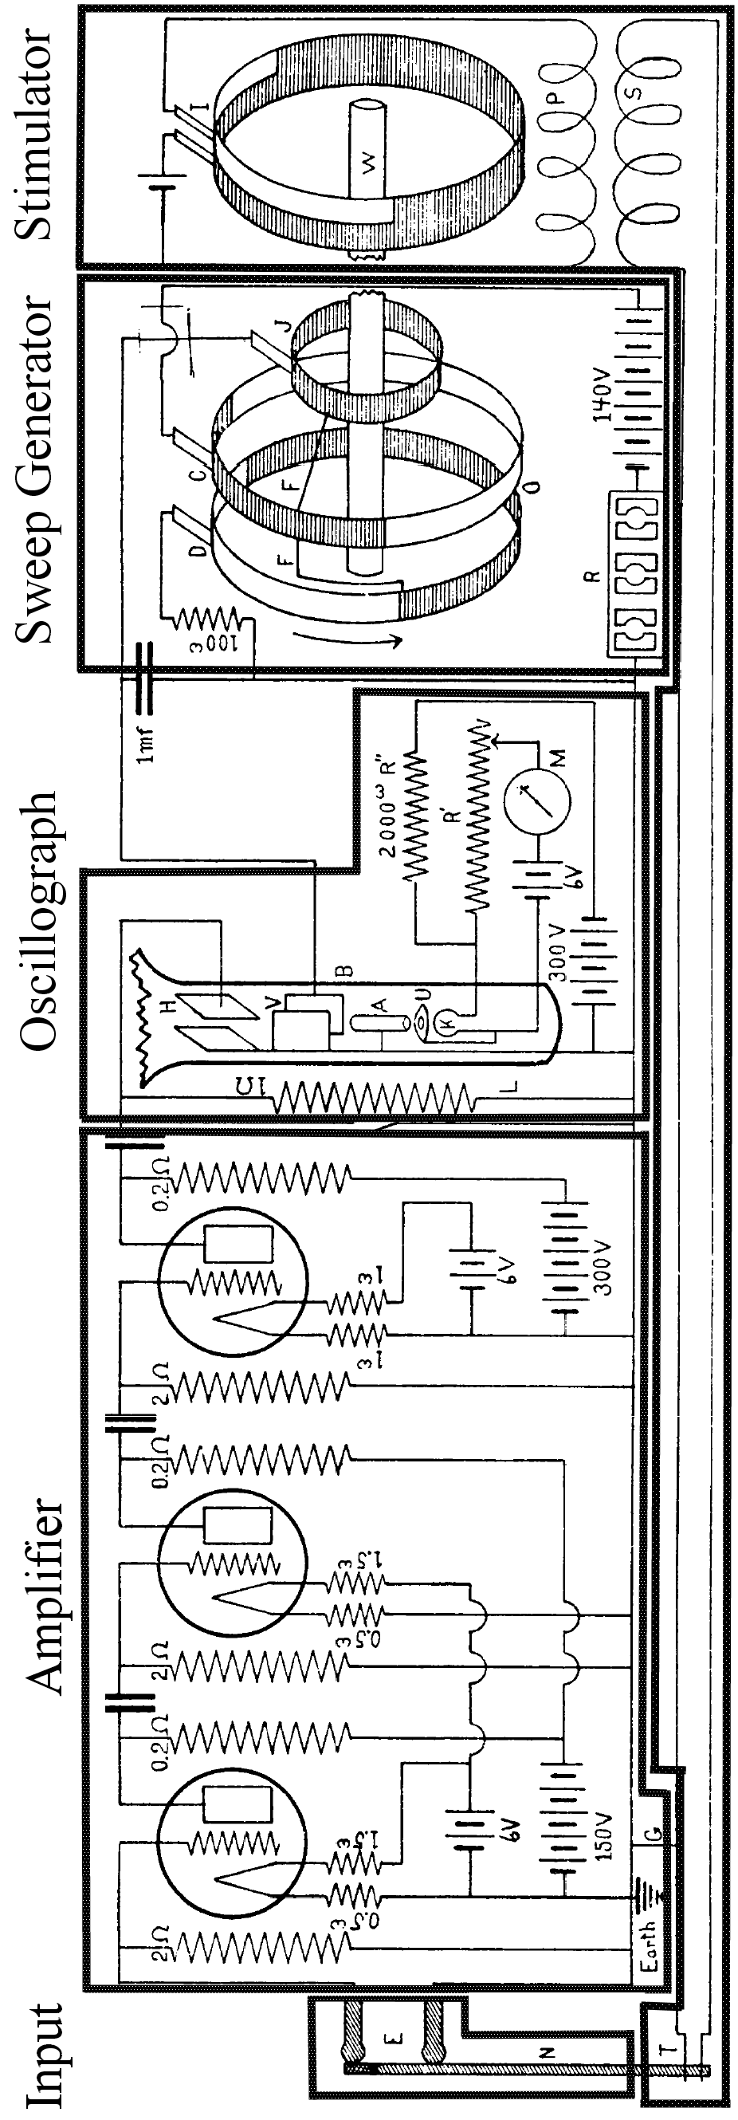
Fig. 1 Circuit diagram of Erlanger et al.’s apparatus (Erlanger et al, 1922: 502)
The oscillograph itself (fig. 2) is an evacuated tube with an electron-emitting cathode at one end and a phosphorescent screen at the other. Between the cathode and the screen are an anode and two pairs of parallel metal plates. The cathode emits electrons. The anode focuses those electrons into a beam and directs that beam toward the screen. The screen produces a bright spot where the electron beam strikes it. Between the anode and the screen, each pair of plates exerts a force on the passing electron beam perpendicular to the plane of the plates’ orientation and proportional to their input voltage. The horizontal-deflection plates take their input voltage from the time sweep generator, and the vertical-deflection plates take their input voltage from the receiving electrodes. The voltage from the time sweep generator has the form of a logarithmic sawtooth wave. Thus, the electron beam produces a spot on the oscillograph screen that reflects the voltage between the receiving electrodes as a function of the logarithm of time. The stimulator and the start of the time sweep generator cycle were coordinated so that Erlanger et al. could stimulate the nerve repeatedly and display each action currents at the same position on the screen. Their primary recording method was to hold photographic film against the screen in a dark room and stimulate the nerve repeatedly until they had generated a clear image (1924, 625).
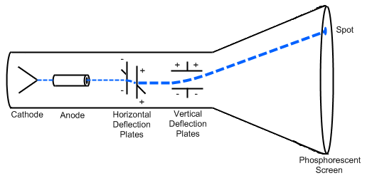
Fig. 2 Cathode-ray oscillograph

The above description of Erlanger et al.’s apparatus amounts to a partial theory of how it produces raw data. If the Process-Theory View were correct, Erlanger et al.’s method of interpreting this raw data would be epistemically dependent on such a theory. However, such a theory involves many strong presuppositions about the physics of a rather complex apparatus, and is thus be a dubious basis on which to rest a raw-data interpretation. Fortunately, Erlanger et al. primarily based their raw-data interpretation not on a theory of their technique but on an empirical calibration procedure that I describe in the next section.

3. Erlanger et al.’s Method of Raw-Data Interpretation

Erlanger et al. did not rely on a theory of how their technique works in order to develop and validate a method of raw-data interpretation. Instead, they used the following empirical calibration procedure. They ran a constant current through a wire to produce a known, unchanging voltage. They then applied this voltage to their oscillograph. They plotted oscillograph response against voltage for a variety of voltages to generate a plot of their device’s “dynamic characteristic” (Fig. 3).

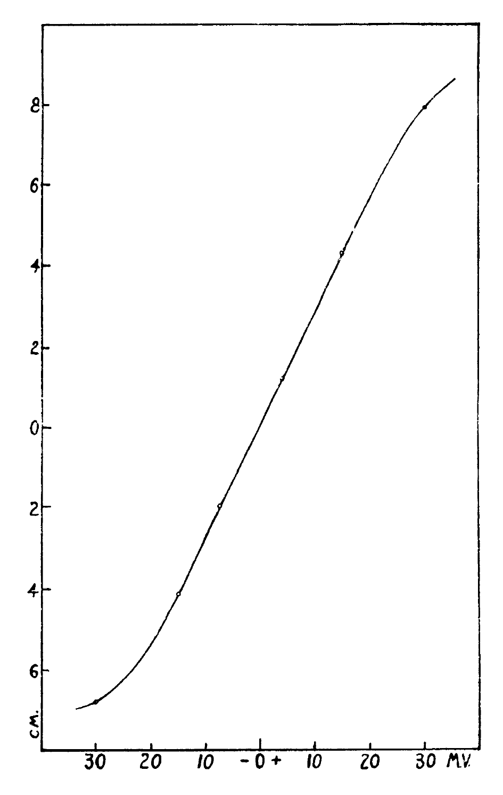
Fig. 3 “Dynamic characteristic:” vertical displacement of the oscillograph spot as a function of input voltage for constant, artificial currents (Erlanger et al. 1922, p. 510)

The dynamic characteristic shows that vertical displacement of the oscillograph spot varied essentially linearly with voltage for a range of input voltages between about -15 and +25 mV. The deviation from linearity outside this range was typical of vacuum tube amplifiers. This deviation was unproblematic because Erlanger et al. were able to maintain input voltages within “the best [i.e., most linear] portion of the characteristic” (between 0 and +15 mV) by “fractioning the input potential” (1922, 508-510). Thus, they were able to infer the voltages generated in an action current from the oscillograph record by invoking a linear relationship between the vertical displacement of the oscillograph spot and the input voltage to the apparatus. Because their amplifier gain varied, Erlanger et al. recalibrated their apparatus against a short current of known voltage before each trial (1922, 512).
This calibration procedure provided Erlanger et al. with a method of raw-data interpretation. However, it raised an extrapolation problem that needed to be addressed. The voltages Erlanger et al. generated in their wires were constant, whereas nerves generate voltages that change rapidly. To validate their technique, Erlanger et al. needed to show that their device, unlike the string galvanometer and capillary electrometer, could follow rapidly changing voltages with fidelity. Fortunately, they had available to them multiple, largely independent arguments that address precisely this point.

4. Arguments by Direct Causal Inference

There are two kinds of strategies for generating arguments that support Erlanger et al.’s method of raw-data interpretation, which I call strategies for direct causal inference and strategies for process tracing. Direct causal inference differs from process tracing in that it does not involve appealing to underlying mechanisms. Direct causal inference has limitations, but it is attractive in that the inferences it draws are often relatively straightforward, involving few if any domain-specific theoretical presuppositions. The Process-Theory View neglects direct causal inference because it assumes that the only way to support a method of raw-data interpretation involves appealing to a theory of the process that produces the raw data, that is, to underlying mechanisms.
As an illustration of both the appeal and the limitations of direct causal inference, consider behaviorist psychology. Behaviorists denied the legitimacy of appeals to mental mechanisms, so they relied heavily on direct causal inference. As a result of their methodological scruples, they were able to discover facts about learning, for instance, that have the advantage of not depending on any substantive theory of mind. Over time, however, behaviorist psychology ceased to be a progressive research program, and most psychologists today think that appealing to mental processes can yield real insights. Behaviorist psychology is an unusual case; in most research programs, direct causal inference and process tracing operate in tandem, guiding and reinforcing one another.
Direct causal inference is a broad category that encompasses multiple strategies. At least three of those strategies can be used to support the claim that Erlanger et al.’s apparatus could follow rapidly changing voltages with fidelity:

Strategies for Direct Causal Inference:
- Checks and calibration, in which observations made using the technique are compared against a known standard.
- Observing artifacts known in advance to be present.
- Manipulating the target and observing the results.

When Erlanger et al. calibrated their apparatus by finding its dynamic characteristic, they were using strategy (I). Two more instances of strategy (I) address the worry that the linear relationship found in the dynamic characteristic might not hold for rapidly varying voltages. First, Erlanger et al. often recorded the sinusoidally varying voltages associated with AC currents of known frequency to create a time scale for their recordings (Fig. 4). The fact that those recordings came out as expected constituted a successful experimental check of their apparatus for rapidly changing voltages.
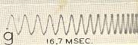
Fig. 4 Oscillograph record of AC voltage (note logarithmic time-scale) (Erlanger and Gasser 1968, 6)

Second, Erlanger et al.’s apparatus responded extremely rapidly when a constant voltage was applied; as Erlanger et al. put it, “a constant current produces an almost instantaneous rise of the oscillograph spot to its full height” (1922, p. 499). For instance, curve C in Fig. 5 was produced by applying +15 mV to the oscillograph at time t=0: accordingly, the display indicates 15 mV almost immediately. Curve C compares favorably to curve c, which was produced by applying 3.75 mV to a string galvanometer at t=0; the galvanometer did not reach full response until after about 6 σ (.006 seconds). The oscillograph’s nearly instantaneous response to applied voltage constituted another experimental check that verified its ability to follow rapid changes in voltage.

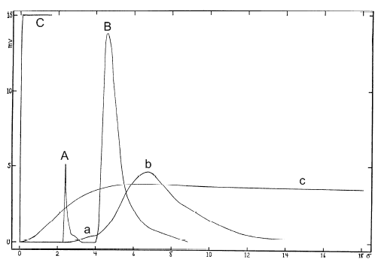
Fig. 5 (Adapted from Erlanger et al. 1922, 499)
A: Oscillograph record of escape.  B: Oscillograph record of action current.  C: Oscillograph record of 15 mV, applied t=0. | a: Galvanometer record of escape.  b: Galvanometer record of action current.  c: Galvanometer record of 3.75 mV, applied t=0.

Fig. 5 also contains information that Erlanger et al. used to apply strategy (II), which involves measuring an artifact known in advance to be present. Erlanger et al. stimulated a nerve to produce an action current by generating a brief voltage spike. That spike would itself travel along the length of the nerve and into the apparatus, generating an artifact Erlanger et al. called an “escape.” Curve A is an oscillograph record of an escape. It looks as it should: a sudden spike in voltage, followed by a return to baseline before the action current begins (Curve B). By contrast, the galvanometer record of an escape (Curve a) is barely visible, and it blends into the record of the subsequent action current (curve b). As Erlanger et al. summarize these points, “In the oscillograph record the shock (or ‘escape’), A, is a distinct curve and the spot returns to the base line before the action current starts. In the string galvanometer reproduction the ‘escape,’ a, is still at its crest when the action current starts, and is very much reduced in amplitude” (1922, 498). The difference between the oscillograph record of an escape and the galvanometer record of an escape is a dramatic illustration of the difference in their abilities to record rapidly changing voltage without distortion.

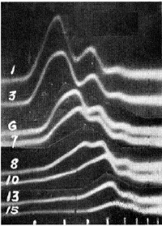
Fig. 6 Records of action currents in a nerve under increasing pressure (Gasser and Erlanger 1929, 585)

Erlanger et al. also used strategy (III), which involves manipulating the target and observing the results. For instance, they applied increasing pressure to nerves and recorded the resulting action currents (Gasser and Erlanger, 1929). They found that the primary peak in the action current diminishes first under increasing pressure, and that the secondary peaks diminish only after the primary peak has been eliminated (Fig. 6). This finding bears a suggestive relationship to the finding that nerves lose motor function before they lose sensory function under increasing pressure. Unlike the arguments discussed above, this instance of strategy (III) does not support the claim that Erlanger et al.’s apparatus can follow rapidly changing voltages with fidelity in a targeted way. However, the fact that their records revealed changes in action currents that relate in a systematic way to losses of function under increasing pressure confirms their apparatus’s reliability in a general way. It also provides targeted support for their finding that nerve action currents can have multiple distinct peaks.
Erlanger et al. went on to deepen this argument for their apparatus by explaining the systematic relationship between changes in action currents and losses of function by ascribing functional roles to nerve fibers of various sizes and citing a linear relationship between fiber diameter and conduction velocity. However, that explanation involved attending to underlying mechanisms, so the deeper version of this argument belongs to the next section, in which I discuss Erlanger et al.’s uses of process tracing.

5. Arguments by Process Tracing

Process tracing involves appealing to information about underlying mechanisms, either in the apparatus or in the target system. As a result, it generally involves substantial theoretical presuppositions. However, it need not depend on a full-blown theory of the entire technique, and it can involve approximations and idealizations. A derivation of the Boyles-Charlse gas law from a molecular-kinetic theory of gases is a typical instance of process tracing in that it appeals to an idealized theory about underlying mechanisms in order to infer facts about causal relationships among observables.
The Process-Theory View distorts process tracing in that, because it sees process tracing as carrying the entire burden of supporting a method of raw-data interpretation, it expects process tracing to provide a complete theory of how an apparatus produces raw data from beginning to end. In fact, process tracing is often piecemeal: it provides a partial theory of the apparatus or the target phenomenon that adds one piece to an overall argument for a method of raw-data interpretation.
Erlanger et al. used the following three strategies for process tracing to validate their apparatus:

Strategies for Process Tracing
- Using an apparatus based on a well-corroborated theory.
- Eliminating plausible sources of error and alternative explanations of one’s results.
- Using a non-ad hoc theory to explain one’s results.

Erlanger et al. used strategies (i) and (ii) when they discussed the physics of electrophysiological recording devices:

All of these instruments are governed by the laws of forced vibration with damping. The differential equation expressing this law is
M(d²y/dt²) + D(dy/dt) + Cy = f(t) (1)
which says that the applied force, f(t), produces a motion which is determined by the mass, M, the damping, D, and another restoring force, C, the mass effect being greater when the acceleration, d₂y/dt², is large; the damping increasing with the velocity, dy/dt; and the restoring force, C, increasing with the deviation of the system from equilibrium (Erlanger et al. 1922, 496).

Erlanger et al. went on to explain that the curve a recording device produces is “the graph of the curve expressing the value of y which is the solution of the above equation,” and that “to get the true form, i.e., f(t)…one would have to operate on y as indicated” (496). However, this procedure faced “great practical difficulties,” the greatest of which lay “in the determination of the acceleration [d²y/dt²] with satisfactory accuracy” (496). They noted that, because of these difficulties, “The need [had] long been felt of an inertialess system for recording physiological currents” (500). The oscillograph satisfied this need: an electron beam’s mass (M) is negligible and—because the oscillograph contains only a “very small amount of gas” (500)—its damping constant (D) is negligible. Thus, the first two terms of equation (1) were essentially zero for the oscillograph, so that equation (1) reduces to Cy = f(t). That is, the deflection of the electron beam is proportional to the applied force.
In citing a well-corroborated theory of recording devices to produce equation (1), Erlanger et al. applied strategy (i). In eliminating the first two terms of equation (1) as plausible sources of error in appealing to the claim that oscillograph output is proportional to input voltage, they applied strategy (ii). This instance of strategies (i) and (ii) counts as an instance of process tracing because it involved appealing to information about how the components of the system behave and interact, such as generalization about how the electron beam behaves (equation (1)), the fact that the electron beam’s mass is negligible, and the fact that the interior of the tube is a near-vacuum so that damping is negligible. It addressed the issue of the extrapolation of the dynamic characteristic from wires to nerves head-on by showing that the device should be able to follow rapid changes in voltage with fidelity.
In other instances of process tracing, Erlanger et al. reconstructed action currents they recorded to a good approximation by assuming that each nerve fiber conducts at a rate proportional to its diameter (Fig. 7).

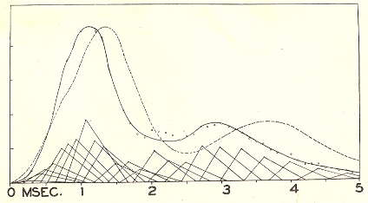
Fig. 7 The solid curve is measured, the dashed curve mathematically constructed on the assumption that conduction speed is proportional to fiber diameter (Erlanger and Gasser 1937, 20)

Erlanger and Gasser explained this procedure as follows:

It is possible by a histological examination of a nerve trunk to predict with some accuracy the form of the action potential it will yield. The reconstructed action potential wave behaves with regard to form, changes of form with conduction (such as increase in the time to maximal potential and decrease of the size of this maximal potential), and appearance of secondary waves, in the same manner as does the corresponding action potential as recorded (Gasser and Erlanger 1927, 546).

The fact that Erlanger et al. were able to explain their recordings (particularly the approximate location and shape of wavelets) in this non-ad hoc way confirms the reliability of their apparatus. As Erlanger et al. pointed out, the hypothesis that larger nerves conduct more rapidly than smaller nerves is independently plausible on the grounds that larger cables conduct electricity more rapidly than smaller cables (although they admitted that the analogy between nerves and cables is tenuous) (1927, 523). Erlanger et al. did consider a small number of other possible relationships between conduction speed and fiber size before settling on conduction speed being proportional to fiber diameter, but given the simplicity and plausibility of this relationship and the fact that it yields satisfactory results for many recordings taken from a broad range of nerves, they could hardly be accused of viciously circular reasoning.
As mentioned at the end of the previous section, the hypothesis that fiber diameter is proportional to conduction speed even allowed Erlanger et al. to explain how the form of an action current changes in the presence of interventions. Because the primary peak arrives first, it reflects the contributions of the faster-conducting fibers. By hypothesis, the fastest-conducting fibers are the largest fibers. As Erlanger et al. pointed out, it is plausible that larger fibers should fail first under pressure “by analogy with the effect of external pressure on thin-walled tubes, where the large tubes would collapse before the small ones” (1929, 584). Thus, the independently plausible hypothesis that larger fibers fail first under pressure, in conjunction with the independently plausible hypothesis that conduction speed is proportional to fiber diameter, explains why the primary peak in the action current diminishes first with the application of pressure (See fig. 6). Moreover, this explanation accounts for the fact that motor function fails before sensory function with the application of pressure, because motor signals are associated with the largest fibers. In accordance with strategy (iii), the fact that Erlanger et al. could explain features of their recordings in this non-ad hoc way confirmed the general reliability of their apparatus.
Process tracing supported Erlanger et al.’s method of raw-data interpretation because it provided a theory of the apparatus, eliminated plausible sources of error, and provided non-ad hoc explanations of their observations. The non-ad hoc explanations supported the overall reliability of Erlanger et al.’s technique for recording certain features of action currents, while the theory of the apparatus provided direct support for their extrapolation procedure.

6. Theory-Independence with a Single Technique

The oscillograph’s predecessors produced flawed records because of their inertial distortion. Consequently, it was often the case that one could not appeal to one of those other techniques in order to validate an observation made using the oscillograph. Nevertheless, Erlanger et al. had good reason to trust their technique: the method they used to infer its dynamic characteristic does not depend on any worrisome theoretical presuppositions, and the extrapolation of that dynamic characteristic to action currents is supported by multiple, largely independent arguments.
Many authors (e.g. Bechtel 1990; Hacking 1983; Culp 1994, 1995; Chalmers 2002) have emphasized that appealing to multiple independent techniques that converge on a common result is a powerful way to validate both one’s techniques. Such arguments from coincidence are indeed powerful and an important part of science. However, they cannot account for certain scenarios, such as (A) when one technique makes possible observations that no other technique can replicate and (B) when the results of multiple techniques fail to converge on a single result.
Instances of scenarios (A) and (B) arose in the use of the cathode-ray oscillograph. For instance, oscillograph records indicated secondary peaks in voltage during the downward phase of an action current that Erlanger et al. called “wavelets” (Fig. 8). According to Erlanger et al., “It is questionable whether the wavelets…correspond to anything that has been previously described” (Erlanger et al. 1922, 519). This case is an instance of scenario (A), in which an argument from coincidence is unavailable because only one technique reveals a particular phenomenon. In another case, oscillograph records indicated that the voltage generated by an action current reaches its maximum between 0.54σ and 0.72σ after the start of the action current, which are “considerably longer durations than those obtained with the capillary electrometer” (Erlanger et al. 1922, 517). This case instantiates scenario (B), in which an argument from coincidence is unavailable because multiple techniques fail to converge upon a single result. Thus, arguments from coincidence were not available either for the claim that the wavelets the oscillograph revealed were real or for the claim that oscillograph measurements of time to maximum and other action current parameters were accurate.

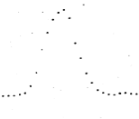asfdgfhgfsafdsafdd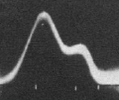
Fig. 8 Left: Capillary electrometer record of an action current, corrected for inertial distortion (Lucas 1912, 236). Right: Oscillograph record of an action current, showing a wavelet (Gasser and Erlanger 1924, 629)

Despite the fact that arguments from coincidence based on convergence with the results of other independent techniques were largely unavailable, worries about theory-independence had little force against the cathode-ray oscillograph. Erlanger et al.’s procedure in arriving at their apparatus’s dynamic characteristic (Section II) was a straightforward instance of direct causal inference in which they manipulated the target and observed the results. The extrapolation from static voltages in nerves to rapidly changing voltages in wires was potentially problematic, but I have recounted seven distinct arguments that supported Erlanger et al.’s method of raw-data interpretation. The following table summarizes those arguments and lists their primary presuppositions.

Argument | Presuppositions
1. Technique records AC current properly, so it can follow rapidly changing voltages in nerves. | - AC current is sinusoidal.  - Time sweep is logarithmic.  - Extrapolation from AC current to action currents in nerves is legitimate.
2. Device responds to newly applied current almost instantaneously, so it can follow rapidly changing voltages in nerves. | - Currents begin to act on apparatus precisely at time t=0 (idealization).  - Apparatus can follow a series of rapid rises and falls in voltage as well as it follows a single rapid rise.
3. Apparatus returns accurate record of shock artifact (“escape”), so it can follow rapidly changing voltages in nerves. | - Record of spike preceding action current is in fact a record of the shock produced by the stimulator.  - That shock is a rapid spike in voltage.  - Extrapolation from rapid, artificial spike in voltage to action currents is legitimate.
4. There is a systematic relationship between loss of individual peaks in action current records and loss of individual kinds of nerve function under increasing pressure, so the apparatus must be capturing real features of action currents. | - There is no alternative explanation of this relationship.
5. Electron beam is governed by equation of forced vibration with damping. The electron beam has minimal mass, and the CRO is (nearly) a vacuum tube, so the mass and damping terms are negligible. Thus, the deflection of the electron beam is proportional to the input voltage, even for rapidly changing voltages in nerves. | - Electron beam governed by theory of forced vibration with damping.  - Electron beam has minimal mass.  - CRO is (nearly) a vacuum tube and thus electron beam experiences negligible damping.  - Only significant forces acting on electron beam come from deflection plates and are proportional to input voltages.
6. Independently motivated theoretical calculation of action current agrees with general form of recorded action current, so device captures general form of action currents. | - Action current in nerve is simple sum of action currents in constituent nerve fibers.  - Action currents in individual nerve fibers have a particular profile.  - An individual nerve fiber conducts at a rate proportional to its diameter.
7. Systematic relationship between loss of individual peaks in action current records and loss of individual kinds of nerve function under increasing pressure is explained by distribution of fiber sizes in nerves, so action current records must be accurate. | - Largest fibers conduct fastest  - Largest fibers fail first under pressure  - Largest fibers are responsible for motor function

Each of arguments (1)-(4), which are arguments by direct causal inference, depends on a small number of fairly unproblematic presuppositions. Even (5)-(7), which involve process tracing, do not depend on a full-blown theory of the entire technique. Most importantly, there is no assumption worth listing on which all of (1)-(7) depend. Moreover, the sets of theoretical presuppositions on which (1)-(7) depend are nearly pairwise independent: only a presuppositions about the relationship between fiber size and conduction velocity appear more than once. The only assumptions that the arguments all have in common are too mundane to mention and are routinely take for granted in science, such as the assumption that there is no deceiving demon of the laboratory. Thus, these arguments together support the reliability of Erlanger et al.’s apparatus in a robust, essentially theory-independent way.

7. Conclusion

According to the Simple Process-Theory View, “interpretations of raw data depend on theories about the processes being used to produce the raw data” (Culp 1995, 450). Contrary to this view, I show that the method Erlanger et al. used to interpret raw-data from their cathode-ray oscillograph is supported by multiple, largely independent arguments. Moreover, each argument depends on less than a full theory of the technique, and the arguments together do not require any substantive theoretical presuppositions. This is not to say that Erlanger et al.’s work was infallible, but rather that their results are generally robust: for them to fail, multiple independent assumptions would have to fail. Appealing to multiple techniques that converge on the same results is one way to achieve robustness, but a high degree of robustness is possible with a single technique.

ACKNOWLEDGMENTS

Special thanks to Carl Craver, Kent Staley, Thomas Sattig, and the Washington University in St. Louis Philosophy of Science Co-op for feedback on earlier drafts. Thanks also to Paul Anderson and Lilla Vekerdy of the Bernard Becker Medical Library for research assistance. Research supported with a grant from the Washington University Center for the Study of Ethics and Human Values.

REFERENCES

Bechtel, William (1990), “Scientific Evidence: Creating and Evaluating Experimental Instruments and Research Techniques”, PSA: Proceedings of the Biennial Meeting of the Philosophy of Science Association 1: 559-572.
Blundell, Stephen J. and Katherine M. Blundell (2006), Concepts in Thermal Physics. Oxford: Oxford University Press.
Chalmers, Alan (2003), “Theory-Dependence of the Use of Instruments in Science”, Philosophy of Science 70: 493-509.
Culp, Sylvia (1995), “Objectivity in Experimental Inquiry: Breaking Data-Technique Circles”, Philosophy of Science 62: 438-458.
--- (1994), “Defending Robustness: the Bacterial Mesosome as a Test Case”, PSA: Proceedings of the Biennial Meeting of the Philosophy of Science Association 1: 46-57.
Erlanger, Joseph and Herbert S. Gasser (1937), Electrical Signs of Nervous Activity, Eldridge Reeves Johnson Foundation Lectures. Philadelphia: University of Pennsylvania Press.
Erlanger, Joseph and Herbert S. Gasser with George H. Bishop (1922), “The Compound Nature of the Action Current of Nerve as Disclosed by the Cathode Ray Oscillograph”, American Journal of Physiology 62: 496-524.
Franklin, Allan (Spring 2009 Edition), "Experiment in Physics", The Stanford Encyclopedia of Philosophy, Edward N. Zalta (ed.), http://plato.stanford.edu/archives/spr2009/entries/physics-experiment/.
Gasser, Herbert S. and Joseph Erlanger (1929), “The Role of Fiber Size in the Establishment of a Nerve Block by Pressure of Cocaine”, American Journal of Physiology 88: 581-591.
--- (1927),“The Role Played by the Sizes of the Constituent Fibers of the Nerve Trunk in Determining the Form of its Action Potential Wave”, American Journal of Physiology 80: 522-547.
--- (1924), “A Study of the Action Currents of Nerve with the Cathode Ray Oscillograph”, American Journal of Physiology 70: 624-666.
Hacking, Ian (1983), Representing and Intervening: Introductory Topics in the Philosophy of the Natural Sciences. Cambridge: Cambridge University Press.
Larsen, Richard J. and Morris L. Marx (2006), An Introduction to Mathematical Statistics and Its Applications. Upper Saddle River, NJ: Pearson Education.
Lucas, Keith (1912), “On a Mechanical Method of Correcting Photographic Records Obtained from the Capillary Electrometer”, The Journal of Physiology 44: 225-242.
Steel, Daniel (2008), Across the Boundaries: Extrapolation in Biology and Social Science. Oxford: Oxford University Press.
Wimsatt, William C. (1981), “Robustness, Reliability, and Overdetermination”, in M. Brewer and B Collins (eds.), Scientific Inquiry and the Social Sciences. San Francisco: Jossey-Nass. 124-163.

Contact the author by email at gsganden@gmail.com or by mail at University of Pittsburgh, Department of HPS, Cathedral of Learning 1017, Pittsburgh, PA 15260.
These terms come from Steel’s discussion of causal inference in the social sciences (2008, 174-197).
One textbook in statistics describes a robust procedure as one “that is not heavily dependent on whatever assumptions it makes” (Larsen and Marx 2006, 497). Similarly, I will use the term “robust” to describe a body of data that is not heavily dependent on theoretical presuppositions. See Wimsatt 1981 for a discussion of robustness in experimental inquiry.
An action current is distinct from an action potential. An action potential is the change in voltage across the cell membrane that occurs when a nerve conducts an impulse, whereas an action current is the concomitant change in voltage along the length of the nerve. At the time Erlanger et al. began their work, no one had developed a way to place an electrode inside a nerve fiber to record an action current.
The capillary electrometer’s moving element is the interface between a column of mercury and a column of sulfuric acid. The galvanometer’s moving element is a metal filament.
Keith Lucas invented a mechanical device that corrected capillary electrometer records for inertial distortion (See Lucas 1912). However, the need to use this device had several drawbacks. The corrections were imperfect and resulted in information loss as they extracted discrete data points from a continuous curve. Moreover, they prevented one from seeing one’s interpreted data in real time during an experiment.
Figure reprinted with permission of the American Journal of Physiology.
Erlanger et al.’s oscillograph also contains a platinum diaphragm between the anode and the horizontal deflection plates (“U” in fig. 1, not pictured in fig. 2). This diaphragm absorbs positive ions that form when the electron beam strikes gas molecules in the tube, thereby preventing those ions from striking the cathode and overheating it.
Figure reprinted with permission of the American Journal of Physiology.
It is not always clear whether a particular argument for a method of raw-data interpretation involves appealing to underlying mechanisms or not. Thus, the distinction between process tracing and direct causal inference is not completely precise and unproblematic. I claim only that, in the cases in which the distinction is clear, it can be quite useful.
These strategies, along with the strategies for process tracing I cite in Section 5, come from Franklin 2009. Franklin does not distinguish between strategies for direct causal inference and strategies for process tracing.
I do not mean to suggest that Erlanger et al. recorded AC voltages with the intention of testing their apparatus. Nevertheless, those recordings functioned as tests in that Erlanger et al. would have been concerned if they had not come out as expected.
Reprinted with permission of the University of Pennsylvania Press.
Figure reprinted with permission of the American Journal of Physiology.
Figure reprinted with permission of the American Journal of Physiology.
These strategies, like those in the previous section, are inspired by Franklin 2009.
Figure reprinted with permission of the American Journal of Physiology.
1 σ = .001 seconds
Left figure reprinted with permission of the Journal of Physiology. Right figure reprinted with permission of the American Journal of Physiology.

