Interventionism and Causal Exclusion∗∗

Jim Woodward
HPS, U of Pittsburgh

1. Introduction

A number of writers, myself included (List and Menzies, 2009, Shapiro, 2010, Shapiro and Sober, 2007, Raatikainen, 2010, Westlake, forthcoming, Woodward, 2008a, b) have recently argued (albeit on somewhat different grounds) that an “interventionist” account of causation of the sort defended in Woodward, 2003 can be used to cast light on so-called “causal exclusion” arguments of the sort discussed in Kim (e. g., 1998, 2005) and many other writers. More specifically, we have suggested that interventionism helps us to see that standard arguments for causal exclusion involve mistaken assumptions about what it is appropriate to control for or hold fixed in assessing causal claims and that interventionism provides a natural way of capturing the idea that macroscopic properties that supervene on (or are “realized by”) other (typically microphysical) properties but that are not identical with those realizing properties are sometimes causally efficacious. These anti-exclusion arguments have in turn been criticized by several philosophers, with Michael Baumgartner providing the most extensive objections in a series of papers (2009, 2010, but see also Marcellesi, forthcoming)
My aim in this paper is to respond to these objections and to defend interventionist criticisms of the exclusion argument. I also attempt to clear up (what from my perspective are) some misunderstandings that have arisen in connection with the application of interventionist ideas to the exclusion argument and more broadly to contexts in which relations of “supervenience”, interpreted as a kind of non-causal dependency distinct from identity, are present. In the course of doing this, I will also touch on a number of topics that I hope will be of independent interest. For example, within an interventionist framework, graphical models are commonly used to represent causal relationships. However, there has been very little discussion of how to represent supervenience relationships within such models or how the presence of such relationships affects the interpretation of such models. There has also been very little discussion of how to deal with cases in which other sorts of non-causal dependency relationships (based, e.g. on logical or conceptual relations) hold among variables in a graphical model. I advance proposals about these matters, which I hope will also help in clarifying the status of the exclusion argument. Finally, a very general issue, raised in a sharp way by the exclusion argument, concerns the rationale for “controlling for” or holding fixed certain variables in assessing the effects of others in systems of causal relations. What should be controlled for and why? This is an important topic for all theories of causation (not just interventionism).
Before turning to details, another prefatory remark is in order. This paper focuses exclusively on the question of whether supervening properties can be causally efficacious. It defends the view that both supervening properties and the properties on which they supervene can be causes of the same effect. For example, I conclude that when mental property M₁ supervenes on physical property P₁ and mental property M₂ supervenes on P₂, then under the right conditions both M₁ and P₁ will be causes of mental property P₂ (and of M₂). It is a further question whether, in such circumstances, there nonetheless are reasons for distinguishing between the causal role of M₁
and of P₁ with respect to M₂. I have argued elsewhere (Woodward, 2008a, b) that even if both M₁ and P₁ cause M₂, there may be important differences between the M₁—>M₂ causal relationship and the P₁→M₂ causal relationship: depending on the details of the case, the causal relationship between M₁ and M₂ may be more stable or better satisfy certain other desiderata, such as “proportionality” than the causal relationship between P₁ and M₂. Or (again depending on the details of the case) the reverse may hold. These differences may justify us in regarding invocation of M₁ as in some way special—perhaps it provides a better causal explanation of M₂ than invocation of P₁ or serves as a better “control variable” in the sense of Campbell, 2010. In what follows, I ignore such considerations, focusing just on whether it is appropriate to think of M₁ as causing M₂.
The remainder of this paper is organized as follows. Section 2 reprises the exclusion argument and Section 3 contains a brief discussion of the notion of supervenience assumed in my discussion. Section 4 describes some of the main ideas of interventionism. Section 5 applies the interventionist apparatus to the exclusion argument and discusses Baumgartner’s criticisms. Sections 6-9 then explore the question of what needs to be controlled for when supervenience and other sorts of non-causal dependence relations are present, arguing that the accounts in Shapiro and Sober, 2007 and in Woodward (2008a, b) are correct.

2. The exclusion argument.

I assume that the basic structure of the exclusion argument is sufficiently familiar that no detailed discussion is required. Consider the following canonical diagram adapted from Kim (2005)

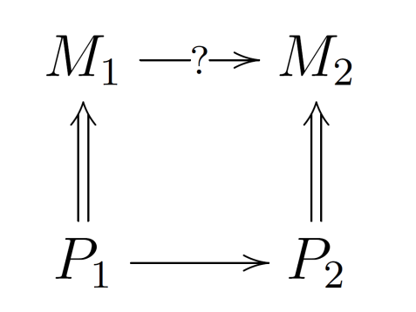
Figure 1

Here M₁ and M₂ are mental properties or events and P₁ and P₂ their respective physical supervenience bases, with the supervenience relationship represented by a double-tailed arrow. Assume for the sake of argument that this supervenience relation is appropriate to non-reductive physicalism: M₁ is not identical with P₁ and M₂ is not identical with P₂. Assume also that P₁ causes P₂, as represented by the single-tailed arrow from P₁ to P₂. The questions of interest is whether it is consistent with these assumptions to suppose that M₁ causes M₂ (or for that matter P₂.) According to the exclusion argument the answer to this question is “no”. One version of this argument runs roughly as follows: By the principle of the causal closure of the physical, P₂ must have a “sufficient” cause that is purely physical—assume without loss of generality that P₁ is such a cause. It follows that “all the causal work” that is required for the occurrence of P₂ is accomplished by the occurrence of P₁. Moreover, once P₂ occurs, it guarantees the occurrence of M₂ in virtue of the supervenience relationship between P₂ and M₂. It thus appears that there is nothing “left over” for M₁ to do in the way of causing M₂ (or P₂). Kim (2005) puts the basic idea as follows:

“Why is M₂ instantiated on this occasion? …there are two seemingly exclusionary answers: (a) “Because M₁ caused M₂ to instantiate on this occasion,” and (b) “Because P₂, a supervenience base of M₂, is instantiated on this occasion.” …: Given that [P₂] is present on this occasion, M₂ would be there no matter what happened before; as M₂’s supervenience base, the instantiation of P₂ at t in and of itself necessitates M₂’s occurrence at t. This would be true even if M₂’s putative cause, M₁, had not occurred. (pp. 39-40)

If we were to draw a single-headed arrow (representing a causal relationship) from M₁ to M₂ or to P₂, we would seem (according to advocates of the exclusion argument) to be introducing an implausible kind of “over-determination” into our picture of the relationships among P₁, P₂, M₁ and M₂. M₂ and P₂ would be over-determined by two sets of causes: P₁ and M₁. Of course, some cases of causal over- determination do occur in nature, as when two riflemen simultaneously shoot a victim through the heart, with each bullet being individually causally sufficient for death. However, such cases of over-determination are rare. By contrast, on an analysis according to which both P₁ and M₁ cause M₂, over-determination is ubiquitous, occurring whenever there is mental causation and, indeed, whenever there is causation by macroscopic properties that supervene on microphysical properties which are also causally efficacious. According to the exclusion argument, this much over-determination is implausible; the more plausible view is that there is just one causally sufficient condition (namely P₁) for P₂ and M₂. Rather than thinking of M₁ as itself causing M₂, we should think instead that what happens when M₁ occurs is this: its supervenience base P₁ occurs, this causes P₂, with M₂ occurring because it supervenes on P₁. Often this is put in terms of a claim about what it is appropriate to “control for “ or “hold fixed” in assessing causal efficacy: from the claim that “controlling for” the influence of P₁, M₁ has no further impact on either M₂ or P₂, we are invited to infer to the conclusion that M₁ is not causally efficacious but instead “epiphenomenal”, with all of the “real casual action” taking place through the P₁ to P₂ route. This line of thought is apparent in the passage from Kim above, with its claim that given the occurrence of P₂, which follows just from the occurrence of P₁, M₂ would have occurred even if M₁ had not occurred and the inference from this to conclusion that M₁ is not itself causally efficacious.
The exclusion argument obviously trades on various general claims about causation --- about what is involved in one event or property (or whatever) causing another, about how the notion of causation interacts with notions like “supervenience”, about what causal over-determination consists in and when it is implausible to assume such over-determination is present, about when it is reasonable to require one cause to act “independently” of another (and how this notion of independence should be understood), about what is appropriate to control for or hold fixed in assessing causal efficacy, and about how we should understand representations of possible causal relationships like those in Kim’s diagram. Interventionists think that several of these assumptions about causation that undergird the exclusion argument appear misguided or at unmotivated. These include the assumption that an appropriate way of assessing whether M₁ is causally inert is to ask whether “controlling for” the influence of P₁, M₁ has a further impact on other properties such as M₂ as well as assumptions about what causal over-determination amounts to.

3. Supervenience

According to the entry on “supervenience” in the Stanford Encyclopedia of Philosophy, “a set of properties A supervenes upon another set B just in case no two things can differ with respect to A-properties without also differing with respect to their B-properties”. (McLaughlin and Bennett, 2011) As the authors of the entry go on to note, this characterization says nothing about the modal force of “can differ. Depending on how this is understood, this supervenience relationship might have any one of a number of different sources: A might be identical with B, nomologically dependent on B, connected to B via some logical or conceptual relationship and so on. A somewhat narrower understanding of supervenience takes it to involve a relationship of dependence of the sort characterized above (“no A-difference without a B-difference”) but where the dependence is understood to have some other source than identity, or nomological or causal or definitional connection. It is this sort of supervenience relation which is generally advocated by non-reductive physicalists: it is claimed that the mental supervenes on the physical, and that this supervenience relation holds as a matter of “metaphysical necessity” of some kind, but that mental properties are not identical with physical properties, are not caused by them or linked to them by law, and cannot be defined in terms of physical properties. It is the consistency of this sort of non-reductive physicalism (and its accompanying supervenience claims) with the causal efficacy of the mental that I take to be at issue in the exclusion argument. In what follows, supervenience wil be understood in this narrower sense unless otherwise specified.
This narrower notion of supervenience is not unproblematic. As a number of writers have noted, the bare assertion that A supervenes on B seems unsatisfying and mysterious when unaccompanied by any positive account of why this relationship holds. (As is the case when we are told only that A supervenes on B, but not because of familiar reasons having to do with identity, nomological dependence, or logical relatedness.) In addition, the suggestion that supervienence holds as a matter of “metaphysical necessity” appeals to a variety of modality that is likely to strike many naturalistically minded philosophers as fundamentally unclear.
These considerations may prompt the thought that the best way to avoid the exclusion argument is to reformulate physicalism in some way that does not appeal to an unexplained supervenience relation, opting instead for some other notion -- “identity” is one obvious candidate -- to describe mental/physical relations. However, despite the attractions of such a strategy, it seems to me that there are reasons for accepting the basic framework of non-reductive physicalism in exploring issues about the causal role of supervening properties. For one thing, there do seem to be many cases in which (non-causal, non-nomological) dependence relations or constraints are present between two or more sets of properties and yet in which more specific notions like identity and definitional dependence do not seem the right way to understand such dependence. In addition to the relation between the mental and physical, other possible examples include cases in which quantities in different theories stand in limiting relations (in the mathematical sense) to each other, and cases in which objects in different theories or different “levels” stand in mereological relations to one another. More generally, the general category of non-causal constraint often seems better suited to capturing relations between different “levels” than more specific notions like identity or full definitional dependence. (The latter are naturally viewed as specific varieties of this more general category.) For this reason, I propose, for purposes of this paper, to accept the intelligibility of a notion of supervenience that does not involve identity, or definitional or causal dependence, and to explore its implications. Readers who are skeptical of this notion may think of what follows as instead simply an exploration of the ways in which we may reason about causal relations in systems in which non-causal dependency constraints of various sorts are present.
As I note below, interventionism takes causal claims to relate variables (or, more precisely, whatever in the world corresponds to variables—since will nothing turn on how we conceptualize these items, I will often describe them as “properties”). The mark of a variable is that it capable of taking two or more different “values”, where particular values of a variable V characterize particular objects of units, as when a particular chair has mass ten kilograms. What does supervenience amount to in such a framework? I will assume that the property corresponding to variable M supervenes on the property corresponding to variable P as long as, for all values of M, the value of M cannot change without a change in the value of P.

4. Interventionism: The Basic Idea

I turn now to some brief remarks about the use of directed graphs to represent causal relationships, since this is a natural way of presenting interventionist ideas shared by both advocates and critics of the application of these ideas to the exclusion argument. (An understanding of these graphs will also cast light on representations like Kim’s Figure 1.)
Within such a directed graph representation, an arrow drawn from variable X, to a second variable Y, ( X→Y) represents that X is a “direct cause” of Y. (For more on what this means, see below.) In standard graphical representations (including Pearl, 2000, Spirtes, Glymour and Scheines, 2000, as well as Woodward, 2003), it is generally assumed that the variables occurring in a graph may be causally related or not or correlated or not, but that such variables are not connected by relationships of non-causal dependency (such as logical, conceptual, or mathematical relationships or supervenience relationships) of a sort that are inconsistent with their standing in causal relationships. ( I will call these “non-causal dependency relations” in what follows) In other words, it is assumed that we are dealing with variables are “distinct” in a way that allows them to be potential candidates for relata in causal relationships. For example, we assume that the same graph does not contain variables that are related in the way that X and X+Y are related or related in the way that “saying hello” and “saying hello loudly” are related. A similar assumption that we are not dealing with (or have some way of excluding) non-causal dependency relationships is made in most other philosophical treatments of causation and seems required in order to avoid obvious counterexamples. I will initially adopt this assumption, in part for expository reasons, and only later consider how the directed graph framework may be extended to encompass cases of non-causal dependency, including supervenience relations. Thus the graphical characterizations of causation discussed in this section are premised on the assumption that we are dealing with “causal” graphs, in which no non-causal dependency relations are present, an assumption that will be relaxed in subsequent sections.
To illustrate the use of causal graphs, suppose smoking S directly causes both yellow fingers Y and lung disease D, but there is no causal relationship between Y and D (instead they are joint effects of the common cause S). This may be represented by the following structure:

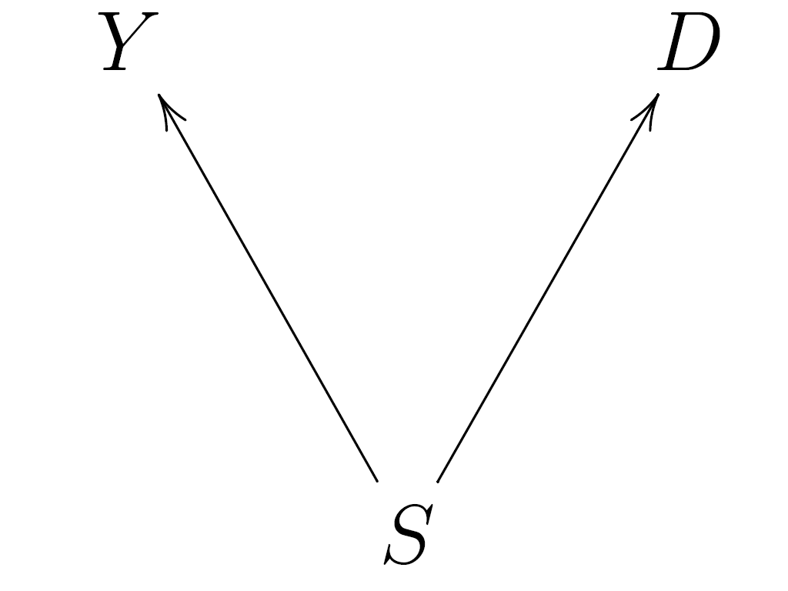

Figure 2

A distinctively interventionist treatment of causation comes into play when we ask how the arrows in a directed should be interpreted: roughly speaking, the idea is that causal claims describe how the values of variables change under interventions on (roughly, unconfounded manipulations of) other variables. To say that X causes Y is (again roughly) to say that Y would change in value under some suitable intervention that changes the value of X. “Direct causation” and other causal notions (including a more general notion of causal relevance) involve refinements of this idea.
The intuitive idea of an intervention is that of an idealized, unconfounded experimental manipulation which would be appropriate for determining whether one variable is causally related to a second variable. To illustrate, suppose that one observes that Y (= whether yellow fingers) is correlated with D (= whether lung disease) in some sample of subjects and is interested in whether Y causes D (or vice-versa). One way of assessing this claim is to do an experiment. Suppose one has a sample consisting of both smokers and non-smokers. For both sets of subjects, the experimenter employs a procedure that randomly assigns each subject to a condition in which they either do or do not have yellow fingers. This might be accomplished by, for example, flipping a coin and if the outcome is heads, introducing a coloring agent that ensures that the subjects fingers are yellow and if the outcome is tails, employing an agent that removes any discoloration of the subject’s fingers. In other words, the procedure is such that it (and nothing else) determines the color of each subject’s fingers and this is done randomly, in a way that is not correlated with other features of the subject.
Given this experiment, one naturally expects that there will be no correlation (among either smokers or non-smokers) between whether subjects have yellow fingers and whether they have lung disease. This in turn is exactly the kind of evidence that would be taken to show that yellow fingers do not cause lung disease. Conversely, if contrary to all expectation, Y and D do turn out to be systematically or regularly correlated under this sort of intervention on Y, this would be compelling evidence that Y causes D.
The basic strategy followed by the interventionist account of causation is to use this connection between what will happen to some variable Y under an appropriately behaved notion of an intervention on another variable X to provide necessary and sufficient conditions for X to cause Y. In fact it turns out that there are a number of different, although interrelated notions of causal relationship that can be characterized in this way. For example, Woodward (2003) characterizes the notions of direct cause and contributing cause in the following way, which I reproduce for future reference:

(M) A necessary and sufficient condition for X to be a (type-level) direct cause
of Y with respect to a variable set V is that there be a possible intervention
on X that will change Y or the probability distribution of Y when one holds
fixed at some value all other variables Z_{i} in V. A necessary and sufficient
condition for X to be a (type-level) contributing cause of Y with respect
to variable set V is that (i) there be a directed path from X to Y such that
each link in this path is a direct causal relationship; and that (ii) there
be some intervention on X that will change Y when all other variables in V
that are not on this path are fixed at some value. (Woodward 2003, 59)
Both the notions of direct and contributing causation embody a “dependency” or “difference-making” conception of causation: X is a direct or contributing cause of Y if and only if there is some intervention on X “makes a difference” for the value of Y when appropriate other variables are held fixed at some values—in this sense some values of Y “depend on” the value of X, when other variables are fixed at certain values. As we shall see, this yields a conception of causation that is importantly distinct from conceptions based on the idea that causes are (or are “parts of” or “conjuncts in”) sufficient conditions for their effects, which seems to be the conception often adopted in discussions of the exclusion argument. If, for example, all possible values of X lead to just a single value of Y, then, although all such values of X are “sufficient” for this value of Y, there are no interventions that by changing the value of X will change the value of Y—one can’t use X as a means of controlling or manipulating which values of Y are realized, so X will not be a direct or contributing cause of Y (or a cause in any other sense captured by the interventionist framework.)
There is another feature of M worth emphasizing: it characterizes relatively non-specific and, as it were, minimal notions of causation, corresponding roughly to the question of whether one variable is causally relevant at all (as opposed to being causal irrelevant to or inert with respect to) a second variable. Satisfaction of M leaves open the question of just which changes in X produce particular changes in Y (for example, what the functional form of the relationship between X and Y is) and the circumstances in which this happens occurs. But for purposes of understanding the exclusion argument, the causal concepts in M seem to be the right ones to focus on. This is because the argument has to do with whether mental properties are causally relevant at all to various effects, rather than causally inert.
Finally, let me emphasize that M characterizes a relatively thin, unmetaphysical notion of causation, which is intended to capture the claim that some values of Y depend on some values of X (given some values other appropriate other variables). In particular, the individual arrows in a causal diagram should not be regarded as representing some “thicker” sort of causal connection between X and Y. For example, an arrow from X to Y should not be interpreted as representing that there is a distinguishable “physical process” or “ physical mechanism” connecting instances of X and instances of Y. And while we may, as we have seen, manipulate variables and in doing so, “break” or disrupt all arrows directed into them, when several arrows are drawn from different variables X and Y into another variable Z, it we should not think of these individual arrows as necessarily corresponding to anything that might be separately interfered with or disrupted. (The relevance of this to the exclusion problem will become apparent below)
I certainly do not claim that M or the project of elucidating causal relationships in terms of responses to interventions is uncontroversial. However, these general aspects of the interventionist program have not been at issue in recent discussions of interventionism and the exclusion problem. Both sides have mainly focused their disagreements on the implications of interventionism for the exclusion problem, rather than on interventionism itself. For this reason, I will put aside further defense of these ideas, referring the reader to my (2003) for more detailed discussion.
There is, however, another aspect of the interventionist program that requires more detailed discussion, since it has very direct implications for the exclusion problem. I said above that whether X causes Y has to do with how Y responds to interventions on X (when certain other variables are “held fixed”). The plausibility of this idea obviously depends on the details of how the notion of an intervention is understood. Suppose Figure 2 is the correct characterization of the causal relationships among S, Y and D and that the experimenter manipulates Y by manipulating whether subjects smoke, which in turn affects whether they develop yellow fingers. Call this manipulation M*. Since smoking also causes lung disease, under manipulation M* of Y, there will be a correlation between Y and D. If we take the existence of such a correlation under M* to show that Y causes D, we will be mistaken. What this (and many other examples) show is that if we want to connect the existence of a causal relation from X to Y to the existence of a correlation between X and Y under “interventions” on X, we need to be careful how we characterize the notion of an intervention. Intuitively, the problem with the manipulation M* just described, is that it is “confounded”: M* is such that any effect of the change in Y on D is confounded with the effect produced by the change in S. To assess the effect of Y on D, what we need to do (among other things) is to “control for” or “hold fixed” the effects of other causes of D that are related to it as S is. The randomized experiment described above accomplishes this—it is such that any correlation between S and Y is “broken”, so that smoking is no longer a potential confounder in assessing the Y—D relationship. What we want is a characterization of “intervention” that captures this difference between “good”, unconfounded manipulations and bad, confounded manipulations like M*. Woodward (2003) offers the following characterization, which I again reproduce for future reference.

(IV) I is an intervention variable for X with respect to Y iff
1. I causes X;
2. I acts as a switch for all other variables that cause X. That is, certain
values of I are such that when I attains those values, X ceases to depend
on the values of other variables that cause X and instead depends
only on the value taken by I;
3. Any directed path from I to Y goes through X. That is, I does not
directly cause Y and is not a cause of any causes of Y that are distinct
from X except, of course, for those causes of Y , if any, that are built
into the I → X→ → Y connection itself; that is, except for (a) any causes
of Y that are effects of X (i.e., variables that are causally between X
and Y ) and (b) any causes of Y that are between I and X and have no
effect on Y independently of X;
4. I is (statistically) independent of any variable Z that causes Y and that
is on a directed path that does not go through X. (Woodward 2003, 98)

(IV) rules out the manipulation M* as counting as an “intervention” on Y with respect to D because M* affects D via a path that does not go through the putative cause variable Y— the direct path from S to D.
The details of (IV) are somewhat complex but the intuitive motivation is straightforward: (IV) embodies a set of assumptions about what variables count as potential confounders one needs to control for in an experiment to determine whether X causes Y. It will be important to keep in mind this motivation in what follows since issues about which variables it is appropriate to control for in assessing the causal efficacy of the mental are at the heart of the exclusion problem. As noted below, different possible characterizations of what an intervention is (or does) correspond to different possible assumptions one might make about which variables are appropriately controlled for in various causal inferences. And to repeat a point made earlier, it is also important to keep in mind that (IV) as well as (M) are formulated with respect to a standard causal graph structure in which the relations represented are assumed to be relations of causal dependency rather than any kind of non-causal dependency. That is, the references in (M) and (IV) to “directed paths”, and so on mean “directed paths in a causal graph in which it is assumed that non-causal relations of dependency are absent”.
Before leaving the notion of an intervention, it is worth drawing attention to another idea we will find useful below: graphically we may think of an intervention I on a variable X as “breaking” all other arrows directed into X, while leaving all other arrows in the graphical representation, including any arrows directed out of X, undisturbed. For example, the effect of an intervention on Y is to replace the original system in Figure 2 with the new system represented in Figure 3. It is because Y and D will not be correlated in the new system in which there is an intervention on Y that we should not think of Y as causing D.
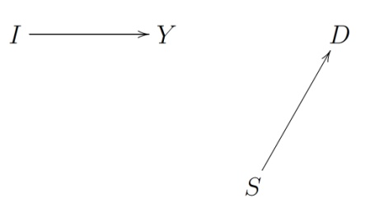

Figure 3

“Arrow-breaking” captures the idea that when an intervention I is carried out on Y, Y comes completely under the control of I so that all other variables which may previously have influenced Y (like S) no longer do so. At the same time, the intervention is assumed to be of such a character that other causal relationships in the system are not disrupted. If we are dealing with variables that do not stand in non-causal dependency relations, it is standard to assume that arrow-breaking interventions are possible on each variable in the graph—that is, that we can set any variable in a causal graph to any of its possible values independently of the values taken by variables elsewhere in the graph. In other words, all possible combinations of settings of such values by interventions are regarded as co- possible and it is assumed that all causal relationships represented in the graph can be “broken” by interventions on appropriate dependent variables). I will call this the assumption of Independent Fixability of values:

(IF): a set of variables V satisfies independent fixability of values if and only if for each value it is possible for a variable to take individually, it is possible (that is, “possible” in terms of their assumed definitional, logical , mathematical , or mereological relations or “metaphysically possible”) to set the variable to that value via an intervention, concurrently with each of the other variables in V also being set to any of its individually possible values by independent interventions.

IF can be connected to the contrast between causal and non-causal dependency relations: while it is standard to assume that the former satisfy IF, the latter will not. That is, an indication of the presence of non-causal relations of dependency is that it is impossible (for conceptual etc.) reasons for some combinations of values of variables to occur and a fortiori for the variables to be set to those values by interventions.
In what follows it will often be useful to think of (non-causal) constraints on possible values of variables as taking a number of different forms and as restrictive to different degrees. At one extreme, the value of a variable completely constrains the value of another, as is the case when these variables represent identical properties. (If the temperature of a gas is identical with the mean kinetic energy of its molecules, the value of one of these magnitudes completely constrains the value of the other.) In other cases, certain combinations of values for two variables may be impossible but a range of others may be possible. Supervenience is of course one example of this. In still other cases, various combinations of values for any two properties or variables may be possible, but not when larger sets of properties are considered together. For example, given variables representing (M) whether Socrates and Xanthippe are married, (S) whether Socrates dies, and (W) whether Xanthippe becomes a widow, suppose that M takes the value married. Then if S takes the value dies, it will be impossible for W to take any value except widow and if S takes the value lives it will be impossible for W to take any value except non-widow. On the other hand if Socrates and Xanthippe are not married, whether Socrates dies does not constrain whether Xanthippe is a widow. If we think of sets of variables such that some combinations of values of those variables are impossible as not fully “distinct”, then these last two cases involve variables which are not identical but also are not fully distinct. At the other extreme, systems of variables that satisfy (IF) will be fully distinct or independent.
Some writers (e.g., Westlake, forthcoming) advocate restricting the use of directed graphs and the interventionist framework to what I have been calling standard contexts, in which all variables satisfy IF. There is certainly a case for doing this, since (as we shall see) extending the standard framework to encompass non-causal dependency relations leads to a number of complications and makes causal interpretation in some respects less natural and transparent. Nonetheless, extensions are certainly possible and in what follows I will explore how they might be made. I want to emphasize, however, that in doing this, one really is extending and altering the standard directed graph framework and its interventionist interpretation. In particular, a “mixed” structure that represents both causal relationships and non-causal relationships of dependency such as Kim’s Figure 1 is not the same structure as a standard directed graph that represents only causal relationships. In employing such mixed structures, one needs to take care to avoid certain inconsistencies and mistaken inferences that can result when directed graphs and interventionist interpretations are applied to both causal and non-causal dependency relationships. For example, if the same directed graph is used to represent both (i) causal relationships and (ii) non-causal dependency relationships between “non-distinct” events, and we treat relationships of kind (ii) as though they are relationships of kind (i), we may be led to mistaken causal conclusions. Indeed, as already suggested, from an interventionist viewpoint, this is one of the central mistakes made by the exclusion argument: it applies interpretations and rules of inference that are only appropriate for causal relationships to non-causal relationships of dependency.
I conclude this section with a further observation about Kim’s diagram and the exclusion argument which I hope will illustrate the power of the interventionist framework and the way in which it can afford novel insights. Although adherents and critics of the exclusion argument of course disagree about whether it is appropriate to regard M₁ as causing M₂, in the context of Kim’s diagram, they have tended to assume that the information in the “remainder” of the diagram ( that P₁ causes P₂, M₁ supervenes on P₁, M₂ supervenes on P₂) is enough to “fix” or determine the overall pattern of association between M₁ and M₂, with the only question being whether this association should be regarded as causal. In fact, with a broadly interventionist framework, this assumption is mistaken. The information in the remainder of the diagram does not even determine whether M₁ and M₂ are correlated.
Here is one of many possible illustrations. Suppose M₁ has two possible values, m₁₁ and m₁₂. M₁ supervenes on P₁, with possible values p₁₁, p₁₂, p₁₃ and p₁₄. m₁₁ may be realized by either of the values p₁₁, p₁₂. m₁₂ may be realized by either p₁₃ or p₁₄. M₂ has two possible values m₂₁ and m₂₂. M₂ supervenes on P₂, with possible values p₂₁, p₂₂, p₂₃ and p₂₄. p₂₁ and p₂₂ are the realizers of m₂₁ and p ₂₃ and p₂₄ are the realizers of m₂₂. There is a “law” linking P₁ to P₂, according to which the values p₁₁, p₁₂, and p₁₃ are followed by p₂₁ and the value p₁₄ is followed by p₂₂. We can interpret this law as a causal claim within the interventionist framework—that is, as claiming that P₁ causes P₂-- since there are interventions that change P₁ (e.g., from p₁₁ to p₁₄ ) that are followed by changes in P₂ (from p₂₁ to p₂₂). However, changes in M₁ from m₁₁ to m₁₂ (or vice-versa) are not associated with (do not lead to) changes in M₂. This is because all of the realizations of the different possible values of M₁ lead via the pattern of dependence of P₂ on P₁ to realizations of the same value of M₂ (namely m₂₁). The alternative value of M₂ (m₂₁) requires for its realization values of P₂ that do not result from any of the values of P₁ that are realized by M₁.
Although this result may seem initially seem counterintuitive, a little reflection shows that it is unsurprising. The supervenience of M₁ on P₁ is consistent with many, many different patterns of dependence of M₁ on P₁ (and vice-versa). Similarly for the supervenience of M₂ on P₂ and for its being true that P₁ causes P₂. How, if at all, M₂ depends on M₁ has to do with how these three different patterns of dependence [F(M₁)→ P₁, G(P₁)→ P₂, H(P₂)→M₂] mesh or fit together—on the composition [H(G(F (M₁)))→ M₂] of these three different dependence mappings. What this composite mapping looks like will depend on the details of these three dependence mappings. The supervenience relationships present in the diagram and the causal dependence of P₂ on P₁ do not provide enough constraints on these mappings to exclude the possibility that the composite mapping takes all values of M₁ into the same value of M₂, in which case M₁ and M₂ will be uncorrelated. If correlation (in this sort of simple case) is a necessary condition for causation, M₁ will not cause M₂. Moreover, it is also the true that even if M₁ and M₂ have non-zero correlation, the relationships in the lower part of Kim’s diagram do not ensure that there is any stable pattern of dependence of M₂ on M₁- i.e., which values of M₁ are followed by which values of M₂ may vary in a highly irregular way.
This example illustrates a general point referred to in section 2: there is a big difference (unappreciated by many philosophers) between saying that one variable Y causally depends on another, X (or that X is a difference-maker for Y), and saying that for each occurrence of a value y of Y, there is a value x of X that is (causally) sufficient for y. In Kim’s diagram, any particular occurrence of a value of M₁ will of course have some physical realizer and by hypothesis that realizer will be sufficient for whatever value is taken by P₂ and hence in virtue of the supervenience relation between P₂ and M₂, sufficient for the value taken by M₂ on this occasion. However, as we have seen it does not follow that the values taken by M₂ depend on the values of M₁ in the sense that there are different possible values of M₁ which will lead to different values of M₂, so that changing the value of M₁ is a way of changing the value of M₂. It is this last possibility that corresponds to the interventionist notions of causation described in section 4.
This in turn suggests a further point. Since the supervenience relations in Kim’s diagram and the causal relation from P₁ to P₂, do not settle what the dependency relation between M₁ and M₂ is, drawing an arrow (or not) from M₁ to M₂ can convey additional information that cannot just be read off from the information in the lower part or “remainder” of the diagram. If the case is one in which M₁ and M₂ are uncorrelated (or exhibit no stable correlation), then, at least within an interventionist framework, one should not draw an arrow from M₁ to M₂, even though M₁ supervenes on P₁, M₂ supervenes on P₂ and P₁ causes P₂. On the other hand, if the case is one in which there is a relatively stable pattern of non-zero correlation between M₁ and M₂, and interventions (properly understood—see below) on M₁ are associated with changes in M₂, then within an interventionist framework, it will be appropriate to regard M₁ as causing M₂.

Section 5: Interventionism and Baumgartner’s Argument

We are now in a position to introduce both the basic argument that interventionism allows for the possibility that mental properties (or whatever is represented by mental variables) are causally efficacious and Baumgartner’s criticism of this argument. The interventionist argument for mental causation has both a positive and negative component. The positive component is simply this: according to interventionism, a sufficient condition for a mental property (state etc.) represented by a value of variable M₁ to cause some other mental property represented by value M₂ (or a physical state P₂) is that changes in M₂ (or P₂) be associated with changes due to interventions on M₁, given satisfaction of the other conditions detailed in M. Proceeding naively, it looks as though this condition for causation is frequently met in ordinary circumstances. We do after all seem to regularly to introduce intervention-like changes in the mental states of others and perhaps in our own mental states as well and these changes in turn sometimes seem to be regularly associated with changes in other mental states and in behavior. Indeed, it is natural to suppose that this is what successful persuasion and deception are all about -- in persuasion I manipulate your beliefs and desires by providing you with information or material inducements, typically with the goal in mind that these changes will in turn cause further changes that I desire in your mental state or behavior. On an interventionist conception of cause, when non-confounded manipulation of your mental states is associated with changes in cognition and behavior, this is all that is required for mental causation – nothing more metaphysically portentous is needed. Legions of experiments from the social and behavioral sciences in which subject’s mental states are manipulated, behavioral changes are observed, and inferences about the causal influence of the former on the latter seem to reflect a similar understanding of causation. Looking at matters this way, it seems that it is appropriate not only to draw an arrow from M₁ to M₂ when interventions on M₁ are associated with changes in M₂, but also to draw an arrow from M₁ to P₂ in such cases, since P₂ will also change under interventions on M₁.
Of course, this line of thought does not yet address the claim, by advocates of the exclusion argument, that when M₁ supervenes on some physical state P₁ and M₂ on physical state P₂, as in Kim’s diagram, P₁ “excludes” any causal role for M₁. As I see it, this claim rests at bottom on the idea that in order for M₁ to be causally efficacious, it must have an independent causal impact (on M₂ or P₂) “holding fixed” or “controlling for” the causal impact of P₁ on these variables. The negative part of the interventionist argument against causal exclusion attempts to show that this idea is misguided: it is based on a misunderstanding about which factors need to be held fixed or controlled for in assessing the efficacy of M₁; in particular, in assessing the causal efficacy of M₁, we should not hold fixed P₁. I will support this contention below, but rather than moving directly to this, I want instead to introduce Baumgartner’s criticisms which also turn on claims about what it is appropriate to control for (or at least on claims about what interventionists are committed to controlling for) when supervenience relations are present.
Baumgartner’s argument is that far from supporting the claim that M₁ causes P₂ in Kim’s diagram, interventionism is actually inconsistent with this claim. (I focus on the M₁→ P₂ relationship in order to follow Baumgartner’s exposition, but see footnote 12). Baumgartner’s reasoning is as follows: Consider (IV). This requires that an intervention on X with respect to Y change the value of X in a way that is statistically independent of all other causes of Y that are not on a path from X to Y. Suppose one attempts to intervene on M₁ with respect to P₂. Then (Baumgartner claims) in Kim’s diagram (Figure 1) P₁ is such an off-path variable which is a cause of P₂. Moreover, it is built into the nature of the supervenience relation that M₁ cannot change in value without a change in P₁. But then it is impossible to change M₁ in a way that it is statistically independent of P₁ (or to change M₁ with P₁ being held fixed). Hence, according to Baumgartner, it is impossible to intervene on M₁ with respect to P₂. If there is no such possible intervention on M₁, then according to the interventionist account of causation, M₁ cannot cause P₂, since M requires that for such causation, interventions on M₁ must be possible. Moreover, a similar line of reasoning, combined with apparently plausible assumptions, seems to lead to the conclusion that M₁ cannot cause M₂.
In responding to this argument, let me begin by distinguishing among three different issues. First, there is the issue of whether Baumgartner is correct in claiming that the characterizations of intervention and causation in MTH imply or require control for supervenenice bases like P₁ in assessing whether M₁ causes P₂ (or M₂). Second, independently of what the formulations in MTH imply, there is the question of whether any account which retains the overall commitments of interventionism must require such control. As I understand him, Baumgartner holds that the answer to this second question is “yes” – he thinks any coherent version of interventionism requires such control. Third, there is the issue of whether, regardless of what interventionism may imply, it is correct to control for supervenience bases in assessing the causal efficacy of supervening properties, as the causal exclusion argument implies. My stance on these issues is as follows. With respect to the third issue, I think it is inappropriate to control for supervenience bases in assessing the causal efficacy of supervening properties. That is, if P₁ is the supervenience base for M₁ one should not control for P₁ in assessing whether M₁ causes P₁ (or M₂.) If this is correct and yet, in connection with the second issue, interventionism requires such control, this would be a fundamental difficulty with interventionism. Fortunately for interventionism, I believe it does not require such control – or so I will argue. Of these three issues, the first strikes me as the least interesting and important, since if the formulations in MTH require control for supervenience bases, the obvious thing to do (assuming such control is incorrect) is to reformulate interventionism so that it does not require such control, assuming it is possible to do so.
In the remainder of this paper I will focus mainly on the second and third of the issues distinguished above. But, for what it is worth, I also think that Baumgartner is mistaken to suppose that anything I say in MTH (or in Woodward 2008a, b) implies that control for supervenience bases is required. In the next few paragraphs, I try to briefly explain why, while relegating some additional discussion to a footnote so as not to clutter up the overall flow of my argument.
I have italicized the sentence in first full paragraph on p. 15 which I believe contains the crucial misstep in Baumgartner’s reasoning. As explained above, IV is intended to apply to systems of causal relationships represented by causal diagrams constructed according to the rules (governing direct causation etc.) given in MTH. Baumgartner apparently assumes that Kim’s diagram is such a causal diagram for the purposes of applying (IV) and that P₁ is the relevant sense, an “off-path variable “in such a graph. But this is incorrect or at least question-begging, assuming (as virtually everyone involved in this discussion, including Baumgartner, agrees) that supervenience relationship represented by the double-tailed arrow is not a causal relationship. (I will say more about this assumption below). IV says nothing about controlling for variables that are “off-path” in the sense that they stand in non-causal supervenience relations to the variable intervened on--- this just isn’t what “off-path” means in the context of IV. Instead, the surrounding context in MTH makes it clear that “off path” in IV means “variable that is off-path in the ordinary causal diagram or graph that represents the causal structure of the system of interest”. P₁ is not an off-path variable in this sense. Of course, if there are no interesting differences between a diagram like Kim’s and an ordinary causal diagram or if the rationale for controlling for ordinary causal confounders embodied in IV implied that one also needed to control for supervience bases, then this would be hair-splitting and Baumgartner would be correct in interpreting IV in the way that he does. But as I have already suggested, ordinary causal graphs are very different structures from diagrams like Kim’s. Moreover, it is question-begging to assume that the justification for controlling for ordinary confounders that IV attempts to capture transfers to a justification for controlling for supervenience bases, since again this is one of the central points at issue at issue in the exclusion argument. Since IV and the associated characterizations in M do not require controlling for or holding fixed supervenience bases in assessing the efficacy of supervening states, they support the claim that supervening states can be causally efficacious.
Of course even if these contentions are correct, they leave open the second and third issues distinguished above. With regard to the third issue, perhaps the interventionist framework as formulated in Woodward, 2003 is simply mistaken in failing to impose a requirement that one control for supervenience bases. After all, interventionists agree that one should “control for” some other causes of Y in assessing whether X causes Y. Why shouldn’t these other causes of Y that need to be controlled for include the supervenience basis SB (X) for X, as the exclusion argument claims? Why shouldn’t we reformulate the interventionist framework in such a way that it requires such control? And returning to the second issue, perhaps there are commitments in the interventionist framework that, on pain of incoherence, require control for supervenience bases (regardless of what is or is not explicitly said in MTH). As already noted, this appears to be Baumgartner’s view—he regards such control as (something close to) a forced move in any plausible version of interventionism.
The remainder of this essay explores these issues, arguing for the following claims. First, and most fundamentally, a requirement that one must control for SB(X) in assessing the causal impact of X on Y leads to mistaken causal inferences. Second, the arguments and considerations that support requirements for controlling for the effects of appropriate “other causes” (as detailed in IV, M) when all of the relationships represented in the graph are causal or correlational simply do not transfer to contexts in which non-causal relations of dependence are present. That is, it is a mistake to assume that because it would be appropriate, in assessing the causal impact of M₁ on M₂, to control for or hold fixed variable P₁ in Kim’s diagram in contexts in which P₁ causes M₁, it must also be appropriate to do this in contexts in which the relationship between P₁ and M₁ is one of non-causal supervenience. When we reflect on the underlying rationale for controlling for various “other variables” in applying the interventionist characterizations of causation, we see that this rationale does not warrant or support controlling for supervenience bases in the way that Baumgartner supposes. Put slightly differently, Baumgartner’s arguments for controlling for supervenience bases seem to me to simply assume that structures in which supervenience relations are present should be treated in exactly the same way for control purposes as structures in which only ordinary causal relations are present, so that all off path variables, including those bearing supervenience relations to the variable intervened on, must be controlled for, and the relevant notion of intervention must be understood as requiring such control. I will argue below that this assumption is both not required by interventionism and is implausible and unmotivated. Indeed, as observed above, adopting this assumption is tantamount to assuming one of central claims of the exclusion argument. So it is not surprising that by making this assumption, Baumgartner is able to conclude that interventionism requires one to conclude that supervening variables must be causally inefficacious.
Of course it would be question-begging to simply assert that the controlling for P₁ in Kim’s diagram leads to mistaken causal inferences. I therefore begin, in the following section, with another sort of example in which non-causal relations of dependency (but in this case, logical, mathematical or definitional dependency – hereafter “definitional dependency” -- rather than supervenience relations of the sort characteristic of non-reductive physicalism) are present and in which treating such relations as ordinary causal relationships leads to what I take to be uncontroversially mistaken causal conclusions, based on mistaken assumptions about what it is appropriate to control for. This will provide a concrete illustration of my more general claim that directed graphs that represent only causal or correlational relationships among distinct variables are very different structures from directed graphs that represent both causal and non-causal relations of dependency and need to be treated differently. I will then argue that a similar conclusion holds for cases in which supervenience relations (not involving definitional dependencies) are present.

6. Causal inference and Control in the Presence of Definitional Dependence

Suppose, following Spirtes and Scheines, 2004, that heart disease (D) is causally influenced by high density cholesterol (HDC), which lowers the probability of disease and low density cholesterol (LDC) which raises the probability of disease. Suppose that we also have a variable representing total cholesterol (TC) which is defined as the arithmetic sum of HDC and LDC (i.e., TC= HDC+ LDC). Assume for the sake of argument that we think of TC as also (causally) influencing D, although its overall impact on any given occasion of course will depend on the precise mix of HDC and LDC that taken together realize TC. If we attempt to put all of these variables together in a single graph, we might be led to the following:

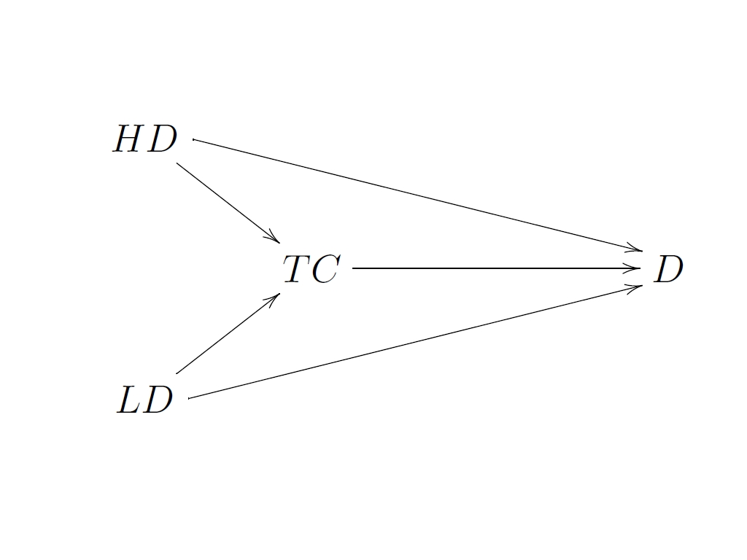

Figure 4

Here the arrows from HD and LD to TC represent the mathematical dependency of TC on HD and LD and the arrows from HD, LD, and TC to D represent that D causally depends on these variables. Thus the graph does not reflect the difference between causal and definitional dependence.
Suppose now that we ask what the effect of a change in LD of such and such a magnitude is on D, holding fixed such “other causes” of D as TC and HD— that is, we consider a (purported or attempted) “manipulation” of LD which holds fixed TC and HD. The first thing to notice is that such a manipulation is not possible, given the definition of TC: if both TC and HD are held fixed, it is not possible to change LD. It seems uncontroversial that someone who argues that LD has no causal impact on D on the grounds that, fixing the values of the “off –path” variables HD and TC, “intervening” on LD seems to produce no change in D is making a mistake— this is not an appropriate way of assessing the causal effect of LD on D. A similar conclusion would follow if it was instead argued that because it is impossible to intervene to change LD while holding HD and TC fixed, LD is causally inert, having no effect on D—again this does not establish the causal inertness of LD. And a similar conclusion also follows if instead we ask what the effect of LD on D is and identify this with the change in D, which would result from an intervention on LD, holding fixed just TC. Any change ∆LD in LD that also holds TC fixed will of course require (again just as a matter of arithmetic) a compensating change in HD of magnitude ∆HD = TC-∆LD. Since a change in HD has the opposite effect on D as a change in LD of the same sign, a manipulation of LD which holds TC fixed will confound the effect of the change in LD on D with the opposite effect of the change in HD. The resulting overall change in D will not give us the effect of (just) LD on D.
The introduction of variables that are related in the way that LD, HD and TC are thus creates problems for the causal interpretation of graphs containing such variables. As noted above, one solution is to simply exclude from our causal representation any variables which are definitionally related: for example, a representation which includes the variables LD and HD but not TC is legitimate but no representation which includes all three is. More generally one might exclude as illegitimate any graph containing variables that violate INF, as the variables under discussion do. However, in what follows, I want to consider how we might proceed if, for whatever reason, we decide to allow variables that are definitionally related into our representation, since this will be suggestive for how we should proceed in cases in which non-causal supervenience relations are allowed into our representation. I should emphasize that my remarks are not intended as a complete theory of how to treat cases of definitionally related variables, but rather as a very partial list of considerations that are meant to be suggestive for cases involving supervenience.
Proceeding in this way, I suggest that when definitional relations among variables are present in a graph, causal interpretation and inference should conform to the following requirements: First, in assessing the causal impact of X on Y, it is not legitimate to consider what would happen to Y under combinations of manipulations of the values of X and other variables (besides Y) that set these to combinations of values that violate the relationships taken to hold definitionally among those variables. In saying this is not “legitimate”, what I mean is that it is not an appropriate way of assessing whether or not X causes Y or what the causal impact of X on Y is. For example, as argued above, in order to characterize the effect of LD on D, it is not legitimate to consider what would happen to D under a “manipulation” that changes the value of LD while HD and TC are held constant.
The most straightforward way of implementing this idea within the interventionist framework is to interpret (or re-interpret) M in such a way that it is understood to say that we should consider only those manipulations/interventions and combinations of these that involve setting variables to combinations of values that “possible” (in the sense of being consistent with definitional constraints) in assessing whether or not X is a direct cause or contributing cause of Y. In other words, in applying M, we confine our attention only to sets of co-possible combinations of interventions and ask concerning these, whether there is an intervention in any such set on X that changes Y when appropriate other variables (as specified in M) are held fixed at some value by other interventions in this co-possible set. Call these the relevant interventions. A necessary (but not sufficient condition—see below) for X to be one or another variety of cause of Y (a direct cause, contributing cause etc.) is that Y change under some combination of relevant interventions on X and other variables, where what counts as an “appropriate” combination is specified in M. If, for every such combination, Y does not change under interventions under relevant interventions on X , then X is not a cause (direct or contributing) of Y. Whether or not Y would change under combinations of “interventions” that are “impossible” in the sense of violating definitional constraints has no bearing, one way or another, on whether there is a causal relationship between X and Y. That is, the fact that it is not possible for definitional reasons to intervene on X while holding various other variables fixed, does not show that X is not a cause of Y—instead this fact is irrelevant to whether X causes Y.
Although this allows us to avoid entanglement, in applying M, in misguided counterfactual queries about what would happen under antecedents that cannot possibly be realized for definitional reasons, it doesn’t yield a full positive account of how to apply the interventionist framework in contexts in which there are definitional dependencies among variables. Suppose, as before, our graph contains variables representing LD, HD, and TC and that we wish to consider the effects of an intervention that changes the value of LD by ∆LD, while HD is held fixed. Confining our attention to just these two variables, there is nothing impossible about this combination of interventions. However, it is obvious that these interventions must also change TC by amount ∆LD if the TC=LD+HD constraint is respected. I suggest that in this case these interventions on LD and HD are in effect (or must be thought of as also amounting to) an intervention on TC. (Indeed, it seems natural to say that the change in TC involves the “same” intervention as the intervention on LD, since nothing further or independent needs to be done to TC once LD is changed and HD held fixed.) Thus when we update the value of LD in order to take account of its having been manipulated (HD being held fixed), we must similarly update the value of TC. Moreover, we need to adjust for the fact that we have done this in considering the effect of LD on D. In particular, it would clearly be mistaken to argue as follows with respect to the graphical structure in Figure 4: an intervention on LD will change D along the direct path from LD to D, but it will also change TC and hence D along the path that goes from LD to TC to D. Thus in assessing the total effect of a change in LD on D, we need to take account of both the direct effect of LD on HD and a second indirect effect that is mediated through TC. This is plainly double counting. There is just one effect here-- the effect of LD on D. TC has no effect on D that is independent of or distinct from the effect of LD on D. Thus in this sort of context we cannot simply identify the effect of LD on D with what would happen under a suitable intervention on LD, without correcting for double counting.
The need to take account of the fact that, when variables are logically dependent, interventions on some variables will “automatically” be interventions on others (and that the ‘same” intervention is involved in both cases), and that, because of the possibility of double counting, the effect of one variable on another cannot just be identified with what happens to the second under a suitable manipulation of the first means that the interpretation of graphs containing such variables will not be as straightforward as the interpretation of ordinary directed graphs. However, if one is willing to tolerate a certain amount of cumbersomeness, one can provide at least the outlines of such an interpretation. To do this, let us first distinguish between ordinary causal relationships and relations of definitional dependency by labeling the former with single tailed arrows, as before, and the latter with double tailed arrows. Thus Figure 4 becomes:
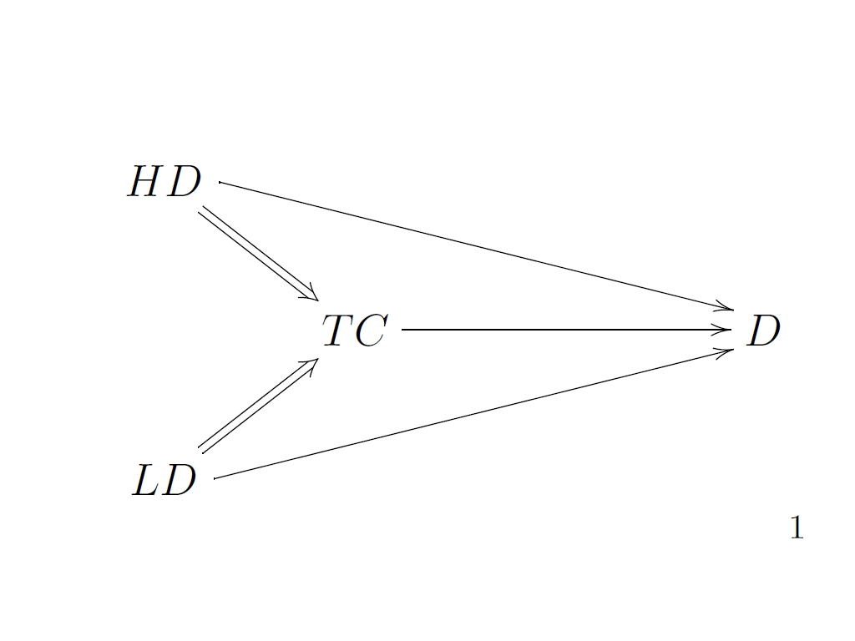

Figure 5

Some rules for the deployment of the notions of intervention and the interpretation of causal relationships in such a graph may then be formulated as follows:

1) Allowable manipulations of variables must respect the definitional constraints (if any) holding among those variables. In particular when variables are joined by a double tailed arrow, an intervention on one such variable may be tantamount to an intervention on the other variable. In such cases the particular value which is imposed on the second variable will of course depend on the value imposed on the first variable and the details of the definitional relationships among the variables in the system of interest.

2) Suppose we wish to assess the causal impact of X on Y by considering the response of Y to an intervention I on X and there is a double-tailed arrow, reflecting a definitional relation, from X to a third variable Z, where Z≠ Y. Suppose also that I is such that the change it produces in X is associated by the definitional relation with a change in Z. We should then think of I as also an intervention on Z. The effect on Y of the change due to I on X (Z) is measured by the result of the single intervention I, counted just once. Thus, graphically, we are in effect thinking of the intervention as operating in the following way:
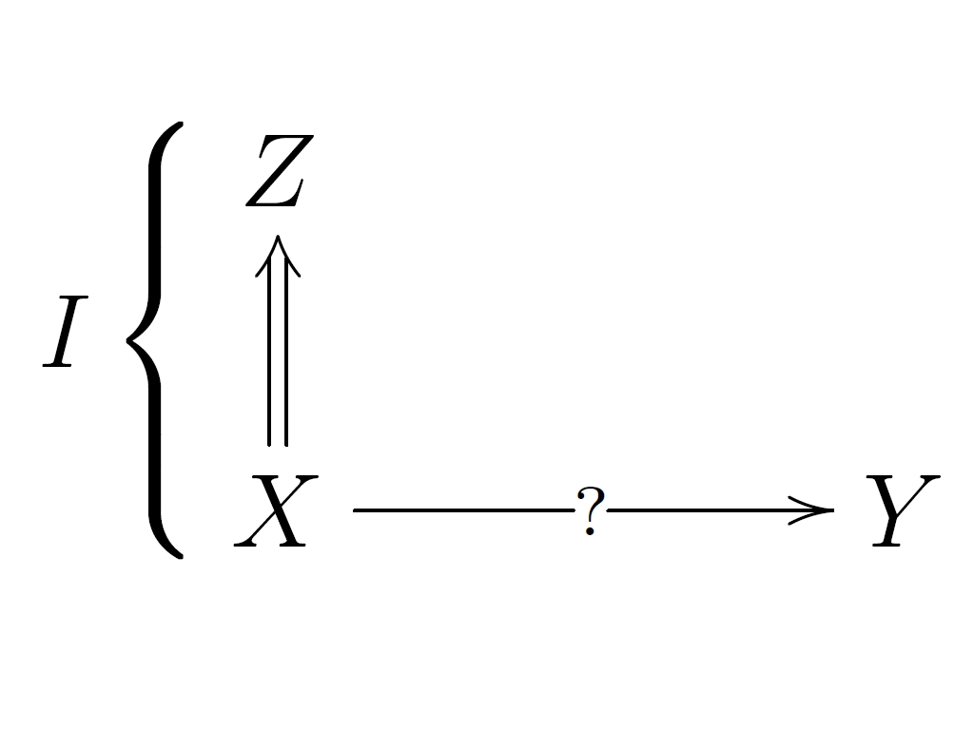

Figure 6
A single intervention I operates on both X and Z.

A similar result holds for an intervention that changes the value of Z: this must also be counted as an intervention that changes the value of X.

3) As we have seen, in some cases a combination of interventions on several variables , although co-possible, may force (because of definitional constraints) a change in additional variables as well. We should either (a) disallow such combinations of interventions for the purposes of assessing causal relationships or (b) somehow compensate for their effects in tracking causal relationships, by taking care to avoid double-counting.

These rules/ constraints are plainly cumbersome. They illustrate the point that when it is possible to do so, it is much more straightforward to employ variables that are not definitionally related and which may be independently set to any combination of values (that are individually possible for those variables) in accordance with IF, as in what I have been calling the standard directed graph representation of causal relationships. They also illustrate the general point that once we allow definitional constraints among variables, our understanding of what interventions do, and the relationship between interventions and causal claims must be understood in a way that reflects these constraints.

7. Causation in the Presence of Supervenience Relationships

I will now argue that roughly parallel points hold with respect to variables that exhibit the sort of supervenience relations postulated in non-reductive physicalism.
To motivate this claim, return to Kim’s diagram. For purposes of contrast, I begin by asking how we should think about interventions and causal relationships if the double- tailed arrows representing supervenience are interpreted as ordinary causal relationships, rather than, as intended by Kim, non –causal supervenience relationships. That is, let us think of P₁ as causing both P₂ and M₁, and of P₂ as causing M₂ and ask what would have to be the case, within the interventionist framework and given these causal relationships, for it to be justifiable to also draw (that is add) a single tailed arrow from M₁ to M₂ (or to P₂), representing that M₁ causes these two variables. Since we are now dealing with an ordinary causal graph for which IF is assumed to hold, M tells us that for M₁ to cause M₂, it must be the case that it is possible to intervene on M₁ where such an intervention is understood (in accord with IV) as setting M₁ to some value independently of the value taken by P₁ and that M₂ must change under some such intervention. Because the relationship between P₁ and M₁ is an ordinary causal relationship, such an intervention on M₁ is possible in the relevant sense and will “break” the arrow from P₁ to M₁, putting M₁ entirely under the control of the intervention variable. In this sort of structure, according to the interventionist account, it is completely appropriate to ask what the effect of a change in M₁ is (on M₂ or P₂) controlling for or holding fixed P₁.
Of course on the usual understanding of the claim that M₁ supervenes on P₁, this relationship is not causal and the intervention on M₁ envisioned above is impossible for “metaphysical” reasons. From an interventionist perspective, this impossibility tells us that the relationship between P₁ and M₁ cannot be interpreted as a causal relationship—if it were so interpretable, it would be possible it would be to intervene on M₁ while holding P₁ fixed and this isn’t possible (cf. IF above).
At this point, we face a choice. On the one hand, we might (i) hold onto the idea that in order for M₁ to have a causal effect on M₂ (or P₂), there must be a possible intervention that changes M₁ while P₂ is held fixed and under which there is an associated change in M₂ (P₂) and infer from the fact that there is no such possible intervention that M₁ does not cause M₂ (P₂) (This is a version of the exclusion argument or something close to it, cast in interventionist terms.) Alternatively, (ii) and following a path analogous to the one we adopted in connection with variables bearing definitional relations to one another, we might conclude that the requirement that in order for M₁ to have a causal effect on M₂, there must be a possible intervention that changes M₁ while P₁ is held fixed and under which M₂ changes, is inappropriate.
Unsurprisingly, I favor this second path. I will first spell out what I am proposing and then turn to its defense. We saw above that when variables are definitionally related, an “intervention/manipulation” of some of those variables must be treated as “automatically” changing others, in a way that respects whatever definitional constraints connect the variables. In a similar vein, I suggest that an intervention on a variable X also should be treated as automatically changing (indeed as also an intervention on) the supervenience base SB(X) of X, with SB(X) changing in whatever way is required by the supervenience relation between X and SB (X) (or as changing in some way or other that is consistent with the supervenience relation if there are multiple possibilities). Consistently with this, when an intervention occurs on X, its supervenience base SB(X) should not be regarded as one of those “off route causes” in IV that one needs to control for or hold fixed in intervening on X. To be more explicit, when (non-causal) supervenience relationships are present, the characterization IV should be interpreted in such a way that in condition (I3) a directed path counts as “going from I to Y through X” even if I also changes (as it must) the supervenience base SB (X) of X, as well as the value of X. Similarly, the reference in (I4) to “any variable Z” should be interpreted as “any variable Z other than those in the supervenience base SB(X) of X”. Put slightly differently, an intervention I on X with respect to Y will (a) fix the value of SB(X) in a way that respects the supervenience relationship between X and SB(X), and (b) the requirements in the definition (IV) are understood as applying only to those variables that are causally related to X and Y or are correlated with them but and not to those variables that are related to X and Y as a result of supervenience relations or relations of definitional dependence. Call this characterization of interventions (IV*) and an intervention meeting these conditions an IV*-intervention.
Turning now to the causal notions in M, how should these be understood when supervenience relations are present? In assessing whether X is a direct cause of Y, the “other variables” in V that we should hold fixed independently of the intervention on X (i) should not include the supervenience base for X and (ii) should not include the supervenience base for Y. Instead, the intervention that sets X to some value x (in this context, an IV*-intervention) will at the same time set SB(X) to some value which is consistent with X=x. In order to assess whether X is a direct cause of Y, we should hold fixed via an IV*- intervention any other variables V_{i} in V that stand in ordinary causal or correlational relations to X and Y. X will then be a direct cause of Y if and only if under these requirements there is an IV*-intervention on X that changes Y when all other variables are held fixed via IV*-interventions at some value. Recall that because of the way IV*-interventions are characterized this will also involve holding fixed the supervenience bases SB(V_{i}) for each of those variables V_{i}. Thus we should not conceive of this as a matter of fixing the value of SB(V_{i}) in a way that is independent of the value assigned to V_{i} by this “fixing” intervention. Instead the intervention that fixes the value of V_{i} at the same time fixes a value for SB(V_{i}). Similarly, whenever some variable SB(V_{i}) in the supervenience base is fixed by an intervention we should at the same time regard this intervention as fixing a value for the corresponding supervening variable V_{i}. In assessing whether X is a contributing cause of Y, when we ask whether there is a directed path D from X to Y and some intervention on X that will change Y when all other variables in V that are not on D are fixed at some value, the other variables that are not on D that need to be held fixed should not include the supervenience bases for X and Y and should not include the supervenience bases for any variables on D . Applying these understandings, we see that it is possible for M₁ to be a (direct or contributing) cause of M₂ as long as M₂ responds to interventions on M₁, with appropriate other variables held fixed, where “appropriate” is specified as above.

8. The Rationale for not Controlling for Supervenience Bases.

Although adopting the proposals in section 7 allows us to conclude that supervening variables like M₁ are causally efficacious there remains the question of why we should adopt these proposals. Why, for example, should we not understand the notion of an intervention along Baumgartner’s lines, that is, as requiring that an intervention on X change X while controlling for or holding fixed its supervenience base SB(X)? Here I would argue that the same motivations that apply to cases of definitionally related variables also apply, mutatis mutandis, to variables related by supervenience and lead to analogous conclusions about what it is appropriate to control for. There are several lines of thought that converge on this assessment. The first appeals to how we should think about tests for causal efficacy that involve counterfactuals with impossible antecedents. I argued in section 6 that counterfactual queries about what would happen under interventions or combinations of interventions that required us to set variables to combinations of values that were impossible for definitional reasons were not appropriate for assessing causal effects (of any kind). It seems natural to suppose that this conclusion generalizes to the use of counterfactuals involving antecedents with combinations of values that are impossible for other sorts of reasons (including reasons deriving from non-definitional relations of supervenience)—it is not legitimate to use such counterfactuals in assessing causal efficacy. Thus, if it is “metaphysically impossible” to change the value of a supervening variable like M₁ while holding P₁ fixed, then the very fact that this is impossible is itself an indication that counterfactuals with this antecedent do not tell us about the causal effect (or the absence of such an effect) of M₁ on other variables. One might think about the matter this way: in the case of an ordinary system of variables bearing just causal and correlational relationships to each other but no non-causal relationships of dependency, the way in which one establishes that a factor X has no effects on Y is either to actually carry out an experiment or to construct a surrogate for an experiment involving statistical methods of control in which potential confounders Z are controlled for—the antecedent of the counterfactual “If X were to change while Z is held fixed, then Y would change” is one that is (in principle) capable of realization and if, when this antecedent is realized, Y does not change, we are justified in concluding that X does not cause Y. Here “in principle, capable of realization” means that the realization of the antecedent is not ruled out by definitional, metaphysical or other sorts of inviolable constraints. By contrast, in the case in which one considers what would happen to M₂ if one changes M₁ while holding P₁ fixed, the antecedent of the associated counterfactual is incapable of actually being realized— this is understood to be ruled out by inviolable constraints. Unlike the previous case, we do not argue for the causal inefficacy of M₁ on the basis of what would happen if the antecedent of this counterfactual were realized. Nonetheless, the exclusion argument invites us to conclude that in this case too M₁ is causally inefficacious—in effect, we infer that M₁ does not cause M₂ (or anything else) from the impossibility of changing M₁ while holding P₁ fixed, while in the more ordinary case of control, we infer that X does not cause Y, by providing evidence that Y does not or would not change were some situation in which X changes while potential confounders Z are held fixed were to be actually realized. In this case, we are not relying on the impossibility of realizing this situation to establish that X is not a cause. This is an important disanalogy between the two cases.
This observation supports a more general conclusion which I have already suggested: one can’t simply assume that because it is appropriate to control for ordinary confounders in cases in which no non-causal dependency relations are present, it must also be appropriate to control for factors like supervenience bases which do represent non-causal dependency relations. This was illustrated in section 6 when the non-causal dependency relations in question were definitional in nature: from the fact that is appropriate to control for the other causes Z of Y that are indicated in M when assessing whether X causes Y and those Zs bear only causal or correlational relations to X and Y, we saw that it does not follow that is appropriate to control for Zs that bear definitional relations to X and Y. Variables that bear definitional relations to X and Y should not be thought of as potential “confounders” that need to be controlled for in the way that variables that bear causal or correlational relations to X and Y may be confounders requiring control. I claim a parallel point holds for variables bearing supervenience relations to X and Y; here too it is a mistake to suppose that arguments for controlling for other variables when only ordinary relations of causation/correlation are present transfer into arguments for controlling for the supervenience bases of X and Y. In particular, it is a mistake to argue that because it would be appropriate to control for P₁ in an otherwise Kim-like diagram in which P₁ causes M₁, it must also be appropriate to control for P₁ when P₁ is the supervenience base for M₁. The supervenience base for M₁ is not a confounder for the causal relations in which M₁ stands in the way in which other variables that stand in ordinary causal relations to M₁ and M₂ may be confounders.
These observations might be less damaging to the exclusionist case if there were other positive reasons, rooted in good scientific methodology, for controlling for supervenience bases. But in fact it seems uncontroversial that, on any conventional understanding of experimental design, such control is regarded as misguided. Consider a researcher who wishes to do an experiment to learn whether ingestion D of a certain drug will cause recovery R from a disease. He proceeds by giving the drug to some subjects (the treatment group) and withholding it from others (the control group). Of course the goal is to design the experiment in such a way that the rate of recovery in the treatment group will be higher than in the control group if and only if the drug is efficacious. In designing the experiment it is crucial that the treatment and control group not differ systematically from one another with respect to other certain other possible causes of recovery – roughly those causes that might affect recovery independently of whether or not subjects take the drug. It is these “other causes” that are (in the ordinary sense of these phrases) “potential confounders” that need to be “controlled for”. (Conditions like IV and M attempt to characterize which such other causes need to be controlled for.) For example, if subjects in the treatment group systematically have better immune systems than those in the control group, this factor – call it S-- may have an independent effect on recovery and thus bias the result of the experiment, leading us to attribute cases of recovery that are in fact due to subject’s health to the drug. Note that this might happen in several different ways—it might be that differences in immune response just happen to be correlated with who gets the drug, as a matter of chance. Alternatively, it may be that those assigning subjects to the treatment and control groups are causally influenced (perhaps unconsciously) by the condition of the subjects—perhaps they want the trial to succeed and unconsciously assign healthier-looking patients (with better immune systems) to the treatment group. In both cases, one remedy is to adopt a randomized double blind design—subjects are assigned to the treatment or control group via some randomized process which (if working properly) insures that immune response is not correlated with who gets the drug. Note that although there may be practical or moral barriers to actually executing such a design, there is no conceptual, logical or metaphysical impossibility involved in doing so.
The need to control for confounders of the sort just described is uncontroversial. Suppose, however, that our researcher next becomes persuaded that the macroscopic features of the drug supervene on (but are not identical with) its underlying chemical features F. Reading the literature on causal exclusion, he becomes persuaded that in testing for efficacy of the drug he should control for F, as well as more ordinary confounders like the state S of his subjects immune system. (After all, he reasons, if it is appropriate to control for S, why shouldn’t he also control for F?) He thus contemplates an experiment in which D is varied, while holding fixed whether subjects receive a drug with F—he takes this to be the appropriate experiment for assessing whether D promotes recovery. Noting that such an experiment is impossible to perform, he concludes that D does not cause recovery. Instead, it is “really” only F that causes recovery. Since previous studies had reported that ingestion of the drug was efficacious, he is excited by his important new result that these studies were mistaken—all the more so, since he has been able to reach this conclusion on very general quasi-apriori grounds, while avoiding the bother of actually doing any experiments himself. He begins writing an article for Science, when it occurs to him that a parallel argument would show that the causal efficacy of F is itself “excluded” if there are underlying causally efficacious features (e.g. perhaps those postulated in some dimly imagined successor to string theory.) on which F supervenes but with which it is not identical. He concludes that unless he can rule out this possibility he is not entitled to claim that F causes recovery.
This little parable is not an argument but it does, I hope, function as an intuition pump. In actual scientific practice, no one supposes that the considerations that support controlling for confounders like S transfer into support for controlling for F. The moral that the researcher ought to draw from the impossibility of doing the experiment that controls for F is not that this shows that ingestion of the drug is not causally efficacious, but rather that this shows that the contemplated experiment is not the right one to test whether D is efficacious. The treatment of interventions (IV*) (along with M, interpreted along the lines suggested above) reproduces these judgments. By contrast, the claim that an intervention on X requires that X be changed independently of its supervenience base—Baumgartner’s construal of (IV) -- supports the researcher’s claims about the appropriateness of controlling for F.
As is apparent from this example, one of the main reasons why we care about controlling for appropriate “other causal factors” in assessing the impact of candidate cause C on E is to deal with the possibility that any correlation we may observe between C and E is “spurious” in the sense of being due entirely to these other factors and rather than reflecting a causal relation between C and E . “Spurious” in this sense has the implication that “controlling” or “manipulating” (in any ordinary sense of these terms) C is not a way of controlling E. In the experiment above, if any correlation between treatment and recovery is due entirely to the fact that those in the treatment group have stronger immune systems, then giving subjects the drug is not a way of increasing their probability of recovery from the disease. By contrast, the “argument” that controlling for F, D has no effect on recovery (or that it is impossible to control for F while manipulating drug ingestion) has none of these implications. That is, this argument does not show that manipulating whether people ingest the drug will be uncorrelated with recovery. Again, this shows how far the argument for controlling for F is from the ordinary motivation for controlling for confounders.
As I see it, then, the dialectical situation is this: the recommendation to control for supervenience bases leads to judgments and practices that seem to be sharply at variance with those usually assumed in science. The case for such control might nonetheless be compelling if there were some convincing positive argument for doing so, rooted in an analogy with the rationale for more ordinary cases of controlling for confounders. But as nearly as I can see there is no basis for such an analogy. In this situation, the burden of proof seems to me to be very much on the defender of the exclusion argument to explain why such control is required.

9. Does Interventionism Require Control for Supervenience Bases?

In his (2010) Baumgartner considers a proposal of the sort I have been advocating for what should be controlled for when supervenience relations are present but rejects it. (Baumgartner’s IV* and M* in the passage quoted below are essentially my proposals for how to understand IV (that is, IV* ) and M when supervenience relations are present.)

Assume we perform an (IV*)- intervention on the mental property
M₁ and assume furthermore that we find this intervention to be followed by
a change in the value of P₂. Does this test result reveal that M₁ is a cause of P₂?
Certainly not. For by IV* - manipulating M₁ we explicitly allowed for changes in P₁ which the non-reductive physicalist takes to be another cause of P₂. This other cause is not located on a path from M₁ to P₂ and, above all, is determined to be causally sufficient for P₂ by the causal closure of the physical. In consequence, our test result significantly underdetermines a causal inference. At least two structures can generate the result of our hypothetical test: Either (i) the change in the value of P₂ is only caused by a change in the value of P₁ which necessarily accompanied our intervention on M₁ or (ii) the change in the value of P₂ is overdetermined by P₁ and M₁. Of course, this ambiguity does not only arise due to a misguided intervention in one particular experimental context, rather, IV* -defined interventions, in general, are not required to be independent of all other causes of an effect under investigation. Supervenience bases of macro-variables may vary and thereby causally influence investigated effects at will when those macro variables are (IV*)- manipulated. Hence, all empirical data that result from (IV*)-interventions and that could stem from macro-to-micro causation might just as well stem from a structure that only features micro-to-micro causation. (IV*)-manipulations never induce an unambiguous inference to macro-to-micro causation. (p 18)

He adds:
somebody who subscribes to (M*) and (IV*) and conceives of the relationship between macro and micro properties in terms of nonreductive supervenience renounces one of the core principles behind interventionism, viz. “no causal difference without a difference in manipulability relations” (p. 19)

There are at least two arguments here. The first simply repeats the claim that the IV* notion of interventions is defective because such interventions fail to be “independent of” (i.e., fail to control for) “all other causes” of the effect under investigation. This claim simply assumes one of the basic premises of the exclusion argument; I have already argued against it. Contrary to what Baumgartner claims, it is a virtue rather than a defect in IV* that it tells us that when assessing the effects of X on Y, SB (X) should not be regarded as among the “other causes” of Y that need to be controlled. A properly characterized notion of intervention should possess this feature.
Second, Baumgartner claims that treating interventions and causal relationships when supervenience relations are present in the manner I advocate results in an under-determination problem and violates the interventionist maxim, “no causal difference without a difference in manipulability relations”. To illustrate with the specific example of Kim’s diagram, suppose that under an IV*-intervention I on M₁, M₂ changes. Following (IV*), this intervention on M₁ involves a change in P₁ which in turn causes P₂ which involves a change in M₂. Adopting a principle like M* (M interpreted as above to fit contexts in which supervenience is present) will lead us to conclude that M₁ causes P₂ (and presumably M₂). Call this causal hypothesis (i). According to Baumgartner, the exact same behavior on the part of M₂ under intervention I is equally consistent with another set of causal hypotheses—that the only causal relationships present in the example are those holding at the micro-level, with the intervention I conceived as changing P₁ which in turn changes P₂, but with no causal relationship between M₁ and M₂, the latter changing only because of its supervenience relation to P₂ and not because of the direct causal influence of M₁. Call this causal hypothesis (ii). According to Baumgartner, it is a fundamentally unsatisfactory feature of IV* that whether (i) or (ii) holds is underdetermined by all possible evidence about what happens under IV*-interventions—it is in this sense that the interventionist maxim is violated.

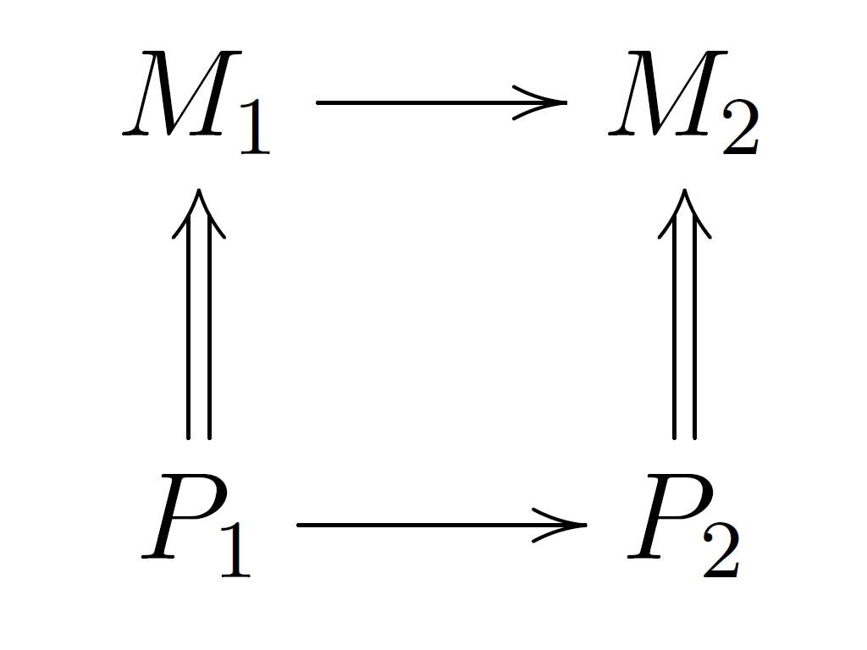
Causal Hypothesis (i)
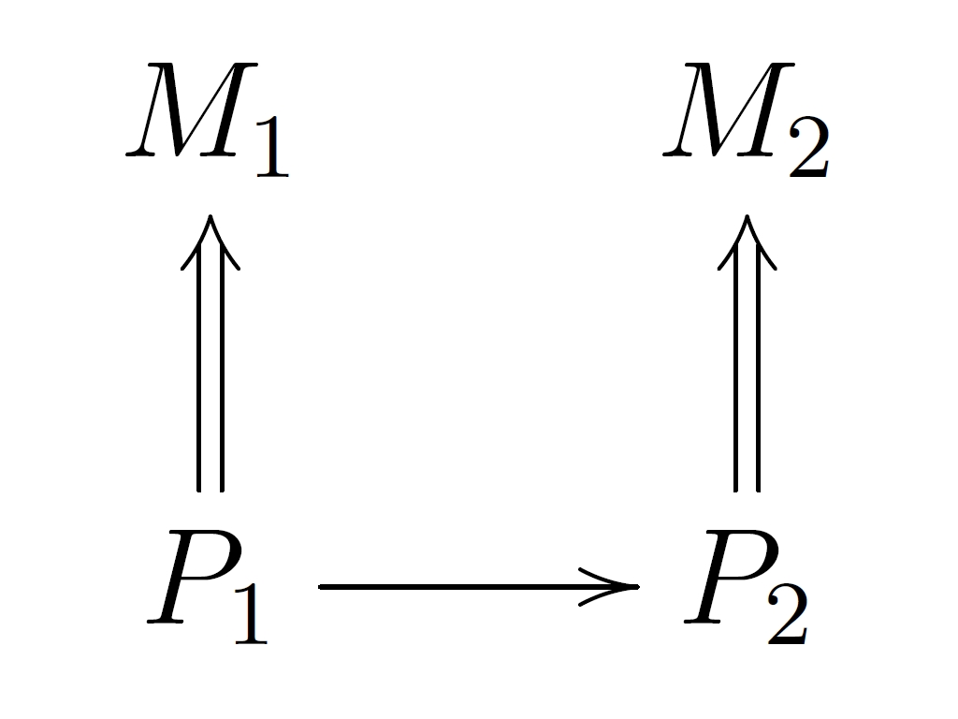
Causal Hypothesis (ii)

Figure 7

There are several points to be made about this argument. First, recall from section 4 that from the facts that M₁ supervenes on P₁, P₁ causes P₂ , and M₂ supervenes on P₂, it does not follow that M₁ causes M₂ ( when “cause” is interpreted along interventionist lines). Thus the information explicitly represented in diagram (ii) does not entail that M₁ causes M₂, while diagram (i) does represent this. In this sense, (i) contains information that is not in (ii). Indeed, if we follow the convention that we should draw an arrow from X to Y if and only if Y changes on some interventions on X (i.e., the omission of an arrow means that Y does not change under any intervention on X), then (i) represents that M₂ will change under an intervention on M₁, while (ii) denies this. They thus disagree about what will happen under some possible interventions and represent different causal structures, in accordance with the interventionist maxim.
I doubt, however, that metaphysically minded defenders of the exclusion argument will find this consideration persuasive. Instead, they are likely to think of it as merely an observation about the representational limitations of diagrams like (ii) and not as bearing on the underlying metaphysics. To develop this line of thought, consider again the mapping F(M₁)→ P₁, giving the details of the pattern of dependence of P₁ on M₁, the mapping G giving the pattern of dependence of P₂ on P₁ and the mapping H(P₂)→M₂ . Call these mappings the “basis facts” for M₁ and M₂. Defenders of the exclusion argument will remind us that even if we grant that (i) and (ii) differ qua representations in the way described, it remains the case that these basis facts taken together are sufficient to fix what pattern of dependence (or its absence) holds between M₁ and M₂. To make this point vivid, compare diagram (i) with an enhanced version of diagram (ii) (call this ii+) in which we make explicit the details of the mappings F, G, and H, while still not drawing an arrow from M₁ to M₂. We also adopt the convention that the absence of arrow from M₁ to M₂ does not mean that they are uncorrelated; rather whether they are correlated or not has to be inferred from the basis facts, rather than being explicitly represented in the diagram.

Causal Hypothesis (ii+). Above diagram and a specification of the dependence mappings F(M₁)→P₁, G(P₁)→P₂, H(P₂)→M₂.

Figure 8

It may now seem as though we can re-run Baumgartner’s underdetermination argument as follows. If, as in (i) we draw an arrow from M₁ to M₂ representing that M₁ causes M₂, we seem to claiming that this arrow represents some additional causal fact, over and above whatever information is contained in (ii+). But as long as the same basis facts hold, a world represented by (i) in which this arrow is present and a world represented by (ii+) in which it is absent have exactly the same implications for what will happen under all possible interventions. We could never tell on the basis of interventional information which world we are in. This is unacceptable and violates the interventionist maxim that there are no causal differences without differences in manipulability relations.
If this captures Baumgartner’s intent, it seems to me that his argument, rather than my proposed treatment of interventions, violates the interventionist maxim. Baumgartner’s underdetermination argument in effect assumes that (i) and (ii+) represent distinct causal structures and complains that information about interventions cannot be used to distinguish between them. But the whole point of the interventionist maxim is that when one has allegedly distinct sets of causal hypotheses that make exactly the same predictions about what will happen under all possible interventions on the variables in those hypotheses, then the hypotheses do not really make different causal claims, in the sense at issue, according to which different causal claims are understood as differing in their empirical content. From this point of view, (i) and (ii+) are different representations of the same casual structure, with (i) making it explicit that M₂ depends on M₁, while in (ii+) this is a fact has to be inferred from the composition of the functions H(G(F)).
Here again, it is useful to consider the analogous issue that arises when variables are related by definition rather than by supervenience. Compare the structure in Figure 4 with the structure in Figure 9:
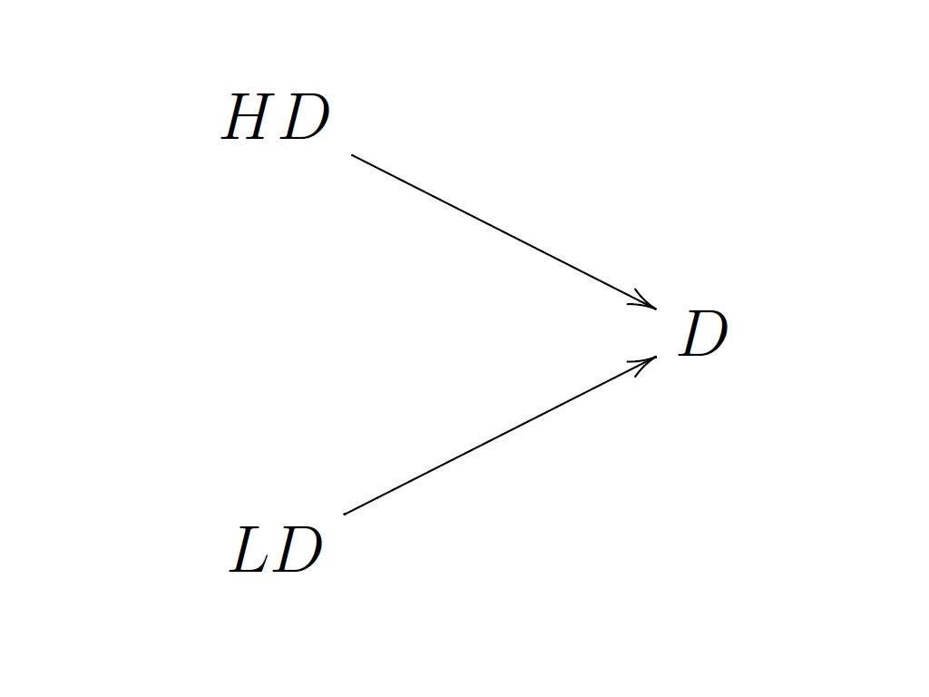

Figure 9

Do the diagrams in Figures 4 and 9 represent different sets of casual relationships? Not if the TC=LD+HD constraint holds inviolably by definition. In Figure 9, an intervention that changes LD by amount ∆LD with HD fixed just is a change in TC of magnitude ∆LD in Figure 4. As we have seen, when LD changes in this way, it is not as though there are two distinct effects on D, one directly due to LD and the other mediated through TC. Instead, we should think in terms of there being just one effect, which is also what we would think if we employed the representation in Figure 9. In the same way, I suggest the diagrams (i) and (ii+) above also should be interpreted as representing the same causal facts.
One might worry that this conclusion trivializes the disagreement between the proponents of the exclusion argument and their critics (like me). If (i) and (ii+) do not represent distinct systems of causal relations, doesn’t it follow there is no real difference between those who endorse the exclusion argument and those who reject it? Not at all. For one thing, the advocate of the exclusion argument is certainly not claiming that a representation according to which M₁ causes M₂ and a representation according to which it does not are both equally legitimate. The whole point of the exclusion argument is supposed to be that representation (i) in which M₁ is taken to cause M₂ is mistaken or defective in some way (because it involves over-determination, misrepresents M₁ as casually efficacious when it is really epiphenomenal etc.) and the representation (ii) or (ii+) is correct. The interventionist account denies this. This is a real disagreement.
That said, Baumgartner’s under-determination argument does bring out an additional feature of the interventionist account that is worth remarking. I remarked above that interventionism embodies a “thin” notion of causation that contrasts with an interpretation according to which the arrows in a causal diagram represent some “thicker” connection such as a “connecting causal process” between X and Y. When arrows are interpreted in this way, it is at least arguable that it makes sense to think of (i) and (ii+) as representing alternative possibilities: (i) might be interpreted as saying there is a connecting process from M₁ to M₂ and a distinct connecting process from P₁ to P₂, and (ii+) as saying that there is only one causal process that goes from P₁ to P₂. If the only instances of variables that can be connected by causal processes are instances of “physical” variables, it follows immediately that (ii+) is the correct representation. In addition, if there is some empirical way of determining when causal processes are distinct (perhaps by interfering with one process independently of the others) or of determining whether one or several causal processes are present, this may provide (in addition) empirical grounds for distinguishing between (i) and (ii+). I take it that when (i) and (ii+) are interpreted in this way and if there were an empirical way of distinguishing them, we would not expect there to be any distinct causal process connecting M₁ and M₂ over and above what is represented in (ii+) and hence that (ii+) is the correct representation. However, diagrams like (i) and (ii+) should not be interpreted in this way within an interventionist framework and the framework provides motivated reasons for holding that the presence of a connecting causal process between X and Y is not required for X to cause Y.
It may help to further clarify these issues about the interpretation of causal diagrams if we turn briefly to the concern that recognizing mental causation commits one to implausible conclusions about the ubiquity of “causal over-determination”. Here it is crucial to be clear about what is meant by “overdetermination”. If all that is meant is that, e.g., in Kim’s diagram M₂ is caused by M₁ and M₂ is caused by P₁, then anyone rejecting the exclusion argument of course will be committed to this sort of underdetermination. However, an interventionist framework can help us see that overdetermination in this sense is importantly different from the paradigmatic examples of over-determination discussed in the philosophical literature (and that are used by exclusionists to motivate the claim that extensive over-determination is implausible). As a familiar illustration, consider again the case of two riflemen who each shoot separate bullets that simultaneously strike the heart of a victim, killing him, where each bullet by itself, in the absence of the other, would have caused victim’s death. Stipulate that the victim’s death would have occurred in just the same way if he was struck just by bullet one or just by bullet two. Examples having this structure have been discussed within an interventionist framework, by several writers (e.g., Hitchcock, 2001, Woodward, 2003). Although I lack the space for detailed discussion, within an interventionist framework this sort of over-determination is understood in terms of a set of counterfactual claims about what would happen under various interventions – e.g. (a, b) If, as a result of an intervention, bullet one (two) had not hit the victim but bullet two (one) had struck his heart, victim still would have died. (c) If, as result of an intervention, neither bullet had struck victim, he would not have died. It is crucial to such analyses that the two shooters affect the victim by means of separate or independent casual mechanisms, where what makes two mechanisms independence is that it is possible to interfere with one without interfering with the other and vice-versa. It is such independence that makes it sensible to talk about what would happen to the victim if one of the bullets had not hit him, but the other had. For example, in the scenario as described, it makes sense to consider a variation in which one of the rifleman shoots while the second doesn’t or that the second bullet is deflected in flight while the first considers unimpeded. But, as we have just seen, an analogous treatment does not apply to the cases of over-determination by both mental and physical causes that concern the exclusion theorist: assuming supervenience it is impossible that the physical cause be present but the putative mental cause that supervenes on it be absent (or vice-versa), so that there is nothing analogous in the mental/physical case to the variation on the riflemen case in which one shoots and the other doesn’t. This of course is a reflection of the fact that the kind of “over-determination” that is present in the two cases is quite different—the shots of the two riflemen are independent (both causally independent and independent in the sense of not standing in any non-causal relation of dependence) while the mental and physical causes of P₂ or M₂ are non-causally dependent. The kind of coordinated action between independent causes that is present in the riflemen case is indeed rare, but this is not the kind of “over-determination” that is assumed by the anti-exclusionist to be present when M₂ is caused by both M₁ and P₁.

References

Michael Baumgartner (2009). “Interventionist Causal Exclusion and Non-Reductive Physicalism”. International Studies in the Philosophy of Science 23 (2):161-178.

Baumgartner, M. (2010). “Interventionism and Epiphenomenalism”. Canadian Journal of Philosophy 40: 359-383

Campbell, J. (2010). “Control Variables and Mental Causation”. Proceedings of the Aristotelian Society 110: 15-30.

Danks, D. (Forthcoming). “Beyond Reductionism versus Autonomy in Psychology”

Engel, E. (1992) A Road to Randomness in Physical Systems. Berlin: Springer-Verlag

Kim, J. (1998) Mind in a Physical World: An Essay on the Mind-Body Problem and Mental Causation. Cambridge, MA: MIT Press.

Kim. J. (2005) Physicalism or Something Near Enough. Princeton: Princeton University Press.

- List, C. and Menzies, P. (2009). “Nonreductive Physicalism and the Limits of the Exclusion Principle.” Journal of Philosophy 106: 475-502.

McLaughlin, B. and Bennett, K. “Supervenience” Stanford Encyclopedia of Philosophy. http://plato.stanford.edu. Accessed May 26, 2011.

Marcellesi, A. Forthcoming. “Manipulation and Interlevel Causation”

Raatikainen, P. (2010). “Causation, Exclusion, and the Special Sciences”.
Erkenntnis 73 349-363.

Salmon, W. (1984) Scientific Explanation and the Causal Structure of the World Princeton: Princeton University Press.

Shapiro, L. 2010. “Lessons From Causal Exclusion.” Philosophy and Phenomenological Research 81: 594–604

Shapiro, L. and E. Sober 2007. “Epiphenomenalism. The Dos and Don’ts.” In Thinking About Causes: From Greek Philosophy to Modern Physics, G. Wolters and P. Machamer, eds., 235–264. Pittsburgh: University of Pittsburgh Press.

Spirtes, P., and Scheines, R. (2005). “Causal Inference of Ambiguous Manipulations”. Philosophy of Science 71: 833-45.

Westlake, B. Forthcoming. “Exclusion Excluded”

Woodward, J. 2003. Making Things Happen: A Theory of Causal Explanation. Oxford University Press.

Woodward, J. 2008a, “Mental Causation and Neural Mechanisms” in Hohwy and Kallestrup, eds. Being Reduced: New Essays on Reduction, Explanation, and Causation. Oxford University Press, pp 218-262

Woodward, J. 2008b, “Cause and Explanation in Psychiatry: An Interventionist Perspective” in Kendler and Parnas, (eds.) Philosophical Issues in Psychiatry: Explanation, Phenomenology and Nosology, Johns Hopkins University Press, 2008, pp. 132- 184.

Woodward, J. 2008c. “Reply to Strevens” Philosophy and Phenomenological Research 77:193-212.

* Thanks to Michael Baumgartner, Bert Leuridan, Alex Marcellesi ,Peter Menzies, Larry Shapiro, Brad Westlake, and Eric Yang for helpful comments on an earlier draft.
This is one of several points at which the treatment of the exclusion argument that follows differs from the treatment in List and Menzies, 2009. The latter take it to be necessary condition for X to cause Y that X satisfy a proportionality requirement with respect to Y. They argue on the basis of this requirement that under the right conditions (when M₁ is “realization insensitive” with respect to M₂), M₁ will cause M₂ but P₁ will not cause M₂; in such cases there is “downward exclusion” in the sense that the efficacy of the upper level cause M₁ with respect to M₂ excludes the efficacy of the lower level cause P₁ . Their case for this claim rests on the further claim that in such situations the counterfactual: “If P₁ had not occurred then M₂ would not have occurred is false”— they claim this is because (1) if P₁ had not occurred some other realizer of M₁ would have occurred and (hence) M₂ would still have occurred. In contrast, I do not regard proportionality as a necessary condition for causation and hence treat M₁ as causing both P₁ and M₂ and P₁ as causing M₂, even when M₁ is realization-insensitive . Hence no “downward exclusion” is present. In addition, my treatment does not depend on the claim (1) which I regard as problematic for reasons described in Woodward, 2008a – see especially footnote 9. Very briefly it seems to me (1) would be clearly true only if some kind of back-up mechanism were in place that insures that when P₁ does not occur, an alternative realizer of M₁ does. This is to construe the relation between M₁ and its realizers as having the same structure as a case of redundant causation in which a rifleman fires and a back-up riflemen is present who will fire if and only if a first rifleman does not fire. Nothing in the relation between M₁ and its realizers seems to me to license this construal and in any case (1) is in my view unnecessary for an adequate treatment of the exclusion argument.
Typical presentations of exclusion argument assume that (1) if P₁ causes P₂ and M₁ supervenes on P₁ and M₂ on P₂, it follows that (2) changes in M₁ must be correlated with changes in M₂, with the only question being whether it is appropriate to think of this correlation as reflecting a causal connection between M₁ and M₂. I note below that this inference from (1) to (2) is mistaken. (2) is an additional, independent assumption that does not follow from (1). If (2) is false, then within an interventionist framework (and I would claim any plausible theory of causation) M₁ does not cause M₂ even if (1) holds. This is why I have formulated the exclusion argument in terms of whether it is “consistent” with (1) to suppose that M₁ causes M₂. In particular, I take the issue to be whether if (1) and (2) hold, we may think of M₁ as causing M₂.
Consider the relationship between the position P₁ of a baseball and the position P₂ of an individual molecule that is a part or constituent of the ball. P₁ constrains P₂ but P₁ does not cause P₂ (or vice-versa).
For a treatment of the relations between different levels of psychological and neurobiological theorizing in terms of the notion of constraint, with identity just one particular kind of constraint (rather than all such constraints being regarded as identities) see Danks, forthcoming.
It is more common in philosophy to think of causation as involving relationships between “events” or types of events but this can be naturally treated as a special case within a “variable” framework, with events or properties and their absence corresponding to binary or indicator variables – see Woodward, 2003 for details. For example, the variable S in Figure 1 is understood as capable of taking either one of two values—smoking or not smoking.
See, for example, Lewis (2000), p.78.
In addition to the characterization (M), MTH also provides characterizations of other causal notions, such as the notions of total and actual causation. Although the differences among these are important for some purposes, they play little role in the exclusion debate. I will accordingly usually abstract away from them, speaking instead simply of X’s causing or being causally relevant to Y, with the understanding that, within an interventionist framework, causal claims of various sorts share a common structure having to do with how Y responds to interventions on X when appropriate other variables are held fixed.
Although the notion of direct causation is defined with reference to a particular variable set V, if X is a direct cause of Y with respect to V, it will be a contributing cause in any expanded variable set V’ (where V is a subset of V’). Similarly if X is a contributing cause of Y with respect to V, it also will be a contributing cause in any expanded variable set. This allows us to define a notion of contributing causation that is not relativized to any variable set - see Woodward, 2008c.
There is an interpretive issue about M (raised in particular by Baumgartner, 2010) that requires some clarification at this point. As already explained, in the formulation above, M should be understood as intended to apply to systems in which no non-causal relations of dependency are present. So understood M requires that for X to be a direct or contributing cause of Y, it must be true both that it is possible to intervene on X (there must “be” such an intervention) and that under this intervention, Y changes when other specified variables be held fixed. The requirement that it is possible to intervene on every variable represented in a graph and to set each such variable to each of its values independently of the values to which other variables are set is described below as the requirement of independent fixability (IF). Although I think this is a reasonable (and certainly standard) assumption when dealing with systems of variables that are not related by relationships of non-causal dependency, it is not a reasonable assumption for systems in which relationships of non-causal dependency are present, since this implies that certain combinations of values of variables are not possible. In particular, it plainly would be misguided to require that if X is a variable in such a system violating IF, then in order for X to be causally efficacious, it must be possible to set X and the other variables in the system to combinations of values that are ruled out by whatever non-causal dependency relations are present in the system. This would immediately entail that X is never causally efficacious. Thus M should not be interpreted as embodying any requirement of this nature about the connection between whether interventions are possible and causal efficacy. Instead, for systems violating IF, we must understand the notion of intervention in such a way interventions on X do not require setting X and other variables to combinations of values that are inconsistent with whatever non-causal dependency relations are present. I develop such an understanding in section 7, with the notion of an IV*-intervention. With this understanding, we can retain the idea that even in systems with non-causal dependency relations interventions on variables must be possible if they are to be judged causally efficacious.
I don’t claim that this gives us an independent way of recognizing when non-causal dependency relations are present. To recognize that IF is not satisfied one has to be able to recognize that certain possible combinations of values of variables are impossible for non-causal reasons. My point is simply that IF is connected to the contrast between causal and non-causal dependency relations.
One might imagine weaker versions of the usual understanding of supervenience in which, say, each value of the supervenience base variable is co-possible with only a limited range of values of the supervening variable, rather than with a unique value of the latter, as is the case with ordinary supervenience.
The first mapping F(M₁)→ P₁ will of course in general not be a function since it is one to many. H(P₂)→ M₂ will be a function as will G(P₁)-- > P₂, assuming determinism. But neither H nor G need be 1-1 and G need not be onto. This raises a general mathematical question to which I do not know the answer: under what conditions on F, G and H will (some) different values of M₁ be mapped into some different values of M₂?
This illustrates another limitation on the usefulness (although not the coherence of) the notion of supervenience. The bare claim that M₁ supervenes on P₁ and M₂ on P₂ places no real constraints on the relation between M₁ and M₂ (and affords no insight into why that relation holds) even if add that the laws linking P₁ to P₂ are deterministic.
Suppose that m₁₁ can be realized by either p₁₁ or p₁₂ and m₁₂ can be realized by either p₁₃ or p₁₄. m₂₁ can be realized by either p₂₁ or p₂₂ and m₂₂ can be realized by either p₂₃ or p₂₄. P₂ depends on P₁ in the following way: both p₁₁ and p₁₃ are followed by p₂₁ and both p₁₂ and p₁₄ are followed by p₂₃. Then depending on whether m₁₁ is realized by p₁₁ or p₁₂, it is followed by either m₂₁ or m₂₂. Similarly, depending on whether m₁₂ is realized by p₁₃ or p₁₄, it is followed by either m₂₁ or m₂₂. If m₁₁ is realized equally often by p₁₁ and p₁₂ and m₁₂ equally often by p₁₃ and p₁₄ (i.e. for each value of M₁ each of its micro-realizers is equally probable) there will be no correlation between M₁ and M₂—another case in which correlation between M₁ and M₂ fails to follow from the information in the lower half of Kim’s diagram. Moreover, if which of p₁₁ or p₁₂ realizes m₁₁ varies unsystematically from occasion to occasion and analogously for the realizers of m₁₂, then even without the assumption that each pair of realizers is equally probable, there may be no stable relationship between values of M₁ and values of M₂. A real-life example (with uncountably many possible realizers for the relevant macro-states but otherwise similar to the relations postulated in Kim’s diagram) is provided by an ordinary roulette wheel: the initial macroscopic state M₁ of the ball and wheel when given an impulse supervenes on their microstates, the end state M₂ of the ball/wheel supervenes on their ending microstate and the dynamics at the level of the microstates is fully deterministic. Yet there is no correlation between M₁ and M₂ if the wheel is functioning properly—an explanation of how this is possible is provided by the “method of arbitrary functions”, as described in Engel, 1992.
Campbell, 2010 argues that arrow-breaking interventions on putative mental causes like beliefs and desires are generally not possible; instead what is possible are so-called “soft” interventions, which involve, roughly, the introduction of exogenous variation in the variable intervened on, which need not bring this variable fully under the control of the intervention. This may well be right but makes no real difference to the argument that follows, since, as shown in Eberhardt and Scheines, 2007, such soft interventions can play largely the same role in inference and causal interpretation as arrow-breaking interventions. I will thus ignore this possibility in what follows.
I emphasize again that the two arrows drawn from M₁ to P₂ and from P₁ to P₂ do not mean that M₁ has an effect on P₂ that is somehow separate from or over and above whatever the effect of P₁ on P₂—see p 9 .
In correspondence Baumgartner has claimed that his criticisms show only that interventionists are committed to the claim that M₁ cannot cause P₂, and leave open whether M₁ can cause M₂. According to Bumgartner, this is because, given the supervenience of M₂ on M₁, the P₁→ M₂ relation is not a causal route. This seems implausible, given the overall context of the exclusion argument and other natural assumptions about how causation operates when supervenience relations are present. In particular, if one regards appeal to non-reductive supervenience relations as legitimate at all, one is likely to think that causation is sometimes transmitted “through” such relations, in the sense that if P₁ causes P₂ and M₂ supervenes on P₂, then P₁ will sometimes cause M₂. (P₁ will cause M₂ when the patterns of dependency are such that interventions on P₁ are associated with changes in the value of M₂.) If causation is never transmitted through supervenience relations in this way, then events or properties in supervenience bases can never cause changes in macro-level supervenience bases. For example, physically characterized changes in the surface of your retina or skin (P₁) cannot cause central mental events like pain or visual experience (M₂), assuming that P₁ causes brain events on which M₂ supervenes. Non-reductive physicalists will wish to reject this conclusion. But if P₁ causes M₂, then Baumgartner’s argument, if cogent, also implies that M₁ cannot cause M₂.
Although my view is that issues about best to interpret MTH are not very interesting, let me try to briefly expand on these remarks for those who do care about such things. When writing MTH, I assumed that we were not dealing with variables which stood in supervenience or other non-causal dependency relations, without making this restriction explicit. (In this I followed most of the literature on causal graphs and Bayes nets, which also assumes a similar restriction without making this explicit.) There is thus no discussion at all in MTH of whether one should control for supervenience bases. In the absence of any stipulation to so control, a natural interpretation of MTH is that one should not control. Certainly it seems unmotivated to read MTH as requiring such control, in the absence of any explicit claim to this effect. Nonetheless the omission of any discussion of causal claims when supervenience relations are presence plus the superficial resemblance of Kim’s diagram to a causal graph (both are graphs with arrows etc.) makes it understandable that Baumgartner (as well as others with whom I have discussed this issue) have been led to the conclusion that interventionism as I formulate it requires such control. In retrospect, it was a mistake not to more clearly and explicitly addressed these issues in MTH. I am grateful to Baumgartner’s discussion for prompting me to do this. I will add that a later paper of mine which Baumgartner discusses (Woodward, 2008a) does argue explicitly that in assessing the causal efficacy of supervening variables one should not, within an interventionist framework, control for their supervenience bases. Other writers (e.g., Shapiro and Sober, 2007) sympathetic to interventionism have advanced similar arguments. Moreover, it should also be clear that within an interventionist framework, the motivation for adopting one or another characterization of the notion of an intervention is exactly to specify what should or should not be controlled for. Thus one would expect interventionists to be committed to an account of intervention that does not require control for supervenience bases. Baumgartner, by contrast, interprets IV as committing interventionists to such control even though this is inconsistent with what they explicitly say in papers written after MTH and even though IV does not explicitly say anything about controlling for supervenience bases.) It seems to me that it would have been more charitable to instead consider the possibility that IV does not require such control, thus bringing the assessment of the exclusion argument in Woodward (2008a) and Shapiro and Sober (2007) into congruence with IV.
Recall that according to M what is required for X to cause Y is that some intervention on X be associated with change in Y, when appropriate other variables are held fixed. One possible view is that as long as some such association holds, for some values of X and Y, X causes Y, even if this association is very unstable, as it is in the case under discussion, since even the direction of the association depends on how X is “realized”. This leads to the claim represented in Figure 4 – that TC is a cause of D even if TC does not have a stable effect on D. An alternative position is that if manipulations that set TC to some value are not associated with a stable changes in D, TC should not be regarded as a cause of D. I opt for the first view here merely because it allows for a convenient illustration.
I put “manipulation” (and below, “intervention”) in scare quotes to capture the fact that these do not involve possible combinations of values of variables, all of which might be realized together—in other words the contemplated intervention/manipulation is not really possible (and may not have a clear sense), for definitional reasons.
Of course, it might also be true that although the intervention I on X changes the value of X, it does not change the value of Z, since the new value of X is compatible with the original value of Z—both values of X realize the same value of Z. I then is not an intervention on Z.
When some value of X=x is multiply realized in SB(X), then of course any particular intervention that sets X=x will involve the setting of SB(X) to just one of the realizing values for X, although which such value is realized will often be unknown. If all realizations in SB(X) of this value of X have the same uniform effect on a second variable Y, then at least for this purpose it does not matter what the realizer of X=x is.
For example if M₁ causes M₂ which in turn causes M₃ and the corresponding supervenience bases for these three variables are P₁, P₂, and P₃, then we should think of an IV*- intervention that fixes the value of M₂ as at the same time fixing P₂ and similarly an IV*-intervention on P₂ will fix M₂. Under such an intervention M₁ will not turn out to be a direct cause of M₃.
Or at least along the lines to which Baumgartner takes interventionism to be committed.
Baumgartner’s versions of the proposal in fact come from proposals that I made in correspondence with him and in a referee report on an earlier version of his paper.
It follows that there is something right about the exclusion argument insofar as its target is some thicker notion of mental causation than what is captured by the interventionist account. Consider the claim that the causal efficacy of M₁ requires that M₁ have an effect on P₂ (and M₂) that is so to speak over and above and distinguishable or separable from the effect that P1 has on M₁ and M₂, in the sense the former effect is somehow added on to the latter or results from a process that is added on to the process resulting from the former. Interventionism agrees with advocates of the exclusion argument that no causation by M₁ of the sort just described is present. But while the exclusionist takes this to show that M₁ is not causally efficacious, the interventionist regards this claim about what causation by M₁ requires as misguided
Once again, “interference with a mechanism” within this framework takes the form of breaking all of the arrows directed into a variable by intervening on that variable. Suppose that P₁ is a variable specifying the position of the first bullet shortly before it strikes the victim, and the causes of P₁ include the first rifleman’s direction of fire F and whether O some obstacle is in the path of the bullet. Then an intervention on P₁ breaks both arrows from F and O into P₁, but there is no requirement that these individual arrows themselves correspond to two spatio-temporally distinct processes. The possibility of intervening on P₁ without intervening on the corresponding variable giving the position P₂ of the second variable shortly before striking the victim (and vice-versa) is what makes the mechanisms by which the two riflemen kill the victim suitably distinct.

