New Work for a Theory of Emergence

Abstract

Many discussions of emergence focus on the putatively irreducible causal powers of emergents. I argue that the question of whether emergents are irreducible causes should be postponed in favor of the question of whether emergents are natural. David Lewis contends that scientifically interesting properties are natural: they account for resemblances and distinguish causally relevant and irrelevant properties. I consider bimanual coordination, as described by the HKB model, as an example of natural emergence. I conclude that emergent properties are those that systemic processes have when they exhibit “instability” and argue that instability is the natural property that unites these processes.

1. Introduction.
Complexity scientists use “emergence” to describe dynamical processes in open systems that produce spontaneous reorganization of their components. Philosophical discussions tend to focus on the putatively irreducible causal powers of emergents relative to the causal powers of their subvenient micro-constituents. I argue that the question of whether they are irreducible causes should be postponed in favor of the question of whether emergents are natural. Lewis (1983) argues that scientifically interesting properties are natural: they account for resemblances among things and distinguish the causally relevant and irrelevant properties. If emergent properties are scientifically interesting, then they are natural. I consider bimanual coordination (described by the HKB model) as an example of emergence in a natural system. Inspired by Rueger (2000), I define emergence as a property that systemic processes have when they begin to exhibit “instability”, and argue that instability is the natural property that unites these processes.

2. Emergents as Irreducible Causes.
Kim thinks that an ontological interpretation of emergence requires that emergent properties have either synchronic or diachronic “downward causal influence”. This interpretation requires that
the emergents bring into the world new causal powers of their own, and, in particular that they have powers to influence and control the direction of the lower-level processes from which they emerge. (1999, 5-6)
Kim finds the notion of synchronic downward causal influence unintelligible because it violates the principle that if an object is caused to have a causal power at a time t, then it cannot exercise that causal power at t (1999, 147). Exercising a causal power happens later than the time of acquisition.
Diachronic downward causal influence, according to Kim, creates an intolerable causal competition between emergents and their non-emergent bases. Kim queries “if an emergent, M, emerges from basal condition P, why can’t P displace M as a cause of any putative effect of M?” (1999, 147) Reductionists argue that an emergent property cannot causally compete with its subvening micro-based physical property. There are several replies that attempt to salvage the causal efficacy of emergents without positing entirely distinct properties. For example, a Pereboomian account of emergence might suggest that token emergent causal powers are materially constituted by token microphysical-based causal powers (2011, 141). Shoemaker’s (2001) account of mental causation suggests that emergent properties are determinables, the causal powers of which are a subset of the causal powers of their microphysical realizers. I think this debate is a bit premature. If we want an ontological interpretation of emergence on which emergents cause anything at all, then we need some reason to think that they are not grueish and gerrymandered. Figuring out the precise relation that emergent properties have to micro-based properties should be postponed until we have some account of that. Whatever is included in the category of “emergent”, the matter of determining whether or not the emergents are gerrymandered is to be settled by paying attention to systematic empirically theorizing.

3. What Would It Mean for Emergence to be Natural?
Lewis (1983, 1986) argues that accounting for the kinds of similarity that distinguishes causally relevant and irrelevant properties requires a metaphysical theory that either includes universals as real primitives or provides an adequate nominalism that does the work that universal would do. Both universals and nominals, according to Lewis, would perform this work by permitting a distinction between natural and unnatural properties:
Because properties are so abundant, they are undiscriminating. Any two things share infinitely many properties, and fail to share infinitely many others. That is so whether the two things are perfect duplicates or utterly dissimilar. Thus properties do nothing to capture facts of resemblance.... Likewise, properties do nothing to capture the causal powers of things. Almost all properties are causally irrelevant, and there is nothing to make the relevant ones stand out from the crowd. (1983, 346)
The perfectly natural properties, for Lewis, would be coupled so tightly to resemblance that two things have exactly the same natural properties just in case they are qualitative duplicates (356). Imperfectly natural properties come in varying degrees because they are built up from suitably “close-knit” perfectly natural properties (ibid., 347). To account for the nature of this close-knit relationship Lewis suggests that perfectly natural properties could stand in resemblance relations to each other. By doing so they would constitute families of imperfectly natural properties, which may themselves constitute families of even less perfectly natural properties. Fundamental sciences study the perfectly natural properties and special sciences concentrate on families of imperfectly natural properties. All of the disjunctive properties are unnatural and scientifically uninteresting because they do not comprise resembling properties.
It is not entirely clear how closely imperfect natural properties must resemble in order to qualify as the domain of a special science. However, I think Lewis’s suggestion here is even more provocative than it appears on the surface. A property that falls under the domain of a particular science by being a member of a resemblance class might also be cross-listed under a different science if it falls under a different resemblance class. Such properties may compose the domain of an interdisciplinary science. Suppose that phenomena across a wide range of traditional fields from chemistry to economics could be accurately simulated using the same mathematical model and that the predictive consequences of this model were all well confirmed. Given that there is an interesting association between duplicability and simulability, this would suggest that there is enough resemblance between these phenomena to compose a domain that deserves its own systematic investigation – especially if there are a sparse number of law-like generalizations that govern a wide range of these phenomena. Complexity Science is an interdisciplinary science of just this sort, and emergence is a central part of its purview. As Bedau remarks, “the models in complexity science are typically described as emergent, so much so that one could fairly call the whole enterprise the science of emergence” (2002, 5).
Lewis distinguishes genuine events from spurious events in order distinguish the causally relevant and irrelevant events (1983, 369). Genuine events have natural properties, which makes them fit to figure into laws and causal relations. Spurious events, on the other hand, are unfit for this task. Like being grue, the properties of spurious events are gerrymandered. The natural/unnatural distinction explains what makes the causally relevant properties stand out from the rest. Lewis also stresses that the coupling of causally relevant events to natural properties explains why “scientific investigation of laws and of natural properties is a package deal…so that laws and natural properties get discovered together” (ibid., 368). He takes it as uncontroversial that causation involves laws. Whether or not they require laws, causal explanations cite natural properties. Indeed, the notion of invariance is wrapped up with the notion of resemblance. If an invariant generalization remains invariant over a fairly wide range of different initial conditions and different types of intervention, then it is reasonable to think that it generalizes over the behavior of natural properties because those are the properties that account for resemblance between like cause and like effect. If dynamical models of complex causal systems have explanatory power then the properties they cite are natural properties. As I argue below, the HKB model explains a variety of surprising properties of coordinated movement.

4. Emergence, Resemblance, and Causal Explanation.
During the last sixty years Complexity Science blossomed out of research originally grounded in General Systems Theory. Because complexity scientists are interested in diachronic processes that display emergence, they look for the similarities relevant to emergence in the dynamics of these processes. Is there a suitably related family of properties that corresponds to these different dynamical processes? I argue that there is such a family. To justify such a sweeping claim is a daunting task, but I can give partial justifications by detailing a dynamical model that illuminates emergence in nature and by describing how other such models do similar work.
The HKB model is a first-order differential equation introduced by Kelso, Hakken, and Bunz to model the behavior of the coupled oscillator systems involved in bimanual coordination (Kelso 1995). Here is a simple experiment that shows how the oscillator governing rhymic motions in your right and left hands exhibit emergent properties when coupled together. Snap with the fingers on your right hand in a rhythmic fashion and then snap with your left hand at the same time. Your snapping fingers will be oscillating in-phase. If you change the snapping rhythm to anti-phase, then you will be snapping a regular beat with a fingersnap on one hand followed by a fingersnap on the other. Only in-phase and anti-phase rhythms are stable. Because the system has two stable states, the system is bistable. Both the in-phase oscillations and the anti-phase oscillations are stable up to a certain frequency. If the frequency crosses a certain critical threshold, the anti-phase pattern becomes unstable. If you keep increasing the rate, you will find yourself snapping in-phase. This is a kind of phase transition known as a bifurcation. The in-phase state is globally stable. As fast as you can snap, you can snap in-phase. Fluctuations in the systems may briefly pull you away from the in-phase pattern, but your snapping behavior will be attracted to the in-phase pattern and repelled away from all others. The relative phase of the oscillations is the variable that captures the stable and unstable states of coordination. This simple discovery is the basis for the HKB model of coordination.
Eq.1 gives an idealized version of the HKB equation that ignores the intrinsic tuning of oscillators and systemic noise.
Eq.1 ϕ* = –a sin(ϕ) – 2b sin(2ϕ)

The parameter ϕ indexes the relative phase of the coupled oscillator system, and ϕ* is the change in relative phase over time. In Eq.1 parameters a and b are the coupling strength coefficients and –a sin(ϕ) – 2b sin(2ϕ) is the coupling term. Decreasing the ratio of b/a is equivalent to shortening the period of rhythmic coordination. Because the oscillators are time-symmetric and cyclical, we can represent their periods as a 360° cycle where possible relative phase φ ranges from –π to π.
The below plots (taken from Kelso 1995, 55) depict the potential function of the HKB model.
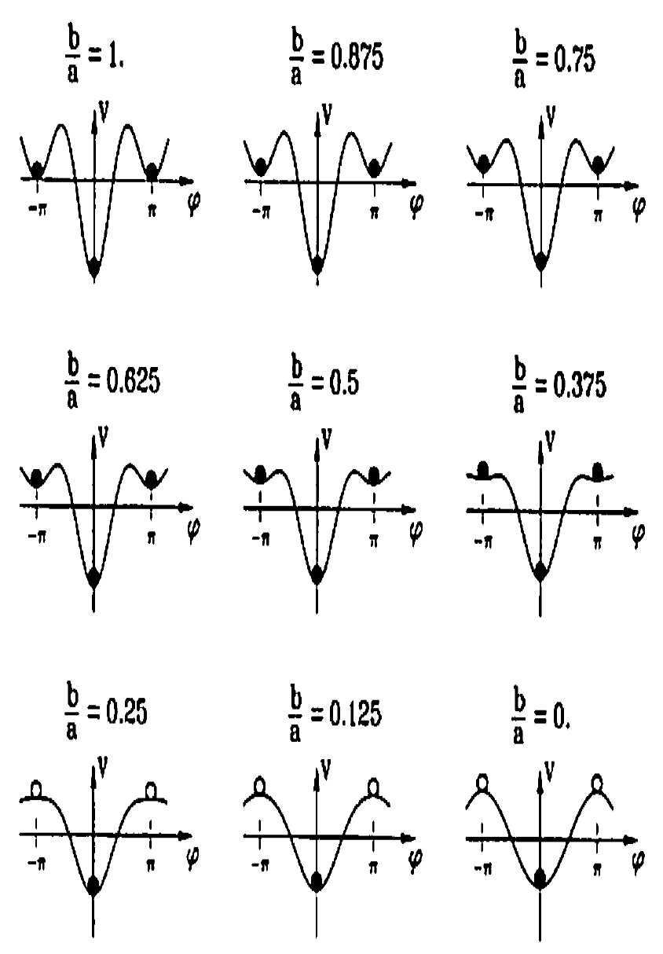

Figure 1
(taken from Kelso 1995, p. 55)

Solid black balls indicate stable attractors and open white balls indicate unstable repellers. At b/a > .25 the system has three stable states corresponding to the two kinds of anti-phase patterns and the in-phase pattern. At a critical value of b/a = .25 there is a phase transition to having only one stable state, which is the in-phase pattern. Why would a gradual increase in frequency of snapping lead to a sudden change in the kinds of stable patterns that one is able to snap? The key to the model is the parameter that measures relative phase. It is what Kelso calls a collective variable, or order parameter, because it measures the cooperative macro-level behavior of the system. Kelso insists that “to understand coordinated behaviors as self-organized, new quantities have to be introduced beyond the ones typical of the individual components.” (1995, 52) When the snapping oscillators are coupled, they constitute a new cooperative system. No account of the behavior can be given at the level of single snapping fingers. You need to introduce a new adjustable parameter in order to understand how and why the coupled system behaves as it does. The model also makes two novel predictions of expected phenomena, critical fluctuations and critical slowing down, not previously recognized, but since confirmed (ibid., 71).
The most interesting feature of the HKB model is the breadth of phenomena that can be understood using the model. Finger snaps are an arbitrarily chosen example of the types of bimanual coordination that the equation models. Among the other factors that have been experimentally demonstrated to break the symmetry of HKB are handedness/ hemispheric asymmetry (Treffner and Peter 2002), mutilimb coordination (Mechsner et. al. 2001), attentional allocation, and speech-hand coordination (Treffner and Peter 2002).
We can now return to the questions that motivated this discussion:
1) Is there a suitably related family of properties that corresponds to self-organizing complex systems such that they are grouped under a natural property?
2) Is there reason to think that such properties figure into causes and can be cited in causal explanations?
3) If so, does this natural property ground the distinction between systemic process that are ones of emergence and ones that are not?
I suggest an affirmative answer to the first two questions. The HKB model’s broad applicability implies that it describes systemic processes that share united features. This is why the model applies to a wide variety of psychological and biomechanical phenomena in humans and non-human animals. Other complex oscillatory models, such as the van der Pol model that accounts for limit cycle behavior in both neural polarization and electrical circuits employing vacuum tubes, are similarly interesting because of their interdisciplinary applications. Likewise, these models give us the kinds of change-relating invariant generalizations that indicate systemic processes with causal powers. In particular, the need to introduce order parameters to describe them signals that there is a unique feature of these kinds of self-organizing complex systems that unites them into a kind that has scientific significance. My answer to the third question is affirmative as well, but to properly address it I first need to do some conceptual housekeeping.

5. Conclusion.
Systems that conform to the HKB model resemble each other in a way that is appropriate to being grouped under a natural kind. But the HKB conforming systems are only one type of system that exhibits non-liner phase transitions. Some (e.g. limit cycles) go from having two stable states to having one stable state. Others (e.g. Rayleigh-Benard convection) go from one stable state to two or more possible stable states. These kinds of systems tend to teeter on the edge of chaos until something pushes them over into complete disorder; they achieve their greatest level of complexity just before they lose structure altogether. Phase transitions, I suggest, characterize only one kind of dynamical process united under the property of emergence. What then characterizes emergence and determines whether or not being a process of emergence counts as a natural property? For all that I have argued so far, emergence might characterize a gerrymandered set of properties that are themselves natural, but not constitutive of a natural family of properties.
Various definitions and desiderata for emergence have been offered in both the scientific and philosophical literature (Wimsatt 2007, Humphreys 2008, Bedau 1997 and 2002, Holland 1998, Ryan 2007). Reuger (2002) intimates a notion of emergence that fits well with the observations made in this essay.
Suppose that the system's dynamics is characterized by an equation of motion with a control parameter p. If the phase space portrait stays qualitatively the same under perturbations of the dynamics, i.e., small variations in the value of p, the system is structurally stable. If the perturbation generates a qualitatively different portrait of trajectories, the system is structurally unstable. (Rueger 2000, 472-473)
The property of being unstable, in this sense, should be defined as counterfactual supporting. A systemic process exhibits instability if it has an order parameter that would create a drastic change in response to certain slight variations in a control parameter. We see this in the bimanual coordination cases. For example, slight variations in the rate of snapping lead quickly to rapid changes in the kind of coordination exhibited. When a system acquires a collective level property that is only described by a novel order parameter, then it increases in complexity; this is so whether or not the phase transition ever actually occurs.
My conceptual housekeeping is now complete and I can offer a definition of emergence that reveals how emergence constitutes a category that unites various resembling processes under the property of having instability.
Def.1 A systemic process S exhibits instability iff there are small changes in the value of S’s control parameter(s) that would lead to drastic changes in the value of S’s order parameter(s).
Def.2 A systemic process S is a process of emergence iff S at time t does not exhibit instability I and at some later time t* S begins to exhibit instability I.
There is one thing to note about this definition, it does not imply that losing an instability is a process of emergence. When systems plunge into chaos that is not emergence because it constitutes a loss of complexity. Despite the terminology, this account entails that falling into chaos entails a decrease of instability. The process of increasing in instability is an interesting property. I suggest that it is a good candidate for being a natural property because it unites instances of emergence under a genuine resemblance relation. Given that emergence is a natural property of the evolution of complex systems, and that having a natural property entails having causal powers, it may now reasonably be asked whether or not those causal powers are reducible. Whatever the answer to that question may be, both an adequate realism and an adequate nominalism about emergence should take account of its status as a natural property.

References
Batterman, Robert. 2002. Devil in the Details: Asymptotic Reasoning in Explanation, Reduction, and Emergence. Oxford: Oxford University Press.
Bedau, Mark. 1997. “Weak Emergence.” In Philosophical Perspectives: Mind, Causation, and World, vol. 11, ed. James Tomberlin, 375-399. Oxford: Oxford University Press.
__________. 2002. “Downward Causation and Autonomy in Weak Emergence.” Principia 6: 5-50.
Chemero, Anthony. 2009. Radical Embodied Cognitive Science. Cambridge, Mass.: MIT Press.
Haken, Hermann. 1983. Synergetics: An Introduction. Berlin, Germany: Springer.
Holland, John. 1998. Emergence: From Chaos to Order. Oxford: Oxford University Press.
Humphreys, Paul. 2008. “How Properties Emerge.” In Emergence: Contemporary Reader in Philosophy of Science, eds. M. Bedau and P. Humphreys, 111-126. Cambridage, Mass.: MIT Press.
________. 2008. “Synchronic and Diachronic Emergence.” Minds and Machines 18: 584-594.
Jaegwon, Kim. 2000. Mind In a Physical World: Essays on the Mind-Body Problem and Mental Causation. Cambridge, Mass.: MIT Press.
__________. 1999. “Making Sense of Emergence.” Philosophical Studies 95: 3-36.
__________. 2006. “Emergence: Core Ideas and Issues.” Synthese 151: 547-559.
__________. 2009. “Supervenient and Yet Not Deducible: Is There a Coherent Concept of Ontological Emergence?” In Reduction: Between the Mind and the Brain, eds. Alexander Hicke and Hannes Leitgeb. London: Ontos Verlag.
__________. 2010. “The Layered Model of the World.” Essays in the Metaphysics of Mind. Oxford: Oxford University Press.

Kelso, J.A. Scott. 1995. Dynamic Patterns: The Self-Organization of Brain and Behavior. Cambridge, Mass.: MIT Press.
Lewis, David. 1983. “New Work For a Theory of Universals.” Australasian Journal of Philosophy 61: 343-377.
________. 1986. On the Plurality of Worlds. Oxford: Blackwell.
Mechsner, Franz, David Kerzel, Günther Knoblich, and Wolfgang Prinz. 2001. “Perceptual Basis of Bimanual Coordination.” Nature 413: 69-73.
Pereboom, Derk. 2001. Consciousness and the Prospects of Physicalism. Oxford: Oxford University Press.
Reuger, Alexander. 2001. “Robust Supervenience and Emergence.” Philosophy of Science 67: 466-491.
___________. 2001. “Physical Emergence, Diachronic and Synchronic.” Synthese 124: 297-322.
Ryan, Alex. 2007. “Emergence is Coupled to Scope, Not Level.” Complexity 13: 67-77.

Shoemaker, Sidney. 2001. “Realization and Mental Causation.” In Physicalism and its Discontents, eds. Carl Gillett and Barry Loewer, 74-98. Cambridge: Cambridge University Press, .

Treffner, P. and M. Peter. 2003. “Intentional and Attentional Dynamics of Speech-hand Coordination.” Human Movement Science 22: 641-697.

Wimsatt, William. 2007. Re-Engineering Philosophy for Limited Beings: Piecewise Approximations to Reality. Harvard University Press.

Woodward, James. 2003. Making Things Happen: a Theory of Causal Explanation. New York: Oxford University Press.

As Woodward (2003) argues, it is more likely that causes are defined by change-relating invariances, which may come in degrees of invariance.

