What's Wrong with Science and Technology Studies? What Needs to Be Done to Put It Right?

Nicholas Maxwell

Published in Pisano R., ed., A Bridge between Conceptual Frameworks: Sciences, Society and Technology Studies, Springer, Dordrecht, 2015, pp. vii-xxxvii.
http://discovery.ucl.ac.uk/1400296/
Abstract
After a sketch of the optimism and high aspirations of History and Philosophy of Science when I first joined the field in the mid 1960s, I go on to describe the disastrous impact of "the strong programme" and social constructivism in history and sociology of science. Despite Alan Sokal's brilliant spoof article, and the "science wars" that flared up partly as a result, the whole field of Science and Technology Studies (STS) is still adversely affected by social constructivist ideas. I then go on to spell out how in my view STS ought to develop. It is, to begin with, vitally important to recognize the profoundly problematic character of the aims of science. There are substantial, influential and highly problematic metaphysical, value and political assumptions built into these aims. Once this is appreciated, it becomes clear that we need a new kind of science which subjects problematic aims - problematic assumptions inherent in these aims - to sustained imaginative and critical scrutiny as an integral part of science itself. This needs to be done in an attempt to improve the aims and methods of science as science proceeds. The upshot is that science, STS, and the relationship between the two, are all transformed. STS becomes an integral part of science itself. And becomes a part of an urgently needed campaign to transform universities so that they become devoted to helping humanity create a wiser world.

1. High Aspirations of History and Philosophy of Science in the 1960s
I came to Science and Technological Studies (STS) by means of a rather circuitous route, via a passionate, childhood desire to understand the nature of the universe which, after reading Eddington, transformed into an obsession with mathematics which in turn, when adolescence struck, transformed into a desire to understand people via the novel - all of which I failed at dismally. I then took up the study of philosophy in the early 60s at Manchester University. As a part of the undergraduate course, I was introduced to Oxford philosophy, which appalled me. It struck me as a species of anti-philosophy. I concentrated on philosophy of science. Philosophy might not matter, but clearly science does. Then, in the Summer of 1961 I had a revelation: philosophy ought to be, not about the meaning of words, but about how to live! The profound mystery is not even "What is the ultimate nature of the universe?" but rather "What is ultimately of value in life and how is it to be realized?" The problem with academic philosophy is that it is produced by academic philosophers who have already decided how to live, and have thereby lost all interest in real philosophy, which concerns what to do with our agonizingly brief time alive. I decided to do an MA at Manchester, say what needed to be said, and then escape from the madhouse of academic philosophy.
And then I discovered the works of Karl Popper, and I became an occasional student at the LSE. Attending Popper's seminars, I was both immensely impressed and somewhat alarmed. Here at last was a philosopher passionately concerned with profound, real problems of the real world which he tackled with fierce intellectual integrity and great originality. There was first his transformation of science - or at least his transformation of our conception of science. Laws and theories cannot be verified in science, but they can be empirically falsified, and that is how science makes progress. As a result of subjecting theories to fierce sustained attempted empirical refutation, we eventually discover where they go wrong, and are thus provoked into thinking up theories which do even better, until they are in turn refuted. Scientific knowledge is simply made up of our best, boldest imaginative guesses that have survived all our most ruthless attempts at empirical refutation.
Then there was his generalization of this falsificationist conception of science to form a radically new conception of rationality. To be rational is to be critical. Just as science makes progress through subjecting our best conjectures to fierce attempted falsification, so more generally, in all areas of human life, we can best hope to make progress by subjecting our best attempts at solving our problems to fierce criticism. Empirical testing in science is just an especially severe form of criticism.
The entire tradition of western philosophy had got it wrong. Scepticism is not the enemy to be vanquished - or to be indulged until it can go no further, thus revealing a bedrock of certainty, as with Descartes, and many empiricists. Quite the contrary, scepticism is our friend, the very soul of reason. It is by means of imagination subjected to sustained, ferocious scepticism that we can learn, and make progress. Science is institutionalized scepticism.
What impressed me most, however, was the application of these ideas to the profound problem of creating civilization or, as Popper called it, "the open society". Rationality is the critical attitude. But this is only really possible in an "open" society, a society, that is, which tolerates a diversity of views, values and ways of life. In a "closed" society, in which there is just one view of things, one set of values, one way of life, there can be no possibility of criticism, since to criticize A we need, at least as a possibility, some alternative view B. Thus the rational society is the open society - not a society enslaved to some monolithic, dictatorial notion of "reason", but simply a liberal society that tolerates and sustains diversity of views, values and ways of life, and can, as a result, learn, make progress, and even create and pursue science.
But the move from the closed to the open society has a severe penalty associated with it. We move from certainty to doubt. Living in the open society requires that we shoulder the adult responsibility of living in a state of uncertainty, of doubt. Everything we believe, everything we hold most dear, and value - the very meaning and value of our whole way of life - may be wrong or misconceived. Doubt is the price we pay for civilization, for reason, for humanity, and for science. In his masterpiece The Open Society and Its Enemies, Popper calls this essential doubt "the strain of civilization", and he points out that all too many people cannot bear it, and seek to return to the false certainties of the closed society. Even some of our greatest thinkers have sought to do this, and they are the enemies of the open society - above all, for Popper, Plato and Marx.
I breathed a great sigh of relief. Popper had, it seemed, solved the problems that had so tormented me. The anguish of the 20th century - the nightmare of not knowing how to live with only a few measly decades available to try to find out - had been explicated as being due to our new exposure to global society and to history: exposure to a multitude of contradictory beliefs, values and ways of life which, inevitably, had the effect of throwing into doubt the validity of one's own entire way of life and set of values.
Popper demonstrated, it seemed to me, that it was possible to be an academic philosopher and yet retain one's intellectual integrity. I moved down to London and got a job as lecturer in philosophy of science in the Department of History of Philosophy of Science at University College London. Larry Laudan and Paul Feyerabend were among my departmental colleagues.
It was an exciting time and place to be doing history and philosophy of science (HPS). London felt like the HPS capital of the world. HPS seemed to be a fledgling academic discipline, having associated with it all the excitement, freshness, high aspirations and optimism of a new discipline. There was the idea that each wing needed the other: history of science would be blind without philosophy of science, which in turn would be empty without history of science. Natural science seemed to be the one great human endeavour that undeniably made progress across generations and centuries. Aside from mathematics, in no other sphere of human endeavour did this happen - not in art, music, literature, politics, or morality. There was technological progress, certainly, and economic progress too, but these were closely linked to, and dependent on, scientific progress. It was the great task of HPS to work out how science did make progress, and what might be learned from scientific progress about how to make progress in other areas of human life: art, literature, law, education, politics, economics, international relations, personal flourishing and fulfilment. Popper had shown the way. But he could hardly be the last word on the subject. Popper's philosophy needed to be applied to itself, and subjected to sustained critical scrutiny in an attempt to improve on it. And there were plenty of contending ideas around. There was Thomas Kuhn's The Structure of Scientific Revolutions, which in part agreed with Popper in stressing the existence and likelihood of scientific revolutions, but also violently disagreed with Popper in holding that the dogmatic puzzle solving of normal science was an essential and desirable aspect of science as well. Popper, outraged, called normal science "a danger to science and, indeed, to our civilization" (which makes perfect sense, of course, given his viewpoint). Then there was Imre Lakatos's attempted resolution of Popper and Kuhn in his "Methodology of Scientific Research Programmes" which acknowledged that research programmes have a "hard core" (Kuhn's "paradigm" under another name), and legitimately get pursued with a degree of dogmatism. And there was Paul Feyerabend, who went one further than Popper, and argued, in effect, that the plurality of views of the open society would need to be imported into science itself. Severe testing - essential, according to Popper, for empirical scrutiny of theories - requires at least the germ of an alternative theoretical idea. We need actively to develop alternative theories simply to be in a position to test severely the reigning, accepted theory - almost exactly the opposite of what goes on, according to Kuhn, during a period of normal science.

2. Beginnings of the Decline of HPS
I am now going to tell the tale of the sad decline of HPS into confusion, irrationality and irrelevance. But before I do so, I want to stress that good work has been done and continues to be done in both history and philosophy of science despite the fashionable stupidities of both disciplines. My complaint is that those who study science and technology - philosophers, historians, sociologists and others - could have done so much better during the period under consideration, the mid 1960s up to 2013. Much energy has been expended on idiotic disputes and urgent and fundamental problems, of great importance for science, and for humanity, have been ignored. HPS lost its way.
There are, on the one hand, those sociologists and historians of science - and a few philosophers - who stress the importance of attending to the social dimension of science but, disastrously, abandon such ideas as that science makes progress, acquires authentic knowledge about the world, improves knowledge of fact and truth, and embodies rationality, and puts progress-achieving methods into scientific practice. On the other hand there are some scientists, and some philosophers and historians of science who defend orthodox conceptions of science against these sociological, anti-rationalist attacks. I must make it very clear, at the outset, that I am critical of both wings of this dispute. The dispute itself - the "science wars" as the dispute came to be called - is the wrong argument to engage in. It is a symptom of the decline in the high aspirations of HPS in the 1960s. It is a distraction from what really needs to be done: to get the scientific community to acknowledge the real, and highly problematic aims of science which have, inherent in them, highly problematic assumptions concerning metaphysics, values and politics. It is here that really dramatic and enormously fruitful developments are to be made - as I shall try to indicate towards the end of this essay. If those who study science had combined with sympathetic scientists to create greater honesty about the problematic aims of science among the scientific community, we might have today a different kind of science, more intellectually rigorous and of greater human value. We might even have a different kind of academic inquiry, rationally devoted to helping humanity create a wiser world. We might even have a different, wiser world - as I will try to explain in what follows. But first I must tell the sad story of decline.
Somewhat arbitrarily, we may begin with a dreadful blunder made by Feyerabend. On Popper's behalf, he assailed the logical empiricists, Hempel, Carnap and Nagel, for holding that meaning had to be transported up from evidence to theory. No, Feyerabend argued, that was not possible, for observational terms are "theory laden", so that conflicting theories would have conflicting, or at any rate different, observation terms, conflicting or different accounts of observational phenomena. There can be no such thing, Feyerabend argued, as a stable observational language independent of theory (an argument to be found in Kuhn as well). But logical empiricism depends utterly on there being just such a theory-independent observation language. The whole position takes it for granted. Its non-existence destroys logical empiricism completely. Its foundations do not exist! So far, so so good. But then Feyerabend made an idiotic mistake. If meaning cannot be transported up, from observation to theory (because a theory independent observation language does not exist), then meaning must be transported down, from theory to observation terms. But this means in turn, Feyerabend argued, that conflicting theories, with different theoretical terms, must have different observational terms as well, which in turn means that the predictions of the conflicting theories cannot be compared. And so the very basis for Popper's philosophy of science - his falsificationism - collapses. Not just logical empiricism, but falsificationism too must be thrown on the rubbish dump of history. Scientists should follow their instincts, Feyerabend concludes. Anything goes. Methodological anarchy reigns supreme. There is no such thing as the rationality of science. It is irrational. And it is damaged when it attempts to conform to some misguided idea of rationality dreamed up by a philosopher of science.
Feyerabend had an absolutely disastrous influence. He became a sort of approved intellectual court jester. All those who deplored what they perhaps saw as the illegitimate mighty authority of science were entranced by Feyerabend's annihilation of science's claim to be rational and methodological, upon which its mighty authority rested. The emperor had no clothes. Feyerabend had stripped science bare. Or so it seemed to all too many.
HPS began to take an absolutely disastrous turn for the worse. The initial great ambitions and optimism of the fledgling discipline were lost sight of. HPS began to tear itself to pieces in an orgy of stupidity, like a political party thrown out of power, or a political movement with no hope of ever gaining power. It came in wave after wave of idiocy.
At about the same time as Feyerabend began to drum up support for relativism and unreason, a very different kind of disastrous stupidity was being incubated in Edinburgh. It was called "the strong programme", and its authors were Barry Barnes and David Bloor. They argued that science is social in character, and therefore needs to be studied by sociologists. This means, they held, that there is no such thing as scientific truth, knowledge, rationality or progress. There is just change of scientific belief, as science goes on its way. Traditionally it has been held that science is rational, its theories being established by evidence, science being entitled to claim it acquires genuine knowledge of factual truth, science thus progressively increasing and improving our knowledge and understanding of the universe. But all this has been shown to be untenable - by Kuhn, Feyerabend and others. Those philosophers of science who do, absurdly, still claim that science makes progress, is rational, and acquires genuine knowledge of factual truth, are unable to say how this is done. The problem of induction remains unsolved. Even Popper, who almost alone does claim to have solved the problem, has not really solved it. So science must be treated as social in character, purely social factors determining what is accepted and rejected in science - namely observational and experimental results, laws and theories. It is the sociologist of science, not the philosopher of science, who can improve knowledge about science, how it proceeds, and modifies its beliefs, its "scientific myths" one might say. Truth, fact, knowledge, scientific progress, method and reason all fly out of the window. These are fantasy ideas of old fashioned philosophy of science, illusory notions that have nothing to do with science as it really is, an integral part of society, social through and through.
At about the time "the strong programme" was being launched on the world, The British Society for the Philosophy of Science held its annual conference in Edinburgh, and naturally the Edinburgh school was given its chance to air its ideas. I remember thinking at the time that ideas as foolish as these would never get anywhere. How wrong I was. I also remember wondering why proponents of "the strong programme" had not bothered to read Popper, for in The Open Society and Its Enemies Popper anticipated and decisively dealt with and obviated the need for this sociological programme.
Popper makes the point that rationality - critical rationality, that is - is essentially social in character, in that criticism requires diversity of views (as we have seen) and so many people in communication to hold and discuss these diverse views. Furthermore, science is fundamentally social in character too, and owes its rationality, its scientific character, to its social character. Far from the social character of science somehow cancelling the scientific character of science, as proponents of "the strong programme" seemed to believe, it is all the other way round: the scientific character of science actually requires science to be inherently social.
Furthermore, what methods are implemented in scientific/social practice may well, quite obviously have an immense impact on whether science meets with success in improving knowledge about the world. Compare M_{1:} "accept theories that are empirically refuted, and reject theories that are empirically confirmed" with M₂: "accept the best explanatory theories that are empirically confirmed, and reject theories that are decisively refuted". We would all agree that a community of scientists that puts M₂ into social/scientific practice is more likely to meet with success and improve knowledge than one that puts M₁ into practice. It is, in short, utterly trivially obvious that what methods are implemented in social/scientific practice may well make a profound difference to the intellectual success or failure of science - its success in acquiring knowledge about the world.
What methods science puts into practice is a vital part of the whole social structure of science which the sociological study of science cannot possibly ignore if it is to be remotely adequate. Both Popper and Kuhn are very good, in their different ways, in pointing out that what matters are the methods that are implicit in scientific practice.
Construing science to be a social endeavour thus does not obviate the intellectual or rational character of science, and certainly does not do away with crucial questions about what methods science does, and ought to, adopt and implement. It does not mean that science does not acquire genuine factual knowledge, and make progress.
Furthermore, science in particular, and our social world more generally, is imbued with values, whether intellectual, moral, legal, or aesthetic, some better than others. It certainly ought to be a part of the professional job of academics to try to discriminate between good and bad intellectual values, and promote the former. Sociologists of science, like scientists themselves, philosophers of science and all other academics, ought to do what they can, in their professional work, to promote good intellectual values - ones having to do with rationality, validity, the successful pursuit of knowledge of fact and truth - at the very least.
"The Strong Programme" is a kind of acid which eats all these things away, and leaves science as a value-denuded, knowledge-denuded, truth and reason denuded, empty social practice. But all this arises from elementary and appalling misunderstandings about the nature of our social world in general, and that bit of it that is science, in particular - a refusal at the outset to see that values and standards, whether intellectual or humanitarian, are essential features of our social world. To exclude all values from the social world a priori, as it were, is to adopt something close to a psychopath's vision of things. Ironically, it probably comes from the unconscious adoption of a very crude philosophy science which says values have no place in science, and hence no place in sociology, or the sociology of science either. (I say "ironically" because, according to the proponents of "the strong programme", philosophy of science is a sort of irrelevant fantasy.)
It is as if proponents of "the strong programme" had convinced themselves of the correctness of the following argument.
1. Reason, validity, valid scientific methods, truth, fact, knowledge, scientific progress are all inherently purely intellectual.
2. The intellectual is not social (and no part of the social is intellectual).
3. But science is wholly and purely social.
4. Hence science is wholly free of the intellectual. It has nothing to do with reason, validity, valid scientific methods, truth, fact, knowledge, scientific progress.
The argument may be valid, but step 2 is false. The intellectual is wholly social in character. That makes step 4 false as well. As I have said, one cannot begin to do justice to the character of our social world if one refuses, at the outset, to acknowledge that the social is quite essentially imbued with values of all kinds, intellectual, moral, legal, aesthetic - imbued not just with values but with what is of value.

3. Social Constructivism and Anti-Whiggism
I have so far concentrated on the damage done to HPS by Feyerabend's methodological anarchism and the blunders of "the strong programme". But damage came from another source as well: French philosophy, Foucault, Derrida and others. The upshot was a whole new way of construing science, which may be called "social constructivism". This is the view indicated above that I have attributed to "the strong programme". Scientific knowledge is merely a social construct, having nothing to do with knowledge, truth and falsity, or reason. In studying science and its history, we must entirely forego the idea that science makes progress, and we must refrain from making intellectual or scientific judgements about one theory being "better", "truer", or "more firmly established" than another. In the main sociologists and historians took to social constructivism, while philosophers of science looked on in amazement and horror, at the idiocy of it. As a result, HPS broke asunder. The integrated enterprise, bringing together history and philosophy of science, which had started out with such high hopes and aspirations, and which was still alive and kicking when I began my academic career around 1965, was no more.
An even more devastating consequence, perhaps, of the widespread adoption of social constructivism among historians of science was that it annihilated the fundamental problem of the discipline. As I stressed at the beginning of this essay, science is almost unique among human endeavours in that it makes genuine progress. We know and understand vastly more about the universe, and ourselves as a part of the universe, than was known to Darwin, to Faraday, to Newton, or to Aristotle. The fundamental problem of HPS is: How has scientific progress come about? And for philosophy of science in particular: How is scientific progress possible? What methods have brought it about? What methods give the best hope of progress?
Social constructivism annihilates these fundamental problems. What ought to be the central problem of the history of science just disappears from view. This is perhaps the strongest indication of the intellectual poverty and destructive character of social constructivism.
Where did this idea that science does not make progress come from? In addition to the intellectual blunders that I have already indicated, it came from a blunder about history. The historian Herbert Butterfield wrote a little book against what he called "Whiggish history". This is history that takes for granted that progress, the spread of enlightenment, democracy and justice are inevitable, and it is the job of the historian to describe this process. An even cruder kind of Whiggish history would have built into it dogmatic assumptions about what does constitute progress, history being written as propaganda to help the process along, or fool the reader into believing that progress in this sense has occurred and is occurring when nothing of the kind is the case.
Whiggish history in these senses is intellectually disreputable. It is, however, utterly absurd to think that this means historians can't ever write histories of any human endeavour whatsoever that does in fact make progress towards some goal, or seeks to make progress towards some goal. That is, clearly, an absurd position to adopt. If there is a human endeavour that makes progress, or seeks to make progress, then it must be possible to write intellectually decent histories of it. It may be very important to do this. Establishing the a priori dogma that any such history must be Whiggish - that is, based on the assumption that progress is inevitable or, worse, mere propaganda on behalf of the endeavour - just ensures that no intellectually decent history of any progress-achieving endeavour will be written, an appalling impoverishment of what history should be.
Science is one of those rare human endeavours that does make progress across generations and centuries. It is vitally important that good, intellectually responsible histories of this progress-achieving endeavour of science are written. How is this to be done so as to avoid Whiggishness? There are a few very obvious points to make.
1. Do not assume progress is inevitable.
2. Do not write propaganda on behalf of science and scientific progress. Praise where praise is deserved, and criticize where criticisms need to be made. Do not conceal deplorable incidents - faking of results, plagiarism, petty disputes about priorities, immoral or criminal behaviour of scientists. Explore controversial issues about science and politics, science and war, science and the arms industry, science funding,
3. Do not just write about scientific success. In order to understand how and why scientific progress occurs it is absolutely essential to take into account the blind alleys, the research projects that led nowhere, the false leads, the ideas that turned out to be unproductive.
4. Do not hesitate to make judgements about how good or bad a piece of scientific research was. Do not assume, however, that scientific work is good if it turns out to be true, successful, or productive, and bad if it turns out to be false, unsuccessful or unproductive. Do not judge the intellectual merit of scientific work purely in terms of the contribution it ultimately makes to scientific progress. Brilliant scientific work may lead nowhere, and contributions that turn out subsequently to be important may come out of shoddy work, even out of mistakes.
5. In writing about past scientific episodes, try to see things from the actors' points of view so as to understand their problems, aims, ideas, theories, prejudices, standards, methods, as they saw them and experienced them. Seek to assess scientific work and contributions in terms of the standard prevalent at the time. But do not shrink from assessing the merit and significance of past work from the standpoint of the best standards and ideals available to us today, in an attempt to assess the significance of past contributions to overall scientific progress - where it is relevant to do this. Do not shrink from criticizing past work from the standpoint of our best current intellectual standards, should it be relevant to do this.
6. Keep in mind that what constitutes progress depends on what aim is presupposed. There are a range of aims that may be assigned to science, all more or less problematic (see below). Whether science as a whole, or a particular science, makes progress or not during a specific period may depend crucially on what aim for science is presupposed. Consider, for example, the aim of science of "improving human knowledge". This may be interpreted as (1) improving knowledge of scientific experts, or (2) improving knowledge of humanity as a whole. A science might make splendid progress given aim (1), but very little progress or none at all given aim (2).
7. Take into account that, in so far as scientific knowledge is conjectural in character, judgements about scientific progress will be conjectural too. Thus the historian's judgements as to whether scientific progress has taken place, what it consists in, and how it was achieved, will be conjectural as well, and may be falsified or at least modified as current scientific knowledge is modified. This is of course more likely to happen to history of recent scientific developments than it is to history of scientific developments a century or so ago.
8. Far from it being assumed at the outset by a history of a progress-seeking endeavour, whether scientific or not, that progress occurs (let alone is inevitable), such a history should be open-minded about the matter. Whether progress has been made, of what type, towards what goal, and of what mixture of advance and regression, are all questions open for historical research to discover. It might indeed emerge that no progress has been made, or that the opposite has happened, and the endeavour has regressed. (Perhaps this is the case as far as HPS itself is concerned.)
9. Make no a priori judgements about whether intellectual or (non-intellectual) social factors influenced some specific piece of scientific work. Much that scientists do is probably influenced by a complicated mixture of these factors. Thus the decision to work on a specific scientific problem may be influenced by (1) curiosity, (2) availability of funds, (3) the guess that the problem will be easily solved, and will thus enhance career prospects, (4) the hunch that it will turn out to be important to solve from the standpoint of social applications (medical, industrial, etc.), (5) a request from the scientist in charge of a scientific team, (6) the presence in the laboratory of relevant equipment. Are any of these considerations wholly "intellectual" or wholly "social"?
10. Science is a human endeavour different for the historian from other, non-intellectual endeavours - even endeavours that also make progress. In the case of science, what the historian studies, and the discipline of history itself, have some common goals: to improve human knowledge and understanding. This means that in the particular case of science, it may well be legitimate for the historian to write history which seeks to help promote the very thing he is writing about. The historian of science may quite legitimately seek to highlight neglected work from the past that may, if better known, have important implications for the future of the science in question. This kind of science-promoting history can be done in a thoroughly intellectually responsible way even though, if done about other kinds of endeavour, it might well amount to no more than a kind of propaganda for the endeavour in question. Serious history of science of this kind should not, however, degenerate into the simplified, distorted, potted history that scientists tell their students for pedagogic purposes. The all-important point, furthermore, is that history of science does not have to be science-promoting, in this way, as the above points, 1 to 9, indicate.
As long as these and similar strictures are kept in mind and observed, there is no reason whatsoever why histories of science that depict science as making progress should not be done that meet the highest standards of intellectual excellence, there being not the faintest whiff of Whiggishness in any of the bad senses.
It is quite extraordinary that so many historians of science have been unable for decades to draw the distinction between "Whiggish history" in the bad senses, and "history of some endeavour that makes progress" that is intellectually responsible and excellent. It is all the more extraordinary, when one considers that the failure to draw this obvious distinction has meant that, for these historians, the fundamental problem of the history of science, "How and why has scientific progress come about?" has died, and disappeared entirely from view. It is as if cosmologists managed to reach the conviction that there is no such thing as the cosmos, or biologists convinced themselves that there is no such thing as life on earth. Intellectual history is turned into mere social gossip.
I encountered the consequences of these elementary intellectual blunders in my professional life as a lecturer in philosophy of science in the Department of History and Philosophy of Science at University College London. We taught a joint MSc Programme with the Wellcome Institute, with Bill Bynum, Chris Lawrence and Mike Neve - these latter all firmly committed to social constructivism in the history of medicine. Students were baffled. At the Wellcome Institute they learnt there is no such thing as scientific progress, rationality, truth or knowledge. In my lectures they heard that there is a fundamental problem concerning the rationality of science - a big, serious, unsolved problem about how it is that science acquires knowledge of truth and makes progress. How to choose between holding that truth, knowledge, progress and reason are of fundamental importance, and holding that there are no such things at all? In the end most shut their eyes and made a Kierkegaardian leap of faith into one or other position. I pleaded with Bynum, Lawrence and Neve to hold a seminar with me and the students to discuss these issues. They refused. One year I did persuade one historian, Rob Iliffe, to take part in such a discussion of the issues, but only if it was informal, after hours as it were, and with beer to drink. He pointed out how bad it is just to assume dogmatically that science makes progress when there is much to criticize in modern science. I replied that if rationality is abandoned, the very possibility of being critical of modern science is abandoned too, for criticism presupposes and requires rationality. Iliffe had no answer. In the end he was reduced to arguing that he had to go along with social constructivism in order to get an academic job as a historian of science.
One bizarre feature of social constructivism is that its proponents are often left wing and highly critical of aspects of modern science. But of course as a result of abandoning rationality, the very possibility of criticism disappears. My attempts to point this out to proponents of "anti-Whiggism" over the years invariably fell upon deaf ears.
Sometime in the 1970's and 1980's a new branch of HPS emerged which came to be called Science and Technology Studies (STS). This emerged out of the sociology of science, out of a concern to give far great emphasis to technology and the technological sciences, and out of a concern to tackle issues associated with science and society - the impact of science on society, and vice versa. From the outset, much of the potential inherent in STS has however been subverted by the influence of ideas stemming from "the strong programme", social constructivism, "anti-Whiggism", and anti-rationalism.
There has been a tendency too for Philosophy of Science to degenerate into a kind of scholasticism in that it has splintered into a multitude of specialized disciplines: philosophies of the specialized sciences - physics, chemistry, neuroscience, astronomy, botany, and so on. As a result, Philosophy of Science has rather lost sight of the magnificent endeavour of natural science as a whole, and has come to ignore the great, fundamental problems that were, initially, the whole raison d'être for its existence: the problem of induction, the problem of the rationality of science, the problem of how, by what means, science makes progress.

4. Alan Sokal's Hoax and The Science Wars
In 1996 the worst excesses of the social constructivists and anti-rationalists were brilliantly satirized by a spoof article by Alan Sokal called "Transgressing the Boundaries; Toward a Transformative Hermeneutics of Quantum Gravity". This was published in an American academic journal called Social Texts, the editors of which took the paper to be a serious academic contribution. Actually, it was a tissue of hilarious nonsense decked out with liberal quotations from the constructivists - although Sokal admitted subsequently that, despite considerable effort, he did not always succeed in the article in attaining the dense obscurity of what he satirized. One of the editors was interviewed on the BBC, on the Today Programme, and made the dreadful mistake of protesting at the immorality of Sokal's hoax, instead of laughing and admitting that they had been had.
Around this time, and partly in response to Sokal's hoax, the "science wars" exploded onto the scene, some scientists and philosophers of science springing to the defence of science against the corrosive acid of social constructivism, anti-rationalism and postmodernism. Paul Gross and Norman Levitt wrote a book assailing the worst excesses of postmodernist writing about science, and subsequently edited a book that continued the argument. Alan Sokal and Jean Bricmont outraged French intellectuals with devastating criticisms of French philosophers' writings about science: Jacques Lacan, Luce Irigaray, Bruno Latour, Gilles Deleuze and others. Noretta Koertge edited A House Built on Sand: Exposing Postmodernist Myths About Science. Others joined the affray. Social constructivists protested that distinctions were being ignored, contexts overlooked.
Did this counter attack on behalf of orthodox conceptions of science win the day, and rid STS of anti-rationalist views? No. They continued to be influential, but in perhaps a slightly muted way. Here is just one fairly recent example of this influence, and how damaging it can be.
In 2009 a young practitioner of STS, Sergio Sismondo, gave a good lecture on the scandal of medical "ghost writing" in my very Department of STS at UCL. "Ghost writing" is the process whereby a drug company writes a paper specifically designed to be published in a particular medical journal, in terms of such spurious features as layout, references, etc. The paper praises a new drug the firm has produced, and then gets an academic who is an acknowledged authority in the field to author the paper, even though he or she has not seen data from trials, in particular data about harmful side effects. The paper is duly published, and what is essentially an advertisement is treated by GPs and other researchers as if it is a genuine contribution to scientific knowledge.
When the talk was over, I made the point, dressed up as a question, that such a contribution could not be regarded as an authentic contribution to knowledge. The deception might well lead to deaths - as happened in connection with Vioxx. No, Sismondo responded, such a paper did constitute a contribution to scientific knowledge because it had satisfied all the criteria for publication of the journal in question - and there could be no question about some of these criteria being epistemologically irrelevant. Social constructivist habits of thought had rendered Sismondo incapable of acknowledging the full extent of the scandal, even the criminality, his talk was about.
Social constructivists and their sympathizers are absolutely right to stress the vital importance of taking social aspects of science and technological research into account. The way this has been done, however, has been an intellectual disaster. It has helped sabotage urgently needed developments in thinking about science which would have brought together scientific and social thinking in sensible, rational and fruitful ways, as I shall try to show in a moment. The point that there is no agreed solution to the problem of induction, the problem of the rationality of science, is absolutely correct. The solution is, however, waiting in the wings to be taken note of. And this solution leads on to a profound transformation in the way we think about the aims of science, science itself, and academic inquiry as a whole, more generally.

5. Metaphysics, Values and Politics Inherent in the Aims of Science
Most scientists and philosophers of science take for granted one or other version of a view of science that I have called standard empiricism (SE). This holds that the basic intellectual aim of science is factual truth (nothing being presupposed about the truth), the basic method being to assess claims to knowledge impartially with respect to evidence. Considerations such as the simplicity, unity or explanatory character of a theory may influence what theory is accepted, but not in such a way that the universe or the phenomena are permanently assumed to be simple, unified or comprehensible. According to SE, what theory is accepted may even be influenced for a time in science by some paradigm or metaphysical "hard core" in the kind of way depicted by Kuhn and Lakatos as long as, in the end, empirical success and failure are the decisive factors in determining what theories are accepted and rejected. The decisive tenet of SE is that no substantial thesis about the nature of the universe can be accepted as a permanent part of scientific knowledge independently of empirical considerations (let alone in violation of empirical considerations).
Even those who - like Feyerabend, social constructivists and postmodernists - reject the whole idea that science is rational, delivers authentic knowledge, and makes progress, nevertheless tend, in a way, to uphold some version of SE as the only possible rationalist conception of science. No rational account of science is possible, they hold in effect, because the only candidate, SE, is untenable (as shown by the failure of SE to solve the problem of induction).
Despite being almost universally taken for granted by scientists, SE is nevertheless untenable. SE very seriously misrepresents the aims of science. The intellectual aim of science is not to improve knowledge of factual truth, nothing being presupposed about the truth. On the contrary, science cannot proceed without making a very substantial and highly problematic metaphysical hypothesis about the nature of the universe: it is such that some kind of unified pattern of physical law governs all natural phenomena. Science seeks, not truth per se, but rather explanatory truth - truth presupposed to be explanatory. More generally, science seeks valuable truth - truth that is of intrinsic interest in some way or useful. This aim is, if anything, even more problematic. And science seeks knowledge of valuable truth so that it can used in social life, ideally so as to enhance the quality of human life. There are, in other words, problematic humanitarian or political assumptions inherent in the aims of science. In holding that the basic intellectual aim of science is truth per se, the orthodox position of SE misrepresents the real and highly problematic aims of science.
The vital task that needs to be done to develop STS in fruitful directions - a task not performed because of the influential absurdities of "the strong programme", social constructivism and the science wars debate - is to give absolute priority to two fundamental questions: What are the real aims of science? What ought they to be? Ever since around 1970, when I began to consider these questions, those associated with HPS and STS ought to have put these two questions at the heart of science studies. If this had been done, science studies, in conjunction with sympathetic scientists, science journalists and others, might have helped develop a conception of science, and even a kind of science, both more rigorous and of greater human value than what we have today. Indeed, a new kind of academic inquiry might have emerged that is rationally devoted to helping humanity make social progress towards as good a world as possible. We might even have begun to see the beginning of a new kind world capable of tackling its immense global problems in increasingly effective and cooperatively rational ways. None of this has come about because the academic disciplines most directly responsible for helping to initiate these developments, HPS and STS, have been distracted by intellectual stupidities.
The key step that needs to be taken to permit these urgently needed intellectual, institutional and humanitarian developments to unfold is the widespread recognition that standard empiricism (SE) is indeed untenable, and needs to be replaced by something better. So, let us see why SE is untenable.
As it happens, reasons for rejecting SE have been spelled out in the literature again and again, ever since 1974. But these refutations of SE have been ignored. In outline, the refutation goes like this.
Theoretical physics persistently only ever accepts unified theories - theories that attribute the same dynamical laws to the phenomena to which the theory applies. Given any such accepted theory - Newtonian theory, classical electrodynamics, quantum theory, general relativity, quantum electrodynamics, or the standard model - endlessly many disunified rivals can be easily concocted to fit the available phenomena even better that the accepted unified theory. These disunified rivals that postulate different laws for different phenomena in a "patchwork quilt" fashion, are (quite properly) never taken seriously for a moment despite being empirically more successful. This persistent acceptance of unified theories in physics even though endlessly many empirically more successful, patchwork quilt rivals can readily be formulated means that physics makes a persistent assumption about the universe: it is such that all seriously disunified theories are false. The universe is such that some kind of underlying unified pattern of physical law runs through all phenomena.
If physicists only ever accepted theories that postulate atoms even though empirically more successful rival theories are available that postulate other entities such as fields, it would surely be quite clear: physicists implicitly assume that the universe is such that all theories that postulate entities other than atoms are false. Just the same holds in connection with unified theories. That physicists only ever accept unified theories even though endlessly many empirically more successful, disunified rival theories are available means that physics implicitly assumes that the universe is such that all such disunified theories are false.
In accepting the unified theories that it does accept - Newtonian theory, classical electrodynamics and the rest - physics thereby adopts a big, highly problematic metaphysical hypothesis, H, about the nature of the universe: it is such that all rival, grossly disunified, "patchwork quilt" but empirically more successful theories are false.

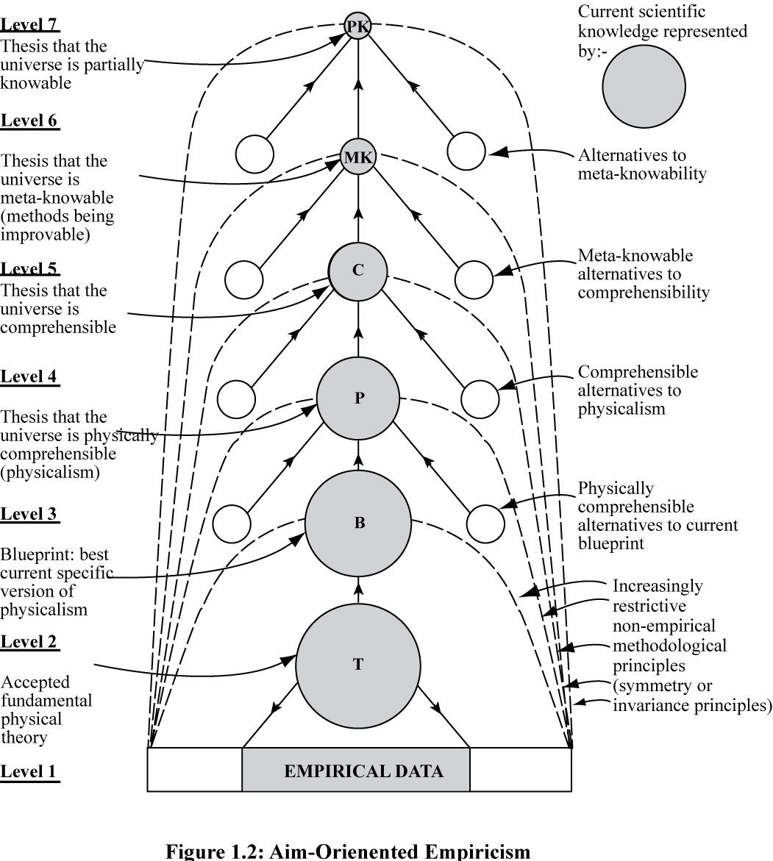
Figure 1: Aim-Oriented Empiricism (AOE)
H, though a metaphysical hypothesis, is nevertheless a permanent, even if generally unacknowledged, item of theoretical knowledge. Theories that clash with it, even though empirically more successful than accepted physical theories, are rejected - or rather, are not even considered for acceptance. Whenever a fundamental physical theory is accepted, endlessly many empirically more successful rivals, easily formulated, are not even considered just because, in effect, they clash with H. Thus H is a permanent item of theoretical knowledge in physics, more securely established in scientific practice indeed than any physical theory. Physical theories tend eventually to be shown to be false, but H persists through theoretical revolutions in physics.
Nevertheless, H is a hypothesis, a pure conjecture. How can we make sense of the idea that science is rational and delivers authentic knowledge if the whole enterprise depends crucially on accepting such an unsupported hypothesis as a secure item of scientific knowledge - a hypothesis that exercises a major influence over what theories are accepted and rejected in physics?

6. Aim-Oriented Empiricism
In order to answer this question, we need to adopt a conception of science that I have called aim-oriented empiricism (AOE). Precisely because H is a substantial assertion about the nature of the universe, an assertion that, though purely conjectural in character, nevertheless exercises a major influence over what theories are accepted and rejected, even to the extent of over-riding empirical considerations, it needs to be made explicit within physics so that it can be critically assessed, rival hypotheses if possible being developed and assessed, in the hope that H can be improved on. We need a new conception of science which represents the metaphysical hypotheses of physics in the form of a hierarchy of hypotheses, as one goes up the hierarchy hypotheses becoming less and less substantial, and more nearly such that their truth is required for science, or the pursuit of knowledge, to be possible at all. In this way we create a relatively unproblematic framework of hypotheses, and associated methodological rules, high up in the hierarchy, within which much more substantial and problematic hypotheses, and associated methodological rules, low down in the hierarchy, can be critically assessed and, we may hope, improved, in the light of the empirical success they lead to, and other considerations: see figure 1.
All this can be reformulated in terms of aims and methods. The aim of science is not truth per se, as SE holds. It is rather truth presupposed to be explanatory - or at least knowable. Precisely because this aim of science presupposes a problematic metaphysical hypothesis, the aim (or the hypothesis presupposed by the aim) needs to be represented in the form of a hierarchy of aims (or hypotheses) as indicated in figure 1, so that attempts to improve aims (or hypotheses) may receive the best possible help. As our scientific knowledge and understanding improve, so aims and methods improve as well. There is something like positive feedback between improving scientific knowledge and improving aims and methods - improving knowledge about how to improve knowledge. Science adapts itself to what it finds out about the universe. It is this positive feedback, this interaction between improving scientific knowledge on the one hand, and improving aims and methods (improving assumptions and methods) on the other, that helps explain the explosive growth of modern science. For all this has gone on in scientific practice despite scientists paying lip service to SE. Allegiance to SE has been sufficiently hypocritical to permit aim-oriented empiricism (AOE) to be put into scientific practice, to some extent at least. Allegiance to SE has nevertheless obstructed full implementation of AOE, and has had damaging consequences for science as a result.
There are now three key points to note about AOE.
1. It is not just theoretical physics that has a problematic aim because of problematic hypotheses inherent in the aim. This is true of most - perhaps all - scientific disciplines. Thus most, or perhaps all, scientific disciplines need to be understood in terms of diverse versions of the hierarchical, meta-methodological structure of AOE depicted in figure 1. The aims and methods of science change as we move from one science to another, and as we move within any given science from one time to another. The common factors are (a) something like the hierarchical, interacting structure depicted in figure 1; (b) the common endeavour to improve knowledge and understanding of the universe, and ourselves and other living things as a part of it. AOE provides a general solution to the problem of the nature of the progress-achieving methods of science.
2. AOE solves fundamental problems in the philosophy of science: in particular, the problem of induction (the problem of the rationality of science); the problem of verisimilitude; and the problem of what it means to say of a physical theory that it is unified.
3. AOE transforms the nature of science, the nature of philosophy of science, and the nature of the relationship between the two. And all this impacts on the nature of the history of science, the sociology of science, and STS. Traditionally, philosophy of science has been conceived of, and practised, as a meta discipline, studying science in the same way as astronomers study the moon or distant galaxies. This might make sense if science had a fixed aim and fixed methods, as SE holds science does. But AOE asserts that, because the basic aims of science are profoundly problematic, they evolve as scientific knowledge evolves, and change from one science to another. AOE demands that there is a two-way interaction between science itself, on the one hand, and its aims-and-methods, or philosophy, on the other hand. Metaphysics and the philosophy of science become vital ingredients of science itself, concerned to help science make progress. The nature of science, the philosophy of science, and the relationship between the two, all change dramatically.
Exploring probing questions about what the aims of science are, and ought to be, goes much further. For science seeks truth presupposed to be explanatory - explanatory truth as one might say - as a special case of the much more general aim of valuable truth - truth that is of intrinsic interest in some way, or of use. A science which increased our knowledge of irredeemably trivial, useless, utterly uninteresting truth would not be said to be making progress. Science both does, and ought to, seek truth that is of use or of value. Merely in order to be accepted for publication, a scientific paper must report a finding that meets some threshold of potential interest. Counting leaves on trees or pebbles on beaches does not, in itself, contribute to scientific knowledge even if the information is new and true.
But the aim of valuable truth is almost more problematic than that of explanatory truth. Of value to whom? And in what way? Is what science seeks to discover always of value to humanity, to those whose needs are the greatest? What of the links that science funding has with the military, corporations of one kind or another, and governments? Do the aims of science always respond to the curiosity and wonder of scientists, or sometimes to their career ambitions and vanity? Given that modern science is expensive, is there not always going to be an inherent conflict between the interests of those who pay for science - the wealthy and powerful - and those whose needs are the greatest - the poor and powerless?
If science is to pursue the problematic aim of valuable truth rationally, and in such a way that justice is done to the best interests of humanity, it is vital that science is pursued within the framework of a generalized version of AOE - humane AOE I have called it - so that three domains of discussion are recognized: (1) evidence; (2) theory; and (3) aims. The third domain of discussion, aims, is as important as the first two. At present it is "repressed"; it goes on in fund giving committees, and in private between scientists, but not openly in journals and conferences along with (1) and (2). Sustained exploration of the problematic aim of valuable truth needs to attempt to articulate (a) what we conjecture to be scientifically discoverable, and (b) what we conjecture it would be of value to discover, so that we may try to determine the all-important region of overlap between the two. The scientific community may have expertise when it comes to (a), but cannot have any exclusive expertise when it comes to (b). If science is to come to serve the best interests of humanity, it is vital that scientists and non-scientists alike cooperate in engaging in sustained imaginative and critical exploration of what it would be of most value for science to attempt to discover - what ought to be the aims and priorities of scientific and technological research. The institutional/intellectual structure of science needs to be changed to facilitate such aim-exploration. Journals and conferences need to be set up. Science journalism needs to contribute. SE, in misrepresenting the aim of science to be truth per se, in effect "represses" the real, problematic aim of valuable truth, and thus damages science by inhibiting the kind of sustained, cooperative exploration of actual and possible valuable aims science does, and might, pursue.
It is important to appreciate that all this comes within the province of philosophy of science which is centrally concerned with problems about the aims and methods of science. Philosophy of science, in order to be done properly, must concern itself with moral, social, value questions about science. It must seek to call into question the less praiseworthy human aspirations science may seek to fulfil - the greed of corporations, the military might of some governments, the self-interests of some scientists. And it must explore neglected avenues of research that might lead to discoveries and technological developments of great potential value to humanity.
It does not stop here. For of course science seeks knowledge of valuable truth so that it may be used by people in life - ideally, so as to enhance and enrich the quality of human life. Science is to be used by people, either culturally, to aid the quest to know, to understand, or practically, as a means to the realization of other goals of value - health, security, travel, communications, entertainment, and so on. Science aims to contribute to the social world. There is a political dimension to the aims of science - once again, profoundly problematic. Everything said above about the value dimensions of the aims of science applies here too to the social, humanitarian or political dimensions. And this, too, comes within the province of philosophy of science, properly conceived. The orthodox distinction between "internal" factors (purely intellectual) and "external" (social, political, economic, evaluative) is a nonsense. At least, the way this distinction is usually drawn is a nonsense.

7. Damaging Irrationality of Knowledge-Inquiry
We come now to the really substantial step in this exploration of problematic aims. We need to look, not just at the aims of natural science and technological science, as we have done so far. In addition, we need to look at the aims of social science too - social science and the humanities, and indeed, the aims of academic inquiry as a whole. The upshot of such an examination of aims is dramatic. We urgently need to bring about a revolution in academic inquiry so that the basic aim becomes wisdom, and not just knowledge.
The official, overall aim of academia, it can generally be agreed, is to help promote human welfare by intellectual and educational means - help people realize what is of value to them in life, help humanity make progress towards as good a world as possible. From the past we have inherited the view that the best way academic inquiry can do this is, in the first instance, to acquire knowledge. First, knowledge has to be acquired; then, secondarily, it can be applied to help solve social problems. Academia organized in this way may be called knowledge-inquiry.
Knowledge-inquiry has, associated with it a severe censorship system. Only that may enter the intellectual domain of inquiry relevant to the pursuit of knowledge: observational and experimental results, factual claims to knowledge, valid arguments, theories, and so on. Everything else must be ruthlessly excluded: values, feelings and desires, politics, political ideas, policies, cries of distress, problems of living and proposals for their solution, philosophies of life - although knowledge about these things can of course be included.
Not everything that goes on in universities today conforms precisely to the edicts of knowledge-inquiry. It is, nevertheless, the dominant view, and exercises a profound influence over what goes on in universities. Knowledge-inquiry is nevertheless profoundly and damagingly irrational in a wholesale, structural way. The irrationality of knowledge-inquiry is so damaging that it is in part responsible for our current incapacity to learn how to tackle effectively our current global problems.
Rationality, as I use the term - and this is the notion that is relevant to the issues we are considering - assumes that there is some probably rather ill-defined set of methods, strategies or rules which, if put into practice, give us our best chances, other things being equal, of solving our problems or realizing our aims. The rules of reason don't tell us precisely what to do (they tell us what to attempt), and they don't guarantee success. They assume that there is much that we can already do, and they tell us how to marshal these already solved problems in order best to tackle new problems.
There are four elementary rules of reason any problem-solving endeavour must implement if it is to be rational, and stand the best chances of meeting with success.
(1) Articulate, and try to improve the articulation of, the basic problem to be solved.
(2) Propose and critically assess possible solutions.
(3) If the basic problem we are trying to solve proves to be especially difficult to solve, specialize. Break the problem up into subordinate problems. Tackle analogous, easier to solve problems in an attempt to work gradually towards the solution to the basic problem.
(4) But if we do specialize in this way, make sure specialized and basic problem-solving keep in touch with one another, so that each influences the other.
Any problem-solving endeavour that persistently violates just one of these rules will be seriously irrational, and will suffer as a result. Knowledge-inquiry violates three of these rules. It is as bad as that.
Knowledge-inquiry puts rule (3) into practice magnificently, especially as exemplified in universities around the world. Endless specialization, disciplines being endlessly subdivided into ever more specialized disciplines, is a striking feature of academia as it exists today. But rules (1), (2) and (4) are all violated.
If we take seriously that academia has as its basic task to help promote human welfare - help people realize what is of value to them in life - then the basic problems academia needs to help solve are problems of living, problems of action in the real world, and not, fundamentally, problems of knowledge. It is what we do - or refrain from doing - that enables us to achieve what is of value in life, and not what we know. Even where new knowledge or technology is relevant, as it is in medicine, for example, or agriculture, it is always what this knowledge or technology enables us to do that enables us to achieve what is of value in life, not the knowledge as such (except when knowledge is itself of value).
So, in order to put rules (1) and (2) into practice, academia needs to give absolute intellectual priority to the tasks of (1) articulating our problems of living, including our global problems, and (2) proposing and critically assessing possible solutions - that is, possible actions, policies, political programmes, strategies, new institutions, new social endeavours, new social arrangements, new ways of living, philosophies of life. But the censorship system of knowledge-inquiry excludes all this from the intellectual domain of inquiry because it does not constitute contributions to knowledge. Just that which academia most needs to do in order help people, humanity, solve problems of living in increasingly cooperatively rational ways is not done within knowledge-inquiry because it does not contribute to the pursuit of knowledge. And in practice in universities today, thinking about problems of living and policy issues is pushed to the periphery of academia, and does not proceed at the heart of the academic enterprise, as the most fundamental intellectual activity. It is in part because universities today fail to do what most needs to be done to help us make progress towards as good a world as possible, that we are in the mess that we are in.
Having violated rules (1) and (2), knowledge-inquiry also violates rule (4). If you fail to engage in thinking about fundamental problems, you cannot interconnect specialized and fundamental problem-solving, as rule (4) requires. As a result, specialized research is likely to become unrelated to our most urgent needs which, one may well argue, is what has happened in our universities today.

8. Wisdom-Inquiry: Problem-Solving Version
We need urgently to transform academic inquiry so that all four basic rules of reason are put into practice in a structural way. The outcome is what I have called wisdom-inquiry. Wisdom-inquiry is what emerges when knowledge-inquiry is modified just sufficiently to correct its severe rationality defects. At the heart of wisdom-inquiry there are the absolutely fundamental intellectual tasks of (1) articulating and improving the articulation of problems of living, including global problems, and (2) proposing and critically assessing possible solutions - possible actions, policies, political programmes, ways of life and so on. More specialized problem-solving, and in particular scientific and technological research, emerge out of this and feed back into it, in accordance with rules (3) and (4). Thinking about our problems of living and what to do about them influences the aims and priorities of scientific and technological research, and the results of scientific and technological research of course influence thinking about problems of living: see figure 2.
Almost every branch and aspect of academia is modified as we move from knowledge-inquiry to wisdom-inquiry. Within knowledge-inquiry, social inquiry is primarily social science. The social sciences and humanities have, as their basic task, to improve our knowledge and understanding of social phenomena, the human world. Within wisdom-inquiry, by contrast, the diverse branches of social inquiry have, as their basic task, to articulate problems of living and propose and assess possible solutions. The basic task is to help people, humanity, tackle conflicts and problems of living in the real world in increasingly cooperatively rational ways so that humanity may make progress towards a genuinely good, wise world - or at least as good a world as possible. Social inquiry, so conceived, within wisdom-inquiry, is intellectually more fundamental than natural science.

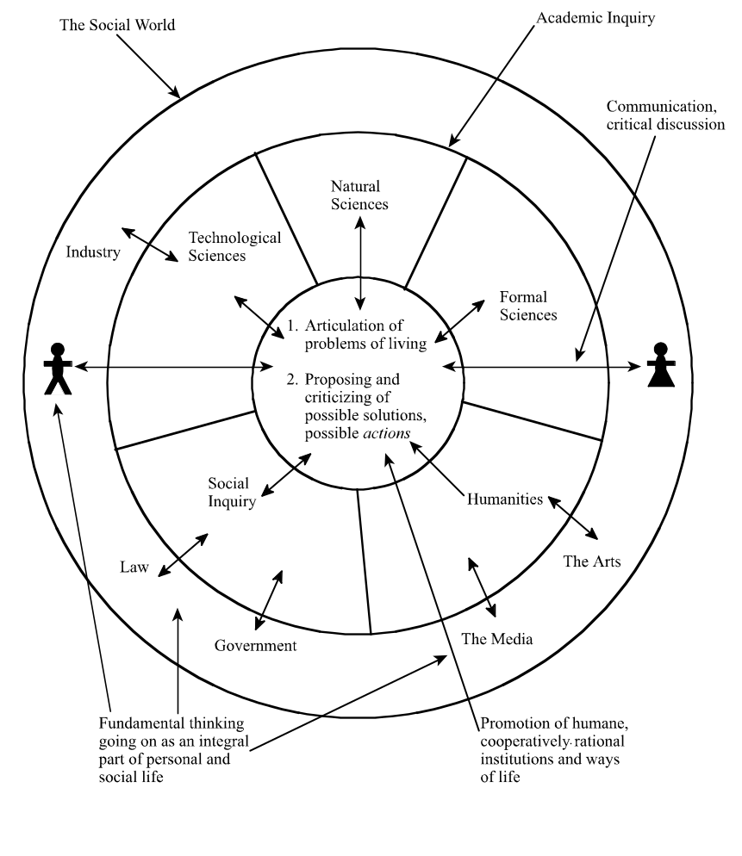
Figure 2: Wisdom-Inquiry Implementing Problem-Solving Rationality

As we move from knowledge-inquiry to wisdom-inquiry the relationship between academia as a whole and the rest of the social world is transformed. Knowledge-inquiry seeks to shield itself from the social world to preserve the objectivity and integrity of the pursuit of knowledge. Wisdom-inquiry, by contrast, seeks to interact with the social world, ideas, experiences and arguments going in both directions, so that academia may help humanity learn how to tackle our immense global problems more effectively. Wisdom-inquiry might be regarded as a kind of civil service for humanity. What actual
civil services are supposed to do in secret for governments, wisdom-inquiry academia does openly for the public.
Knowledge-inquiry has two quite distinct fundamental aims: the intellectual aim of knowledge, and the social or humanitarian aim of helping to promote human welfare. There is a sense in which wisdom-inquiry fuses these together in the one basic aim of seeking and promoting wisdom - wisdom being the capacity, and perhaps the active desire, to realize what is of value in life, for oneself and others, wisdom thus including knowledge and technological know-how but much else besides.

9. Wisdom-Inquiry: Aim-Pursuing Version
Granted that the argument of the previous section is correct, and universities today, dominated as they are by knowledge-inquiry, are damagingly irrational in structural way, an obvious question to ask is: When and how did this come about?
It all goes back to the 18th century Enlightenment, especially the French Enlightenment. The Philosophes of the Enlightenment, Voltaire, Diderot, Condorcet and the rest, had the magnificent idea that it might be possible to learn from scientific progress towards greater knowledge how to make social progress towards an enlightened world. Unfortunately, in developing and implementing this magnificent idea, they blundered. They botched the job. They thought the task was to develop the social sciences alongside the natural sciences. This got developed throughout the 19th century, and got built into universities in the early 20th century with the creation of Departments of social science. The outcome is what we have, by and large, today: knowledge-inquiry.
But all this represents a series of dreadful blunders. In order to implement the profound, basic idea of the Enlightenment properly, there are three crucial steps it is essential to get right. The Philosophes got all three steps wrong.
First, it is essential to get clear about what the progress-achieving methods of science are, what methods, precisely, make scientific progress possible.
Second, these methods need to be correctly generalized so that they become potentially fruitfully applicable to any worthwhile, problematic human endeavour, whatever the aims may be, and not just applicable to the scientific endeavour of improving knowledge.
Third, These correctly generalized progress-achieving methods then need to be got into the social world, into government, industry, agriculture, education, the media, the law, international relations, and so on, so that they may be exploited correctly in the great
human endeavour of trying to make social progress towards an enlightened, wise world.
From the 18th century down to today, scientists and philosophers of science have accepted one or other version of standard empiricism (SE) which, as we saw in section 5, very seriously misrepresents the aims and methods of science. In order to get the first step right we need to adopt aim-oriented empiricism (AOE).
In order to get the second step right, we need to generalize AOE so that it becomes potentially fruitful to any problematic worthwhile human endeavour, and not just science, in this way creating a conception of rationality that helps us improve aims when they are problematic. I have called this aim-pursuing conception of rationality aim-oriented rationality (AOR). The vital point to appreciate is that it is not just the aims of science that are problematic; this is true in life as well, in all sorts of personal, social and institutional contexts. Aims conflict. They have unforeseen, undesirable consequences. They are not as desirable as we suppose, or not as realizable, or both. We may misrepresent our aims. The more "rationally" - that is, effectively - we pursue a bad aim, the worse off we will be. We need to try to improve our aims as we act. Quite generally, whenever we pursue problematic aims, we need to represent them in the form of a hierarchy, along the lines depicted in figure 1, thus giving ourselves the best chances of improving our aims and methods as we act.
In order to get the third step right, we need to try to get AOR, arrived at by generalizing AOE, the progress-achieving methods of science, into all our other worthwhile, problematic endeavours besides science - into government, industry, finance,
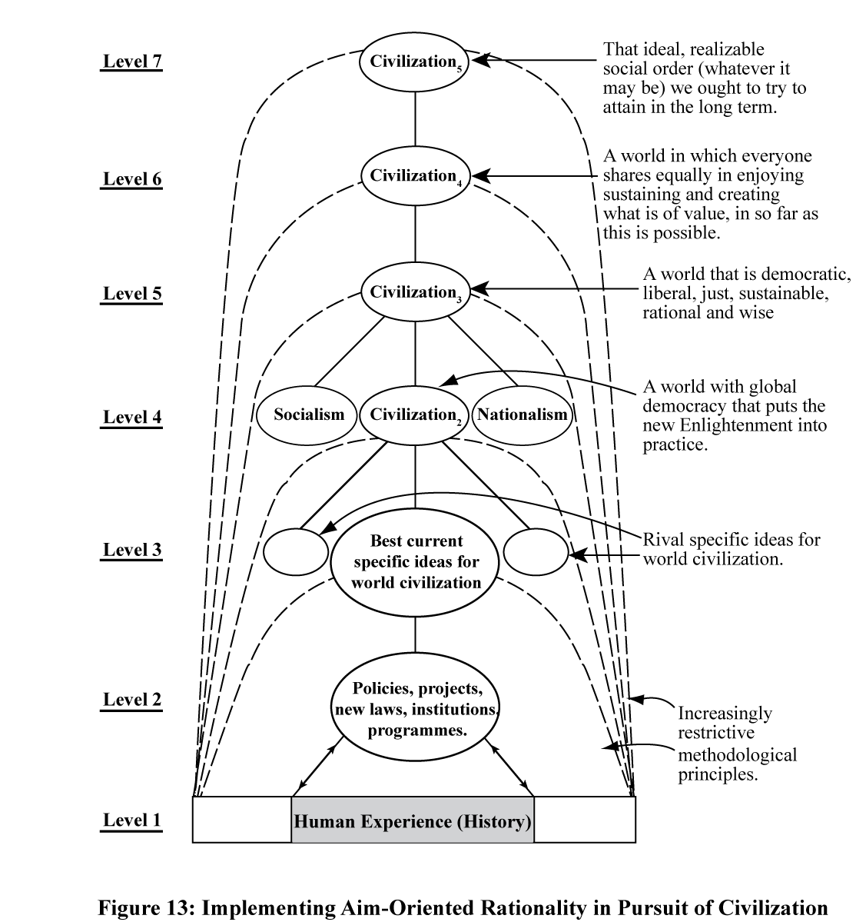
Figure 3: Hierarchical Social Methodology Generalized from Science

agriculture, education, the media, the law, international relations, and so on. Above all, we need to get AOR into the endeavour to make progress towards the profoundly problematic aim of creating an enlightened world: see figure 3. The philosophes made the disastrous mistake of applying a misconceived conception of scientific method, SE, to the task of improving knowledge of social phenomena, thus creating social science, when what they ought to have done is apply AOR to social life itself so that humanity may make progress towards an enlightened world. According to this second version of wisdom-inquiry (building on the first version), social inquiry is not social science, but rather social methodology or social philosophy. What ought to be the relationship
between philosophy of science and science, within the framework of AOE, so too that ought to be the relationship between social inquiry and society. Sociology thus emerges as social methodology, and the sociology of science, in particular, emerges as scientific methodology, or in other words, philosophy of science. At present, philosophy of science and sociology of science are at loggerheads with one another - partly because of social constructivist disagreements. Within this second version of wisdom-inquiry, however, philosophy of science and sociology of science emerge as one and the same discipline, both concerned with what ought to be the intellectual and social aims and methods of science.

10. The Future of Science and Technology Studies
When these arguments for AOE and wisdom-inquiry, just summarized, were spelled out in detail in my book From Knowledge to Wisdom in the Orwellian year of 1984, Christopher Longuet-Higgins in a rave review in Nature said:

Maxwell is advocating nothing less than a revolution (based on reason, not on religious
or Marxist doctrine) in our intellectual goals and methods of inquiry ... There are
altogether too many symptoms of malaise in our science-based society for Nicholas
Maxwell's diagnosis to be ignored.

But this is just what has happened. By and large, my diagnosis has been ignored - especially by those who should be most concerned professionally, those engaged in HPS, STS and philosophy. Instead of bringing to scientists, to fellow academics and to the public the message that universities, in so far as they put knowledge-inquiry into practice, betray both reason and humanity, these scholars have, rather, devoted themselves to wrangles about social constructivism, and the traditional fare of science studies. The fundamental question What kind of inquiry can best help humanity learn how to make progress towards as good a world as possible? continues, scandalously, to be ignored.
I can only hope that this essay will provoke some STS folk to take up intellectual cudgels on behalf of reason and humanity.

11. Conclusion
In order to create a better, wiser world, we need to learn how to do it. That in turn requires that our institutions of learning, our schools and universities, are well-designed, rationally designed and devoted for the task. At present they are not. It is this that is in part responsible for our global problems and our current incapacity to tackle them effectively. We urgently need to bring about a revolution in universities around the world so that they become devoted to seeking and promoting wisdom - helping humanity create a better world. As far as the long term interests of humanity are concerned, there is probably no more important thing that we need to do. Is this academic revolution really needed? What would it imply? What are its advantages and disadvantages? How ought universities to develop? If the revolution is required, what can be done to help bring it about? These are some of the questions STS ought to tackle.

References
Barnes, B., 1977, Interests and the Growth of Knowledge, Routledge & Kegan Paul, London.
______, 1982, T. S. Kuhn and Social Science, Macmillan, London.
______, 1985, About Science, Blackwell, Oxford.
Barnes, B., D. Bloor, and J. Henry, 1996, Scientific Knowledge: A Sociological Analysis, University of Chicago Press, Chicago.
Bloor, D., 1976, Knowledge and Social Imagery, Routledge and Kegan Paul, London.
Butterfield, H., 1951, The Whig Interpretation of History, Bell and Sons, London (first published in 1931).
Feyerabend, P., 1965, 'Problems of Empiricism', in Colodny, R. G., ed., Beyond the Edge of Certainty, Prentice-Hall, New York, pp. 145-260.
______, 1970, 'Problems of Empiricism, Part II', in Colodny, R. G., The Nature and Function of Scientific Theories, University of Pittsburgh Press, Pittsburgh, pp. 275-354.
______, 1975, Against Method: Outline of an Anarchistic Theory of Knowledge, New Left Books, London.
______, 1978, Science in a Free Society, New Left Books, London.
______, 1987, Farewell to Reason, Verso, London.
Gross, P. and N. Levitt, 1994, Higher Superstition: The Academic Left and Its Quarrels
with Science, John Hopkins University Press, Baltimore.
Gross, P., N. Levitt and M. Lewis, eds., 1996, The Flight from Science and Reason, John
Hopkins University Press, Baltimore.
Hardy, A., 1968, The Living Stream, Collins, London.
Harper, W. L., 2011, Isaac Newton's Scientific Method, Oxford University Press, Oxford.
Koertge, N., 1998, A House Built on Sand: Exposing Postmodernist Myths About Science, Oxford University Press, Oxford.
Kuhn, T. S., 1962, The Structure of Scientific Revolutions, Chicago University Press, Chicago.
Lakatos, I., 1970, 'Falsification and the Methodology of Scientific Research Programmes', in Lakatos and Musgrave (1970, pp. 91-195).
Lakatos, I. and Musgrave, A., eds., 1970, 'Criticism and the Growth of Knowledge, Cambridge University Press, London.
Longuet-Higgins, C., 1984, 'For goodness sake', Nature, vol. 312, p. 204 (available online at http://www.ucl.ac.uk/from-knowledge-to-wisdom/reviews/#goodness).
Maxwell, N., 1974, 'The Rationality of Scientific Discovery', Philosophy of Science, vol. 41, pp. 123-153 and 247-295.
______, 1976, What's Wrong With Science? Towards a People's Rational Science of Delight and Compassion, Bran's Head Books, Hayes, Middlesex (2nd ed., 2007).
______, 1980, 'Science, Reason, Knowledge and Wisdom: A Critique of Specialism', Inquiry, vol. 23, pp. 19-81.
______, 1984, From Knowledge to Wisdom: A Revolution in the Aims and Methods of Science, Blackwell, Oxford.
______, 1992, 'What Kind of Inquiry Can Best Help Us Create a Good World?', Science, Technology and Human Values, vol. 17, pp. 205-27.

______, 1993, 'Induction and Scientific Realism: Einstein versus van Fraassen', British Journal for the Philosophy of Science, vol. 44, pp. 61-79, 81-101 and 275-305.
______, 1998, The Comprehensibility of the Universe: A New Conception of Science, Clarendon Press, Oxford.
______, 1999, 'Are there Objective Values?', The Dalhousie Review , vol. 79, no. 3, pp. 301-317.
______, 2000a, 'Can Humanity Learn to Become Civilized? The Crisis of Science without Civilization’, Journal of Applied Philosophy 17, pp. 29-44.
______, 2000b, 'A new conception of science', Physics World, vol. 13, no. 8, pp. 17-18.
______, 2001, The Human World in the Physical Universe: Consciousness, Free Will and Evolution, Rowman and Littlefield, Lanham, Maryland.
______, 2002, 'The Need for a Revolution in the Philosophy of Science', Journal for General Philosophy of Science, vol. 33, pp. 381-408.
______, 2004, Is Science Neurotic?, Imperial College Press, London.
______, 2005, 'Popper, Kuhn, Lakatos and Aim-Oriented Empiricism', Philosophia, vol. 32, nos. 1-4, pp. 181-239.
______, 2007a, From Knowledge to Wisdom: A Revolution for Science and the Humanities, Pentire Press, London (2nd ed. of my 1984, revised and extended).
______, 2007b, 'From Knowledge to Wisdom: The Need for an Academic Revolution', London Review of Education, vol. 5, no. 2, pp. 97-115.
______, 2008, 'Do We Need a Scientific Revolution?', Journal for Biological Physics and Chemistry, vol. 8, no. 3, pp. 95-105.
______, 2009a, 'How Can Life of Value Best Flourish in the Real World?', in McHenry (2009a, pp. 1-56).
______, 2009b, 'The Metaphysics of Science: An Account of Modern Science in Terms of Principles, Laws and Theories (review of book by Craig Dilworth), International Studies in the Philosophy of Science, vol. 23, no. 2, pp. 228-232.
______, 2010, Cutting God in Half - And Putting the Pieces Together Again: A New Approach to Philosophy, Pentire Press, London (available online at http://discovery.ucl.ac.uk/view/people/ANMAX22.date.html).
______, 2011, 'A Priori Conjectural Knowledge in Physics', in What Place for the A Priori?, ed., M. Shaffer and M. Veber, Open Court, Chicago, pp. 211-240.
______, 2012a, 'Arguing for Wisdom in the University: An Intellectual Autobiography', Philosophia, vol. 40, pp. 663-704.
______, 2012b, 'How Universities Can Help Humanity Learn How to Resolve the Crises of Our Times - From Knowledge to Wisdom: The University College London Experience', Handbook on the Knowledge Economy, vol. 2, ed. G. Heam, T. Katlelle and D. Rooney, Edward Elgar, Cheltenham, pp. 158-179.
______, 2014a, How Universities Can Help Create a Wiser World: The Urgent Need for an Academic Revolution, Imprint Academic, Exeter.
______, 2014b, ' Unification and Revolution: A Paradigm for Paradigms', Journal for General Philosophy of Science, vol. 45, pp. 133-149, http://philpapers.org/rec/MAXUAR.
McHenry, L., ed., 2009a, Science and the Pursuit of Wisdom: Studies in the Philosophy of Nicholas Maxwell, Ontos Verlag, Frankfurt.
______, 2009b, 'Ghosts in the Machine: Comment of Sismondo', Social Studies of Science, 39, pp. 943-947.
Popper, K., 1959, The Logic of Scientific Discovery, Hutchinson, London (first published in German in 1934)..
______, 1963, Conjectures and Refutations, Routledge and Kegan Paul, London.
______, 1969, The Open Society and Its Enemies, Routledge and Kegan Paul, London (first published in 1945).
______. 1970, 'Normal Science and Its Dangers' in Lakatos and Musgrave (1970, pp.51-58).
______, 1974, The Poverty of Historicism, Routledge and Kegan Paul, London.
Sismondo, S., 2009a, 'Ghosts in the Machine: Publication Planning in the Medical Sciences', Social Studies of Science, 39, pp. 171-198.
______, 2009b, 'Ghosts in the Machine: Response to McHenry', Social Studies of Science 39, pp. 949-952.
Sokal, A., 1998, 'Transgressing the Boundaries; Toward a Transformative Hermeneutics of Quantum Gravity', in Sokal and Bricmont (1998, pp. 199-240).
______, 2008, Beyond the Hoax: Science, Philosophy and Culture, Oxford University Press, New York.
Sokal, A. and Bricmont, B., 1998, Intellectual Impostures, Profile Books, London.

Notes

See my (2012a pp. 673-679).
See my (2012a, pp. 679-688). See also my (2009a).
Popper could be ferociously critical in his seminars. Rarely did the speaker get past the title before Popper's attack began. Once he reduced a young visiting speaker - now a well known philosopher of science - to tears.
See Popper (1959; 1963).
"inter-subjective testing is merely a very important aspect of inter-subjective criticism, or in other words, of the idea of mutual rational control by critical discussion." Popper (1959, p. 44, note 1*). Popper refers the reader to his (1969, chs. 23 and 24) - first published in 1945.
See Popper (1969).
As in note 6.
See my (2012a, pp. 688-699).
Kuhn (1962).
Popper (1970, p. 53).
Lakatos (1970).
Feyerabend (1965).
To cite just one recent book in the field that I find very impressive: Harper (2011).
Logical positivism held that the meaning of a proposition, or theory, is the method of its verification. The idea was to render scientific theories meaningful, but metaphysics, which cannot be verified empirically, meaningless. This failed for the simple reason that scientific theories cannot be verified. So logical positivism morphed into the very much weaker doctrine of logical empiricism which held that theoretical terms acquire their meaning as a result of being linked to observational terms by means of bridge statements. It was this doctrine that Feyerabend set out to demolish.
Not really very good, of course, for even if observational terms are theory-laden, nevertheless given any two conflicting theories ostensibly about the same, or overlapping, ranges of phenomena, one can always concoct observational terms that are such that the theory presupposed by them is neutral between the two theories: see my (2014b). That this can always be done means that empirical predictions of conflicting theories about overlapping phenomena can always be assessed in terms of these phenomena described by means of terms that presuppose low-level theory that it neutral between the conflicting theories in question. Feyerabend's argument for incommensurability, methodological anarchy and dadaism collapses completely. I did my best to point this out to Feyerabend in person, but he was having none of it. And nor was Kuhn when I tried to point out that his argument for incommensurability rested on the same fallacy. The problem was solved long ago by Michael Faraday in scientific practice in connection with his work on electrolysis. How extraordinary that, over a century later, two leading philosophers of science could not grasp what Faraday had understood long ago: see my (2014b).
Feyerabend (1970).
Feyerabend (1975; 1978; 1987).
Harry Collins, John Henry and others were, and still are (at the time of writing) associated with the movement.
Bloor (1976); Barnes (1977; 1982; 1985); Barnes, Bloor and Henry (1996).
Popper (1969, vol. 2, chs. 23 and 24).
See previous note, and Popper (1974, section 32, 'the institutional theory of progress', pp. 152-159). See also Kuhn on normal science: Kuhn (1962, chs. III-V).
For value realism see my (1984 or 2007a, ch. 10; 1999; 2001, ch. 2).
Butterfield (1951). Butterfield seems to believe that ideally history would be about everything. He says at one point "The value of history lies in the richness of its recovery of the concrete life of the past" (1951, p. 68). He ignores that history is always about something specific - power, the black death, the potato, or whatever - and may quite legitimately be about something that seeks, and even perhaps achieves, progress.
Intellectual factors at work in science are social in character. We can thus distinguish two kinds of social factors influencing science: the intellectual, and the non-intellectual.
I have attempted something along these lines in my (2010, ch. 10, especially pp. 276-289). Following Alister Hardy's lead in his (1965), I call upon some neglected and misrepresented history of evolutionary thought to provide support for an interpretation of Darwinian evolution which gives an increasingly important role to purposive action in evolution, and which holds that the mechanisms of evolution themselves evolve.
Sokal (1998). See also Sokal (2008) for an annotated version of the hoax article, and essays on related matters.
Gross and Levitt (1994); Gross, Levitt and Lewis (1996).
Sokal and Bricmont ((1998).
Koertge (1998).
See Sismondo (2009a). For a criticism see McHenry (2009b); and for a reply see Sismondo (2009b).
Kuhn (1962); Lakatos (1970).
See my (1974; 1993; 1998; 2000b; 2002; 2004; 2005; 2007a, chs. 9 and 14; 2009b; 2011; 2014b).
Here is a demonstration of this point. Let T be any accepted fundamental physical theory. There are, to begin with, infinitely many disunified rivals to T that are just as empirically successful as T. In order to concoct such a rival, T₁ say, all we need to do is modify T in an entirely ad hoc way for phenomena that occur after some future date. Thus, if T is Newtonian theory (NT), NT₁ might assert: everything occurs as NT predicts until the first moment of 2050 (GMT) when an inverse cube law of gravitation comes into operation: F = Gm₁m₂/d³. Infinitely may such disunified rivals can be concocted by choosing infinitely many different future times for an abrupt, arbitrary change of law. These theories will no doubt be refuted as each date falls due, but infinitely many will remain unrefuted. We can also concoct endlessly many disunified rivals to T by modifying the predictions of T for just one kind of system that we have never observed. Thus, if T is, as before, NT, then NT₂ might assert: everything occurs as NT predicts except for any system of pure gold spheres, each of mass greater than 1,000 tons, moving in a vacuum, centres no more than 1,000 miles apart, when Newton’s law becomes F = Gm₁m₂/d⁴. Yet again, we may concoct further endlessly many equally empirically successful disunified rivals to T by taking any standard experiment that corroborates T and modifying it in some trivial, irrelevant fashion - painting the apparatus purple, for example, or sprinkling diamond dust in a circle around the apparatus. We then modify T in an ad hoc way so that the modified theory, T₃ say, agrees with T for all phenomena except for the trivially modified experiment. For this experiment, not yet performed, T₃ predicts - whatever we choose. We may choose endlessly many different outcomes, thus creating endlessly many different modifications of T associated with this one trivially modified experiment. On top of that, we can, of course, trivially modify endlessly many further experiments, each of which generates endlessly many further disunified rivals to T. Each of these equally empirically successful, disunified rivals to T - T₁, T₂, … T∞ - can now be modified further, so that each becomes empirically more successful than T. Any accepted fundamental physical theory is almost bound to face some empirical difficulties, and is thus, on the face of it, refuted - by phenomena A. There will be phenomena, B, which come within the scope of the theory but which cannot be predicted because the equations of the theory cannot (as yet) be solved. And there will be other phenomena, C, that fall outside the scope of the theory altogether. We can now take any one of the disunified rivals to T, T₁ say, and modify it further so that the new theory, T₁*, differs further from T in predicting, in an entirely ad hoc way, that phenomena A, B and C occur in accordance with empirically established laws L_{A}, L_{B} and L_{C}. T₁* successfully predicts all that T has successfully predicted; T₁* successfully predicts phenomena A that ostensibly refute T; and T₁* successfully predicts phenomena B and C that T fails to predict. On empirical grounds alone, T₁* is clearly more successful and better corroborated, than T. And all this can be repeated as far as all the other disunified rivals of T are concerned, to generate infinitely many empirically more successful disunified rivals to T: T₁*, T₂*, … T∞*.
For expositions of this argument see Maxwell (1974, part 1; 1993, part 1; 1998, ch. 2; 2000b; 2002; 2004, ch. 1; 2005; 2011; 2013.
For expositions of, and arguments for AOE see works referred to in note 32
Maxwell (2004, pp. 39-47).
Maxwell (1998, chs. 3-6; 2004, chs 1, 2, and appendix; 2007a, ch. 14; 2014b).
See works referred to in note 32.
See my (1976; 1984; 2001; 2004; 2007a; 2010; 2014a).
See previous note.
The "from knowledge to wisdom" argument I am about to sketch was first expounded in my (1976). It was spelled out in much greater detail in my (1984); see also my (2007a). See also my (1998; 2001; 2004; 2010; 2014a). For summaries that expound different aspects of the argument see Maxwell (1980; 1992; 2000a; 2007b; 2008; 2011b; 2012a; 2012b)
For more about rationality see my (1984, pp. 69-71 and ch. 5; or 2007a, pp. 82-84 and ch. 5).
Longuet-Higgins (1984).

