Can Scientific Method Help Us Create a Wiser World?
Nicholas Maxwell
Emeritus Reader, Science and Technology Studies, University College London
Abstract
Two great problems of learning confront humanity: (1) learning about the universe, and about ourselves as a part of the universe, and (2) learning how to make progress towards as good a world as possible. We solved the first problem when we created modern science in the 17th century, but we have not yet solved the second problem. This puts us in a situation of unprecedented danger. Modern science and technology enormously increase our power to act, but not our power to act wisely. All our current global crises have arisen as a result. What we need to do is learn from our solution to the first great problem of learning how to go about solving the second one. Properly implemented, this idea leads to a new kind of inquiry rationally devoted to helping humanity make progress towards as good a world as possible.

Introduction
Two great problems of learning confront humanity: (1) learning about the universe, and about ourselves and other living things as a part of the universe, and (2) learning how to make progress towards as good a world as possible. We solved the first problem in the 17th century when we created modern science. That is not to say that we know everything that there is to be known, but rather, that we have discovered a method which enables us progressively to improve our knowledge and understanding – the empirical method of science. But we have not yet solved the second problem. And that combination of solving the first problem and failing to solve the second one puts us in a situation of unprecedented danger. For, increasing our scientific knowledge and technological know-how enormously increases our power to act. Often, of course, this has magnificent outcomes. Modern science and technology have made the modern world possible, with all its immense benefits. But, in the absence of the solution to the second problem, our enhanced powers to act have also led to all our current global crises: global warming, explosive population growth, destruction of natural habitats and rapid extinction of species, depletion of finite natural resources, vast inequalities of wealth and power around the globe, pollution of earth, sea and air, the lethal character of modern war, the menace of modern armaments, even the Aids epidemic (Aids being spread by modern travel). All these have come about, paradoxically, because of our successes, our enhanced powers to act bequeathed to us by modern science and technology, via modern industry, agriculture, medicine, hygiene, transport, and the technology of war. They have come about because of our immensely increased powers to act without an accompanying increase in our power to act wisely.
Many blame science for our problems. But that is entirely to miss the point. What we need to do, rather, is learn from our solution to the first great problem of learning how to go about solving the second problem. We need to learn from scientific progress how to achieve social progress towards a good world.

The Enlightenment
This was the basic idea of the 18th century Enlightenment, especially the French Enlightenment. Unfortunately, in developing this profoundly important idea, the philosophes of the Enlightenment made a series of blunders, and it is the defective version of the Enlightenment Programme which emerged as a result, that we built into the institutions of academia in the early 20th century when we created departments and disciplines of social science. The outcome is a kind of inquiry devoted, in the first instance, to the acquisition of knowledge – knowledge-inquiry as I shall call it. This holds that, first, knowledge is to be acquired; once acquired, it can be applied to help solve social problems. It is this that we are still suffering from today.
In order to implement properly the profound Enlightenment idea of learning from the solution to the first great problem of learning how to go about solving the second one, there are three crucial steps that we need to get right.

1. The progress-achieving methods of science need to be correctly identified.
2. These methods need to be correctly generalized so that they become fruitfully
applicable to any worthwhile, problematic human endeavour, whatever its aims
may be, and not just applicable to the endeavour of improving knowledge.
3. These correctly generalized progress-achieving methods then need to be exploited
correctly in the great human endeavour of trying to make social progress towards as
good a world as possible.

Unfortunately, the philosophes got all three steps wrong. They misconstrued the nature of the progress-achieving methods of natural science; they failed to generalize the methods of science properly; and, most disastrously of all, they made the entirely wrong application of these methods. They applied these methods to developing social science, to the task of improving knowledge of the social world, whereas they ought to have applied the properly generalized progress-achieving methods of science directly to social life, to the social world itself. Instead of seeking to make social progress towards an enlightened world, the philosophes ended up seeking to make no more than intellectual progress in knowledge about the social world.
Academic inquiry as it exists by and large today – knowledge-inquiry – still embodies these ancient blunders. As a result, academia as we have it today is a botched attempt to create institutions of learning designed to help us solve the second great problem of learning. In order to create what we so urgently need, a kind of inquiry rationally designed to help us make progress towards as good a world as possible, we need to modify academia as it exists today just sufficiently to correct the three blunders we have inherited from the past. The outcome would be a new kind of academic enterprise that I shall call wisdom-inquiry. Wisdom-inquiry is designed to enable us to learn from our solution to the first great problem of learning how to go about solving the second problem. Here is what we need to do to create wisdom-inquiry.

Correcting the first Blunder: Scientific Method
First, we need to correct current orthodox ideas about the nature of the progress-achieving methods of science. From D’Alembert in the 18th century to Karl Popper in the 20th, the widely held view, amongst both scientists and philosophers, has been (and continues to be) that science proceeds by assessing theories impartially in the light of evidence, no permanent assumption being accepted by science about the universe independently of evidence. Preference may be given to simple, unified or explanatory theories, but not in such a way that nature herself is, in effect, assumed to be simple, unified or comprehensible.
This orthodox view, which may be called standard empiricism is, however, untenable. If taken literally, it would instantly bring science to a standstill. For, given any accepted fundamental theory of physics, T, Newtonian theory say, or quantum theory, endlessly many empirically more successful rivals can be concocted which agree with T about observed phenomena but disagree arbitrarily about some unobserved phenomena, and successfully predict phenomena, in an ad hoc way, that T makes false predictions about, or no predictions. Physics would be drowned in an ocean of such empirically more successful rival theories.
In practice, these rivals are excluded because they are disastrously disunified. Two considerations govern acceptance of theories in physics: empirical success and unity. In demanding unity, we demand of a fundamental physical theory that it ascribes the same dynamical laws to the phenomena to which the theory applies. But in persistently accepting unified theories, to the extent of rejecting disunified rivals that are just as, or even more, empirically successful, physics makes a big persistent assumption about the universe. The universe is such that all disunified theories are false. It has some kind of unified dynamic structure. It is physically comprehensible in the sense that explanations for phenomena exist to be discovered.⁶
But this untestable (and thus metaphysical) assumption that the universe is physically comprehensible is profoundly problematic. Science is obliged to assume, but does not know, that the universe is comprehensible. Much less does it know that the universe is comprehensible in this or that way. A glance at the history of physics reveals that ideas have changed dramatically over time. In the 17th century there was the idea that the universe consists of corpuscles, minute billiard balls, which interact only by contact. This gave way to the idea that the universe consists of point-particles surrounded by rigid, spherically symmetrical fields of force, which in turn gave way to the idea that there is one unified self-interacting field, varying smoothly throughout space and time. Nowadays we have the idea that everything is made up of minute quantum strings embedded in ten or eleven dimensions of space-time. Some kind of assumption along these lines must be made but, given the historical record, and given that any such assumption concerns the ultimate nature of the universe, that of which we are most ignorant, it is only reasonable to conclude that it is almost bound to be false.
The way to overcome this fundamental dilemma inherent in the scientific enterprise is to construe physics as making a hierarchy of metaphysical assumptions concerning the comprehensibility and knowability of the universe, these assumptions asserting less and less as one goes up the hierarchy, and thus becoming more and more likely to be true, and more nearly such that their truth is required for science, or the pursuit of knowledge, to be possible at all. In this way a framework of relatively insubstantial, unproblematic, fixed assumptions and associated methods is created within which much more substantial and problematic assumptions and associated methods can be changed, and indeed improved, as scientific knowledge improves. Put another way, a framework of relatively unspecific, unproblematic, fixed aims and methods is created within which much more specific and problematic aims and methods evolve as scientific knowledge evolves. There is positive feedback between improving knowledge, and improving aims-and-methods, improving knowledge-about-how-to-improve-knowledge. This is the nub of scientific rationality,

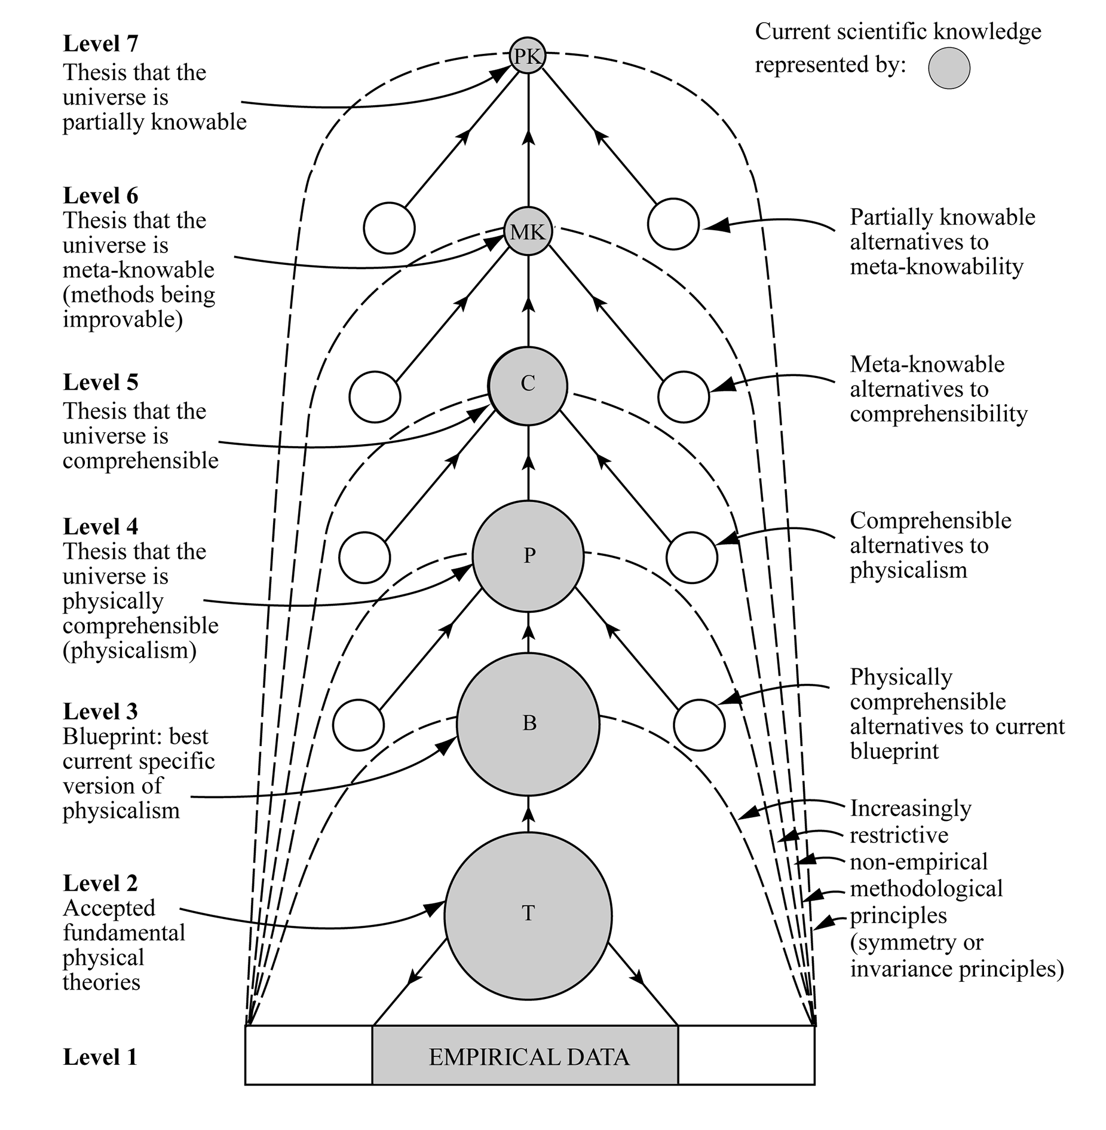
Figure 1: Aim-Oriented Empiricism
the methodological key to the unprecedented success of science. Science adapts its nature to what it discovers about the nature of the universe.
This hierarchical conception of physics, which may be called aim-oriented empiricism, is depicted in Figure 1. At level 7, there is the assumption that the universe is such that we can acquire some knowledge of our local circumstances. If this minimal assumption is false, we have had it whatever we assume. It can never be in our interests to abandon this assumption. At level 6 we have the more substantial and risky assumption that the universe is such that we can learn how to improve methods for improving knowledge. This promises to be too fruitful for progress in knowledge not to be accepted. At level 5 there is the assumption that the universe is comprehensible in some way or other – it
being such that something exists which provides in principle one kind of explanation for all phenomena. At level 4 there is the even more substantial assumption that the universe is physically comprehensible, there being some kind of invariant physical entity, pervading all phenomena which (together with instantaneous states of affairs) determines (perhaps probabilistically) how events unfold in space and time. The universe is such, in other words, that the true physical “theory of everything” is unified, or physically comprehensible. At level 3 there is the even more substantial assumption that the
universe is physically comprehensible in some more or less specific way. Superstring theory, or M-theory, might be this assumption today. At level 2 we have currently accepted fundamental theories of physics: at present, the standard model, and general relativity. At level 1 we have accepted empirical data.
As we descend this hierarchy, we go from an assumption at the top almost certain to be true to an assumption, at level 3, that is almost bound to be false. The hope is that we can keep falsity confined to assumptions as low down in the hierarchy as possible. The idea is to concentrate criticism where it is most likely to be fruitful – low down in the hierarchy. We need to try to modify ideas here, so that they are compatible with assumptions higher up in the hierarchy, and at the same time accord best with empirical progress at levels 1 and 2 – or promise to promote empirically progressive research programmes at these levels.
Thus physics seeks, not truth per se, but rather truth presupposed to be explanatory. But science does not just seek explanatory truth; more generally, it seeks valuable truth – if anything, even more problematic. And it seeks truth to be used by people, and by institutions, in one way or another, if anything even more problematic. There are, in short, highly problematic assumptions concerning metaphysics, values, and human use implicit in the aims and priorities of scientific research. These need to be made explicit within science, and subjected to sustained imaginative and critical scrutiny, by scientists and non-scientists alike, in an attempt to improve aims so that they come to represent the best interests of humanity. The aim-oriented empiricist conception of the methods of physics depicted in figure 1 can readily be generalized to take into account problematic assumptions associated with the aims of science having to do with values, and the social uses or applications of science. It can be generalized so as to apply to the different branches of natural science. Different sciences have different specific aims, and so different specific methods although, throughout natural science there is the common meta-methodology of aim-oriented empiricism.
So much for the first blunder of the traditional Enlightenment, and how to put it right. It is important to correct this blunder, not only for science, but also because it is only when this has been done that scientific method becomes especially helpful, indeed vitally necessary – when generalized – in enabling us to make progress towards as good a world as possible, as we shall see.

Correcting the Second Blunder: Generalizing Scientific Method
The second step involves generalizing the progress-achieving meta-methods of science, just indicated, so that they become fruitfully applicable, potentially, to all worthwhile, problematic human endeavours. Whatever we are doing, our aims may well be problematic, because they are (more or less) unrealisable, undesirable, or both. When this is likely to be the case we need to represent our aim in the form of a hierarchy, aims becoming less and less specific, and so less and less problematic, as we go up the hierarchy. In this way, we create a framework of relatively unproblematic aims and methods, high up in the hierarchy, within which much more specific and problematic aims and methods may be imaginatively and critically assessed, in the light of experience, what we enjoy and suffer, as we act, and in the light of less problematic aims higher up in the hierarchy. This hierarchical meta-methodology – aim-oriented rationality - arrived at by generalizing the hierarchical progress-achieving methods of aim-oriented empiricism depicted in figure 1, enables us to improve social policies, ideas for living, philosophies of life, in the light of experience, much as science improves knowledge.

Correcting the Third Blunder: From Social Science to Wisdom-Inquiry
The third step corrects by far the biggest and most serious blunder we have inherited from the Enlightenment. It involves applying aim-oriented rationality (arrived at by generalizing aim-oriented empiricism, the progress-achieving methods of science), not to social science, not to the task of improving knowledge of social phenomena, but directly to social life, to the task of improving the social world. The social sciences and humanities need to be transformed so that they take up the task of helping humanity get into individual, institutional, social and global life the aim-improving, hierarchical methodology of aim-oriented rationality. Properly implemented, in short, the Enlightenment idea of learning from scientific progress how to achieve social progress towards an enlightened world involves developing social inquiry, not primarily as social science, but rather as social methodology, or social philosophy. The basic task of social inquiry and the humanities would be to help people tackle problems of living in increasingly cooperatively rational ways so that what is of value in life may be attained. Somewhat as natural science, in the pursuit of knowledge, proposes and attempts to falsify conjectured solutions to problems of knowledge, so social inquiry and the humanities, in order to help people achieve what is of value in life, would propose and critically assess conjectured solutions to problems of living - possible social actions, policies, political programmes, new social arrangements and institutions, ways of living, philosophies of life. Social inquiry and the humanities would have the task too, of course, of actively promoting cooperatively rational tackling of problems of living in the social world. And again, somewhat as natural science ought to put aim-oriented empiricism into scientific practice, so too a basic task of social inquiry and the humanities would be to get into personal and social life, and into other institutions besides that of science – into government, industry, agriculture, commerce, the media, law, education, international relations – the progress-achieving methods of aim-oriented rationality (designed to improve problematic aims) arrived at by generalizing the methods of science.
It is just this that the philosophes failed to do. Instead of applying aim-oriented rationality to social life, the philosophes sought to apply a seriously defective conception of scientific method to social science, to the task of making progress towards, not a better world, but better knowledge of social phenomena. And this ancient blunder, developed throughout the 19th century by J.S. Mill, Karl Marx and many others, and built into academia in the early 20th century with the creation of the diverse branches of the social sciences in universities all over the world, is still built into the institutional and intellectual structure of academia today, inherent in the current character of social science.
The upshot of correcting the three blunders of the Enlightenment would be a revolution in academia. Instead of academia being devoted, in the first instance, to the pursuit of knowledge - knowledge-inquiry as I have called it - we would have a new kind of academic enterprise devoted to the pursuit of wisdom - wisdom-inquiry as I have called it. Wisdom is to be understood here as the capacity and the active endeavour to realize what is of value in life, for oneself and others ("realize" meaning both "apprehend" and "make real" or "create"), wisdom in this sense including knowledge, technological know-how and understanding, but much else besides. Wisdom-inquiry puts problems of living at the heart of the academic enterprise. It strives to help humanity tackle problems of living - especially grave global problems indicated above - in increasingly cooperatively rational ways, and strives, too, to help humanity put aim-oriented rationality into practice in its diverse endeavours, above all the endeavour to make progress towards as good a world as possible.

Adverse Consequences
So far, we have failed to correct the three blunders of the Enlightenment. We have failed to transform knowledge-inquiry so that it becomes wisdom-inquiry. We have failed to get the aim-improving meta-methodology of aim-oriented rationality into the fabric of social life, into our diverse institutions and social endeavours. Even worse, we have not as yet had the idea that this urgently needs to be done. The idea has been around for decades, but it has been ignored.
The consequences of these blunders have been dire indeed. Almost all our current global crises have arisen because we have successfully pursued aims that seemed inherently desirable but which have subsequently turned out to have adverse repercussions. We strive to achieve progress – economic, industrial, social – and, as a result, along with much that is good, we bring about global warming, pollution, depletion of natural resources. We strive to cure and prevent disease, and usher in rapid population growth. We promote modern agriculture, and destroy natural habitats and bring about the extinction of species. We pursue wealth, and plunge the world into debt. We seek security, build up our armies and armaments in defence, prompt others to do likewise, and provoke war. Traditional ideas about what constitutes a good world and how to achieve it, from both right and left, have had such damaging consequences when attempts have been made to put them into practice that the whole idea of making progress towards a good world has become discredited.
In order to avoid these adverse consequences of our actions it is vital that we put aim-oriented rationality into practice so that we may discover unsuspected drawbacks in the aims we pursue early on, and so that we may develop social and political muscle able to
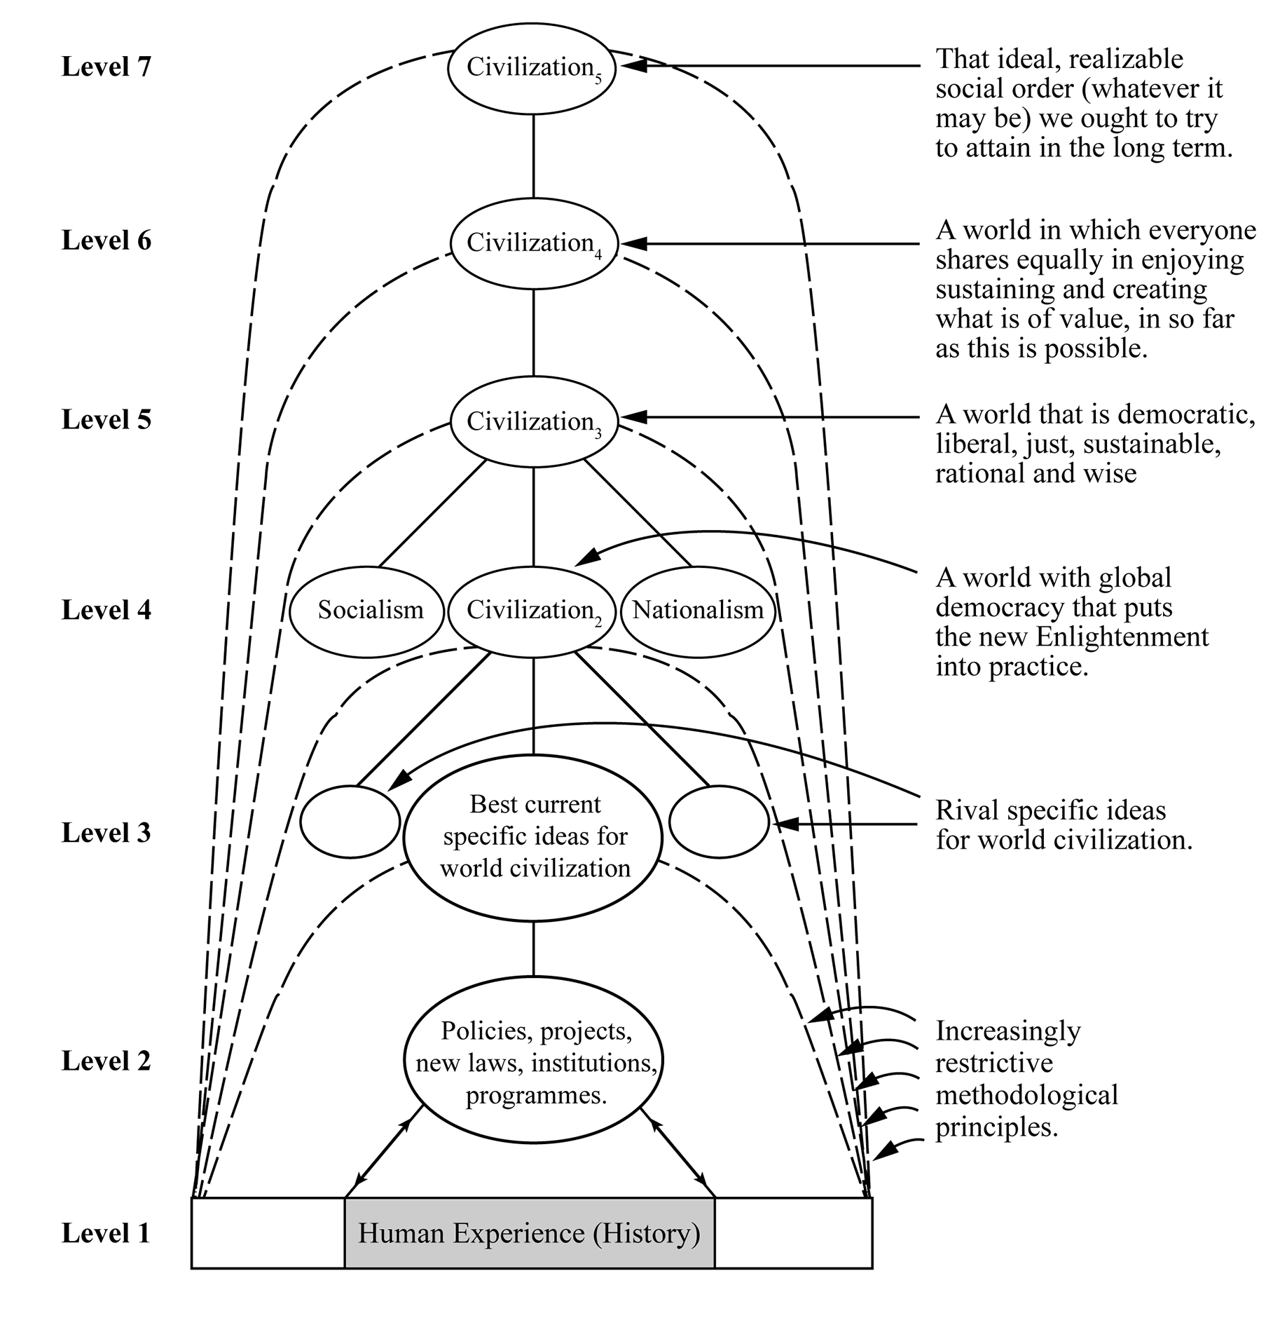

Figure 2: Aim-Oriented Rationality Applied to Creating Civilization
modify our aims, our actions, in the light of what we discover. It is this that we have singularly failed to do. Indeed, we have not even seen the need to make the attempt. Current conceptions of rationality, from Bayesianism to critical rationalism, fail to stress the vital need to improve aims as we act. Social inquiry, instead of actively helping humanity build aim-oriented rationality into social life, has instead concentrated on acquiring knowledge of social phenomena.
It is above all when we come to the immense, and profoundly problematic enterprise of making social progress towards an enlightened, wise world that it is vital to put aim-oriented rationality into practice. The aim of such an enterprise is notoriously problematic. For all sorts of reasons, what constitutes a good world, an enlightened, wise or civilized world, attainable and genuinely desirable, must be inherently and permanently problematic. Only the effective social and political implementation of aim-oriented rationality could hope to empower us to make progress towards such a highly problematic goal as a genuinely good world. Figure 2, formally analogous to Figure 1, indicates what might be involved.
Our failure to correct the three blunders we have inherited from the Enlightenment has meant that we have failed to exploit – even recognize – the full resources of the progress-achieving methods of science which, when generalized, promise to provide the vital assistance we need in order to make social progress towards a genuinely civilized, enlightened world. Aim-oriented rationality is not sufficient; but it is necessary.

Technology and Practical Wisdom
Once upon a time, technological discovery and development seemed to be the key to progress towards a better world. Medical technology enhanced health and longevity; agricultural technology vastly increased production of food; technology in transport, communications, power production, architecture, entertainment, and indeed in every aspect of life, enhanced the quality of life in a multitude of ways.
But in the last few decades, as we have seen, a darker side to all this technological and human progress has become all too apparent. Modern medicine and hygiene have led to the population explosion; there may be as many as 11 billion people on earth by the end of this century, many more than our planet can comfortably sustain. Technologically-enhanced modern agriculture has just about kept pace with the growing human population, but at the expense of the natural world. It has led to the destruction of tropical rain forests and other natural habitats, and the rapid extinction of species. We are living in an age of mass extinction of unprecedented rapidity, caused by us. There is the technology of war, which has vastly increased our power to maim and kill - to the extent that we now even have the power to destroy our world by means of nuclear war. Something like 12 million people were killed in wars in the 19th century, whereas in the 20th century over 100 million people died as a result of war - and we are not doing too well in the 21st century so far. Once upon a time we relied on spears and arrows; now we have the technology of conventional, nuclear, chemical and biological armaments. Perhaps most serious of all, there are the impending disasters of climate change, engendered by the technology of power production and transport that pumps carbon dioxide into the atmosphere (aided by aspects of agriculture and forest destruction). These global problems impact on and intensify each other. Population growth intensifies problems of food production just at a time when climate change sabotages agriculture; as vast areas of the earth, in north Africa, Asia and elsewhere, become uninhabitable, those who have lived there will try to flee to neighbouring lands, already under stress, and will be repulsed - just the conditions for war.
The root of the problem is the one I have already identified. We once thought - and our universities are organized as if we still think - that the key to human progress consisted in this: first, we need to acquire scientific knowledge and technological know-how; then, secondarily, this knowledge and know-how can be applied to help solve social problems. But this traditional procedure, inherited from the Enlightenment, is an intellectual disaster, and a recipe for human disasters - as our modern world reveals all too clearly. If our concern is to make progress towards as good a world as possible, then the problems that fundamentally need our attention and concern are, not problems of knowledge or technology, but our problems of living - problems we encounter as we live our lives, and problems we, and our children, will encounter in the future if we go on as we are, and present trends continue. Problems of living are resolved by what we do, or what we refrain from doing. Even when new knowledge and technology are required - as they are in connection with medicine and agriculture for example - it is always what this knowledge and technology enables us to do, or refrain from doing, that solves the problem, not the knowledge and technology in itself.
At the heart of our thinking, whether in life or in universities, we need to put our problems of living and what we need to do about them, at all levels, from the personal, the social, the institutional, to the international and global. We need to develop in our culture, our social world, traditions of serious, imaginative, critical exploration of what our problems are, and what we might do about them. We need to try to transform our social world so that it comes to encourage and facilitate cooperatively rational tackling of problems of living. Schools and Universities need to engage with, and need to promote, such cooperatively rational tackling of problems of living. And we, the public, need to do this too. Technology without practical wisdom can be, as we have seen, a menace.
There is, however, a gulf between the problems of living we encounter at the personal level as we live our lives, and the problems of living encountered by humanity as a whole - our global problems indicated above. Individually we strive to earn a living, find love, bring up children, achieve success - or perhaps just get enough to eat from day to day. We may be aware of looming global crises: rapid population growth, climate change, devastating loss of natural habitats, disappearance of wild animals and species, wars, tyrannies, pollution of earth, sea and air. Some of us of course, are more aware of these global problems than others. These global crises arise, of course, as a result of the combined actions of humanity. And yet, as far as most of us are concerned, our personal contribution to the creation, maintenance or intensification of these global problems is minute. There is this massive disconnect between the global problems that confront humanity, and the personal problems that confront each one of us in our personal lives.
This is, above all, why we so urgently need to bring wisdom-inquiry into existence. It would be a primary task of wisdom-inquiry to help us bridge the gulf that exists at present between our personal problems of living, and our common global problems confronting all of us together, humanity as a whole. A basic task of wisdom-inquiry would be to help us discover how we can act with others to get the powers that be - governments, multi-nationals, industry, banks, economic systems, media outlets - so to change their ways that we all begin to do what needs to be done to begin to resolve the immense and grave problems that confront us all. We need wisdom-inquiry to help us discover how we can begin to take charge of our future intelligently, rationally, humanely - that is, wisely.
The crises we face have been made possible by the astonishing successes of modern science and technological research. This prompts some to condemn science and technology. We have seen, however, that this is the wrong thing to do. We need to learn from our immense success in solving the first great problem of learning how to go about solving the second problem. The methods employed in solving the first problem - that is, the progress-achieving methods of natural science - when properly understood, properly generalized and, above all, properly implemented, become profoundly relevant to resolving those problems of living, from the personal to the global, that we need to solve in order to make progress towards an enlightened, civilized world. The methods of science hold the key to the practical wisdom we need to acquire to create global civilization.

Conclusion
The upshot of correcting the three Enlightenment blunders, still built into the intellectual/institutional structure of academia today, is a new kind of inquiry – wisdom-inquiry – rationally organized and devoted to help us solve the second great problem of learning, make progress towards as good a world as possible. The scientific task of improving knowledge and understanding of nature becomes a part of the broader task of improving global wisdom – wisdom being the capacity to realize what is of value in life, for oneself and others, wisdom thus including knowledge and technological know-how, but much else besides (realize meaning both “apprehend” or “experience”, and “make real” or “create”).
Universities as at present constituted betray both reason and humanity. We urgently need to bring about a revolution in our universities and other institutions of learning so that they take up the task of helping us solve the second great problem of learning, make progress towards a better, wiser world.

What Needs to be Done to Transform Knowledge-Inquiry into Wisdom-Inquiry
1. There needs to be a change in the basic intellectual aim of inquiry, from the growth of knowledge to the growth of wisdom — wisdom being taken to be the capacity to realize what is of value in life, for oneself and others, and thus including knowledge, understanding and technological know-how (but much else besides).
2. There needs to be a change in the nature of academic problems, so that problems of living are included, as well as problems of knowledge – the former being treated as intellectually more fundamental than the latter.
3. There needs to be a change in the nature of academic ideas, so that proposals for action are included as well as claims to knowledge – the former, again, being treated as intellectually more fundamental than the latter.
4. There needs to be a change in what constitutes intellectual progress, so that progress-in-ideas-relevant-to-achieving-a-more-civilized-world is included as well as progress in knowledge, the former being indeed intellectually fundamental.
5. There needs to be a change in the idea as to where inquiry, at its most fundamental, is located. It is not esoteric theoretical physics, but rather the thinking we engage in as we seek to achieve what is of value in life. Academic thought is a (vital) adjunct to what really matters, personal and social thought active in life.
6. There needs to be a dramatic change in the nature of social inquiry (reflecting points 1 to 5). Economics, politics, sociology, and so on, are not, fundamentally, sciences, and do not, fundamentally, have the task of improving knowledge about social phenomena. Instead, their task is threefold. First, it is to articulate problems of living, and propose and critically assess possible solutions, possible actions or policies, from the standpoint of their capacity, if implemented, to promote wiser ways of living. Second, it is to promote such cooperatively rational tackling of problems of living throughout the social world. And third, at a more basic and long-term level, it is to help build the hierarchical structure of aims and methods of aim-oriented rationality into personal, institutional and global life, thus creating frameworks within which progressive improvement of personal and social life aims-and-methods becomes possible. These three tasks are undertaken in order to promote cooperative tackling of problems of living — but also in order to enhance empathic or “personalistic” understanding between people as something of value in its own right. Acquiring knowledge of social phenomena is a vital but subordinate activity, engaged in to facilitate the above three fundamental pursuits.
7. Natural science needs to change, so that it includes at least three levels of discussion: evidence, theory, and research aims. Discussion of aims needs to bring together scientific, metaphysical and evaluative consideration in an attempt to discover the most desirable and realizable research aims. It needs to influence, and be influenced by, exploration of problems of living undertaken by social inquiry and the humanities, and the public.
8. There needs to be a dramatic change in the relationship between social inquiry and natural science, so that social inquiry becomes intellectually more fundamental from the standpoint of tackling problems of living, promoting wisdom. Social inquiry influences choice of research aims for the natural and technological sciences, and is, of course, in turn influenced by the results of such research. (Social inquiry also, of course, conducts empirical research, in order to improve our understanding of what our problems of living are, and in order to assess policy ideas whenever possible.)
9. The current emphasis on specialized research needs to change so that sustained discussion and tackling of broad, global problems that cut across academic specialities is included, both influencing and being influenced by, specialized research.
10. Academia needs to include sustained imaginative and critical exploration of possible futures, for each country, and for humanity as a whole, policy and research implications being discussed as well.
11. The way in which academic inquiry as a whole is related to the rest of the human world needs to change dramatically. Instead of being intellectually dissociated from the rest of society, academic inquiry needs to be communicating with, learning from, teaching and arguing with the rest of society — in such a way as to promote cooperative rationality and social wisdom. Academia needs to have just sufficient power to retain its independence from the pressures of government, industry, the military, and public opinion, but no more. Academia becomes a kind of civil service for the public, doing openly and independently what actual civil services are supposed to do in secret for governments.
12. There needs to be a change in the role that political and religious ideas, works of art, expressions of feelings, desires and values have within rational inquiry. Instead of being excluded, they need to be explicitly included and critically assessed, as possible indications and revelations of what is of value, and as unmasking of fraudulent values in satire and parody, vital ingredients of wisdom.
13. There need to be changes in education so that, for example, seminars devoted to the cooperative, imaginative and critical discussion of problems of living are at the heart of all education from five-year-olds onwards. Politics, which cannot be taught by knowledge-inquiry, becomes central to wisdom-inquiry, political creeds and actions being subjected to imaginative and critical scrutiny.
14. There need to be changes in the aims, priorities and character of pure science and scholarship, so that it is the curiosity, the seeing and searching, the knowing and understanding of individual persons that ultimately matters, the more impersonal, esoteric, purely intellectual aspects of science and scholarship being means to this end. Social inquiry needs to give intellectual priority to helping empathic understanding between people to flourish (as indicated in 6 above).
15. There need to be changes in the way mathematics is understood, pursued and taught. Mathematics is not a branch of knowledge at all. Rather, it is concerned to explore problematic possibilities, and to develop, systematize and unify problem-solving methods.
16. Literature needs to be put close to the heart of rational inquiry, in that it explores imaginatively our most profound problems of living and aids personalistic understanding in life by enhancing our ability to enter imaginatively into the problems and lives of others.
17 Philosophy needs to change so that it ceases to be just another specialized discipline and becomes instead that aspect of inquiry as a whole that is concerned with our most general and fundamental problems — those problems that cut across all disciplinary boundaries. Philosophy needs to become again what it was for Socrates: the attempt to devote reason to the growth of wisdom in life.
18 Academic contributions need to be written in as simple, lucid, jargon-free a way as possible, so that academic work is as accessible as possible across specialities and to non-academics.
19. There needs to be a change in views about what constitute academic contributions, so that publications which promote (or have the potential to promote) public understanding as to what our problems of livings are and what we need to do about them are included, in addition to contributions addressed primarily to the academic community.

In addition, the following four institutional innovations ought also to be made to help wisdom-inquiry to flourish:

20. Natural science needs to create committees, in the public eye, and manned by scientists and non-scientists alike, concerned to highlight and discuss failures of the priorities of research to respond to the interests of those whose needs are the greatest – the poor of the earth – as a result of the inevitable tendency of research priorities to reflect the interests of those who pay for science, and the interests of scientists themselves.
21 Every university needs to create a seminar or symposium devoted to the sustained discussion of fundamental problems that cut across all conventional academic boundaries, global problems of living being included as well as problems of knowledge and understanding.
22. Every national university system needs to include a national shadow government, seeking to do, virtually, free of the constraints of power, what the actual national government ought to be doing. The hope would be that virtual and actual governments would learn from each other.
23. The world’s universities need to include a virtual world government which seeks to do what an actual elected world government ought to do, if it existed. The virtual world government would also have the task of working out how an actual democratically elected world government might be created.
References
Aron, R. (1968). Main currents in sociological thought, 1. Harmondsworth: Penguin.
Aron, R. (1970). Main currents in sociological thought, 2. Harmondsworth: Penguin.
Barnett, R. & Maxwell, N. (Eds.), (2008). Wisdom in the university. London: Routledge.
Farganis, J. (1993). Introduction. In J. Farganis (Ed.), Readings in social theory: the classic tradition to post-modernism. New York: McGraw-Hill.
Gay, P. (1973). The enlightenment: an interpretation. London: Wildwood House.
Hayek, F. (1979). The counter-revolution of science. Indianapolis: LibertyPress.
Longuet-Higgins, C. (1984). For goodness sake. Nature 312, 204.
Maxwell, N. (1974). The rationality of scientific discovery. Philosophy of Science 41, 123-153.
Maxwell, N. (1976). What’s wrong with science? Hayes, UK: Bran’s Head Books. 2nd ed., 2009, London: Pentire Press.
Maxwell, N. (1977). Articulating the aims of science. Nature 265, 2.
Maxwell, N. (1980). Science, reason, knowledge and wisdom: a critique of specialism. Inquiry 23, 19-81.
Maxwell, N. (1984). From knowledge to wisdom. Oxford: Blackwell. 2nd ed., 2007, London: Pentire Press.
Maxwell, N. (1993). Induction and scientific realism: Einstein versus van Fraassen. British Journal for the Philosophy of Science 44, 61-79, 81-101 & 275-305.
Maxwell, N. (1998). The comprehensibility of the universe: a new conception of science. Oxford: Oxford University Press.
Maxwell, N. (1999). Has science established that the universe is comprehensible? Cogito 13, 139-145.
Maxwell, N. (2000). A new conception of science. Physics World 13, 8, 17-18.
Maxwell, N. (2002). The need for a revolution in the philosophy of science. Journal
for General Philosophy of Science 33, 381-408.
Maxwell, N. (2004). Is science neurotic? London: Imperial College Press.
Maxwell, N. (2005). Popper, Kuhn, Lakatos and aim-oriented empiricism. Philosophia 32, 1-4, 181-239.
Maxwell, N. (2006a). Practical certainty and cosmological conjectures. In M. Rahenfeld, (Ed.), Gibt es sicheres wissen? (pp. 44-59). Leibzig: Leipziger Universitätsverlag.
Maxwell, N. (2006b). The enlightenment programme and Karl Popper,. In I. Jarvie, K. Milford & D. Miller (Eds.), Karl Popper: a centenary assessment. Volume 1: life and times, values in a world of facts (pp. 177-190). London: Ashgate.
Maxwell, N. (2007). From knowledge to wisdom. London Review of Education 5, 2, 97-115.
Maxwell, N.. (2008). Do we need a scientific revolution? Journal for Biological Physics and Chemistry 8, 3, 95-105.
Maxwell, N. (2010). Cutting God in half – and putting the pieces together again: a new approach to philosophy. London: Pentire Press.
Maxwell, N. (2011). A priori conjectural knowledge in physics. In M. Shaffer & M. Veber (Eds.), What Place for the A Priori? (pp. 211-240). La Salle, Illinois: Open Court.
Maxwell, N. (2012). How universities can help humanity learn how to resolve the crises of our times – from knowledge to wisdom: the University College London experience. In G. Heam, T. Katlelle & D. Rooney (Eds.) Handbook on the knowledge economy, 2. Cheltenham: Edward Elgar.
Maxwell, N. (2014) How universities can help create a wiser world: the urgent need for an academic revolution. Exeter: Imprint Academic.
McHenry, L. (ed.). (2009) Science and the pursuit of wisdom: studies in the philosophy of Nicholas Maxwell. Frankfurt: Ontos Verlag.
Notes

See Gay (1973).
See Maxwell (1984, chs. 2, 3 and 6; or 2nd ed., 2007, chs. 2, 3 and 6).
See Maxwell (1998, pp. 36-45).
See Maxwell (1974; 1984, ch. 9, or 2nd ed., 2007, ch. 9 and 12; 1998, ch. 2; 1999; 2000; 2004, chs. 1 and 2; 2005; 2010, ch. 5; 2011; )
For a detailed account of what it means to assert of a physical theory that it is unified, including a procedure for grading degrees of unity, see Maxwell (1998, ch. 4; 2004, pp. 160-174; 1984, 2nd ed., 2007, pp. 373-386).
See works referred to in note 4 and Maxwell (1993; 2002; 2006a).
Maxwell (1984, ch. 9, or 2nd ed., 2007, ch. 9 and 12; 1998; 2002; 2004, chs. 1, 2 and appendix; 2005; 2006a; 2011).
See Maxwell (1977; 1984 or 2nd ed., 2007, ch. 5; 2004, pp. 51-67; 2008).
See Maxwell (2004, pp. 39-47).
Maxwell (1984 or 2nd. ed., 2007, ch. 5; 2004, ch. 3).
See Barnett and Maxwell (2008); Longuet-Higgins (1984); Maxwell (1976; 1980; 1984 or 2nd ed., 2007; 2004, chs. 3 and 4; 2006b; 2007; 2012; 2014); McHenry (2009).
See Aron (1968; 1970); Farganis (1993); Hayek (1979); Maxwell (1984, or 2nd ed., 2007, ch. 6). Autobiographical Note I have devoted much of my working life to arguing that we need to bring about a revolution in academia so that it seeks and promotes wisdom and does not just acquire knowledge. I have published eight books on this theme, including: From Knowledge to Wisdom (Blackwell, 1984), The Comprehensibility of the Universe (Oxford University Press, 1998), and Global Philosophy: What Philosophy Ought to Be (Imprint Academic 2014). For a book about my work see L. McHenry, ed., Science and the Pursuit of Wisdom: Studies in the Philosophy of Nicholas Maxwell (Ontos Verlag, 2009). For nearly thirty years I taught philosophy of science at University College London, where I am now Emeritus Reader. In 2003 I founded Friends of Wisdom, an international group of academics and educationalists concerned that universities should seek wisdom and not just acquire knowledge (see www.knowledgetowisdom.org). For more about my work see http://www.ucl.ac.uk/from-knowledge-to-wisdom and http://discovery.ucl.ac.uk/view/people/ANMAX22.date.html .

