Entanglement, decoherence, and measurement
Art Hobson
Department of Physics, University of Arkansas, Fayetteville

Abstract: The fully entangled “Schrodinger’s cat state” (|A1>|B1> + |A2>|B2>)/√2 obtained immediately upon measurement of a superposed 2-state quantum system A by a detector B is often said to paradoxically predict macroscopically different outcomes, B1 and B2, simultaneously. However, non-local interferometry experiments and their accompanying quantum-theoretical analyses, testing momentum-entangled photon pairs over the full range of phases, demonstrate that the cat state does not fit this description. This state instead represents two non-locally coherent (i.e. dependent on a non-local phase) correlations between its sub-systems A and B. That is, entanglement means that A1 is coherently correlated with B1, and A2 with B2. Even if B is a cat, this state is not paradoxical. Furthermore, standard quantum theory correctly predicts the experimentally-observed non-paradoxical outcomes. Thus both quantum theory and quantum experiments show there is no “Schrodinger’s cat paradox” associated with measurement. This resolves the problem of definite outcomes and, with it, the measurement problem: upon entanglement with a detector, superpositions collapse non-locally and unitarily to one definite macroscopic outcome. No special collapse postulate is needed.

1. INTRODUCTION

As is known, an idealized minimal-disturbance detection (“measurement”) of a 2-state quantum system A in a superposition

|A> = (|A1> + |A2>/√2 (1)

entangles A and its detector B in the state

|AB> = (|A1>|B1> + |A2>|B2>)/√2 . (2)

Here, the |Aj> (j = 1, 2) are orthogonal eigenvectors of an observable with eigenvalues Aj, the |Bj> are orthogonal detector states corresponding to |Aj>, and B is a detector that distinguishes between the |Aj>. Analysts have for decades assumed |AB> predicts the detector is simultaneously in two macroscopically different states. Prediction of such an indefinite outcome (a Schrodinger’s cat state with a dead-and-alive cat) is paradoxical.
This paper shows we have gotten the physical interpretation of |AB> wrong. Both quantum experiments and standard quantum theory demonstrate that |AB> is not a superposition of individual outcomes of A alone or of B alone, but instead a superposition of correlations between outcomes of A and B. More precisely, |AB> implies |A1> and |B1> are non-locally coherently correlated, |A2> and |B2> are non-locally coherently correlated, and precisely one outcome occurs for A and one outcome occurs for B. Even if B is macroscopic, this is not paradoxical.
A similar analysis of entanglement was published previously. The present analysis refines the previous paper and extends it to the entire measurement problem.
The idea behind this paper is that a better understanding of |AB> can resolve the measurement problem. |AB>’s key characteristic is entanglement, which implies a non-local (i.e. violating Bell’s inequalities) relationship between A and B. Furthermore, as Einstein (at Solvay 1927) first pointed out, quantum measurements imply instantaneous non-local connections. This suggests we can better understand |AB> by studying the research on non-locality. A key feature of this research is that it considers the full range of possible non-local phase differences for entangled states such as |AB>, rather than simply phase angles 0 and π corresponding to the perfect correlation or perfect anti-correlation required for measurement. Phase variations of this state’s outcomes reveal precisely what |AB> superposes. In terms of Schrodinger’s iconic image, this state does not superpose an alive and dead cat. It superposes only the correlations between an undecayed nucleus and a living cat, and between a decayed nucleus and a dead cat. This is not paradoxical.
Section 2 studies relevant research on entanglement and non-locality. Section 3 applies the results to the measurement problem. Section 4 summarizes the results.

2. ENTANGLEMENT AND DECOHERENCE

To understand precisely what is superposed in the “measurement state” |AB>, it’s not sufficient to simply analyze measurements because measurements require A and B to be perfectly correlated, implying the phase angle between the superposed terms is fixed at 0 or π. To study a superposition, one must continuously vary its phase. Thus, in this Section we turn to entangled microscopic superpositions.
The interferometer experiment of Fig. 1 exemplifies the non-entangled superposition (1). One photon enters a beam splitter BS1 and reflects along path 1 while transmitting along path 2. Mirrors M reunite the beams, phase shifters φ₁ and φ₂ vary the two path lengths, a second optional beam splitter BS2 mixes the beams at the intersection, and the photon is detected at B1/B2. Over many trials, outcome probabilities vary smoothly from 100% B1 to 100% B2 as the phase difference φ₂−φ₁ varies from 0 to π. Since interference occurs regardless of which phase shifter varies, the single photon must be on both paths.
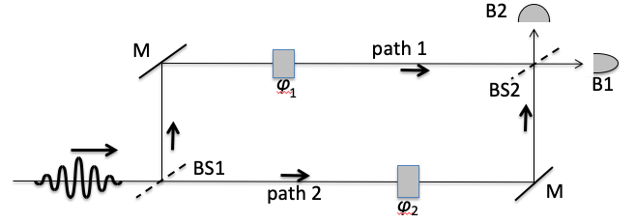
Figure 1. A Mach-Zehnder interferometer. Figures are reproduced from Art Hobson, Tales of the Quantum (Oxford University Press, 2017).

In 1990, two independent groups, Rarity and Tapster and Ou, Zou, Wang, and Mandel, reported on experiments using two entangled photons to study |AB> (Fig. 2). In these "RTO" experiments, the source creates photon pairs A, B in the pure state |AB>. Each pair is in a superposition of moving outward along the solid path and also along the dashed path. Thus A moves along two paths to detectors A1/A2 while B moves along two other paths to detectors B1/B2. The experiment amounts to two back-to-back interferometer experiments (Fig. 1) with two entangled photons and with BS1 located inside the source. It's fruitful to regard the composite system AB as a single "atom of light" superposed along the solid path and the dashed path. Phase shifters φ_{A} and φ_{B} vary the phase difference between the two paths. Each photon encounters a beam splitter that combines the photon’s two beams before detection. The experiment can be regarded as a study of the measurement state |AB>, using microscopic subsystems in order to be able to continuously vary the phase. Each photon “measures” the other.
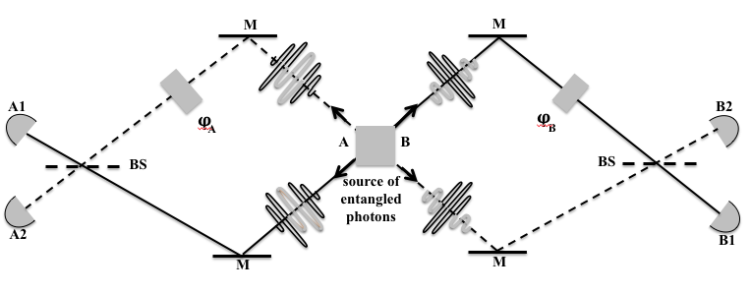
Figure 2. The RTO experiments.

The entanglement changes everything. Strikingly, and (as we shall see) key to understanding quantum measurements, both detectors register phase-independent 50-50 “local mixtures.” Thus, unlike the photon of Fig. 1, neither photon interferes with itself despite being mixed by beam splitters before detection! Note however that neither photon is really in a mixed state, because the overall state of the composite system is the pure state |AB>. Thus, these states are called “local mixtures.” Entanglement has “decohered” both photons, rendering them unable to interfere with themselves even though both participate in a global pure state.
This and further wonders are predicted by a standard (but complex) optical-path-length analysis that simply counts wavelengths from the source to each detector. The experiment has four single-trial outcomes: two "correlated" outcomes (A1,B1) and (A2,B2), and two "anti-correlated" outcomes (A1,B2) and (A2,B1). The optical-path analysis predicts the following probabilities:

P(correlated) = P((A1,B1) or (A2,B2)) = 1/2[1 + cos(φ_{B} − φ_{A})]
P(anticorrelated) = P((A1,B2) or (A2,B1)) = 1/2[1 - cos(φ_{B} − φ_{A})].

The degree of correlation, defined as C = P(correlated) - P(anticorrelated), is simply cos(φ_{B}−φ_{A}), as the experiment confirms (Fig. 3). C varies continuously with φ_{B}−φ_{A}. Despite the arbitrary separation between A and B, an observer at A or an observer at B can instantly change the phase and thus change the correlations. Such local control of the global phase is possible only because the photons are entangled. Were the photons not entangled, the experiment would be back-to-back versions of Figure 1; each photon would interfere with itself in a phase-dependent manner, and the non-local coherence demonstrated in Figure 3 would not occur.
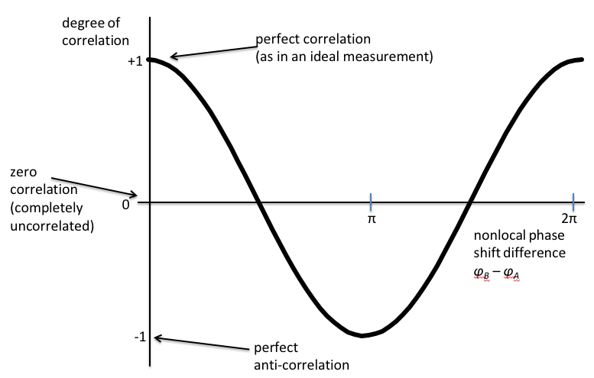
Figure 3. Non-local interference in the RTO experiment.

As the non-local phase varies from 0 to π, we find the full range of correlations between A and B (Fig. 3). The non-locality is obvious. For example, at zero phase the correlation is perfect. How can the two distant outcomes, at A1/A2 and at B1/B2, agree perfectly despite the presence of beam splitters just prior to detection? It’s as though fair coins were flipped at both stations and the outcomes always agreed.
Table 1 compares outcomes of the simple superposition (Fig. 1) with those of the entangled superposition (Fig. 2) at five phase angles. As mentioned, the variation of Table 1 Column 2 with phase demonstrates the single photon interferes with itself. In contrast, Table 1 Column 4 shows the decoherence effect: Entanglement renders both A and B incapable of interfering with themselves so both photons exhibit 50-50 phase-independent mixtures. Indeed, it’s not hard to show directly that, when a composite system AB is in the entangled state |AB>, neither subsystem can be in a superposition c₁|A1> + c₂|A2> (c₁ ≠ 0 and c₂ ≠ 0 ). Thus, when a coherently superposed system A entangles with another system B to form the state |AB>, A loses its coherence and transforms into a phase-independent local mixture.
But the composite system AB remains coherent throughout, as we see from Table 1 Column 5. In the entangled state, the correlations between the subsystem outcomes, rather than the subsystem outcomes themselves, vary continuously and coherently with the non-local phase. That is, (1) is a superposition of states (the state of A varies from |A1> at zero phase to |A2> at 180º), while (2) is a superposition of correlations between states (the correlation between A and B varies with phase from perfectly correlated at zero phase to perfectly anti-correlated at 180º). For example, at zero phase (the measurement situation) |A1> is perfectly correlated with |B1> AND |A2> is perfectly correlated with |B2>, where “AND” indicates the superposition. This is not paradoxical, even if one subsystem is macroscopic. In fact, it’s not paradoxical even if both subsystems are macroscopic, as has been demonstrated.

Table 1. Comparison between a simple superposition (Fig. 1) and an entangled superposition (Fig. 2). In Fig. 1, the single photon's measured state varies with phase. In Fig. 2, entanglement decoheres both photons, and only the correlation between the photons varies with phase.
Simple superposition Entangled superposition of two sub-systems
φ₂−φ₁ State of photon φ_{Β} − φ_{A} State of each photon Correlation between photons
0 100% 1, 0% 2 0 50-50 1 or 2 100% corr, 0% anticorr
π/4 71% 1, 29% 2 π/4 50-50 1 or 2 71% corr, 29% anticorr
π/2 50% 1, 50%2 π/2 50-50 1 or 2 50% corr, 50% anticorr
3π/4 29% 1, 71% 2 3π/4 50-50 1 or 2 29% corr, 71% anticorr
π 0% 1, 100% 2 π 50-50 1 or 2 0% corr, 100% anticorr

3. DECOHERENCE AND MEASUREMENT

In the previous Section, we studied |AB> as an entanglement between two photons, with a non-local phase φ_{B} − φ_{A} that varied from 0 to π. In this Section we return to the measurement situation, where subsystem B is now a macroscopic detector, and the non-local phase is fixed at 0 for perfect detection. In this case, Section 2 tells us |AB> has the following characteristics:

A and B are both in 50-50 local mixtures of their states Aj and Bj;
furthermore, Aj is perfectly and non-locally correlated with Bj (j=1,2). (3)

The term “local mixture” is meant to indicate that neither A nor B are really in mixed states; they are, instead, decohered by the entanglement so A and B behave locally as if they were in mixtures even though they are not in mixtures.
In a single trial of the entangled photons, (3) implies the following: A registers at A1 or A2 with 50-50 probabilities, B registers at B1 or B2 with 50-50 probabilities, and these outcomes have the proper correlations. Thus there is a single definite outcome of the measurement, either A1/B1 or A2/B2 with 50-50 probabilities. This is precisely what we want, and it resolves Schrodinger’s cat.
But this does not entirely solve the measurement problem because (2) is reversible, while a measurement must provide a macroscopic outcome which is, presumably, irreversible. This is a thermodynamic rather than quantum issue. To consider it, let’s study a specific measurement example: The experiment of Fig. 1 but with BS2 now removed so that B1/B2 becomes a which-path detector. After passing through BS1, the photon is in the superposition (1). Approaching the detector, the photon couples with B1/B2 in a unitary von Neumann measurement process that converts the superposition into |AB>.
At the instant of entanglement, correlations form between A and B and the sub-systems jump into incoherent local mixtures, while the composite system AB remains coherent throughout. The composite system transforms unitarily into state (2), but the subsystems lose their coherence, transforming instantly into local mixtures. These mixtures can also be obtained (but with less theoretical rigor) by tracing over either subsystem. A local observer of A observes an instantaneous transition from the coherent superposition (1) to an incoherent mixture. It’s reasonable to call this a “collapse.” The most surprising feature of all this is decoherence: A local observer will find the subsystems in 50-50 local mixtures even though they are both really in the pure state |AB>. There is little doubt about this, because it is verified by both the RTO experiment and its theoretical analysis.
Continuing the measurement analysis: When the photon interacts with the detector to create the entangled state |AB>, a single definite outcome occurs at A and at B, with the proper correlations, and the other outcome does not occur. This resolves the issue Einstein and others have raised: The measurement process must embody a mechanism ensuring that, when one correlated pair (A1 and B1 for example) occurs, the other pair simultaneously does not occur. Entanglement’s non-local properties ensure this.
In a typical photon detector, the interaction excites a single electron that in turn triggers a many-electron avalanche. Detection involves amplification of this avalanche, a process that cannot be reversed in practice because it is complex and unique on each trial, despite that each step in the process is unitary and reversible. Such microscopically reversible processes that are nevertheless irreversible “for all practical purposes” (FAPP) can be described only statistically and are what the second law of thermodynamics is all about. Reconciling the second law with reversible microscopic motion has been a problem for both classical and quantum systems since Boltzmann's day. In other words, at this point our task of explaining how a single macroscopic outcome occurs is finished.

4. CONCLUSION

The RTO experiment and the supporting theory show that subsystems of an entangled composite system are not themselves superposed because entanglement decoheres the subsystems. Thus the entangled measurement state does not entail superpositions of its subsystems and is not paradoxical, even when one subsystem is a macroscopic detector of the other subsystem. This resolves the definite outcomes problem: Schrodinger’s cat is not dead and alive; it is dead or alive.
When a superposed two-state system is measured, the system entangles unitarily with a macroscopic detector. The interaction instantly transforms the global composite system into an entangled pure state while the quantum system transforms into a local mixture having definite outcomes, i.e. the entanglement decoheres the superposed system. Thus one outcome occurs while the other doesn’t occur; the detector’s pre-measurement state transforms into a local mixture of outcomes; and the correlations for which the detector was designed occur. The entire process is unitary. The single outcome that occurs is then amplified and a macroscopic mark registers. The amplification involves numerous microscopic processes that are individually unitary and reversible but that, cumulatively, are for-all-practical-purposes irreversible. This resolves the measurement problem.
This resolution has been “hiding in plain sight” for decades. The key to the solution is the non-local character of measurement. This non-locality implies that entanglement must play an important role. This rather straightforward understanding of the measurement problem has been long delayed by the physics community’s difficulties and delay in understanding non-locality.

ACKNOWLEDGEMENTS

I thank my University of Arkansas colleagues Suren Singh, Julio Gea-Banacloche and Barry Ward for many helpful discussions. I also thank Nathan Argaman, Rodney Brooks, Mario Augusto Bunge, Klaus Colanero, Allan Din, Moses Fayngold, Ron Garret, David Green, Robert B. Griffiths, Ulrich Harms, Norbert Ibold, Ken Krechmer, Franck Laloe, Peter Morgan, Michael Nauenberg, Oliver Passon, Ravi Rau, Gustavo Esteban Romero and Herve’ Zwirn for helpful feedback.

REFERENCES

J. von Neumann, Mathematische Grundlagen der Quantenmechanik (Springer, Berlin, 1932), translated into English by R. T. Beyer as Mathematical Foundations of Quantum Mechanics (Princeton University Press, Princeton, 1955), p. 440.
M. Schlosshauer, Decoherence and the Quantum to Classical Transition (Springer, Berlin, 2007), p. 64.
E. Schrodinger, The present situation in quantum mechanics: a translation of Schrodinger’s ‘cat paradox’ paper, by J. Trimmer, Proc. Am. Phil. Soc. 124, 323-338 (1937).
N. G. van Kampen, “Ten theorems about quantum mechanical measurements,” Physica A 153, 97-113 (1988).
J. Bell, “Against Measurement,” Phys. World 3, 33-40 (1990).
A. Ney, “Introduction,” in A. Ney and D. Albert (Editors), The Wave Function: Essays on the Metaphysics of Quantum Mechanics (Oxford University Press, New York, 2013), pp. 24, 26; also “Ontological reduction and the wave function ontology,” p.171.
Valia Allori, “Primitive ontology and the structure of fundamental physical theories,” in A. Ney and D. Albert op. cit., pp. 67, 68.
D. Wallace, “A prolegomenon to the ontology of the Everett interpretation,” in A. Ney and D. Albert op. cit., pp. 209, 210.
R. Sherrer, Quantum Mechanics: An Accessible Introduction (Pearson/Addison-Wesley, San Francisco, 2006).
L. Ballentine, Quantum Mechanics: A Modern Development (World Scientific, Singapore, 1998).
D. Griffiths, Introduction to Quantum Mechanics (Pearson/Prentice Hall, Upper Saddle River, JN, 2005).
W. Greiner, Quantenmechanik. I, Einfuehrung (Springer, Berlin, 1994).
A. Rae, Quantum Mechanics (Institute of Physics, Bristol, UK, 2002).
A. Hobson, “Review and suggested resolution of the problem of Schrodinger’s cat,” Contemporary Physics 59, 16-30 (2018).
J. Bell, “On the Einstein-Podolsky-Rosen paradox,” Physics 1 (1964), 195-200.
Manjit Kumar, Quantum: Einstein, Bohr, and the Great Debate About the Nature of Reality (W. W. Norton & Co., New York, 2008), pp. 263-266.
L. Gilder, The Age of Entanglement: When Quantum Physics Was Reborn (Alfred A. Knopf, New York, 2008), pp. 110-112.
J.G. Rarity and P.R. Tapster, "Experimental violation of Bell's inequality based on phase and momentum," Phys. Rev. Letts. 64, 2495-2498 (1990).
Z.Y. Ou, X.Y. Zou, L.J. Wang, and L. Mandel, "Observation of non-local interference in separated photon channels," Phys. Rev. Letts. 65, 321-324 (1990).
For a non-technical introduction to the RTO experiments, see A. Hobson, Physics: Concepts & Connections (Addison-Wesley/Pearson Education, fifth edition 2010), pp. 303-307.
M. Schlosshauer op. cit.
M.A. Horne, A. Shimony, and A. Zeilinger, "Introduction to two-particle interferometry," in Sixty-Two Years of Uncertainty, ed. by A. I. Miller (Plenum Press, New York, 1990), 113-119.
The data violate Bell’s inequality at all phase angles except nπ/2 (n = 0, 1, 2, 3, 4). Thus the experiment doesn’t actually violate Bell’s inequality at zero phase, despite the obvious non-locality due to the presence of the beam splitters. Violation of Bell’s inequality is a sufficient, but not necessary, condition for non-locality.
A. Hobson, “Two-photon interferometry and quantum state collapse,” Phys. Rev. A 88, 022105 (2013).
L. Ka Chung and colleagues entangled the vibrational states of two diamonds, each a thin flat square 3 mm on a side containing 10¹⁶ carbon atoms, separated by 15 cm. L. Ka Chung et. al., “Entangling macroscopic diamonds at room temperature,” Science 334, 1253-1256 (2011).
M. Schlosshauer op. cit., p. 64.
M. Schlosshauer op. cit., pp. 41-42, 48-49.
J. Bell, “Against measurement,” op. cit.
A. Hobson, Concepts in Statistical Mechanics (Gordon and Breach Science Publishers, New York, 1971; republished by the CRC Press, Taylor & Francis, 1987), Chapter 5 “Irreversibility.”

