The Realist Game: Scientific Theories and QBist Ontology
Gino Elia
Stony Brook University
Introduction
The question I am posing in this talk is, how should we understand the search for ontology assuming that metaphysics, physics, and metascience are not fundamentally separable? Can one make a list of criteria for that search? Philosopher of physics Tim Maudlin has argued that if metaphysics should play a role for investigating ontology, it should be a “careful analysis of our best scientific theories” and what they imply about the world (2007, 104). In one sense this is a positive appraisal of metaphysical analysis, but in another sense, the writing is on the wall. Maudlin denies that there is anything like “pure metaphysical relations” and then looks to theories like gauge theory to convey ontological structures. Maudlin also believes his ‘physics-first’ stance toward metaphysics is “different than that commonly practiced today” (2007, 104). The bread and butter of traditional metaphysics in the history of Western philosophy has been to find a framework of sorts that offers terra firma for the sciences. We ask for this grounding when we draft a map or a narrative about why science works, and we often have these conversations without citing any specific scientific theory. This reason, I suspect, is why it is harder to agree with Maudlin’s argument than at first glance. Maudlin’s attitude supports the notion that metaphysics cannot undermine the intelligibility of physics, but since many philosophers of physics are also physicists and physics educators, we still want a coherent story about what physics means that is resilient enough to withstand modest changes within and across physical theories but also not so bland that the mission of physics is to simply “investigate stuff” (although for some, that’s absolutely enough!).
This pedagogical point is the most obvious goal of what I call “the realist game.” The game of realism is to articulate a reasonable “list” of ontological commitments and strategies - like McMullin’s longevity, explanatory power, and so on - that satisfy the need for physics to articulate its intelligibility without philosophers swooping in and imposing a metaphysics that tells us, perhaps misleadingly, what physicists are “really doing.” Philosophers have played the realist game many times (too many to cite in fact!). My strategy for playing the game is to heed Maudlin’s advice: “one must look to scientific practice rather than philosophical prejudice” (2007, 1). Winning the realist game then is about describing how scientific practices articulate their own ontological commitments. Our priorities change with this shift in perspective. Maybe we tend to misunderstand the search for ontology as a search for “THE” ontology, almost akin to an ideal object. But the so-called “invariants” from our practices, our formalism, our diagrams, our experiments, etc. – are already ontologically robust.
I. Ontology almost never looks like “an” ontology
Before I give my version of the realist game, I want to motivate the guiding idea behind it, that one can devise, implement, and reap the rewards of an ontologically fruitful strategy without committing to a single ontology. David Kaiser’s book Drawing Theories Apart illustrates this virtue. Kaiser studies the dispersion of Feynman diagrams from Feynman himself to physicists across the world. A Feynman diagram is a simplified representation of particle interactions.
Here are some Feynman diagrams from physicists at Cornell, Columbia, Rochester, Chicago, Urbana, and Oxbridge (Kaiser 2005, 21):
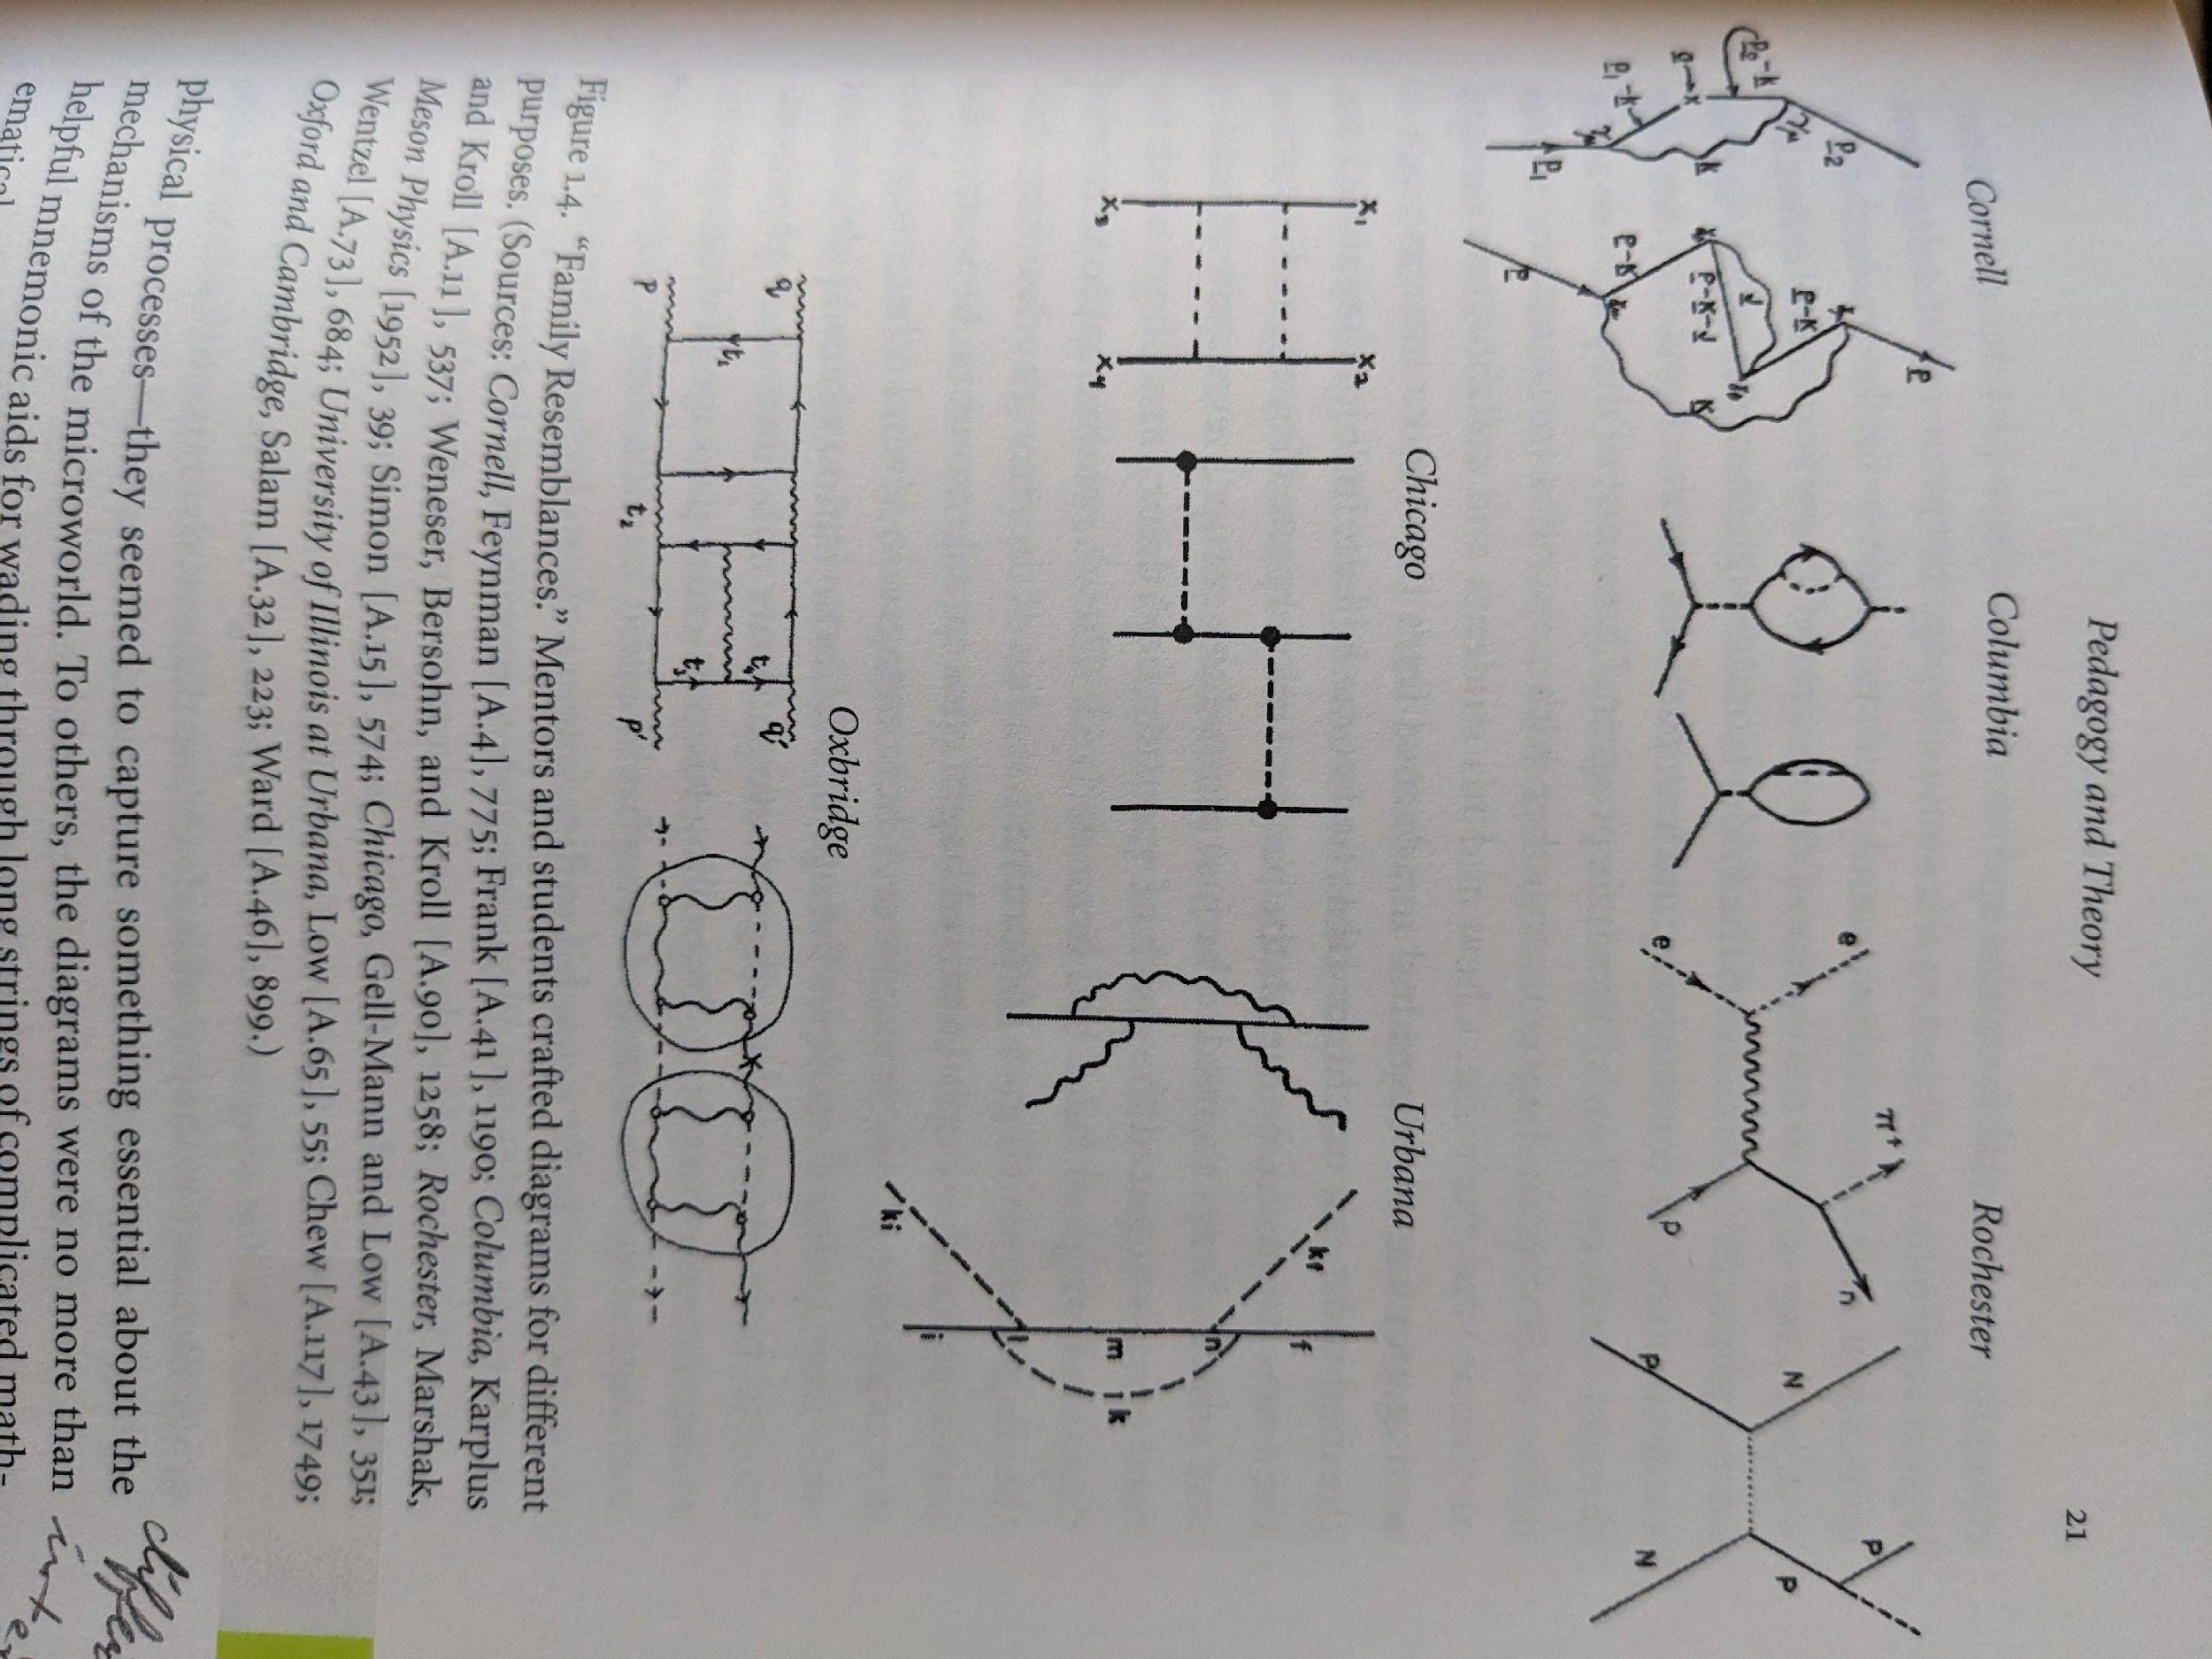
Each representation tells a slightly different story, whose diversity multiplies when the diagram is coupled to the interests and intentions of physicists. When a cynical person sees a diversity of opinions and representations in science, they may hold that scientists do not know what they’re talking about (muddying expertise). An equally cynical person may say that all these scientists must be presupposing an ontology in order for these representations to be said to “represent” anything at all (all or nothing). Kaiser wants to dissuade us from these pessimistic thoughts while emphasizing that no uniform theoretical picture was latent in physicists’ minds:
…physicists in various places differed on what their diagrams purported to show. To some, the diagrams functioned as pictures of physical processes – they seemed to capture something essential about the mechanisms of the microworld. To others, the diagrams were no more than helpful mnemonic aids for wading through long strings of complicated mathematical expressions – they were not to be confused with the stuff of the real world. Still others developed the diagrams as tools for a new kind of diagrammatic reasoning…Most often these distinct roles blurred together in practice (2005, 21).
What I want to say about this diversity is that one can dignify the ontological value of a paper tool without turning it into its own signifier. In this sense, nothing about Feynman diagrams is exceptional; this is the norm. The “looseness” of the representation works to its benefit, as opposed to another cynical take, like saying that these representations become “incommensurable” with each other over time.
Feynman himself did not try to impose any uniform interpretation on his tools:
The diagram is really, in a certain sense, the picture that comes from trying to clarify visualisation, which is a half-assed kind of vague [picture], mixed with symbols. It is very difficult to explain, because it is not clear…what I am really trying to do is to bring birth and clarity, which is really a half-assedly thought out pictorial semi-vision thing. OK? (Schweber 1994).
Of course, as far as ontology is concerned, Feynman’s description is certainly not bad! Kaiser’s broader point, however, is that in his historical study of Feynman diagrams, we do not find well-defined “theories” articulated as objects (2005, 377-378). We find “paper tools” or “theoretical technology” for mediating representations of phenomena (Kaiser 2005, 9).
II. There is no such thing as theories!
Philosopher of physics Steven French reaches a very similar conclusion as Kaiser in his book, there are no such thing as theories (the title gives it away) (2020). Of course, French is not saying we cannot formulate and defend theories; his point is that the theories are not “objects out there.” This is also not to say that we can simply identify theories with scientific practice either. In his view, this would turn “types” of practices into “types” of theories. Rather the “truth-makers” for our theories, as he calls them, are grounded in the relevant scientific practices: the postulates, the diagrams, the experiments, the formulae, and so on... So when we say, “quantum mechanics is an elegant theory,” the theory itself is not a referent that grounds truth-conditions. Those come from all the criteria and meta-criteria we use (and argue about) to judge “elegance,” such as an equation’s simplicity or its symmetry. For truthiness, French wants to refer us to the sausage-making of science.
French’s argument is clearly directed to philosophers who objectify theories and their elements as to ontologically inflate them to an intolerable extent. Of course, ontological inflation poses other problems for scientific realism. Many philosophers criticize representations full stop on the grounds that being ontologically committed to their elements is a form of reification (French 2020, 96). Reification plays into Maudlin’s concern about undermining physical ontology. If I say, “Schrodinger’s equation is true,” it seems bizarre to claim that I have “reified” nature into a bunch of wave functions or regard this equation as furniture of the world. But that’s not what I mean at all! Philosopher of physics Hans Halvorson has poked fun at philosophers who oscillate between treating quantum states like literal things or treating them as mere calculational devices (2019). We, as singer-songwriter Billy Joel once said, “go to extremes” between literalism and instrumentalism.
French argues this puzzlement originates in the notion that we are treating theories like things. Kaiser and French both caution that we cannot take for granted a seemingly pristine presentation of a theory in histories and textbooks as “THE” theory (2020, 223). French’s solution is to look for “truth-makers” that are not carbon-copies of the theory itself, hence his emphasis on relevant scientific practices.
III. QBism’s Ontological Strategies
As I turn to QBist ontology, it seems we can tell a similar story. QBism does not treat quantum theory as an “object” out there, but like with the Feynman diagrams, this does not mean we should read physicists who decline to turn ontology into a thing as also declining ontological commitments altogether. Physicist Chris Fuchs has often described quantum mechanics as a “user’s manual,” but one can always ask what is it about the world that makes this manual the right one for interacting with quantum systems. As Fuchs says:
QBism’s tack was to ask over and over, what is it about the world that makes us well-advised to use the calculus of quantum mechanics for structuring our probabilities?...Getting reality right would follow for those who had patience enough to pass the marshmallow test (2023, 1).
QBism asks us for patience in our ontological search. In that spirit, since QBism does not treat quantum states like real things, it misses the point to ask what they are realist about. But our patience does not have to stretch out to infinity; we can talk about QBist methods to investigate reality. I’ll briefly mention three ontological strategies in QBism:
- Reconstruct quantum theory in a way that hints at its most fundamental principles.
- Identify invariants of the theory to which we must all agree on to make useful predictions (like the Born Rule).
- Stating what quantum theory is not about clarifies what nature is about (cutely called “apophatic” quantum mechanics, but I think is closer in spirit to Weyl’s ‘‘ineliminable residue of the annihilation of the ego,” or separating subjective from objective without getting rid of either notion).
The emphasis of these strategies is figuring out the ‘shape’ of ontology or what’s suggestive about the formalism more so than proposing an ontology ready-made. The ontological search does not have to take existing formalism as sacrosanct or restrain that search to reading formalism into nature. One can reconstruct a theory to shine a light on what’s most interesting about it, why these tools are useful for us. For an analogy, Fuchs asks us to imagine the tail of a single-celled organism called a Euglena: “The tail is a single-user tail. But we can look at the tail and ask things like, what might we learn about the environment by studying its structure?... So quantum mechanics is a single-user theory, but by dissecting it, you can learn something about the world that all of us are immersed in” (2016, 13). As embedded beings, we survey the world from within, but one can still ask, through this situatedness, what kind of world is that?
My take on these ontological strategies is that they do hint at a concrete claim about reality. If one does not think that states are predicates of systems, as QBism holds, and if one believes that our theories are about existence without encapsulating that existence in a formal system, then the “aboutness” of a theory itself is a feature one can point to. In fact, it is a perpetual aboutness that nearly mimics that fundamentally provisional nature of science. Meaning, the ontological value we attribute to certain phenomena may not be the same all the time. A “bet” on a quantum system does not compel nature to obey one’s state assignment even when certain; nature, by virtue of its externality, can surprise us.
IV. Playing the Realist Game
With this setup, I think the realist game is easier to play. Some of the traditional criteria we ask for a philosophy of science to express are
- a physicalist demand,
- a realist demand,
- and a naturalist demand.
As we have seen, the goal of these demands is to articulate ontological commitments while not overcommitting to a single viewpoint. I define the physicalist demand as follows.
Physicalism. Physics is about whatever physics is about.
Some readers will recognize the philosophy of Stanley Cavell in this definition when he expressed, “Ordinary language philosophy is about whatever ordinary language is about.” The aim of this definition is to prevent an external source of intelligibility from telling us what physics is about, thereby reifying the discipline.
Moving on, the realist demand is:
Realism. Physics, broadly construed, has an ontological status.
A common tendency is to regard realism as a hypothesis that physics can affirm or deny. I personally do not think reality is hypothetical, but we can immediately see how reality would look that way when we construe “the real” as being a feature of our preferred ontology. If we said realism means being a realist about quantum states, for example, then we automatically make many physicists “anti-realists” in our imagination. Reality becomes an open question. The problem is to conflate our ontological intuitions with realism itself. If our outlook is constrained to a single ontology, then we lose the ability to tell the difference between genuine ontological disagreements about physics and the doctrine of anti-realism. The damage this does to science, in my view, is underestimated. The realist demand, as I defined it, expresses ontological commitments, but to play nice with the physicalist demand, it has to be open-ended.
The naturalist demand is similar to French’s position:
Naturalism. There is an ontologically preferred language that helps me “get around” to different theories.
I believe the demand for naturalism is often a statement about intelligible translation, i.e. continuity, between different ways of looking at the world. I found this aspect very helpful in French’s account. He does not identify an ontologically preferred language with a single theory or a sweeping generalization. An ontologically preferred language is a throughline among different ways of talking about nature, whatever form it takes. We do not want adopting theory-one to render unintelligible and mysterious theory-two. In a naturalist frame, one can emphasize, in the story of ‘Eddington’s two tables,’ the oneness of the table as the focal point of theory-change despite Eddington himself playing up the drama of the classical table being a different world-picture than the quantum table. The ontological significance of that focal point - even as a placeholder - is non-negligible. The idea is that a natural philosophy of science can accommodate the multiplication of theories without rendering the world “unnatural” according to some other theory, but this is precisely what happens when we take the notion of “theory” too literally.
Conclusions: Should we play this game?
We end with the questions; can one pitch a perfect game for realism? Are the well-known frustrations of the realist/anti-realist debates worth the effort? If the distinction between science and metascience is a nothing-burger, then it seems excluded from the outset to even consider a set of meta-criteria for philosophy of physics that act as an “independent framework” for activities within physics. Someone has to make a concrete claim somewhere, and without a magical “cut” between science and metascience, we are left with the realization that philosophers of physics operating at the meta-scientific level are addressing physics in a way physicists can respond to and vice versa.
I argued a plausible way to play the realist game is to acknowledge this and try to take advantage of the blurriness between metascience and science. A good example of the realist game is Ernan McMullin’s A Case for Scientific Realism, where he argues it is the necessity of vagueness in our criteria that prevent realism’s “easy refutation” (1984). I would add that this vagueness is more of the ‘usefully ambiguous’ variety. One philosopher’s vagueness is another’s sign that we may be misconstruing what ontology is really like for us. On the first pass of the realist game, the shifty “aboutness” of physics was a sort of ontological minimum, but now this aboutness itself is a site of future analysis. In addition, I brought in Kaiser and French to build the intuition that one can already appreciate the ontological value of scientific practices without turning them into ontological signifiers, but one is not simply done. Those practices are analyzable in their particulars. QBism also facilitates this observation. In the absence of proposing an object-like ontology, new ontological strategies emerge as salient.
Of course, my sketch does not preclude stating or defending one’s ontological intuitions, but it seems wrong to say that not having “an” ontology means that physicists don’t have ontological commitments at all. I have a critique of philosophers David Wallace and Peter Lewis in mind, both of whom have said the quest for reality is either metaphysics, conventionally understood as an articulated ontology, or “shut up and calculate” (they “go to extremes”) (Lewis 2016, 43; Wallace 2021, 130). Despite their dichotomy, many they mislabel as shutting up and calculating likely do see ontological value in their work. This suggests it is disingenuous to leverage somebody’s realist/anti-realist distinction to attempt to give credibility to one’s preferred metaphysics. Instead, the thesis that capital “O” Ontology does not automatically take the form of “an” ontology, like a “thing,” is the one I understand as worth pursuing.

References
Clifton, Rob, Jeffrey Bub, and Hans Halvorson. 2003. “Characterizing Quantum Theory in Terms of Information-Theoretic Constraints.” Foundations of Physics 33 (11): 1561–91.
French, Steven. 2020. There Are No Such Things as Theories. Oxford University Press.
Fuchs, Christopher A. 2016. “On Participatory Realism.” https://arxiv.org/abs/1601.04360.
———. 2023. “QBism, Where Next?” In Phenomenology and QBism.
Kaiser, David. 2005. “Drawing Theories Apart: The Dispersion of Feynman Diagrams in Postwar Physics.” University of Chicago Press.
Lewis, Peter J. 2016. Quantum Ontology: A Guide to the Metaphysics of Quantum Mechanics. Oxford University Press USA.
Halvorson, Hans. 2019. “To Be a Realist about Quantum Theory.”
Maudlin, Tim. 2007. The Metaphysics within Physics. Vol. 69. Oxford University Press.
McMullin, Ernan. 1984. “A Case for Scientific Realism.” In Scientific Knowledge, edited by Janet Kourany, 369–85. Wadsworth Publishing.
Schweber, S.S. 1994. QED and the Men Who Made It: Dyson, Feynman, Schwinger, and Tomonaga. Princeton University Press.
Wallace, David. 2021. Philosophy of Physics: A Very Short Introduction. Oxford: Oxford University Press.

We could go further. Sellars pursues a very similar line of thinking in Science, Perception and Reality (1963, 96-97). French argues the claim that theories don’t exist pairs with the claim that we are ontologically committed to the relevant scientific practices that act as truth-makers for the theory. Sellars pairs the claim that “tables don’t really exist” with the claim that a scientific theory has a more preferred ontological language for talking about tables. For French and Sellars, the move is to avoid ontological foundationalism, to say the “table exists” if and only if the table itself, as its ontological entity, exists. Truth conditions for the existence of tables does not compel table-ontology. Same for particles. According to French, we can be loose in making truth claims about particles without a theory telling us they do (or more crudely, treating them as metaphysically simple). Particle existence does not compel particle-ontology. Of course for both philosophers, we can ask how they are using table, particle, theory as ontological placeholders as they juggle explanatory frameworks for their ontology.
See Cavell’s Must We Mean What We Say (1958). The definition is based on “Ordinary language philosophy is about whatever ordinary language is about” (Cavell 2002, 95).

