A brief response to Seifert

Eric Scerri

Abstract. In this brief article I respond to Seifert’s recent views on the periodic law and the periodic table in connection with the views of philosophers regarding laws of nature. I argue that the author makes some factual as well as conceptual errors which are in conflict with some generally held views regarding the periodic law and the periodic table.

---------------------------------------------------------------------

In a recent article Seifert correctly points out that little attention has been devoted to the question of laws in chemistry.[1] She then proceeds to summarize, in some detail, the main current views on laws of nature among philosophers, including the Humean as well as the necessitarian approach.

Having done so, the author turns to chemistry and considers what she believes to be two candidates for laws in chemistry, namely the so-called periodic law and chemical reactions. In this brief response I intend to address just the first of these topics, the periodic law. Seifert begins with the sentence that,

The periodic table is a visual representation of all the known chemical elements (Seifert, 2025).

This statement seems a little loose, at least to the present author, who would prefer to rephrase it to emphasize that the periodic table is a visual representation of the relationship that exists among certain groups of elements. Said otherwise, it is a visual representation of chemical periodicity and not just of the elements *tout court*.[2]

I have a more substantial objection to the very next two sentences in the article in question.

The elements are placed in order of increasing atomic number and chemists employ it so as to make statements about various physical and chemical properties of matter. Such statements include for instance that ‘Metals are poor conductors of heat’, ‘Plutonium is radioactive’ or ‘When a metal reacts with oxygen it forms a metal oxide’ (Seifert, 2025).

The first sentence would appear to be reasonable, were it not for the fact that it is so general as to render it rather impotent. As can be seen in the quotation, Seifert then gives three examples of properties which in my view are completely independent of the periodic law. Let us examine each example in turn.

Example 1. Metals are poor conductors of heat.

Before commenting on this claim, it must be pointed out that it is factually incorrect in that the opposite is true! It is a well-known fact in elementary chemistry that metals are good conductors of heat as well as of electricity. Think for example of putting one’s hand on a metallic car radiator after the engine has just been switched off. On the other hand, it is non-metals that are poor conductors of heat. This is why coffee cups are often made out of polystyrene which is of course a non-metal. If one consults a list of elements that show their relative conductivity of heat it becomes glaringly obvious that the vast majority of good conductors are metals, while all poor conductors are non-metals (Ho et al., 1972). Nor does the author’s statement appear to be a typographical error given that it is repeated on a further three occasions in the same section of the article.

Be that as it may, let us consider a corrected version of what the author should have stated,

Metals are good conductors of heat.

The main point I wish to make is that this property of metals is independent of the periodic table and/or the periodic law. Consider for example the sequence of ten consecutive elements in the first transition series from scandium to zinc, all of which have high thermal conductivities. The periodicity in the properties of the elements which lies at the heart of the periodic law is not at play here, and nor is it relevant in the case of all the other metallic elements which are situated in many different parts of the periodic table.

The only sense in which the author’s claim might have been true would have been if only the members of one or two particular groups of elements were good conductors. In such a case the property of heat conduction could be explained, at least in a veery loose sense, by pointing to the fact that these elements are related to each other via chemical periodicity. Needless to say, this would still be a rather weak appeal to chemical periodicity since the explanation of thermal conductivity lies in the physics of heat conduction and not in the mere fact that the elements might fall into the same column of the periodic table.[3]

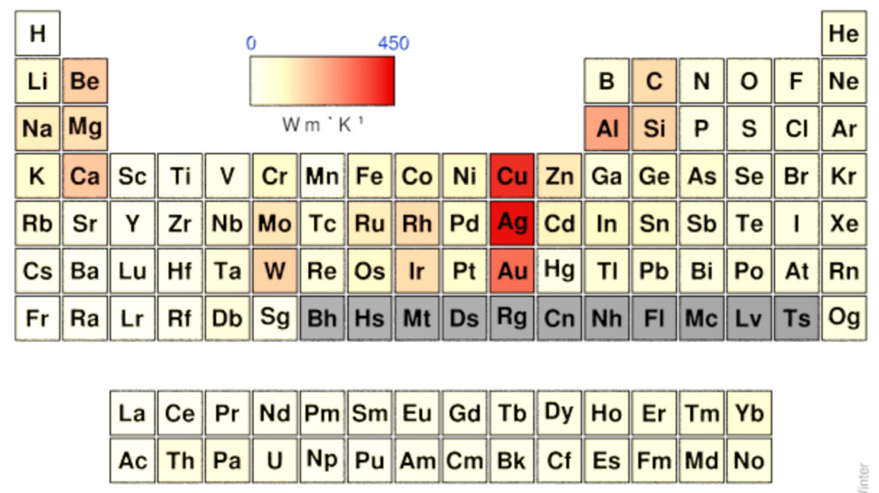

Figure 1. Thermal conductivity of elements. The highest thermal conductors among all

the elements are copper, silver and gold. Elements with paler shading are poor conductors of heat, including all the non-metallic elements with the exception of carbon and silicon. By permission from Professor Mark Winter, <https://www.webelements.com/periodicity/thermal_conduct/>

Example 2. Plutonium is radioactive.

Fortunately, this statement is factually correct. However, I think it may be even less relevant to the question of whether chemists refer to chemical periodicity and the periodic table in making statements of this kind? This is because Siefert’s example refers to a single element unlike her first example which dealt with metallic elements in general. In trying to improve on the authors second example might I suggest a statement such as “elements with high atomic numbers tend to be radioactive”. This modified version would represent at least some connection with the periodic table, although again not with the essence of chemical periodicity, which consists in the approximate repetition of properties after certain intervals in the atomic number sequence.[4] In fact the majority of radioactive elements follow each other in a sequential manner starting with polonium which has an atomic number of 84.[5]

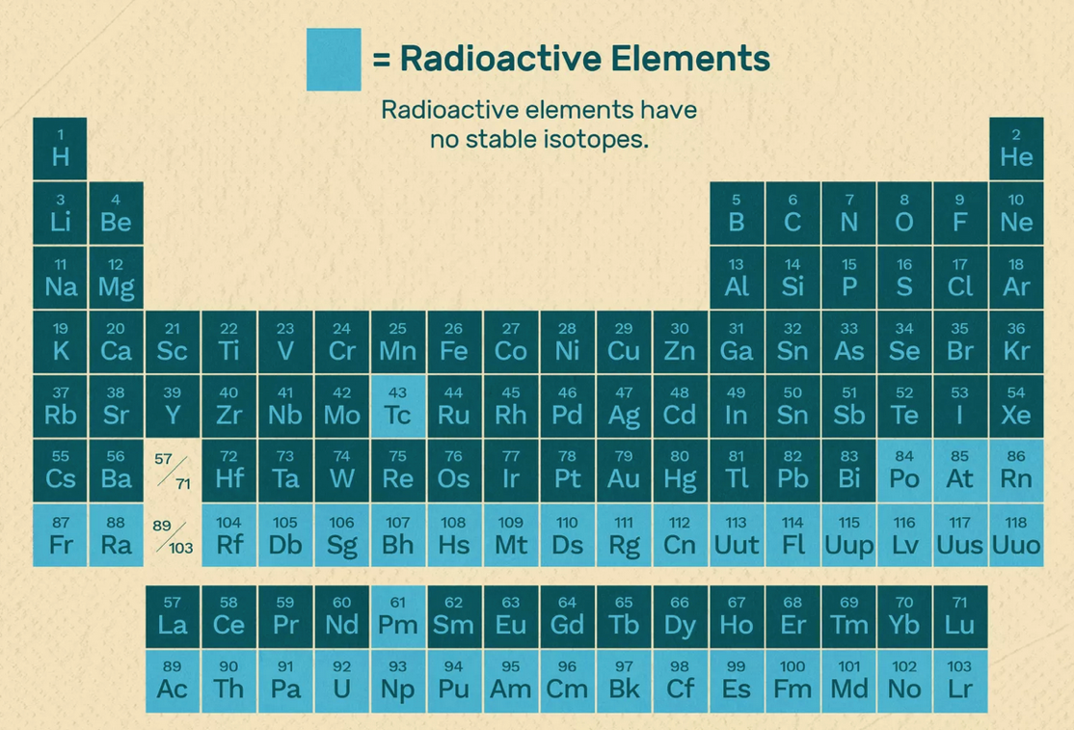

Example 3. When a metal reacts with oxygen it forms a metal oxide.

The statement if of course correct but quite independent of the periodic table. As in the case of example 1, this is a property of all metals and therefore not related to chemical periodicity as such. A chemist making statements about such reactions as those involving metals with oxygen does not need to appeal to the periodic table. Again, if we were living in an alternative world in which only the elements in group one, for the sake of argument, were to form metal oxides then some appeal to group behavior might be appropriate. In addition, the example is rather uninformative and virtually tautological. Perhaps the author intended to write that metals combine with oxygen to form basic oxides while non-metals which form acidic oxides.

**Is the periodic table a representation of one or many laws?**

Seifert believes that the periodic table is a representation of many laws, although she does not elaborate this claim any further in the paper under discussion. She writes,

The statements chemists make by employing the periodic table such as that ‘Metals are poor conductors of heat’ (sic) are candidate statements of laws of nature. Once again, I don’t see why a chemist needs to enlist the periodic table even if they should wish to claim that the thermal conductivity behavior of metals might be a law. The author proceeds to say that there are two good reasons to consider these statements as laws. The first is that the example statement shows all the following properties,

They are statements that involve general concepts and not proper names,

Their truth is not decided on the basis of logic,

They unify diverse matters of fact,

They explain and predict a vast range of phenomena,

They are used to make inductive inferences about particular matters of fact.

But such criteria are rather general and could apply to theories as much as to laws for example.

For example, consider the second of these desiderata for laws, namely that their truth is not decided on the basis of logic. Surely there is very little in the practice of science that is decided just on the basis of logic. Does this desideratum really rule out statements that are not laws?

Similarly, there are other things in the practice and theory of science that unify diverse matters of fact but we would not necessarily wish to call them laws. More importantly, even if the above criteria were to suffice to identify true laws of nature, what is to be gained from the establishing the fact that there are many laws within the discipline of chemistry that are subsumed by the period law? [6]

Seifert moves on to making the following claim,

In fact, examining the regularities expressed by the periodic table in the context of the two main accounts on laws can inform existing questions and problems regarding the latter. For example, a major issue (if not problem) in the context of the BSA is how to evaluate simplicity and strength. As mentioned above, these values have been criticized because- among other things- there are different ways to spell them out and this may be suggestive of their ambiguous- if not subjective- nature. From the perspective of the periodic table, it is possible to cast new light onto these values in a way that can contribute positively to the further development of the BSA (Seifert, 2025).

However, instead of explaining how this vague promise could be fleshed out, the author immediately leaps forward to make another promissory and unfulfilled claim,

Similarly, with the necessitarian view. One interesting issue is that of uninstantiated laws and how it is dealt by standard necessitarian accounts, such as Armstrong’s account in terms of universals (see above). According to Armstrong, “(s)tatements of uninstantiated law tell us that a certain law would govern the antecedent universal, if, contrary to fact, that universal existed, that is, was somewhere instantiated” (1983: 117). In the case of the periodic table, one could argue that there are uninstantiated universals in the form of super-heavy elements which have not yet been discovered but are (or at least seem) possible. Do the regularities purported by the periodic table about these elements count as examples of uninstantiated laws and, if so, does this undermine Armstrong’s denial of such laws? (Seifert, 2025).

Seifert does not however venture any view as to whether or not unsubstantiated elements, taken to mean yet undiscovered super-heavy elements, do or do not support Armstrong’s position.

Finally, the section on the periodic table ends with Seifert’s admission that she has failed to put up any position whatsoever regarding her prime example of a chemical law, namely the periodic law and all the many laws that she believes it subsumes.

Admittedly, there is a lot to unpack here and I do not purport to have sufficiently sup-ported any of these views of laws with respect to the regularities depicted by the periodic table. I do not wish to convince the reader that the statements chemists make via the use of the periodic table are definitely laws of some form (see Seifert accepted/preprint). Instead, I wish to show that one can coherently entertain this idea and that interesting research questions arise by doing so (Seifert, 2025).

One has to wonder what purpose this article is intended to serve, other than as a summary of the various views about laws of nature that are currently on offer. As many authors go to great lengths to point out, the best work in the philosophy of science consists of paying close attention to actual scientific details and trying to draw some philosophical conclusions from them. What Seifert is engaged in appears to be of quite the opposite kind of project. She is conducting a survey of the various accounts of laws of nature among philosophers and then attempting to impose these views onto what may or may not be laws in chemistry.

Then as an afterthought Seifert recalls that there has already been an attempt to investigate the nature of chemical laws while concentrating on the periodic law. Or as Seifert writes,

Andrea Woody brings out the idea of lawful regularities with respect to the periodic table and emphasizes the need to thoroughly examine the table from the perspective of laws. As she states:

(Chemistry’s periodic law) has served as stock example in contemporary discussions of the relative evidential weight of accommodation versus prediction even while its status as a law has seldom been scrutinized. (Woody 2014: 3)

In the following section I briefly consider Woody’s views of the periodic law as well as Seifert’s comment above.

**Seifert’s interpretation of Woody on the periodic law**

Contrary to what Seifert writes above, Woody does not in fact bring out the idea of lawful regularities with respect to the periodic law. Instead, Woody writes that the periodic law *cannot* be made to fit the standard philosophical mold of scientific laws for a number of reasons. One of her reasons for saying so is that “few efforts have been made to give it a mathematical form”. As I commented in my response to Woody, and which Seifert fails to cite, this objection is somewhat irrelevant given that the periodic law has been given a quantum mechanical explanation in a suitable mathematical form (Scerri, 2020). Moreover, as one moves away from fundamental physics into chemistry, any chemical laws are not surprisingly less mathematically precise than those in physics. The approximate nature of the periodic law should not therefore be regarded as a reason for rejecting its law-hood in the chemical realm.

In a further interesting twist, Woody believes that the it is the periodic table itself, rather than the periodic law, that serves an explanatory purpose.[7] Unfortunately, the only evidence that Woody is able to marshal in favor of this view is a quotation from a single 50-year-old chemistry textbook in which the author states that,

With the help of the periodic law, it is possible to organize and to systematize the chemistry of the elements into a manageable subject. Learning descriptive chemistry then becomes a process of discovery and assessment of facts, prediction and veriﬁcation of chemical behavior, and evaluation of correlations and explanations. All this leads to an understanding of why elements have the properties they do (Mahan, 1975, p. 569 (my italics))

As I have argued elsewhere, I consider neither the periodic table not the periodic law as serving an explanatory purpose. In my view the periodic table is a graphic representation of the periodic law, which in turn is in need of an explanation rather than capable of providing explanations (Scerri, 2025).

As I also argued in the same article from 2020, I believe that explanations of chemical phenomena that are embodied in the periodic table are explained by atomic and electronic structure and ultimately by quantum mechanical theory. It is one thing for a student of chemistry or an instructor to point to the position of an element in the periodic table as providing some kind of ‘explanation’ but this is not something that a professional chemist would consider to be explanatory. This is why I think that Woody’s appeal to the word “explanation” in a single chemistry textbook, in the context of the periodic table, misses the mark by a long distance. While the periodic table provides relative comparisons between elements, it fails to yield accurate numerical predictions in the way that quantum mechanics is capable of doing. To the extent that the periodic table itself can provide any explanation it can surely only be in an approximate qualitative sense.

Rather than attempting to fit the periodic law to the mold of all the accounts of law-hood that are currently on offer, it might have been more beneficial for Siefert to engage with Woody’s quite different position. Instead, Seifert cites a single paragraph of Woody’s article out of context, presumably because it mentions that the status of “chemistry’s periodic law” has “seldom been scrutinized”. With this take-home message Seifert appears to be implying that she is now undertaking the only serious analysis of the periodic law, although as I have tried to emphasize, and by her own admission, she does she commit herself on anything of substance in the article under examination, regarding the two main approaches to the nature of laws in the philosophical literature.[8]

1. **Notes**

   However, she fails to cite the work of Ross (2018), Stemwedel (2001) and Tobin ( 2013).
2. For an actual visual representation of the elements see the many periodic tables designed by Theo Gray.
3. The three highest thermally conducting elements of copper, silver and gold do all fall into the same column of the periodic table. This would seem to provide the one and only realistic case in which chemical periodicity can be invoked as an explanation of this similarity.
4. In the same section, the author claims that the development of the periodic table by Mendeleev took place “almost two centuries ago”. In fact, Mendeleev’s first periodic table dates from just over 150 years ago. The year 2019 saw the 150th celebrations of his discovery in the form of many international conferences and special issues of journals.
5. There are two lighter elements that are radioactive, namely technetium and promethium which have atomic numbers 43 and 61 respectively.
6. I postpone a discussion of whether the periodic law serves an explanatory purpose to a later section of this article.
7. On this point there is a definite disagreement between the views of Seifert and Woody.
8. I believe the same can be said for another article by Seifert on the same theme which she also cites as (Seifert, accepted).

   **References**

   [C. Y. Ho](javascript:;), C.Y., Powell, R.W., Liley, P.E., Thermal conductivity of the elements, J. Phys. Chem. Ref. Data 1, 279–421 (1972). <https://doi.org/10.1063/1.3253100>

   Mahan, B. H. (1975). University chemistry. Reading, MA: Addison-Wesley Publishing

   Company.

   # Ross, L. N. (2018). Causal explanation and the periodic table, *Synthese*, 198, 79-103, (2018) https://doi.org/10.1007/s11229-018-01982-0

   Scerri, E.R., The periodic table and the turn to practice, *Studies in History and Philosophy of Science*, 79 (2020) 87–93.

   # Scerri, E.R., Laws of nature according to some philosophers of science and according to chemists, Foundations of Chemistry, published online, 11 September, 2024, to appear in print. <https://link.springer.com/article/10.1007/s10698-024-09517-x>

   Seifert, V.A.: Chemistry’s Metaphysics. Cambridge University Press, Cambridge (2024). https:// doi. org/ 10.1017/ 97810 09238 861

   Seifert, V.A. (accepted/preprint) The many laws in the periodic table, https:// phils ciarc hive. pitt. edu/ 23732/

   Seifert, V.A., The value of laws in chemistry, *Foundations of Chemistry*, https://doi.org/10.1007/s10698-024-09523-z

   Stemwedel, J,D., [*Underlying Stories: The Structure of Causal Talk in Chemistry and in Everyday Life*.](https://philpapers.org/rec/STEUST) Dissertation, Stanford University, 2001.

   # Tobin, E., [Chemical Laws, Idealization and Approximation](https://philpapers.org/go.pl?id=TOBCLI&proxyId=&u=https%3A%2F%2Fdx.doi.org%2F10.1007%2Fs11191-012-9445-9), [*Science & Education*](https://philpapers.org/asearch.pl?pub=1002) 22 (7):1581-1592 (2013).

   Woody, A.I.: Chemistry’s periodic law: Rethinking representation and explanation after the turn to practice, in: Soler, L., Zwart, S., Lynch, M., Israel-Jost, V. (eds.) *Science after the Practice Turn in Philosophy, History, and the Social Studies of Science,* pp. 123–150. Routledge Taylor & Francis Group, London (2014)