**The Born-Oppenheimer and its role in the reduction of chemistry**

Eric Scerri,

UCLA

Department of Chemistry

Los Angeles

CA 90049

**Abstract**

The article sets out to clarify a number of confusions that exist in connection with the Born-Oppenheimer approximation (BOA). It is generally claimed that chemistry cannot be reduced to quantum mechanics because of the nature of this commonly used approximation in quantum chemistry, that is popularly believed to require a ‘clamping’ of the nuclei. It is also claimed that the notion of molecular structure, which is so central to chemistry, cannot be recovered from the quantum mechanical description of molecules and that it must be imposed by hand through the BOA. Such an alleged failure of reduction is then taken to open the door to concepts such as emergence and downward causation.

Another mistaken view is that chemists have no choice but to use the BOA whereas there is an entire sub-discipline which involves non-Born Oppenheimer calculations, and which regularly and successfully calculates many chemical and biochemical properties of molecules. Yet another misconception, according to the present author, is the view that the application of the BOA represents a violation of the Heisenberg Uncertainty Principle.

Many of the claims made in the philosophy of chemistry community are based on the highly technical papers of authors such as Sutcliffe and Wooley, many of which date from about 50 years ago. While these authors remained skeptical of the possibility of recovering molecular structure from quantum mechanics, others

maintained that it would eventually possible to do so. Significant progress has now been made in this direction. For example, whereas it is claimed that the full, or Coulombic Hamiltonian, for a molecule precludes the existence of molecular dipoles, some recent calculations have succeeded in obtaining the *exact value* of dipole moment of the LiH molecule.

Even more significantly, a group in Norway has now succeeded in recovering the structure of the D3+ molecule in a completely ab initio manner without applying the BOA, but through the use of a Monte Carlo approach.

1. **Introduction**

Many authors warn against doing armchair metaphysics, of the kind that shows little regard to what science has to say. I take it that the metaphysicians in this audience generally operate in a different manner, namely through naturalized metaphycis. But there are perils even for metaphysicians who do appeal to scientific findings. The danger is that today’s science may well be refuted by what is discovered tomorrow.

The field of metaphysics sits in a somewhat uncomfortable place of claiming to speak about the way things really are, beyond the limitations of current theories, while at the same time needing to gain respectability by appealing to existing scientific findings.

Now if metaphysicians are to appeal to current science. then it had better really be current sciience. As I will argue, the views of many authors in contemporary philosophy of chemistry on the question of the Born-Oppenheimer approximation (BOA) and molecular structure are about 50 years out of date. The most frequently cited authors on these questions, are Primas, Sutcliffe and Wooley, most of whose articles date from the 1970s or even earlier (Primas, Sutcliffe and Wooley, 1977; Wooley, 1977). Part of the motivation for the present article is to attempt to bring matters up to date.

On a general note, it is hardly surprising that gaps should exist between the classical chemical notion of molecular structure and the putative physical reducing theory of quantum mechanics. I suggest that if it comes to a choice of whether to obtain one’s ontology from chemistry or physics, the metaphysician would do well to concentrate on the picture from chemistry. This is because classical chemical concepts, such as molecular structure are grounded in observations, whereas the ontology afforded by any theory, such as quantum mechanics, is based on abstract theory. In the case of quantum mechanics, in particular, the available ontologies are many and varied, and there is little if any evidence to favor any one or other of the current interpretations (Wallace, 2021).

It is one thing to assume a realist stance about observable properties such as molecular structure and quite another to assign any form of realism to as abstract a theory as quantum mechanics, even if the latter may represent our best shot at being a ‘theory of almost everything’.

1. **Does BOA violate Heisenberg’s Uncertainty Principle?**

Perhaps the leading question in the field of philosophy of chemistry, since its inception, about thirty years ago, has been whether chemistry reduces to quantum mechanics. One of the main arguments against the reduction of chemistry to quantum mechanics has centered around the nature of the Born-Oppenheimer approximation (BOA), which widely used in calculations involving molecules. Several prominent philosophers have claimed that the use of this approximation represents a violation of the Heisenberg Uncertainty Principle and that this feature implies that chemistry does not reduce to quantum mechanics (Chang, 2015; Cartwright, 2022; Lombardi, 2013, 2023). The same authors also claim that chemists have no choice but to use this approximation in order to solve the appropriate Schrödinger equation for each system. Here I will argue that both of these claims are mistaken, by examining the nature of the BOA and the more general Born-Huang (B-H) representation.

For example, in a recent book, Nancy Cartwright writes,

The typical method of quantum-mechanical treatment of molecules begins with the Born–Oppenheimer approximation, which separates out the nuclear wavefunction from the electronic wavefunction (Ψtotal = Ψnuclear x Ψelectronic). Additionally, it is assumed that the nuclei have ﬁxed positions in space (Cartwright, 2022)

But this fundamentally violates quantum mechanics which, following the Heisenberg uncertainty principle, maintains that we cannot have a simultaneous assignment of ﬁxed positions and ﬁxed momenta (Cartwright, 2022).

The simplest of all molecules, or strictly speaking the simplest ion, is the H2+ system, which will be used to examine how the Born-Oppenheimer is used in quantum mechanical calculations, before moving onto many electron molecules.

As is well-known, central equation in quantum mechanics, is the time independent Schrödinger equation, as shown in its most compact below in equation (1).

H Ψ = E Ψ (1)

It consists of a Hamiltonian operator, H, which acts on the wavefunction for the system Ψ and thereby yields an infinite set of possible discrete energy values denoted by the eigenvalues, E. The Hamiltonian itself contains operators specifying the kinetic and potential energies of every particle in the system. In the case of the H2+ system there are two protons and just one electron. Consequently, there are two kinetic energy terms, one for each of the protons, in addition to a potential energy term due to their mutual repulsion. In the case of the electron there is a kinetic energy term and two potential energy terms, for the attraction between the electron and each of the protons. The mathematical expression for the Schrödinger equation in which the Hamiltonian is shown explicitly is,

[ - ½ M ∇A2 - ½ M ∇B2 + e.e - ½ m ∇2  - e.e - e.e ] Ψ = E Ψ (2)

RAB rA rB

where ∇ is the Laplacian differential operator, M and m are the masses of the proton and the electron respectively, RAB the distance between the protons, rA and rB the distance of the electron from each of the nuclei A and B and e is the charge on the electron.

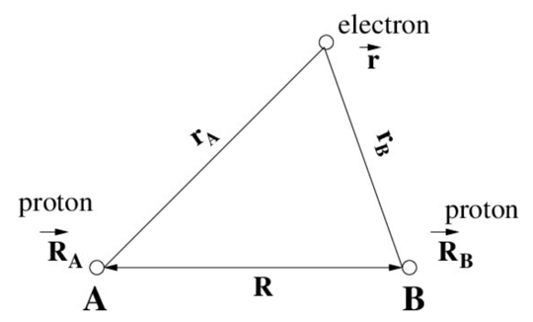

Figure 1. The H2+ system consisting of two protons and one electron.

The application of the Born-Oppenheimer approximation consists in recognizing that electrons are so much lighter than protons, namely a ratio of 1 to 1836. If one assumes that an equal momentum is given to a proton and an electron, and if M and m are the masses of the proton and the electron respectively,

Momentum = M vproton = m velectron

= 1836 x vproton  = 1 x velectron

velectron / vproton = 1836 / 1

The relative speeds of the electron and the proton are therefore 1836 to 1 in favor of the electron. According to the usual interpretation of BOA, this discrepancy in velocities is taken to the limit, so that protons are assumed to have a velocity of zero as compared to that of electrons. It follows that their kinetic energies (1/2 mv2) is zero. Consequently, most textbooks state that all kinetic energy terms for protons can be neglected under the BOA scheme and that equation 2, therefore reduces to equation (3).

[ + e.e - ½ m ∇2 - e.e - e.e ] Ψ = E Ψ (3)

RAB rA rB

Furthermore, the first term in (3) takes on a constant value for any particular fixed inter-proton distance. The result computed in this way for the ground state energy of the H2+ differs from the experimentally obtained value by approximately 1%. Clearly the BOA appears to be justified for this system, in numerical terms. Moreover, the error decreases when one considers molecules with heavier nuclei. For example, in the case of the C2 molecule, the nuclei concerned are twelve times as heavy as the proton which means that the error will be reduced to at least 1/12th of the value for the H2+ system.

Let us now return to what some philosophers of science, as well as some philosophers of chemistry, have made of this situation. The widespread view among philosophers of chemistry, as exemplified in the opening quotations, is that the use of the BOA results in treating particles in a fundamentally non-quantum manner, because fixed positions are assigned to the nuclei and that this step represents a violation of the Heisenberg Principle. These same authors frequently go on to claim that without such classical “scene setting” the quantum calculations are quite impossible, as can also also be seen in the further quotation,

Additionally, it is assumed that the nuclei have fixed positions in space. In this “clamping-down” approximation, the atomic nuclei are treated essentially as classical particles; as Olimpia Lombardi (2013) points out, this picture is non-quantum in a very fundamental way as the simultaneous assignment of fixed positions and fixed momenta (namely, zero) to them violates the Heisenberg uncertainty principle. But without such classical scene-setting, the quantum calculations are quite impossible (Chang, 2015).

The notion that denying any motion to nuclei in a molecule represents a violation of the Heisenberg Principle ignores the fact that scientific theories frequently contain internal inconsistencies. Stated otherwise, scientific progress is not restricted by matters of principle. Numerous instances from the history of science can be used to show that progress was achieved by violating what may hitherto have seemed to be inviolable restrictions. For example, the Bohr model contains several apparent inconsistencies and yet it represented a major step forward, namely the beginnings of the quantum theory of atoms which culminated in the discovery of quantum mechanics (Vickers 2013).

What matters more in scientific practice is obtaining a result. If an approximation provides a calculation that falls short of the experimental value by 1%, or less, it is considered perfectly reasonable, even if it may appear to violate a central principle of the theory that is being utilized. So even if the BOA were to represent a violation of the Uncertainty Principle, I do not believe that this would have such a negative impact on the claim that chemistry is reduced to quantum mechanics. But as later sections will argue, there is in fact *no* such violation of the Heisenberg Principle.

1. **BOA does not in fact violate Heisenberg’s Uncertainty Principle.**

In addition to the general point mentioned above, there is a significant sense in which the use of the BOA does *not* in fact represent a violation of the Heisenberg Principle. Solving equation (3) above involves obtaining many solutions for the total electronic energy, one for each particular chosen internuclear distance. It is only by doing so that a graph of the potential energy of the nuclei can be plotted against distance (Figure 2), in order to obtain the minimum in the plot and thereby the ground state energy and bond length of the system in question. Even though each particular solution may seem to keep the nuclei stationary, the fact that one is considering many different inter-nuclear distances serves to restore the motion of nuclei. The Heisenberg Principle could only be said to be violated if one were to focus on just a single data point on the energy graph shown below.

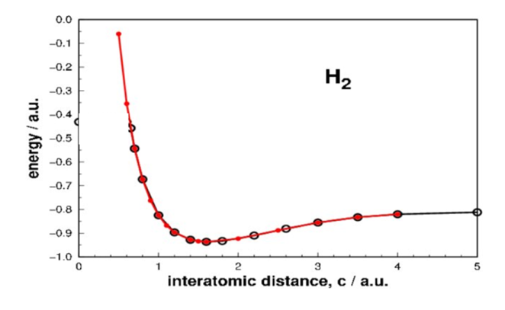

Figure 2. Potential energy of nuclei against inter-nuclear distance.

The second claim by some philosophers of science and of chemistry is that quantum chemists are somehow obliged to use the BOA. In fact, there has long existed a thriving branch of quantum chemistry which specializes in non-Born-Oppenheimer calculations (Agostini and Curchod 2022; Hammes Schiffer, 2022). Such calculations have a wide variety of applications in chemistry such as the interaction between light and matter, ultrafast reactions and out-of-equilibrium nuclear dynamics. This work includes the photochemistry of isolated and solvated molecules as well as excited-state dynamics with long timescales. The application of such studies also extends to biological systems involving the simultaneous transfer of protons and electrons such as in the study of photosynthsis and enzymic activity in general (Hammes Schiffer, 2022).

1. **The Born-Oppenheimer approximation for any many-electron system.**

In the present section we consider how the approximation applies to any many-electron molecule.

 (3)

This expression differs from equation 2 above in that it includes a term for electron-electron repulsions (the 3rd term on the rights side), which was absent in the one electron case for H2+. The expression can be simplified by collecting together all the terms which refer to the electrons, namely all but the first on the right-hand side, as the Hamiltonian operator for the electrons,

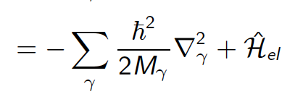(4)

This molecular wave function therefore describes both the nuclei and the electrons. In the BOA the nuclear kinetic energy term, or the first term on the right-hand side in equations 3 and 4, is very small, given the large mass of the nuclei M as compared with the masses of the electrons. This nuclear kinetic energy operator can therefore be considered as a small perturbation. It is worth noting that it is not set to zero, and that one should again not conclude that the nuclei have been clamped. Within this approximation the eigenstates and eigenvalues can then be calculated by solving the time-independent Schrödinger equation for the electronic motion.

**5. The Born – Huang generalization of BOA**

Although the BOA was first proposed and put to work in 1927, the starting point to the modern approach to BOA consists of the more general Born-Huang (B-H) representation as expressed in equation 5.

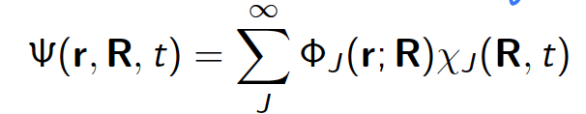(5)

where the J’s are labels for the electronic states and ϕJ (r ; R) are the electronic wavefunctions and the coefficients χJ (R, t) are related to the nuclear wavefunctions in each electronic state. This equation, unlike the earlier Born-Oppernheimer equation is formally exact (Born, Hunag, 1954, Tully, 2000). Whereas the BOA is only concerned with the ground state wavefunction of any particular molecule, the B-H approximation considers all excited state wavefunctions in addition to that of the ground state. In the B-H framework the sum of all these wavefunctions provides an exact solution to the Schrödinger equation for the system and it can be shown, in a more rigorous manner, that the naïve notion that the BOA demands that all nuclei be stationary is incorrect.

The terms that are neglected in the BOA are those that couple nuclear motion to the motion of the electrons with the change of electronic states. In this more general B-H frame-work it is clear that the nuclei move, even if they do so only slowly, so that in many cases the electrons can adapt quickly to such changes. In the terminology of quantum mechanics, the electrons adapt adiabatically to the nuclear motion, in that they remain in the same eigen state. This is an example of the general quantum mechanical principle called the adiabatic theorem. It states that if one has a wavefunction that depends on parameters that can change then, provided that they are changed slowly, the wavefunction always remains in a given eigenstate.

However, if the nuclei move rapidly this is no longer the case. The B-H description of the molecular wavefunction makes precisely this statement. If the nuclei move quickly, which is what occurs in photochemical reactions and other ultra-fast chemical processes, the electrons experience a moment of ‘confusion’ and the motion of the nuclei results in a change in the eigenstate. Such a situation constitutes a non-B.O effect, which can be successfully tackled through numerous mathematical approaches have been developed for this purpose (Nikitin, 1999; Hammes-Schiffer et al., 2008; Xu et al., 2022).[1]

As a further clarification, when applying the BOA, one limits oneself to just one term in the B-H representation, which means that the nuclear degrees of freedom can only evolve on a single electronic eigenstate. This limitation is removed when one turns to the B-H representation. The situation can be expressed formally as follows,

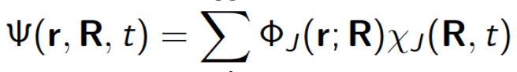

Born-Oppenheimer

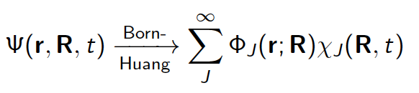

The difference is that the BOA, unlike the B-H representation, does not involve a summation over different electronic eigenstates.

Needless to say, Sutcliffe and Wooley were well aware of the B-H generalization of BOA, but they objected to it on the grounds that it did not include the continuum states that were required as a result of translational invariance. This objection has now been successfully countered by the work of Jecko and others who have developed methods to incorporate these additional states within B-H (Jecko, 2014).

1. **A further note concerning the uncertainty principle**

The uncertainty principle states that the product of the uncertainty of the position and that of the momentum of a quantum particle is greater than a constant, namely h/4π, where h is Planck’s constant or 6.63 x 10-34 J.sec. There are two possible interpretations of this principle. The first is that quantum particles lack trajectories unlike classical particles, i.e., they do not have well-defined position and momentum, which is sometimes referred to as the metaphysical interpretation. The second interpretation is that quantum particles do have definite trajectories, yet our knowledge is restricted to either position or momentum, which is referred to as the epistemic interpretation. This latter interpretation is the basis of Bohmian approach to quantum mechanics.  
 If we take the Born-Oppenheimer approximation to assume that nuclei are fixed in space in well-defined positions, as do Cartwright, Chang, the uncertainty in their positions zero and consequently these authors argue that this assumption violates the uncertainty principle. Even if this is accepted, this argument can only show that, fixing the position of the nuclei only violates the metaphysical interpretation of the uncertainty principle. The epistemic interpretation, on the other hand, is immune to this attack. Indeed, fixing the position of the nuclei simply implies that we remain ignorant about their momentum (or kinetic energy), which is of course not in contradiction with the uncertainty principle, but rather its essence.1

**7. Non-B.O calculations in contemporary chemistry**

The notion that quantum chemists are obliged to use the BOA, is expressed by various authors, including this further example,

The BOA, as used in the context of quantum chemistry, is a vivid example of how scientists “outrageously” appeal to incompatible theories in their practice. In this case, quantum chemical models of molecules are obtained by combining classical mechanics to describe the nuclei and quantum mechanics to account for the motion of the electrons. As explained, such a combination is not an innocent strategy that could be circumvented if we had access to a higher level of calculating power (Lombardi, 2023, 15).

In fact there are literally thousands of studies that go beyond the BOA in a sub-disciple that concerns itself with non-Born-Oppenheimer calculations. Such calculations have widespread applications throughout contemporary chemistry. As stated above, the BOA is only applicable to the ground states of molecules. Much research in areas such as photochemistry requires an analysis of the excited states of molecules. Such analyses are carried out routinely by considering the coupling of nuclear and electronic motion or, stated otherwise, by considering a non-adiabatic situation in which the motion of the nuclei *does* influence that of the electrons in a molecule. In such cases the electronic motion does not readjust itself instantaneously when the nuclei move.

For example, if the coupling terms are included it becomes possible to treat systems such as the H5O2+ ion, which is the simplest model of a hydrated proton. A simulation of this so-called Zundel cation (figure 3) requires a quantum treatment of the five hydrogen nuclei in their full dimensionality of 15 degrees of nuclear freedom.

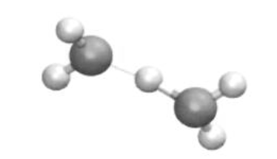

Figure 3. The H5O2+ or Zundel ion.

A calculation of the potential energy surface, and through it that of the infra-red pre-dissociation spectrum of the system, shows excellent agreement with the experimental spectrum as can be seen in figure 4.

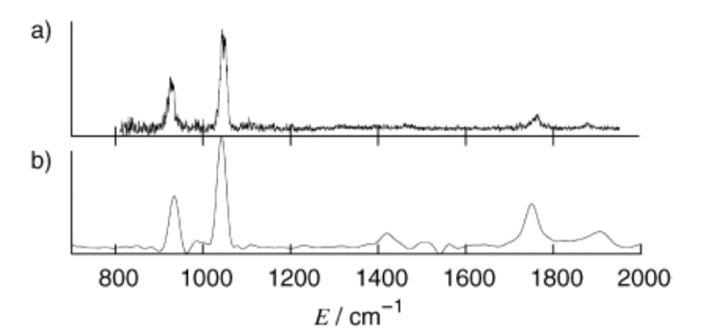

Figure 4. Comparison of the experimental spectrum (a) and the calculated predissociation spectrum of the H5O2+ ion (b) (Vendrell et al, 2007).

Clearly, calculations *can* be carried out even if the BOA is not applied, and with considerable success in terms of obtaining a close match with experimental data.

1. **Permutation and rotational symmetry.**

Some philosophers of chemistry are under the impression that the BOA is not truly quantum mechanical since it ignores the symmetry properties of fundamental particles like protons and electrons, whose wavefunctions are antisymmetrical on exchange of any two particles. Said otherwise, quantum mechanics requires that all the nuceli and electrons in a molecule must be indistinguishable.

However, many contemporary quantum chemists work in the complete absence of the BOA and *do* incorporate the indistinguishability of fundamental particles. The total non-relativistic Hamiltonian for a molecular system in the laboratory Cartesian coordinate system is written so as to make no distinction between electrons and nuclei, and referencing n + 1 general particles with masses Mi, charges Qi, and positions Ri, where i = 1...n + 1, where the additional particle is that of the ficticious center of mass.

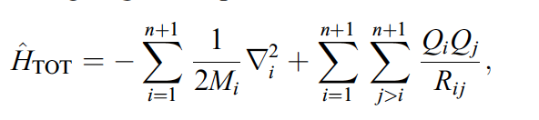

and where *Rij =* |*Rj* – *Ri*| are inter-particle distances. This Hamiltonian describes a system in which electrons and nuclei move in concert.

The model of the molecule described by this Hamiltonian is quite similar to that of an atom. It consists of the analogue of the nucleus, with the heavy particle at the center of the internal co-ordinate system, and the analogues of electrons in the internal particles. The main diﬀerence between this model and an atom is that while the internal particles in an atom are all electrons, those in the molecular atom may be both electrons and nuclei. Formally this diﬀerence manifests itself in the eﬀective masses of the pseudoparticles and in the way that the permutational symmetry is implemented in the wave function (Cafiero, Abramowicz, 2004).

1. **Molecular dipoles**

Turning to rotational symmetry, Wooley has emphasized that the full Hamiltonian for molecular systems has spherical symmetry and cannot therefore be used to recover the existance of dipole moments.[2] He believes that it is only by applying the BOA, that is by fixing the molecular framework, that the very notion of a dipole moment can be understood. The implication seems to be that absent the BOA, dipole moments cannot be calculated. Once again the situation appears to have moved on since Wooley published his thoughts on the matter. Dipole moments can be calculated within the BOA and even without it. In fact non BOA calculations have been used to obtain more accurate values for the dipole moments of molecules such as those in table 1. For example in the case of the LiH molecule the calculation is essentially exact compared with the experimental value, when the wavefunction expansion length reaches 244 terms ( Cafiero et al., 2003). If one considers reduction to mean just how closely calculations can recover any particular molecular property, as I suggested in previous articles, then this surely must count as a successful reduction (Scerri, 1994).

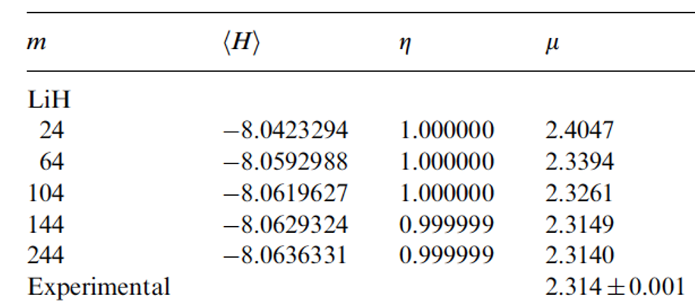

Table 1. Energies and dipole moments (μ) for the LiH molecule for various expansion lengths

in the wavefunction (m).

The reason for the non-zero dipole moment is that in the computations based on the BO approximation ‘fix’ the frame of the molecule in space. In experiments that aim to measure the dipole moment the molecular frame is also aligned in a certain way because, the molecules are placed in an electric field. The electron charge distribution for a molecule with fixed nuclear positions is obviously not spherically symmetric. However, If we were to consider all possible orientations of the molecule in space and calculated an average then it would yield a zero dipole moment as long as all orientations are equally probable.  If one does not assume the Born-Oppenheimer approximation, i.e. if both electrons and nuclei are treated equally as quantum particles with certain masses and charges, there is no way to separate out the rotational motion of the nuclei, i.e. there is no way to "fix" the molecular frame in space. But it is still possible to extract the dipole moment from non-BO calculations by means of some numerical manipulations, which is what was done in non-BO calculations by Cafiero et al. mentioned above.

1. **Computer Simulation including the Monte Carlo Method**

Philosophers of science have for sometime recognized that computer simulations represent a legitimate and categorically new way of conducting scientific research.

[…] computer simulations are not simply number crunching techniques. They involve a complex chain of inferences that serve to transform theoretical structures into specific concrete knowledge of physical systems […] this process of transformation […] has its own unique epistemology. It is an epistemology that

is unfamiliar to most philosophy of science […]. (Winsberg 1999, p. 275)

[…] computer simulation provides […] a qualitatively new and different methodology for the natural sciences, and […] this methodology lies somewhere intermediate between traditional theoretical science and its empirical methods of experimentation and observation. Scientific activity has thus reached a

new milestone somewhat comparable to the milestones that started the empirical approach (Galileo) and the deterministic mathematical approach to dynamics (Newton and Laplace). Computer simulation is consequently of considerable philosophical interest. (Rohrlich 1991, p. 507, italics original)

For example, theThe Monte Carlo Method is a widely used statistical technique which is used to solve problems which are too complex to analyze analytically. It depends of the use of random number generators and computational power. A simple or toy example is often presented to explain the method, namely that of calculating the value of $π.$

Consider a square of side 1 unit and a circle which fits neatly within the same square (Figure 5). It follows that the radius of the inscribed circle is 0.5 units, and whereas the area of the square is 1 square unit, that of the circle is given by r2 or (0.5)2.. The area of the circle divided by that of the square is therefore (0.5)2/ 1 or /4.

Imagine that we throw darts at the square/circle dart board and count whether the dart falls within the circle or in one of the four segments that fall within the square but outside the circle (fig 4). Mathematically one would need the computer to ask whether the value of (x2 + y2)1/2 is less than 0.5, assuming a coordinate system centered at the center of the circle. We then count the number of darts that have fallen within the circle and divide by the total number of darts that have been thrown. If enough darts are thrown we can obtain an estimate of the value of $π$ by multiplying our result by a factor of 4, since as mentioned above the area of the circle/are of square = $π$/4.

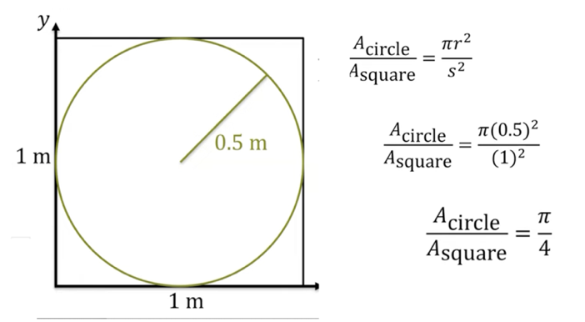

Figure 5. Elementary example of Monte Carlo method used to calculate pi.

1. In a typical experiment, the result of calculating of $π$ resulting from throwing 8000 darts is 3.1840, while 24,000 dart throws gives an improved value of 3.1467. The actual value of $π$ to 6 significant figures is 3.14159. Clearly the value obtained will continued to approach the correct value provided that enough random dart throws are performed and a count is meaintained of where the ficticious darts land.

   **11. Monte Carlo Method and the chain folding problem**

   A more scientific application of the Monte Carlo method is found in the well-known chain folding problem of molecular biology. This issue has been something of a ‘holy grail’ in the field of computational biology for something like 50 years. The problem consists of attempting to calculate precisely how the folding occurs in a protein chain having of a known sequence of amino acids. Progress in this field has been rather slow since it was first initiated some 40 years ago. However, it appears that the problem has essentially been solved, as of the year 2020, by a Monte Carlo simulation in combination with the *Deep Mind* artificial intelligence technology (Service, 2020).

   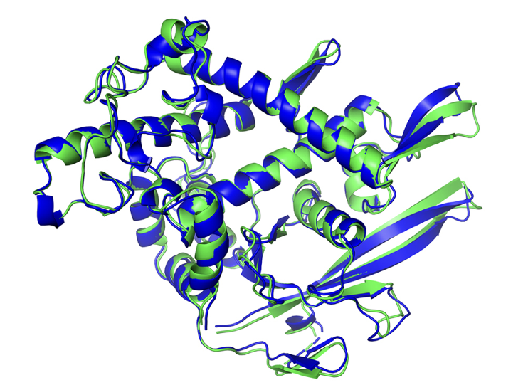

   Figure 6. The structure of a protein as predicted by a Monte Carlo method (blue) and experimentally (green) showing an almost perfect match.

   **12. Monte Carlo Method applied to the problem of how to extract molecular structure from quantum chemical calculations.**

   Since it has become possible to treat electrons and nuclei on the same quantum-mechanical footing without invoking the BOA at any stage, several attempts have been made to extract molecular structure from the full wave function. However until recently it has not been possible to unambiguously obtain the structure of even triatomic molecules.

   In a very recent study from Norway, Lang et al. explain their motivation in the following opening passage,

   While supported by an overwhelming body of empirical evidence, the classical notion of molecular structure is hard to reconcile with the probabilistic nature of the quantum theory of indistinguishable particles. This conflict between the most fundamental concept in chemistry and the thoroughly established physical theory of the atomic-scale world has given rise to debates over several decades...

   The fundamental conflict persists, however (Lang et al., 2024).

   The authors point out that that molecular structure is essentially a manifestation of strong statistical correlation between the positions of the nuclei. Consequently, it should be possible to extract molecular structure information from the joint probability density, i.e., square of the wave function ρ(r, R) = |Ψ(r, R)|2, where r and R are the internal coordinates of the electrons and nuclei, respectively.

   These authors have now developed an approach that can distinguish between different structures simultaneously present in a molecular wave function and that directly generates a visualization of the complete molecular structure without any human input or bias. Their method considers conditional probabilities whereby the position of one nucleus is fixed and 3D space is then scanned via a Monte Carlo method in order to calculate maxima in the probabilities of the other nuclei. Its application to the D3+ molecule unambiguously shows that it possesses an equilateral triangular structure. As the authors claim, this provides a major breakthrough in our understanding of molecular structure from fundamental quantum principles (Lang et al, 2024). Any reader who may be skeptical of such a statistical sampling approach to the problem should consider the fact that the variational method, which is a staple of quantum chemistry, is also essentially a method of sampling.

   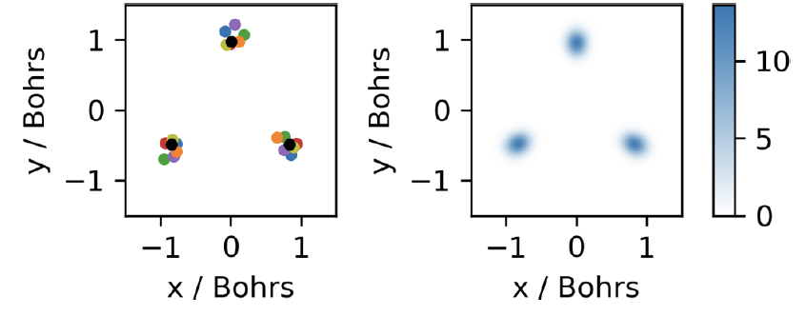

   Figure 7. Snapshots of most probable nuclear configurations in various colors

   and average location of nuclei after calculated alignment of these positions.

   Returning to the philosophical question, it may be correct to say that structure does not reduce to BOA, but it begins to seem that it does reduce to QM in general. The error that many philosophers of chemistry are making is to conflate the two claims, presumably because they are not aware of the existance of the entire field of non-Born Oppenheimer calculations.

   To conclude,

   1. The use of BOA does not represent a violation of Heinsenberg Uncertainty.
   2. It is certainly not the case that quantum chemists have no choice but to use the BOA.
   3. Non-BOA calculations fully incorporate the indistinguishability of particles
   4. Wooley’s symmetry problem is not as urgent as usually stated. For example dipole moments can be calculated without first imposing a structure onto a molecule.
   5. Last but not least, it has now become possible, through Monte Carlo simulations to genuinely recover molecular structure from quantum mechanics without applying the BOA.

   **Notes**

   1. I am very grateful to one of the reviewers for suggesting this line of argumentation.

   **References**

   Agostini, F., Curchod, B.F.E., 2022 Chemistry without the Born–Oppenheimer approximation. *Phil. Trans. R. Soc. A* 380: 20200375. <https://doi.org/10.1098/rsta.2020.0375>

   Born M, Oppenheimer J.R., Zur Quantentheorie der Molekeln*, Annals of Physics*, 84: 457, 1927.

   Born, M., Huang, K., Dynamical Theory of Crystal Lattices, Oxford University Press, Oxford, 1954.

   Caﬁero, M., Bubin, S., Adamowicz, L., Non-Born–Oppenheimer calculations of atoms and molecules, *Phys. Chem. Chem. Phys.*, 5, 1491–1501, 2003.

   Caﬁero, M., Adamowicz, L., Molecular structure in non-Born–Oppenheimer quantum mechanics,

   *Chemical Physics Letters*, 387, 136–141, 2004.

   Cartwright, N., *A Philosopher Looks at Science*, Cambridge University Press, Cambridge, 2022.

   Chang, H., Reductionism and the Relation Between Chemistry and Physics, in T. Arabatzis et al (eds), *Relocating the History of Science*, Springer, Berlin, 2015.

   Hammes-Schiffer, S., et al., Proton-Coupled Electron Transfer in Solution, Proteins and Electrochemistry, *Journal of Physical Chemistry B*, 112, 14108-14123, 2008.

   Hammes-Schiffer, S. Theoretical perspectives on non-Born–Oppenheimer effects in chemistry. *Phil. Trans. R. Soc .A,* 380: 20200377, 2022 <https://doi.org/10.1098/rsta.2020.0377>

   Jecko, T., On the mathematical treatment of the Born-Oppenheimer approximation, *Journal of Mathematical Physics,* 55(5), 053504, 2014.

   Lang, L., Cezar, H.M, Adamowicz, L., Pedersen, T.B., *J. Am. Chem. Soc.* 146, 1760−1764, 2024.

   Lombardi, O., Pragmatic Realism in Chemistry, *Cogency: Journal of Reasoning and Argumentation*, 15, 104-119, 2023.

   Nikitin, E.E., Nonadiabatic Transitions, *Annual Reviews of Physical Chemistry*, 50, 1-21, 1999.

   Primas, H., *Chemistry, quantum mechanics and reductionism (2nd ed.),* Springer, Berlin, 1983.

   Rohlich, F., Compueter Simulation in the Physical Sciences, *Proceesings of PSA Association*,(2):507-518, 1990.

   Scerri, E.R., 1991. Electronic Configurations, Quantum Mechanics and Reduction, *British Journal for the Philosophy of Science,* 42, no. 3, 309-325.

   Scerri, E.R., Has Chemistry Been at Least Approximately Reduced to Quantum Mechanics? in *PSA* 1, D. Hull, M. Forbes, and R. Burian, eds. 160-170, 1994.

   Sutcliffe, B., Wooley, G., Molecular Structure and the Born-Oppenheimer Approximation, *Chemical Physics Letters*, 45, 393-398, 1977.

   Tulley, J.C., Perspective on ``Zur Quantentheorie der Molekeln'' Born M, Oppenheimer R (1927) Ann Phys 84: 457, *Theoretical Chemistry Acc*ounts 103:173±176, 2000.

   Vendrell, O., Gatti, F., Meyer, H-D., 2007. *Angewandte Chemie International Ed*ition, 46,6918.

   Vickers, P., 2013, *Understanding Inconsistent Science*, Oxford University Press, Oxford, UK.

   Villaveces, J.L., Daza, E.E., On the Topolgical Approach to the Concept of Chemical Structure, *International Journal of Quantum Chemistry: Quantum Chemistry Symposium*, 24, 97-106, 1990.

   Wallace, D., *Philosophy of Physics, A Very Short Introduction*, OUP, Oxford, 2021.

   Winsberg, E., Sanctioning Models: The Epistemology of Simulation,” Science in Context, 12(3): 275–92. 1999.

   Wooley, R.G., Quantum theory of atoms and molecular structure, *Advances in Physics*, 25, 27-52, 1976.

   Wooley, R.G., Is there a quantum deﬁnition of a molecule? Journal of Mathematical Chemistry, 23,3–12, 1998.

   Xu, J., et al., Nuclear-electronic orbital approach to quantization of protons in periodic electronic structure calculations, *The Journal of Chemical Physics*, 156, 22411, 2022.
2. From a purely mathematical point of view, the dipole moment of a molecule is zero because the charge distribution is spherically symmetric. This is true regardless if we use the Born-Oppenheimer approximation or not. If one has a spherically symmetric charge distribution given by the absolute square of the wave function and then multiplies it by the dipole operator, which has an inversion symmetry, i.e. it changes sign when we replace r with -r, and then performs an integration over all space, the result is zero.