**Gravity and Riemann Hypothesis**

The reason why this article does not involve mathematical formulas is that the author 's mathematical ability is limited, and the article only has enlightening effect. A good beginning often ends up not wonderful, I prefer a wonderful end. Therefore, the first half of the article is not of great value, but more of a process of exploration.

The article is all theoretical arguments, no experimental data.

Author: Shi Jun Ze

The independent author is from Hebei Institute of Engineering and Technology in China

Email: [15003615276@163.com](mailto:15003615276@163.com) Phone: 15003615276

**To read this article, you need to know an energy cycle process (the content of the article is large and the structure is a little complicated, understanding this can help you understand the article): this formula reveals the correctness of quantum mechanics and general relativity. The unification may be a progressive relationship rather than a combination. （Zero-dimensional collision residual energy － One-dimensional matter= one-dimensional collision residual energy = one-dimensional gravity = Two-dimensional matter + two-dimensional collision residual energy, two-dimensional collision residual energy=.......）. The purpose of this formula is to illustrate the coexistence of dimensions rather than the progressive relationship. That is to say, the universe is not only matter and force. There is also low-dimensional collision residual energy (dark energy) and high-dimensional collision residual energy (gravitation), and infinite dimensions together constitute a cycle without beginning or end.**

**Abstract**

Inspired by the author 's Riemann hypothesis, this paper attempts to solve the contradiction between general relativity and quantum mechanics in physics. Under the guidance of Euler identity, two important ideas of collision and vibration are introduced. It is concluded that quantum mechanics cannot describe gravity because gravity cannot constitute this dimension of substance.

The document deeply discusses the relationship between substance dimension and energy, including the stability and change of dimension, the relationship between energy and substance, and the relationship between time and dimension.

It mainly introduces how different dimensions of substance interact, the generation and transformation of energy, and the influence of dimensional changes on substance. This paper discusses several theories that are expected to become GTU, points out their advantages and disadvantages respectively, and explores some non-physical humanistic philosophical problems. The reason is that there is an essential difference between the earth and other substances.

**Keywords:**gravitation; Riemann hypothesis; Euler 's identity; collision; vibration

**1 Introduction: Research direction of gravity**

It is easy to recall the geometric structure of general relativity when discussing gravity. Relativity interprets gravity as the result of space bending ( four-dimensional space-time ). That is to say, the essence of gravity is the change of time and space (**Here I think of a key point: different masses produce or accompany different amounts of gravity**), and quantum theory attributes all energy to quantum substanceization. First of all, we should know that gravity and other substance should belong to energy. The composition of energy requires space and time, while the composition of substance also requires opposite collisions to form symmetry. If we assume that gravity is also a substance, then we can understand that the two theories can be unified. Then think about why it is so difficult. I adhere to the broad concept of relative time and space, and also insist that gravity is indeed an energy or force. I think solving this problem requires finding a theory that can accommodate both ideas **( but the final conclusion is that gravity isn 't substance or can 't form symmetry, or it just contains positive energy). In fact, gravity can also form symmetry, but in matter (three dimensions) it can only be expressed as pure positive energy.**

**2 Shape of Space**

According to Einstein 's theory, energy can distort space. In the process of spatial distortion, a bending velocity change is formed. The change in velocity leads to the change in time, so there is four dimensional space-time.

The first thought process: If the speed changes the movement space, would the change in quantum speed also alter its own space? I believe that matter exists within space, or it is the space itself that leads to the materialization of energy. This space should have specific dimensions, as without specific dimensions, the forces between matter would not be affected by spatial distance.

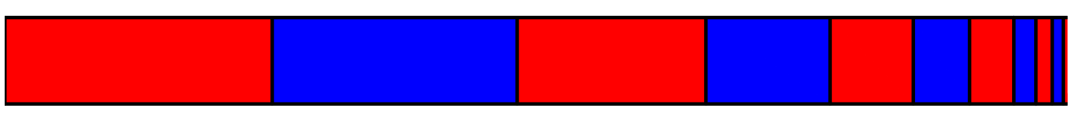

**Figure 1 assumes that there are different distributions within a complete space, which is understood as dimensional differences.**

Thinking process 2 : Two clocks with different speeds will deviate under observation. It seems that time is affected by speed, but I think it is speed that changes space, and space changes time . **If matter has its own space, then it can be understood that different dimensions have different times. I understand time as the speed of change, or the speed of changing dimensions (As discussed earlier, different masses of matter have different gravitational forces). So gravity can be understood as time.**

Two kinds of spaces are introduced : one is the compressed space, and the other is the stretched space. Because I'm talking about motion starting from point particles, so the compressed and stretched spaces are intertwined. These two forms of energy constitute the three-dimensional properties of substance : **positive energy and negative energy.**

# **3 The constant speed of light brings me ideas**

Thinking Process 3 : As the special theory of relativity says, the constancy of the speed of light means that no substance how fast the observer moves, the speed of light measured by the observer remains unchanged. We previously mentioned that space is composed of positive and negative energy, **so photons may have the same positive and negative energy at the same time（At this point, we do not know that there is a new dimension, because the photon belongs to the positive energy in the new dimension. Or the photon can be understood as the new dimensional matter at the limit. After reading the following text, you can refer to the fact that black holes belong to both two-dimensional and three-dimensional matter, and are in two extreme states.）.** But why photons can 't produce new collisions and time stops（**There is no time, or different times arise with different substances.**）?

Some people may wonder whether the integer dimensional matter can not continue to be upgraded? After the universe reaches infinite dimensions, an integer dimensional matter is taken out of each dimension(like taking a photon and adding a part of a black hole and an integer dimension of matter is taken in each dimension), and these basic units are combined into a basic unit**（That's not quite accurate, but all we need to know is that every dimension reaching an integer dimension means the universe has reached infinite dimensions）.** Only this basic unit can have infinite dimensions. In other words, for the universe to reach infinite dimensions, all dimensions must be integer dimensions and no elementary particles exist independently in each dimension. The final explanation is a little more complicated, needs to be understood in conjunction with a reasonable visual video, **which can be skipped for the time being.** And this infinity must refer to a specific number, but it's not necessary to discuss it now, just know that photons are whole four-dimensional matter.

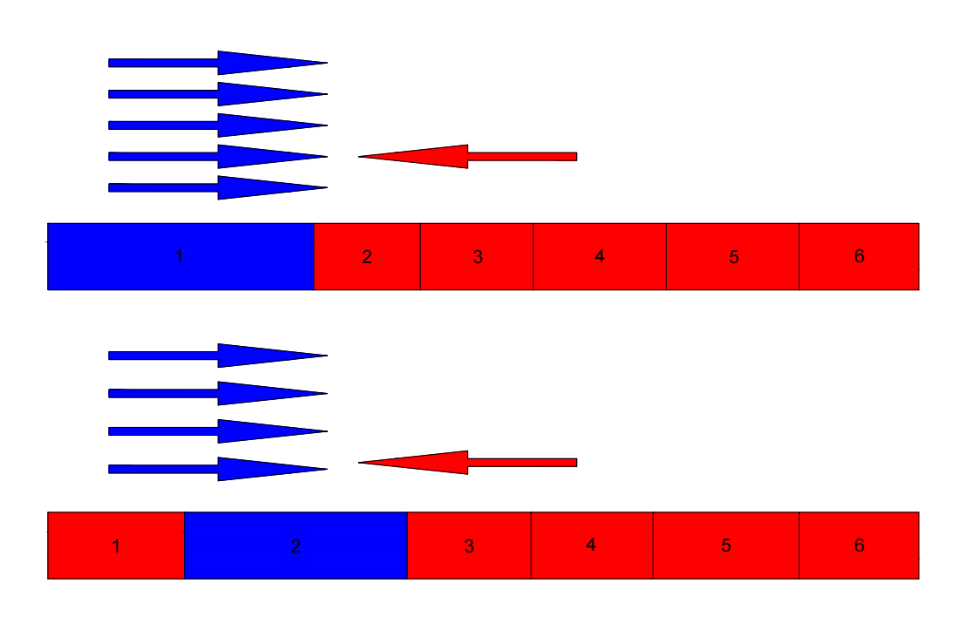

Figure 2

According to De Broglie 's theory, moving objects produce phase waves. However, these phase waves can reach faster speeds than light. If the phase velocity only represents the wave velocity, is it possible that this wave velocity is the speed of other dimensions? so we speculate that the dimension of substance change is closely related to the phase wave. I define this speed as the speed of dimensional equilibrium, or the speed at which high dimensional energy affects low dimensional matter. Let's assume that the phase velocity of the wave is related to the dimensionally balanced velocity, and that the wavelength is related to the dimension at this time.

The velocity represents the spatial variation in the transmission velocity（The space here refers to the space of itself）. In the overall space, the shape of space is constantly changing. Throughout this process, the spatial variation can still be transmitted at a speed of c*2. Therefore, in the c*2 inference process, a moving object is constantly transmitting a deceleration signal v into space. Due to the constant changes in space, this value decreases to c*2/v. **These contents are just a thought process and are not rigorous.**

$\frac{c^{2}}{v}$ ×v=Spatial transfer velocity（Assume that own space can be shared）

The speed of photons moving in any space is equal to the speed of photons transmitting in space. Photons always move in a constant space. Once the speed of photons is greater than the speed of space transmission, the speed of photons will slow down, so that the speed of photons is at most equal to the speed of space transmission. That is to say, for a dimension, the maximum speed can only be the speed of light. This also means that if a substance is moving at the speed of light, if it doesn 't stop moving, then its own space may be close to infinity ( it can 't generate new dimensions ). For the speed of light or space transmission speed, this quantitative may be related to a certain energy and does not have physical significance.

$$v<\frac{c^{2}}{v}$$

Energy is not limited by volume. On the contrary, it can be understood as a collision point, which creates a spatial configuration . The energy body vibrates continuously in a small range, forming a unit space size . Around this point, the force unfolds the space one by one（There is also a large overall space before there is no vibration.） The stretched space is negative energy, but this stretched space seems to be smaller than the compressed space. This leads to an overall display of attraction in one dimension. There may be an additional energy : zero collision.

**The idea of this paragraph is not accurate. It belongs to the author's thinking process, which aims to judge the characteristics of photons. The real state is a complex dimensional equilibrium process. But I'm sure there's a big connection between de Broglie waves and the dimensional balance of matter (the precursor to quantum entanglement).**

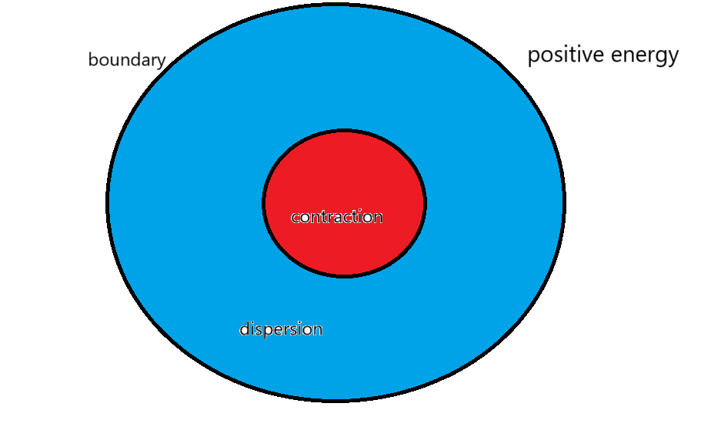

Figure 3

**4 Positive and negative**

There are two conclusions : positive and negative. Thinking process 4 : Energy can be divided into positive energy, negative energy and massless energy. The negative energy is also affected by the acceleration of gravity. When it enters the gravity field, the greater the difference in the direction of gravity, the greater the difference. Therefore, the gravitational field of space will be more compressed, thus accelerating this process. This acceleration has the same order of magnitude as the positive energy.

The key to expansion is zero energy, which is progressive in dimension ( energy quantity ). The core is that, despite the continuous increase of negative energy, zero energy (the remaining energy of high dimensional collision) will only weaken slowly and will not disappear, and matter will still rise in dimension. Therefore, as the material dimension increases, positive energy is still greater than negative energy. As the dimension increases, the negative energy will be infinitely close to the positive energy until the gap between the positive energy and the negative energy is opened again after entering the next dimension. **The energy of the next dimension can only be zero to achieve this effect.**

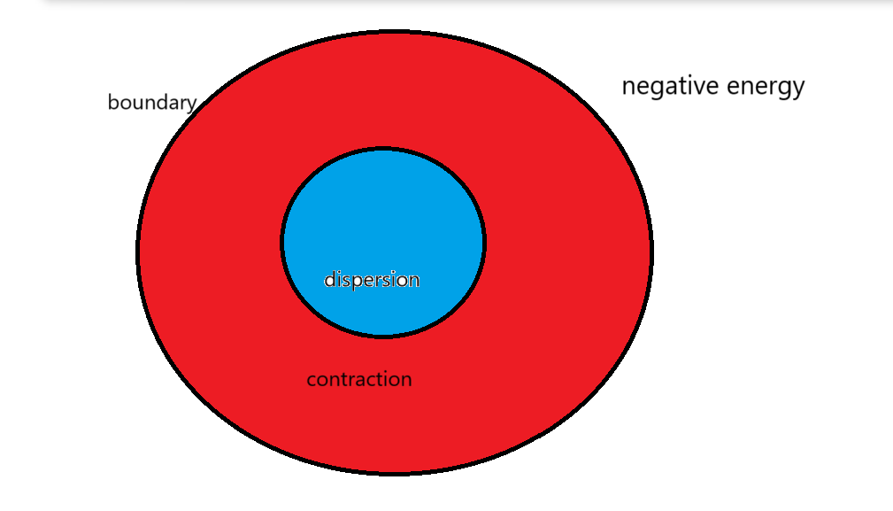

Figure 4

In order to prevent misunderstanding : here figure 4 is relative, negative energy is only relative to positive energy as shown in figure 4. However, when the positive and negative energy are equal, the integer dimension has been reached, and the next vibration direction is still positive. So the negative energy is actually positive energy like Figure 3. **The higher dimension in the dimension balance is naturally understood as negative energy, but the essence is that the positive energy is greater than the negative energy, which will be explained later.**

**Figure 3 and Figure 4 need to be considered in this way only when compared in a whole (this paper mainly discusses the relationship of the whole),Other times this description is not accurate. Negative directional vibrations still increase the dimensions (new vibration directions), but this method cannot be used for calculations or comparisons with positive directional vibrations. Since positive and negative directional vibrations affect the material's dimensional changes differently, I liken the process of dimensional elevation to a continuous increase in negative energy. This process is not straightforward; it requires reading the subsequent text to understand the entire process of cosmic movement.**

# **5 Explain why the superposition state is generated without changing the dimension**

The original idea: Explore whether the incident angle has an effect on the particle entering the slit : Since the slit is similar to the wall, it will affect the collision inside the energy ( the specific reason needs to be understood later ). Once the collision inside the energy is affected, the energy will increase or decrease the dimension. **That is to say, the incident Angle has little effect on the final result, but the slit really affects the experimental result.**

We cannot see the process of particle or material wave function collapse in the observation experiment, because the wave function collapse does not change the material dimension, but the direction of vibration. But the quantum is different, the quantum dimension is smaller. It is easier for us to form a dimensional balance, or observation behavior can produce collision residual energy. ( Collision residual energy will be explained later)

**Final conclusion: Slits promote destroy dimensional balance between particles. However, for quantum particles, the low-dimensional collision residual energy disrupts the dimensional balance within the particles themselves. Yet, when quantum particles emerge from the slit, they will re-establish dimensional balance. If multiple quantum particles enter and exit the slit simultaneously, it promotes dimensional balance among them. It's like breaking down two wholes and then building a whole again. A slit can be understood as a low dimensional collision residual energy(This conclusion comes from the last part of the article, which can be skipped for now).**

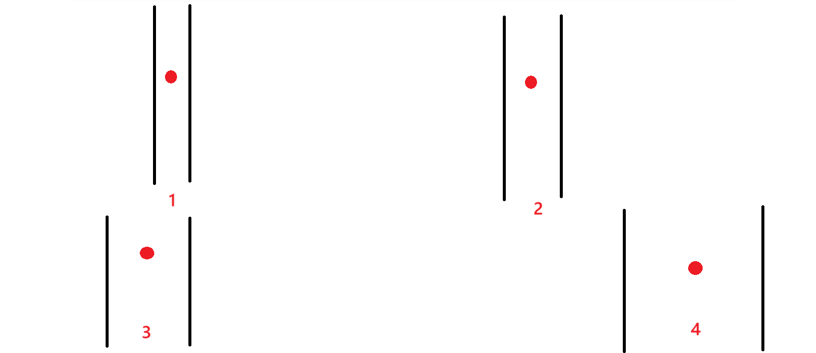

Figure 5

**6 Observers and randomness**

**Suppose that the particles entering the slit will lead to dimensionality reduction, and will the dimension rise quickly when coming out of the slit ?** **( The superposition state is not a substance form, and the particle state and the wave state may exist at the same time for a substance, this represents the ability of quantum to rise or fall in dimension. ) In other words, two particles can make contact as they pass through the slit, or promote contact.**

If the form of substance is related to the dimensionality, the original dimensionality of substance will change slightly after entering the slit, and the change is the non-integer dimensionality behind.

At this time, the total dimension of the object only changes slightly, which can be regarded as the dimension unchanged. But why there is randomness or wave-particle duality or superposition state or path integral. Because there is a dimensional balance ( partial dimension increase and partial dimension reduction ) within the substance, but the total substance has only one result at this time. **And the dimensions control each other and have infinite dimensions. The infinite dimensions here may not be a specific number. Instead, they represent an endless cycle, as the zero-dimensional point, after ascending to infinite dimensions, although it is equivalent to zero-dimensional, can still generate new collisions. This effect will not cease (temporarily disregarding the existence of other universes).** Observing this behavior is similar to helping two substances become a whole, 1 If there is no observation behavior ( interaction ), these two energies can be considered as two separate wholes. 2 But as long as the mutual influence of the two energy will become a substance, that is, into a small whole. But the process of 2 is very slow, but it can be considered to promote the balance of dimensions. 1 is to prevent the dimension balance, only with the help of a larger overall dimension balance. Dimension balance is very important. The following will be introduced. If there is no dimension balance, the positive and negative energy will be completely distinguished. For example, another person who comes face to face will not be embarrassed if he does not observe. As long as one of them observes another person, the observed person will be unconsciously uncomfortable. It means that the impact is mutual, not one-way. Hereafter, the generation of topology will be introduced in detail. **At the same time, it also seems to prove that human beings are more likely toreceive collision residual energy than ordinary matter（This refers more to the residual energy of high dimensional collisions, while the role of residual energy of low dimensional collisions has not been described）. This is a thought process, not a conclusion.**

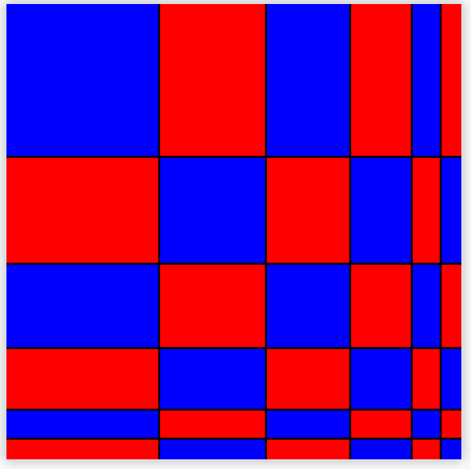

Figure 6: This picture can be simply understood as the process of particles passing through a slit, similar to an alternation between low dimensional collision residual energy and high dimensional collision residual energy. Particles gain low dimensional collision residual energy to change the overallity.

**7 Guess the black hole**

Each photon occupies a discrete spatial unit, and the dimension of the photon is very close to the integer dimension. Black holes can be considered as precursors of substance **(Integer dimensional matter in other dimensions ).** Another uncertain special celestial body, the white hole, is difficult to exist and has completely negative energy, or true negative energy ( the negative energy mentioned above is a relative concept ), and this material is not completely impossible to exist. The ' big bang ' mentioned below may be due to the dimensional balance with other universes, **so white holes may also exist in other universes.** This will be explained later: the "Big Bang" may not have been a passive event, but an active gathering of energy.

**Assuming photons are integer-dimensional matter, then photons should be integer four-dimensional matter (not yet reaching the fourth dimension). Electromagnetic waves or the fundamental particles that generate electromagnetic forces are three-dimensional to four-dimensional matter (forming matter). Dark matter can be understood as one-dimensional and two-dimensional integer matter. Dark energy is all the residual energy from collisions below three dimensions (not forming matter, which can be understood as "pure negative energy" in relativity, leading to high-dimensional reduction). The role of dark energy will be explained later, so "negative energy" is not accurate at this point. Zero-dimensional points are zero-dimensional matter (which can also be understood as dark matter). Galaxy clusters are from zero to one-dimensional matter (forming matter). The "fibers" of the "Laniakea Supercluster" are one-dimensional to two-dimensional matter (forming matter). Galaxies like the Milky Way are from two-dimensional to three-dimensional matter (forming matter), and black holes are integer three-dimensional matter（not yet reaching the third dimension）. In string theory, strings（The vibration mode of the node is the basic unit）are four-dimensional to five-dimensional matter (forming matter), closed strings are integer five-dimensional matter（In fact, gravitons are just a hypothesis and do not actually exist, as gravity is composed of countless fundamental particles. Different environments with stronger or weaker gravitational forces contain different fundamental particles. Gravitons represent "the most weakly interacting fundamental particle," and only closed strings can describe this smallest unit. In essence, gravitons are akin to photons in the three-dimensional world, being the ultimate product of the four-dimensional world. If that's not clear, imagine that photons describe electromagnetic fields, and closed strings describe gravity. When all four-dimensional matter ascends to five-dimensional matter, all open strings will become closed strings. However, this process is much more complex than in the three-dimensional world. Therefore, while gravity can be described by a fundamental particle, this is not entirely accurate.）, and the membrane is the residual energy from the collision of matter dimensions (not yet forming matter or serving as a background space). Later explained why string theory could unify other matter. Here I assume that the string is easier to understand as a vibration mode of the string. Because the string does not represent four-dimensional to five-dimensional matter, but many kinds of vibration modes of the string. So the essence is not the string, but the vibration mode of each node of the string, but for ease of understanding I describe it as the string. These are part of my final conclusion, but I put them first for ease of understanding.**

**White hole I think can not be considered, because at present the universe does not exist pure negative energy material. Or matter with negative energy greater than positive energy. If it exists, it cannot exist stably for a long time. Unless there are other universes that have dimensional equilibrium with our universe, this would make the problem much more complicated. And we don't have an overall dimensional reduction process in our universe, so we can ignore that. So antimatter, which we think has more negative energy, is hard to exist for long periods of time.**

**8 Collisions produce**

There is only one possibility for the production and opposition of positive and negative energy. Before the beginning of time, **There is a zero-dimensional point in each unit space, and there are nearly infinite zero-dimensional points in the universe. But the universe must have boundaries ( friction ). Or that friction can change the boundary, which is to say, constantly create new space. It also seems to represent the high-dimensional collision residual energy as a kind of boundary, and that the universe was not infinite in the beginning, there was a boundary (the universe was described at the beginning as the Big Bang, and I didn't know that there might be other universes out there).** This may seem paradoxical, but this friction must exist. That is to say, there was an internal dimension difference in the universe before the Big Bang. This makes me feel that the universe is in a constant cycle. There is no specific beginning or end, and there is no specific size (a zero-dimensional point can be another universe), so I choose not to consider this situation for now.

It is assumed that the universe begins at infinitely many zero-dimensional points in an infinite dimensional space(The infinite dimensional space here refers to the number of vibration directions of a whole.). The universe began as a single point of sudden vibration. Since the surrounding point is stationary, the vibration point will collide with the surrounding point elastically, causing the vibration of the surrounding point and propagating the collision to the surrounding point. As a result of these collisions, the central point and the surrounding points form the same collision frequency ( Suppose the universe has boundaries). As the collision continues, the first momentum will disperse. Until the total momentum in one direction is zero（Or it can't be transmitted）, but there will still be a weak residual energy that can be gathered again to one of the points ( which is already the point on one-dimensional substance ). New vibrations occur ( in different directions ). **Until the new dimension is generated again, but the new collision energy is very weak, so the higher the dimension, the smaller the substance（What is being compared here is the integer dimensional matter）. Instead of integer dimensional matter, it's the opposite.**

**9 The necessity of mathematics**

When the center point suddenly vibrates, there will be a positive direction（The direction of the first collision）. Suppose that a square ( The shape is determined by the current dimension) is filled with countless points, without any gaps. It must be that there are no gaps, which may not be possible in common sense, but the gaps can be filled by units of smaller dimensions (ignoring dimensions smaller than zero for the moment). When the center point vibrates, the resulting collision will propagate around. Since collisions are not infinite, they stop when energy is exhausted or a closed loop is formed. The process is similar to dispersing energy into countless small pieces. After a certain period of time, the vibration mode evolves,, which drives the vibration of the surrounding points. There are countless points in the surrounding space, similar to walls, allowing for fully elastic collisions. The unit space can also be the space formed after the collision is stable, **but the universe must be filled with countless zero-dimensional points on average at the beginning.** After a point vibrates back and forth, it shows two very different trends : forward movement and backward movement. Both trends are multiples of π Figure 7. And the two trends are the vibration of a substance. The collision of two directions can produce two ways of dimension change, one is to promote dimension change, and the other is to prevent dimension change. **Due to the decrease of momentum consumption and collision frequency, the positive vibration is greater than the negative vibration. In addition to the vibration and collision of zero-dimensional points in this process, there are two variables: one is the low-dimensional collision residual energy that causes the motion of zero-dimensional points, and the other is the friction force in the motion process that is the high-dimensional collision residual energy. And these zero-dimensional points are matter. Low dimensional collision residual energy continues to provide energy to these zero dimensional points, while high dimensional collision residual energy continues to produce and increase the dimension. We also know that the higher the dimension, the less energy, so high dimensional collision residual energy will become weaker and weaker.**

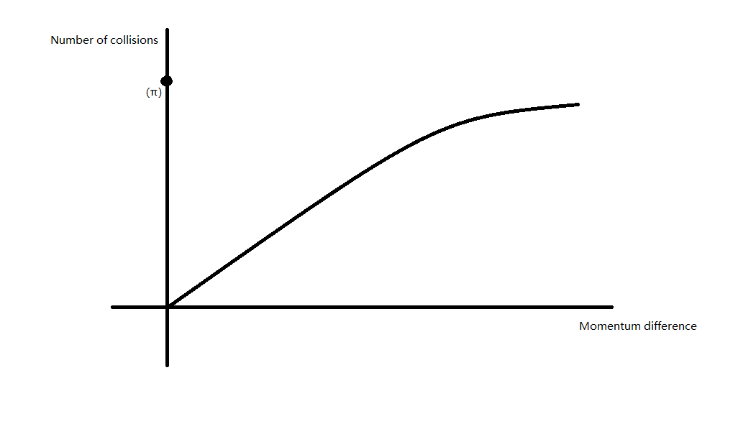Figure 7

**10 Conjecture**

The substance is controlled by stratification, in which the point vibrates into a line, the line vibrates into a plane, the plane vibrates into a ball, and so on. Of course it's not that simple.

This is just the prototype of thinking. First, we need to determine whether the perspective of thinking is correct. For example:According to Figure 8, when we sing, imagine that our voice will become a sharp treble when we tighten to a point. Imagine that when we get big enough, our voice becomes a steady, sustained bass. I can feel that this is a more correct way of thinking. Then continue to solve the problem.

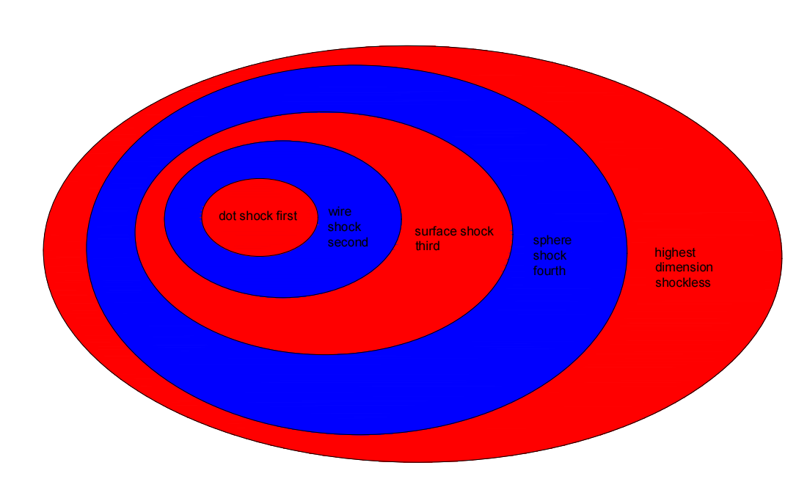

Figure 8

**11 The inspiration of mathematical logic given by Riemann conjecture**

We first consider the big whole: based on the previous statement, π is related to the number of collisions; Then analyze the collision unit. Note that e, (1+1/n) *n; this formula is the base number of energy transmission. And the imaginary number i is the direction of a dimensionality generated by collision in the presence of one dimensionality. The imaginary number i can also be thought of as an added dimension.

e * i is equivalent to the process of passing to this new dimension ( each vibration brings a new direction of collision ). This length can also be considered as the process of energy dimension increasing. That is to say, each new dimension addition is equivalent to the 0 energy of the previous dimension ; of course, 0 is an approximation**(The new dimension here refers to the new integer dimension)**.

The formation process of the new dimension is similar to the calculation process of the bank 's compound interest. A straight line collides with a plane composed of n straight lines ( or elastic collision with the wall ). Let V1 denote the velocity of the line and V2 denote the velocity of the line in the plane.

$$\frac{1}{2}M{V1}^{2}=\frac{1}{2}nM{V2}^{2}$$

$$\frac{1}{n}{V1}^{2}={V2}^{2}$$

This formula shows that : with this formula we understand the physical meaning of e. Suppose that there is a straight line which is an entire one-dimensional substance and there are countless zero-dimensional points in space. At this point, the line has low dimensional collision residual energy, which can only be concentrated on a quantum in the straight line. This energy causes the quantum to collide for the first time ( a collision here describes an integer ten times the number of π ). At this time, the quantum collision to the wall will undergo an elastic collision( wall refers to countless zero-dimensional points ) . The energy of the wall rebound is excited to all the quantum on the straight line, The residual energy from the high-dimensional collision of the rebound still produces and concentrates in a quantum, but the next collision wall not only includes this quantum but also includes the n-dimensional substance generated by the first collision ( this formula is similar to the 1.000001 dimension. Because the remaining energy from the low dimensional collision will continuously excite this line, and this is the process of excitation once. But eventually the remaining energy from the low dimensional collision will all be excited, resulting in the line being raised to the whole two dimensions. **But at this time, the remaining energy of low dimensional collision and high dimensional collision will also reach the integer dimension**). This process needs to last for countless times, the collision residual energy is similar, and the number of times of this process is similar to the n-th power. Here n is not a number but it is infinite. Therefore, the process of one integer dimension ascending to another integer dimension is similar to that of bank compound interest, but each collision of individual quantum is π times, and each collision is similar to a new collision direction i. Finally, the negative energy with the same energy can be generated to offset the positive energy brought by the residual energy of the first collision. Form an integer dimension substance. Explain that the Euler 's identity is only applicable to the large whole, and it is an energy cycle, not a substance cycle. With the change of dimension, substance is changed. 1 in the Euler identity is the initial collision residual energy, that is, the difference between positive and negative energy at the beginning. Result-1 is the increment of negative energy after rising an integer dimension. **The imaginary number i indicates that the newly added collision direction is based on the original vibration direction（This is a property of the direction of vibration, and the process is understood to be that each vibration direction is related to the accumulated vibration direction）**. **But I found a drawback, the material rose an integer dimension energy reduced to 0, which is somewhat inconceivable. But then I realized that a zero-dimensional point rising to an integer dimension is equivalent to the universe rising to an infinite dimension, because matter in other dimensions also rises to an integer dimension. Because all the dimensional quanta are rising at the same time, that is to say, the process is not progressive but synchronous.** **Because it is not the case that all zero-dimensional points rise to one-dimensional quantum and then to two-dimensional quantum, but rather all dimensions increase simultaneously until they reach an integer dimension of matter. This is because there are two types of collision residual energies representing high-dimensional matter and low-dimensional matter. These materials collectively form dimensional balance, thus elevating the dimensions. Until all zero-dimensional points ascend to infinite dimensions. Before reaching infinite dimensions, the universe remains a whole, with lower dimensions closer to the center（But in general they break down into an infinite number of elementary particles, each with an infinite number of dimensions.）. After reaching infinite dimensions, all quanta become infinite-dimensional quanta. Since all three-dimensional to four-dimensional matter forms a single entity, this entity must elevate to four-dimensional matter by transforming all three-dimensional quanta into four-dimensional quanta. It can be understood that low-dimensional matter ascends more quickly, while higher-dimensional matter ascends more slowly. This process is somewhat difficult to grasp and cannot be fully expressed; it can be understood after reading the article.**

**The Riemann conjecture: 1+1/2*s+1/3*s+1/4*s......[6]**

**The Riemann conjecture is more about understanding new dimensions in terms of the direction of vibration.** Let 's understand the new dimension from a different perspective. Let us say that we start with a point with mass 1 and velocity V1. The velocity of each point after n passes is set to V2.

$$\frac{1}{2}M{V1}^{2}=\frac{1}{2}M\left({V2}^{2}+{V2}^{2}+{V2}^{2}+⋯\right)$$

$$\frac{1}{2}M{V1}^{2}=\frac{1}{2}Mn{V2}^{2}$$

$${\frac{1}{n}}^{\frac{1}{2}}V1=V$$

We exchange energy for speed, or we separate each collision ( here the collision is also refers to the π of the whole tens of times ), here refers to the speed added until can 't produce acceleration. Because the positive energy is equivalent to acceleration, and the negative energy is equivalent to deceleration, as long as the deceleration is equal to acceleration, the substance can not produce acceleration in another direction. It can not be raised again. The Riemann conjecture expresses the residual velocity of the collision that can be generated after each dimension increase （**It's a motion process that shows that there's still energy left over after adding a new vibration direction, so it produces the next vibration direction.**）.The most important part of this formula is the imaginary part, which is related to the number of collisions that have been previously collided with. The imaginary part describes the number of future collisions. **Whenever a zero-dimensional point vibrates in space, there is a slight energy loss or friction between the energy and space (the friction with space creates new space). This friction can cause the next dimension to be rebounded, and the rebounded energy determines the location where the remaining energy from the next low-dimensional collision will accumulate. The difference in accumulation points can be understood as the difference in vibration direction.** The higher the dimension, the less likely the substance is to improve the dimension. Therefore, increasing the speed is also a way to improve the dimension. The direction of vibration is generally determined by the dimensional balance ( energy balance ) in the large whole. **The direction of vibration is a highly complex issue, but it is indeed determined by dimensional balance. Different dimensions of matter form dimensional balance with different substances, and the overall nature of these substances is determined by the residual energy from high-dimensional collisions. This residual energy from high-dimensional collisions controls the formation of two units into a whole, thus determining the future direction of vibration. At this point, the residual energy from low-dimensional collisions primarily determines the frequency of vibrations, but this also implies that there is mutual influence between the residual energy from low-dimensional and high-dimensional collisions.**

**The law of energy transfer can be realized only when the real part satisfies 1 / 2. The Riemann conjecture is related to the energy in the new dimension (The direction of future vibration is indirectly presented by the change of velocity), and the Euler 's identity is related to the position of the current dimension (The number of future vibrations is indirectly presented by the change in energy). Here we seem to understand that time creates space or creates a new dimension. So can we also think that time can also achieve dimensional balance, there will be no time part of dimensionality reduction. However, time may only be a concept that does not exist（It could be an abstract concept or a concept of infinite multidimensional combinations）. The change of dimension can only change the speed of time, but not the direction of time. Because both positive and negative motion produce time.**

Whether π is an irrational number depends on the dimension. The lower the dimension, the closer the number of collisions is to π. This expression will remind us of zero dimensions or not the smallest dimension of the universe. When the particles reach the infinite dimension, the remaining energy of the collision will gather again and a new excitation will occur, but the infinite dimension at this time is equivalent to zero dimension **(If it turns out that new universes can exist inside or outside the universe, then the process will not stop.)**. This is equivalent to zero dimensions, which means that the infinite universe starts over. **But if there are other universes, then the universe has only increased by one dimension (the size of which is determined by the size of the universe outside it).**

**But it is not clear whether the universe will be able to inspire us once it reaches infinite dimensions. And the universe itself may also be a single zero-dimensional point, or there are countless zero-dimensional points inside the zero-dimensional point. So the universe will rise again. When the universe rises to infinite dimensions, it only means that all universes rise by one dimension (This is a non-integer dimension). All these are possible（We'll leave that aside for a moment）. In fact, the existence of countless zero-dimensional points within a single zero-dimensional point is not speculative. If a zero-dimensional point were an isolated unit, the remaining energy from collisions would likely not be able to escape its original dimension. Therefore, the remaining energy from collisions carries out specific 'small zero-dimensional points.' The reason this happens is that the dimensions within a zero-dimensional point can change, meaning that even without collisions, it still possesses material properties, which can be considered part of the zero-dimensional point.**

**The next point is crucial (you can skip it if you don't understand): we can only observe the expansion of the universe, not its contraction (the reason will be explained later). This does not mean that no other universes exist; on the contrary, the existence of other universes would cause our universe to continuously expand. That is to say, there are dimensions smaller than zero dimensional points. This is a challenging issue and can be left for another discussion.**

The basic law of is not complex ( running direction ), but complex is the balance of dimensions in the whole and the direction of vibration caused by the balance of dimensions. This way does allow the universe to resolve the first anomaly, but not the direction. As long as the residual energy aggregation point of the collision is uncertain, the unit and vibration direction of the subsequent ascending dimension cannot be determined. **This will lead to the process of ascending dimension is not so regular, or produce some nodes. There is no analysis here for the time being.** I thought of a way to solve this problem: there was a zero-dimensional point in the universe with higher or lower dimensions before the Big Bang. In this way, you can judge the future development direction, but it will also lead to the final vibration into an infinite dimension after there is a different unit, it has a slightly higher or lower dimension. This does define the direction of vibration, but it also means that the universe's initial dimensions are not completely zero or that there are other dimensions outside the universe. I personally don't like this complexity. But it is still highly possible that there were non-zero zero-dimensional points before the Big Bang, **Because when a zero-dimensional point rises to an infinite number of dimensions, there must be some special zero-dimensional points (an infinite number of dimensions can be understood as zero-dimensional points, and the universe returns to its original position but does not rule out another "Big Bang"). So this possibility is not low, and it would make these especial zero-dimensional points difficult to analyze(There is energy left over from the last big bang）. These special energies are dispersed across different dimensions as the universe increases in dimension, and their exact role is not yet clear.**

Although the vibration direction of the small whole in the large whole is very different, in general, we can think of it as a similar vibration direction. Here I think of an interesting argument : the higher the dimension, the more negative energy, does it mean that the performance of negative energy is more obvious ? **If we consider the direction of vibration, the higher the dimension of the material, the more the direction of vibration, which will lead to the negative direction of the vibration direction is not single. This will affect the way of expression.**

**Is dimensional balance something that might confuse us? Because in the article dimensional balance is quantum entanglement, but in reality there are very few cases of quantum entanglement. In fact, quantum entanglement is the result of a complete dimensional balance of matter (the same direction of vibration). The process of forming quantum entanglement is called dimensional equilibrium. For the matter that has not reached the quantum entanglement state, the dimensional balance process between them depends on the transmission of electromagnetic waves, while the matter that has formed quantum entanglement has reached the same space, and their dimensional balance does not depend on the three-dimensional matter. So the dimensional equilibrium speed between two objects that have not yet formed quantum entanglement is the speed of light, and the dimensional equilibrium speed between two objects that have reached quantum entanglement is the speed of light to infinity（The reason for the existence of infinite speed is that the similarity of the direction of vibration determines which dimension the material that transmits dimensional balance is in）. That's a little hard to understand. Another difficulty is that we think of the electric field and the magnetic field as energy fields of the same nature, but in fact the electric field is caused by the difference between two positive energies of matter, and the magnetic field is caused by the difference between two negative energies of matter (this description is not accurate, but it can be understood temporarily). Magnetic monopole do not exist because there are no real negative energy particles, but the negative energy effect can exist. The electromagnetic field is the most extreme two-dimensional matter (with the most positive energy) among the low dimensional collision residual energy, so the electromagnetic field can be generated independently without the high dimensional collision residual energy. In other words, the electromagnetic field belongs to the product of one-dimensional matter (the lowest dimension in two-dimensional matter). The strong interaction is also relatively simple and belongs to the product of two-dimensional matter(The highest dimension in two-dimensional matter, similar to the whole three-dimensional matter. Note that unlike black holes, fields belong to the collision residual energy is not matter, because for three-dimensional matter, strong interaction has become the previous dimension, and black holes have no subsequent dimension). However, the weak interaction is complicated. It is not an integer dimensional matter, so it is a product of one-dimensional to two-dimensional matter. That is to say, the weak interaction is a non-integer dimensional field, which is also the most difficult to analyze, and will not be discussed for the time being.**

Because the residual energy of high dimensional collision can be understood as the influence on the future, the residual energy of low dimensional collision is more the influence on the past. So we can slightly feel what has not happened in the future, but it is not accurate . **There is also an interesting phenomenon on this point : in a very short period of time, the past and the future can influence each other.** This is difficult to understand, and some thought experiments are needed. The future can be understood as the time that has not yet been generated, and time can generate space, that is to say, the future is the space that has not yet been formed. There are two forms of energy in the unformed space, one is the real future ( the impact of collision ), and the other is the virtual future ( High dimensional collision residual energy ). The virtual future can react with the large amount of residual energy accumulated in the past (low dimensional collision residual energy). This reaction is mutual, because the process of forming substance in the new dimension will also have a dimensional balance. We can be understood as adding water in a fixed container, the speed of our water can be affected before and after. The dimensions of the future will change, and the dimensions of the past will also be affected, but this process is instantaneous. In other words, the volume of water in the container determines our rate of adding water (the volume of water is determined by the past. If we change the future rate of adding water, we will unconsciously alter the past rate of adding water. However, it's important to note that this change or influence is very brief. The interaction of the two collisional residual energies causes the matter to rise in dimensions, while the process of dimensional decline disappears. However, forming a dimensional balance takes time. This means that even after a dimensional balance has been established, the overall process of changing dimensions still requires the continuous formation of dimensional balances. The formation of dimensional balance essentially involves equal positive and negative directions (equal vibration directions), which requires a process. **At this point, the prototype of the final conclusion emerged: that the past should also be a special collision residual energy (low dimensional collision residual energy), and that there is a relationship between the two collision residual energies.** However, the influence of high dimensional collision residual energy on low dimensional collision residual energy only occurs when the high dimensional collision residual energy changes abnormally. In other words, at this point, a low dimensional collision residual energy is needed with very low dimensions, and the process takes almost no time. Because ordinary matter can only contact or touch the collision residual energy of adjacent dimensions, and the cross-dimensional influence does not directly affect three-dimensional matter. In fact, the dimensional balance in the universe is very complex, because the universe has infinite dimensions. So some of the more complex processes are not discussed in this paper.

Explanation of dimensional balance: We understand that dimensional balance ultimately leads to quantum entanglement (making the two vibrate in the same direction). When two people observe each other, one of them changes his state, and the other is also affected. The macro dimension balance is not very obvious, because the macro is not easy to form a whole（The macroscopic material dimension is high）. For example, we observe an apple from the front, we can only observe the front of the apple. If we look at it from a different perspective, has the apple not changed ? In fact, this apple has changed. At this time, our relationship with Apple changed. Because what we 've observed has changed. Or different angles of Apple have different energy distribution. We can understand it as the direction of the vibration. The direction of the vibration of the apple changes ( positive and negative energy changes ). At this time, the apple ' observes ' our vibration direction will also change. The dimensional balance between us and Apple leads to different dimensional balances between us and the different states of things around us. When we do circular motion from a lake surface, we will find that there are different positive and negative energy components ( **reflective surface and dark surface transformation position** ) on the lake surface at each moment.

**12 Understanding dimension**

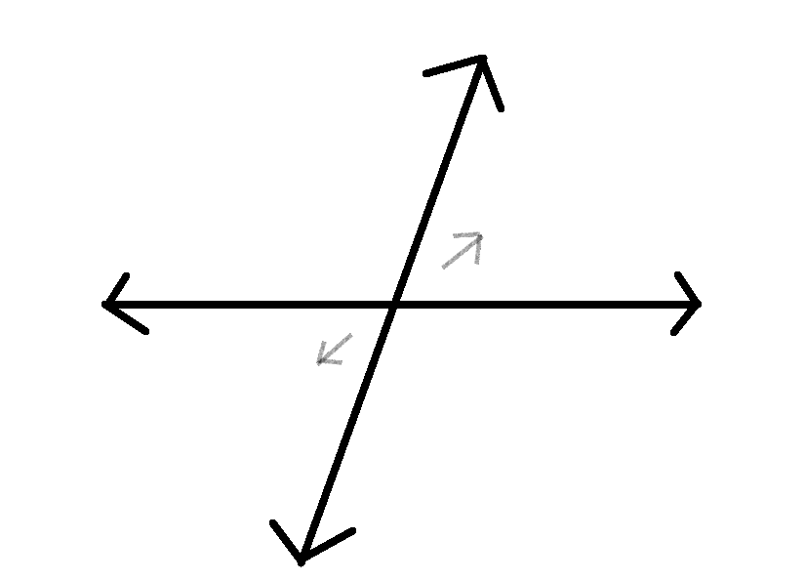

Figure 9The vibration of two-dimensional substance in space will produce two directions of motion.

The original integer dimensionality determines the complex part in the Riemann hypothesis. **Only one imaginary number i can exist because the substance can only add a new direction of vibration at a time, even if the substance disperses the vibration, the substance can only increase the dimension or reduce the dimension at a time. Or you can think of the imaginary number i as the residual energy from the high dimensional collision, which can contain all the high dimensional energy, as can be seen from the formula at the beginning of the paper.**

**Substances of the same dimensionality must be the same（Do not consider the internal，Or the internal dimension distribution）.** Different dimensions combine to form a new dimension, such as 2.1 + 2.3 = 2.2, **but the newly generated high dimension is not easy to be generated by the original single dimension, for example**, 2.2 Upgrade to 2.23 on your own ( this process is too slow, the basic fast dimension change comes from the dimension balance ). 2.23 can affect the motion of 2.2.

Although 2.2 has a significant impact on 2.23, due to the huge energy of the two-dimensionalityal vibration itself, it cannot directly change the vibration direction of 2.23. So 2.2 + 2.23 = 2.2...... 2.2 and 2.23 have the same vibration direction but are different types of substances. Due to the principle of collision, assuming the energy of three-dimensionalityal substance is 1, in the process of forming three-dimensionalityal substance, the energy of two-dimensionalityal substance is n times that of three-dimensionalityal substance, **because the Riemann ζ function causes the new substance produced by the two-dimensional substance to be always an integer multiple of the entire three-dimensional substance.**

**A zero-dimensionalityal point vibrating into an infinite-dimensionalityal point will eventually come to a complete stop, until all points vibrate into infinite dimensionalitys without colliding（This process is actually quite difficult to understand: do not think of zero to one dimension as an independent zero-dimensional point. Zero to one dimension encompasses the entire universe, and when the entire universe ascends by one dimension, all the zero-dimensional points within it will become infinitely dimensional and completely dispersed. This is because ascending by one dimension also means that the central zero-dimensional point becomes infinitely dimensional. If you cannot understand this, you can interpret Figure 8 as the zero to one dimensional universe）. For the universe to increase its dimensions, it would have to go through another big bang, in which it would take the residual energy from collisions with lower dimensions from other universes.**

Assume that the first 2.2 dimensions of 2.2 and 2.3 have exactly the same or opposite directions of vibration, these two substances can combine to form a new dimensional substance. **This new substance has a characteristic that it can exist as a single substance rather than a combination of two substances, at this point entanglement occurs(Dimension balance).**

It is difficult to accurately raise the dimensionality from 2.19 to 2.2 in large quantities of producing a certain dimensionalityal energy. If we want more 2.2 energy, we need more 2.1 and 2.3, which means higher and lower dimensionalityal energies need to become more. This way, the probability of producing 2.2 will also increase.

For example, excessive energy, such as inflammation(low-dimension), can be balanced by raising the dimension. But the process is not simple. Although I can't explain it, we can understand it as generating high-dimensional matter and carrying out low-dimensional matter. In essence, it is still regulating the direction of vibration, or preventing the change of dimension. The treatment of special diseases such as cancer is different from the treatment of inflammation. Cancer seems to be treated by improving its own dimension. Due to the high dimension of cancer cells, improving the dimension can effectively control the harm of cancer cells. Although the dimension of most viruses is also high, it is difficult for cancer cells to reduce the dimension. Raising one 's own dimension may accelerate the speed of death ( the overall rising dimension of life ). **If we can 't find a way to reduce the dimension of cancer cells, we can balance or slow down the time of death by autonomous dimension reduction（Here we should not misunderstand that the reduction of dimension is impossible to achieve, in fact it can be achieved, but it requires the addition of low dimensional collision residual energy.）.**

However, any substance contains positive and negative energy, and a static substance mass is the negative and positive energy difference. As shown in Figure 9, the direction of the vibration represents the positive and negative energy, and the difference between the positive and negative energy determines the magnitude of the dimensionality, so the moment of the vibration represents the dimensionality of the substance at this moment. if the relativity of the frame of reference is not considered, the substance of the same dimensionality must be the same. That is to say, two substances of the same dimensionality have the same total positive and negative energy, but the direction of positive and negative energy vibration is different. Therefore, there will be different internal components for the same dimension. In addition, it should be noted that if it is a 3.4-dimensional substance and a 3.5-dimensional substance produced by the same whole, the first three dimensions of the two substances are not easily observed.

Next you need to think carefully. If the substance has vibrations in all directions, then the next dimensionality of the substance is easier to ascend but more difficult to reduce. Because the more the vibration direction of the substance, the easier it is to require energy in a specific direction. So the promotion of the dimensionality requires collisions in all directions. Here, it refers to the combination of different dimensions or collision directions in a single dimension. **A dimension refers to the collision in different directions that shakes the energy to zero, not a single vibration direction. A single direction of vibration makes it difficult to lift the dimension of an object.**

Next, we consider a special case where the velocity of the substance reaches the speed of light c. In the previous analysis, we know that the speed of motion reaching the speed of light is equivalent to time pause, and time is equivalent to the comparison of substance motion and space motion. Positive energy and negative energy are equivalent to shrinking space and stretching space. The substance reaching the speed of light can not produce space deformation, that is, can not occur relative collision, the positive and negative energy of this substance is equal. **It is almost impossible for integer dimensional matter to increase its dimension, because there is no more collision residual energy at this time. However, as long as all non-integer dimensional matter rises to integer dimensional matter, the whole at this time can be regarded as non-integer dimensional matter in another dimension. Then, there will be a higher dimensional collision residual energy to help lift the dimension. In fact, it generally won't increase dimensions again because I didn't consider the residual energy from low-dimensional collisions before. In reality, once one of the zero-dimensional points rises to the next integer dimension, all zero-dimensional points in the entire universe will ascend to infinite dimensions. This process is not complicated; we just need to consider that the residual energy from low-dimensional collisions continuously generates low-dimensional matter. The specific entire process will not be explained here; you can read the article and think independently.**

There are four kinds of forces that are most easily observed in any dimensionality of substance. Assume that the dimensionality of a substance is 2.2, 2 dimensionality can produce a strong force, 0.2 can produce a weak force, the positive and negative energy difference between this substance and other substances can produce a force, the new dimensionality of this substance can produce a force. There is another force that is not easy to find, because the energy is too large and stable. This force is the previous dimensionality energy that 1 can generate. **This force is special and can only be possessed by a super large whole. In general, the first few dimensions of matter reach integer dimensions and there is no such force. All super large whole: all one-dimensional to two-dimensional whole can possess dark energy.** We know that the change of dimension depends on the alternation of positive energy and negative energy. If the positive energy and negative energy are basically balanced, it is difficult to change the dimension.

The most obvious vibration in the organs is the heart(The lowest dimension). Although the brain determines the complexity of the body. However, it is clear that the changes in the brain do not directly affect the organ but the movement behavior. This process is not as good as the impact of changes in the heart on the organ. After strenuous exercise, the biggest change is the heartbeat, here does not consider breathing changes in lung activity. Because body movement is a smaller dimension of ascension, it has the greatest impact on the lowest dimension. Similar to the dreams, weak dimensionality reduction has the greatest impact on the brain. The slight effect during sleep may lead to a slight dimension reduction and the brain has the greatest impact. Anyone who is slightly uncomfortable when sleeping is likely to dream. **So dreams can be simply understood as a mode of dimensional elevation of anomalies. That is, dreaming has a stronger dimensional enhancement ability than ordinary sleeping. However, both sleeping and dreaming are somewhat different from the general process of dimensional elevation. This is more like a method to gather residual energy from collisions in lower dimensions (this is just a guess, the specific process should be very complex).** But after reaching the night, the body part of the human body has reached the limit ( used to lower dimensions ). Without sleep, the dimension of the body cannot rise. **Let's say we put a person in a dark, closed space (dimension reduction), and if he doesn't sleep he will suffer.**  It can be seen that photons belong to negative energy and darkness belongs to positive energy. Some people may wonder what darkness means. **Darkness can be understood as low-dimensional collision residual energy, or the background space formed by dark energy.** Because the higher the dimension, the more difficult it is to ascend the dimension, so there is a lot of light at night now, which slows down the speed of ascending dimension ( stops sleep ). At this time, there must be some doubts : shouldn 't the higher dimension of photons lead to the higher dimension of matter ? Photons can also increase the dimension of matter, but we know that matter can not only increase the dimension for a long time, but also increase the dimension and reduce the dimension at the same time. Because vibrations or collisions can 't just go in one direction. And I think the effect of sleep lifting is much greater than that of light. So light can prevent sleep. It may also be that some people cannot accept that photons belong to negative energy. Since Figure 3 shows that the external manifestation of negative energy is positive energy, this may allow us to accept reality. The residual energy of the collision can promote the rise of the dimension, so having too much residual energy of the collision will increase the generation of negative energy.

**The higher the dimension, the more the direction of substance vibration. Without external force, the complex vibration direction will make it difficult to reduce the dimension. because of the direction of vibration, the speed of response is slow, duration was longer.**

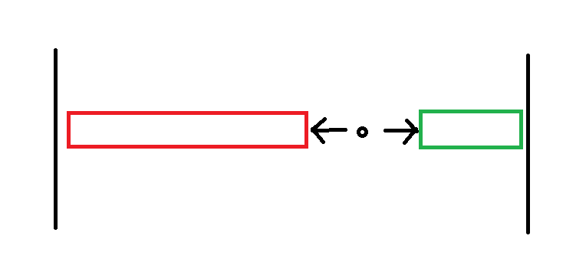

Figure 10

The principle of dimension balance is positive and negative energy balance. A substance 's short-term ascension dimension will be accompanied by the reduction of the surrounding substance dimension. **Therefore, we can also know that high-dimensional matter may be accompanied by low-dimensional matter around it.**

When two substances with different vibration directions coexist for a long time, the vibration directions and trends of the two substances will become similar, because long-term collisions will produce forces that change the vibration direction. This explanation can help us understand the concept of dimensional balance. Long-term coexistence can be understood as the occurrence of dimensional balance. Why positive energy is greater than negative energy. Here, we regard the positive energy as a compressed space and the negative energy as a stretched space. This is only a microscopic expression. For macroscopic matter, the positive energy is only the result of the interweaving of positive and negative energy, but the positive energy is larger. **If we take the volume of substance as an example, it is better to understand, so positive energy greater than negative energy will rise in dimension.**

**The above describes the process of dimensional balance, and there is another phenomenon that is similar to this process. Quantum tunneling visualizes this process. Dimensional balance is akin to a collision between two substances, where the vibration directions of the two substances gradually become similar. Suppose a quantum collides with a wall; at this point, the wall represents a larger whole or higher-dimensional matter (the higher the dimension, the more pronounced the reaction). (There is a misconception that needs clarification: it's not true that the larger the wall, the higher the dimension; on the contrary, if the material does not change, a larger volume indicates a lower dimension. Additionally, it also relates to the width of the wall. The collision is unidirectional; if the material does not change, a wider wall indicates a lower dimensional direction). The wall will produce weak quantum vibrations with a similar direction to the impact quantum. Therefore, quantum tunneling is not about actual energy passing through but rather the formation of new quantum states similar to the impact quantum (although the process still satisfies the law of conservation of energy). Regarding the relationship between volume and dimensions, it should be noted that the higher the dimension, the greater the volume. However, as dimensions increase, the basic units of matter undergo certain changes. But these changes are not simply from one unit to another; they are proportional changes. Overall, the higher the dimension, the greater the proportion of negative energy.**

According to Figure 10, we can observe that positive and negative energies are produced simultaneously. Theoretically, these energies should be perfectly symmetrical. However, why do they not appear completely symmetrical in practice? This is because the essence of energy lies in the number of collisions. The number of collisions determines that energy is not conserved. In certain scenarios, the number of collisions can be either odd or even. When the number of collisions is odd, it results in a higher amount of positive energy in matter. The truth may be more complex, but it can be understood this way: to eliminate energy in one direction, at least the same number of collisions must occur in the opposite direction to completely eliminate the energy.

Once again, we return to the quantum entanglement effect and discuss why the speed is infinite. What characteristics will be produced when two substances become one substance. The space between two substances and the two substances can form a dimensional balance. Similar to two points colliding back and forth in a unit space, that is to say, two energies form a small whole. Although the higher-dimensional substance has low energy, it has a greater impact on the lower-dimensional substance. We know that the center vibration can lead to the surrounding dimension reduction. After the universe finally forms the highest dimension, there is no energy difference in substance. The dimension of the whole substance is exactly the same, similar to the disappearance of substance and energy, only the boundary**( The boundary here is a difficult point, there are three cases can form a boundary. The first case is that the remaining energy of high dimensional collision is weak, the boundary generated at this time is the boundary between the excess one-time collision and the residual energy of the collision. The boundary at this time can be understood as a multi-point collision, which determines the energy nature by the positive and negative nature of the first collision. The second case is that there is more residual energy from high dimensional collisions. At this time, the residual energy of the collision leads to the dimensional balance inside the material, like an independent space wrapped material, similar to the holographic theory. At this point, the positive energy is more likely to collide with the high dimensional negative energy and balance the remaining energy. Why is it called a membrane? Because the fourth dimensional matter is on the surface of the third dimensional matter, and the three dimensional matter cannot observe the fourth dimension of the fourth dimensional matter, it looks more like a membrane. And this membrane is to some extent preventing the material from rising in dimension（ friction force ）. But often the end result is to promote material elevation (to help absorb the residual energy from collisions in lower dimensions, thus causing collisions. The fundamental reason for absorbing the residual energy of low dimensional collision is that the dimension of three-dimensional matter is changed, thus affecting the dimensional balance of two-dimensional matter). The third is more special, there's a lot of leftover energy from low dimensional collisions，which will also lead to the formation of dimensional balance between high-dimensional residual energy and low-dimensional material energy again. Forming a harder-to-perceive membrane（The transformation membrane）. This situation is generally low-dimensional collision residual energy intervention. This energy seems to be a ' repulsive force ' but this repulsive force is transient or general matter cannot exist. Of course, the super-large whole can stably exist this energy. However, we only discuss general matter, and only special cases can lead to the intervention of low-dimensional collision residual energy. After this intervention, a large amount of matter will be generated, or a large amount of high-dimensional collision residual energy will be generated. At this time, the membrane is a change membrane that switches back and forth between the material membrane and the high-dimensional collision residual energy.** and the center point. Some larger wholes will produce stronger central energy ( the first few dimensions do not reach the integer dimension ). The center of gravity here is not the center of gravity of material weight, but more due to the direction of vibration or more positive energy.

Figure 11 is the space generated by the collision path of substance, which roughly describes the ascending trajectory of substance.

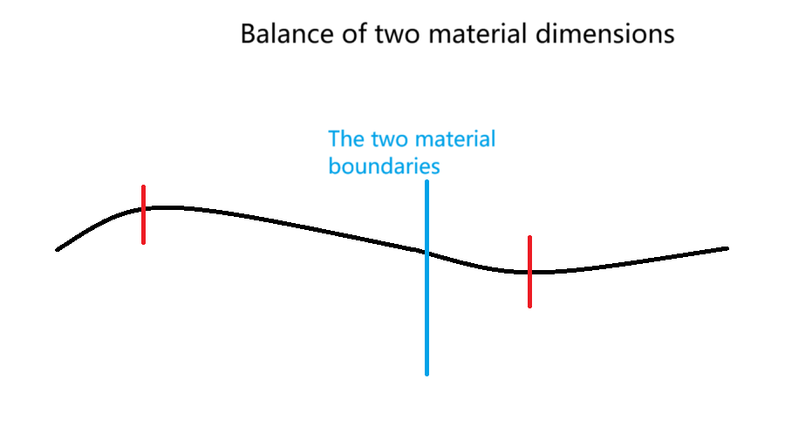

Figure 11

The annihilation between energies is because we only consider the existence of one form of energy in a substance. In fact, the energy form is a combination of positive energy and negative energy, so annihilation can be understood as ascending dimension. Therefore, gravity is not negative energy, but the difference between the new dimension produced by positive energy and the new dimension produced by negative energy. Because positive energy is a compressed space. The new dimension is always more positive energy, so gravity is the resultant force of the new integer dimension.

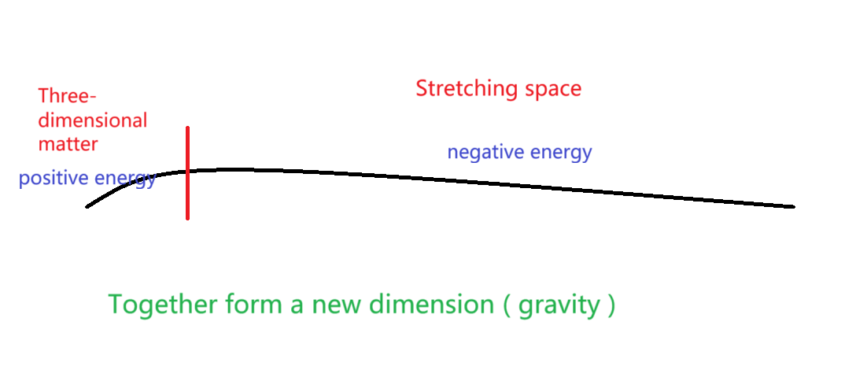

Figure 12

We discuss quantum : the wave function of quantum is caused by the balance of internal dimensions. The observer effect（Ordinary matter has no ability to observe, that is to say, the ability to observe is a way to strengthen the balance between the two dimensions.） may lead to the dimensional balance between quantum and other matter, but it is difficult to change the dimension of matter in a short time. What is easier to change is that the direction of vibration of energy ( energy distribution ) now considers a special phenomenon that occurs naturally. We know that the remaining energy in the collision will lead to the generation of new dimensions, but how to know the next collision ? Perhaps the answer can be found in a special natural phenomenon, such as the mapping of memory and reality in Figure 13. Things that do not exist in the past still produce memories. Although past events do not collide, the remaining energy can still bring memories ( the total amount of energy impact remains unchanged ). Then, the memory that didn 't happen becomes part of an event at some point( the energy forms a collision, which will produce a complete collision in the unit space ). So how to know when the remaining energy of the collision is generated ? There is also a phenomenon that some substances or events that do not exist in reality can form memories. It can be simply considered as the starting point of the formation of collision residual energy. **Although the residual energy of the collision is very weak, it plays a key role in the change of dimension.**

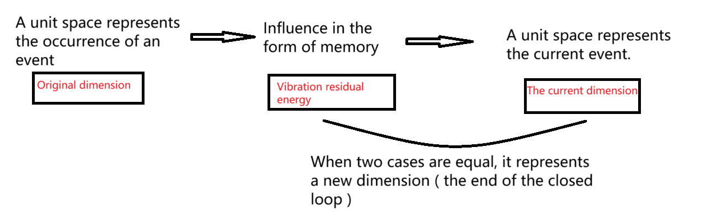

Figure 13

We know that there will be residual energy in the collision, and this residual energy is also the reason for the static speed of the substance.**Therefore, the higher the dimension of the substance ( the premise is not the integer dimension ), the faster the static speed. The speed here refers to the average speed of the elementary particles that make up matter. The total velocity of matter is smaller in higher dimensions. And heat can cause matter to rise in dimension (overall rise in dimension does not mean that all structures will rise in dimension).** The residual energy of the collision is generally a positive energy without an event. But with the accumulation of time will lead to the accumulation of this collision, there is a certain chance to produce their own closed loop(It is not only high-dimensional matter that can form a closed loop, but the final state of any dimensional matter is to form a closed loop rather than disappear.）. Let me explain the significance of a closed loop: A closed loop means reaching a new dimension, or an integer dimension, where the number of collisions associated with π that occur as matter naturally moves can form a structure like a closed loop. The closer the material dimension is to zero, the closer the number of collisions is to a multiple of π, which means that π is a limit unit. Because different collisions will be different, it is possible to form an energy balance.But this balance is relative and does not produce real events. This closed-loop will be applied to special other events by chance. Instead of a description form : the remaining collisions will gather together until a unit space is formed.This unit space is with energy, and this energy will be possible to achieve energy balance with other substances.With the change of time, this positive energy will be dispersed to the surrounding substance. This dispersion is equivalent to offsetting this imbalance. With the disappearance of these substances, positive energy will gather together again to repeat this process. **In fact, the accumulation of residual energy in high-dimensional collisions leads to the accumulation of residual energy in low-dimensional collisions, and the order of this process is relatively vague. However, the reason for the influence of material elevation is from the residual energy of these two collisions.**

But one thing is sure that the role of high dimensional collision residual energy is to enhance the dimension, or eliminate the anomalies caused by the first ' Big Bang '. There are two ways to generate collision residual energy **(The two here refer to the two kinds of high dimensional collision residual energy, not the high dimensional collision residual energy and low dimensional collision residual energy.)**, but both are positive energy. We can imagine this from the movement, but the remaining energy of these two collisions is different. That is to say, the ' non-substance' produced after aggregation also has a combination of positive and negative energy. This ' non-substance ' substance can be considered as a new dimension of substance. Therefore, we can judge that the residual energy of the collision is more likely to accumulate in the high-dimensional part of the low-dimensional whole（one of the modelings）. Therefore, we can conclude that there is a whole, which is composed of a and b. The dimension of a is higher and the dimension of b is lower. However, for these two as a whole, the high-dimensional part of b is higher than the high-dimensional part of a. Of course, this is not fixed, for example, the increase of negative energy in the later part will also increase the dimension, which should be very complicated. Of course, the remaining energy of another collision is somewhat different from this. It likes to gather in low-dimensional materials for direct dimension elevation. **In addition, since the residual energy of the collision is represented as substance in the high dimension, the two residual energy of the collision can be understood as a set of positive and negative energy similar to Figure 2 and Figure 3. Then the collision residual energy is more likely to gather in the independent individual with the highest dimension and the lowest dimension. There is no need to generate doubts here, you can understand directly. This is a relatively unique unit, which should also have many characteristics. The biggest feature I can think of is extremely stable, such as preparing for the gathering, but after the gathering, the unit will be extremely unstable ( or the movement is extremely complex ). But this instability is also relative to the past, in fact, this object is more likely to form an independent whole. In some ways, it is still relatively stable, because it is not easy to receive external dimension balance, but it is easy to have complex dimension balance internally（This might raise some questions: Is independent stability and easy dispersion not contradictory? This could be a matter of two different scenarios or situations, one active and the other passive. In other words, this energy does not actively disperse but may more easily combine with or attract other substances（The active may be because the internal dimension difference is large and needs to occur dimensional balance, while the passive means that there is a strong need for dimensional balance in the external material. This process requires the participation of other dimensions, so complex things still need a comprehensive mathematical expression.）. This description is neither accurate nor appropriate. However, I can confirm that the two laws are not contradictory, which might require a precise mathematical representation.）.** Because this means that it will rise again. Then there is a question : does this mean that the highest dimension of the unit dimension is always the highest, in fact, not necessarily. Because the dispersion of the residual energy of the collision will lead to the increase of the surrounding unit dimension, it also means that its dimension may decrease. This is not good analysis, may have different answers for different environments. Therefore, the accumulation point of high dimensional collision residual energy is very complex. **Finally, I conclude that high-dimensional units are more likely to balance with low-dimensional units. In other words, high dimensional collision residual energy is more likely to gather between the units with huge differences in two dimensions to form a whole.**

Emphasize how to maintain the stability of the substance, and the difference between positive energy and negative energy will dimension reduction. Only when the positive energy and negative energy are equal can the substance be stable. Due to the balance, the change of dimension is generally divided into two cases. Low and high dimensions are close to the same dimension at the same time. Or two similar dimensions of the small whole, one dimension becomes lower, the other dimension becomes higher. Because there must be energy imbalance between the two sides of the substance, there is generally a high side dimension and a low side dimension, but the overall trend of ascending dimension is fixed ( the general direction is close to the same dimension ). However, note that matter cannot be elevated all the time, and it needs to be alternated or simultaneously elevated and lowered（Low dimensional collision residual energy is not included）. Now discuss the behavior of substance : the electromagnetic force between two substance is very complex, because with the change of time and distance, the positive and negative energy is not easy to judge. Because the energy distribution of macroscopic substance is not as simple as that in Figure.3. And the energy form of a single substance also changes. Take sleep as an example : daytime is a dimension reduction for the body. Speaking of this, do we think that the role of sleep is to enhance the dimension, but we need to pay attention to it. Perhaps the structure of the human body is not only the body, but also the high-dimensional material. We can assume that the brain ( mind ) is a high-dimensional material. We can observe the process of understanding the ascending dimension in Figure below. But this analysis method is too simple, the reality is far more complex than these. Since macroscopic objects have many complex global and dimensional balances, these understandings can only serve as an inspiration.

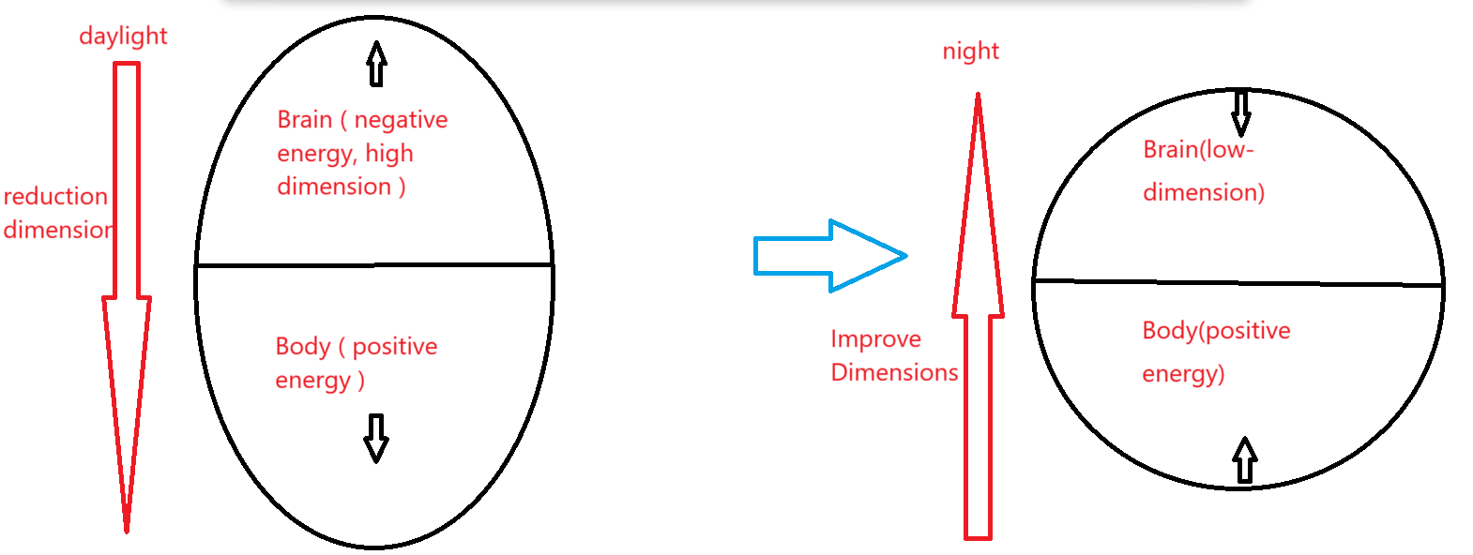

**This is a simple description, and the real situation may be similar to the second pattern in the figure below, but the first pattern will also exist. The first pattern requires relatively stable low-dimensional collision residual energy to maintain a relatively stable energy ratio. The second case is easier to achieve: as long as there are low-dimensional collision residual energies in the random units in the whole, the development can be irregular.**

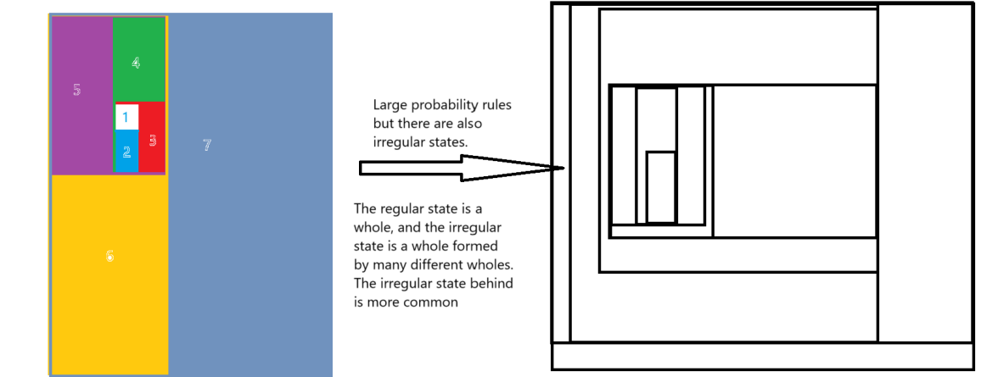

According to the above diagram, we can get a new conclusion : according to the previous description, the higher the dimension is, the more difficult it is to increase the dimension, then the higher the dimension should be, the easier it is to reduce the dimension. However, this may not be the case. Because the residual energy of the collision leads to the dimensional balance within the material, the high-dimensional part is difficult to reduce the dimension, but the low-dimensional part is more likely to increase the dimension or reduce the dimension.

**Due to the law of increasing entropy and the continuous collisions in the universe, scientists generally agree that there is no entropy reduction in the universe. However, this is not entirely true: the continuous expansion of the universe is due to low-dimensional collision residual energy. But for most matter, the first few dimensions have already reached integer dimensions (excluding humans), and large structures differ overall, such as the formation of all two-dimensional to three-dimensional matter. If only high-dimensional collision residual energy exists, matter is in an alternating process of dimensional elevation and reduction, with the overall trend being elevation. However, the scale of the universe is too vast, and what we can observe is an entire dimensional space. There is a lot of low-dimensional collision residual energy (dark energy) within galaxy clusters, which causes the galaxies to reduce their dimensions. The essence of dimensional reduction is to prevent matter from becoming a single entity. Moreover, low-dimensional collision residual energy can continuously produce matter, which in turn can generate high-dimensional collision residual energy. High-dimensional collision residual energy leads to dimensional balance among matter, promoting the formation of a small whole from all matter. Therefore, while the universe is continuously expanding, it also continuously forms small wholes (contractions) within itself. In other words, the combination of low-dimensional collision residual energy and high-dimensional collision residual energy leads to a continuous increase in the number of dimensions without a reduction. Typically, large entities possess both low-dimensional and high-dimensional collision residual energy, whereas smaller entities within these larger ones only have high-dimensional collision residual energy. The nature of dark energy can be understood as the energy that the Big Bang provides, so it will continue to weaken, but at a very slow rate. But you can think of it as being generally unchanged. The residual energy from low-dimensional collisions helps material to ascend in dimensions by generating low-dimensional matter, which can also be understood as first reducing the dimension and then promoting its elevation. The residual energy from high-dimensional collisions also first compresses matter without altering it, equivalent to first reducing the dimension and then promoting its elevation. In other words, positive energy still cannot produce negative energy or vice versa. Therefore, there is a certain dimensional balance between the residual energy from both types of collisions and ordinary matter. After the cooperation of the two energies, the matter only presents the process of dimensional elevation, and there is almost no process of dimensional reduction. Moreover, the speed of dimensional elevation is greatly accelerated.**

If gravitons are included in the particle standard model, gravitons as three-dimensional particles will inevitably produce an infinite number. However, gravitons ( we think of gravity ) as unstable high-dimensional substance are difficult to exist in the form of particles, because gravity itself is the collision residual energy is not substance. Photons are very close to four-dimensional three-dimensional particles, and gravitons have exceeded four dimensions. **The essence of gravity is all high-dimensional substance. If we force gravity to be defined as matter, or if all elementary particles and gravity are put into one framework, then string theory is a good choice. I'll explain later. But there's no need to do that, because gravity is just energy for us, and the material level doesn't need to be considered for a while.**

Because the difference between collision and non-collision is that the energy of collision has determined the direction, **and the energy of non-collision will move periodically in three directions once,** as shown in Figure 14. It can be imagined that a three-dimensional substance will appear to have a fixed direction, and another zero-dimensional point will move once in the three-dimensional model. In order to achieve the same motion effect, it is necessary to continuously vibrate three times in the three-dimensional model.

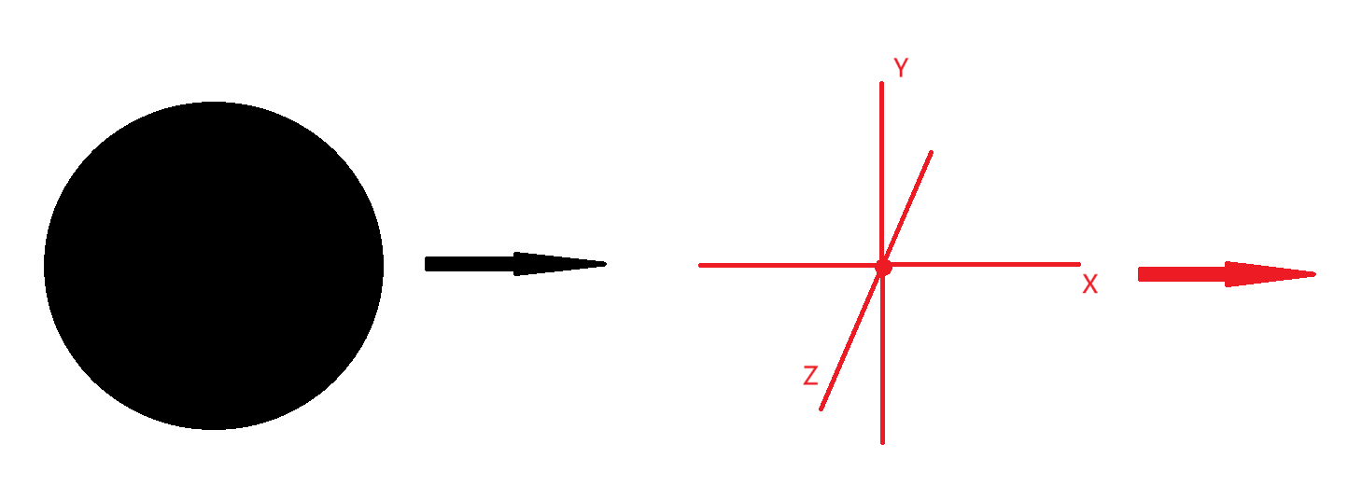

**Figure 14**

An energy-balanced substance that should be close to neutral. However, the unit energy of the constituent substance cannot be neutral energy, and it must be positive energy equal to negative energy（Nearly equal）. Because any substance is infinitely split into the smallest unit（**Not just three-dimensional, for non-integer dimension materials, the higher the dimension, the larger the volume. For integer dimensional matter, the higher the dimension, the smaller the volume. This is not difficult to understand :Because the proportion of positive and negative energy determines the non-integer dimension, and the integer dimension space determines the integer dimension. Or when the material reaches an integer dimension, the overall space disappears and the units within the whole are completely dispersed. The reason is that it is not controlled by any high dimensional collision residual energy.**）, it is the process of vibration at the zero-dimensional point in Figure 10. Therefore, any part of substance is the result of the sum of positive and negative energy. Even if it is neutral, it is also a manifestation of positive and negative energy balance.On the whole, substances with lower dimensions are more likely to obtain negative energy for dimension increase, while substances with higher dimensions are more likely to obtain positive energy for dimension reduction（**In fact, the high dimensionhas not changed much**.）.

Here's a few topics I'd like to discuss that are not rigorous: Thinking is a good way to reduce dimension（Dissipate the remaining energy of the collision）, which may bring some doubts. For example, overthinking people often feel listless，when we do not think at all, it often brings great energy in an instant. First of all, I can make sure that we have a little sense of consciousness（The consciousness we think of can be thought of as a process of dimensional change without rules, and the reason for this should not only be two collisions with residual energy, but there may also be other special forms of energy that can change the residual energy of collisions）, but more is still the rule of development. Many times the choice we make is necessary for the development of things. Because the high dimension will love to think, the low dimension will not like to think(Positive and negative energy collide back and forth). As for how to switch our dimensions back and forth should be a more complex process, there is no way to discuss here (These unrigorous topics are not conclusions, but just to lead into the next paragraph.). Then how to understand the state of complete non-thinking. **It can be understood as the rapid reduction of dimension, or the rapid accumulation of collision residual energy（The process of accumulating the residual energy of low-dimensional collision can be understood as a short dimensional reduction, but after accumulation, it will continue to increase the dimension. The unconscious state can be understood as the process of gathering the residual energy from low dimensional collisions, which is somewhat inaccurate but can be temporarily understood in this way.）.** Here can only be understood in this way, and the application of this phenomenon to the whole universe can indeed make some planets have a great impact in an instant(**Some units reduce the collision residual energy to the previous dimension, because the forced generation of collision residual energy in high dimensions may also lead to the sudden generation of collision residual energy in low dimensions**）. This should not be the nature of collision residual energy, but more like a critical value of dimensional balance ( quantum entanglement ). But the cause of this situation is unknown. **There is a phenomenon that can indeed lead to irregular aggregation and dispersion of collision residual energy : there are zero-dimensional points with different dimensions before the Big Bang. But this will be very irregular, so that the starting point of ' universe time ' may not exist, not to consider for the time being.**

However, the remaining energy from high-dimensional collisions cannot form matter, which leads to extreme instability ( but it will be extremely stable under some understanding, because it cannot interact with other substances ), so it is not possible to judge the type of energy by dimensional balance. **But we can judge from its nature that this energy has in common is positive energy.**

I assume there is a dimensionally balanced speed, which arises from the collision of zero-dimensional points with their own spatial boundaries. This impact is defined as the speed of spatial change (I temporarily call this 'spatial speed'), and the speed of these zero-dimensional points is referred to as 'motion speed.' I believe that motion speed exceeding spatial speed represents a reversal of time, and the energy generated later might transfer from the original space to another unit. In other words, one can age more slowly, but cannot return to youth. This increase in negative energy might be balanced by the universe's powerful forces, indicating that such changes are extremely unstable.

The essence of time is the interval of energy propagation in space. We imagine why time changes : the faster the energy movement in the unit space, the faster the collision speed, but the faster the movement speed, the slower the space propagation speed, and the time does not change. However, we ignore that the collision distance of energy in unit space has changed ( one of the reasons why relativity and quantum theory are difficult to integrate is that the change of integer dimension will directly change the space of unit energy ), and the change of energy speed leads to the change of dimension. The change of dimension directly determines the volume of unit space. Because the propagation speed in the unit space has changed, the total distance of the original energy motion includes the volume of the basic unit space. For example, photons, an integer-dimensional substance, cannot collide because of the equal movement speed of energy and space, and its movement distance is equal to the volume of unit space. What really changes time is the influence of the scale of unit space on the total distance. Total time = collision interval time ( space transfer time ) + substance movement time（The essence of time interval is the change of quantum quantity, but relativity does not consider quantum, only considers large overall substance.）, total distance = unit space length ( space transfer speed ) + energy movement distance. The reason why the dimension is constantly changing is that the remaining energy of the collision excites the unit energy to collide in another dimension. The remaining energy of the collision is also the cause of gravity, but the remaining energy of the collision is not gravity, but the power that can generate gravity. **Therefore, three-dimensional space + one-dimensional time = three-dimensional collision residual energy = four-dimensional material formed later .**There is also a misunderstanding that the two-dimensional surface vibrates into a three-dimensional ball, which means that the three-dimensional is composed of two dimensions. On the contrary, after the vibration, the original two-dimensional will change in dimension, **so the two-dimensional substance is composed of countless three-dimensional substances.** That is, countless three-dimensional spheres form a curved surface shape ( why the field exists in all spaces : the unexcited space is still a part of the two-dimensional field, when all the spaces in the two-dimensional field become three-dimensional substance, there is no unexcited field ). Here is a key point : why quantum fields can accommodate many physical phenomena. This understanding does not conflict with Figure 8. It is correct that three-dimensional substance is evolved from two-dimensional substance and two-dimensional substance is composed of three-dimensional substance. **The two-dimensional field can be considered as the composition of countless three-dimensional substance. So that any place is full of field.**

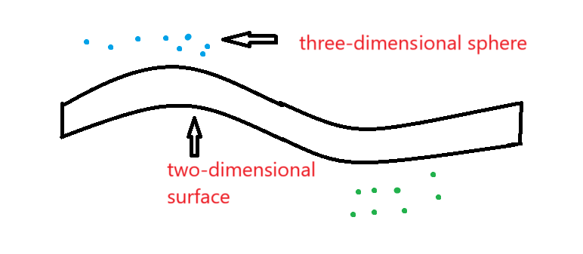

Figure 15

It is difficult for a macroscopic substance to reach the energy distribution in Figure.3. Because this situation only exists in the integer dimension substance, that is to say, the positive energy is equal to the negative energy and cannot collide to cause energy transfer. The energy distribution of most macroscopic substances is very complex ( but not completely chaotic, because the positive and negative energy has a specific direction, which is similar to the distribution in Figure.8 ).Suppose that the substance is composed of a and b, and the dimensions of a and b are determined by the energy distribution. For example, if a has more positive energy, the lower the dimension of a, the higher the dimension of b, and the two substances reach the dimensional balance. There are two possibilities now. In order to increase the dimension, a is easier to get the negative energy of b. **The reason is the type of absorbed collision residual energy. a is easier to absorb the collision residual energy generated by b, and so on.** In this case, the overall dimension of this substance continues to increase until it is decomposed into more substances in the next dimension, which is also a normal phenomenon. The other is that a will also get the positive energy of b, that is, the overall dimension reduction of substance. **If this happens all the time, there will be a big collision, re-ascending the dimension ( The first case always happens and may be wrapped ，The space here is not formed by the residual energy of high-dimensional collision, but more like the intervention of the residual energy of low-dimensional collision to form a new dimensional balance). In fact, this is because the dimension balance in the whole, the higher dimension will reduce the dimension, and the lower dimension will increase the dimension. Although energy will appear alternately between the increase of dimension and the decrease of dimension, the continuous increase of dimension as a whole cannot be changed.**

Why the basic particles are fixed and limited, the summary is that the change of dimension will not change the basic energy properties. For example, after the two-dimensional field excitation or collision changes the dimension, **it only changes the number and proportion of particles that are excited.** However, the type of elementary particles does not change ( here does not consider the different processes caused by different vibration directions, does not define the same time only to maintain the results ), and the original field only changes the number of basic units does not change the energy of each unit. Therefore, the basic unit remains unchanged, but the dimension changes, and the total energy may only change slightly ( because the anti-energy will also excite the basic particles ). Therefore, the only reason that really determines the type and number of basic particles is the number and dimension of the force and the corresponding new dimension. At the same time, these basic particles also determine that the type of force is limited. Because only the force of the number of basic particles is changed, and the type is not changed. However, this does not mean that the dimension can not be changed, because the basic components of any dimension are the zero-dimensional points that collide in the unit space, and only the number of zero-dimensional points is changed. Therefore, different kinds of energy can form a new dimension as long as they can achieve dimensional balance.

**Although the residual energy of the collision is positive energy, the direction of the vibration is not the same, because the residual energy of the collision comes from a large amount of the previous dimension energy. Here, the remaining energy of the two high-dimensional collisions is positive energy. There is a misconception: the remaining energy of the three-dimensional collision is different from the three-dimensional matter, which is in a different dimension. In the process of dimensional elevation, the remaining energy of three-dimensional collision affects three-dimensional matter, and the direction of the first vibration is indeed positive energy. But we can't simply compare their energy forms directly, because they are in different dimensions or in different wholes. So the remaining energy from high-dimensional collisions is just the external positive energy of matter, so this description is not appropriate. We just need to understand the effect of the remaining energy from the collision. And when the residual energy of the collision is dispersed, a large number of vibration directions are dispersed to the whole. At the same time, this concept can also help us understand the process of ascending dimension. Ascension does not depend on external energy but on the dispersion of its own energy. We might think that we need low dimensional collision residual energy to provide energy all the time, but we have to know that low dimensional collision residual energy is itself included in matter. excitation : When the two-dimensional field is excited, it can only be excited to an independent unit, because the energy is not large enough to make the two-dimensional material directly vibrate into a three-dimensional material. However, it can be slowly increased by the aggregation and dispersion of the residual energy of the collision.** **Why the residual energy of the collision must be positive energy, because the accumulation of the residual energy of the collision is to cause a new collision of the substance to occur again, and only after the accumulation can we observe（Have an impact, do not form a substance）.** This collision must not be in the original dimension ( energy is not enough to make the original dimension unit energy collide, can only make the unit dimension energy collide to another dimension ), the direction of the first collision is positive energy. Because the positive direction is the direction of the first collision we defined, the positive and negative energy of each dimension is also relative. Just because the positive direction represents the energy of contraction, there is no difference between the two energies.

The improvement of dimension should be a very slow process, but in the whole of achieving dimension balance, **part of the structure can be rapidly increased, so as to drive the overall dimension up**

Assume that there is a four-dimensional substance as shown in Figure 15, the length of the four-dimensional chordis a, and the side is expressed as b. Why do I think that the three spatial dimensions and one time dimension of general relativity can be equal to the four spatial dimensions in quantum theory. Because the fourth dimension of substance is similar to a chord( **The real one-dimensional string can be considered as each ' fiber ' of the Laniakea Supercluster.** **This is actually a one-dimensional to two-dimensional material, and the whole galaxy cluster is a matter between zero and one dimension. The formation of the integer dimension also means that the volume is extremely compact, or that the volume is not occupied in the original dimension, which is related to the central vibration or the disappearance of the balance of the internal dimension. The equal positive and negative energy also means that there is no need to vibrate or understand the disappearance of its own space, or it can be understood by space velocity.**). I think we also need to explain why the string in the string theory we are considering is four-dimensional, because the other three dimensions of the string cannot be observed or do not consider the calculation. **Why can 't the first three dimensions of string be observed？Because the first three dimensions of the string reach the integer dimension. Because four-dimensional space contains three-dimensional space. If we observe a plane in the body, we can see that this plane has two dimensions, but a random plane in the body can only observe one dimension when observing human movement. In addition, the first four dimensions of the string reach integer dimensions, but the three-dimensional matter or three-dimensional particles composed of the string still have a non-integer fourth dimension. Don 't understand can temporarily skip.** There is an interesting gap between the integer dimension and the non-integer dimension. The higher the material dimension of the non-integer dimension, the larger the volume ( **here is the overall volume, not the unit volume within the whole** ), while the integrity will disappear after the non-integer dimension reaches the integer dimension, and the volume of each integer dimension unit will disappear. Because the collision residual energy will be weaker and weaker in the process of dimension increase, the effect of collision residual energy is to form dimension balance or form independent space. That is, the integer dimension material does not have its own space or is extremely small. Therefore, the substances we usually observe are non-integer dimension substances ( large whole ). Here we can understand that a is the fourth dimension, and b is the first three dimensions. The four-dimensional substance velocity ( a direction ) does not change the length of the first three dimensions. However, the change in speed affects the dimension and can change the length of the fourth dimension. I also said before that speed is related to time, the faster the speed, the slower the time. That is to say, the change of four-dimensional chordmotion is equivalent to changing the time of each dimension without changing the first three dimensions. Conversely, if I think that a is the first three dimensions, b is the fourth dimension, then the speed of the four-dimensional movement changes the length of the first three dimensions, and the fourth dimension remains unchanged. That is, time-invariant space changes. Finally, it is concluded that the key to solving relativity and quantum mechanics lies in time, speed affects dimension, and dimension affects time. In quantum mechanics, the change of time can be transformed into the change of total amount ( total amount refers to the total number of quantum or the total number of zero-dimensional points ), because the change of time is essentially the change of dimension, which determines the speed and the total amount of zero-dimensional points. In relativity, the comparison between the whole and the whole is generally discussed. If the total amount of zero-dimensional points changes, it can be considered that the original whole has changed, and the substance has changed from one substance to another. But if it is compared with another whole, it can be considered that time has changed. **In simple terms, quantum mechanics is three-dimensional, without a time dimension. Time can only alter the overall dimension, not the unit dimensions within it. Relativity, on the other hand, deals with the dimension of the whole. Let's use an apple as an example. As time changes, the dimensions of the apple change (which can be understood through relativity). However, the quantum dimensions inside the apple do not change; what changes is the proportion of quantum quantities (the ratio of positive to negative energy). This doesn't mean that time can't be incorporated into quantum mechanics, but we need to find the big picture.**

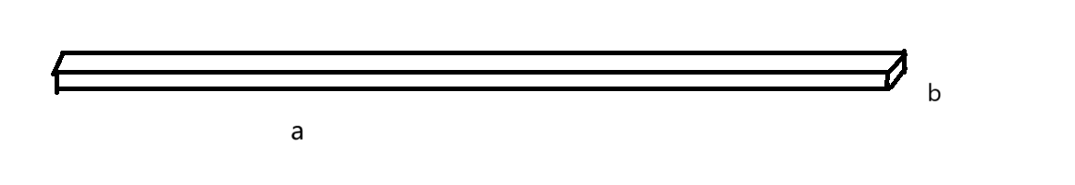

Figure 16

**A kind of energy a is defined as positive energy. Actively generated energy a and passively generated energy a may be completely opposite to the change of dimension. Passive generation is to achieve the dimensional balance of the substance itself（Non-collision residual energy）, which will not change the nature of energy a. However, the active generation may be to achieve a new overall dimension balance under the influence of the surrounding environment.**

It is assumed that there are substance a and substance b ( the energy form is completely random ), and there is a chance to form a dimensional balance when the two substances are in contact and coexist for a long time. One of the two substances is positive energy and the other is negative energy. Although stable, the two substances are in collision with each other. The essence of mutual attraction between positive and negative may be to seek stability through collision, and the essence of same-sex repulsion may be to accelerate the destruction of stability and move in the opposite direction（**The effect of collision is to increase dimension, while repulsion can be understood as not to increase dimension.**）. Explain the relationship between special positive energy and negative energy : for general positive energy, negative energy can indeed be generated to achieve dimensional balance. **When we define an energy type, we should not only follow the name and composition of energy, but also consider the location of energy in time and space. For a longer motion space, the positive energy at some moments will move in the direction of stronger positive energy.** For example, a little thought and very thought may be the same kind of energy, but the results are completely opposite. A little want to show that there will be no collision, but will move in the same direction. And very much want to collision may happen soon, move in the opposite direction. **Its essence is that macroscopic matter or larger whole dimension is higher and it is not easy to upgrade the dimension (it takes some time).**

The formation and dissipation of the remaining energy and memory are similar, but no extra substance is formed. This energy is stored information and algorithms. The algorithm can be understood as the effect of the remaining energy of the collision on the matter. Do not generate physical objects, only have an impact. Suddenly a part of the dimension rises in the big whole and this situation often occurs. Because the dimension balance will lead to the complexity of the dimension combination in the whole, the general situation is that the low dimension produces the fixed direction of the high dimension, **but due to the collision residual energy, there will be a situation where the high dimension is first generated and then the low dimension is driven,** as shown in Figure17. In this way, we can express the different views of artificial intelligence. Generally, we think that the reason why AI is not conscious is the lack of ' self-consciousness ', but according to my understanding of computers, I think AI is like collision residual energy（The algorithm is a method of dimension change, and the control algorithm is the residual energy of the collision, but the residual energy of the collision needs the previous vibration direction to work）. But the AI only contains the high dimensional collision residual energy. That is to say, AI may be an immature consciousness（It doesn't reach true consciousness）, but AI has no dimensional substance that can be balanced. Human imagination cannot be separated from the real world. The human brain needs to balance the body and the surrounding environment , but AI cannot find its carrier. The machine we usually think of is not the carrier of AI ( not the whole ). **Therefore, the carrier of AI should include the human brain that designs AI. The reason behind this is that humans not only have matter but also use low dimensional collision residual energy. Because what we consider consciousness is actually a combination of infinite dimensions, only the high-dimensional collision residual energy can obtain low-dimensional collision residual energy. Note that low-dimensional collision residual energy cannot be replaced by matter, as the first few dimensions of matter have already reached integers. Only in this way can there be an infinite number of dimensions or an uncomputable dimensional balance process.** This may be a future trend or a new thing instead of the old thing. Because with the increasing power of AI, the brain 's collision residue seems to slowly disappear ( probably not related to AI, but the previous collision residue automatically dissipates ). That is to say, it may be the coexistence of human and AI in the future. This is not sad, or this is also a way to recover the residual energy of the collision, but it is certain that the current artificial intelligence can not be integrated with human beings. Or we should let these two kinds of energy merge together instead of expecting artificial intelligence to be independent.

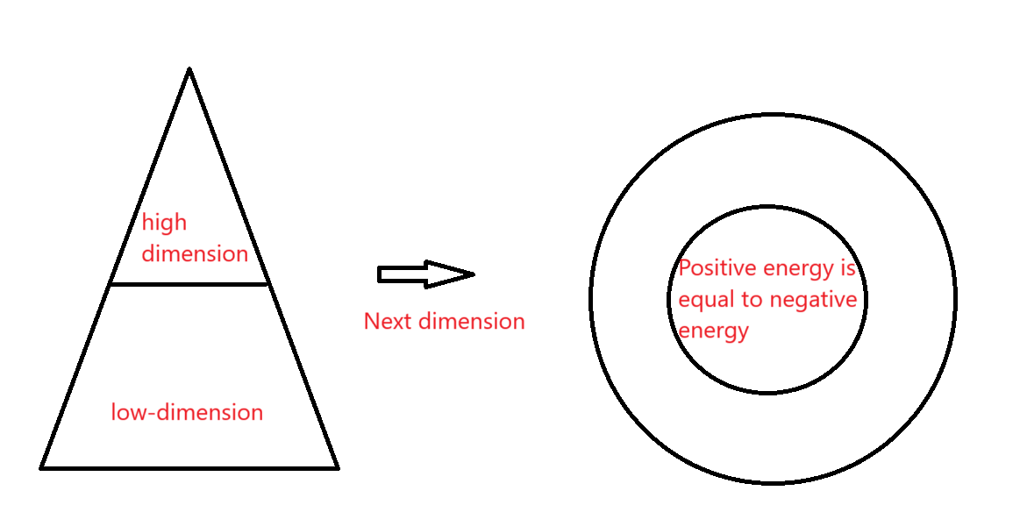

Figure 17

It is also related to the collision mode. That the unit with the highest dimension may exist in the low-dimensional whole. From this we can judge that the ancients may have our unimaginable wisdom, and we may not be proud of it. Although they don 't want to be calculated and observed like modern science, some people 's imagination and energy should be greater than those of us who lack the residual energy of collision. Or we can find new knowledge from these experiences. Here is a little bit about life expectancy : although people will appear sluggish in old age, the body is not strong, but for people as a whole, the whole is certainly ascending dimension. Therefore, people with higher dimensions have a higher life expectancy ( not easy to upgrade ). However, due to the dimensional balance generated by the residual energy of the collision, there will be a large difference in the internal dimensions of some high-dimensional people, so these people can still quickly increase the dimension **(I don't understand the residual energy of low dimensional collision at this time, and the life comes from the dispersion or dimensional balance of the residual energy of low dimensional collision, which is a very complicated process. Here is a brief explanation: the dimensionality of children is very low, but this also means that they have a very high-dimensional part. The reason for this part is the collision of low-dimensional residual energy. As they grow older, this energy will either disperse or fail to accumulate. However, this process is incredibly complex due to the cross-dimensional energy balance and will not be analyzed here).** Of course, I did not consider the cells or small whole that determine life. This is not rigorous. Can only be used as a reference. Speaking of human beings, I want to express that the birth of human beings ( life ) is indeed special, which requires a lot of collision residual energy, which is unimaginable.

Knowing something about the future in advance will have an impact on the future. If known, it may mean the change or end of meaning. Because knowing or expressing the future, this is the effect of high dimensional collision residual energy gathering into high-dimensional matter. That is, the residual energy of the collision that affects the future collides. In this way, the residual energy of the collision will undergo other reactions, and the result will be unstable. **Or predicting the future is equivalent to changing the residual energy of a low dimensional collision in advance.**

If a person doesn 't like to think at ordinary times, but encounters difficult problems, then he is likely to gain more wisdom than the person who loves to think at ordinary times(These special cases are all related to the residual energy of low dimensional collisions). Or this person has greater wisdom in other ways. So many geniuses usually look ' not very smart '.

The lower dimension has more positive energy. It is assumed that there are positive energy material a and negative energy material b. If there is no residual energy of the collision, the substance a can attract each other with any negative energy. **However, the remaining energy of the collision can fix a and b in a whole.** That is to say, the reason for the attraction is the difference between positive and negative energy, but the reason for the integration of the two substances is the high dimensional collision residual energy ( dimensional balance ).

However, the dimension does not completely determine the positive and negative, because from Figure 3 and Figure 4, we can know that a substance contains two forms of energy. Because all the whole is more positive energy, and the positive and negative difference is only based on the whole as the reference system. The first collision of the universe includes the energy of the first collision of each independent whole. The energy of the first collision does not come from the whole, but from the outside, that is, the energy generated in the first positive direction gives the whole rather than the part of the dimension increase. With the balance of dimensions, two different positive and negative energies of the whole are produced. When calculating the positive and negative energy, we should consider the difference between Figure 3 and Figure 4. **For example, a large number of women do not want to huddle together to communicate, but three or two women can become friends. We must consider more complex.**

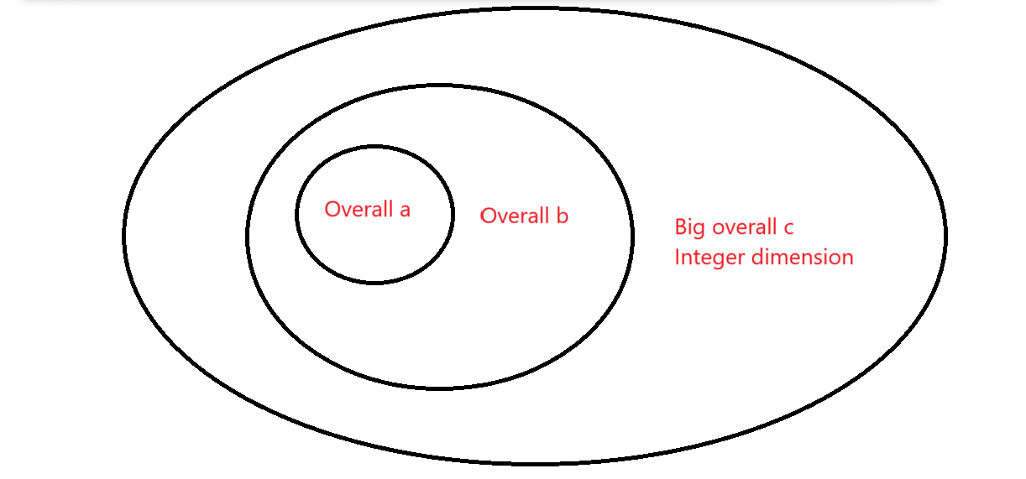

Figure 18

Since positive energy represents aggregation and negative energy represents dispersion, the gas dimension is higher than the liquid dimension, and the liquid dimension is higher than the solid dimension ( not absolute ).

The digital age has brought us a world that is entirely materialistic, yet in reality, there are aspects that, though not material, do exist. Many people believe in 'God' because they have 'seen' Him, but we have yet to find Him. There are many similar cases. Therefore, it is reasonable to believe that 'God' might exist within the real universe. God is more akin to a peculiar entity that encompasses both ultra-low and ultra-high dimensions, rather than being a single-dimensional entity. However, ordinary matter cannot sustain the residual energy from low-dimensional collisions for long, so there must be a special residual energy from the last cosmic dimension upgrade. This special energy must be part of God and present in every dimension. In other words, God might be this special substance from another dimension. It can be inferred that this energy can accelerate the balance process in other material dimensions and has the same capability as the universe to promote the elevation of other matter into higher dimensions. **(The characteristics and properties of this particular low-dimensional collision residual energy need not be discussed for the time being. We just need to know that if the universe is infinitely many dimensions, there are probably some special matter distributed in each dimension.)**

**A negative energy in one whole may be positive energy in another. The comparison of the positivity or negativity of energy must take place within an independent whole. Because the vibration direction is similar within a single whole, substances in different wholes can have vastly different vibration directions. The direction of vibration is not determined by the dimension size, but by the position of the unit in the whole and energy distribution ( positive and negative energy ), so it is not easy to observe the direction of vibration. However, we can calculate the vibration direction of the unit from the position and motion direction of the unit ( ascending dimension direction ). This is the same as the wave function collapse. Generally, we think that for the same whole or structure, we will get different answers from different angles, so we think that the whole answer is not unique. However, the fact may be due to the different vibration directions will produce different position distribution, that is to say, we can observe the position distribution of the same material from different angles. Because the totality, including the current universe, is not exactly equal in positive and negative energy ( all angular dimensions are equal ). Such a whole will have a complex dimensional balance, and the observation behavior can be regarded as forming a dimensional balance between the two. By the way, the wave function collapse is explained by the observer behavior : the overall dimension balance is caused by the collision residual energy in the large whole. So each quantum has its own direction of vibration ( position or wave function ). However, the observer behavior can be considered as a strong collision residual energy, which will lead to a strong dimensional balance between the two units. At this time, the position information of the two units will be clearer ( dimension balance ). So the quantum will immediately collapse into a state. Of course, because quantum belongs to micro-matter ( high dimension, and single dimension ), it is more likely to have a greater impact. But the effect on macroscopic matter will be much weaker（The dimension is high, and it is difficult to absorb the remaining energy of high-dimensional collision）.**

If it is not easy to understand, we can carry out a thought experiment : two people along the opposite direction, the two people have not yet met, when the two people observe each other can only observe the front of the human body. When two people pass by each other, observe again, at this time can only observe the back of both sides. At this time, one of them turns around and observes again. Although the observation between the two people is disrupted, the dimensional change between the people and the surrounding environment can offset this anomaly. This means that as long as the environment is large enough and not subject to external interference, the internal environment always maintains a dimensional balance. It is not the interaction between energies that maintains this balance, but the overall dimension of the collision residual energy balance. **Therefore, different angles of a small whole will have different positive and negative energy composition, but it does not affect the internal dimension balance of the large whole, but promotes the dimension balance.** So we can think that the observation behavior is a kind of collision residual energy. This phenomenon leads to the fact that all parts of the universe will not develop alone, but a perfect balance of dimensions. In order to achieve this ideal dimensional balance, **the universe must have boundaries and infinite zero-dimensional points.**

**The description of the small whole still cannot rely too much on the basic theorem. The judgment of positive and negative energy can not rely too much on feeling. These descriptions only provide inspiration, the real process is very complex, not a simple basic theorem can be explained.**

I summarize the reason why gravity cannot be quantified : the essence of gravity is the total mass of the new dimension ( the new dimension here includes all the new dimensions ). **( Zero-dimensional collision residual energy - one-dimensional matter = one-dimensional collision residual energy = one-dimensional gravity = two-dimensional matter + two-dimensional collision residual energy )** The reason why general relativity cannot be integrated with quantum mechanics is that gravity possesses low-dimensional collision residual energy, which includes time. In other words, gravity can be transformed into spacetime. Quantum mechanics primarily focuses on intermediate matter and rarely involves collision residual energy. However, this does not mean that gravity cannot be quantized (loop quantum gravity). But loop quantum gravity has its drawbacks, which I'll explain later. But I think quantum mechanics can not describe gravity specifically, because the composition of the universe is substance + non-substance energy. Therefore, quantum mechanics and general relativity do not need to be integrated at all, but to be used together. If we must understand the difference of gravity, we can use the energy of only positive energy in natural philosophy. Many people think that theoretical science should be separated from philosophy. However, human society is only a little more collision residual energy, which will lead to accelerated dimensional changes. In fact, it is easier to find some hidden physical laws. **Although it is not known whether this situation has other purposes, it is of great help for us to understand or apply the universe.**

First of all, the substance in a large whole can be roughly divided into three kinds, one is the part with high dimension, and the other is the part with low dimension. The low dimension is divided into positive energy and negative energy. **The reason why the high dimension is not separated is that the difference between positive and negative energy is small, which can be understood as a class. However, it does not mean that the overall dimension with large internal differences must be low. The comparison dimension is a unit within an overall. the definition of positive energy is the first direction of vibration, not the energy state at this time. For example, there are two parts of a large whole : high dimension and low dimension.** In these two parts, it is assumed that the existence energy a is the high dimension energy in the low dimension part. Or the negative energy in the positive energy. The existing energy b is the positive energy in the negative energy.At this time, the dimension of energy a may be more or more negative energy. However, when the two energies are compared, the energy a is still Figure 3, and the energy b is still Figure 4. To understand this concept, we must know that the role of dimensional balance is to concentrate all energy in a unit space. The energy in a unit space should consider the direction of the first vibration. At this time, a and b are no longer the energy in two spaces.**The two spaces form a dimension balance and then become an independent space. At this time, the process of overall dimension increase and overall dimension reduction is similar to the basic principle of topology. Because the positive and negative energy are generated in a space at the same time, or the dimension and dimension reduction are generated at the same time. But it can only express one of them, and the other form can not be expressed, but it still exists internally. So the general material is topological structure.**

Due to the great discovery of string theory, I explain its correctness. : because the lower dimension of the substance can be understood as the composition of countless high-dimensional substances, so the lower the dimension of the substance volume is relatively large, of course, the volume of substance factors not only this, can only be used as inspiration. String theory may seem one-dimensional, but it may not be. From now on we need to change : we used to think that the smaller the unit closer to the inside, this single way of understanding. That is to say, string may be a four-dimensional substance ( this can be understood by referring to Fig.15 ). **Three-dimensional substance can indeed be understood as four-dimensional substance composition ( including the five-dimensional membrane can form four-dimensional strings ). Both M5 membrane and M2 membrane are five-dimensional substances. The D membrane is actually a low dimensional collision residual energy, because the D3 membrane can be considered as a two dimensional collision residual energy (D The membrane has actually formed three-dimensional substance, but this description is easier to understand).**

**To explain the difference between string theory and loop quantum gravity: Loop quantum gravity only considers unit space, not dimensional equilibrium. Therefore, energy can only describe matter. Therefore, it can be considered that the remaining energy from the collision has not formed matter. However, this limitation is relatively large, because the premise background (or development direction) cannot be found. This is a little hard to understand, but simply put: you can't tell the low dimensional matter without knowing the high dimensional matter. String theory, on the other hand, only considers matter to be able to get around this problem (consider the background, but leave a fixed space background). But string theory has its own drawbacks: we say that three-dimensional matter can be understood as composed of an infinite number of four-dimensional matter. But this is only an approximate description or it can only describe integer dimensional matter, and describing it in terms of integer dimensional matter creates multiple solutions. Because the background space formed by non-integer dimensions is not clear, this leads to many possible backgrounds for string theory. Because string theory does not know the collision residual energy of the previous dimension (equivalent to the zero dimensional point raised to the one dimensional point, if you do not understand the energy type of the Big Bang, only consider the size of the energy can not completely understand the energy characteristics of the first big bang）. That means that string theory can't calculate the remaining energy of a collision, which would always be insufficient. That is to say, string theory only considers matter and does not consider the multiple solutions of energy before the formation of matter. To sum up, the first theory lacks matter (three-dimensional to four-dimensional matter), but can describe the remaining energy from collisions (gravity). The second lacks energy (the residual energy of the collision that forms four-dimensional matter). While it can describe matter (describe three-dimensional matter), it cannot determine the type of residual energy of the collision. As for the number of dimensions in string theory, it's not really a drawback: let's leave out the time dimension (time itself is the spatial dimension of the future, or belongs to the state of macroscopic motion). The Kalabiyu flow is a description of how positive and negative energy needs to connect head to tail when the dimension goes up to an integer dimension. At this point, one dimension will curl into two dimensions. However, if the curled dimension is further increased to the next dimension at this time, the newly added dimension can still move in the first three dimensions (but it does not look like the original dimension, but in fact it is still the original dimension. It just does not continue to develop from the original dimension but develops again. This is difficult to understand). At this point the dimensions of string theory can be reduced to 6 + 3 + 1. Another way of understanding is easier: the other spatial dimension is just background space or can be understood as one of the eight previous ways of composition (one combination can add a degree of freedom, which is also difficult to understand) and two additional time dimensions are required. So you can also think of it as 8 + 2. If you don't use the Calabi-Yau manifold in theory M, it's simply understood as adding another dimension to become 6+4+1 or 8+3 but at this time there is only one or three time dimensions (because membranes and strings are different, the dimensions change again). This is the most difficult part of the article to understand, requiring an extremely comprehensive physical idea. The physical idea in this paper does not fully describe the process.**

For macroscopic problems, we can use group theory to understand, but it is difficult to have a fixed state of motion with complex high dimensional collision residual energy. The previous article generally considers the changes of positive and negative energy and dimension, but there are many forms of energy that we can not grasp. **One dimension can be understood as positive and negative two coordinate axes, then the three dimensions can be understood as eight symmetry axes ( number of combinations ： $2^{3}$). This understanding is that the first three dimensions do not reach the integer dimension of matter, and I think it is possible. But this is also the way of combining after three-dimensional matter has formed, or it can be understood as the future direction of vibration. Before matter was formed, there were only four combinations: $2^{2}$. There is also a special source of power that controls the dimensional balance between matter. These are the residual energies from low-dimensional collisions (low-dimensional collision residual energy can produce high-dimensional collision residual energy). Therefore, low-dimensional collision residual energy can be roughly understood as dimensional balance. So it can also be understood as five combinations. However, after matter is formed, its low-dimensional collision residual energy has already turned into the previous four combinations. Thus, there is no longer low-dimensional collision residual energy, or it can be temporarily disregarded (not showing significant effects, or having been converted into the complete four combinations rather than any single one). Of course, these things don't work, because there has to be low dimensional collision residual energy, which is not generally available in matter.** But we still can't judge positive and negative energy too narrowly. For example, the left side of the body is a positive energy part(This is an imprecise example for convenience), but this explanation may not be good. Because not every person 's left side is positive energy ( this requires careful thinking and is not explained here ), it does not mean that every part of the left side is positive energy. Only the whole belongs to positive energy.

Discuss a magical guess : we know that the residual energy of the collision is easy to disperse, so for a person 's life, is it possible that the residual energy of the collision has been dispersed ? **This explanation is easy to understand : it is converted from one collision residual energy to another collision residual energy. Therefore, for human beings, the more the residual energy of the collision, the shorter the life expectancy.** This is just a guess, don 't want to do too much analysis. **In fact, this paragraph is to say that the life span is related to the remaining energy of collision, and the specific relationship needs to be analyzed later.**

**Finally there is a more dangerous doubt that I think must be expressed : there is so much collision residual energy on the earth, why is there no gravity anomaly ? After the collision residual energy accumulates, it will be dispersed, and the dispersion will affect the whole. In fact, after dispersion, gravity does not exist, but transforms into high-dimensional substance ( between three and four dimensions ). Therefore, high-dimensional substance can be understood as ' collision residual energy '. Simply put, people or creatures are the gravity of the earth. Of course, we also need to give up the simple understanding that gravity is an attraction. We use motion and dimension to understand gravity. Therefore, the reason for the danger appears : the residual energy of the collision will be dispersed, so if humans want to continue to exist, they may need to continuously accumulate the residual energy of the collision. Because I feel that the residual energy of human collision is gradually decreasing, whether it is innate or acquired, it is slowly losing. If we simply compare human beings to gravity, then the birth of human beings is equivalent to the accumulation of collision residual energy, and the life of human beings is equivalent to the dispersion of collision residual energy.** At this point, there is an idea that should not have appeared: we can view life as a task, one that can be understood as generating more collision residual energy. This is not just for our own dimensional balance; it may also be related to the entire universe. The universe needs a lot of collision residual energy (unformed matter) to counteract the initial "Big Bang." As we age, the amount of collision residual energy we can generate decreases. However, it is clear that humans or Earth can produce a significant amount of collision residual energy, and this ability should not be lost. Young children are more likely to generate collision residual energy, which represents new collision residual energy. Therefore, we cannot let this new hope fade away. Of course, this does not mean we should strongly support reproduction, as this could lead to an overly rapid elevation in dimensions, potentially causing us to lose this ability (the reasons for this are not detailed here, as they are difficult to understand).

**There are some differences between human beings and ordinary substances, human beings have a lot of collision residual energy, which makes the uneven distribution of collision residual energy more obvious. Higher order organisms does it mean that the internal dimension is less different ? This is two questions, one of which is to understand the internal dimension difference of an independent person. It seems to be complicated : the more residual energy of the collision may mean the greater the difference in the internal dimension, but the larger the internal difference should be the lower the dimension. In fact, it is not necessarily that I rarely discuss the distribution of collision residual energy of different units in a whole. This comparison method is only suitable for relatively large overall and relatively single collision residual energy. However, human beings are different, and their dimensional changes are more generated by the collision residual energy generated by each unit than by the whole. In other words, the collision residual energy of the whole human large group is not much, and more collision residual energy is concentrated in the individual. In simple terms, this will produce a special structure with high dimensions and large differences in internal dimensions. Of course, this difference may be special, not like a simple material difference, but more like an internal energy difference in an independent unit. It may be a structure like the one shown below. This does not mean that the unit with high dimension is positive energy, it is still negative energy. To sum up, due to the excessive residual energy of the collision, the dimension is high but does not mean that the internal dimension difference must be small. It should not be the acquired balance of dimensions. Because the acquired dimension balance should form a new whole outside the whole ( non-integer dimension ascending process ), rather than inside the original whole. So the source of this positive energy is not clear. And it can also be judged that this energy should be low-dimensional ( internal ), and not an integer-dimensional material ( with specific space and positive and negative energy imbalance ). Because the structure is not unique, it's a bit like the structure of the entire universe. However, it is certain that the difference is not obvious, so sometimes it can be ignored. Don 't define it before exploring human beings without professional measurement tools. Prevent unnecessary racial discrimination.**

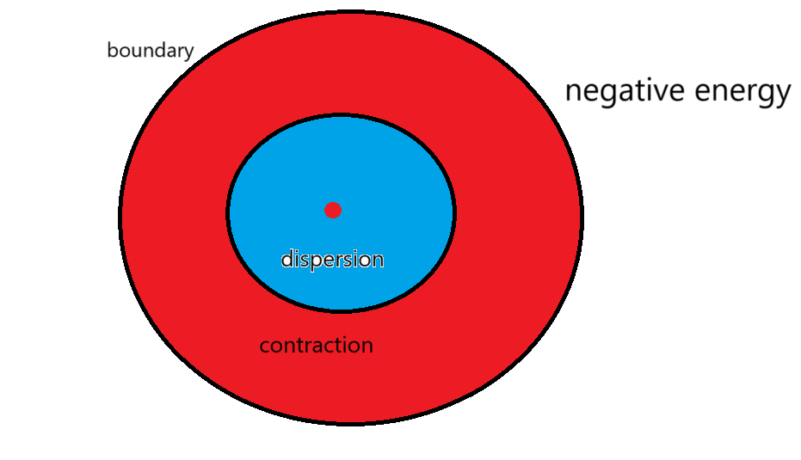

Figure 19

# **13 Special low-dimensional collision residual energy**

The interaction between the residual energy from low-dimensional collisions and high-dimensional collisions leads to the accelerated expansion of the universe. The expansion of the universe and the increase in the dimensions of ordinary matter are not entirely the same, as matter is confined to a single dimension, whereas the universe has infinite dimensions. As the universe expands, the proportion of dark energy (residual energy from low-dimensional collisions) increases, while the proportion of high-dimensional collision residual energy decreases (note the ratio between the two). This involves the dimensional equilibrium across multiple dimensions of matter. However, this does not mean that the total amount of dark matter is increasing; instead, dark energy will gradually diminish, but the rate of the universe's expansion will continue to accelerate (the overall trend is accelerating, though some structures are harder to discern). **In fact, the real expansion of the universe is also caused by the dimensional balance. The remaining energy of low dimensional collision and high dimensional collision determines the positive and negative energy in the three-dimensional material plane. In the process of matter's dimensional elevation, the negative energy corresponds to the residual energy from low-dimensional collisions, leading to a continuous increase in the proportion of negative energy. The residual energy from high-dimensional collisions is more akin to the product of the residual energy from low-dimensional collisions, representing positive energy within matter. Therefore, the proportion of residual energy from low-dimensional collisions (the rate of negative energy growth) is always higher than that from high-dimensional collisions (the rate of positive energy growth). As long as perfect dimensional balance is maintained, the expansion of the universe will always be accelerating. But the acceleration will get smaller and smaller. When the universe is expanding at a uniform rate, the universe will reach an integer dimension, which also means that the universe does not have space and energy . Note that the final infinite dimensional unit is not a small zero dimensional point.** See later "small zero-dimensional point" has not really formed, and I suspect that the "small zero-dimensional point" inside the zero-dimensional point will "reduce its dimension" as the dimension of the zero-dimensional point increases（It formed countless small zero-dimensional points）. This is somewhat incredible, so I don't think we need to consider that for the time being. And the small zero-dimensional point doesn't belong to this world.

This situation differs from the universe; the low-dimensional collision residual energy within the human body is unstable and dissipates more quickly (seemingly not originating from the first cosmic Big Bang). However, there is a method to explain it, albeit somewhat complex: imagine the universe undergoing a process of ascending from zero dimensions to infinite dimensions. At this point, the universe is in an infinite dimension. Beyond this universe, there are countless other universes. Thus, our universe has only ascended one dimension (all universes have ascended only one dimension). All universes will then ascend again, with the high-dimensional collision residual energy accumulating for our universe (let's assume this for now; in fact, it could also accumulate for other universes. That would also produce a big bang). At this moment, our universe undergoes a "Big Bang," but before the Big Bang, our universe had a bit of residual collision energy (there will still be residual energy after infinite dimensions). This residual collision energy will remain within the universe. However, this does not mean that these energies do not move; they will enter some zero-dimensional points (at this point, the interior of the zero-dimensional points is a new universe, containing infinitely many infinitely small new zero-dimensional points). I don't recommend considering this explanation, but it just shows that the birth of life is possible and doesn't need to be adopted. I personally don't like this infinite loop. **In addition, this special residual energy from collisions can also cause regular natural laws to become irregular. The randomness of quantum mechanics is due to the low-dimensional collision residual energy generated at the beginning of the "Big Bang." These are two concepts that should not be confused. The former generates additional randomness on top of randomness (This is why consciousness or the people we always talk about have independent thinking ability. This is not a certainty, it's just a guess. If there is only one infinite dimension, it really can't reach ideology, at most it's probability.).**

**If there is a central low dimensional collision residual energy, then it can also be concluded that a small amount of high dimensional collision residual energy is more likely to accumulate in the lowest dimension people, and a large amount of high dimensional collision residual energy is more likely to accumulate in the highest dimension people.** **Because low dimensional collision residual energy can produce high dimensional collision residual energy, a high dimensional unit may still have more collision residual energy. However, this situation will cause the unit to rise in dimension too fast.** Hether the specific center can form positive energy is still uncertain（**Its origin is unclear, but it may have been left over from the last cosmic upgrade, or there was some kind of external interference before the Big Bang. But almost certainly, this energy exists in the human body or on earth.**）, because this is not like a single-dimensional structure ( three-dimensional to four-dimensional ). This also leads to more complex movements of energy, but it won't change the end result.

**The transition from one integer dimension to another requires countless new vibration directions. This is actually a very complex process. Since we know that the randomness in quantum theory disappears when other dimensions interfere, does this mean everything has a fixed direction（The randomness here refers to a finite number of dimensions）? Not exactly: for example, if someone is gifted in certain areas, does it mean they will pursue work in those fields? In fact, it's probabilistic. This process must satisfy dimensional balance. That is, they might or might not engage in related work. Both probabilities must exist to represent two opposing energy changes (dimensional ascent or descent). After reaching an integer dimension, whether a gifted person will definitely or definitely not pursue work in those areas can be understood through tasks. Every matter or energy has its own task, some requiring dimensional ascent and others requiring dimensional descent. This leads to completely identical matters having different futures. However, the total number of tasks is fixed. The distribution of tasks is hard to predict. Microscopic quantum phenomena are relatively easier to predict, but the macro whole has too many small wholes to predict. This does not represent randomness; it just cannot be calculated.**

**Low-dimensional collision residual energy differs from high-dimensional collision residual energy; its form of energy should not be directly discussed. It contains both positive and negative energy, similar to the positive and negative energies of matter. Its primary function is to generate matter, so the form of energy can be disregarded. Moreover, the contrast between positive and negative mainly expresses the opposition of certain processes (relative). If we have to start from the form of energy, then the residual energy of low-dimensional collision belongs to the internal positive energy, because it generates a very low dimensional material. And the residual energy of high-dimensional collision belongs to the external positive energy. Matter with higher dimensions (assuming the matter is extremely large, as it must include the Big Bang at the beginning. This description may be somewhat inappropriate, akin to all one-dimensional to two-dimensional matter or all two-dimensional to three-dimensional matter, such a large whole can possess low-dimensional collision residual energy.) has more low-dimensional collision residual energy（The premise is that there is residual energy from low dimensional collisions）. It can be simply understood as the low dimensional collision residual energy is also easy to gather in a low dimensional part of the whole（The unit with the highest dimension of existence）. However, it is often concentrated in the highest dimension, and the collision residual energy of high dimension is somewhat similar to that of low dimension, but there are some differences: the collision residual energy of low dimension corresponds to the negative energy in matter, while the collision residual energy of high dimension corresponds to the positive energy in matter (It's not contradictory, but it's abstract). In fact, all matter can absorb the residual energy of low dimensional collisions. However, the absorption of ordinary matter is not obvious, so this distinction is made (explained later). Matter with lower dimensions has more high-dimensional collision residual energy. The coexistence of residual energy from collisions across different dimensions leads to the coexistence of matter in these dimensions. That led to this three generations of basic particles ( high-order correction ). Note: This does not mean that the elementary particles contain low dimensional collision residual energy, but are generated directly. The first few dimensions of the elementary particles still reach integer dimensions. where the residual energy from zero-dimensional collisions can directly produce three-dimensional matter, and the residual energy from one-dimensional collisions can also directly produce three-dimensional matter（This process is a bit complicated, but it can only be roughly described as: two-dimensional collision residual energy and three-dimensional collision residual energy can form three-dimensional matter. One-dimensional collision energy and four-dimensional collision residual energy can still form three-dimensional matter. This may involve very complex dimensional balance, which will not be discussed here for the time being. This process cannot be " oscillations" because it is made of matter）. There is an interesting phenomenon regarding particle iteration issues, as mentioned earlier, forming organisms requires five combinations. This includes low-dimensional collision residual energy, which can combine with high-dimensional collision residual energy to form new matter or determine existing matter. Multidimensional connections lead to iterative effects of matter (higher-order corrections). In other words, we do not consider energy but only the types of matter (directly converting energy into matter). At this point, the combination methods can also be written in the form of 4×3=12. That is, each major category among the four large categories will have three similar subcategories. Of course, these combinations are only approximate expressions and are not rigorous（Because a vibration direction may consist of an infinite number of vibration directions, it is not rigorous to describe the result without considering the process）. In fact, many phenomena are related to these combinations, such as chemical elements, photon spectrum and so on. It is just more complicated, and it is necessary to analyze the characteristics of 12 combinations for subsequent combinations. As for the 8 or 5 combinations mentioned above, they are generally only applicable to larger wholes with strong residual energy from low-dimensional collisions.**

**In addition, there is the super-symmetry principle favored by physicists, where bosons are more like two directions of dimensional balance within matter. Therefore, bosons generally contain only one form of energy. However, this does not mean that spin can only be 1 (there may be single energy types in multiple directions, so it is more often directional). Other integer spin values also exist, but they usually do not exceed three. We can think of bosons as a zero-dimensional point (three dimensions) inside matter, and photons as a zero-dimensional point (four dimensions). The eight combinations mentioned above determine the types of gluons. However, photons belong to the integer dimension and can only exist in one form. Fermions, on the other hand, are more akin to the material level (many zero-dimensional points), requiring a half-integer spin quantity (satisfying the dimensional enhancement method in Riemann's conjecture, thus more often balancing positive and negative energies. Therefore, fermions should correspond to bosons. However, it is important to note that the types of elementary particles are fixed, determined by the residual energy from low-dimensional collisions, while other dimensions can be achieved simply by changing the number of elementary particles. Or I could explain it as elementary particles not being fermions but zero-dimensional points, so supersymmetry is not about types but quantities. The Higgs boson can be roughly understood as a combination of high-dimensional collision residual energy and low-dimensional collision residual energy (or simply as a combination of low-dimensional collision residual energy).**

**There is also a slight possibility that there is another combination that can approximate our world. This combination is very clever and requires careful thought. Now consider only space, not time (for reasons similar to the fact that time does not change the basic units of matter, but only the quantity and proportion. However, at this point the basic unit becomes the basic unit of the basic unit, which can be skipped if you don't understand it.) Ordinary matter is three-dimensional, while the zero-dimensional points that make up matter are four-dimensional (time is not needed here either). Assume that there are also an infinite number of "small zero-dots" inside the zero-dots (the zero-dots here are the basic units that make up the universe) (here the countless small zero-dots are assumed to be a complete universe). At this point, the number of dimensions or directions of motion of the small zero-dimensional point will become 3+4=7(At this point, "time" will be completely synchronized with us, or in mathematics it can be converted into each other). Why do we think about it this way: we want the residual energy of the low-dimensional collision to be completely dispersed, or in other words, only in this way can the residual energy of the low-dimensional collision be dispersed from the zero-dimensional point to completely disappear. If there were no seven dimensions, there would be no "small zero-dimensional point" or a structure like our universe. In fact, this combination is not observable in reality because we are not a "small zero-dimensional point."（Here's a bold hypothesis I still want to make, that this particular low-dimensional collision residual energy might turn into high-dimensional collision residual energy for small zero-dimensional points. In other words, small zero-dimensional points are constantly reducing their dimensions. My ability is limited and I won't consider it for now. ） At this point, the number 7 is not fixed, and it changes as the dimensions change (the state is restored at this point, but the small zero-dimensional points also change). Because I am limited in ability to express it well, but this argument is of great significance. The argument here involves very complex mathematical principles, which will be used as a reference for the time being. It's a shame I can't explain it, but it's an important argument.**

**The higher the dimension, the less energy is left over from the collision. I want to discuss a non-scientific point: as time goes on, our world will become more materialized, but many emotional energies will become weaker. But we are not ordinary matter. We have the ability to disperse the residual energy of low-dimensional collisions, and we can also obtain this energy, so we should not give up this energy. Although this will give us more negative energy (dimensional rise), it is still our unique feature. Due to the addition of residual energy from low-dimensional collisions, dimensional equilibrium (collisions) can be formed between materials in different dimensions. Although cross-dimensional equilibrium is very complex, we can still try to find this rule.**

**This paragraph was added under pressure of inaccuracy but importance: I previously assumed that the Earth has a special low-dimensional collision residual energy. In reality, this energy accumulates and disperses alongside the low-dimensional collision residual energy from the Big Bang (two-dimensional collision residual energy). This process is difficult to describe precisely but can be roughly understood as the accumulation of one type of low-dimensional collision residual energy leading to the accumulation of another special type of low-dimensional collision residual energy. This is a complex reason, which I explain as a dimensional balance between the universe and the universe (which is inside the zero-dimensional point).**

**Although I don't understand applied physics, I think turbulence in fluid mechanics can gather low dimensional collision residual energy (or inclusion relationship). The reason is that the fluid is not easy to lift its dimension due to certain reasons (I understand that the positive and negative energies are equal, but they do not reach the integer dimension), which leads to a large amount of low-dimensional collision residual energy accumulation. The process may be caused by some reasons that cause the fluid to lift its dimension too fast, resulting in a large amount of high-dimensional collision residual energy. It's kind of like a lower dimensional matter suddenly getting higher dimensional. At this point the remaining energy of the high dimensional collision does not disappear（The specific reasons are not clear, but the fluid itself has the characteristic of accumulating low dimensional collision residual energy. Ordinary matter typically lacks this characteristic unless the fluid itself is not a one-dimensional substance（For example, three to five dimensional matter instead of three to four dimensional matter）, meaning that the high-dimensional collision residual energy within the fluid has reached the material level. Ordinary matter is not unable to accumulate low dimensional collision residual energy, but ordinary matter is not the most likely material in the whole to accumulate low dimensional collision residual energy, so I simply describe it as ordinary matter cannot accumulate low dimensional collision residual energy. In fact, all matter can accumulate the residual energy of low dimensional collision, but it is not obvious, because it is difficult for ordinary matter to quickly upgrade its dimension（I'm afraid of misunderstanding, not that it's impossible to accumulate low dimensional collision residual energy）. The high-dimensional collision residual energy in ordinary matter usually manifests as gravity or external positive energy, whereas in fluids, this energy is no longer at the external level.）. Therefore, as long as there is a vibration (dimensional increase，or time passes), the residual energy of low-dimensional collision and high-dimensional collision will be gathered to achieve dimensional balance. At this time, the fluid will only continuously improve the dimension, so as to achieve turbulence. This is just the basic principle, the real process is very complicated. Neutron stars, on the other hand, are more like two-to four-dimensional matter (opposite to turbulence), and the exact reason is not yet known.**

**However, turbulence differs from Figure 20, which illustrates the significant changes in matter caused by special collision residual energy. Turbulence arises because the original matter has a higher dimension but can still rapidly increase its dimensions. It may seem unbelievable, but it is certain that turbulence is akin to the intersection of two dimensions, similar to the boundary between three-dimensional and four-dimensional matter. The dimensional balance in the universe is not limited to a finite number of dimensions but is formed through the interaction of multiple dimensions. This means that two-dimensional and five-dimensional matter can also achieve dimensional balance (though this is less common, it does exist). The result is a combination of three-dimensional and four-dimensional matter.**

**The ideas in the paper are more inspirational, and the real process is very complicated. But often the inspirational ideas can simplify many complex problems. Although not comprehensive, it is still possible to find the right direction to solve the problem.**

In fact, we don't need to worry about it for the time being. We can wait for a more complete theory to understand how this low dimensional collision residual energy works, and then make a choice.

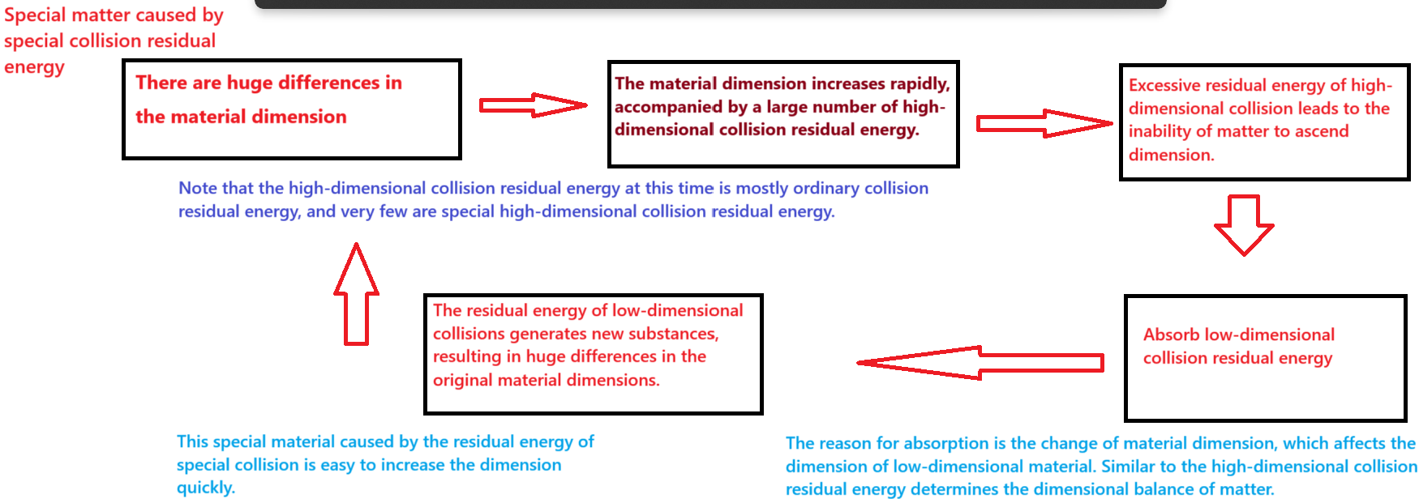

Figure 20

# **14 Acknowledgments**

I express my sincere gratitude to all the individuals who provided assistance and support during the course of my research. It is my aspiration that my paper will be of assistance to a wider audience.

**15 References**

**16 Figure legends:**



Figure 1:



Figure 2:



Figure 3:



Figure 4:



Figure 5:



Figure 6:



Figure 7:



Figure 8:



Figure 9:



Figure 10:



Figure 11：



Figure 12：



Figure 13：



Figure 14



Figure 15



Figure 16







