Creativity and Practical Underdetermination: How Experimental Science Steps into the Epistemic Adjacent Possible

There is a tendency in the philosophy of science to present the scientist as a ghostly being that just has degrees of belief in various descriptive statements, which are adjusted according to some rules of rational thinking (e.g. Bayes’ theorem) . . . We need a more serious understanding of scientists as agents, not as passive receivers of information or algorithmic processors of propositions . . .
--Hasok Chang (2020 pp. 27-28)

= = = = = = = = = = = = =
Acknowledgements: Thanks to Nancy Cartwright, Chris Eliasmith, Manuel Vargas, Richard Vagnino, Juan-Carlos Gonzalez, Dan Burnston and the rest of the attendees at the symposium in honor of William Bechtel’s retirement for helpful discussion on an early version of this material. Thanks to John Bickle and attendees at the 2023 meeting of the Deep South Philosophy and Neuroscience Workgroup in Pensecola, FL. Daniel Brooks, Stuart Firestein, Thanks to Doug Erwin for insightful comments on the manuscript. Special thanks to Alok Srivastava for helping me identify the “armature.” Thanks to attendees at the Memphis in Spring II meeting of the Deep South Philosophy and Neuroscience Workgroup, and especially Ken Aizawa for his invite to the Rutgers Seton-Hall philosophy workshop in September, 2024. Thanks to the other participants of that workshop: Caitlin Mace, Mark Couch, Mark Povich, Ori Hacohen. Special thanks Jim Griesemer, Elihu Gerson, Kelli Barr, Shane Jinson, Peter Hundt, Ed Wilson, and Carol Bromer. And, of course, special thanks to Bill Bechtel to whom this paper is dedicated.
= = = = = = = = = = = = =

Introduction

Humans can use artifacts for purposes other than those to which they are conventionally put. This is a banal fact. Colonel Mustard need be no creative genius to recognize that candlesticks aren’t just for holding candles. But he does need to be minimally creative—at least in the sense of the word that I intend here. The purpose of this paper is to offer some insight into this form of creativity and, more importantly, to locate its exercise within experimental practice in science. I claim it is operant in the means by which researchers cope with what philosophers of science have called problems of “practical” (or sometimes “transient”) underdetermination.
In contrast with “permanent underdetermination” embodied in the various theses to which philosophers appeal in problematizing realist interpretations of our best scientific theories, practical underdetermination is, according to some, “familiar,” “routine,” and epistemologically “non-threatening” (Kitcher 2001). Permanent underdetermination implies the threat that, for any scientific theory, there are (now or in the future) empirically equivalent theories that scientists would be as well justified in believing as they are in believing the theories they in fact do. For many philosophers, this raises serious skeptical concerns and hence has been a primary focus of philosophical discussion. On the other hand, some philosophers have argued that practical underdetermination, the mere “routine” fact that in work-a-day science researchers at a given time might have a number of hypotheses between which their evidence cannot adjudicate, warrants at best, short philosophical shrift.
I am certainly not the first to disagree with that assessment (Biddle 2013, Brown 2013, Elliott 2011, Intemann 2005). Helen Longino (1990; 2016), to give a particularly influential example, has argued that practical underdetermination is the primary form with which philosophers ought to be concerned. Permanent underdetermination, she suggests, is overly tied up with purely philosophical concerns about realism and the authority of science. Practical underdetermination, in contrast, represents a “genuine feature of scientific inquiry” that concerns the means by which actual scientists’ “fix evidential relevance and evaluate the background assumptions that facilitate such fixing” (Longino 2016). A key aspect of her view is that fixing evidential relevance requires taking on board, wittingly or otherwise, potentially value-laden background assumptions that mediate the evidential relations between data and hypotheses. This is how non-epistemic values get smuggled into the context of justification.
Many writing on values in science have followed suit and, with Longino, construe background assumptions as vehicles through which non-epistemic or “contextual” values enter into scientific reasoning and practice (see Biddle 2013 for a summary). Indeed, along with related considerations of “inductive risk,” philosophical reflection on how scientists cope with practical underdetermination has led philosophers to identify significant consequences for our understanding of scientific rationality (Douglas 2000). As Holman and Wilholt (2022) state, there is “now a general consensus amongst philosophers . . . that values necessarily play a role in core areas of scientific inquiry.” So much for practical underdetermination being philosophically uninteresting.
In the analysis of practical underdetermination problems I develop here, I also follow Longino in highlighting the role of background assumptions (or “empirical criteria” as I call them) in mediating inferences from data to hypothesis. However, rather than focusing on their role as vehicles for values in science, this paper seeks to understand them from a point of view concerned with of the development of science. More specifically, in the context of the analysis I develop here, they represent indices for the operation of a characteristically creative form of human epistemic agency, one that explains how experimental practice in science can develop in genuinely novel or, as Stuart Kauffman (2019) would say, “unprestatable” ways.
In developing the analysis, I aim to offer a partial answer to Hasok Chang’s (2022) call to pursue a “a more serious understanding of scientists as agents,” not as “passive receivers of information or algorithmic processors of propositions.” I am motivated, in part, by his comment that “there is a tendency in the philosophy of science to present the scientist as a ghostly being that just has degrees of belief in various descriptive statements, which are adjusted according to some rules of rational thinking (e.g. Bayes’ theorem).” Though my priorities in this paper do not permit me to argue for the claim at length, I want to suggest, here in my introduction, that this tendency haunts discussions of practical underdetermination and that the analysis I provide can help us exorcise it.
Often, practical underdetermination problems are framed as “gaps” left over when scientists find that the “epistemic” resources of evidence and logic are insufficient to adjudicate between multiple hypotheses (Intemann 2005). DiMarco and Khalifa (2019), for example, characterize the gap in the following way: “There exists some hypothesis h and some time t such that there is some other hypothesis h* that is as well supported as h by all of the epistemic considerations available at t.” As they make clear elsewhere, by “epistemic considerations” they mean “empirical evidence” as well as “rules of reasoning that take evidence and background information as their inputs and probabilities of hypotheses as their outputs.” “Rules of reasoning” include the “canons of inductive and deductive inference, plus some prima facie plausible methodological maxims, e.g. ‘ceteris paribus, if h correctly predicts some novel phenomenon e, then P(h/e) > P(h).”
Note that in this “gap” formulation no explicit reference is made to the scientists facing the practical underdetermination problem. I want to suggest, however, that in as much as the “epistemic gap” formulation aspires to offer an analysis of a “genuine feature of scientific inquiry,” it implies a particular view of those scientists. These implicit scientists are “ghostly” indeed—they are little more than where the “rules of reasoning” to which DiMarco and Khalifa refer are housed. On the “epistemic gap” formulation of practical underdetermination, these ghostly scientists are ones whose typical practice is not impeded under “normal” non-evidentially underdetermined circumstances. After all, in such circumstances, evidence and logical rules of reasoning alone can do the trick in determining which hypothesis is best supported by the evidence. But, when faced with problems of practical underdetermination—circumstances in which “evidence and logic leave off”—those otherwise ghostly scientists are imbued with human values to facilitate a decision when evidence and logic alone cannot make a determination.
In other words, these implicit (hence, “ghostly”) scientists are, in the first instance, Chang’s “algorithmic processors of propositions.” They are merely contingently endowed with the sort of genuinely agential capacities—“values”—that Chang exhorts us to make essential to our conception of the human scientist. I want to suggest that my analysis of how scientists cope with practical underdetermination problems represents a step toward answering Chang’s call. In contrast to the “gap” formulation, what I will call my “experimental dead-space” formulation of practical underdetermination explicitly models human scientists. And it does so in a way that makes them out to be more recognizably human than is the purely rational “ghost” implicit in the “epistemic gap” formulation.
Turning now to the main focus of the paper, I borrow the particular problem of practical underdetermination that I discuss from my previous work (Bollhagen, 2021). In the case, researchers studying the movement of a molecular motor protein called kinesin constructed what I then called an “experimental dead-space”—a practically underdetermined space of alternative hypotheses between which they could not adjudicate using the experimental tool that anchored their research. Here, I build on the philosophical apparatus that I introduced in giving my prior account of the means by which researchers coped with this practical underdetermination problem. To this end, I construe an experimental dead-space as a construct built within a broader unit of analysis, namely, a research platform (Griesemer 2013). Finally, I identify an “experimental dead-space” with an “epistemic adjacent possible.” Borrowing the idea of the “adjacent possible” from Kauffman (2019) enables us to characterize the form of creativity I have in mind and to illustrate scientists’ exercise of it in resolving the practical underdetermination problem they confronted in the concrete case I analyzed in my previous work. Overall, the analysis enables us to describe how the exercise of this form of creativity enables experimental practice in science to develop in genuinely novel “unprestatable” ways.
As I mentioned, I believe that this analysis represents a step toward answering Chang’s (2022) call to develop “a more serious understanding of scientists as agents,” not merely “algorithmic processors of propositions” (27-28). Kauffman’s framework of the adjacent possible is particularly useful in this regard. He develops it in giving an innovative account of the means by which systems in the biosphere evolve—one on which they do so “creatively” in a sense Kauffman contrasts with “algorithmically.” By identifying the practical underdetermination problem that researchers in the case confronted with an epistemic adjacent possible, we can likewise offer an account of the means by which the researchers resolved their problem on which their doing so involved the exercise of a form of “non-algorithmic” creative agency.
Section I provides a brief introduction to Kauffman’s framework of the adjacent possible. I build specifically on Kauffman’s (2019) remarks according to which biological evolution occurs by creative, “non-algorithmic” means. As we will also see in this section’s discussion of the Duncker Candle Task, there is a clear analogy to this kind of creativity in the sphere of human activity. Section II walks through the “Inchworm Episode” and introduces the conceptual apparatus that I developed to give my philosophical account of it. Section III further develops this apparatus. The section highlights how my case study reflects the exercise of the form of creativity I have in mind, and how it enabled researchers to solve their practical underdetermination problem and “step into” their experimental dead-space, i.e. the epistemic adjacent possible. Section IV ties up some loose ends.

Section I: Creativity and “The Adjacent Possible”

Think of chess. As moves in chess are bound by a finite set of well-defined rules, we can specify or, as Kauffman (2019) puts it, “prestate,” for any given board position, a space of alternative possible configurations into which the board can develop given a single legal move. The given board position represents what Kauffman calls “the actual.” The possibility space we “prestated” is its “adjacent possible.” According to Kauffman, current “actual” systems in the biosphere also have adjacent possibles. The difference, though, is that on Kauffman’s view, the evolution of such systems is not explicable in terms of a finite set of well-defined rules. So, we cannot prestate their adjacent possibles. But, if not by means amenable to explication in terms of a finite set of well-defined rules, how do systems in the biosphere change? Kauffman’s answer is that they do so “non-algorithmically,” “inventively,” or, to use the term I favor here, creatively. What does “creatively” mean in this context?
Kauffman illustrates using two examples—exaptations and screwdrivers (Kauffman 2019). An “exaptation” or “Darwinian preadaptation” is a trait that evolves for one function but is later co-opted for a different one. Analogously, a screwdriver can be used to screw in a screw or, if circumstances call for it, open a can of paint. Kauffman uses these examples to motivate a distinction between two different kinds of change. I quote him at length:

. . . Darwin had many brilliant ideas. Among them was his . . . realization that the heart, in a different environment, might come to be selected for some causal aspect other than pumping blood. Perhaps as a resonant chamber, my heart might pick up earthquake pre-tremors. I rush outside, escape a dreadful quake, become famous, mate with many, and my dominant genetic mutation for a heart able to sense pre-tremors is passed onto my manifold children . . . With that, a new function would come to exist in the biosphere. These are very common and are called Darwinian preadaptations with no hint of foresight on the part of evolution. S.J. Gould renamed these Darwinian exaptations . . . (116).

. . . Perhaps my favorite Darwinian preadaptation is the swim bladder. Some fish have a bladder that holds air and water. The ratio of air to water in the sac tunes neutral buoyancy in the water column. Paleontologists think swim bladders evolved from the lungs of lung fish. Water got into some lungs, which now had a mixture of air and water and were poised to evolved into a swim bladder . . . With the swim bladder’s emergence, a new function came to exist in the biosphere: neutral buoyancy in the water column. But there is more . . . might a worm or bacterium evolve to live only in swim bladders? Yes, of course. So the swim bladder, by existing, opens a new crack in the floor of nature, to borrow from Darwin, and a worm can live in that new crack . . . (116-117).

Do you think you could have said ahead of time that the swim bladder . . . would emerge? Could you have prestated the swim bladder? Try to prestate all the Darwinian preadaptations in humans for the next 5 million years. You cannot. We’ll see why . . . when we discuss screwdrivers . . . (117).

. . . I hand you a common screwdriver. Please list for me all the uses of a screwdriver in, say, New York, in 2017, Well, go ahead: screw in a screw, open a can of paint, scrape putty from a window, stab someone, display as an objet d’art, scratch your back, wedge the door open, prop a window open, jam a door closed, tie to a stick and spear a fish, rent the spear out at 5 percent of the local catch, and so on . . . (118).

. . . is the number of uses of a screwdriver infinite? No, for discretely different things, like the uses of screwdrivers, to mean “infinite,” we require a recursion, 0, 1, 2, 3, N, N+1 as for the integers . . . But if we have N uses of a screwdriver, what is the next, N+1, use of a screwdriver? Can you enumerate it forever, for all N to infinity? No you cannot . . . the number of uses of a screwdriver is indefinite (italics in original). . . The uses of a screwdriver are merely a nominal scale. There is no ordering relation between the different uses of a screwdriver and no fixed intervals. . .(119).

I claim two major results: (1) no rule-following procedure, or algorithm, can list all the uses of a screwdriver; and (2) no algorithm can list the next new use of a screwdriver! . . . But Darwinian preadaptation, or exaptations, are new uses of screwdrivers (119; italics original).

Again, Kauffman’s discussion is not about exaptations and screwdrivers per se but to distinguish between two different conceptions of change. On the one hand, there is the kind of change that is explicable in terms of a finite set of well-defined rules. There are such conceptions of change in biology. Erwin (2017) discusses Maynard Smith’s conception of how proteins change between functional states due to single base-pair changes in the genes that code for them. Iteratively applying the rule “change a single base pair” to a gene allows us to “prestate” the possibility space that the corresponding protein can explore. Similar to chess, each “step” in its exploration will represent a kind of change explicable in terms of the application of the rule to the system.
In contrast, according to Kauffman, the kind of change involved in “a new function coming to exist in the biosphere” in the form of an exaptation is not so analyzable. A structure functioning as a lung does not, over the course of evolution, change into one functioning as a swim-bladder in such a way that is amenable to the kind of “algorithmic” analysis given to proteins above. If it did, then, in principle, we could exhaustively “pre-state” the possible evolutionary trajectories of the lung-fish’s lungs at a time prior to the swim bladder’s actual evolution by means of iteratively applying a rule to the lungs, as we did to genes in the paragraph above. But, and this is Kauffman’s point, not even LaPlace’s Demon could prestate the space of the lung’s possible evolutionary futures much less predict which one of those possibilities—the swim bladder, for instance—the lung’s actual evolution would realize. This is a key premise in Kauffman’s argument that change in the biosphere is not governed by “laws” and therefore that biology constitutes a “world beyond physics.”
At the end of the discussion that I quoted at length above, Kauffman goes onto describe what he calls “jury-rigging”—the creative human activity of “using a set of things or processes for purposes other than those for which they may have been designed.” To illustrate, he gives the example of a man who “fixed” a leak in a ceiling by rigging “a funnel attached below the leak, to a tube leading out the front door over a railing, dropping toward the ground, slowly draining. Finding that a lamp in his house was hanging too low, the man also slung the lamp cord over the tube, jury-rigging on jury-rigging” (120). We could not, Kauffman claims, have a deductive theory of jury-rigging. “There is no deductive theory of jury-rigging to solve different problems, but we do it all the time. We are inventive. So is evolution . . . And none of us can predict in advance what we might invent and what might be invented from our inventions” (121).
The kind of change involved in an artifact coming to serve, in the hands of a user, a function other than that for which it may have been designed is analogous to that involved in Kauffman’s discussion of exaptations. To repeat Kauffman, “The uses of a screwdriver are merely a nominal scale. There is no ordering relation between the different uses of a screwdriver and no fixed intervals.” You might put the point by saying that the screwdriver’s use, open a can of paint, is not some distance in a metric space from its use as a paper weight. After all, in the space of possible screwdriver uses, there is no notion of distance between points in the way that a metric space as such requires. It makes no sense to say, for example, that within the space of possible screwdriver uses open a can of paint is twice as far from screw in a screw than is remove gunk from a baseboard. Alternatively, as Kauffman’s allusion to integers suggests, you might say that uses of a screwdriver are not commensurable with each other in the way that integers are. As I have put the point elsewhere, “5 is commensurable with 10 insofar as there is some base unit out of which they can both be constructed. Take “5” as our base unit. 5 is made out of one “5” and ten is made out of two “5”s. Or take “1” as our base unit. 5 is made out of five “1”s and 10 is made out of ten “1”s. The prime-ness of prime numbers consists in the fact that they can only be shown to be commensurable with natural numbers less than themselves by appeal to a base unit of “1”” (Bollhagen, 2021). We might say, then, there is no base unit out of which one can construct, for a screwdriver, both open a can of paint and use as a paperweight.
Whether we put the point in terms of metric spaces or in terms of commensurability, these are, for my purposes, two ways of saying the same thing. And, I take it, two ways of saying the same thing that Kauffman himself puts in terms of “algorithmicity.” That is, Kauffman’s way of saying it goes that the change involved in moving from one use of a screwdriver to another is not explicable in terms of a finite set of well-defined rules. By analogy, the kind of change involved in biological structures adopting new functions is likewise not “algorithmic.” We can call this form of change “discontinuous.”
Although using screwdrivers and jury-rigging with funnels clearly involves human cognitive activity, Kauffman’s point is to illustrate how the evolution of systems in the biosphere works. His ultimate point, in other words, is an ontological one that he uses to characterize “the emergent, creative, unentailed, becoming of the biosphere . . .” (Kauffman 2014). Here, in giving his idea an “epistemic twist,” my focus remains on human epistemic agents.
So, keeping the focus on humans, what is cognitively involved in jury-rigging? Psychologists have studied this form of creativity in humans using an experimental paradigm named after its inventor, the Gestalt psychologist, Karl Duncker (Duncker & Lee 1945). In the Duncker Candle Task, subjects are seated at a table next to a wall on which a cork board is mounted. They are given a wax candle, a box of tacks, and a book of matches and are told to find a way to support the candle above the table such that, when the candle is lit, it does not drip wax onto the table. As psychologists put it, the solution hits subjects as an “insight.” The insight is to realize that the box of tacks is not merely a box of tacks but is materially such that it can support an alternative functional deployment, namely, candle holder. What Kauffman calls “jury-rigging” is essential here. Successful subjects will dump the tacks onto the table emptying the box, and then use the tacks to pin the empty box to the cork board. They will then melt the bottom end of the candle, press it into the box, and let it cool so that the candle stands upright. When the match is lit, the empty box serves as a well to catch the dripping wax (Figure 3).


Figure 1: The Duncker Candle Task

Psychologists characterize the difficulty involved in succeeding on this task as “functional fixedness”—a tendency to understand artifacts narrowly, i.e., in terms of their conventional or designed purpose. The insight is a matter of breaking out of this functionally fixed mindset. The term “insight,” however, might sound slightly hyperbolic given the banality of jury rigging. While an artifact’s conventional use may carry some psychological inertia in our interactions with it, we do, in fact, overcome that inertia and break through functional fixedness often enough to where the act hardly warrants the epithet “insight.” As Kauffman writes, “we jury-rig all the time.” It is “routine.” Indeed, appropriately so, for my purposes, given that philosophers have characterized scientists’ coping with practical underdetermination in precisely those terms.
As we will see in the next section, researchers in the “Inchworm Episode” modified the conventional use of their research platform to test for features beyond those which prior conventional usage countenanced. The form of change that the research platform underwent as a result is the same as that involved when, for Kauffman, a “new function comes to exist in the biosphere.” In fact, as we will also see, this change opened up a new “crack in the floor knowledge,” to paraphrase Darwin, for the research platform to develop into that was not antecedently “prestatable.”
Before turning to the case study, I want to note that there is much more to be said about the form of creativity studied in the Duncker Candle task. Indeed, I believe that further analysis of this form of creativity and how it is exercised in scientific practice has much to contribute in answering Hasok Chang’s call to develop “a more serious understanding of scientists as agents, not as . . . algorithmic processors of propositions . . .” (2020, p. 27-28). Here, however, I simply point out that the creative means by which Duncker Candle-taskers, jury-riggers or scientists break through functional fixedness and re-deploy an artifact to serve a function other than that with which it is conventionally associated are “non-algorithmic” in precisely the sense that Kauffman intends that I described above.

Section II: The “Inchworm Episode”

According to Bollhagen (2021), from 1989-2002, researchers studying the motor protein kinesin produced data supporting the hypothesis that the proper characterization of its stepping pattern along its microtubule “tracks” was “hand-over-hand” as depicted in (Figure 2).

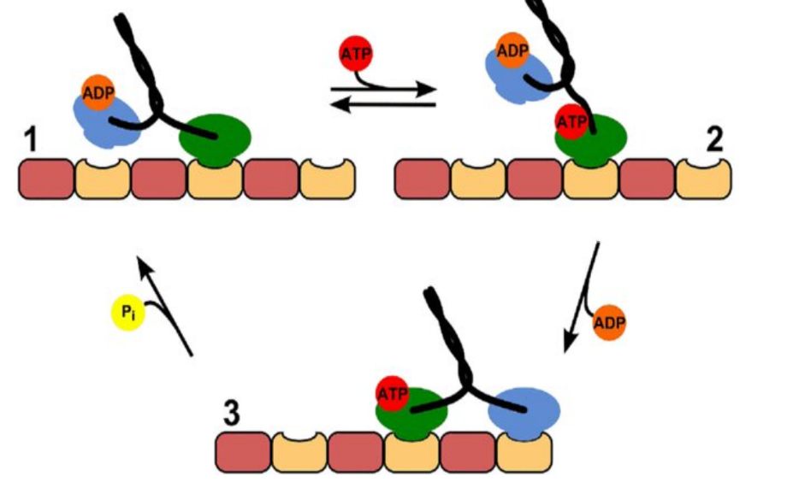
Figure 2: The trailing head (blue) “steps” over the leading head (green) to become the new leading head. The “track” along which the molecule walks is a microtubule, a cytoskeletal filament composed of tubulin. Image from Sozanski et al. (2015).
On that recounting, a number of experimental studies using what was then a novel tool, the single-molecule motility assay, supported the claim. The assay took one of two forms. First, in the “bead assay,” researchers immobilize microtubules to glass coverslips, attach single kinesin molecules to plastic beads large enough to visualize under a video microscope, and watch the beads move as kinesin carried it like cargo down the immobilized microtubule. A second version, the “gliding assay,” flipped the geometry of this design. Here, researchers would immobilize single kinesin molecules “heads up” to a glass coverslip and watch them slide microtubules around (Figure 3). In either case, researchers were drawing inferences from data that they could see—moving beads or microtubules—to the phenomenon that they could not, the characteristic stepping pattern of the molecular motor.

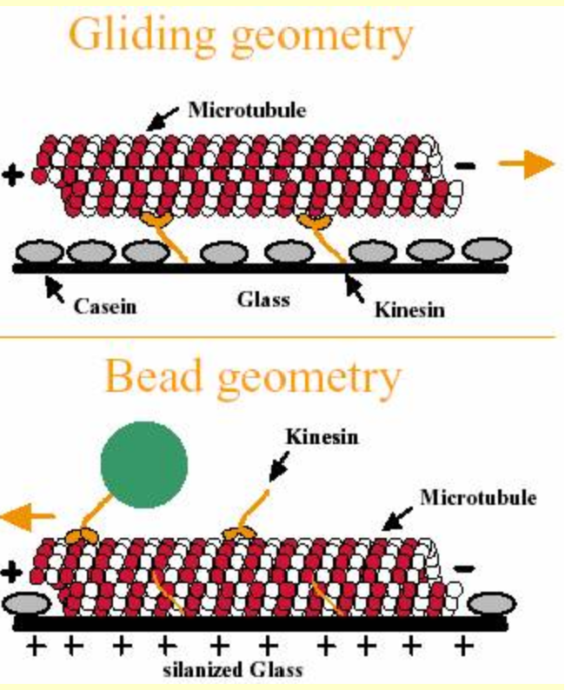
Figure 3: Two geometries of the single-molecule motility assay. Image from https://homepages.uc.edu/~deange/Old-files/2004/gomesme/motility_assays.htm

How did these “data-to-phenomenon inferences” work (Bogen & Woodward 1989)? As I described in my last paper, the hand-over-hand hypothesis was operationalized in terms of what I called two empirical criteria: 1) processivity and 2) coordinated head activity. Processivity means that the molecule remains attached to the microtubule at all times during its walk. Co-ordinated head activity means that the behavior of one head is dependent upon or “gated by” the behavior of the other (e.g. the trailing head can only release once the leading head has securely bound to the microtubule). Thus, if data using the single-molecule assay indicated that the molecule was processive and coordinated the activity of its heads, it would support the hand-over-hand hypothesis over “stroke-release,” an alternative which denied that the molecule was processive and coordinated the activity of its heads. If, for example, researches using a bead assay saw that the beads moving along immobilized microtubules would intermittently diffuse away from the microtubule, this would indicate that the protein driving the bead’s motion occasionally “jumps”—separates entirely from the microtubule—on its journey. It would indicate, that is, that kinesin’s stepping pattern is not processive and that therefore “hand-over-hand” is not an accurate characterization of its movement.
From 1989-2002 researchers understood how to deploy the single-molecule motility assay to test for processivity and coordinated head activity. During that time, researchers did substantial experimental work that provided support for the “hand-over-hand” hypothesis. However, there remained a practically underdetermined space of alternative hypotheses—an “experimental dead-space,” as I called it then—that attributed both processivity and coordinated head activity to kinesin’s stepping pattern, but also attributed to it further features beyond those that researchers understood how to functionally deploy their tool to assay for (Figure 3). In other words, they attributed to it features other than those attributed to it by hypotheses like “hand-over-hand” and “stroke release” which were formulated in terms of empirical criteria.

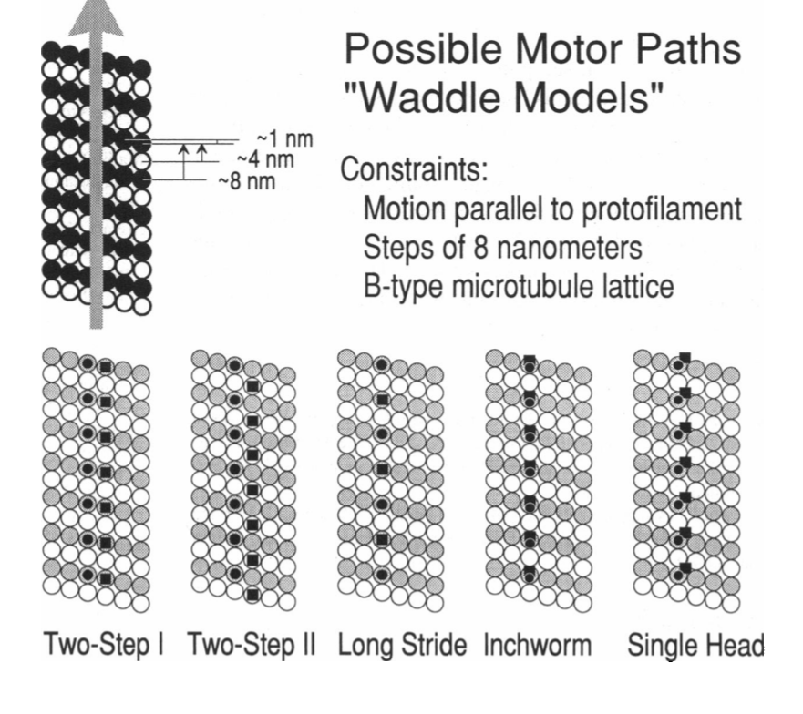
Figure 4: Experimental dead-space for kinesin stepping patterns. From Block and Svaboda (1995).

Notice, briefly, that “inchworm” counts as a species of hand-over-hand according to (Figure 3). This might be counterintuitive given that, on inchworm, the rear “hand” never passes “over” the leading “hand.” Rather, the same one is in the lead during the entire duration of its walk. Nonetheless, it maintained that the molecule was processive and coordinated the activity of its heads, and so counted as a hand-over-hand hypothesis by the lights of the relevant empirical criteria. The problem was that although researchers could, as they put it, “conceptually” distinguish “inchworm” from the other hypotheses in the experimental dead-space, they could not do so “empirically,” i.e. in terms of empirical criteria. This will be important shortly when we see how researchers formulated a new empirical criterion which changed the overall space of alternative hypotheses in such a way that inchworm was rendered experimentally live.
The experimental dead-space represented in Figure (4) persisted for as long as coordinated head activity and processivity constituted the empirical criteria in terms of which kinesin motility was conventionally operationalized within single-molecule research (1989-2002). However, Hua et. al., (2002) introduced a new empirical criterion—torque generation—and, around it, built a new space of alternative hypotheses in which the formerly “dead” inchworm hypothesis became experimentally live. Taking cues from a key review article (Howard 1996), these researchers noted that, if the molecule’s two heads move hand-over-hand as they step, this would result in a reversal of the molecule’s orientation with respect to the microtubule axis with each step. This, in turn, would generate torque which would be communicated to the cargo the molecule is carrying. By using a stiff-necked kinesin derivative to ensure that the torque would not be taken up by the native molecule’s torsionally flexible neck, they reasoned that, if the molecule generates torque, they should observe 180-degree rotations of microtubules in a gliding version of the single-molecule motility assay. If the microtubule rotated, it would confirm hand-over-hand, now formulated in terms of the empirical criterion, torque generation, in addition to processivity and coordinated head-activity. If not, it would confirm inchworm, now an experimentally live hypothesis formulated empirically as a non-torque generating processive and coordinated walk.
Hua et. al. (2002) created their stiff-necked kinesin mutant and took to deploying the single-molecule platform to test for torque generation. They did not observe the 180-degree microtubule rotations that they “understood and anticipated” torque generation to produce visibly and, therefore, concluded that inchworm is the correct characterization of kinesin’s stepping pattern. But these observations did not constitute the whole of their argument. As Hua et. al., acknowledge, there is a third possibility—“asymmetric hand over hand,” a putative hand-over-hand-style walk in which a structural asymmetry between kinesin’s two globular heads is such that the molecule’s step compensates for the torque that a symmetric hand-over-hand walk would otherwise generate. Since both “inchworm” and “asymmetric HoH” are non-torque generating walks, and since the relevant empirical criterion in this study was torque generation, this experiment could not empirically distinguish between them. Thus, while their introduction of “torque-generation” as an empirical criterion, enabled access to the pre-2002 experimental dead-space by empirically distinguishing “inchworm” from “symmetric hand-over-hand,” it also created a new experimental dead-space populated by “inchworm” and “asymmetric hand-over-hand.”
In other words, with the introduction of torque generation, “hand-over-hand” split into two versions—symmetric and asymmetric—such that “inchworm” became empirically distinguished from the former but not the latter (Figure 5). Concomitantly, a new experimental dead-space opened up, occupied by inchworm and asymmetric HoH. Acknowledging that their experiment could not adjudicate between these hypotheses, Hua and colleagues criticized asymmetric HoH indirectly, arguing a priori that it was implausible to attribute to the molecule the kind of complex and nuanced structure that it would have to have in order for it to perfectly compensate for the torque it would otherwise generate. In other words, though they acknowledge that these hypotheses occupy a newly constructed experimental dead-space, they conclude in favor of inchworm based on both their empirical data and an a priori argument to the effect that the alternative is implausible.

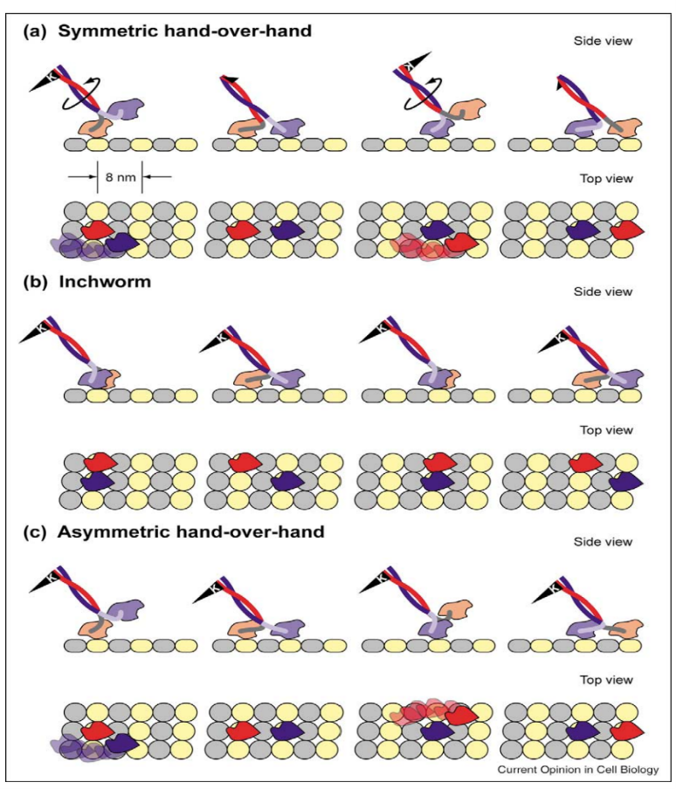
Figure 5: Introducing torque generation as an empirical criterion rendered the formerly “dead” inchworm hypothesis experimentally live and, concomitantly, introduced asymmetric hand-over-hand. While torque generation enabled researchers to access the 1989-2002 experimental dead-space, it also created a new dead-space occupied by inchworm and asymmetric hand-over-hand.

This new experimental dead-space did not persist long, however. In the following two years, researchers published a number of studies in which they introduced yet another new empirical criterion that empirically distinguished between inchworm and asymmetric hand-over-hand, namely, limping. A number of researchers reasoned that if the molecule walks in an asymmetric hand-over-hand manner, a “limp”—a difference between the time one head spends attached to the microtubule vs. the other—should be discernible in their data. As I discussed previously, a number key studies discerned the limp such that, by 2005, the consensus among single-molecule researchers was that asymmetric hand-over-hand is the correct characterization of kinesin’s stepping pattern.
Hua et al.’s introduction of torque generation was characteristically “creative” in the sense illustrated in my discussion of the Duncker Candle Task. As I discuss in more detail in the next section, these researchers realized that the “material conditions” of their research platform were such that they could be functionally deployed to assay for a putative feature of kinesin’s stepping pattern other than those for which it had conventionally been deployed to assay. In other words, like successful Duncker Candle taskers, these researchers had the “insight” that they could deploy their research platform to test for torque generation, rather than merely processivity and coordinated head activity. Accordingly, the kind of change that characterized the dynamic reorganization of the overall space of alternative hypotheses that was catalyzed by the introduction of torque generation is not a form of change that can be explicated “algorithmically” in the sense I described above. To see this more clearly, I step back now to build upon the philosophical apparatus that I introduced in my initial analysis of the Inchworm Episode.

Section III: Embedding Experimental Dead-Spaces in Research Platforms

The single-molecule research platform was anchored in the use of a particular experimental tool to study kinesin stepping—the single-molecule motility assay. A research platform is “a collection of conventions for the use of material circumstances, conditions, or resources to which researchers commit for the sake of regulating and standardizing their work practices and procedures” (Griesemer, 2013). This characterization gives philosophers wide berth in applying it to the analysis of cases. In analyzing the dynamics of a particular research platform, one will differentially emphasize those aspects that Griesemer builds into his characterization depending upon the contingencies of the case and the purpose of the analysis. Depending on one’s interest in analyzing a case, that is, one might emphasize the relevant material circumstances or, perhaps, the financial resources available to practitioners. I would also add, as a nod in the direction of the usefulness of my analysis for discussions of values in science, that an analysis of a research platform may involve identifying the ways in which values, biases, political environment or other “contextual factors” contribute to its structure of a at a time.
Accordingly, I emphasize certain aspects of the single-molecule research platform that I take to be key in understanding the creative form of change that characterized its development as presented above. Of particular interest is what I take to be the distinctively epistemic aspect, namely, what Griesemer calls “conventions.” I identify these with the empirical criteria around which researchers organized a space of alternative hypotheses about kinesin’s stepping pattern, constructed experiments to test those hypothesis, and in light of which they interpreted the resulting data. In the Inchworm Episode, then, “processivity” and “coordinated head activity” were the 1989-2002 “conventions” to which researchers committed for the use of their “material circumstances, conditions, or resources” to the end of “regulating and standardizing” the empirical study of kinesin’s stepping pattern.
As empirical criteria are an important category in my prior analysis, I pause here to show how identifying them with Griesemer’s “conventions” represents a development on the original idea. In the previous paper I wrote, “Empirical criteria individuate [hypotheses about] the phenomenon along lines experimentally tractable from the point of view of a particular experimental tool” (19). Thus, insofar as alternative hypotheses are formulated in terms of different empirical criteria, they count as “empirically distinct” (16, 19). In my telling of the inchworm episode, “stroke release” was a hypothesis which denied that the molecule was processive and coordinated the activity of its heads and, therefore, was empirically distinct from the hand-over-hand hypothesis. Second, I used “empirical criteria” to refer to “certain supposed features of the phenomenon that are understood or expected to give rise to characteristic patterns of data in [a particular experimental tool]” (20). Researchers take the presence or absence of these features to explain why certain characteristic patterns of data show up on the display side of their tools while other ones do not. In this way, empirical criteria facilitate data-to-phenomenon inferences (Bogen and Woodward, 1988; Woodward, 2011).
As I mentioned, I build on this by understanding these empirical criteria as conventions characteristic of the single-molecule research platform which regulated and standardized the deployment of the single-molecule motility assay. Identifying my “empirical criteria” with Griesemer’s “conventions” enables me to embed the former category and, in turn, the idea of an “experimental dead-space,” into a wider unit of analysis, namely, a “research platform,” that includes the other aspects that Griesemer mentions in his characterization of it. These other aspects are also crucially important for giving an account of the creative change that the research platform underwent with the 2002 introduction of torque generation as a new empirical criterion.
First, take Griesemer’s “material circumstances.” I identify these with the technological and biological material constitutive of the single-molecule motility assay including glass coverslips, video microscopes, ATP, kinesin molecules, microtubules, etc. Under the 1989-2002 epistemic conventions (empirical criteria), researchers’ understood the biological and technological material they were working with to be functionally deployable to test for processivity and coordinated head activity in the same way that functionally fixed Duncker Candle-taskers understand the material they are working with to be functionally deployable as a box of tacks. Thus, by embedding my prior philosophical apparatus into Griesemer’s wider one, I can characterize a notion of function on which the function of a research platform at a time is specified by the conventional empirical criteria operative during that time period. Insofar as those empirical criteria do not change, I will say that the research platform remains functionally fixed. Thus, insofar as it was used to adjudicate between alternative hypotheses regarding kinesin’s stepping pattern, the single-molecule research platform remained functionally fixed from 1989-2002 and was thereby unable to access its experimental dead-space.
Finally, I also make use of Griesemer’s “researchers” which I encourage readers to identify with Chang’s “epistemic agents.” In the model of the Inchworm Episode I am developing, these agents are characteristically creative in the “non-algorithmic” sense discussed in connection with Kauffman and the Duncker Candle Task above. They have the banal human capacity to deploy material artifacts for purposes other than those to which they are conventionally put. Like successful Duncker Candle-taskers, it was the researchers, specifically Hua and colleagues in the Inchworm Episode, who had the “insight” to introduce a new empirical criterion—torque generation—and who thereby functionally re-deployed the material conditions characteristic of the single-molecule motility assay in order to test for it.
So, as I characterize it, the research platform relevant to the Inchworm Episode consists of its epistemological conventions (empirical criteria), its material conditions (the technological and biological “stuff” of the single-molecule motility assay), and its researchers (creative epistemic agents). Lastly, a research platform is “tangled” with other research platforms within a broader field of research (Cartwright, 2022). Other molecular motors researchers studied kinesin using x-ray crystallography, electron microscopy, and various other tools of the cell biologist’s trade to produce structural and functional data that single-molecule researchers could draw upon in formulating hypotheses—both live and dead—about kinesin’s stepping pattern. In more general terms, hypotheses about the phenomenon formulated within one research platform can be—perhaps typically is—motivated by information coming from outside of that platform through the variety of communicative channels that characterize the entangled social organization of scientific research in which creative scientists are embedded.
This organizational entanglement is also key to understand the exercise of the form of creativity I attribute to researchers in my analysis of the Inchworm Episode. As I mentioned, the 2002 researchers who ran the key study were inspired by a 1996 review paper. This article put forward the possibility that, during its walk, kinesin’s tail might “wind up like the rubber band on a toy airplane.” This thought nudged them into having the creative insight that they could use the material conditions of their research platform to assay for torque generation. Why this key idea from a 1996 paper lingered somewhere out in the communicative channels running through the entangled web of research platforms characteristic of 1989-2002 single-molecule kinesin research I do not know. But that is an important question that an analysis more complete than the one I can give here would seek to answer.
A final note about that last point. It is because of something about the character of that “tangle” that the key idea of the 1996 review paper that inspired Hua et al. only nudged someone to have their insight as late as 2002. However, it is also because of that “tangle” that the insight was communicated at all. For my purposes here, the importance of this point is that we cannot simply say that single-molecule kinesin research was functionally fixed from 1989-2002 because people were just not thinking creatively enough. After all, humans cannot simply will themselves to think more creatively. A bald injunction to “think more creatively” is unintelligible as advice for how researchers should break through their functional fixity. Rather, the exercise of scientific creativity and the occurrence of creative insights in science is scaffolded, for better or for worse, by the entanglements characteristic of the social organization of research. I suggest that it is due to the character of these entanglements that, on the one hand, it took a full 6 years after the publication of the key idea in 1996 for that idea to inspire Hua and colleagues’ creative insight and, on the other hand, for that idea to finally give the nudge that was needed to break the single-molecule kinesin research platform out of its functionally fixed state. In short, the structure of entanglements between research platforms in a broader field of research is responsible for both the fixity and the insight.
I have discussed various ways in which I draw on Griesemer (2013) to build on the conceptual apparatus I introduced in my previous work on the Inchworm Episode. I mentioned in my introduction that I was also going to do so by identifying an experimental dead-space with an epistemic adjacent possible. To close the loop, call the single-molecule research platform from 1989-2002—the period during which it was functionally fixed—“the actual.” Call the experimental dead-space (Figure 4) that persisted during that time “the epistemic adjacent possible.” The story of the Inchworm Episode is the story of how creative epistemic agents “stepped into” the epistemic adjacent possible by creatively introducing torque generation as a new empirical criterion into the conventions regulating and standardizing the functional deployment of their research platform. This is just to say that they realized creatively that the material conditions characteristic of their research platform could be functionally re-deployed to assay for features other than those for which it was conventionally used to assay in light of the 1989-2002 empirical criteria. This concomitantly generated a new epistemic adjacent possible—a “new crack in the floor of knowledge” into which the research platform could develop—in the form of an experimental dead-space occupied by inchworm and asymmetric hand-over-hand. Researchers, in turn, stepped into this adjacent possible as they creatively introduced limping, another new empirical criterion. Thus, to follow Kauffman, even from the point of view that a Demonic Laplacian philosopher of science could take on the pre-2002 history of the development of the single-molecule research platform, its post-2002 development could not be prestated. The new post-2002 “actual” of the single-molecule research platform was incommensurable, in the sense I described above, with the pre-2002 “actual.” Such is the nature of the discontinuous change the single-molecule research platform underwent over the course of its 1989-2005 development. Indeed, I would suggest, such is the nature of scientific change generally.

Conclusion

I mentioned in my introduction that philosophers are keen to emphasize that, in contrast to permanent underdetermination, problems of practical underdetermination are “genuine features of scientific inquiry” (Longino 2016). I take it, then, that we want realistic analyses of these problems. I want to close with two points about how analyzing problems of practical underdetermination in the manner of this paper helps us to achieve such realism.
First, I opened this paper with a claim that I take to be obviously true. Humans can use objects for purposes other than those to which they are conventionally put. This is indeed a mundane fact, both in the sense that it appears somewhat trivial and in the sense that further argument is hardly required to establish its truth. Granted, it is a fact that calls out for explanation—as I mentioned in Section I, there is much more to be said about this human capacity. The banality of the fact that humans have this capacity, however, entails that I need not offer any such explanation in order to be justified in attributing this capacity to the epistemic agents in my model of the Inchworm Episode. That said, while the fact that humans have this capacity is banal, the consequences of making this realistic attribution to epistemic agents in models of how they cope with practical underdetermination problems is anything but. As the analysis of the Inchworm Episode shows, in making this capacity central to our conception of scientists as epistemic agents, we can understand at least one way in which experimental practice in science works such that it can develop in genuinely novel “unprestatable” ways. We can appreciate, in other words, a sense in which experimental science is a genuinely creative enterprise.
Second, my introduction contrasted the approach I pursue with the “epistemic gap” analysis of practical underdetermination problems. The latter understands relationships between evidence and hypothesis to be, in the first instance, logical ones. In turn, it analyzes problems of practical underdetermination as ones in which “logic and evidence leave off.” As is clear (I hope) from the discussion above, the data-to-phenomenon inferences that researchers in the Inchworm Episode drew were not logical ones at all. Rather, that inferential work was facilitated by empirical criteria—substantive local “background” knowledge about kinesin’s behavior. These inferences, in other words, were material in the sense of (Norton 2021) as opposed to formal. As we saw, the creative introduction of torque generation as a new empirical criterion changed the structure of the overall space of hypotheses and, concomitantly, enabled a new material inference to be drawn from data observable in the single-molecule assay (microtubule rotations or the lack thereof) to the hypothesis that kinesin walks in an inchworm (or symmetric hand-over-hand) fashion. This is just another way of putting the point I made above, namely, that with the introduction of torque generation, “inchworm” became an experimentally live hypothesis, one on which data materially can bear as evidence. Indeed, we can only appreciate the way in which the single-molecule research platform developed in the creative way that it did by acknowledging, in our philosophical analysis of the episode, that the inferences researchers drew were material as opposed to logical. The more immediate point, however, is that contrary to what the “epistemic gap” approach suggests, problems of practical underdetermination are not realistically analyzed as circumstances in which “some . . . hypotheses . . . are underdetermined by logic and the currently available evidence (Biddle 2013; my emphasis). Rather, they represent circumstances in which the possibilities of material inference from evidence to hypothesis are limited by the empirical criteria (or, to use Longino’s broader term “background assumptions”) that scaffold such inferences.
Finally, I suggest that, realistically construed, problems of practical underdetermination just are what I have called “experimental dead-spaces” and that understanding them as such discourages thin “logical” analyses of practical underdetermination problems. In other words, recognizing that the “genuine features of scientific inquiry” that we are analyzing when we analyze problems of practical underdetermination are, in fact, experimental dead-spaces encourages us to identify, minimally, the tool researchers are using to study a phenomenon and the empirical criteria they have in place that both facilitate and limit the kinds of material-inferences they draw from the data they produce to the hypotheses they formulate. Further, it encourages us to develop an understanding of epistemic agency as involving the kinds of capacities relevant to understanding how actual human scientists interface with each of the dimensions that characterize, as Cartwright (2023) might put it, the “tangle of science”—material, administrative, epistemic, organizational, financial, political, ethic material, organizational, administrative, financial.
I believe that the creative capacity I have invoked here is an important one, in particular for understanding how single-molecule kinesin researchers coped with their practical underdetermination problem. I also take it to be singularly important for understanding the nature of scientific change. That said, I do not mean to suggest that it is the only capacity philosophers might be allowed to attribute to epistemic agents in their models of how science works. However, as a methodological injunction, I do take it to be the case, however, that whatever capacity one attributes to epistemic agents in the course of developing an account of how science works, should be one that we have independent reason for thinking is a real capacity of human beings. One might think of this as the role of my discussion of the Duncker Candle Task above.

= = = = = = = = = =
The author has no conflict of interest to disclose.
This work was supported by a grant from The John Templeton Foundation (#62385). Any opinions, findings, and conclusions or recommendations expressed in this material are those of the author and do not necessarily reflect the views of the John Templeton Foundations.
= = = = = = = = = =

References

Astumian, R. D. (2010). Thermodynamics and kinetics of molecular motors. Biophysical journal, 98(11), 2401-2409.

Biddle, J. (2013). State of the field: Transient underdetermination and values in science. Studies in History and Philosophy of Science Part A, 44(1), 124-133.

Block, S. M., Goldstein, L. S., & Schnapp, B. J. (1990). Bead movement by single kinesin molecules studied with optical tweezers. Nature, 348(6299), 348-352.

Block, S. M., & Svoboda, K. (1995). Analysis of high resolution recordings of motor movement. Biophysical journal, 68(4 Suppl), 230S.

Bogen, J., & Woodward, J. (1988). Saving the phenomena. The philosophical review, 97(3), 303-352.

Bollhagen, A. (2021a). The inchworm episode: Reconstituting the phenomenon of kinesin motility. European Journal for Philosophy of Science, 11(2), 50.

Bollhagen, A. (2021b). Hempel's Raven Revisited. The Journal of Philosophy, 118(3), 113-138.

Brown, Matthew J. 2013. "Values in Science beyond Underdetermination and Inductive Risk." Philosophy of Science 80 (5):829-839. doi: 10.1086/673720.

Cartwright, N., Hardie, J., Montuschi, E., Soleiman, M., & Thresher, A. C. (2022). The tangle of science: reliability beyond method, rigour, and objectivity. Oxford University Press.

Cartwright, N., Hardie, J., Montuschi, E., Soleiman, M., & Thresher, A. C. (2023). The tangle of science: reliability beyond method, rigour, and objectivity. Oxford University Press.

Chang, H. (2022). Realism for realistic people. Cambridge University Press.

DiMarco, M., & Khalifa, K. (2019). Inquiry tickets: Values, pursuit, and underdetermination. Philosophy of Science, 86(5), 1016-1028.

Douglas, H. (2000). Inductive risk and values in science. Philosophy of science, 67(4), 559-579.

Duncker, K., & Lees, L. S. (1945). On problem-solving. Psychological monographs, 58(5), i.

Elliott, Kevin C. 2011. Is a little pollution good for you? : incorporating societal values in environmental research, Environmental ethics and science policy series. New York: Oxford University Press.

German, T. P., & Defeyter, M. A. (2000). Immunity to functional fixedness in young children. Psychonomic Bulletin & Review, 7, 707-712

Griesemer, J. (2013). Integration of approaches in David Wake’s model-taxon research platform for evolutionary morphology. Studies in History and Philosophy of Science Part C: Studies in History and Philosophy of Biological and Biomedical Sciences, 44(4), 525-536.

Holman, B., & Wilholt, T. (2022). The new demarcation problem. Studies in history and philosophy of science, 91, 211-220.

Howard, J. (1996). The movement of kinesin along microtubules. Annual review of physiology, 58(1), 703–729.

Hua, W., Chung, J., & Gelles, J. (2002). Distinguishing inchworm and hand-over-hand processive kinesin movement by neck rotation measurements. Science, 295(5556), 844–848.

Intemann, Kristen. 2005. "Feminism, underdetermination, and values in science." Philosophy of Science 72 (5):1001-1012.

Kauffman, S. A. (2014). Prolegomenon to patterns in evolution. Biosystems, 123, 3-8.

Kauffman, S. A. (2019). A world beyond physics: the emergence and evolution of life. Oxford University Press.

Kitcher, P. (2001). Science, truth, and democracy. Oxford University Press.

Kukla, A. (1996). Does every theory have empirically equivalent rivals?. Erkenntnis, 44(2), 137-166.

Longino, H. E. (1990). Science as social knowledge: Values and objectivity in scientific inquiry. Princeton, NJ: Princeton University Press.

Longino, H. (2016). Underdetermination: A Dirty Little Secret?. Department of Science and Technology Studies, UCL.

Norton, J. D. (2021). The material theory of induction (p. 680). University of Calgary Press.

Quine, W. V. O. (1951). Two dogmas of empiricism. The Philosophical Review,60,20–43.

Sozański, K., Ruhnow, F., Wiśniewska, A., Tabaka, M., Diez, S., & Hołyst, R. (2015). Small crowders slow down kinesin-1 stepping by hindering motor domain diffusion. Physical review letters, 115(21), 218102.

Stanford, P.K. (2001). Refusing the devil’s bargain: What kind of underdetermination should we take seriously? Philosophy of Science, 68, S1-S12

Turnbull, M. G. (2018). Underdetermination in science: What it is and why we should care. Philosophy Compass, 13(2), e12475.

Wimsatt, W. C. (2007). Re-engineering philosophy for limited beings: Piecewise approximations to reality. Harvard University Press.

Woodward, J. F. (2011). Data and phenomena: A restatement and defense. Synthese, 182, 165-179.

Turnbull (2018) distinguishes between “equivalence underdetermination (Kukla 1996), “holist underdetermination” (Quine 1951), and “transient underdetermination” (Stanford 2001) I follow Kitcher (2001) in labeling these as forms of permanent underdetermination. While some philosophers have labeled as “transient underdetermination” what I am calling “practical underdetermination,” I use the latter in order to distinguish it from the form of permanent underdetermination that Stanford (2001) calls “transient.”
In focusing on the development of science, my analysis overlaps with DiMarco and Khalifa (2019) in highlighting the “temporal dimensions” of how scientists cope with practical underdetermination problems.
This is the way practical underdetermination problems are formulated in order to run what Intemann’s (2005) calls “gap argument.”
I take my point here to be in line with Brown’s (2013) point that the “gap” formulation adopts a “criterion of lexical priority of evidence over values” (829). I also take my analysis to be in line with his call for philosophers to fashion “alternative ideal for science” that captures its “ability to surprise us with new information beyond or contrary to our hopes and expectations” (830).
It should be recognized that here I only offer one case of practical underdetermination that I borrow from Bollhagen (2021). However, I believe that the analysis I give of the particular case can provide guidance as to how to reconstruct practical underdetermination problems more generally.
In this paper, I do not offer additional positive argument for Kauffman’s view. Rather, I take it on in order to see what we can see from the analytic perspective it offers on the case study.
By “algorithm” I mean just what Kauffman means, as I understand him. Specifically, an algorithm in this sense is a finite set of well-defined rules that, when iteratively applied to a system in a particular state at a time, enable an exhaustive specification of all possible states into which the system might develop in the next timestep. I acknowledge that there are other definitions of “algorithm” that are inconsistent with my use of the term here.
Erwin, D. H. (2017). The topology of evolutionary novelty and innovation in macroevolution. Philosophical Transactions of the Royal Society B: Biological Sciences, 372(1735), 20160422. Erwin also points out that Kauffman may be incorrect regarding the predictability of evolutionary processes due to the latter’s being unaware of the extent of co-option of developmentally relevant genes. “One can predict to a near certainty that, if an organism is going to evolve a neurotoxin, evolution will co-opt a neurotransmitter to do the job” (personal correspondence).
In Kauffman (2014), he formulates the argument as follows: 1) the uses of a screwdriver are indefinite. 2) The uses of a screwdriver are, unlike integers, unorderable. Therefore, 3) “No algorithm, or ‘effective procedure’ can list all the uses of a screwdriver or find the next use. I have just . . . shown you that uses of a screwdriver are not be found algorithmically (5). Evaluating this argument is beyond the scope of this paper. Here I am merely taking on board an understanding of his view for purposes of building my analysis of the case.
Thanks to Jim Griesemer for the phrase “epistemic twist” in application to Kauffman’s framework.
My purpose here is not to give a full answer to this question. My discussion is meant to illustrate the parallel between the “creative” means by which systems in the biosphere evolve on Kauffman’s view, and the “creative” means by which subjects solve the Duncker Candle task. The key point is that both cases involve the functional redeployment of prior structure over time.
German, T. P., & Defeyter, M. A. (2000). Immunity to functional fixedness in young children. Psychonomic Bulletin & Review, 7, 707-712.
To put the point in terms I have developed elsewhere, by “creativity” I mean to refer specifically to the “indeterminate yet characteristic means by which discontinuous change is brought about (Bollhagen 2021). In this sense, both the means by which discontinuous change is brought about in biological evolution and the means by which it is brought about in research platforms are “creative.”
For reference to “stroke-release” see: Block, S. M., Goldstein, L. S., & Schnapp, B. J. (1990).
See Bollhagen (2021) for more detailed discussion of further examples such studies.
Griesemer and Gerson (under review) discuss “anchoring” in more detail.
I ignore, for example, the patterns of funding that enabled single-molecule researchers to do their research and various administrative constraints that might have enabled or limited research. In some cases and for some purposes these might be precisely the aspects of a research platform on which one might want to focus.
In other words, it remained functionally fixed at the threshold of its epistemically adjacent possible.
Notably not “tangled” with the work of the single-molecule research platform was that of chemists and physicists who model molecular motor activity in terms of chemical kinetics and thermodynamics. I take it that this “sociological” fact is important in understanding debates between experimentally inclined biologists and more theoretically inclined chemists and physicists over how to understand free-energy transduction in molecular motors. See e.g. Astumian (2010).
I note that I am following Kauffman here uncritically. As Doug Erwin has pointed out to me, whether the claim that a system undergoes discontinuous change has the implications for prediction that Kauffman thinks it does is perhaps more of a matter of contention than I let on in this paper. As he notes, “I can predict, to a near certainty, that if an organism is going to evolve a neurotoxin, evolution will co-opt a neurotransmitter to do the job” (personal correspondence). Thus, the issue of predictability is separate from the issue of whether the kind of change under discussion here is discontinuous. My point in this paper is to show how “discontinuous” is an accurate characterization of the form of change that the single-molecule research platform underwent. It might turn out that our knowledge of the characteristically “creative” means by which such change occurs can facilitate prediction in spite of that. This is what I take Erwin to be suggesting is the case in evolutionary biology. This interesting philosophical issue falls outside the scope of this paper however.
This background knowledge is tentative, of course. It might be that researchers deploy a bit of background knowledge as empirical criteria within a research platform only to later find out that it was not accurate.

