**NOTES ON JACOB BARANDES’ VERSION OF QUANTUM MECHANICS**

**By David Albert**

**ABSTRACT**: I begin by presenting a new and very simple formulation of Jacob Barandes’ version of quantum mechanics – a formulation that I hope the reader will find less opaque, and easier to reason with, than Professor Barandes’ original formulation was. The bulk of the paper, however, is devoted to a critical assessment of Professor Barandes’ theory, and a discussion of some of its implications for the foundations of quantum mechanics.

I am going to present Professor Barandes’ version of quantum mechanics here in a way that is not exactly *his* way of presenting it – but which I think amounts, nonetheless, to a way of presenting *exactly his* *theory*.[1] It has (in particular) exactly the same fundamental *ontology* as his theory does, and it makes exactly the same claims about how those fundamental ontological constituents of the world *behave* as his theory does. Or so (at any rate) I believe. I present it in my own way, rather than in Jacob’s way, because I find my way easier to follow, and easier to reason with, and easier to connect and compare with the standard quantum-mechanical formalism.

The fundamental ontology of Jacob’s version of quantum mechanics – at least in the non-relativistic first-quantized case[2] - consists entirely and exclusively of some presumably finite collection of *particles*. Just as in the case of Classical Mechanics, each of these particles invariably has some perfectly determinate position in space – and the history of those positions, the history (that is) of the *configuration* of that collection of particles, constitutes the complete physical history of the world.

And what Jacob’s theory gives us is a way of assigning a definite numerical probability to every possible such configuration, at any time t, given the configuration at an initial time t0. The procedure for *calculating* those probabilities is as follows: Stipulate (to begin with) that the quantum-mechanical wave-function of the world at t0 is that eigenfunction of the configuration whose eigenvalue is the one associated with the actual configuration of the particles at t0.

And let me pause here to acknowledge two fairly urgent questions which will likely already have arisen in the reader’s mind.

1. One of Jacob’s central claims for his theory is precisely that it *does away* with wave-functions. And notwithstanding the fact that I have just now alluded to something called “the wave-function of the world”, I think there is a very important sense in which Jacob’s claim is correct. Bear with me. Everything will be clear, everything will be explained, in a minute.
2. There are, as everybody knows, *no such mathematical objects* as eigenfunctions of location or configuration in ordinary, continuous, position-space. Put that worry aside for the moment. Pretend – just for the time being, and just in order to keep the initial sections of this discussion as simple and as accessible as I can – that there *are* such mathematical objects as eigenfunctions of particle-configuration, and that those eigenfunctions can (moreover) be plugged in to the Schrodinger equation as initial conditions. I will return to this worry, and briefly consider what it amounts to, and what might be done to address it, a bit later on in these notes.

Good. Let’s begin (with that on the table) again. The procedure for calculating the probability of any particular configuration of the world at any time t > t0, given that the configuration of the world at the initial time t0 was C, is as follows: Stipulate that the quantum-mechanical wave-function of the world at t0 is that eigenfunction of the configuration whose eigenvalue is the one associated with C. Then evolve that initial wave-function from t0 to t in accord with the Schrodinger equation. Then evaluate the probability of any particular configuration C’ at t using the evolved wave-function of the world at t and the Born rule.

And that’s it. That (in so far as I understand it) is the whole theory.

The rest is commentary.

1. **The Role of the Wave-Function**

Let me begin – as promised – with the question of the metaphysical status of the wave-function in Jacob’s theory.

Think (by way of comparison) of Bohmian Mechanics, or of the GRW theory.

In Bohmain Mechanics, a dynamically complete specification of the initial conditions of the world involves a specification of *both* the initial particulate configuration of the world *and* the world’s initial wave-function. And note that although the choice of the initial wave function of the world probabilistically constrains the choice of the initial particulate configuration of the world, the choice of an initial particulate configuration of the world in no way constrains the choice of an initial wave-function of the world. In Bohmian Mechanics (in other words) the wave-function of the world enters into the specification of the initial physical conditions of the world as a *separate* and *independent* and *free-standing* fundamental degree of freedom. And nothing like that is the case on Jacob’s theory. The business of specifying dynamically complete initial conditions of the world, on *Jacob’s* theory, is entirely and exclusively a matter of specifying the initial *configuration* of the world – and it is that initial configuration, *all by itself*, that determines what initial wave-function we are going to need to plug into the Schrodinger equation in order to calculate the configuration-probabilities later on. You might say that on Jacob’s theory, the role of the initial wave-function of the world is merely to *represent* – in a particular mathematical language - the initial particulate configuration of the world.

And the contrast between the role of the wave-function in Jacob’s theory and the role of the wave-function in the *GRW* theory is even more stark. In Bohm’s theory – as I have just remarked - the wave-function of the world enters into the specification of the initial physical conditions of the world as a separate and independent and free-standing fundamental degree of freedom. In the *GRW* theory – on the other hand – a specification of the initial wave-function of the world is literally *all there is* to a specification of the complete dynamical initial conditions of the world. And (mind you) this true whether we are working within an interpretation of the GRW theory on which the wave-function of the world is the unique fundamental concrete physical object or in interpretations that add “primitive ontology” in the form of (say) mass-densities, or flashes – because the primitive-ontological history of the world, if there is one, is uniquely and entirely determined (on these interpretations) by the history of its *wave-function*, and not the other way around. And (again) nothing like that is the case on Jacob’s theory.

And so, on *Jacob’s* theory (unlike in Bohmian Mechanics, and unlike in the GRW theory) there is simply *nothing at all* – in so far as the metaphysical status of the wave-function is concerned - to *wonder* about, or to *worry* about, or to *debate* about. The wave-function, on my way of presenting Jacob’s theory, is an entirely innocent and unmysterious *mathematical instrument* – an element of one particularly simple and straightforward way of formulating the law that gives us the probability that the world has this or that particular configuration at any time t as a function of its configuration at the initial time t0. And the law in question here can be formulated in other ways – as Jacob himself does – which make no *mention* of wave-functions. And it is that law – *however* it may happen to be formulated – that (I take it) exhausts the physical content of Jacob’s theory.

And so the fact that wave-functions get alluded to in my way of presenting Jacob’s theory should not be construed as an indication that what I am presenting is anything other than Jacob’s theory *itself*, and the fact that wave-functions get alluded to in my way of presenting Jacob’s theory should not be construed as in any way *undermining* Jacob’s claim that wave-functions are no part of the fundamental physical furniture of the world that his theory describes.

Jacob’s theory – if it can really be made to *work*, and if it can be made sufficiently *plausible* and *adaptable* and *attractive* – might simply *do away*, at a single stroke, with all of the questions that presently trouble us about *what* wave-functions *are*. And this is a noteworthy and exciting possibility, and one which I think merits careful study.

1. **Indivisibility**

Consider the structure of the various proposals for a fundamental physical theory with which we are already familiar. The laws of Newtonian Mechanics determine the complete physical condition of the world at any time given the complete physical condition of the world at any *other* time. And exactly the same thing is true of Maxwellian Electrodynamics. And exactly the same thing is true of (say) Bohmain Mechanics. The case of the GRW theory – on the other hand – is a little different. The laws of the GRW theory determine a unique *probability-distribution* over the possible complete physical conditions of the world given the complete physical condition of the world at any *earlier* time – but they tell us almost *nothing at all* about complete physical condition of the world given the complete physical condition of the world at any *later* time.

And Jacob’s theory is not like any of the above – and not like anything we have encountered in physics before. The laws of *Jacob’s* theory determine a unique probability-distribution over the possible complete physical conditions of the world at any time given the complete physical condition of the world at a *single* and *specific* and *particular* earlier time – call it the “initial” time.

And this – because it is so unfamiliar – will be worth rubbing in. Consider four times in the history of the universe – t0 (the “initial” time), and three arbitrary later times t1 < t2 < t3. On Jacob’s theory, the particulate configuration of the world at t0 will determine unique probability-distributions over the possible particulate configurations of the world – as I described above – at t1 and t2 and t3. But the particulate configuration of the world at t1 – which is to say: the complete physical conditions of the world at t1 - is going to tell us *nothing* (over and above what can be inferred from the configuration of the world at t0) about the particulate configuration of the world at t2 or t3. And the particulate configuration of the world at t2 is going to tell us nothing (over and above what can be inferred from the configuration of the world at t0) about the particulate configuration of the world at t3 or t1. And so on.

We are not free, in Jacob’s theory (as we are in classical mechanics, and in Maxwellian Electrodynamics, and in Bohmian Mechanics, and in the GRW theory, and in standard textbook formulations of quantum mechanics), to start with the complete physical condition of the world at any time we like, and to calculate *from there* into the future. And we are not free, in Jacob’s theory (as we are in classical mechanics, and in Maxwellian Electrodynamics, and in Bohmian Mechanics, and in the GRW theory, and in standard textbook formulations of quantum mechanics) to *divide up* the calculation from t0 to t2 into two separate *steps* – the first of which takes us from t0 to t1 and the second of which takes us – by means of the same set of general dynamical laws - from t1 to t2.

All of this can be made particularly vivid in the context of the double-slit experiment.

The system of interest to us here consists of a single particle, which interacts with a fixed and impenetrable external potential barrier in the shape of the “enclosure” shown in figure 1 (at the end of this paper). The particle is initially located at point P, and it follows (on my version of Jacob’s theory) that the wave-function of this world, at that initial time t0, is the eigenfunction of position with eigenvalue P. And we can calculate the distribution of probabilities over the various possible positions of the particle at *later* times by means of the simple procedure I outlined above. And we know a good deal, of course, about how those later probability-distributions are going to look. We know (in particular) that a time will come – call it t2 – when the probability-distribution in the region I will present the famous double-slit interference pattern.

Let’s set things up a little more precisely. Suppose (just to keep things simple) that the probability-distribution at time t1 – where t0<t1<t3 – is uniform within the two regions A and B, and zero elsewhere. And remember that at t1 – as at *all* times, on Jacob’s theory – there is a perfectly determinate fact of the matter as to where the particle is located in space. And remember that at t1 – as at *all* times, on Jacob’s theory – a specification of the location of this particle in space amounts to a *complete* specification of the present physical condition of the world. And note that if all of that is true - and if we assume (in addition) that we are free, in Jacob’s theory (as we are in classical mechanics, and in Maxwellian Electrodynamics, and in Bohmian Mechanics, and in the GRW theory, and in standard textbook formulations of quantum mechanics), to start with the complete physical condition of the world at any time we like, and to calculate *from there* into the future - then it will follow that there must necessarily be a way of *dividing up* the calculation of the probability-distribution at t2 from the state of the world at t0 into *two separate steps*, as follows:

Step 1) Start with the location of the particle at *t0*. Assign a wave-function to the particle at t0 which is an eigenfunction of location in space, and whose associated eigenvalue is the actual location of the particle (P) at t0. Evolve that wave-function from t0 to t1 with the Schrodinger equation, and then evaluate the probability that the particle is at any particular location in space at t1 using the evolved wave-function of the particle at t1 and applying the Born Rule. (And remember that we are imagining here – just to keep things simple – that that distribution is the one that’s uniform throughout the disjoint region A U B, and zero elsewhere.)

Step 2) Take any point – call it Q - within the disjoint region A U B. And consider a wave-function – call it ΨQ - which is an eigenfunction of location in space, and whose associated eigenvalue is Q. Evolve ΨQ from t1 to t2 using the Schrodinger equation, and then convert that evolved wave-function into a probability-distribution over locations in space at t2 using the Born Rule. Repeat this process for every point {Qi} within A U B, and evaluate the weighted sum of *all* of them – where the weight of the ith term in the sum is equal to the probability that the particle is located at the point Qi, at t1, that we obtained in step 1.

But a moment’s reflection will show that the probability-distribution that we obtain at the end of this *two-step* calculation and the probability-distribution that we obtain at the end of the *one-step* calculation that I described above – the calculation (that is) in which we evolve the wave-function *directly* from t0 to t2 – *are not going to match*. The two-step calculation (in particular) is *not* going to give us the familiar double-slit *interference pattern* at t2 - and what it gives us *instead* of that interference pattern is the old-fashioned classical *direct sum* of the probability-distribution that would have developed at t2 if the probability-distribution at t1 had been non-zero only within region A and the probability-distribution that would have developed at t2 if the probability-distribution at t1 had been non-zero only within region B. The two-step calculation (in other words) gives us predictions which contradict both the results of the one-step calculation *and* our empirical experience of the world.

And it is therefore a fundamental tenant of Jacob’s theory, it is therefore a fundamental *law* of Jacob’s theory, that the two-step calculation is *forbidden*. The history of the world is – in Jacob’s terminology – “indivisible”. The “initial” time – which is presumably to be understood, in the most general case, as *the beginning of the universe* – has a special and unique metaphysical status, of a kind which has no parallel, in so far as I know, in the previous history of physics.

The theory – in what may be more familiar language – is radically *non-Markovian*.

1. **Measurements and “division-events”**

Add another particle to the simple example of a double-slit experiment that we considered before. This position of this second particle is going to function as the “pointer” – and (moreover) as the only dynamical degree of freedom – of a measuring-device for the position of the original particle.

At t0, the pointer particle is confined to the box labelled “C”, as shown in figure 2 (at the end of this paper). At t1, when the probability-distribution over the possible positions of the original particle is uniformly distributed over A U B, the right and left walls of C open, and allow the pointer particle to float out into the tubes leading to boxes “R” and “L”. And we will suppose that the pointer particle is much much lighter than the original one – and that there is an attractive inter-particle force between them – so that the wave-function of the pointer-particle would quickly collect in box “L” if the wave-function of the original particle were confined, at t1, to region “A”, and it would quickly collect in box “R” if the wave-function of the original particle is confined, at t1, to region “B” (with only a negligible effect, in either case, on the wave-function of the original particle). And we will suppose, as well, that this collection-process is more or less complete[3] at a time t1+ε - where ε << (t2-t1) – and that at t1+ε, the R and L boxes permanently close, so as to generate a stable and permanent record of the location of the original particle at t1.[4]

Of course, in the actual case at hand, the wave-function of the original particle just prior to t1 will be a *coherent superposition* of one wave-function which is confined to region A and *another* wave-function which is confined to region B. And it follows that at t1 (or at t1+ε, or – better – *as we proceed* from t1 to t1+ε) the wave-function of the pointer particle and the wave-function of the original particle will become *entangled*, and the phase-relation between the part of the original particle’s wave-function that is localized in A and the part of the original particle’s wave-function that is localized in B will be destroyed - and there will be *no* double-slit interference pattern in region I at t2. And so, if the position of the original particle is *measured* at t1, the *one-step* calculation of evolution of the world from t0 to t2 and the *two-step* calculation of the evolution of the world from t0 to t2 will, for all practical purposes, *agree*. If the position of the original particle is measured at t1, evolution of the world from t0 to t2 becomes (in Jacob’s terminology) *divisible*, for all *practical* purposes, at t1 – and the measurement at t1 is referred to as a “division-event”.[5]

And note that if we look at the probability-distribution over possible configurations of this two-particle universe at t2 – or (indeed) at any time *later* than t2 - and if we *conditionalize* that distribution on the proposition that the pointer-particle is (say) in box R, then the resulting probability-distribution over the possible positions of the *original particle* will be, for all practical purposes, the one that *would* have obtained, at the time in question, if the probability-distribution at t1 had been non-zero only within region B. You might say that this is the *statistical vestige*, in Jacob’s theory, of the phenomenon of the “effective collapse of the wave-function” in Bohmian Mechanics. Or you might say that this is the statistical vestige, in Jacob’s theory, of the phenomenon of measurement-induced *branching* in Everett’s understanding of quantum mechanics. And this will of course be as general a phenomenon in Jacob’s theory as the phenomena of effective collapse and measurement-induced branching are in Bohmian and Everettian versions of quantum mechanics.

And (in particular) the fact that the environment, in worlds like ours, is so constantly and efficiently and redundantly measuring the positions of macroscopic material objects, is clearly going to give rise to an analogous kind of *statistical vestige*, in Jacob’s theory, of the phenomenon of the environmentally-induced “emergence of classicality” that we see in the Bohmian and Everettian versions of quantum mechanics.

1. **The issue of the δ-functions**

My initial formulation of Jacob’s theory ran as follows: “The procedure for calculating the probability of any particular configuration of the world at any time t > t0, given that the configuration of the world at the initial time t0 was C, is as follows: Stipulate that the quantum-mechanical wave-function of the world at t0 is that eigenfunction of the configuration whose eigenvalue is the one associated with C. Then evolve that initial wave-function from t0 to t in accord with the Schrodinger equation. Then evaluate the probability of any particular configuration C’ at t using the evolved wave-function of the world at t and the Born rule.” And the obvious worry about this formulation is – as I mentioned at the time - that there is no such mathematical object as an eigenfunction of particulate configuration.

But I don’t think this is going to be a deal-breaker.

Let’s step back: The appeal of Jacob’s idea is (again) that it transforms the wave-function from something *fundamental* (as it is in Bohmian Mechanics, and in the GRW theory, and in Everettian quantum theory, and in all of the standard textbook presentations of quantum theory) into something merely *derivative*. The appeal of Jacob’s idea is (in particular) that the initial wave-function of the world is entirely determined – on his theory - by the world’s initial particulate configuration. And the question of exactly *how* it is determined – the question of the exact *rule* by which it is determined – seems (on reflection) of secondary importance.

Suppose we were to say (for example) that rule whereby the initial configuration determines the initial wave-function is not that the wave-function is an eigenfunction of the configuration – with the eigenvalue associated with the actual initial configuration of the world – but (rather) that initial wave-function is (say) a *gaussian*, with a certain characteristic *width*, that is *centered* (in configuration space) on the actual initial configuration of the world. Then (as above) we evolve that initial wave-function from the initial time t0 to any later time t in accord with the Schrodinger equation. And then we evaluate the probability of any particular configuration C’ at t using the evolved wave-function of the world at t and the Born rule.

The width of the initial Gaussian would presumably amount to a new fundamental constant of nature – and it would need to be chosen with some care. If the Gaussian were too narrow, the energy of the universe might be so high that it would in all sorts of ways utterly fail to resemble the world that we find that we live in. And so on. But that can probably be worked out.

Another solution might be to stick with an eigenstate of the configuration, but the stipulate that the configuration-space of the world forms a discrete *lattice*, rather than a continuum – and to re-formulate the Schrodinger equation as a finite difference equation, rather than a differential equation.[6] Here again, the lattice-spacing would apparently amount to a new constant of nature, which would need to be chosen wisely.

Anyway – something, one hopes, can be done.

1. **The incompleteness of Jacob’s theory**

What we expect of a fundamental physical theory, I take it, is that it tell us what fundamental stuff there *is*, and that it tell us what that fundamental stuff *does*. Jacob’s theory does the former, but it only does a *part* of the latter. It gives us (in particular) probabilities that the configuration of the world will be this or that at any time t given its configuration at the initial time t0 – but (unlike, for example, Bohmian Mechanics) it tells us nothing about what *path* the world may have taken, through the space of possible configurations, to *get* there. Here’s another way to put that: Jacob’s theory, as it stands, gives us probabilities that the configuration of the world is this or that at any time t given its configuration at the initial time t0 – but for any two times ta and tb, neither of which is the unique and metaphysically privileged “initial” time t0, it tells us *nothing whatever* about how the configuration of the world at tb *depends* on the configuration of the world at ta.

Jacob, in so far as I can tell, does not regard this as a particularly worrisome shortcoming. What I think he must be thinking is that the probability that the world has this or that configuration at this or that time must already *include* everything there is to say about the probability that this or that *experiment* has this or that *outcome* – since those outcomes must presumably *supervene* on those configurations. And it follows that any theory that gets those probabilities *right* must be *empirically adequate*. And it follows that in so far as his theory *does* get those probabilities right, it has already delivered everything that we have any legitimate right to *expect* of a fundamental physical theory. And the business of telling ourselves stories about what *path* the world might be taking from one of those times to another – once those probabilities have been specified - is idle, speculative, unconfirmable, fluff.

But this is much too fast.

Consider (for example) the following way – you might call it the *minimal* way - of *completing* Jacob’s theory: (1) The probability that the configuration of the world at any time t is this or that, given its configuration at t0, is the one we get from my original version of Jacob’s original theory. (2) Given any two times ta and tb, neither of which is t0, the probability-distribution over possible configurations of the world at tb is *independent* of the configuration of the world at ta.

On this “minimal completion” of Jacob’s theory, the configuration of the world *jumps discontinuously around*, from instant to instant - and the only *constraint* on the way it jumps around is that at each new instant, the probability that the world has some given new configuration is the one prescribed by my original version of Jacob’s original theory. The configuration of the world at any *one* instant (so long as it is any instant other than the “initial” instant) exerts *no influence whatsoever* over its configuration at any *other* instant. The configuration of the world at *one* instant contains no *record* or *trace* or *memory* of its configuration at any *earlier* instant. The “traces” and “records” and “memories” of “the past” that seem to present themselves at any *single* instant – although they are all consistent with one another – are all completely unreliable as indicators of *actual* past configurations.

Let me make that a little more explicit. Let PC*(C, t) represent the probability (according to the “minimal completion” of Jacob’s theory that I described above) that the configuration of the world is C at time t given that it was C* at the “initial” time t0. And conditionalize PC*(C, t) on the existence, at time tk, of a certain book, in a certain (existent) library, in a certain (existent) city, that describes the life of Napoleon. That conditionalized distribution will assign a high probability to the existence – at tk – of *other* books, and of paintings, and of videos, and of memories, and so on, that describe the life of Napoleon as well. And *this* is an example of the phenomenon that I referred to earlier as the *statistical vestige*, in Jacob’s theory, of the Bohmain-Mechanical phenomenon of “effective collapse”, or of the Everettian phenomenon of *branching*. But note that this same distribution – the distribution that we obtain (that is) by conditionalizing PC*(C, t) on the existence, at time tk, of a certain book, in a certain (existent) library, in a certain (existent) city, that describes the life of Napoleon – is going to assign an astronomically *low* probability to the very existence of the *earth* in 1804, or (for that matter) 10 minutes ago, or (for that matter) at tk – (1 nanosecond).

And consider whether there are really any “measurements” or “observers” or “experiences” *at all* in a world like that. One might very reasonably think (for example) that it is absolutely of the essence of what it is to be an “observer” or a “measuring-instrument” that the system in question (that is: the “observer”, or the “measuring instrument”) *responds*, in certain more or less reliable ways, to certain features of its *environment*. One might very reasonably think (in other words) that it is absolutely of the essence of what it is to be an “observer” or a “measuring-instrument” that the system in question (that is: the “observer”, or the “measuring instrument”) is possessed of certain more or less reliable *behavioral dispositions*. And the worry is that there are *no* such dispositions – *none at all* – in this “minimal completion” of Jacob’s theory. And there will presumably be similar worries about the existence of observers or experiences or measuring-instruments in other imaginable completions of Jacob’s theory on which the variations in configuration of the world from moment to moment are not completely random but nevertheless – whatever, exactly, this means - *too wild*.

And perhaps it is worth emphasizing, at this juncture, that the fact that the positions of macroscopic material bodies are being measured, millions of times a second, by their environments - and the fact that those measurements are going to be generating, millions of times a second, new “division events” – is *completely irrelevant* to the considerations of the previous four paragraphs. Those “division events” are going to give rise to probability-distributions over the possible configurations of the world which display all of the instantaneous “statistical vestiges” of Bohmian effective collapses or Everettian branchings that I was talking about above – but the facts about *which* branch the world is (apparently) on, or which outcome (apparently) emerged in some past experiment, or which quasi-classical macroscopic trajectory the world is (apparently) following, are going to jump around, with no pattern, and no continuity, and no rules, and no limits, at each new *instant*.

And so the incompleteness of Jacob’s theory – as it currently stands – seems like a very serious shortcoming. It seems to me that in the absence of any particular suggestion for *completing* the theory with a law governing these trajectories through configuration-space, the question of its empirical adequacy, and the deeper and prior question of whether it has any empirical content *at all*, remains (at best) radically unsettled.

1. **Prospects for completing Jacob’s theory**

It turns out (though) that if we put aside all concerns about *elegance* and *plausibility* and *naturalness*, it isn’t hard to write down a more dynamically well-behaved completion of Jacob’s theory.

Here’s an example: Suppose that rule whereby the initial configuration determines the initial wave-function is that initial wave-function is (say) a *gaussian*, with a certain characteristic *width*, that is *centered* (in configuration space) on the actual initial configuration of the world – and suppose that from that time onward, the wave-function evolves in accord with the Schrodinger equation. And stipulate that the evolution of the configuration of the world proceeds as follows:

1. From the initial time t0, up to the time t0+(1 nanosecond), the wave-function of the world determines the velocity of the configuration-point of the world by way of the familiar Bohmain-Mechanical Guidance condition.
2. At the time t0+(1 nanosecond), the configuration of the world discontinuously jumps to some *new* configuration, where the probability of any particular new configuration is given by the wave-function of the world at that time via the usual Born Rule.
3. From the time t0+(1 nanosecond) onward, the wave-function of the world again determines the velocity of the configuration-point of the world by way of the Bohmian guidance condition.[7]

This is, of course, an ugly and awkward and implausible way to build a world. But it is a world with observers and measuring-instruments and reliable recordings in it. And it is a world in which macroscopic material objects move around in more or less classical ways. And it is a word in which all of the standard quantum-mechanical predictions about the outcomes of experiments – or at least about the outcomes of those experiments that are performed after t0+(1 nanosecond) - are true. And it is a world which presents us with no temptations to ask difficult metaphysical questions about the nature of the wave-function.

Another way to go might be to start with the discrete lattice version of Jacob’s theory that I mentioned at the end of section 4 – and then to add dynamical transition-probabilities, per unit time, from one lattice-point to another, which are governed by the probability-currents in the wave-function.

Anyway, it feels like something or other – hopefully something not too ugly and awkward and implausible - might be cooked up.

1. **Non-locality**

On the question of locality – or the lack of it - much of what Jacob has said and written strikes me as confused and misleading.

In so far as I can tell, Jacob does not dispute that the probabilities of the outcomes of experiments that emerge from his theory violate the Bell Inequalities.[8] And this could hardly be otherwise. Jacob’s theory (after all) is explicitly designed to reproduce all of the standard statistical predictions of quantum mechanics, and those standard statistical predictions trivially and straightforwardly violate those inequalities. Period. Case closed. End of story.

What Jacob *does* dispute, if I have understood him correctly, is that the conception of locality that is at work in the EPR argument, and in the subsequent extension of that argument by Bell, is the *right* conception, or the *interesting* conception, or the *relevant* conception of locality. What Jacob disputes is that the conception of locality that is at work in EPR and Bell is one that is truly *deserving of the name* - one that truly captures the intuition that space-like separated events cannot causally influence one another. And he thinks he has a new one that does. And he has an argument to the effect that *his* theory is – in this new and *proper* sense of the term – *local*.

I am not going to say anything about Jacob’s new conception of locality here. I simply want to point out that his critique of the *old* conception - the EPR-Bell conception – is unmotivated and confused.

Jacob says in a recent paper[9] that “Importantly, Bell’s 1964 paper assumed the soundness of the EPR argument, which, in turn, implicitly relied on several contestable principles. These included appealing to an explicit form of wave-function collapse, as well as treating measurement interventions as primitive axiomatic ingredients of quantum theory.” But this is simply not true – and it seems to completely miss the real power and simplicity and generality of EPR’s argument. The EPR argument does not appeal to any notion – explicit or otherwise – of wave-function collapse, and it does not treat measurements as primitive axiomatic ingredients of quantum theory. The question (in particular) of how measurements are “treated” in quantum theory – the question (that is) of how predictions about the outcomes of measurements are *arrived at* in quantum theory - plays *no role at all* in the EPR argument. The argument simply assumes that the standard quantum-mechanical predictions about the outcomes of measurements on a pair of particles in a singlet state – *however* one arrives at them - are *correct*, and that what measurements are carried out in one space-time region cannot affect any of the elements of the reality of another space-time region which is entirely space-like separated from the first.[10] And the argument shows how it follows from those two premises alone that there are circumstances in which quantum-mechanical wave-functions cannot possibly amount to complete descriptions of the world.

Jacob seems to think that the conception of locality that is implicit in this second premise is (as I said above) somehow not *right* or not *interesting* or not *relevant* or not *deserving of the name* – and that there is consequently nothing particularly momentous or unsettling about the discovery that the world fails to be local in *that* sense of the term. But he has not given us any *reason* – in so far as I can tell – for thinking anything of the sort.

He has some other principle in mind – something he calls “causal locality” – which he regards as interesting and important, and which he thinks it would be crazy for the world not to obey, and which he claims *his* theory *does* obey. And I have no reason to doubt that whatever principle it is that Jacob has in mind will be well worth looking at, and thinking about. But if his principle can hold in worlds where EPR-Bell locality does not, then I would claim that it is *his* principle, and not the one that EPR and Bell had in mind, that does not deserve to be called a principle of “locality”.[11] And Jacob’s numerous announcements to the effect that he had found a formulation of quantum mechanics which is “causally local” must have suggested to many students of the foundations of quantum mechanics that he had found a formulation of quantum mechanics that is “local” in the usual and familiar and canonical and *correct* sense of EPR and Bell. And that is certainly not the case.

1. **Summing up**

Let’s see where that leaves us.

I am convinced, for the reasons I described in section 7, that the claims Jacob makes about locality of his theory are wrong and misleading. And I am very skeptical, for the reasons I described in section 5, that the theory that Jacob presents to us (which is to say: the theory that I describe at the very beginning of these notes, the theory that has not yet been “completed” with some explicit set of laws of the motions of the particles) has any empirical content *at all*.

But the claims about locality can simply be disavowed. And the theory that I describe at the very beginning of these notes can hopefully be *supplemented*, in some way or other, with sensible dynamical laws. And once that’s done, what we are left with is a picture of quantum mechanics, or the *beginning* of a picture of quantum mechanics, or an *intimation* of the *possibility* of a picture of quantum mechanics, on which there is no temptation whatever to think of the wave-function as any metaphysically interesting kind of a *thing*.

If this picture can in fact be developed into something sufficiently clear and plausible and adaptable and attractive, it might simply *do away*, as I said towards the beginning of these notes, with all of the questions that presently trouble us about the metaphysical character wave-functions – and give us back a world that consists of nothing, at the fundamental level, but *particles*.

There would be costs, of course – some of which we can already see, and others of which will no doubt come into view as the picture is further explored and developed – but they might be worth considering.

**ACKNOWLDEGEMENTS:** I am very grateful for helpful conversations with Jacob Barandes, and Barry Loewer, and Jill North, and Emily Adlam, and Justin Bollag. Of course, none of them should necessarily be understood as *endorsing* my conclusions here – and the responsibility for whatever mistakes I may have made is obviously and entirely my own.

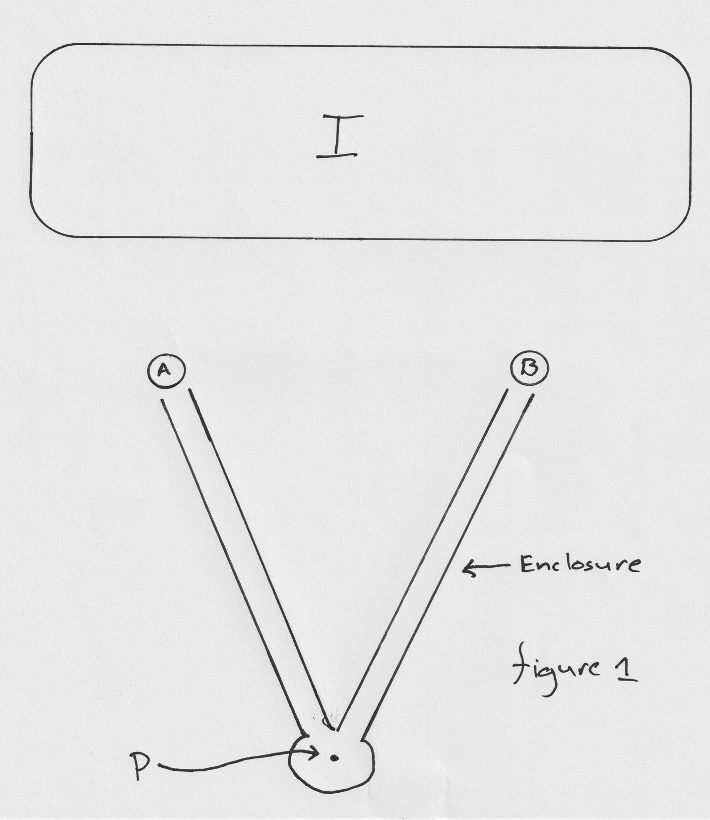

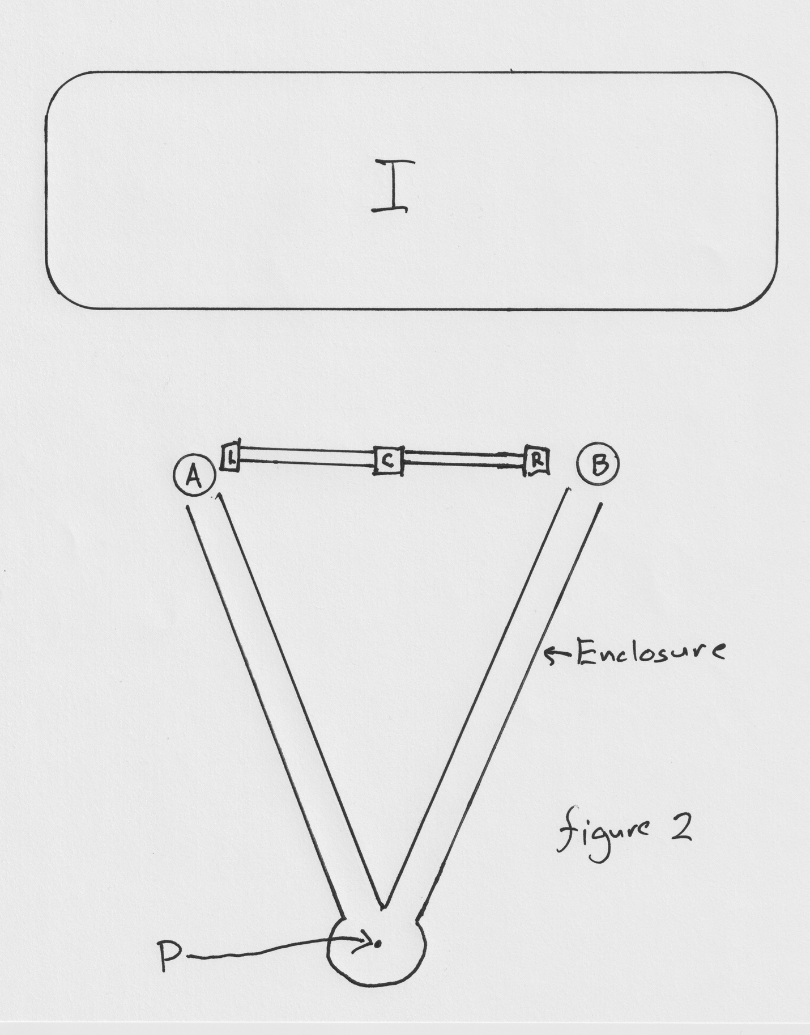

1. For Professor Barandes’ *own* presentation of his theory, see (for example) J. A. Barandes. “The Stochastic-Quantum Correspondence”, 2023. URL: https://arxiv.org/abs/2302. 10778, arXiv:2302.10778.
2. My remarks in these notes will be confined to the case of non-relativistic first-quantized theories – but I suspect that they will translate pretty straightforwardly to relativistic and field-theoretic versions of Jacob’s picture as well.
3. Note that this process of “collection” can never be more than *more or less* complete. In other words: the wave-function of the pointer particle will always have *tails*. And this will be turn out to be important to the discussion that follows.
4. Throughout this discussion, we will be treating these boxes, and tubes, and their various “openings” and “closings” as time-dependent *external potentials*. The only *dynamical degrees of freedom* in this story are the positions of the two particles.
5. This “for all practical purposes” alludes to the matter discussed in footnote 2. So long there is *any overlap at all* between the branch of the pointer-particle wave-function that is headed towards the *left* and the branch of the pointer-particle wave-function that is headed towards the *right* – for example – the one-step calculation is going to give us tiny traces of the original two-slit interference-pattern in region I, and the two-step calculation is going to give us no such traces at all. But if the pointer-particle is, for all practical purposes, a reliable indicator of the position of the original particle at t1 – or (rather) *to the extent* that the pointer-particle is, for all practical purposes, a reliable indicator of the position of the original particle at t1 – these differences will amount, for all practical purposes, to nothing. Of course, it is a fundamental principle of Jacob’s theory that the calculation that is *strictly correct* is always the *one-step* calculation.
6. Jacob has mentioned to me in conversation that his theory, as it stands at present, only has a lattice formulation. I suspect – but I am not sure – that his reasons for saying that must have to do with precisely this δ-function issue, or (rather) with whatever *analogue* of this issue arises in *Jacob’s* formulation of his theory.
7. Why not just stipulate that from the initial time onward, the wave-function of the world determines the velocity of the configuration-point of the world by way of the Bohmain-Mechanical Guidance condition? Because that would give us a *completely deterministic* theory - a theory (that is) in which the entire history of the world is uniquely picked out by its initial configuration. And the thought is that a theory like that will describe a world in which the probabilities that are the distinctive empirical signature of quantum mechanics are simply never going to *show up*.
8. This, in light of the conclusions of section 5 of these notes, needs to be said with some care. The theory we are talking about here is going to need to be a theory on which there *are* such things as “experiments” and “outcomes”. The theory we are talking about here is (in other words) going to need to be one of the *dynamical completions* of Jacob’s theory – *any* of the dynamical completions of Jacob’s theory – that (unlike the “minimal completion” that I discussed in section 5) actually accommodate the *existence* of “experiments” and “outcomes”.
9. Jacob Barandes, “New Prospects for a Causally Local Formulation of Quantum Theory” arXiv:2402.16935
10. Jacob goes on to say that “At an even deeper level, the EPR argument depended on an *interventionist conception of causal influences*, in which causal influences are supposed to be explicated in terms of abstract *agents* carrying out formal *interventions* on one set of variables that then imply changes in another set of variables.” And I can make no sense of this either. The EPR argument works perfectly well if we understand their notion of “causal influences” in terms of (say) simple counterfactual dependence – with no mention of “abstract agents” or “interventions” or what have you.
11. Jacob has remarked to me, in conversation, that – on *his* conception of “locality” – the question of whether or not Bohmian Mechanics is local is simply not *well posed*. That sounds really bad. If Bohmian Mechanics isn’t clearly and unambiguously non-local, then I don’t know what *is*.