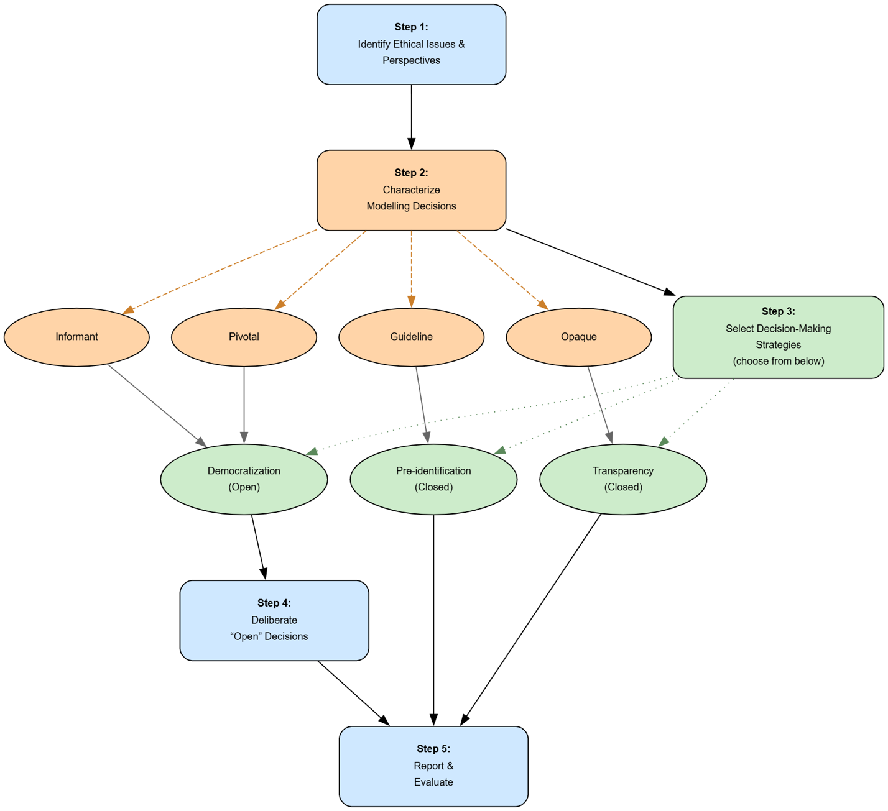
Figure 1. Values in Modelling Framework Process Overview

