Supp. Mat. 1: Table 1. LEAP project meeting timeline and attendance notes
Meeting | Date(s) | Attendance notes (Initials indicate team member—see * for name & role)
Project kick-off: preparatory materials and workplan review, open discussion | September 15, 2023 | AA, IJ, KJ, MR, RC, SCH, SH, SHC, TL, ZZ present
Characterization of modelling decisions and selection of decision-making strategies | Various (2023) | SH, KJ, EW
Team deliberation: ethical significance of decision-making in modelling HEPA filters | February 21, 2024 | AA, MR, SH, TL, ZZ present—meeting recording circulated for asynchronous viewing
Team deliberation: modelling future wildfire | March 8, 2024 | AA, IJ, RC, SCH, SH, TL present—meeting recording circulated for asynchronous viewing
Team deliberation: modelling PM2.5 impact on asthma outcomes | December 6, 2024 | CN, KJ, ME, RC, SH, SHC, SL, TL present—meeting recording circulated for asynchronous viewing
Team deliberation: modelling PM2.5 impact on asthma outcomes | January 15, 2025 | KJ, RC, SH, TL, ZZ present—meeting recording circulated for asynchronous viewing
Team deliberation: modelling future wildfire PM2.5 impact on asthma outcomes | March 24, 2025 | CN, KJ, ME, RC, SH, SHC, SL, TL, ZZ present—meeting recording circulated for asynchronous viewing

*AA: Amin Adibi, LEAP project senior modeller; IJ: Isha Joshi, Legacy for Airway Health (LAH) Community Partner Committee (CPC) manager; Kate Johnson, LEAP project Principal Investigator; Megan Rousthorne, government knowledge user; Rachel Carter, LAH CPC member; Mark Ewert, LEAP project modeller/trainee; Sian Hoe Chong, LAH CPC member; Stephanie Harvard, LAH Senior Scientist/meeting facilitator; Tony Lanier, LAH CPC member; Spencer Lee, LEAP project modeller/trainee; Cristina Novakovic, LEAP project modeller/trainee; Eric Winsberg, Professor of philosophy of science/climate modelling ethics; Zainab Zeyan, LAH CPC member. See Author list and Acknowledgements for detailed affiliations.

Supp. Mat. 2: Table 1. KJ’s considerations when selecting a CRF
Study Setting | LEAP is a Canadian model. Average PM2.5 concentrations vary between countries (e.g. densely populated Asian cities are more polluted than rural BC). Because the CRF is likely not linear, the impact of the same incremental change in PM2.5 concentration will be different depending on average PM2.5. Therefore, Canadian studies are strongly preferred.
Study Population | LEAP simulates asthma in the general population, therefore studies sampling from the general asthma population are preferred over narrow patient subgroups.
PM2.5 Measurement | There are many different ways to measure PM2.5; e.g. indoor vs. outdoor concentrations, remote monitoring vs. integrating other sources such as satellite data, differences in models etc. LEAP uses historical PM2.5 concentrations from a model called CanOSSEM (developed by the BCCDC). Studies using the same PM2.5 data source (CanOSSEM) are strongly preferred.
Asthma Control Measurement | LEAP measures asthma control as well controlled, partly controlled and not well controlled, which is based on a symptom score (determined by daytime symptoms, night wakings, use of reliever medication, activity limitation). This measurement method is somewhat transferable to other patient-reported symptom scores such as the asthma control test but may not be transferable to non-standardized ways of measuring asthma control. Studies using a standardized method measuring asthma control are strongly preferred.
Asthma Exacerbation Measurement | LEAP measures asthma exacerbations as mild (increase in the intensity of symptoms, without patients seeking care), moderate (managed on an outpatient basis with prescriptions of oral corticosteroids), severe (emergency department visit) or very severe (hospitalization). While some proxies may be acceptable (such as outpatient visits without measuring oral corticosteroids prescriptions), identical exacerbation definitions are preferred.
Time Period | Whenever possible, more recent studies are preferred. On average, PM2.5 concentrations have increased over time as wildfires become more frequent and intense, meaning that data from decades ago may no longer be applicable. In addition, PM2.5 concentration is measured monthly in LEAP. PM2.5 measurement periods of 1 month or greater are preferred to shorter term measurements (such as days or weeks), as this may overestimate PM2.5 effect on monthly outcomes.
Statistical Considerations | Larger sample sizes are preferred, as are exposure models that adjust for other pollutants.
Special Considerations | Studies conducted by members of our group should be used whenever possible for project management reasons.

Supp. Mat. 2: Table 2. Pros and cons of selected and non-selected studies identified through literature review
Outcome | Author & Year | Pros/Cons
Selected Studies
Asthma Control | Yao et al. 2016 | Pros:  - BC setting, general asthma population (all ages)  - PM2.5 measurement model is a precursor to CanOSSEM model used in LEAP & previously published CEA by our group  Cons:  - Older study period (2003-2010)  - Salbutamol dispensations is used as a proxy for asthma control
Moderate Exacerbations | Yao et al. 2016 | Pros:  - BC setting, general asthma population (all ages)  - PM2.5 measurement model is a precursor to CanOSSEM model used in LEAP & previously published CEA by our group  Cons:  - Older study period (2003-2010)  - Only asthma-related physician visits are measured (without measuring subsequent oral corticosteroid use)
Severe to Very Severe Exacerbations | Agache et al. 2024 | Pros:  - Extremely large (148 studies) and recent meta-analysis  - Broad geographic coverage: Europe (26%), China (22%), USA (20%)  - Many different asthma populations and PM2.5 measurement methods  - Definitions of exacerbations match those used in LEAP  Cons:  - Will require choosing a lagged effect for input into LEAP. Lag is defined as the difference in days between the exposure to PM2.5 and the exacerbation
Asthma Incidence (<18 years) | Khreis et al. 2017 | Pros:  - Fairly large (10 studies), fairly recent meta-analysis  - Broad geographic coverage (mostly Europe and North America)  - Diverse asthma population and PM2.5 measurements  - Different CRFs for 3-6 years and 7-18 years.  Cons:  - Some lack of equivalence among the exposure measures, populations and asthma definitions.
Asthma Incidence (>18 years) | Lee et al. 2025 | Pros:  - Fairly large (18 studies), very recent meta-analysis  - Broad geographic coverage (mostly Europe and North America) diverse asthma population and PM2.5 measurements.  - Study conducted by a member of our group  Cons:  - There were a lot of differences in CRFs between studies, some due to explained differences such as average PM2.5 concentration, but most differences were unexplained.
Non-Selected Studies
Asthma Control  (All ages) | Meng et al. 2010 | Pros:  - Large sample size of all ages  - Subgroup analysis for adults and children  Cons:  - Control categories should be modelled using GINA criteria  - Cross sectional  - Data is 20+ years old
Asthma Control  (>18 years) | Lin et al. 2024 | Pros:  - Large sample size  - ACT can be converted to GINA categories  Cons:  - Cross-sectional  - Higher baseline [PM2.5] than CA  - Older patient population (40+ years)
 | Kang et al. 2023 | Pros:  - ACT can be converted to GINA cat.  - Use of indoor and outdoor pollutant concentrations  Cons:  - SEs are large because of small sample size
 | Hussain et al. 2019 | Pros:  - ACQ can be converted to GINA cat.  Cons:  - Limited applicability to general asthma population  - Small sample size
Asthma Control (<18 years) | Hansel et al. 2019 | Pros:  - Multi-pollutant exposure is an advantage  - ACT can be converted to GINA cat.  Cons:  - Higher baseline PM2.5 concentration in Peru
 | Li et al. 2019 | Pros:  - Multi-pollutant exposure is an advantage  - ACCI can be converted to GINA cat.  Cons:  - Short term PM2.5 measurement (7 days) vs monthly measurement in LEAP
 | Zora et al. 2013 | Pros:  - ACQ can be converted to GINA cat.  Cons:  - Very short term PM2.5 exposure  - Small sample size
Asthma Control (Salbutamol) | Elliott et al. (2013) | Pros:  - BC study setting  - Covers significant portion of province  Cons:  - Salbutamol dispensations as a proxy for asthma control  - Single monitor per Local Health Area (LHA), some of which cover a large geographic area
 | Yao et al. (2013) | Pros:  - BC study setting  Cons:  - Salbutamol dispensations as a proxy for asthma control  - Single monitor per Local Health Area (LHA), some of which cover a large geographic area  - Unclear coverage of province/LHAs
Asthma Exacerbation | Huang et al. 2022 | Pros:  - Large (84 studies) and recent meta-analysis  - Includes all levels of exacerbations  Cons:  - High heterogeneity of RRs  - RRs are smaller than the chosen study
 | Fan et al. 2016 | Cons:  - Small sample of studies  - Only looked at severe exacerbations  - Not clear on what constitutes short-term exposure
 | Zheng et al. 2015 | Pros:  - Sub-analysis of children  Cons:  - Combined severe/very severe exacerbations into one  - Old compared to other studies identified

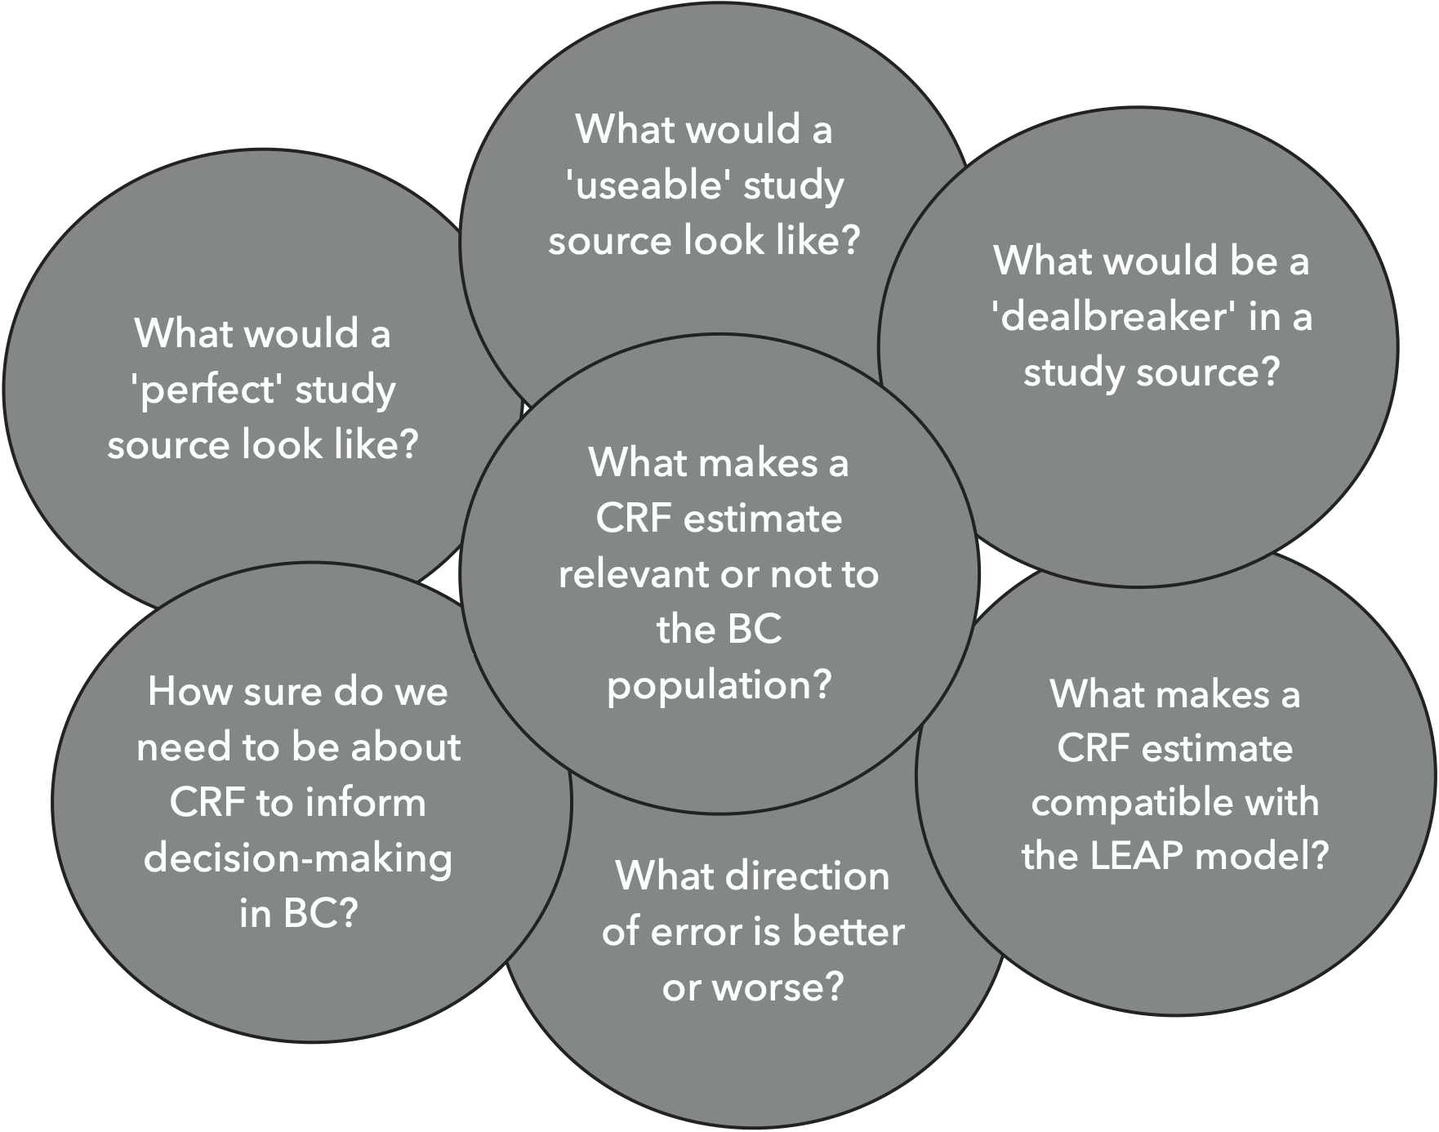
Figure 2. LEAP Team Discussion Questions: Concentration Response Functions

Supp Mat 3. Table 1. Patient Engagement in Research Scale (PEIRS-22) Summary Scores.
Patient Partner | PEIRS-22 Score | Procedural Requirements (PN) | Convenience (CN) | Contributions (CT) | Team Environment & Interaction (T) | Support (SU) | Feel Valued (FV) | Benefits (BE)
# of questions | 22 | 7 | 3 | 3 | 2 | 2 | 2 | 3
1 | 100.0 | 100.0 | 100.0 | 100.0 | 100.0 | 100.0 | 100.0 | 100.0
2 | 97.7 | 96.4 | 100.0 | 100.0 | 100.0 | 100.0 | 100.0 | 91.7
3 | 96.6 | 100.0 | 91.7 | 100.0 | 100.0 | 100.0 | 75.0 | 100.0
4 | 77.3 | 92.9 | 75.0 | 83.3 | 62.5 | 62.5 | 75.0 | 58.3

LEAP Patient partners’ degrees of meaningful engagement and areas of low meaningful engagement captured using PEIRS-22. Meaningfulness thresholds are: Extremely Meaningful (green) with scores in [92.0, 100], Very Meaningful (yellow) with scores in [82.7, 89.9], Moderately Meaningful (blue) with scores in [70.1, 82.6], and Low Meaningfulness (red) with scores in [0, 70.0]. Subdomain scores were scaled to a 0–100 range to allow direct comparison across subdomains of varying numbers of questions and interpreted using the same PEIRS-22 thresholds for meaningfulness (original subdomain scores are reported in Supp. Mat 2 alongside the PEIRS-22 instrument). While most partners reported high overall engagement, the lowest subdomain scores averaged across partners were observed in Feel Valued (FV) and Benefits (BE). Specifically, question FV3 “I was offered sufficient recognition for my contributions (for example, payment, authorship, or gifts” and question BE2 “I made an impact on the decisions in the project” had the lowest average scores across all questions. (Note: Original raw score values were captured at a reverse scale of "Strongly Agree"=1 to "Strongly Disagree"=5, so scale was corrected to have "Strongly Disagree"=0 to "Strongly Agree"=4.)

Supp. Mat. 3. Table 2 PEIRS Scale Original Subdomain Scores

Participator | Total PEIRS-22 Score* | Procedural Requirements (PN) Max Score is 28.0 and Cutoff is 22.3 | Convenience (CN)  Max Score is 12.0 and Cutoff is 9.6 | Contributions (CT)  Max Score is 12.0 and Cutoff is 9.6 | Team Environment & Interaction (T)  Max Score is 9.0 and Cutoff is 6.4 | Support (SU)  Max Score is 9.0 and Cutoff is 6.4 | Feel Valued (FV)  Max Score is 9.0 and Cutoff is 6.4 | Benefits (BE) Max Score is 12.0 and Cutoff is 9.6
1 | 100 | 28.0 | 12.0 | 12.0 | 8.0 | 8.0 | 8.0 | 12.0
2 | 97.7 | 27.0 | 12.0 | 12.0 | 8.0 | 8.0 | 8.0 | 11.0
3 | 96.6 | 28.0 | 11.0 | 12.0 | 8.0 | 8.0 | 6.0 | 12.0
4 | 77.3 | 26.0 | 9.0 | 10.0 | 5.0 | 5.0 | 6.0 | 7.0
*Total PEIRS scores correspond to “Degrees of Meaningfulness” (i.e., of engagement) as follows: 92- 100 “Extremely”; 87.2- <92 “Very”; 70.1-<87.2 “Moderately”; <70 “Low”. The term “Cutoff” as applied to subdomain scores refers to the score below which the meaningfulness of engagement in that subdomain is considered “Low”. “Low” subdomain scores are highlighted in red. Note: Original raw score values were captured at a reverse scale of "Strongly Agree"=1 to "Strongly Disagree"=5, so scale was corrected to have "Strongly Disagree"=0 to "Strongly Agree

Patient Engagement In Research Scale – PEIRS-22
Name:
Date:
Your project’s name:

INSTRUCTIONS: Thinking about your experience as a patient partner in the project, please respond to the statements by choosing only one box for each statement. If you are unsure about which option to choose for a statement, please give the best response you can. This questionnaire may take you about 3 to 7 minutes to complete.

Procedural Requirements
The following seven (7) statements are about your general experiences throughout the project.
PR2. | The research team members were properly introduced to each other
 |  | Strongly Agree  ☐ | Agree  ☐ | Neutral  ☐ | Disagree  ☐ | Strongly Disagree  ☐

PR9. | In general, I had sufficient opportunities to contribute to the project
 |  | Strongly Agree  ☐ | Agree  ☐ | Neutral  ☐ | Disagree  ☐ | Strongly Disagree  ☐

PR10. | I was able to perform my tasks for the project
 |  | Strongly Agree  ☐ | Agree  ☐ | Neutral  ☐ | Disagree  ☐ | Strongly Disagree  ☐

PR11. | I participated in making decisions about the project
 |  | Strongly Agree  ☐ | Agree  ☐ | Neutral  ☐ | Disagree  ☐ | Strongly Disagree  ☐

PR12. | I received sufficient updates about the project
 |  | Strongly Agree  ☐ | Agree  ☐ | Neutral  ☐ | Disagree  ☐ | Strongly Disagree  ☐

PR13. | Communication within the research team was clear throughout the project
 |  | Strongly Agree  ☐ | Agree  ☐ | Neutral  ☐ | Disagree  ☐ | Strongly Disagree  ☐

PR14. | The project was worth the time I spent on it
 |  | Strongly Agree  ☐ | Agree  ☐ | Neutral  ☐ | Disagree  ☐ | Strongly Disagree  ☐

Convenience
The following three (3) statements are about how convenient it was for you to contribute throughout the project.
CN1. | I had the opportunity to provide input into selecting my tasks for the project
 |  | Strongly Agree  ☐ | Agree  ☐ | Neutral  ☐ | Disagree  ☐ | Strongly Disagree  ☐

CN3. | Throughout the project, I had sufficient time to complete my tasks for the project
 |  | Strongly Agree  ☐ | Agree  ☐ | Neutral  ☐ | Disagree  ☐ | Strongly Disagree  ☐

CN4. | I had opportunities to express my views
 |  | Strongly Agree  ☐ | Agree  ☐ | Neutral  ☐ | Disagree  ☐ | Strongly Disagree  ☐

Contributions
The following three (3) statements are about your contributions throughout the project.
CT1. | I contributed by providing my perspective
 |  | Strongly Agree  ☐ | Agree  ☐ | Neutral  ☐ | Disagree  ☐ | Strongly Disagree  ☐

CT2. | My contributions were a good use of my time
 |  | Strongly Agree  ☐ | Agree  ☐ | Neutral  ☐ | Disagree  ☐ | Strongly Disagree  ☐

CT4. | My workload in the project was manageable
 |  | Strongly Agree  ☐ | Agree  ☐ | Neutral  ☐ | Disagree  ☐ | Strongly Disagree  ☐
Team Environment and Interaction
The following two (2) statements are about the research environment and interaction throughout the project.
T2. | I was an equal partner in the research project team
 |  | Strongly Agree  ☐ | Agree  ☐ | Neutral  ☐ | Disagree  ☐ | Strongly Disagree  ☐

T5. | There was trust among the research project team members
 |  | Strongly Agree  ☐ | Agree  ☐ | Neutral  ☐ | Disagree  ☐ | Strongly Disagree  ☐

Support
The following two (2) statements are about the support provided throughout the project.
SU1. | I received sufficient support to contribute to the project (for example, orientation, readings, training workshops, webinars)
 |  | Strongly Agree  ☐ | Agree  ☐ | Neutral  ☐ | Disagree  ☐ | Strongly Disagree  ☐

SU2. | Any concerns I had were addressed
 |  | Strongly Agree  ☐ | Agree  ☐ | Neutral  ☐ | Disagree  ☐ | Strongly Disagree  ☐

Feel Valued
The following two (2) statements are about your feeling of being a valued member of the research team.
FV1. | The research project team appreciated my contributions
 |  | Strongly Agree  ☐ | Agree  ☐ | Neutral  ☐ | Disagree  ☐ | Strongly Disagree  ☐

FV3. | I was offered sufficient recognition for my contributions (for example, payment, authorship, or gifts)
 |  | Strongly Agree  ☐ | Agree  ☐ | Neutral  ☐ | Disagree  ☐ | Strongly Disagree  ☐

Benefits
The following three (3) statements are about the benefits of your involvement in the project.
BE1. | I enjoyed being a part of the project
 |  | Strongly Agree  ☐ | Agree  ☐ | Neutral  ☐ | Disagree  ☐ | Strongly Disagree  ☐

BE2. | I made an impact on the decisions in the project
 |  | Strongly Agree  ☐ | Agree  ☐ | Neutral  ☐ | Disagree  ☐ | Strongly Disagree  ☐

BE4. | My involvement had positive impacts on my life
 |  | Strongly Agree  ☐ | Agree  ☐ | Neutral  ☐ | Disagree  ☐ | Strongly Disagree  ☐

