Presented at Biological Explanations of Behavior, Hannover, Germany, 14 June 2008
DRAFT; DO NOT CITE WITHOUT AUTHOR’S PERMISSION

Difference Mechanisms
James Tabery, University of Utah
______________________________________________________________________________
In recent years, philosophers of science have found a renewed interest in mechanisms. The motivation is the thought that the elucidation of a mechanism generates a causal explanation for the phenomenon under investigation. For example, a question such as, How do rats form spatial memories of their environments?, is answered by elucidating the regular causal mechanisms responsible for the individual development of spatial memory in rats. But consider a slightly different question: How do some rats come to have better spatial memory than other rats? This is a question about the causes of variation responsible for variation in spatial memory. The first question demands an answer about regularity; the second question demands an answer about variation. The account of causal-mechanical explanation on offer by philosophers of science captures regularity, but it neglects variation. In this essay, I attempt to modify the mechanical program so as to incorporate both regularity and variation. The task is to explicate the relationship between the regular causal mechanisms responsible for individual development and the causes of variation responsible for variation in populations. As it turns out, this is precisely the relationship that has divided the biometric research tradition and the developmental research tradition in the long-standing debates over genotype-environment interaction, or G×E. Ultimately, the product will be an account of causal-mechanical explanation that captures both regularity and variation, and which may be utilized to resolve an aspect of the debates over G×E. ______________________________________________________________________________

Word Count: 9,200

1. Introduction. In recent years, philosophers of science have found a renewed interest in mechanisms. Unsatisfied with traditional law-based accounts of explanation which do not capture the nature of explanation in special sciences such as biology, philosophers have turned to mechanisms as an alternative. The motivation is the thought that the elucidation of a mechanism generates a causal explanation for the phenomenon under investigation (Bechtel and Richardson 1993; Glennan 2002; Little 1990; Machamer, Darden, and Craver 2000; Schaffner 1993; Woodward 2002). There are differences between the various accounts of a mechanism. But the accounts hold in common the basic idea that a scientist provides a successful causal explanation by identifying and manipulating variables in a regular causal mechanism thereby determining how those variables are situated in and make a difference in the mechanism; the ultimate explanation then amounts to the elucidation of how those variables act and interact to produce the phenomenon under investigation. The accounts are meant to explain how scientists answer questions such as the following: How are neural messages relayed across a synapse (Machamer, Darden, and Craver 2000)? How do immune systems identify and attack antigens (Schaffner 1993)? How do plants convert solar energy into chemical energy (Tabery 2004)? How does a cell supply the substances needed to fuel the Krebs cycle (Bechtel and Abrahamsen 2005)? Or, how do rats come to form spatial memories of their environments (Craver and Darden 2001)? The thought is that such questions are answered by elucidating the regular causal mechanisms responsible for synapse transmission, immunologic response, photosynthesis, glycolysis, or the formation of spatial memory. To take just one example (see Figure 1), Carl Craver and Lindley Darden show how scientists provide an explanation for the phenomenon of spatial memory by elucidating the various entities and activities involved in regular causal mechanisms at the molecular, cellular, brain-system, and organismal levels that produce spatial memory in rats (Craver and Darden 2001).
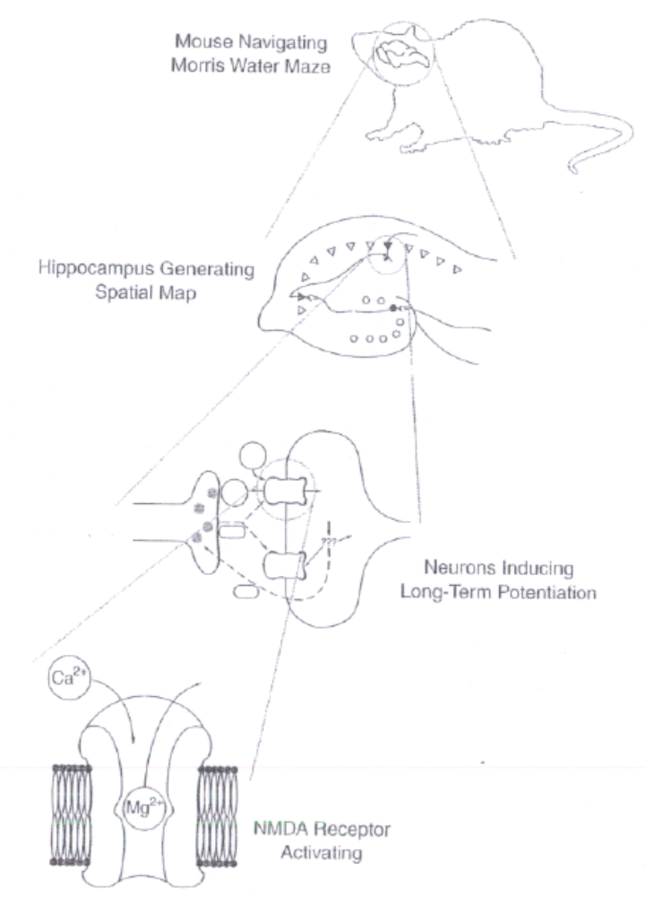
Figure 1. Molecular, cellular, brain-system, and organismal mechanisms involved in the production of spatial memory in rats. From Craver and Darden (2001, 6.4).

But consider a slightly different question: How do some rats come to have better spatial memory than other rats? One common way to test spatial memory in rats is to place them in a Hebb-Williams maze test (Figure 2); rats start at one corner and attempt to navigate to a food source at the other end (Hebb and Williams 1946). The rats are scored for how many “errors” they make, which occur when the rats deviate from the correct path by crossing one of the dotted lines. Not surprisingly, there is quite a bit of variation in how well different rats do in these maze tests; that is, some rats develop better spatial memory than other rats (Cooper and Zubek 1958).
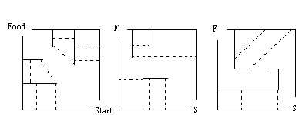

Figure2. Sample Hebb-Williams maze test configurations.

The question that Craver and Darden (2001) consider involves an investigation into the regular causal mechanisms responsible for the individual development of spatial memory. It is about spatial memory in the average rat, or what one might think of as spatial memory in the Platonic form of the rat. The second question involves an investigation into the causes of variation responsible for population-level variation in spatial memory. It is about spatial memory in the distribution of rat populations, or what one might think of as spatial memory in the messy world of actual rats. The first question demands and answer about regularity. The second question demands an answer about variation. In focusing only on the first question, philosophers of science have thus far confined themselves to providing an account of causal-mechanical explanation that captures regularity. But what about variation?
When you think about it, it is actually quite striking that the philosophers of science who turned to mechanisms left out variation. Variety is the spice of life, and variation is the space of natural selection. In contrast to a physicist who is generally safe assuming that an electron, is an electron, is an electron, a biologist is often interested in precisely what makes one species different from another, one population different from another, or one individual different from another because it is the difference that provides for the variation. Philosophers of science, remember, have turned to mechanisms out of a dissatisfaction with the accounts of scientific explanation that were forged in physics and do not apply to biology. And yet, one of the core features of the biological world—variation—is lacking from this mechanical program.
The purpose of this essay is to modify the mechanical program in order to capture this essential element of biological explanation. The task, then, is to determine what the relationship is between, on the one hand, regular causal mechanisms responsible for individual development and, on the other hand, causes of variation responsible for variation in populations.
As it turns out, formulating this relationship is not simply an exercise for the armchair philosopher. For it is precisely this relationship that resides at the heart of the nature-nurture debate. How do scientists successfully investigate the etiology of complex traits, such as spatial memory or major depressive disorder? The answer, it turns out, is hotly disputed. On the one hand (see Table 1), an early twentieth century population geneticist such as R. A. Fisher, a mid-twentieth century agricultural geneticist such as Jay Lush, or a contemporary quantitative behavioral geneticist such as Robert Plomin employ statistical methodologies in order to answer how-much? questions about the causes of variation responsible for variation in phenotypic traits (Fisher 1918; Lush 1939; Plomin 1990). This research tradition, devoted to partitioning the relative contributions of genotype and environment, may be referred to as the biometric research tradition in biology (Tabery Forthcoming). On the other hand (see Table 1), an early twentieth century experimental embryologist such as Lancelot Hogben, a mid-twentieth century developmental geneticist such as Conrad Hal Waddington, or a contemporary developmental psychobiologist such as Gilbert Gottlieb employ interventionist methodologies in order to answer how? questions about the regular causal mechanisms responsible for the individual development of phenotypic traits (Hogben 1933; Waddington 1957; Gottlieb 2002). This research tradition, devoted to determining the way in which developmental combinations of genotype and environment contribute to variation, may be referred to as the developmental research tradition in biology (Tabery Forthcoming).

Components | Biometric Tradition | Developmental Tradition
Problem | Individual Differences | Variation in Populations
Approach to Causation | Causes of Variation | Causal Mechanisms
Causal Question | How Much? | How?
Methodology | Statistical | Interventionist

Table 1. The components of the biometric and developmental research traditions.

Over the course of the nature-nurture debate, members from these research traditions have disputed the relative merits of each approach. Often, these disputes have revolved around genotype-environment interaction, or G×E. The concept of G×E refers to cases in which different genetic groups respond differently to the same array of environments. While members of the developmental tradition point to G×E as being of fundamental importance for understanding variation, members of the biometric tradition have generally dismissed G×E as being little more than a potential nuisance. These differing interpretations arise from the fact that members of the developmental tradition identify G×E as shedding light on the relationship between individual development and variation, while members of the biometric tradition argue that G×E has nothing to do with individual development. In the face of this debate, which has raged now for nearly a century, a form of isolationist pluralism has emerged, wherein disputants from both sides have attempted to calm the storm by suggesting that these two traditions simply operate at different levels of analysis. The biometrically-oriented biologists investigate the causes of variation responsible for population-level variation, and the developmentally-oriented biologists investigate the causal mechanisms responsible for individual development…and ne’er the twain shall meet (Tabery 2007). In this essay, I want to challenge this isolationist pluralism with an integrative alternative. In so doing, I will use this as a case to develop the relationship between the regular causal mechanisms responsible for individual development and the causes of variation responsible for variation in populations, thereby generating the modified account of causal-mechanical explanation that captures both regularity and variation.
The thesis defended here will be the following: The biometric research tradition and the developmental research tradition may be united based upon a shared problem—the elucidation of what I will call difference mechanisms. Differences mechanisms are regular causal mechanisms made up of difference-making variables that take different values in the natural world. I will attempt this unpacking by drawing on and extending the idea of understanding causes as difference-makers, which has been developed by several philosophers in recent years (Lewis 1973; Sterelny and Kitcher 1988; Waters 1994, Forthcoming; Woodward 2003). The relationships, then, will look like this: Variation is the effect of difference-makers in development that take different values in the natural world; the difference-making variables in the regular causal mechanisms responsible for individual development simultaneously are the causes of variation when the difference-making variables naturally take different values. Finally, I will take this general framework and apply it to the debate over G×E, arguing that G×E results from the interdependence of difference-makers in development that take different values in the natural world. Ultimately, then, the product will be a modified account of causal-mechanical explanation that captures both regularity and variation, and which may be utilized to resolve an aspect of the debates over G×E.

2. The Case of Genotype-Environment Interaction. It is a truism that genes and the environment interact during the course of individual development. Scientists in the biometric tradition such as quantitative behavioral geneticists, however, traditionally ask questions about how much causes of variation are responsible for variation in populations. For example, authors of the popular Behavioral Genetics textbook write, “For the complex traits that interest psychologists, it is possible to ask not only whether genetic influence is important but also how much genetics contributes to the trait. … The question about how much genetics contributes to a trait refers to effect size, the extent to which individual differences for the trait in the population can be accounted for by genetic differences among individuals.” (Plomin et al. 1997, 77-78)
The standard methodology for investigating variation is the statistical analysis of variance (ANOVA). In its simplest form, ANOVA partitions total phenotypic variation (V_{P}) into a source attributable to genetic variation (V_{G}) and a source attributable to environmental variation (V_{E}):
V_{P} = V_{G} + V_{E} (1)
In this simplest of cases, the two sources of variation are additive, meaning that V_{G} and V_{E} (the “main effects”) together fully account for V_{P}. When this simple case applies, we can also then talk about the proportion of the total variation attributable to genetic or environmental differences; for example, the proportion of genetic variation is referred to as the broad heritability (h²) of a trait, calculated as:
h² = V_{G}/V_{P} (2)
However, when different genetic groups respond differently to the same array of environments, the additivity between V_{G} and V_{E} breaks down, requiring an addition to the equation in the form of G×E. G×E creates a potential problem for biometricians because it generates its own variation (V_{G×E}), breaking down the additivity in Equation (1), forcing a modification to Equation (3), and also eliminating the ability to calculate the heritability of a trait.
V_{P} = V_{G} + V_{E} + V_{G×E} (3)
The additive and non-additive situations in Equations (1) and (3) may also be contrasted by considering reaction norm graphs, such as those in Figures 3(A) and 3(B). Three genetic groups are represented in the graphs, each with its own reaction norm. The three groups are differentiated based on the particular variant of the promoter region in the serotonin transporter gene (5-HTT) carried (s/s vs. s/l vs. l/l) and measured for a particular trait (probability of a major depression episode, y-axis) across an array of environments (number of stressful life events experienced, x-axis). The “s” stands for a short form of the promoter region in the gene, while the “l” stands for a long form of the promoter region. Individuals receive either an s or an l from each of their parents, and the short promoter region generates relatively less serotonin binding than the long promoter region. When V_{G} and V_{E} are additive, then the reaction norms will be parallel as they are in the hypothetical example found in Figure 3(A). But when V_{G} and V_{E} are not additive—when there is G×E—then the reaction norms will be non-parallel as they are in Figure 3(B) drawn from empirical data (Caspi et al. 2003).
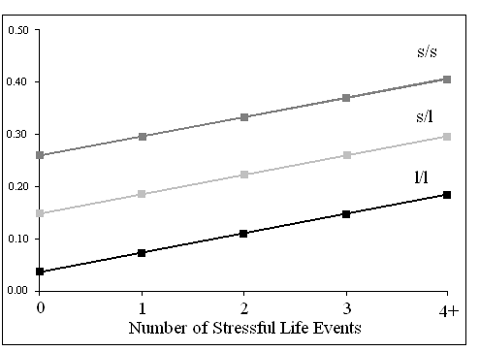A 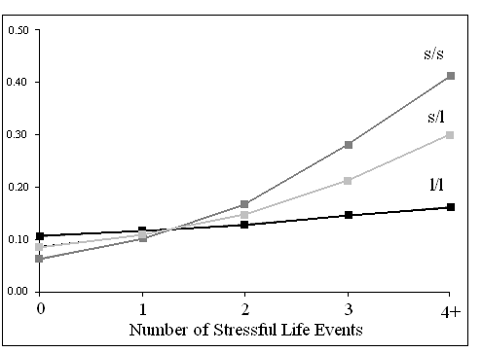B
Figure 3. Reaction norm graphs for s/s, s/l, and l/l groups measured for probability of a major depression episode (y-axis) across an array of environments (x-axis). (A) Hypothetically parallel reaction norms. (B) Non-parallel reaction norms drawn from empirical data (Caspi et al. 2003).

2.1. The Call for an Isolationist Pluralism. Notice that we have now introduced two notions of interaction: (a) the interaction between genes and the environment in the regular causal mechanisms responsible for individual development, and (b) the interaction between genetic and environmental causes of variation responsible for variation in a population. What does the former notion of interaction have to do with the latter? Scientists in the developmental tradition criticize scientists in the biometric tradition for their focus on main effects and their attempts to avoid the complications posed by G×E. More specifically, they understand G×E to somehow reflect the developmental relationship between genes and the environment, and so ANOVA’s trouble with G×E, they argue, is symptomatic of the biometricians’ more general trouble with elucidating the causal mechanisms of individual development. For example, David Layzer warns, “For complex animal characters there is little reason to expect additivity and independence to prevail. On the contrary, such characters usually reflect a complicated developmental process in which genetic and environmental factors are inextricably mingled.” (Layzer 1972, 275; see also Layzer 1974) And Richard Lewontin scolds, “…relations between genotype, environment, and phenotype are at base mechanical questions of enzyme activity, protein synthesis, developmental movements, and paths of nerve conduction…For these problems, statistical descriptions, especially one-dimensional descriptions like heritability, can only be poor, and, worse, misleading substitutes for pictures of the machinery.” (Feldman and Lewontin 1975, 1167-1168; see also Lewontin 1974) And Gilbert Gottlieb complains, “The population view of behavioral genetics is not developmental. It is based on the erroneous assumption that a quantitative analysis of the genetic and environmental contributions to individual differences sheds light on the developmental process of individuals.” (Gottlieb 2003, 338)
This critical analysis of the biometric tradition, and especially that formulated by Lewontin and Layzer, resonates in the philosophy of science. Philosophers including Block and Dworkin (1976), Block (1995) Downes (2004), Kaplan (2000), and Sarkar (1998) all reiterate Lewontin and Layzer’s criticisms of ANOVA, emphasizing the statistical methodology’s trouble with G×E along with its inability to elucidate the causal mechanisms of individual development.
Faced with such criticisms based on the importance of interaction, scientists in the biometric tradition naturally mount a defense. To do so, they draw a firm distinction between their focus on variation along with the statistical concept of G×E that applies to variation in populations, and the causal-mechanically-minded biologists’ focus on individual development along with their developmental notion of interaction (Tabery 2007). Robert Plomin, John DeFries, and John Loehlin, for instance, begin their assessment of G×E by complaining, “Unfortunately, discussions of genotype-environment interaction have often confused the population concept with that of individual development. It is important at the outset to distinguish genotype-environment interaction from what we shall call interactionism, the view that environmental and genetic threads in the fabric of behavior are so tightly interwoven that they are indistinguishable (Plomin, DeFries, and Loehlin 1977, 309). This distinction between the population-level concept of G×E and a purportedly muddle-headed “interactionism” is often deployed by defenders of ANOVA. Arthur Jensen utilizes the defense in an attempt to protect his employment of ANOVA and heritability estimates for attributing the gap in average IQ scores between black and white populations to genetic differences (Jensen 1969). So when critics such as Layzer and Lewontin appeal to the interaction between genes and the environment during the course of individual development, Jensen replies that “‘interactionism’ has become merely a substitute for extreme environmentalism. … This position has arisen from a failure to understand the real meaning of the term ‘interaction’ as it is used in population genetics; but even more it is the result of failure to distinguish between (a) the development of the individual organism, on the one hand, and (b) differences among individuals in the population.” (Jensen 1973, 49)
This distinction between statistical interaction and a muddle-headed interactionism is often framed in terms of a difference in levels of analysis. For instance, Thomas Bouchard and Nancy Segal complain, “It is common for theorists of the heredity × environment controversy to confuse the statistical concept of interaction with a viewpoint called interactionism. The problem arises because each concept applies at a different level of analysis.” (Bouchard and Segal 1985, 393) The distinction between interaction and interactionism conjoined with this notion of different levels of analysis now also penetrates the philosophy of science. Neven Sesardic (2005) also distinguishes two forms of interaction: commonsense interaction (interaction_{c}) and statistical interaction (interaction_{s}). “Interaction_{c} of genes and environments is always present but it generates no problems for the estimation of heritability,” Sesardic claims. “On the other hand, the existence of strong interaction_{s} between genes and environments may really undermine the usefulness of heritability claims, yet the existence of such interaction is itself an open empirical question. Briefly, interaction_{c} is ubiquitous but irrelevant for discussions about heritability, whereas strong interaction_{s} is potentially a problem for heritability, but the extent of its presence remains a contentious issue.” (Sesardic 2005, 49) So in response to Layzer, who criticizes Jensen for ignoring the complications posed by individual development, Sesardic counters, “Layzer’s argument (defended by many other authors) that complexities of developmental processes preclude the possibility of partitioning the phenotypic variation into genetic and environmental components seems to be the result of confusing different levels of analysis.” (Sesardic 2005, 73)

2.2. The Call for an Integrative Solution. In more recent years, however, scientists have begun calling for an integrative model, attempting to move beyond the isolationist model advocated for so many years (Caspi and Moffitt 2006; Kendler 2005; Rutter 2006). The proposal by Avshalom Caspi and Terrie Moffitt, in particular, is worth looking at in detail. It was their research that I utilized to construct the reaction norm graph for the 5-HTT gene, stressful life events, and depression in Figure 3B earlier. With the increasing attention given to their research on G×E, Caspi and Moffitt have recently recognized the usefulness of outlining for their readers the methodological and philosophical reasoning that guides them. To this end, Caspi and Moffitt (2006) develop a relationship between their statistical research on variation in depression and the scientists who study the underling mechanisms of depression. What, Caspi and Moffitt ask, is the relationship between the statisticians’ work and that of the causal-mechanically-minded scientists? The answer, they argue, is that both are working together towards developing a nomological network. “A nomological network refers to the interlocking system of laws—the predicted pattern of theoretical relationships—which define a construct.” (Caspi and Moffitt 2006, 587) The idea is that the theoretical relationships under investigation by members of both the biometric and developmental research traditions may unite under this interlocking system of laws in order to integrate the fields. It is an idea borrowed from Lee Cronbach and Paul Meehl (1955), who introduced the concept of a nomological network in order to address the problem of validation in psychological tests.
There are several reasons, however, to be skeptical of how well the concept of a nomological network will capture the relationship between the two research traditions. For starters, appeals to timeless, universal generalizations (i.e., laws of nature) in biology have received extensive criticism from philosophers (Beatty 1995; Brandon 1997; Mitchell 2003; Sober 1997). It is argued that generalizations in biology are only contingently true because of their reliance on the contingencies of evolution (Beatty 1995).
In addition to this point, there is also a problem with how well the concept of a nomological network is designed to address the problems faced by biologists investigating the etiology of complex traits. As mentioned above, Cronbach and Meehl (1955) developed the idea to address problems with the validation of psychological tests. They were wrestling with a standard problem in psychology: What are psychological tests measuring? That is, to what extent do the constructs of intelligence or personality tests accurately map onto real features of individuals, such as general intelligence or temperament? But the problem with which Caspi and Moffitt (2006) are struggling pertains not to construct validity; it pertains to the main question of this essay—What is the relationship between the regular causal mechanisms responsible for individual development and the causes of variation responsible for variation in populations? Thus, we should expect a solution to Caspi and Moffitt’s problem to reside in an account of this relationship rather than in the nomological network.
There is one more reason to be skeptical of how well the concept of a nomological network applies to the relationship between the statistical and the causal-mechanically-minded scientists. This has to do with the nomological network’s reliance on (in addition to laws) theories. Like laws of nature, the prevalence of theories (in the standard linguistic sense) in biology has come under increasing scrutiny. For rather than searching for theories and theoretical relationships, biologists more often search for mechanisms as a means of providing biological explanations (Craver 2001). And, in fact, when we turn to the work of Caspi and Moffitt along with the authors whom they cite as embodying the nomological network (Caspi and Moffitt 2006, 587), it is not the search for laws and theories that we find; it is the search for mechanisms:

We hope that the present article will encourage further collaboration between genetic epidemiology and experimental neuroscience in a joint effort to unravel the complex mechanisms that underlie gene-environment interactions (Caspi and Moffitt 2006, 587).

Identifying biological mechanisms through which genes lead to individual differences in emotional behavior is paramount to our understanding of how such differences confer risk for neuropsychiatric illness (Hariri and Holmes 2006, 182).

In the Caspi et al. (2003) study, the impact of the serotonin polymorphism was seen only in the context of the environmental stressors. A mechanistic study of this nature is now possible by, for example, pairing mice heterozygous for the serotonin transporter with a specific stress paradigm, such as maternal separation (Leonardo and Hen 2006, 132).

If the biometric and the developmental traditions cannot be integrated around their efforts to construct a nomological network, how can these traditions be integrated? The answer, I will now argue, comes from a shared problem—the elucidation of difference mechanisms.

3. Difference Mechanisms. Difference mechanisms are regular causal mechanisms made up of difference-making variables that take different values in the natural world. There is regularity in difference mechanisms; interventions made on variables in the mechanisms that change the values of the variables lead to different outcomes in the phenomena under investigation. There is also variation in difference mechanisms; interventions need not be undertaken to find differences in the outcomes because, with difference mechanisms, the variables already take different values in the natural world and so there already are differences in the outcomes. With difference mechanisms, nature is the interventionist.
This section is devoted to showing just how the causes of variation responsible for variation in populations and the regular causal mechanisms responsible for individual development are related. I first introduce the common philosophical idea of treating causes as difference-makers. Then, with that groundwork set, I expand on this notion by drawing attention to mechanisms where the difference-making variables naturally take different values. I will call these particular variables difference-makers in development that take different values in the natural world. It will be here that I provide the general framework for deriving the relationship between the various components of the biometric and the developmental research traditions. Finally, with that general framework in place, I return to the debate over G×E, arguing that G×E results from the interdependence of difference-makers in development that take different values in the natural world.

3.1. Causes as Difference-Makers. Philosophers have long conceived of causes as difference-makers. David Lewis, for instance, introduces his counterfactual theory of causation by explaining, “We think of a cause as something that makes a difference, and the difference it makes must be a difference from what would have happened without it.” (Lewis 1973, 557) Lewis, however, traces his idea to the second half of David Hume’s definition: “…we may define a cause to be an object, followed by another, and where all the objects, similar to the first, are followed by objects similar to the second. Or in other words, where, if the first object had not been, the second never had existed.” (Hume [1777] 1993, 51) The job for philosophers is explicating this idea of difference-maker; Lewis, for instance, attempts the explication with his theory of counterfactuals based on possible-world semantics.
A more recent explication of causes as difference-makers can be found in James Woodward’s (2003) manipulationist conception of causation and causal explanation. The basic idea for Woodward is that scientists causally explain when they know how to manipulate. Manipulations are understood counterfactually. If some particular variable is a cause of some outcome, then manipulating the value of the variable would be a way of manipulating the outcome. These counterfactual experiments formulate and then answer, as Woodward explains, what-if-things-had-been-different questions; and, in so doing, they establish a pattern of counterfactual dependence between the explanandum (the thing to be explained) and the explanans (the thing or things that do the explaining).
Counterfactual dependence, for Woodward, is understood with the closely related concepts of intervention and invariance. An intervention consists of an idealized experimental manipulation of the value of some variable, thereby determining if it results in a change in the value of the outcome. So the counterfactuals are formulated in such a way that they show how the value of the outcome would change under the interventions that change the value of a variable; that is, they are formulated to show how the difference-makers make their difference. Invariance, then, is a characterization of the relationship between variables (or a variable and an outcome) under interventions on Woodward’s account. When there is an invariant relationship between a variable and an outcome, then that relationship is potentially exploitable for manipulation, and because of this it is a causal relationship.
My appeal to difference makers is by no means unique in the philosophy of biology. Kim Sterelny and Philip Kitcher (1988) and, more recently, C. Kenneth Waters (1994, Forthcoming) also draw on the difference-maker concept to engage debates over causation among philosophers of biology. Sterelny and Kitcher (1988) and Waters (1994, Forthcoming) are primarily interested in debates revolving around the special causal status of genes in biological explanations. Genes, these authors argue, are special because of their unique difference-making status in the mechanisms being explained by biologists. As I will argue below, however, the difference-making status of genes is intimately connected to other difference-making variables in these mechanisms. The empirical research that points to this intimate connection suggests moving the philosophical discussion beyond individual difference-makers and to the more interactive notion of difference mechanisms.

3.2. Difference-Makers in Development that Take Different Values in the Natural World. If we understand causes to be difference-makers, then a relationship between the regular causal mechanisms responsible for individual development and the causes of variation responsible for variation in populations becomes apparent. In short, the difference-making variables in the mechanisms simultaneously are the causes of variation when the difference-making variables take different values in the natural world. For example, the regular causal mechanisms responsible for the individual development of, say, major depression consist of a number of variables (e.g., genes, neurotransmitters, brain systems, environmental insults), which may take different values in the natural world. Variation in incidences of major depression results from the differences in the values of these difference-making variables in the mechanisms. Variation, then, is the effect of the difference-makers in individual development when the difference-makers naturally take different values.
To completely understand this idea, we should look at the example in more detail (Figure 4). The regular causal mechanisms responsible for depression are far from elucidated. But that need not prevent us from drawing on the portions that are known. The regular causal mechanisms responsible for depression are multi-level. At the (A) molecular level, the promoter region of the serotonin transporter gene (5-HTT) is involved in the mechanism of protein synthesis, which produces the serotonin transporter molecule as its amino acid product. At the (B) neural level, the serotonin transporter is involved in the mechanism of synapse transmission between pre- and post-synaptic neurons. At the (C) brain system level, the amygdala and the cingulate interact via feedback mechanisms that control chemical response to stressful environmental conditions. And at the (D) organismal level, humans experience environmental stressors such as, say, the death of a loved one or the loss of a job, which are involved in mechanisms that generate stress. The 5-HTT gene, the serotonin transporter, the amygdala, the cingulate, and environmental insults, then, amount to several of the many difference-making variables in the regular causal mechanisms responsible for the individual development of depression. This difference-making capacity is determined because, as Woodward (2003) rightfully stresses, interventionist manipulations made on the values of these variables result in changes in the outcome. For example, inactivating the 5-HTT gene in mice (a “knockout experiment”) results in elevated levels of serotonin in certain regions of the brain, pointing to the role of the 5-HTT gene in mediating the reuptake of serotonin (Bengel et al. 1998).

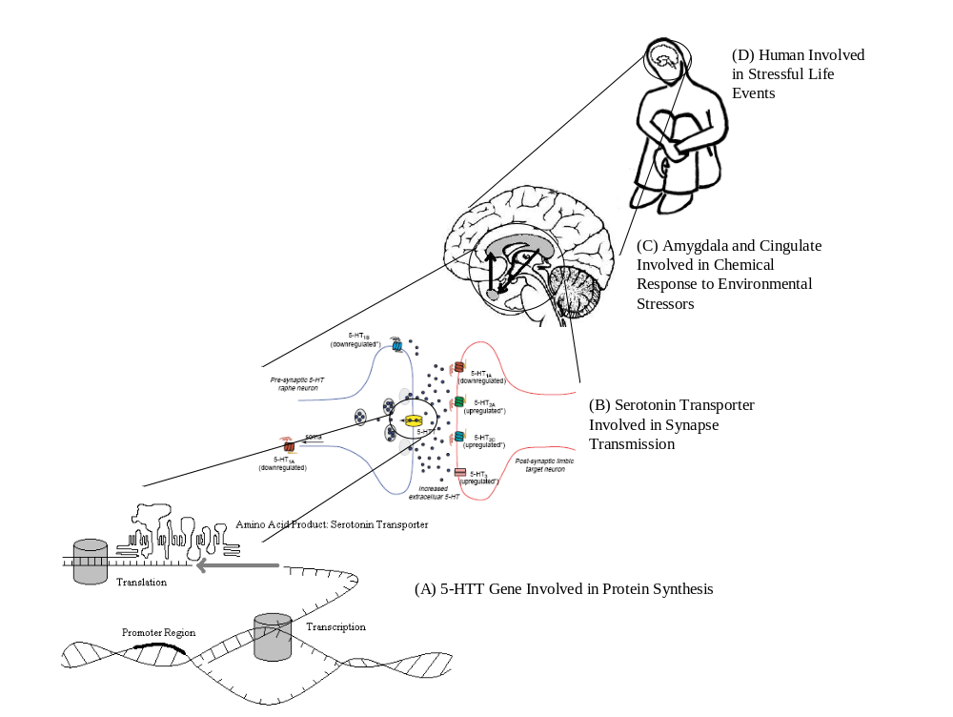
Figure 4. Mechanisms involved in the production of depression. (A) Protein synthesis at the molecular level. (B) Synapse transmission at the cellular level (C) Amygdala-cingulate feedback at the brain-system level. (D) Experience of stressful life events at the organismal level.

I have intentionally modeled Figure 4 so as to resemble the earlier diagram (Figure 1) by Craver and Darden (2001) explicating the causal-mechanical explanation of spatial memory in rats. Whether it is spatial memory in rats or major depression in humans, biologists provide explanations of complex behavioral traits by elucidating the regular causal mechanisms involved in the individual development of these traits. Interventions are made on variables to change the values of the variables so as to determine what the causal relationship is between a particular variable and another variable or the outcome of interest. Importantly, these interventions often are designed to force the variables to take unnatural values. For example, a gene knockout experiment attempts to determine the causal relationship between a genetic variable and a phenotypic trait by forcing the genetic variable to take an unnatural value—non-existence. Likewise, an animal deprivation study attempts to determine the causal relationship between an environmental variable and a phenotypic trait by forcing the environmental variable to take an unnatural value—extreme deprivation. Scientists, by isolating a variable and manipulating its value to extremes, try to hold all other relevant variables constant and then attribute the change in outcome to the change in the variable’s value, thereby identifying the causal relationship between the variable and the outcome.
But what about the other question: How do some people come to experience a complex trait such as major depression, while others do not? This is the question that demands an answer about variation. In providing a causal explanation for this question, we cannot just point to how the difference-making variables make their difference in the regular causal mechanisms responsible for the individual development of major depression by, say, knocking out the 5-HTT gene, for this does not yet address the question about why there is actual variation in incidences of major depression across populations. This is because we do not expect to find actual individuals with this extreme value taken by this variable in the natural world. To address variation, then, we must determine what values the variables take in the natural world and determine how the differences in those real-world values lead to actual variation in the outcome. That is, we must identify the difference-makers in development that take different values in the natural world; or, in the words of Waters (Forthcoming), we must identify the “actual difference-makers”.
Biometric behavioral geneticists take it upon themselves to answer the question about the causes of variation responsible for variation in populations. They have identified the different forms of the promoter region in the 5-HTT gene (s/s, s/l, and l/l) and determined that a small portion of total variation in depression (3-4%) is attributable to individual differences in the value of this genetic variable (Lesch et al. 1996). More proximally, behavioral geneticists have found differences in the value of the 5-HTT variable to be related to differences in amygdala activity; individuals with the “s” allele exhibit much greater amygdala activity than l/l individuals when presented with images of fearful and angry human faces (Hariri et al. 2002). Also, individuals with the “s” allele, compared with l/l individuals, exhibit a weaker coupling between the amygdala and the cingulate in the feedback mechanisms responsible for the chemical response to environmental stressors (Pezawas et al. 2005).
The biometric behavioral geneticists seek causes of variation responsible for variation in the incidences of major depression. But these causes of variation are not distinct from the difference-making variables in the regular causal mechanisms. They are not isolated at different levels of analysis, as the advocates of isolationist pluralism suppose. Rather, the difference-making variables in the regular causal mechanisms simultaneously are the causes of variation just when the difference-making variables take different values in the natural world. The promoter region of the 5-HTT gene, for example, is a difference-maker in the individual development of depression, as the knockout experiments reveal. Though the precise mechanism has not been elucidated, the variable seems to make a difference in how the amygdala coordinates with the cingulate to respond to environmental stressors. The promoter region of the 5-HTT gene is simultaneously a cause of variation because it takes different values in the natural world (s/s, s/l, and l/l), and the differences in the value of the genetic variable are responsible for slight variation in major depression. Variation, then, is the effect of difference-makers in individual development when the difference-makers naturally take different values.
Difference mechanisms, remember, are regular causal mechanisms made up of difference-making variables that take different values in the natural world. In the case of major depression, the promoter region of the 5-HTT gene is one of these variables that naturally takes different values; it is a difference-maker in development that takes different values in the natural world. Consider Figure 5: At the molecular level, differences in the promoter region of the 5-HTT gene are responsible for differences in the number of serotonin transporters that are available for synapse transmission at the cellular level; the shorter promoter region generates relatively less serotonin transporter molecules. Differences in synapse transmission, then, are responsible for differences in amygdala-cingulate feedback at the brain-system level; individuals with an “s” allele have a relatively weaker coupling between the amygdala and the cingulate in response to environmental stressors, leading to relatively prolonged exposure to negative emotional states. And differences in amygdala-cingulate feedback are responsible for differences in major depression; relatively prolonged exposure to negative emotional states puts one at risk of developing depression if environmental stressors are encountered often enough.
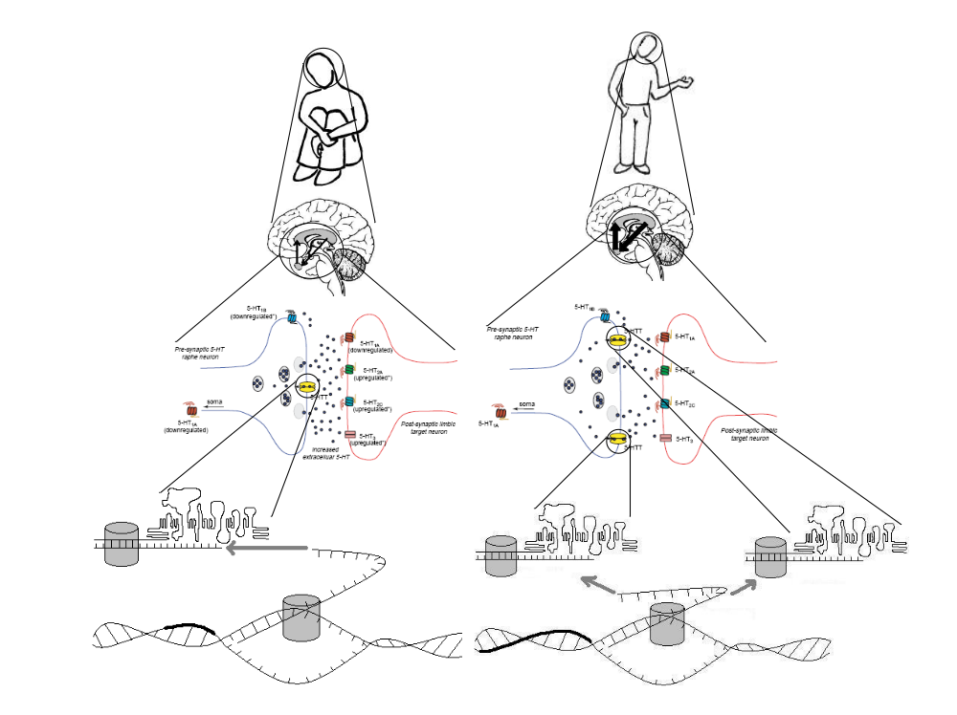
Figure 5. Difference mechanisms involved in the production of major depression.

Philosophers of science interested in the concept of a mechanism have focused thus far on how causal explanation arises from the elucidation of the regular causal mechanisms responsible for the individual development of a particular trait. They have focused thus far on how scientists provide causal explanations by identifying and manipulating the difference-making variables in regular causal mechanisms in an attempt to determine how those difference-makers make their difference. I have tried to show in this section, however, that the scientists in the biometric tradition are involved in a different enterprise, and so the philosophy of mechanisms must be revised if it is to be extended to cover the causal explanations of variation sought by scientists in the biometric tradition. Focused on variation, these scientists do not provide causal explanations by showing how difference-makers make their difference in the regular causal mechanisms. Rather, they causally explain by showing how or to what extent differences in the natural values of the difference-makers result in differences in the trait or in differences in the values of more proximal variables. I have also tried to show, however, that a scientist’s focus on differences does not somehow isolate her at a unique level of analysis. Scientists in the biometric tradition are examining causes of variation responsible for variation in populations, but these causes of variation just are the difference-makers in the regular causal mechanisms when the difference-makers take different values in the natural world. And the variation just is the effect of the difference-makers in development that naturally take different values.

4.3.3. The Interdependence of Difference-Makers in Development that Take Different Values in the Natural World. Appeals to different levels of analysis in the nature-nurture debate draw a firm line between a legitimate, statistical notion of interaction and a muddle-headed, developmental notion of interactionism. It is certainly the case that G×E does not simply follow from each and every interaction between genes and the environment during individual development, and so it is misleading to point to developmental interactions and assume that G×E must follow. In this sense, the following criticism of the biometric tradition is muddle-headed: “An analysis of variance abstracts from (actual) interaction effects and thus cannot offer an accurate picture of development…. Behavioral geneticists, then, should acknowledge that an analysis of variance is a statistical method that does not fit reality and should be judged against the background of the best material model we have of development, which is one of dynamics and interactions.” (Vreeke 2005, 44) Perhaps the ignominious “interactionism” should be reserved for such confusions.
But must all invocations of individual development in considerations of G×E be of the muddle-headed sort? Not at all. As I argued in the last section, the difference-making variables in the regular causal mechanisms simultaneously are the cause of variation when the variables take different values in the natural world. Now, if difference-making variables interact during the course of individual development, then a variable (X) taking a particular value (X₁) in interaction with another variable (Y) will likely lead to different outcomes depending on the value taken by Y (Y₁ vs. Y₂); but this difference in outcomes may have been quite different if variable X had taken a different value (X₂). Or, to continue with the major depression example, the regular causal mechanisms responsible for the individual development of major depression consist of a number of variables (the 5-HTT gene, the serotonin transporter, the amygdala, the cingulate, environmental insults, etc.), some of which take different values in the natural world. As explained in the last section, variation in incidences of major depression result from differences in the value of the promoter region of the 5-HTT gene and from differences in the value of the number of stressful life events experienced. But, as we will see, variation in incidences of major depression also result from differences in particular combinations of 5-HTT and stressful life events as these two variables have the opportunity to interact during the course of individual development.
Again, we should look at this example in more detail to completely understand the idea. As mentioned in the last section, we know that the promoter region of the 5-HTT gene is a difference-making variable in the regular causal mechanisms responsible for the individual development of major depression; we also know that this variable takes different values in the natural world. We know that stressful live events are a difference-making variable in the regular causal mechanisms responsible for the individual development of major depression; we also know that this variable takes different values in the natural world.
Now, suppose that no matter how many stressful life events one experienced, having the s/s value of the promoter region would increase the probability of individuals experiencing major depression by 10% relative to having the s/l value, and by 20% relative to having the l/l value. Likewise, suppose that no matter which value of the promoter region one had, every stressful life event experienced increased the probability of individuals experiencing major depression by 5%. I have been saying “suppose” because the hypothetical situation I am describing here was depicted in the hypothetical reaction norms graphed in Figure 3(A) and is recreated in Figure 6(A) with the individuals from the discussion of difference mechanisms now mapped onto the reaction norms. This case, remember, arises when the genetic and environmental sources of variation are additive and the reaction norms are parallel. The total phenotypic variation in depression is fully accounted for by pointing to the separate differences in the value of the genetic variable and the differences in the value of the environmental variable.
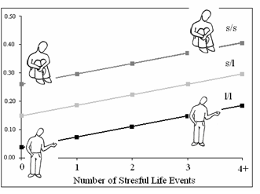A 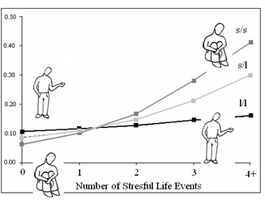B
Figure 6. Reaction norm graphs for probability of depression (y-axis), promoter region of serotonin transporter gene (s/s vs. s/l vs. l/l), and number of stressful life events experienced (x-axis). (A) Hypothetically parallel reaction norms. (B) Reaction norms drawn from empirical data with change in rank highlighted.

But remember that this hypothetical situation was first introduced only to contrast it with the empirical data from the actual reaction norms graphed in Figure 3(B). In the empirical example, as the reaction norms clearly show, there is variation due to G×E in addition to the variation resulting from differences in the value of the genetic variable and differences in the value of the environmental variable. Thus, there is no way to predict who is more at risk of developing major depression—either individuals with the s/s, s/l, or l/l genotype—before the environmental conditions of development are experienced (see Figure 6(B)). Caspi and Moffitt found that in environments with multiple stressful life events experienced, individuals with the s/s genotype are at a relatively greater risk of developing major depression; while, in environments without multiple stressful life events experienced, individuals with the s/s genotype are at a relatively lesser risk of developing major depression. That is, there is a change in rank for the relationship between the genetic variable, the environmental variable, and the phenotypic trait (Lynch and Walsh 1997).
With the interaction in this empirical example in mind, let us return to the debate between the defenders of the biometric tradition and their causal-mechanically-minded critics who appeal to the complications posed by individual development. What precisely does the concept of G×E mean? Does it incorporate an element of individual development, or not? The suggestion on offer by those who appeal to different levels of analysis is that G×E just is the breakdown in additivity between main effects measured by ANOVA. But we can go on and ask, what causes this breakdown in additivity? The answer is that this breakdown in additivity is caused by the interdependence of difference-makers in development that take different values in the natural world. That is, G×E results from differences in particular combinations of genetic and environmental variables when both variables are difference-makers in development that naturally take different values and the difference that each variable makes is itself dependent upon the difference made by the other variable. Difference mechanisms, then, arise when difference-making variables in the regular causal mechanisms take different values in the natural world. And difference mechanisms also arise when there are differences in the interactions between difference-making variables depending on which values the difference-makers take.

4. Conclusion. Philosophers of science, in recent years, have developed a renewed interest in mechanisms. The account of causal-mechanical explanation on offer is designed to capture causal explanations of regularity. For example, the account is designed to show how a causal explanation follows from the elucidation of the regular causal mechanisms responsible for the individual development of a complex behavioral trait such as spatial memory in rats or major depression in humans. Focused on regularity, however, this account of causal-mechanical explanation neglects variation, one of the core features of the biological world and, in turn, of biological explanation. That is, the account fails to show what role in causal explanation is played by the elucidation of the causes of variation responsible for variation in spatial memory or major depression across populations.
The purpose of this essay was to modify the mechanical program so as to capture both regularity and variation. This relationship, as it turns out, is not just of interest to the armchair philosopher. For it is precisely this relationship that resides at the heart of debates over G×E between scientists in the biometric research tradition and scientists in the developmental research tradition. The solution was the identification of a shared problem between the biometric and developmental research traditions—the elucidation of what I called difference mechanisms. Difference mechanisms are regular causal mechanisms made up of difference-making variables that take different values in the natural world. With this general framework, the relationship between the regular causal mechanisms responsible for individual development and the causes of variation responsible for variation in populations becomes apparent. The difference-making variables in the regular causal mechanisms responsible for individual development simultaneously are the causes of variation responsible when the variables take different values in the natural world; that is, when the variables are difference-makers in development that take different values in the natural world. And variation in populations is the effect of these difference-makers in development that naturally take different values. This general framework was then applied to the debates over G×E. G×E, in contrast to appeals to different levels of analysis, does incorporate an element of individual development; G×E results from the interdependence of difference-makers in development that take different values in the natural world. Ultimately, then, the product was a modified account of causal-mechanical explanation that captured both regularity and variation, and which was utilized to resolve as aspect of the debates over G×E.

REFERENCES:
Beatty, John. 1995. “The Evolutionary Contingency Thesis”, in G. Wolters and J. G. Lennox (eds.), Concepts, Theories, and Rationality in the Biological Sciences. Pittsburgh: University of Pittsburgh Press, pp. 45-81.
Bechtel, William and Robert. C. Richardson. 1993. Discovering Complexity: Decomposition and Localization as Strategies in Scientific Research. Princeton: Princeton University Press.
Bechtel, William and Adele Abrahamsen. 2005. “Explanation: A Mechanist Alternative”, Studies in the History and Philosophy of Biology and the Biomedical Sciences 36: 421-441.
Bengel, Dietmar, Dennis L. Murphy, Anne M. Andrews, et al. 1998. “Altered Brain Serotonin Homeostasis and Locomotor Insensitivity to 3,4-Methylenedioxymethamphetamine (“Ecstacy”) in Serotonin Transporter-Deficient Mice”, Molecular Pharmacology 53: 649-655.
Block, Ned. 1995. “How Heritability Misleads About Race”, Cognition 56: 99-128.
Block, Ned and Gerald Dworkin. 1976. “IQ, Heritability and Inequality”, in Ned Block and Gerald Dworkin (eds.), The IQ Controversy. New York: Pantheon, pp. 410-540.
Bouchard, Thomas J. and Nancy L. Segal. 1985. “Environment and IQ”, Handbook of Intelligence: Theories, Measurements, and Applications. B. B. Wolman. New York: John Wiley and Sons, pp. 391-464.
Brandon, Robert 1997. “Does Biology Have Laws? The Experimental Evidence”, Philosophy of Science 64: S444-S457.
Caspi, Avshalom, Karen Sugden, Terrie E. Moffitt, et al. 2003. “Influence of Life Stress on Depression: Moderation by a Polymorphism in the 5-HTT Gene”, Science 301: 386-389.
Caspi, Avshalom and Terrie E. Moffitt. 2006. “Gene-Environment Interactions in Psychiatry: Joining Forces with Neuroscience”, Nature Reviews Neuroscience 7: 583-590.
Cooper, Roderick M. and John P. Zubek. 1958. “Effects of Enriched and Restricted Early Environments on the Learning Ability of Bright and Dull Rats”, Canadian Journal of Psychology 12: 159-164.
Craver, Carl F. 2001. “Structures of Scientific Theories”, in P. K. Machamer and M. Silberstein (eds.), Blackwell Guide to the Philosophy of Science. Oxford: Blackwell.
Craver, Carl F. and Lindley Darden. 2001. “Discovering Mechanisms in Neurobiology: The Case of Spatial Memory”, in P. K. Machamer, R. Grush, and P. McLaughlin (eds.), Theory and Method in the Neurosciences. Pittsburgh: Pittsburgh University Press, pp. 112-137.
Cronbach, Lee J. and Paul E. Meehl. 1955. “Construct Validity in Psychological Tests”, Psychological Bulletin 52: 281-302.
Downes, Stephen. 2004. “Heredity and Heritability”, in Edward N. Zalta (ed.), The Stanford Encyclopedia of Philosophy. URL = <http://plato.stanford.edu/archives/fall2004/entries/heredity/>.
Feldman, Marcus W. and Richard C. Lewontin. 1975. “The Heritability Hang-up”, Science 190: 1163-1168.
Glennan, Stuart. 2002. “Rethinking Mechanistic Explanation”, Philosophy of Science 69: S342-S353.
Gottlieb, Gilbert. 2003. “On Making Behavioral Genetics Truly Developmental”, Human Development 46: 337-355.
Hariri, Ahmad R., Venkata S. Mattay, Alessandro Tessitore, et al. 2002. “Serotonin Transporter Genetic Variation and the Response of the Human Amygdala”, Science 297: 400-403.
Hariri, Ahmad R. and Andrew Holmes. 2006. “Genetics of Emotional Regulation: The Role of the Serotonin Transporter in Neural Function”, TRENDS in Cognitive Science 10: 182-191.
Hebb, Donald O. and K. Williams. 1946. “A Method of Rating Animal Intelligence”, Journal of General Psychology 34: 59-65.
Hume, David. 1993 [1777]. An Enquiry Concerning Human Understanding. Indianapolis: Hackett Publishing Company.
Jensen, Arthur R. 1969. “How Much Can We Boost IQ and Scholastic Achievement?”, Harvard Educational Review 39: 1-123.
Jensen, Arthur R. 1973. Educability and Group Differences. New York: Harper and Row, Publishers.
Kaplan, Jonathan Michael. 2000. The Limits and Lies of Human Genetic Research. New York: Routledge.
Kendler, Kenneth S. 2005. “Toward a Philosophical Structure for Psychiatry”, American Journal of Psychiatry 162: 433-440.
Layzer, David. 1972. “Science or Superstition? (A Physical Scientist Looks at the IQ Controversy)”, Cognition 1: 265-299.
Layzer, David. 1974. “Heritability Analyses of IQ Scores: Science or Numerology”, Science 183: 1259-1266.
Leonardo, E. D. and Rene Hen. 2006. “Genetics of Affective and Anxiety Disorders”, Annual Review of Psychology 57: 117-137.
Lesch, Klaus-Peter, Dietmar Bengel, Armin Heils, et al. 1996. “Association of Anxiety-Related Traits with a Polymorphism in the Serotonin Transporter Gene Regulatory Region”, Science 274: 1527-1531.
Lewis, David. 1973. “Causation”, The Journal of Philosophy 70: 556-567.
Lewontin, Richard C. 1974. “The Analysis of Variance and the Analysis of Causes”, American Journal of Human Genetics 26: 400-411.
Little, Dan. 1990. Varieties of Social Explanation: An Introduction to the Philosophy of Social Science. Boulder: Westview Press.
Lynch, Michael and Bruce Walsh. 1997. Genetics and Analysis of Quantitative Traits. Sunderland, Massachusetts: Sinauer Associates, Inc.
Machamer, Peter K., Lindley Darden, and Carl F. Craver. 2000. “Thinking About Mechanisms”, Philosophy of Science 67: 1-25.
Mayr, Ernst. 1961. “Cause and Effect in Biology”, Science 134: 1501-1506.
Mitchell, Sandra D. 2003. Biological Complexity and Integrative Pluralism. Cambridge: Cambridge University Press.
Pezawas, Lukas, Andreas Meyer-Lindenberg, Emily M. Drabant, et al. 2005. “5-HTTLPR Polymorphism Impacts Human Cingulate-Amygdala Interactions: A Genetic Susceptibility Mechanism for Depression”, Nature Neuroscience 8: 828-834.
Plomin, Robert, John C. DeFries, and John Loehlin. 1977. “Genotype-environment Interaction and Correlation in the Analysis of Human Behavior”, Psychological Bulletin 84: 309-322.
Plomin, Robert, John C. DeFries, Gerald E. McClearn, and Michael Rutter. 1997. Behavioral Genetics. New York: W.H. Freeman and Company.
Rutter, Michael. 2006. Genes and Behavior: Nature-Nurture Interplay Explained. Malden, MA: Blackwell Publishing.
Sarkar, Sahotra. 1998. Genetics and Reductionism. Cambridge: Cambridge Universitiy Press.
Schaffner, Kenneth F. 1993. Discovery and Explanation in Biology and Medicine. Chicago: The University of Chicago Press.
Sesardic, Neven. 2005. Making Sense of Heritability. Cambridge: Cambridge University Press.
Sober, Elliott. 1997. “Two Outbreaks of Lawlessness in Recent Philosophy of Biology”, Philosophy of Science 64: S458-S467.
Sterelny, Kim and Philip Kitcher. 1988. “The Return of the Gene”, The Journal of Philosophy 85: 339-361.
Tabery, James G. 2004. “Synthesizing Activities and Interactions in the Concept of a Mechanism”, Philosophy of Science 71: 1-15.
Tabery, James. 2007. “Biometric and Developmental Gene-Environment Interactions: Looking Back, Moving Forward”, Development and Psychopathology 19: 961-976.
Tabery, James. Forthcoming. “R. A. Fisher, Lancelot Hogben, and the Origin(s) of Genotype-Environment Interaction”, Journal of the History of Biology.
Tinbergen, Nikolaas. 1963. “On the Aims and Methods of Ethology”, Journal of Comparative Ethology 20: 410-433.
Vreeke, G. J. 2000. “Nature, Nurture and the Future of the Analysis of Variance”, Human Development 43: 32-45.
Waters. C. Kenneth. 1994. “Genes Made Molecular”, Philosophy of Science 61: 163-185.
Waters, C. Kenneth. Forthcoming. “Causes that Make a Difference”, The Journal of Philosophy.
Woodward, James. 2002. “What is a Mechanism? A Counterfactual Account”, Philosophy of Science 69: S336-S378.
Woodward, James. 2003. Making Things Happen. Oxford: Oxford University Press.

I received valuable feedback from William Bechtel, Stephen Downes, Paul Griffiths, Brian Keeley, Peter Kung, James Lennox, Peter Machamer, Sandra Mitchell, David Moore, Robert Olby, Michael Pogue-Geile, Richard Purcell, Kenneth Schaffner, and members of the UCSD Philosophy of Biology Reading Group on earlier versions of this work. Moreover, I am indebted to a number of individuals for enlightening conversations about G×E: Avshalom Caspi, Roderick Cooper, Gilbert Gottlieb, Terrie Moffitt, Robert Plomin, and Michael Rutter. Finally, versions of this paper were presented at the Science Studies Colloquium (UCSD, San Diego, CA, 8 October 2007), the 3rd Queensland Biohumanities Conference (Univ. of Queensland, Brisbane, Australia, 16 December 2006), the Nature-Nurture Conference (Univ. of Indiana, Bloomington, IN, 24 March 2007), Rice University (Houston, TX, 17 January 2007), and Pomona College (Claremont, CA, 13 February 2007). Conversations with a number of participants helped me to clarify ideas on this topic.
I say “renewed” to contrast these more recent endeavors with the classical mechanical philosophy.
For instance, there is a difference in the way in which the parts of a mechanism are understood to behave. This behavior has been characterized as a function (Bechtel and Abrahamsen 2005), an activity (Machamer, Darden, and Craver 2000), an interaction (Glennan 2002; Woodward 2002), and an interactivity (Tabery 2004). See Tabery (2004) for an analysis of this difference and the relationship between the various accounts.
This concept will be explicated in detail with an example in the next section.
The appeal to different levels of analysis is not unique to the nature-nurture debate. There is a long history of uniting different explanation-seeking questions with different explanatory levels (Mayr 1961; Tinbergen 1963). And appealing to these different levels as a means to defend against cross-disciplinary criticism is also by no means unique to the nature-nurture debate. For analysis of a similar debate over the origins of the female orgasm, see Mitchell (2003).

