Calibration in everyday scientific practice: a conceptual framework
Léna Soler, Catherine Allamel-Raffin, Frédéric Wieber and Jean-Luc Gangloff (members of the PratiScienS group, Nancy, France)

1. Introduction
Calibration is an important but often neglected topic in the philosophy of science.
Calibration is an important topic, since it essentially conditions the constitution and the reliability of instrumental methods which play a major role in science. The outputs of measurement apparatuses commonly used in everyday laboratory practices would be no more than marks deprived of any significance, unless the apparatuses in question have been correctly calibrated. New devices or techniques must successfully pass calibration tests (or tests akin to calibrations) in order to be recognized as sound candidates for further development (standardization and broader diffusion in the scientific community).
Yet although important, calibration is an often neglected topic, probably because it is treated as a preliminary and unproblematic procedure that precedes the ‘main show’, namely the investigation of the object under interest by means of what has been previously calibrated in this purpose. But the study of calibration practices shows that even in everyday uses of well-mastered instruments, calibration procedures are often delicate, complex, and problematic activities. This a fortiori holds for the calibration involved in creative metrological practices and in practices dedicated to the elaboration of new instrumental prototypes.
When calibration is mentioned in the literature devoted to the study of science, the word appears to be used in different senses. Now, the core idea of calibration, that brings together all the different uses, seems to be the following: any calibration involves a comparison between, on the one hand a questioned object or procedure (say X), and on the other hand an already fixed, already accepted and taken-as-more-robust object or procedures which works as a reference (say R). The comparison aims to conclude about the properties or reliability of X on the basis of the reference R.
This general definition of calibration shows the recursive structure of calibration. Indeed, the object or procedure which plays the role of the reference R in a given context must have acquired this status through antecedent calibration tests and operations which themselves must have used another reference, and so on.
Given the previous very general definition of calibration, the kind of X which might be the targeted object of a calibration, and the nature of the process through which the reliability of X is assessed against an R taken as a benchmark, can vary according to the kind of scientific practice under scrutiny. In the present paper, we discuss a circumscribed configuration within the set of the varied practices that can be categorized as calibrations: we focus on the calibration of already well-known and well-mastered instrumental devices in everyday laboratory practices. Our aim is to elaborate a conceptual framework in order to better grasp the nature what is at stake in this kind of calibration procedure.

To say that the focus is on calibrations of already well-known and well-mastered instrumental devices in everyday laboratory practices, is to mean that we will not consider other kinds of scientific practices also concerned with calibration, including practices to which one perhaps primarily think about when calibration is mentioned, for example calibration of new instrumental devices and techniques, or still more closely associated with the idea of calibration, calibration in metrological practice. But before to turn to our specific object, let us say a word about its relation to metrological calibrations.
Metrologists are measurement experts who build the primary standards that realize basic units. Calibration in metrological practice consists in conceiving and building standard instruments, objects and units which work as reference with respect to the development of secondary standards, and more generally with respect to chains of standards ordered in terms of accuracy. If we consider the relation between the this kind of calibration procedures and the kind we will discuss in the present paper, clearly, the metrological calibrations come first, both logically and chronologically, with respect to the calibration of already well-mastered instruments in everyday laboratory practices. The everyday procedures of calibration presuppose the metrological calibrations: indeed, they rely on metrological primary and secondary standards as their reference.
This illustrates the recursive structure of calibration mentioned just above. Since the metrological procedures seem to constitute the end-point of the regression, since they seem to be the source of the whole process and the basis of the whole edifice through primary standards, the question arises of the nature of the reference involved in metrological practices. This will be the issue of subsequent researches. In a first moment, and with the aim to tackle the problems one by one, it is convenient to take the metrological achievements for granted (to treat them as something given, as they are treated by practitioners in the calibration practices we are now going to analyze), and to investigate the calibration practice which seems at first sight the less problematic, namely the everyday practice of scientific users of already well-mastered devices.

So in this paper, calibration is analyzed from the standpoint of scientific users of instrumental devices in everyday scientific practice, that is, the standpoint of practitioners who deal with instruments that are already well-designed and whose use is already entrenched in the scientific community. In order to clarify the nature of this kind of practice and to improve our understanding of its internal logic, we have elaborated a conceptual and taxonomic framework. In the paper, we will only present some fragmentary – although pivotal – pieces of this framework. But as an introduction, we would like to situate this circumscribed result in the broader perspective of our collective research program PratiScienS, “Rethinking science from the standpoint of scientific practices”.
One axis of this program is devoted to calibration practices in a broad sense of the term ‘calibration’. In order to understand and classify these practices, we started with a set of examples of actual practices of calibration. These examples mostly came from two members of the PratiScienS group. First from a physicist, namely Cathy Dufour, who worked as an experimenter, during more than twenty years, in a Laboratory of condensed mater physics based in Nancy, the « Institut Jean Lamour. Matériaux-Métallurgie-Nanosciences-Plasmas-Surfaces » (Jean Lamour Institute. Materials-Metallurgy-Nonosciences-Plasma-Surfaces). A large part of our starting examples of calibration practices have been provided by Cathy and are related to the actual practices at the IJL. It is the case of the single example that we will be able to analyze in this paper, namely calibration procedures in X-rays experiments. A second set of examples came from some ethnographic studies conducted by another member of PratiScienS, Catherine Allamel-Raffin, in the field of astrophysics and pharmacology. These examples will not been analysed in the present article.
Starting from this quite diversified set of actual examples of calibration practices, we tried to grasp their very nature, their common core features and the significant differences between them. For this purpose, we built numerous successive versions of conceptual frameworks. The prism of each version shed a new light on our examples, but at the same time, new kinds of difficulties appeared, with which we had to cope through modified conceptualizations. So the framework we are going to present below is the result of a long and sinuous maturation process, constituted of a back and forth movement between our examples of calibration and multiple attempts to understand and classify them. But contemplating the final result apart from the process of its constitution, the work invested in the clarification of the difficulties encountered along the way, and in the construction of satisfying solutions, is difficult to perceive in the end-product. Given that, the framework we are going to present might appear obvious, straightforward, and thus perhaps uninteresting. That is why we wanted at least to say a word about the nature of the building process, since it is not possible to give details about the work involved in it.

2. A conceptual framework in order to grasp calibration
When we scrutinize everyday scientific uses of already-well mastered instruments, it appears that the practices that can be related to calibration are diversified and at first sight not obviously homogeneous. In such a situation, different categorizations are always possible, and categorization decisions are inevitable. We have tried to render them explicit in the process of our research, and we have favored a strategy that we will also follow in the present paper.
Our strategy has been to identify and characterize what we call the ‘prototypical case of calibration’. The prototypical case is like an exemplar in the Kuhnian sense. It refers to a configuration that likely nobody would hesitate to categorize it as a calibration. In this article, the prototypical case of calibration will be illustrated through the example of a relatively simple and familiar instrument: a balance, that is, a weighing scale with beam arms of equal length (see figure 1).
Figure 1:
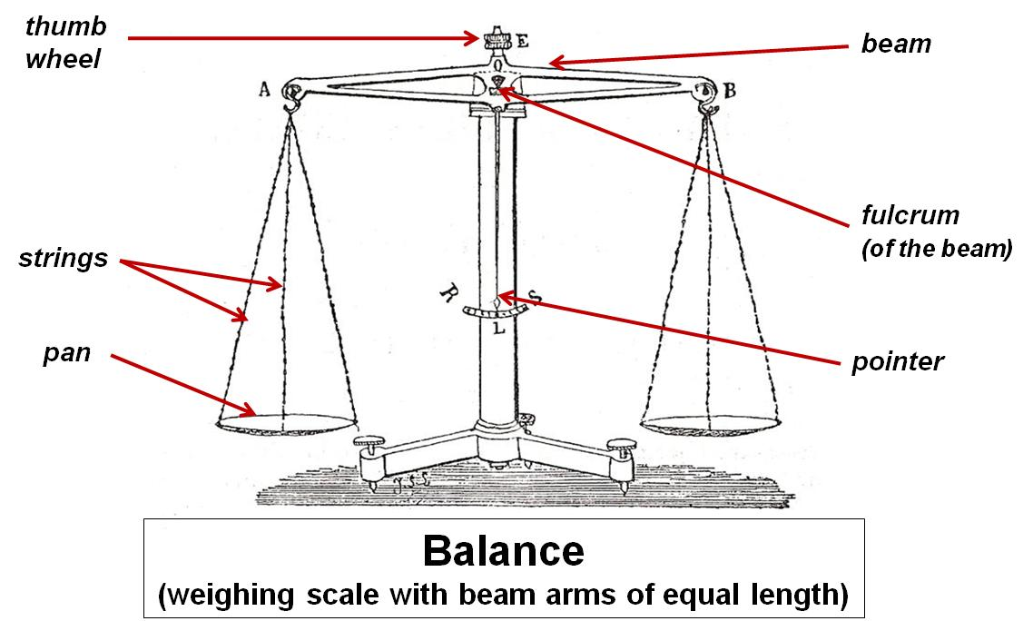

In order to define the prototypical case of calibration, we investigate four questions: the target T of a calibration; the presuppositions P involved in a calibration; the aim of a calibration; and the logical stages which constitute a calibration procedure.
2.1. The target of calibration
The first question is: what kind of thing can be the object of a calibration? This is the question of the target T of calibration.
If we examine the uses related to the calibration vocabulary, it appears that T can refer to heterogeneous kinds: a measurement device; a measured sample; an algorithm used to analyze data; or even scientists themselves in their capacity as instrument-readers (or more generally instrument manipulators).
Now in the prototypical case as we define it, the target is a measuring device or, as we will call it for short, a ‘measurer’.
To go further, we must distinguish two sides of any measurer:
- The measurer as a conceptual object, that is, a certain type of instrumental device. For example: a scale of the type ‘balance’, that is, a weighing scale with beam arms of equal length (see figure 1). We call this: the ‘measurer- type’.
And
- The measurer as a particular real instantiation of a given type, which is a singular material object: this particular balance here and there. For example: one of the precision balances constructed by Fortin for Lavoisier. We call this: the ‘measurer- token’.
Armed with this distinction we can answer to our first question: The targeted object T of a calibration is a measurer-token.
But not all procedures directed toward a measurer-token are calibrations. So we must specify further what distinguishes a calibration test from other possible tests of a measurer-token that would not count as calibrations. One important difference lies in some presuppositions about the measurer.
This leads us to our second question.

2.2. The presuppositions P of calibration
What presuppositions P about the measurer are constitutive of the kind of procedure that calibration is?
In order to answer to this question, we must investigate further what a measurer-type is, and what individuates a measurer as one type different from another one.
The function of a measurer is to evaluate certain determinate variables. We will call the variables in question the ‘mesuranda’. In the case of a balance, the measurandum is the mass.
A measurer converts certain determined operations into a definite value of the measurandum. In our example, these operations are, typically: to place a material object O on one pan of the balance, and then to add standard masses on the other pan until the beam is as close to zero equilibrium as possible.
The conversion of such operations into one value of the mass of M involves some scientific theories (in our case: mechanics). More exactly, the passage from these operations to a value of the mass is realized through a certain scientific scenario based on some scientific principles. In our example this scenario, roughly characterized, goes as follows : when a massive object O is placed on one pan, it exerts on the end of one arm of the beam a vertical force F₁ whose magnitude is proportional to the mass of O. In order to restore the equilibrium position of the beam, standard masses are then placed on the other pan of the balance. They exert a vertical force F₂ on the end of this other arm of the beam. If the magnitude of F₂ is equal to the magnitude of F₁, then the equilibrium position of the beam is restored.
The scientific principle centrally involved in this scenario is the lever principle, or more fundamentally, the principle of the composition and equilibrium of parallel forces.
This scenario (and its underlying scientific principles) is actually what defines, at the most fundamental level, a type of measurer. It is what individuates a measurer as one determined type different from another type. For example what individuates the type ‘balance’ and differentiates it from another type such as, for instance, the type ‘electronic spring scale’ (which characterizes, say, a digital kitchen scale).
Given the fundamental principles that define a type of measurer at the most general level, a multiplicity of different particular concrete embodiments of this generic type can be conceived (this is typically the task of engineers). Each of these conceived particular instantiation of the generic type, or each sub-type, we call it a ‘model of the measurer-type’ or, for short, a measurer-model.

The measurer-model is a conceptual object which corresponds to a detailed description of a real measurer-token and its performances. As an illustration, in the case of a balance, the model will specify:
- The materials, the form and the dimensions of the beam, of the strings and of the pans; the position of each component with respect to the others; etc.
- The attainable performances, in particular the sensitivity (which notably depends on the beam mass and on the distance between the center of gravity of the beam and its fulcrum).
- The conditions of use, taking into account real-life environmental variations. For example, air currents in the room can affect the balance's operation when performing very precise measurements (That is why analytical balances are placed inside a transparent enclosure with doors – which also prevents dust to be collected in the pans).
The measurer-model is, as stressed above, a conceptual object as the measurer-type is, but it can be described as the lowest level of conceptualization (and in any case a lowest level – a less general, more concrete and more detailed level – than the level of the type): a level so-to-speak ‘contiguous’ to the real measurer. Actually, the model can be seen as a sub-type (and the net division between the type and the model is a simplification that should be replaced, in a finer-grained characterization, by a scale of multiple, more or less general hierarchic levels).
With respect to an analysis of calibration, it is useful to distinguish two aspects within the characterization of the measurer-model:
- On the one side, a characterization of the optimal working, including the error bar
This tells the users what is at best actually obtainable from a measurer-token generated according to the model. At best, that is, just after the fabrication, assuming no accident or uncontrolled events during the fabrication process, assuming normal conditions of utilization, etc.: in brief, assuming the conformity of the real token to the stipulations of the conceptual model.
- On the other side, a characterization of predictable possible deviations with respect to the optimal working:
For example, in the case of our balance, a difference in the way each pan is altered over time which leads to two pans of different masses; a blunting of the three balance knife edges; etc.
The whole set of specifications just described delimitates the identity of the model, and at the same time defines what should be the identity of each individual measurer-token generated according to the model. So the model-measurer provides the normative identity of an (indefinitely large) class of individual measurer-token, those which are supposed to be instantiations of this model. It gives a normative characterization of any individual instantiation of the class defined by the model.

We are now in a position to answer to our second question about the presuppositions P involved in a calibration.
The question is: What is taken for granted about the measurer, which delimitates what is not granted and has to be checked and controlled in a calibration procedure?
Our answer is: two presuppositions are involved in the prototypical case of calibration as we define it.
The first presupposition is: the measurer as a conceived object is not problematic. Which means that neither the type, nor the model of the measurer-token are questioned. In other words, all the elements of the previous characterization are taken as robust, as uncontroversial pieces of human knowledge. This is clearly the case for the balance. The underlying principle of the composition and equilibrium of parallel forces is a totally unquestioned and deeply entrenched principle. A balance is a fully-understood and well-mastered type of weighing scale. And nobody contests the ability of the existing models of the type ‘balance’ to enable reliable measurements of mass.
The second presupposition is: the token-measurer is not defective, there is no breakdown, no failure. Re-described in our categories: the shift between the real, individual measurer on the one hand, and on the other hand the conceptual, measurer-model, is not too important.
Of course this assumption can be questioned in the course of a sequence of actions firstthought as a calibration. But as soon as this assumption is abandoned, the nature of the action changes and the procedure then involved is no more adequately categorized as a calibration (typically, it is a repair).

2.3. The aim of calibration
Our next and third question is about the aim of calibration. What is the aim of a calibration applied to a measurer-token T under presuppositions P?
Expressed at the more general level, the aim is to master – in a sense of ‘master’ that will be specified below – the possible shift between the measurer-token and the measurer-model. More precisely, the aim is to master the possible shift between:
- On the one hand, the instrumental outputs actually obtained with this individual measurer at a given time in a given context (in our example: the position of the pointer of the balance with respect to the equilibrium zero position, which is convertible in the value of a certain mesurandum, here the mass);
- On the other hand, the value of the mesurandum that should have been obtained in the optimal configuration (that is: if this measurer-token as used in this context actually coincided with the measurer-model in optimal working).
To make short, we will call this shift the obtained / optimal shift.
So the aim of calibration is to master the obtained / optimal shift of a measurer-token at a given moment in a given context.
In practice, the way this aim is translated into concrete actions depends on the subsequent measurements that are the ‘true aim’ of practitioners and the reason why the calibration procedure is undertaken. A calibration procedure is never accomplished just for itself, but always with the intention to perform other, more or less pre-determined targeted measurements. We will call them the ‘end-measurements’. The expression ‘end-measurements’ intends to play on the two-fold meaning of the term ‘end’.
- First it intends to suggest the idea of a finality as involved in a means-end relation: here the end is to realize reliable subsequent measurements, and calibration is one means with respect to this aim.
- Second, it intends to suggest the idea of the end of a story: in our case, the end of an experimental sequence in which calibration plays the role of the introductive chapter.
A calibration procedure cannot be adequately thought in isolation, independently of its relation to the end-measurements in view to which it is accomplished. Indeed, the calibration of one and the same measurer-token can vary, depending on, for example, the degree of precision that is sought in the end-measurements, the more or less good knowledge already acquired about the object under study in the end-experiments, etc.

2.4. The logical stages of calibration
Our fourth and last question is: through what kind of logical stages is the aim of calibration achieved?
We just said that the aim was to master a certain kind of possible shift. Now we have to specify what the ‘to master’ means.
To master the possible obtained / optimal shift means:
- First to evaluate the importance of the shift;
- Second, if needed – depending on the result of such evaluation and on the nature of the end-measurements – to correct the shift or to take it into account in a way or another (this last formulation remaining deliberately vague in order to encompass the multiple kinds of actions possibly involved).
So a calibration procedure can be divided into two logical moments:
- A moment devoted to calibration tests; and
- A moment consisting in the application of calibration operations according to the conclusions of the testing phase.
As for calibration tests, two species are commonly involved in prototypical cases of calibration.
- Blank (or background) calibration tests: these give the blank indication of the device under test
For example, the blank calibration of our balance would consist in assessing the position of the balance pointer when the pans are empty. The calibration test is ‘blank’, in the sense that a measure is undertaken in the absence of any object of the same kind as the one the end-measurements aims to characterize (note here the indispensable reference to the end-measurements). The principle of a blank calibration test is to perform a measurement in all points similar to the end-measurements (same measurer-token, same experimental context, same measurandum) except one: no measured object of the kind involved in the end-measurements is involved in the calibration test measurement (in our example: no material object is placed on the pans of the balance). So ideally, the calibration test measurement and the end-measurements are in the following relation: without/with a measured object of the kind under study all other things being equal.
If this is actually the case, the blank test gives the background noise specifically due to the measurer-token. This noisy contribution of the individual measurer is determined by a comparison between the instrumental outputs obtained as the result of the blank calibration (for example: a position of the pointer corresponding to 10 grams), and the prescriptions of the model in optimal working (a position of the pointer corresponding to the equilibrium zero position (taking into account the accuracy of the reading). The difference, that is, the signal generated by the individual balance in the absence of any material object, is something that practitioners must be careful not to count as a contribution of the object under study.
- The second species of calibration test use working measurement standards.
A working measurement standard is an object of already well-known properties. In our example, it would correspond to a standard mass, and a calibration test with such a standard could be: to take two standard masses corresponding to the same mass value, and to place one and the other on each pan of the balance.
The underlying logic of a calibration test with standard is, as it was the case for blank calibration test, a differential logic in which the end-measurements play the role of a reference point. Ideally, the calibration test with a standard is in all points identical to the end-measurement (same measurer-token, same experimental context, same measurandum, and – very important – same kind of measured-object), except in one respect: the properties of the measured object used in the calibration test are already well-characterized, before and independently of the calibration test. As a consequence, the instrumental outputs that should be obtained with a measurer-token of this model if the token coincided with the optimal working are pre-determined (in our example: the position of the pointer should coincide with the zero position).
If the calibration test leads to another instrumental output, the difference corresponds to the shift obtained/optimal (say: plus 10 grams). This contribution of 10 grams must be attributed to the measurer-token, and not to the object under study in the end-measurements.
In calibration tests with a standard as well as in blank calibration tests, a circumscribed contrast is created between the end-measurements and the calibration tests measurements. In both cases, this contrast allows to delimitate differentially what must be attributed, on the one hand to the measurer-token, and on the other end to the measured-objects involved in the end-measurements. The difference between the two cases lies in the fact that in calibration tests with a standard, the token-measurer is in interaction with a measured object of the kind under interest (it is employed in conformity to its intended function and normal use: indicate the mass of objects placed on its pans). The possible shifts obtained / optimal are not necessarily due to the same causes in the two cases (with / without weighting objects on the pans). Hence the two species of calibration tests provide possibly different and complementary informations about the token-measurer and its drift with respect to the measurer-model.

Once calibration tests have been performed, practitioners have to decide, according to the shift obtained / optimal they have found and to some desiderata imposed on the end-measurements, if calibrating operations are required or not, and, if yes, which ones.
Two kinds of calibrating actions are commonly involved in prototypical calibrations: Material operations and symbolic operations.
- Material operations correspond to concrete manipulations exerted on the individual instrument, which introduce effective and tangible modifications of the measurer-token as a material body. For example, with the balance: to manipulate a thumb wheel in order to restore the equilibrium of the beam by displacing it slightly with respect to its fulcrum, so that the pointer, which initially coincided with 10 grams, finally coincides with the zero.
- Symbolic (or intellectual) operations are diversified, but as a prototypical illustration, they correspond to mathematical corrections applied to the instrumental outputs actually obtained. In the case of our balance, it would amount to subtract 10g to the values actually obtained in the end-measurements.
Material operations transform the token-measurer so as to make the real individual instrument as close as possible to the model in optimal working. Symbolic operations do not intervene on the measurer-token as a concrete physical object: the shift between the real individual instrument and the model in optimal working remains unchanged; it is treated intellectually, by a thought operation applied to the instrumental outputs actually obtained.

3. A less prototypical case: calibration in X-ray diffraction experiments in a nanoscience Laboratory
This conceptualization of prototypical calibration aims at being a tool for the scrutiny of other, less prototypical and more problematic candidates for calibration. The intention is to discuss these other cases in reference and by contrast to the prototypical case: to analyze them as specified, more or less important variations with respect to the prototype, and on this basis, to motivate the decision to count them as calibrations or not.
In this paper, we will only be able to consider one other case, and still, only in a fragmentary and sketchy manner. The case deals with X-ray diffraction experiments and the related calibration procedures currently undertaken at the Jean Lamour Institute (hereafter IJL) in Nancy. Compared with the prototypical calibration, this case is specific and instructive in (at least) two important respects.
- First, it involves a more complex measurer, in the sense of ‘composed of multiple parts’. This complexity directs the attention on the possible relations that might hold between calibration of the measurer as a whole and calibration of its parts.
- Second, it points to instances in which the target T of a calibration, although being a part of a measurer, is not itself a measurer.

3.1. The end-experiments
In order to characterize the calibration procedures related to X-ray experiments undertaken at the nanoscience Laboratory under study, the first thing to do is to describe the end-measurements. Indeed, as already stressed above, the characteristics of the end-measurements constitute the reference which gives their sense to calibration tests and operations and which determines the relevant constraints imposed on the calibration procedure.
The IJL has an expertise in the growth and production of very thin (nanometric) films with specific properties. The aim of the end-measurements we are going to discuss is to characterize some structural properties of mono-crystalline thin-films. A monocrystalline thin-film is a material characterized by a determined, regular internal structure. Successive stacking of crystalline planes are separated by a given distance, called the inter-reticular distance (hereafter noted d). Considered in different directions, different successive crystalline planes define the crystal lattice. In order to characterize one particular monocrystalline thin-film, one has to determine the inter-reticular distance for each successive stacking of crystalline plan (i.e. for each direction perpendicular to one stacking of planes).
In the particular case we are going to consider below, the aim of the end-measurement is to determine the inter-reticular distances between the different crystalline planes of the thin-films synthesized at the laboratory at a given time (say t₁). This is informative about the growth process and about the structural quality of the thin-film sample that has been produced (is it a ‘perfect’ crystal? What is the degree of deformation of the thin layer?). We will also consider below end-measurements that aim to evaluate the possible evolution over time of the quality of a thin mono-crystalline layer. This evaluation involves the reiterations of measurements of the inter-reticular distances at different times (say t₁ and t₂), and to create conditions that enable to compare (i.e., to situate on one and the same scale) the values respectively obtained at t₁ and t₂.
With respect to these end-mesurements, the mesurandum is the inter-reticular distance d (or so will we admit at this stage, before to come back to this point below).

3.2. The measurer-type and the measurer-token
Let us now turn to the type of instrumental device involved. The instrumental device used in the end-measurements is a token of the type ‘X-ray diffractometer’, more precisely a token of the type ‘four-circle diffractometers’, and still more precisely a token of the type ‘high resolution X-ray diffractometer for thin-film analysis’.
This instrumental device is identified with the measurer.
Let us now describe briefly the fundamental scientific principle and scientific scenario that define this type of measurer and individuate it as one single type.
The fundamental scientific principle corresponds to what is called the “diffraction of X-ray by a crystal”. The phenomenon of diffraction is the result of a particular type of interaction between radiation and matter. An X-ray beam is conceived as a certain kind of radiation constituted of photons (the range of X-ray wavelengths is placed between the ultraviolet region and the region of γ-rays emitted by radioactive substances). When an X-ray beam is directed on a crystal, different physical interactions occur. In particular, some photons of the incident X-ray beam interact with the electronic clouds of the atoms of the crystal and are deflected without a loss of energy. These deflected photons constitute the scattered radiation, and this scattered radiation presents certain characteristic properties which depend on the internal structure of the crystal. This is, roughly sketched, the scientific scenario associated with the diffraction of X-ray by a crystal and with the type of measurer that a diffractometer is.
More precisely, the scenario goes as follows: when a monochromatic X-ray beam of wavelength λ is directed on a mono-crystalline thin-film according to a given direction θ (The interval of λ of particular usefulness in crystallography ranges between 0.4 and 2.5 Ǻ), the scattered radiation that is collected as a result of the interaction between the X-ray and the crystalline thin-film, obeys to determined and well-known laws, which connect:
- on the one hand some properties of the scattered X-rays, namely the direction and the intensity of the scattered beam (called the angle of diffraction and the diffracted intensity),
- and on the other hand, some properties of the internal structure of the crystal (such as, for example, the inter-reticular distance d between crystalline planes).
These laws are, for the diffractometer, the equivalent of the lever principle for the balance. They correspond to the fundamental scientific principle which underlies and define the type of measurer that a X-ray diffractometer is.
In the particular case under scrutiny, namely in the case of end-measurements aiming at the determination of the inter-reticular distance d between crystalline planes, the relevant law is one fundamental X-ray crystallography law known as the “Bragg’s law” (see figure 2):
2 d sin θ= n λ
d is the inter-reticular distance for one stacking of planes
θ is Bragg’s angle, that is, the angle between the incident X-ray beam and the reticular planes
n is an integer
λ is the wavelength of the monochromatic X-rays beam

Figure 2: Bragg diffraction [from http://hyperphysics.phy-astr.gsu.edu/hbase/quantum/bragg.html].
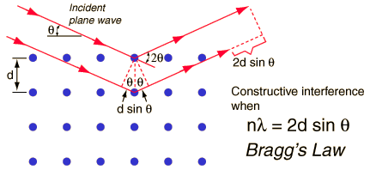

Having given information about the type of the measurer-token, let us now turn to the model of the diffractometer-token currently used at the Jean Lamour Institute.
At the IJL, they use a certain model of diffractometer, which is sold under the technical name “X’pert Pro MRD PANalytical” (PANalytical is the trademark).
Figure 3 shows a picture and a scheme with legends of the corresponding diffractometer-token.
Figure 3.
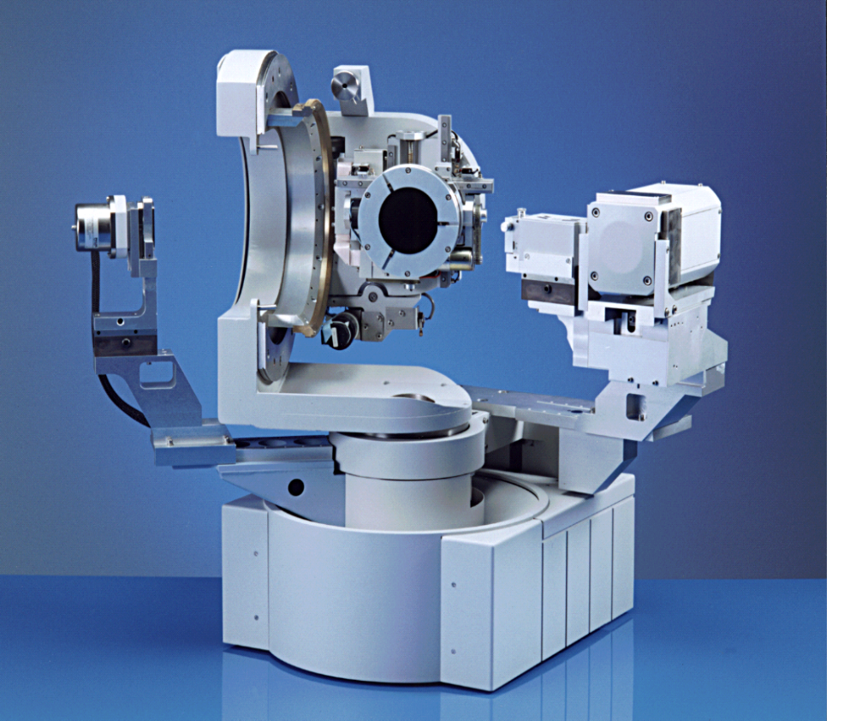
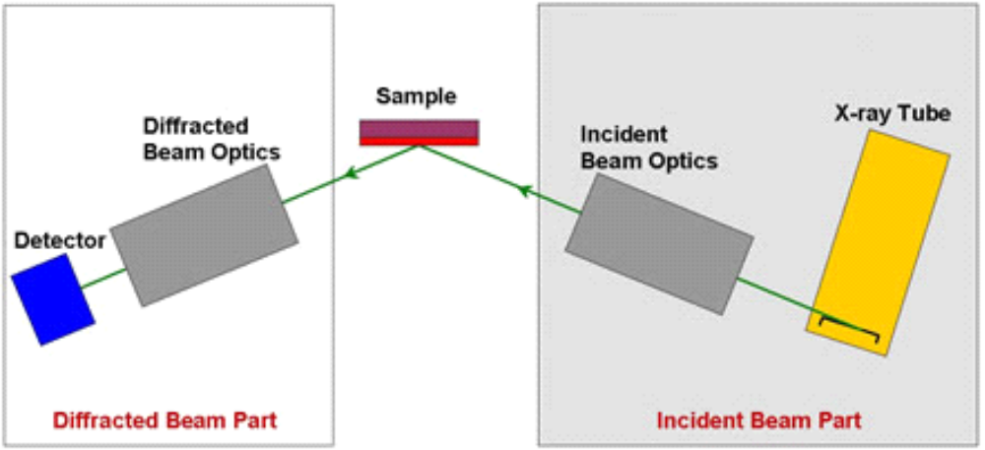

The scientific scenario that underlies this model of diffractometer, described at a basic level, is the following: to generate an X-ray monochromatic beam of a certain intensity I_{inc}; to direct the incident intensity I_{inc} on a crystalline thin-film sample according to a certain angle θ; to record the diffracted intensity I_{diff} of the X-rays diffracted by the sample at an angle 2θ (see figure 2).
Figure 3 shows:
- The X-ray source, here a Cu-anode sealed-tube. It produces an incident monochromatic X-ray beam with an intensity I_{inc}, which is directed on the crystalline thin-film to be analyzed.
- The sample holder where the crystalline thin-film sample is laid down.
- The X-ray detector, here a “Linear Position Sensitive Detector” (LPSD). It collects the X-ray beam diffracted by the crystalline sample in a given direction, and indicates, for each angle, the diffracted intensity I_{diff}, that is, the number of diffracted X-ray photons.
Other instrumental modules are involved and play an important role.
- A goniometer system. Its function is the determination of the relative positions of the source, the crystalline sample and the detector. In particular, it enables to orientate the sample in a precise direction with respect to the incident RX beam and to remain in the beam while varying the incident angle. The control of these positions is crucial for the interpretation of the instrumental outputs, since the determination of these spatial coordinates is equivalent to (directly convertible in) the determination of the angles involved in the experiment, and first of all the angles between the sample and the X-ray beam.
- Some optical devices, namely a monochromator, used to produce, as its name indicates, a monochromatic incident beam, and a collimator, used to filter the diffracted X-rays in order to collect only the X-rays photons arriving at 2 θ.
- A diffractometer control software program. This program carries out all real-time instrument control functions. For example it drives the goniometer motors, monitors the detector system, etc.
For this model of diffractometer, the instrumental outputs are graphs. These graphs show the intensity of diffracted X-ray (I_{diff}) versus the angle θ of the incident beam (or more briefly: they correspond to diffraction spectra I_{diff}(θ)). In other words, they give the number of X-photons diffracted by the thin-film crystal for different directions of the incident beam. Typically, they present a peak of intensity for a particular angle, namely the Bragg’s angle involved in the Bragg’s law given above (2 d sin θ= n λ).
From such diffraction spectra, practitioners can go back, through Bragg’s law, to the values of the mesuranda under interest, namely to the values of the inter-reticular distances.
So this model of diffractometer converts certain humanly performed operations (namely here: to put the crystalline thin-film in the desired position; to switch the X-ray beam on; etc.), into one definite value of the mesurandum under interest (namely here: the value of the inter-reticular distance d).
The conversion relies on some scientific theories, here the theory of diffraction of X-rays by crystals (which itself involves crystallographic theories and wave theories). The passage from the above-mentioned humanly performed operations to a determined value d1 of the mesurandum d, is realized through a scientific scenario based on the Bragg’s law of the kind described above, but specified according to the specific characteristics of the model: the monochromatic X-ray beam of wavelength λ emitted by the Cu-anode sealed-tube reaches the thin-film according to the direction θ prescribed by the goniometer; the Linear Position Sensitive Detector collects the scattered intensity for an interval of angles prescribed by the control software program… And so is finally produced a diffraction spectrum as the instrumental output of the diffractometer).
This scenario (for which more or less detailed versions can be provided) is one part of the definition of the diffractometer-model. Its most detailed version provides the characterization of the diffractometer in optimal working (i.e., what is at best obtainable with a diffractometer-token generated according to this model). The other part of the definition of the diffractometer-model involves the possible deviations with respect to the optimal working that are anticipated according to the model. For example, a decrease of the intensity of the X-Ray beam over time is predicted.

3.3. Discussion about the mesurandum
We will come back to this point below, but before, let us come back, as promised above, to the question of the identification of the mesurandum. Above, we identified the mesurandum with the inter-reticular distance d. This was motivated by the fact that the determination of d (translatable into a verdict about the structural quality of the crystal) is the ultimate aim of the end-experiments (=what practitioners want to know, the reason why they perform these experiments and why they want to have their diffractometer correctly calibrated).
But on the other end, the variable d is not what is directly obtained (measured) as the result of the end-measurements themselves or as the result of the calibration test measurements. The variable involved and actually measured by the diffractometer in these experiments is an intensity (the intensity diffracted at a certain angle). From this intensity actually measured, or in other words, given the graphs I_{diff}(θ) obtained as a result of the measurements with the diffractometer-token, practitioners determine the inter-reticular distances by a calculus : they calculate a certain value of d by means of the Bragg’s law. Since the calculated value of d might seem completely determined by the measured value, and since the calculus might seem to come in addition to and to stand apart from the performed experiments themselves, we could be tempted to identify the mesurandum with the intensity rather than with the inter-reticular distance, especially if we conceive the notion of a mesurandum in relation with and in reference to a specific kind of measurer (as our first definition of the mesurandum at the beginning of this paper implicitly suggests, by presenting the mesurandum as the variable that it is the function of a certain kind of measurer to evaluate, e.g., for a balance, the mass).
Actually, both choices might be valuable – the adequacy of each has to be assessed in reference to the kind of issue the philosopher of science wants to discuss. But another possibility – rather than to choice one possibility to the detriment of the other – is to reframe the situation in terms of different levels of mesuranda. In that vein, the diffracted X-ray intensity can be viewed as an intermediate mesurandum, that is, as a mesurandum of lower-level compared with the mesurandum which is the ultimate aim of the end-measurements, namely the inter-reticular-distance (and thus some information concerning the structural quality (possible deformation) of the thin-film.
Considered in this perspective, the case of the diffractometer is instructive, in that it highlights a general point and illustrates a widespread configuration which remains quasi-invisible when we reflect on the case of the balance, namely the involvement of hierarchic levels of mesuranda convertible one into the other according to certain operations. From an analytical standpoint, the recognition of such a hierarchy moreover enables, with respect to certain purposes, to focus on some level while ignoring the others, for the sake of simplification and to the benefice of clarifications.
This is actually what we are going to do in the remainder of the developments. We are going to ‘forget’, or at least to let in the shadow, the higher-level mesuranda (i.e. the inter-reticular distances and the more or less good quality, deformation etc., of the thin-film). Instead, we are going to focus on the (comparatively) lower-level mesurandum ‘intensity’ (more exactly I_{diff}(θ)). This focus can be vindicated as adequate and even desirable with respect to our purpose: since we aim to characterize calibration, our interest lies primarily in the way the experiments are actually performed and the way their instrumental outputs are actually obtained, rather than in the calculus which is subsequently applied to these instrumental outputs.

3.4. The calibration procedure directed toward the X-ray source
Let us now turn to the calibration procedures related to the diffractometer.
Before to perform the end-experiments aiming at the characterization of the structural quality of a thin-film, practitioners have to test if their measurer-token, here their particular X-ray diffractometer, is sufficiently close to the measurer-model in optimal working. With respect to these end-measurements and to the robustness of their results, the target T of the calibration procedure is the diffractometer-token as a whole.
But the calibration of this diffractometer-token is more complicated than in the case of the balance, because here, the measurer is complex in the sense of ‘composed of multiple parts’. This complexity is of course not a ‘natural’ or ‘absolute’ property of the X-ray diffractometer: it is a practical complexity which is relative to the experimenters’ concrete actions. Indeed the balance, like the diffractometer and any other instrument, could as well be decomposed in multiple parts. If the diffractometer is treated here as a composed measurer rather than as an ‘instrumental atom’, it is because practitioners themselves treat it as composed in their practices of calibration, in the sense that they perform different calibration tests directed toward different parts of the diffractometer. This ‘spatial complexity’ also implies a temporal complexity: the calibration of the diffractometer as a whole involves a long sequence of actions which can be decomposed in multiple sub-sequences or calibration steps more especially focused on this or that sub-part of the whole (with sometimes constraints on the order according to which the steps have to be implemented).
In this paper we will only discuss one of these steps, namely a calibration procedure directed toward the X-ray source, more precisely devoted to the mastering of the parameter ‘intensity of the beam delivered by this source’.
This calibration procedure is not systematically undertaken at the IJL, but it is required with respect to certain sub-classes of end-experiments (note one more time the crucial importance of the end-experiments regarding the conception and relevant features of the calibration procedure). It is required with respect to the end-experiments which involve a comparison of the structural quality of one and the same mono-crystalline thin-film at different times. When such a comparison is projected, the calibration tests must care about the height and width of the peaks of diffracted intensity, and not just about the fact that there is a intensity peak at a certain angle, no matter its height and width.
Practitioners of the IJL frequently want to check whether the quality of their thin-films has been altered or not, since its first production and over time; in case an evolution has occurred, they may want to evaluate (with more or less accuracy depending on the aim of the end-measurements) to what extent the internal structure has been altered (importance of the deformations). To that purpose, practitioners must reiterate, at a time t₂, a structural characterization of the thin-film of the same kind as the characterization previously performed at an anterior time t₁. The instrumental outputs of all these measurements are, as we saw, diffraction spectra I_{diff}(θ). So practitioners are left with (at least) two diffraction spectra, I_{diff}(θ)t₁ and I_{diff}(θ)t2, that they have to confront. However, the values of the diffracted intensities (height and width of the peaks) that appeared on the graphs recorded at t₁ and t₂ are directly comparable, only under the condition that, at t₁ and t₂, the X-ray source-token delivered an incident beam having the same intensity Iinc.
This is of course not necessarily the case, so this has to be checked. Some accident or other unexpected event may have altered the production of X-ray photons by the source. More fundamentally, and more relevantly with respect to the topic of calibration, the model of the X-ray source predicts a decrease of the intensity of the X-Ray beam over time (ageing). Such a decrease is a case, and provides a supplementary illustration, of a predicted deviation with respect to the optimal working. In our framework, it is part of the definition (of the identity) of the measurer-model (more exactly here: part of the definition of a sub-module of the diffractometer-model, namely of the model of the X-ray source).
In order to determine if (and how much) the structural quality of a thin-film has been altered over time, practitioners must assess the shift between, on the one hand, the intensity of the X-ray source-token at a time t₂ close to the one of the end-measurements, and, on the other hand, the intensity of the model of the X-ray source-token at an anterior time t₁.
Now, suppose that t₁ corresponds to the first installation in the laboratory of a new X-ray source-token just after the fabrication, and that the source-token presents no default with respect to the specifications of the model (practitioners of course check this conformity when they receive a new instrument). In that case, the X-ray source-token at t₁ coincides with the X-ray source-model in optimal working (and hence delivers the maximal incident intensity Inc indicated by the model). In that case, the diffraction spectra recorded at t₁ (typically with working standards) constitute a reference point which characterizes the optimal working regime. Referred to this time t₁ at which the X-ray source-token coincided with the optimal working as defined by the model, the aim of the calibration tests and operations directed toward the same source-token but performed at a subsequent time t₂ can be characterized, in complete conformity to the definition proposed above for the prototypical case, as: to master the obtained / optimal shift – here the shift of the intensity of a sub-part of the measurer (i.e. the diffratometer as a whole), the X-ray source. If the X-ray source-token is, at t₂, still conform to the X-ray source-model in optimal working, the diffraction spectra obtained at t₂ will be directly comparable to the one obtained at t1 in optimal working (by simple superposition of the graphs).
However, in practice at the IJL, the comparison is not always directly and explicitly referred to the ‘initial’ time where the source-token coincided with the optimal working. The comparison often contrasts what holds at a time t3 with an anterior time t2 where the source had already shifted from the optimal working. In such cases, our initial definition of the aim of calibration as the obtained / optimal shift (here of the shift of the intensity of the X-ray source-token) must be slightly modified, in the sense of a generalization and a complexification. In such cases, the shift that practitioners aim to assess in the calibration test is no more the obtained / optimal shift but, more generally, an ‘obtained at t_{n} / obtained at t_{n+1}’ shift (when t_{n} corresponds to the optimal working, this general definition reduces to the prototypical definition).
Actually, this general definition is still a simplification, since in reality, what is at stake is, of course, not just two moments t₁ and t₂, but a whole temporal trajectory, which might involve an indefinite number of relevant moments, say t₀ (=optimal working), t₁, t₂, …, t_{n}. A sound assessment of the state of an instrumental device under test at a given time t (here an assessment of the intensity that is actually delivered by the source-token at a given time t) requires to take all of them into account. More exactly, it requires to consider altogether the different measurements (values of the intensity) performed at the different moments t₁, t₂, …, t_{n}, and not just the two more recent ones (to be convinced of this point, imagine that a slow decrease of the source intensity is recorded from t₀ to t₂, and that subsequently, at a time t₃ close to t₂, a drastically much more lower intensity value is measured: in such a situation, practitioners will not analyze the situation at tn in the same way, and will not suspect the same problems, than they would have if the intermediate measurements made at t₁ and t₂ were not available). Moreover, for these kinds of assessments, practitioners never completely forget the optimal working: they always continue to ‘keep an eye’ on the properties corresponding to the optimal working, since these properties play the role of benchmarks, are like a compass. Even if their immediate aim is to compare the diffraction spectra at two moments t₁ and t₂ for which it is known that the source has already shifted from the optimal working, and even if this aim is initially formulated without any explicit reference to the optimal working at t₀, if something goes wrong at a point – for instance a diffraction spectra with unexpected features is obtained at t2 – the indications of the model with respect to the intensity in optimal working will be taken into account for the analysis of the problem.
That said, for the sake of simplicity and in order to isolate important features of non prototypical cases of calibrations, we will, in what follows, reduce the problem of the calibration procedure directed toward the intensity of the X-ray beam to the comparison of two moments, say t2 and t0, and to a situation in which the first moment t0 corresponds to the optimal working. In such a case, the aim of the calibration procedure coincides with the one defined for the prototypical case, namely to master the possible obtained / optimal shift, and we can consider apart interesting differences with respect to the prototypical case.

As already stressed, the calibration test under scrutiny is only one among several others calibration tests of the diffractometer-token (or equivalently, is only one step of in the temporal sequence corresponding to the calibration tests of the diffractometer-token), one which takes a specific sub-part of the diffractometer, namely the X-ray source, as its specific target.
This calibration test presents a first important difference with respect to the prototypical case illustrated through the example of the balance. The difference is due to the fact that the X-ray source, although being a part of a measurer (i.e. the diffractometer), is not in itself a measurer. As a consequence, the calibration test of the X-Ray source inevitably requires, in addition to the X-Ray source under test, another instrumental device, which plays the role of a measurer and is able to record the intensity delivered by the X-Ray source-token at a time t2 close to the end-measurements. This additional device is another part of the diffractometer, namely the X-Ray detector.
So in the calibration tests aiming at testing the X-ray beam intensity, measurements of intensities are performed on the X-ray source-token with the X-ray detector-token, in a configuration of the diffractometer similar to the one involved in the end-measurements (e.g., using the same optics, etc.). The instrumental outputs of the detector (which coincide with the instrumental outputs of the diffractometer) obtained at t2 are then compared to the ones that should have been obtained for an optimal working of the X-ray source according to the model of the source, and that have actually been obtained at t0 with this X-ray source token, this detector-token, these optics etc.
Having described the calibration test, let us turn to the issue of calibrating operations. If no significant difference is obtained between t0 and t2, no calibrating operation is required. The diffraction spectra obtained as the instrumental outputs of the end-measurements are directly comparable: a simple superposition of the spectra at t0 and t2 enables to compare the values of the diffracted intensities. If, to the contrary, a significant difference appears, then some calibrating operations must be applied. In the present case, they correspond to a symbolic operation applied to the instrumental outputs of the diffractometer (or equivalently: of the detector). More precisely, the diffracted intensities of the diffraction spectra obtained in the end-measurements are multiplied by a certain factor (a proportionality rule is applied).

3.4. Some non-prototypical features of the calibration procedure of a complex measurer
Let us try to draw some general lessons from this particular case.
First, ‘to be a part of a measurer’ does not necessarily imply ‘to be a measurer’. This point has been illustrated above by the case of the X-Ray source, but it can be generalized. For example, it applies as well to the optical devices involved in the diffractometer.
Consequently, and secondly, there are calibration tests which differ from the prototypical case in that their targeted object T is not a measurer but another kind of instrumental device. In such non prototypical cases, there is a dissociation between the targeted object T of the calibration test on the one hand (in the example of the diffractometer: the X-ray source-token), and on the other hand, the device which provides the values of the mesurandum (in the example: the X-Ray detector which provides the values of the intensity delivered by the source).
Thirdly, this dissociation at the level of the calibration test has repercussions at the level of the calibrating operations when the latter are symbolic operations. Indeed, the corresponding corrections (in our example: the application of a proportionality factor) cannot be applied directly to the instrumental outputs of the device which is the target of the calibration test (in our example: the X-ray source), since these outputs are not directly accessible but must me recorded by the intermediary of another device which plays the role of the measurer (in our example: the X-ray detector). The symbolic operation performed in order to take into account the X-ray source intensity decrease is thus inevitably applied to the instrumental outputs of another device (the X-ray detector) than the target T of calibration.
This situation is not deprived of epistemological consequence. Indeed, fourthly, the individual X-ray detector system could, of course, itself shift from the optimal working corresponding to its model. Hence if the detector-token involved in the calibration test of the source-token is itself not properly calibrated, the calibration test directed toward the optimal / obtained shift of the X-ray source will not be reliable. With such considerations, we begin to meet the holistic features of the calibration procedure directed toward a complex instrumental device.
As a matter of fact, in the experimental laboratory of the IJL, practitioners do not perform themselves the calibration tests and operations directed toward the detector-token. This part of the diffractometer is, according to its model, much less subject than the source to an important shift over time. So in routine practices, experimenters of the IJL do not perform any calibration tests which take the detector as their target. But beyond the particular case of experimental practices of the IJL, the situation just described points to a widespread interesting configuration with respect to calibration practices: Something like a co-calibration of the multiple instrumental modules involved in a complex measurer. Let us elaborate this point a little bit further.
Any calibration test of an instrumental device (say D) which is not a measurer inevitably requires, in addition to the device under test, another instrumental device which is a measurer (say M). Hence all the conclusions about the calibration of D hang on the hypothesis that M is itself properly calibrated (and a fortiori is not defective).
Consider a complex instrumental device (say C) composed of multiple sub-modules, among which one finds a measurer M and an instrumental device D which is not a measurer. Imagine now that the instrumental outputs of C obtained in the calibration tests coincide with some expected characteristics (typically referred to some working standard). In such a situation, all the sub-modules involved (notably D and M) will be considered as correctly calibrated altogether. In such a situation, we can consider that the measurer M serves as a mean to test the adequate calibration of the non-measuring device D, and at the same time, that reciprocally, D serves as a mean to test the adequate calibration of M. Such a scheme can be characterized as a co-calibration.
Alternatively, imagine that the instrumental outputs obtained with C in some calibration test are not the expected ones. In such a situation, it is often required to find the source of the problem. In the example of the diffractometer, a possibility would be to use several (say three) X-ray detectors and to test the intensity of the source with each of them at one and the same moment (that is, in practice, at three moments close one to another). If the instrumental outputs of two of them coincide and the outputs of the third is very different, practitioners will suspect that it is the third detector, and not the source, which is not correctly calibrated. If the instrumental outputs of the three detectors coincide and correspond to a value of the intensity which is not close to the value in optimal working indicated by the model, practitioners will suspect that the origin of the deviation is the source. And so on. In such a situation, we can talk of a co-calibration of the source and the three detectors.
This leads us back to the holistic features of the calibration procedure directed toward a complex instrumental device. When dealing with a complex instrument such as a diffractometer, practitioners have to perform a multiplicity and a long sequence of calibration tests, successively directed toward this or that sub-part of the instrument. At each moment of the whole calibration sequence focused on a particular instrumental module (say S as Sub-part) taken as the target T of the calibration test, practitioners think as if all the other modules S’, S’’ etc. coincided with the optimal working (or more generally with some other determined reference). And so on from step to step, when permuting the instrumental module under test and the other assumed-as-optimal modules. A ceteris paribus condition must be presupposed all along the temporal process of the calibrating sequence: practitioners must assume that the obtained / optimal shift of S does not vary during the evaluation of the obtained / optimal shift of S’, and so on. Of course, this assumption is not a specificity of calibration procedures with respect to other scientific temporal procedures. In particular, scientists must assume that the ‘all other things being equals’ condition holds, not just throughout the calibration sequence, but also as well subsequently, during the temporal interval which separates the end of the calibration sequence and the end of the end-measurements. But although the ‘all other things being equals’ assumption is not specific to calibration procedures, it has to be stressed that the more the calibration sequence is long and composed of a high number of delicate partial tasks, the more the ceteris paribus clause can fail to apply in reality.

3.5. Additional remarks about the appropriated way to conceptualize the non-prototypical calibration of a complex measurer
Finally, let us sketch briefly how the distinction between blank calibration tests and calibration tests with working standards applies to the case of the calibration directed toward the X-ray source and the intensity of the incident beam.
The whole procedure of calibration just described can be categorized as a blank calibration of the diffractometer-token. Let us motivate this claim.
It is a blank calibration according to the characterization we gave above of a blank calibration, since the calibration tests are (i) measurements of the same kind as the end-measurements (same source-token, detector-token, optics… that is, same diffractometer-token; same mesurandum, namely the RX-intensity), and (ii) measurements undertaken in the absence of any object of the same kind as the object the end-measurements aim to characterize (a diffracting crystalline sample).
It is a blank calibration… Of what? This question did not arise in the example of the balance. This is because we treated the balance as an instrumental atomic unit, so that the calibration procedure could not be something else than the calibration of this unique instrumental unit, that is, the calibration of the balance. However, in the case of a treated-as-composed instrument like (such as we treated the diffractometer), an hesitation might occur. What is it, that practitioners have calibrated, at the end of a calibration procedure directed toward the X-ray intensity? The X-ray source? The diffractometer? Both? Did they performed a blank calibration of the source? Of the diffractometer? Are some of these ways to conceptualize the situation forbidden, more or less appropriated?
The hesitation is generated by the circumstance that another instrumental device, namely the detector, is inevitably required, in addition to the X-ray source under test, in order to perform the test, with the consequence that the symbolic operations are inevitably applied to the outputs of the detector and not directly on the source. Since the corrections are applied to the outputs of the detector, we might hesitate to say that practitioners have calibrated the source as far as calibrating operations are concerned (as far as calibration tests are concerned, there is no problem to talk about a calibration test of the X-ray source, and more, we should prefer this formulation, since it is the most accurate characterization of the situation at hand: indeed, to talk, alternatively, about a calibration test of the diffractometer, although possible, is much less precise).
However, nothing forbids to say that practitioners have calibrated the source by applying the symbolic corrections to the outputs of the detector (or equivalently, by applying intellectual corrections to the outputs of the diffractometer). Actually, this seems a perfectly adequate way of conceptualize the situation. To realize that, imagine a structurally similar situation, but which differs from the previous one only in that it involves material rather than symbolic operations. We would have no problem to say that practitioners have calibrated the source (since the material operations would be applied directly to the source). The fact that there is no fundamental structural difference between these two calibration procedure encourages to conclude that it is not only permitted, but also appropriated, to say that the calibration procedure discussed above is a calibration of the X-ray source. It is also possible, also less precise, to say that it is a calibration of the diffractometer (more exactly: one among others, one step in the calibration sequence of the diffractometer).
There is only one formulation that must be rejected: we cannot say that the procedure above-described is a blank calibration of the R-ray source. This is because the idea of a blank calibration essentially requires a reference to the global instrumental configuration involved in the end-measurements. The end-measurements and the blank calibrations must meet the following relation: with/without a diffracting sample all other things being equals (where the ‘other things’ must include the other parts of the diffractometer in addition to the source). So as far as the calibration procedure is characterized as ‘blank’, we must talk about a blank calibration of the diffractometer.

4. Concluding remarks
In this paper, because of lack of space, only one single moment of one single non-prototypical calibration example has been discussed, as a way to illustrate the working power of our general conceptual framework and, correlatively, to characterize some non-prototypical features of calibration procedures. In subsequent publications, we will examine multiple other, less and less prototypical cases, with the intention to show the adequacy and the conceptual import of our framework, and to develop and refine this framework in the same movement. The examination of these case will provide arguments in favor of the claim, which, as said in the introduction, partly motivates our research on calibration, that calibration procedures are not straightforward, un problematic and epistemologically uninteresting practices.

Bibliography related to the topic of calibration
Blondel C. & Dörries M. (eds.) (1994) Restaging Coulomb. Usages, controverses et réplications autour de la balance de torsion, Firenze, Leo S. Olschki.

Boumans M. (2002) “Invariance and Calibration”, Measurement in Economics, Boumans M. (ed.), Elsevier, 231-248.
Boumans M. (2004) “The Reliability of an Instrument”, Social Epistemology, 18, 2-3, 215-246.
Boumans M. (2005) “Measurement outside the Laboratory”, Philosophy of Science 72, 850-863.
Boumans M. (2006) “The Difference between Answering a ‘Why’ Question and Answering a ‘How Much’ Question”, Kueppers J., Lehnard J., Shinn T. (eds.), Simulation: Pragmatic Construction of Reality, Dordrecht, Springer, 107-124.

Bourget M.-N., Licoppe C. & Sibum H. O. (2002) Instruments, Travel and Science: Itineraries of Precision from the Seventeenth to the Twentieth Century, London, Routledge.

Bovens L. & Hartmann S. (2002) “Bayesian Networks and the Problem of Unreliable Instruments”, Philosophy of Science, 69, 1, 29-72.

Chang H. (2004) Inventing Temperature: Measurement and Scientific Progress, New York, Oxford University Press.
Chang H. & Yi S. W. (2005) “The Absolute and its Measurement: William Thomson on Temperature”, Annals of Science, 62, 281-308.

Collins H. M. (1985) Changing Order: Replication and Induction in Scientific Practice, Chicago, University of Chicago Press. Second edition: 1992
Collins H. M. (2004) Gravity shadow, Chicago, University of Chicago Press.

Culp Silvia (1995), “Objectivity in Experimental Inquiry: Breaking Data-Technique circles”, Philosophy of Science 62, 430-450.

Cunningham M. J. (1981) “Measurements, Errors and Instrument Inaccuracies”, Journal of Physics. E: Scientific Instruments, 14, 901-908.

Eisenhart C. (1963) “Realistic Evaluation of the Precision and Accuracy of Instrument Calibration Systems”, Journal of Research of the National Bureau of Standards, vol. 67C, 2, 161-187.
Eisenhart C. & N. E. Dorsey (1953) “On Absolute Measurement”, The Scientific Monthly, 77, 2, 103-109.

Franklin A. (1993) “The Rise and the Fall of the Fifth Force”, New York, American Institute of Physics.

Franklin A. (1994), “How to Avoid the Experimenters’Regress”, Studies in History and Philosophy of Science”, 25, 3, 463-491.
Franklin A. (1995) “The Appearance and Disappearance of the 17 keV Neutrino”, Review of Modern Physics, 67, 457-490.
Franklin A. (1997) “Calibration”, Perspectives on Science 5, 1, 31-80.
Franklin A. (2002), Selectivity and Discord: Two Problems of Experiment, Pittsburgh, University of Pittsburgh Press.

Franklin A., Anderson M., Brock D., Coleman S., Downing J., Gruvander A., Lilly J., Neal J., Peterson D., Price M., Rice R., Smith L., Speirer S., Toering D. (1989), “Can a Theory-Laden Observation Test the Theory?”, The British Journal for the Philosophy of Science, 40, 2, 229-231.

Heering P. (2007) “Public Experiments and their Analysis with the Replication Method”, Science & Education, 16, 637-645.
Heering P. (2005) “Weighing the Heat: The Replication of the Experiments with the Ice-Calorimeter of Lavoisier and Laplace”, Beretta M. (ed.) Lavoisier in Perspective, München, Deutsches Museum, 27-41.

Licoppe C. (1996) La formation de la pratique scientifique. Le discours de l’expérience en France et en Angleterre (1630-1820), Paris, La Découverte.

Livengood J. (2009) “Why was M. S. Tswett’s chromatographic adsorption analysis rejected?”, Studies in History and Philosophy of Science, 40, 1, 57-69

Luca M. & Sartori S (2007) “A Relational Theory of Measurement: Traceability as a Solution to the Non-Transitivity of Measurement Results”, Measurement, 40, 233-247.

Mallard A. (1998) “Compare, Standardise and Settle Agreement: On Some Usual Metrological Problems”, Social Studies of Science, 28, 4, 571-601.

O’Connell J. (1993) “Metrology: The Creation of Universality by the Circulation of Particulars”, Social Studies of Science, 23, 1, 129-173.
Rasmussen Nicolas (1993) “Facts, Artifacts, and Mesosomes: Practicing Epistemology with the Electron Microscope”, Studies In History and Philosophy of Science, 24, 2, 227-265.

Schickore J. (2007) The Microscope and the Eye, Chicago, Chicago University Press.

Sibum H. O. (1995) « Reworking the Mechanical Value of Heat: Instruments of Precision and Gestures of Accuracy in Early Victorian England », Studies in History and Philosophy of Science, 26, 1, 73-106.

Sibum H. O. (2002) “Exploring the Margins of Precision”, Bourget M.-N., Licoppe C. & Sibum H. O. (eds), Instruments, Travel and Science: Itineraries of Precision from the Seventeenth to the Twentieth Century, London, Routledge, 216-242.

Skipper, Robert A. (2004) “Calibration of Laboratory Models in Population Genetics”, Perspectives on Science, 12, 4, 369-393.

Tal E. (2009) “Computer Simulation as Evidential Tools: Calibration and Epistemic Power” (ppt).
Tal, E. (2011) “How Accurate is the Standard Second?”, forthcoming in Philosophy of Science.
Tal, E. (2011) “From Data to Phenomena and Back Again: Computer-Simulated Signatures”, Synthese, 182, 1, 117-129.
Tal, E. (in progress) “Calibration, Modeling and the International System of Units”

Woodward J. (2000) “Data, Phenomena and Reliability”, Philosophy of Science 67, PSA, S163-S177.

That it is a neglected topic is manifested by the poor bibliography related to the topic. At the end of the paper, we list the references we have found which deals with calibration. As the reader will see, the bibliography is not very long. Moreover, for many of these references, calibration is not the only or even the main subject of the corresponding work.
For a philosophical analysis of metrological practices of calibration, see Eran Tal, “Calibration, Modeling and the International System of Units” (in progress). In this paper, Tal characterizes what he takes to be the fundamental nature of any practice of calibration (therefore including the particular case considered in the present paper). + Reference to the symposium organized by PratiScienS in Nancy in 2011, with Tal on metrological practices of calibration and Livengood on practices akin to calibration in the case of a newly conceived instrument.
Very sadly Cathy Dufour, who is one of the co-authors of the present work, who has been a crucial contributor of the PratiScienS research group, and who was also a very dear friend, prematurely passed away in march 2011 at the age of 46 years. This reference to her contribution is also an occasion to pay homage to her.
Although this is under examination seldom so simple and straightforward.
Although as already suggested in the previous note, a finer-grained study of actual practices show that most of the time, the two steps are not two completely independent sequential steps (for example, retroactions might happen: the calculated value can suggest that something is wrong with what has previously been identified to the value of the intensity).
Actually, this is often also the case with real procedures of calibration of a balance. The characterization provided above, which treated the balance as a one-piece instrumental unit, has to be understood a simplification.

